CIRCUMCISION AND
NAME OF JESUS

TRINITY EVANGELICAL LUTHERAN CHURCH | Saline, Michigan
WELCOME TO WORSHIP January 1, 2023
Thank you for joining us in God’s house today! We cordially ask that our Guests sign one of the guestbooks located at either the front or back entryways, or fill out a “Let’s Get Acquainted” card located in the hymnal pew rack and place it in the collection plate.

THANK OFFERING: Members of Trinity give their offering as an expression of love and thankfulness to the Lord and to help support the Lord’s work in our community and around the world. Visitors need not feel obligated to participate in this offering which supports our ministry.

Restrooms are located at the back of the upper level (the annex), and in the basement (down the back stairs of the sanctuary or annex). Handicap access is available, please ask an usher for assistance.

Young Families / Toddler Bags – We are GLAD YOU BROUGHT YOUR CHILDREN to our worship service. Jesus said: “Let the little children come to me and do not hinder them, for the kingdom of God belongs to such as these.” We know that having little children in church can be a challenge, but DO NOT WORRY about it. Many of your fellow worshippers have been in your shoes and are just happy you brought your children with you. For your convenience, we have reserved the back rows of seating for parents with small children. These areas provide more flexibility for your family, as well as, easy access to move downstairs if necessary. A closed-circuit TV system allows families to continue participating in the service while downstairs. Pre-school toddler bags and children’s bulletins are available for their enjoyment. Ask an usher for one to use during the service and please return the toddler bag afterwards.

celebration of holy communion:
In His Word, God makes it clear that the Lord’s Supper is to be shared by people of a common proclamation of faith (1 Corinthians 11:26; 1 Corinthians 10:16-17). Without judging anyone’s hearts, we invite those who share in our confession by their membership in our congregation or another congregation of the Wisconsin Evangelical Lutheran Synod (WELS) or the Evangelical Lutheran Synod (ELS) and who are properly prepared (1 Corinthians 11;27-29) to receive the Sacrament. Page 295 in Christian Worship provides a guide for preparation.
Guests, we would love to have you join us in communion fellowship in the future, and for that to be possible, we ask that you speak with one of the pastors so that we may speak with you on how that would be possible. We thank you for respecting the way we celebrate the Lord’s Supper in our congregations.
the SERVICE – setting one - WITH HOLY COMMUNION CW, page 154
368 Now Greet the Swiftly Changing Year CW 368
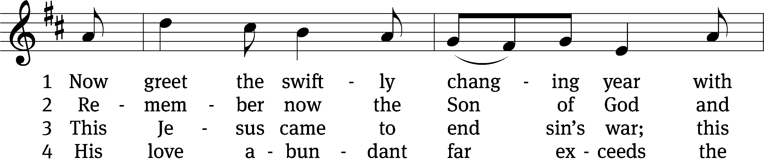
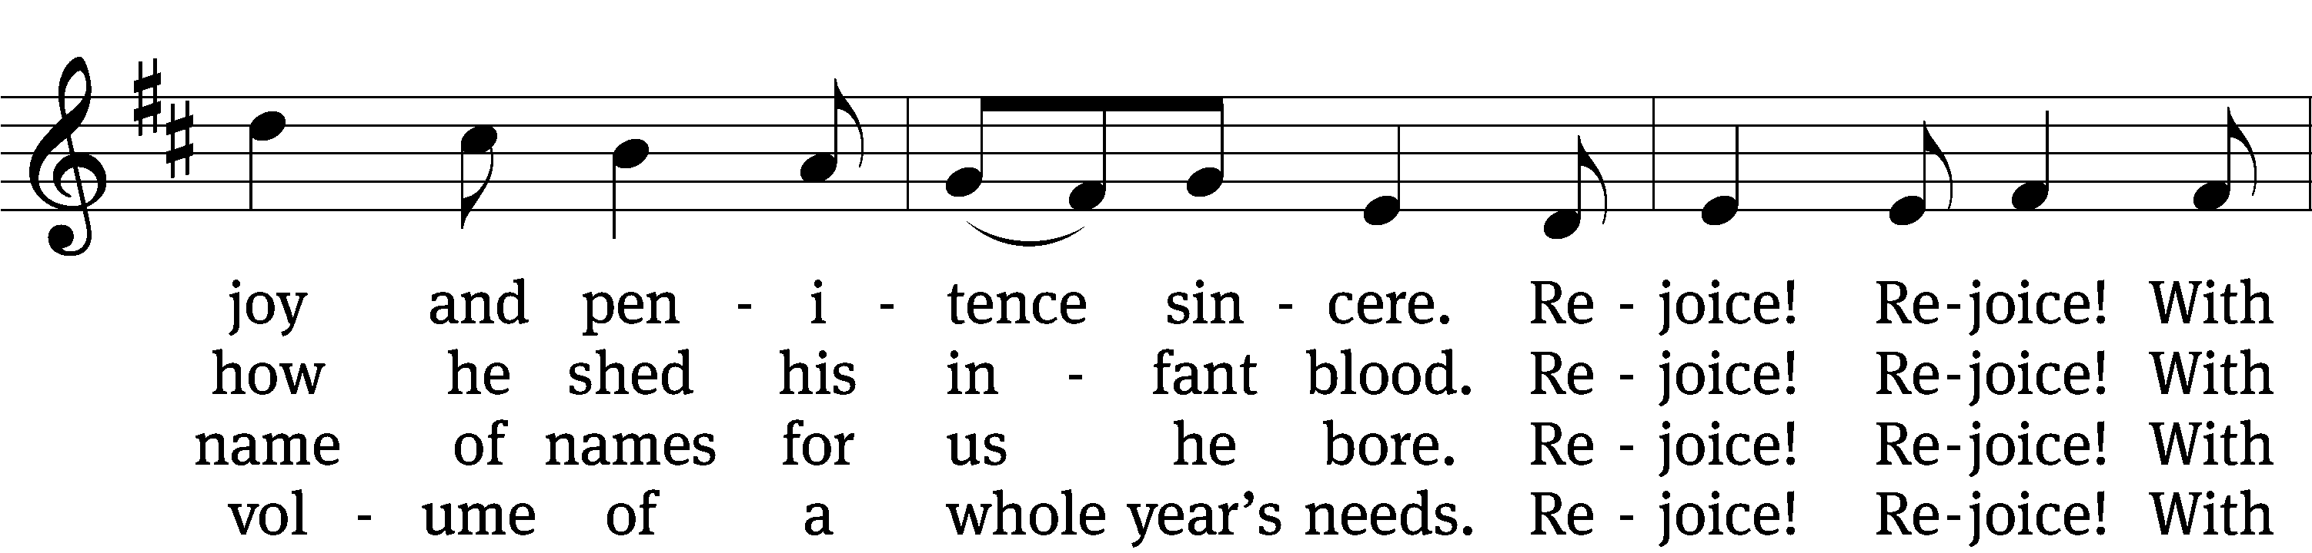
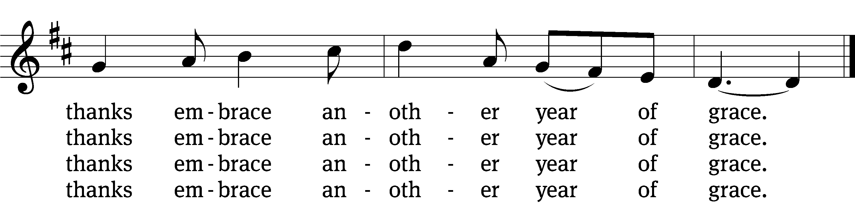

5 With him as Lord to lead our way
in want and in prosperity,
what need we fear in earth or space
in this new year of grace?

6 “All glory be to God on high,
and peace on earth!” the angels cry.
Rejoice! Rejoice! With thanks embrace
another year of grace.

7 God, Father, Son, and Spirit, hear!
To all our pleas incline your ear;
upon our lives rich blessing trace
in this new year of grace.
Text: tr. Jaroslav J. Vajda, 1919–2008, alt.; Cithara Sanctorum, Levoca, 1636 Tune: Alfred V. Fedak, b. 1953
Text: © 1969 Concordia Publishing House. Used by permission: OneLicense no. 727703
Tune: © 1990 Selah Publishing Co., Inc. Used by permission: OneLicense no. 727703
Please stand, if you are able
Invocation
In the name of the Father and of the Son and of the Holy Spirit.
Amen.
Confession
If we claim to be without sin, we deceive ourselves and the truth is not in us.
If we confess our sins, God is faithful and just
and will forgive us our sins
and purify us from all unrighteousness.

Let us confess our sins to the Lord.
Holy God, gracious Father,
I am sinful by nature
and have sinned against you in my thoughts, words, and actions.
I have not loved you with my whole heart;
I have not loved others as I should.
I deserve your punishment both now and forever.
But Jesus, my Savior, paid for my sins
with his innocent suffering and death.
Trusting in him, I pray: God, have mercy on me, a sinner.

Our gracious Father in heaven has been merciful to us. He sent his only Son, Jesus Christ, who gave his life as the atoning sacrifice for the sins of the whole world. Therefore, as a called servant of Christ and by his authority, I forgive you all your sins in the name of the Father and of the Son and of the Holy Spirit.
Amen.

Lord, Have Mercy

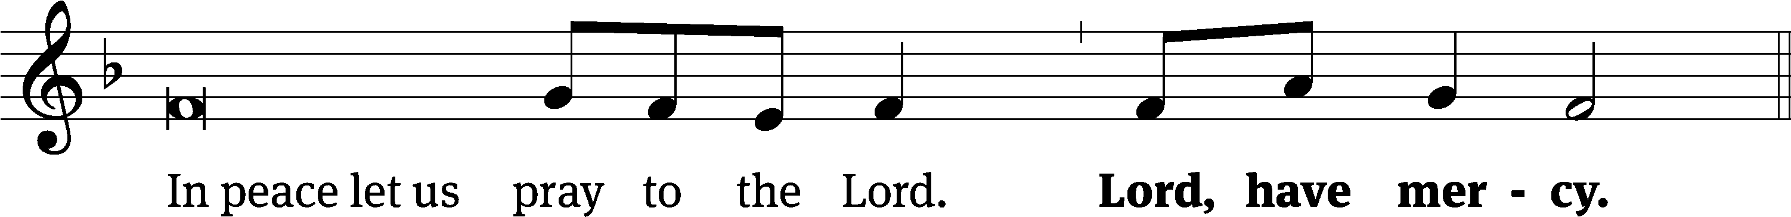
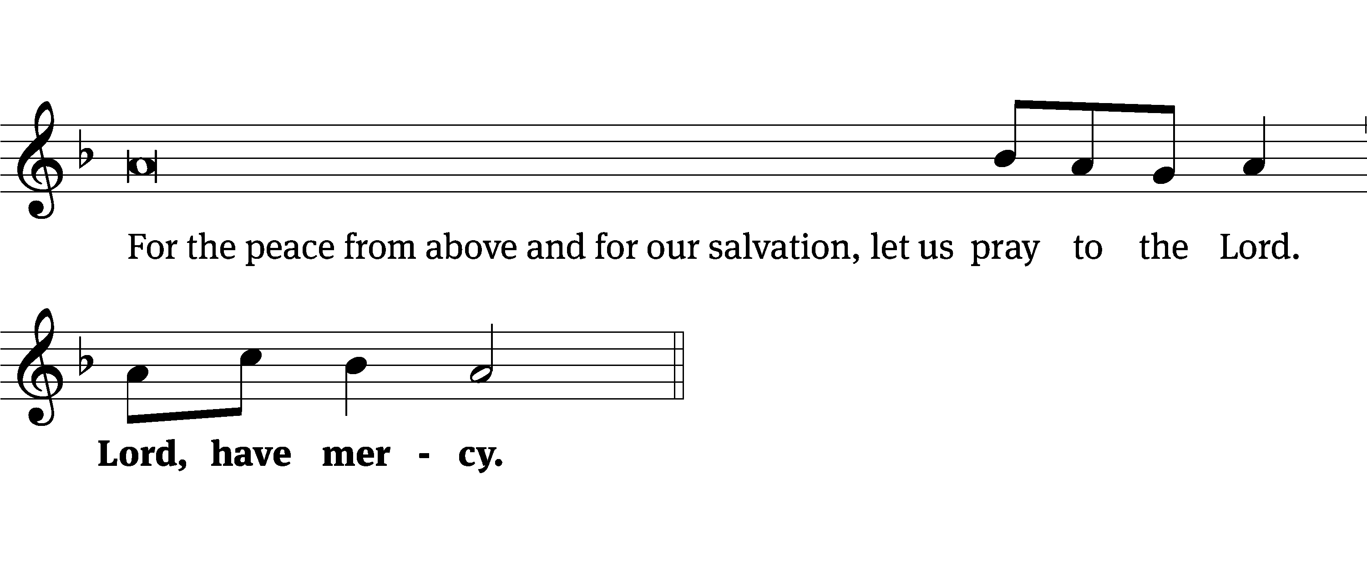
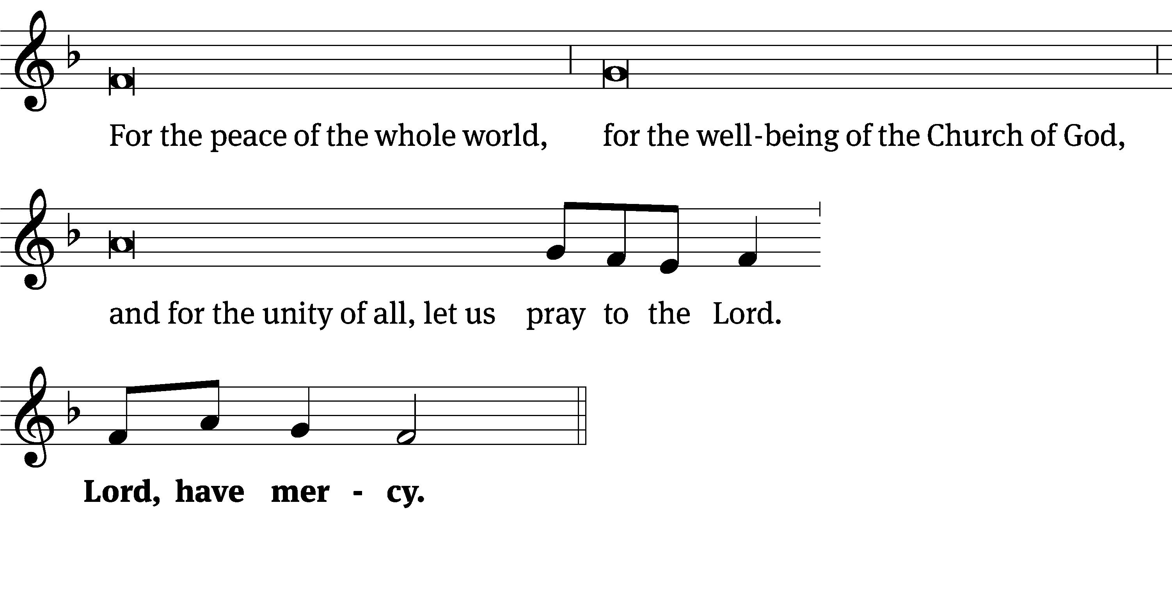
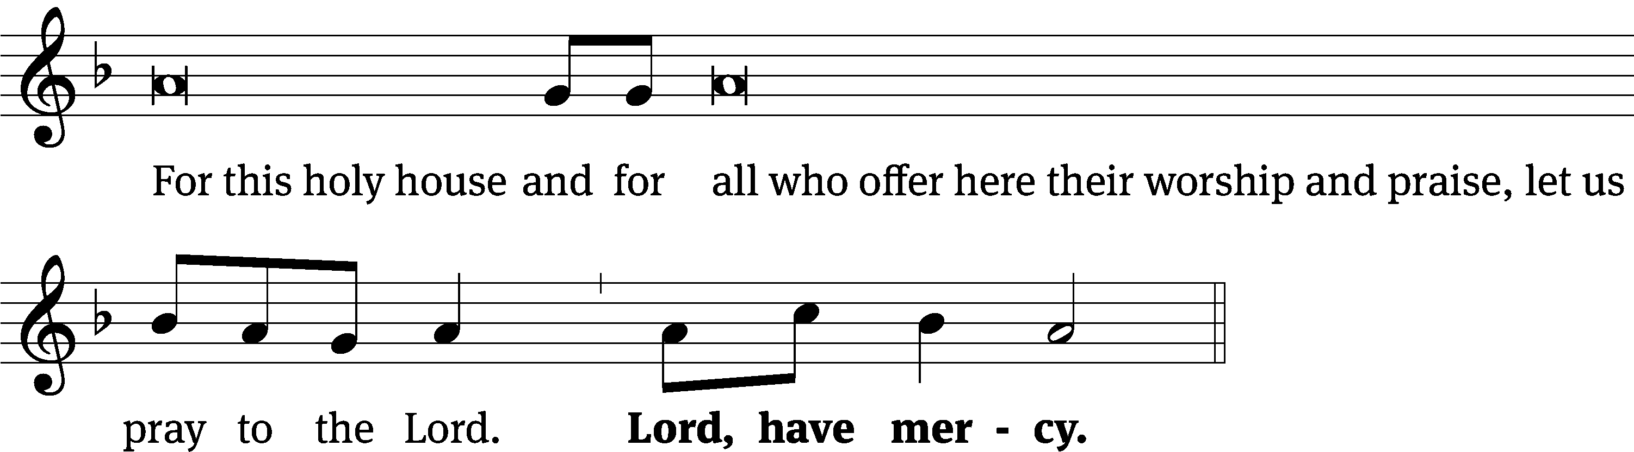
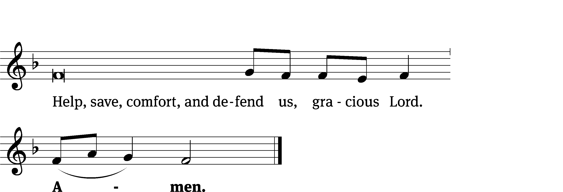
Glory Be to God CW 157
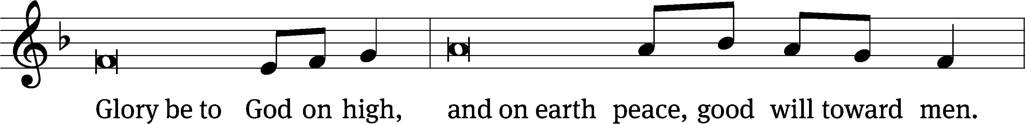
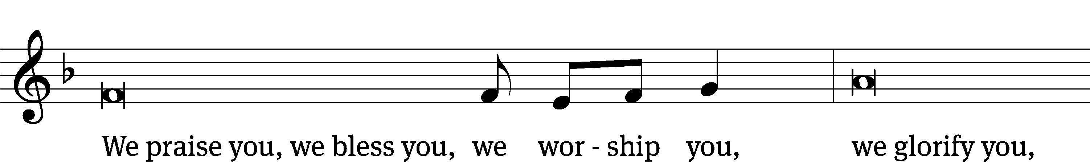
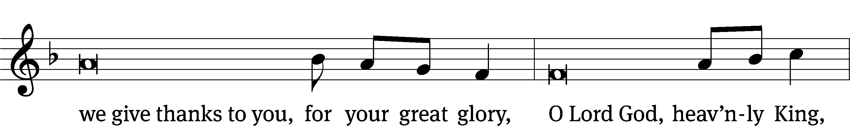
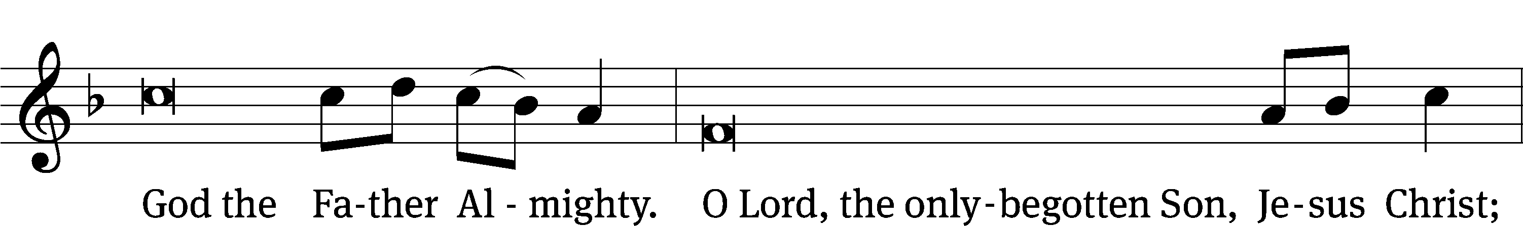
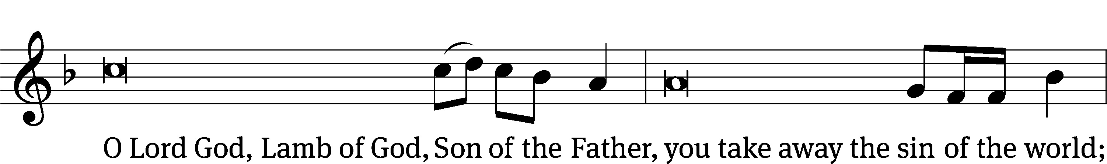
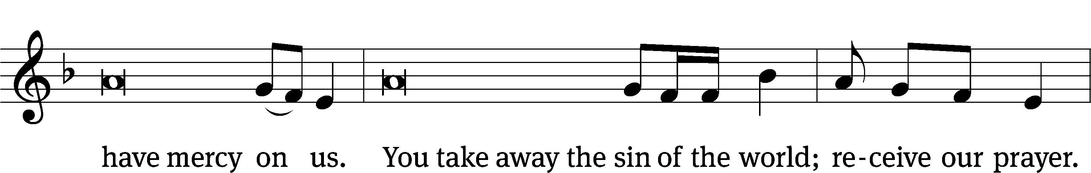
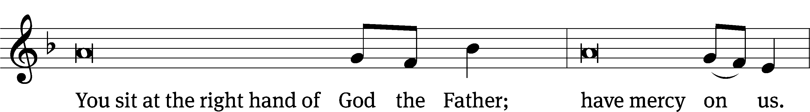
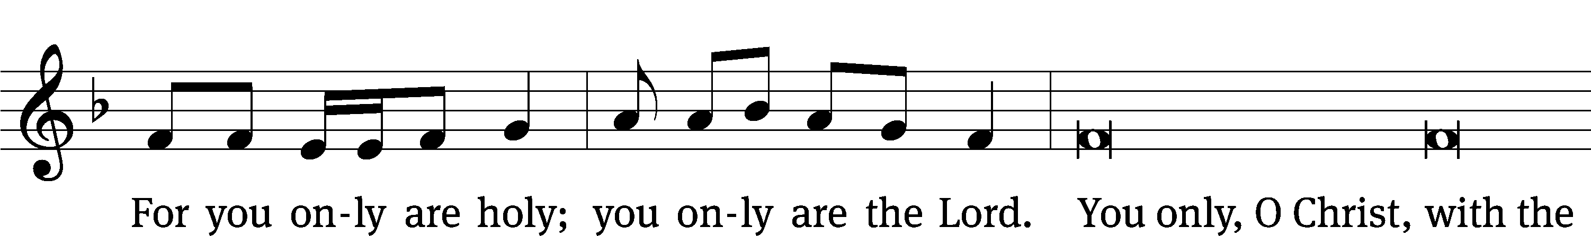
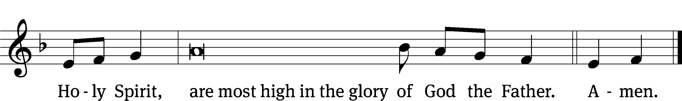

The Lord be with you.
And also with you.
Prayer of the Day
Let us pray.

Eternal Son of God, on this day you were called Jesus, a name that proclaims you to be the Savior of all people. Give us strength in the new year to live each day to the honor of your name; for you live and reign with the Father and the Holy Spirit, one God, now and forever.
Amen.

Please be seated

First Reading Numbers 6:22-27

²² The Lord told Moses ²³ to speak to Aaron and to his sons and to tell them to bless the Israelites with these words:
²⁴ The Lord bless you and keep you.
²⁵ The Lord make his face shine on you
and be gracious to you.
²⁶ The Lord look on you with favor
and give you peace.
²⁷ In this way they will put my name on the Israelites, and I will bless them.

The Word of the Lord.
Thanks be to God.
8A O LORD, Our Lord Psalm 8A
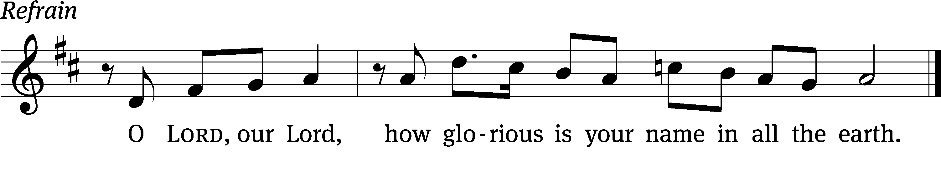

When I consider your heavens, the work of your / fingers,
the moon and the stars, which you have / set in place,
what is a human being that you are mind- / ful of him,
a Son of Man that you / care for him? Refrain

You have made him a little lower than the / angels
and crowned him with glory and / honor.
You made him ruler over the works / of your hands;
you put everything un- / der his feet.
Glory be to the Father and / to the Son
and to the Holy / Spirit,
as it was in the be- / ginning,
is now, and will be forever. / Amen. Refrain
Tune: Kurt J. Eggert
Setting: Dale A. Witte
Tune: © 1993 Kurt J. Eggert, admin. Northwestern Publishing House. Used by permission: OneLicense no. 727703
Setting: © 2021 Dale A. Witte, admin. Northwestern Publishing House. Used by permission: OneLicense no. 727703

Second Reading Galatians 3:23-4:5
²³ But before this faith came, we were held in custody under the law, imprisoned until the coming faith was revealed. ²⁴ So the law was our chaperone until Christ, so that we might be justified by faith. ²⁵ But now that this faith has come, we are no longer under a chaperone.
²⁶ In fact, you are all sons of God through faith in Christ Jesus. ²⁷ Indeed, as many of you as were baptized into Christ have been clothed with Christ. ²⁸ There is not Jew or Greek, slave or free, male or female, for you are all one and the same in Christ Jesus. ²⁹ And if you belong to Christ, then you are Abraham’s descendants^{[c]} and heirs according to the promise.
4 What I am saying is this: As long as the heir is a young child, he is no different from a slave. Although he is owner of everything, ² he is still under guardians and managers until the day set by his father. ³ So also, when we were younger children, we were enslaved under the basic principles of the world. ⁴ But when the set time had fully come, God sent his Son to be born of a woman, so that he would be born under the law, ⁵ in order to redeem those under the law, so that we would be adopted as sons.

The Word of the Lord.
Thanks be to God.

Please stand, if you are able

Gospel Acclamation Matthew 1:21
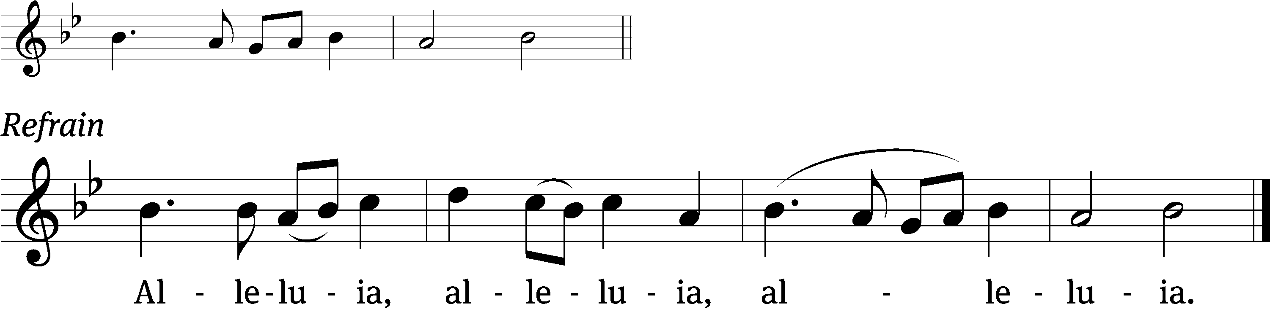
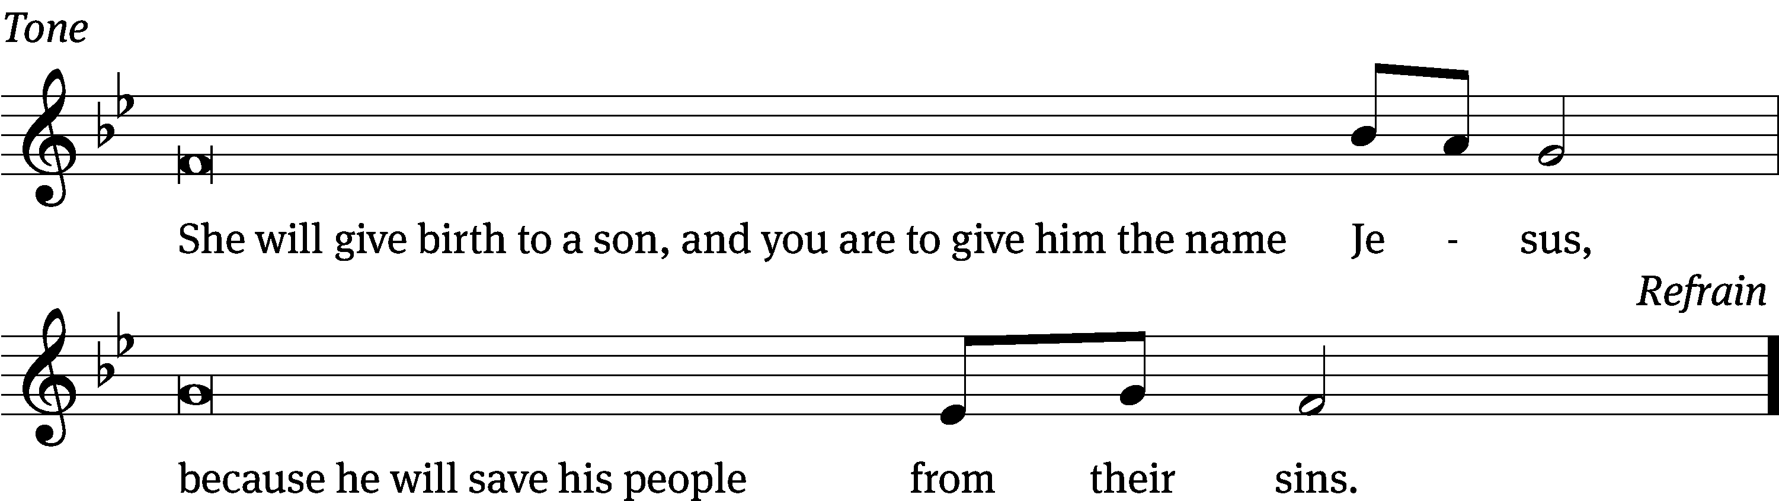
Tune: © 2021 Northwestern Publishing House. Used by permission: OneLicense no. 727703

Gospel Luke 2:21
²¹ After eight days passed, when the child was circumcised, he was named Jesus, the name given by the angel before he was conceived in the womb.

The Gospel of the Lord.
Praise be to you, O Christ!

Please be seated

496 Jesus! Name of Wondrous Love CW 496
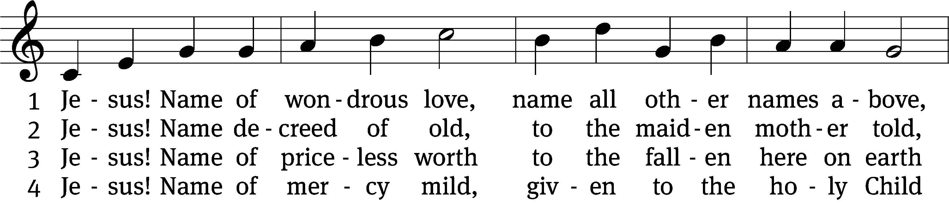
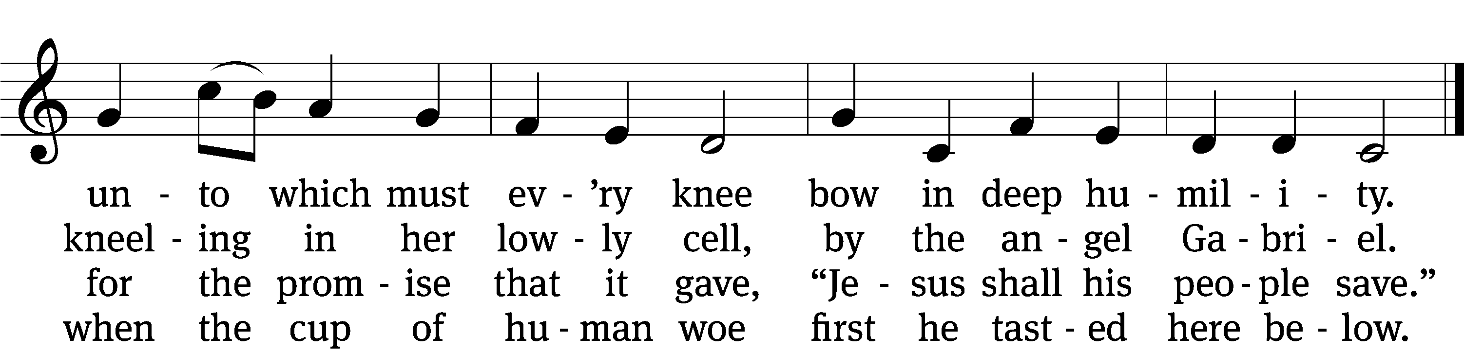

5 Jesus! Only name that’s giv’n
under all the mighty heav’n
whereby those to sin enslaved
burst their fetters and are saved.

6 Jesus! Name of wondrous love,
human name of God above;
pleading only this, we flee
helpless, O our God, to thee.
Text: William W. How, 1823–1897, alt.
Tune: Geist-reiches Gesang-Buch, Halle, 1704, ed. Johann A. Freylinghausen, alt.
Text and tune: Public domain

SERMON Luke 2:21
“A Savior Born Under the Law”

Please stand, if you are able

Nicene Creed
We believe in one God, the Father, the Almighty,
maker of heaven and earth,
of all that is,
seen and unseen.
We believe in one Lord, Jesus Christ, the only Son of God,
eternally begotten of the Father,
God from God, Light from Light, true God from true God,
begotten, not made,
of one being with the Father.
Through him all things were made.
For us and for our salvation, he came down from heaven,
was incarnate of the Holy Spirit and the Virgin Mary,
and became truly human.
For our sake he was crucified under Pontius Pilate.
He suffered death and was buried.
On the third day he rose again in accordance with the Scriptures.
He ascended into heaven
and is seated at the right hand of the Father.
He will come again in glory to judge the living and the dead,
and his kingdom will have no end.
We believe in the Holy Spirit,
the Lord, the giver of life,
who proceeds from the Father and the Son,
who in unity with the Father and the Son
is worshiped and glorified,
who has spoken through the prophets.
We believe in one holy Christian and apostolic Church.
We acknowledge one baptism for the forgiveness of sins.
We look for the resurrection of the dead
and the life of the world to come. Amen.
Prayer of the Church

The Sacrament
Preface CW 165
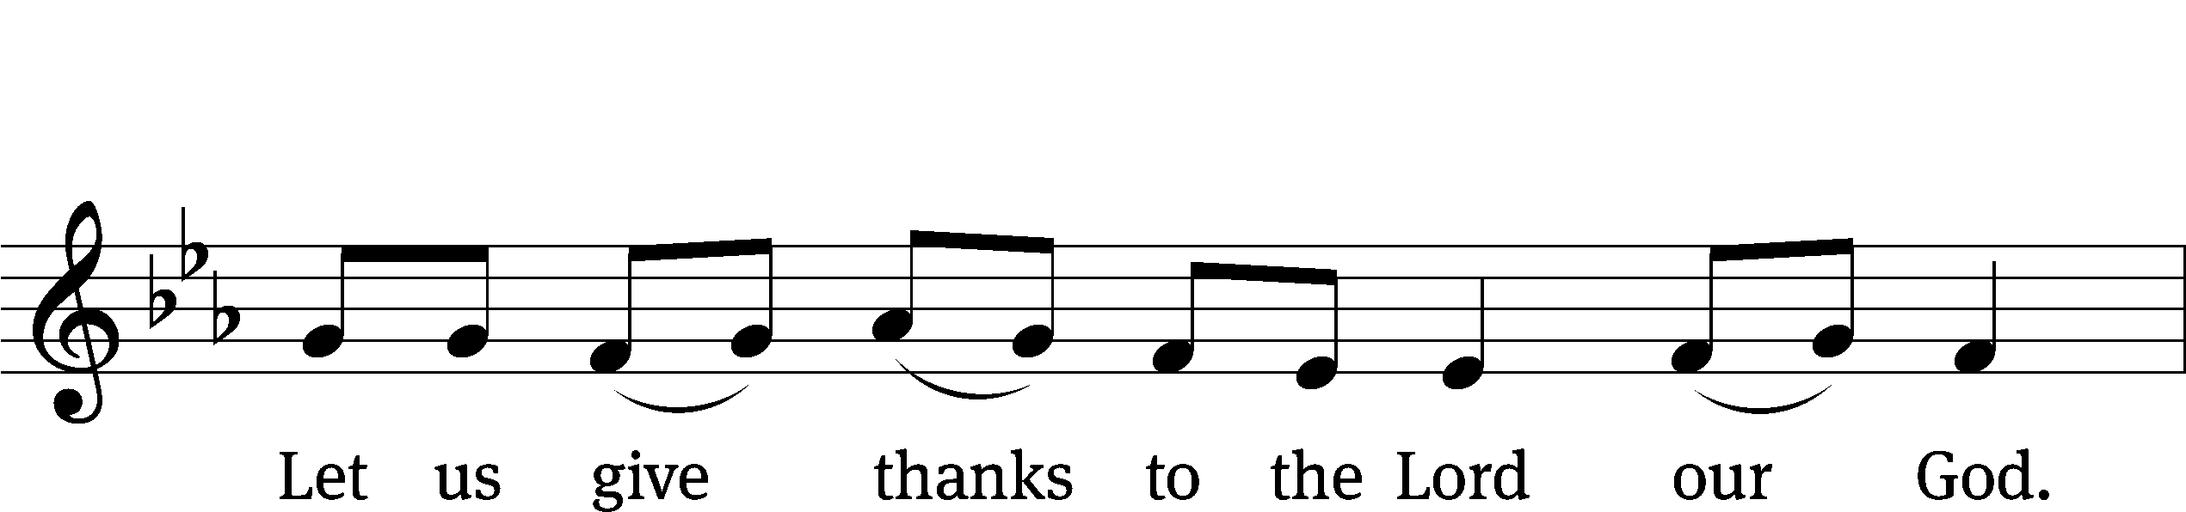
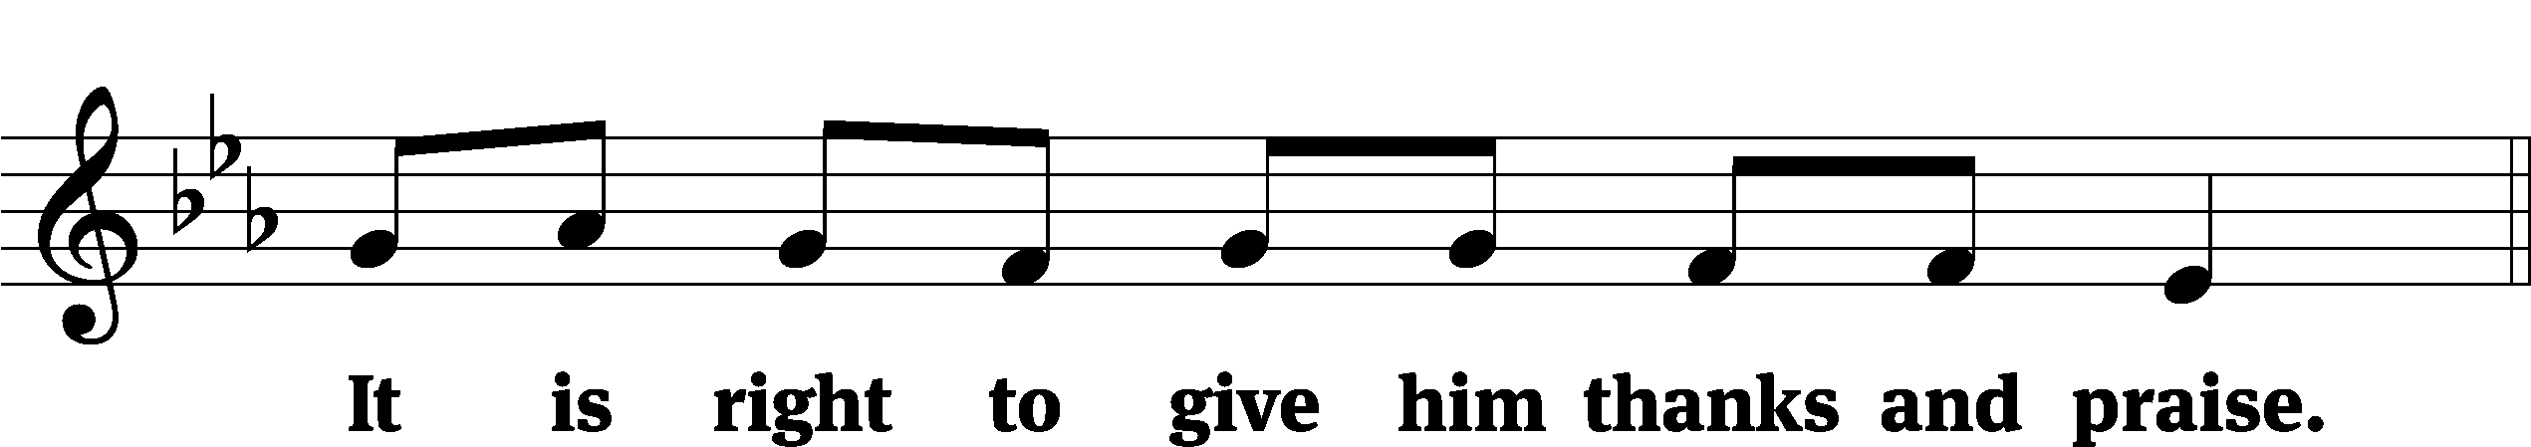

It is truly good and right that we should at all times and in all places give you thanks, O Lord, holy Father, almighty and everlasting God, through Jesus Christ our Lord, who promised that wherever two or three come together in his name, there he is with them to shepherd his flock until he comes again in glory. Therefore, with all the saints on earth and hosts of heaven, we praise your holy name and join their glorious song:
Holy, Holy, Holy CW 167
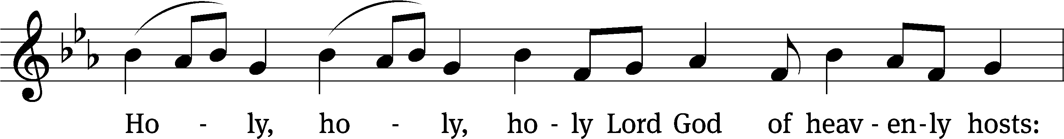
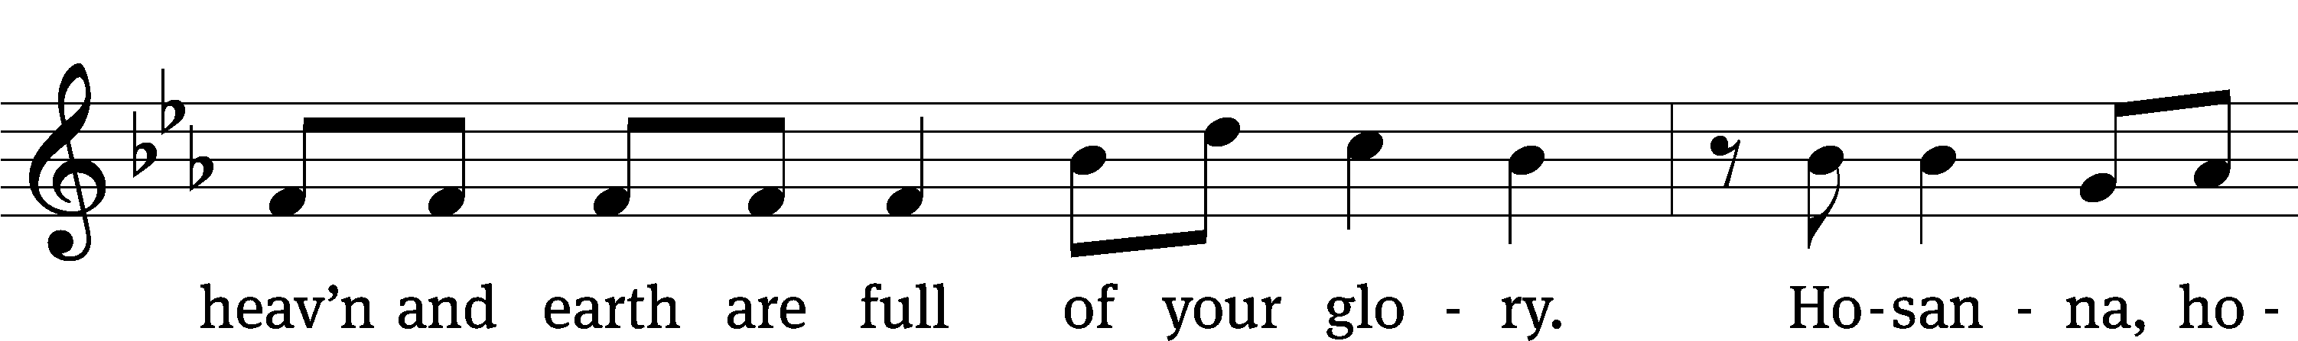
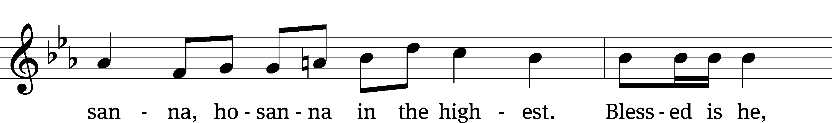
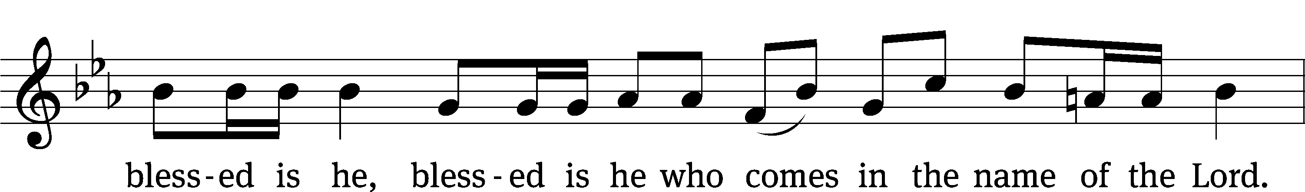
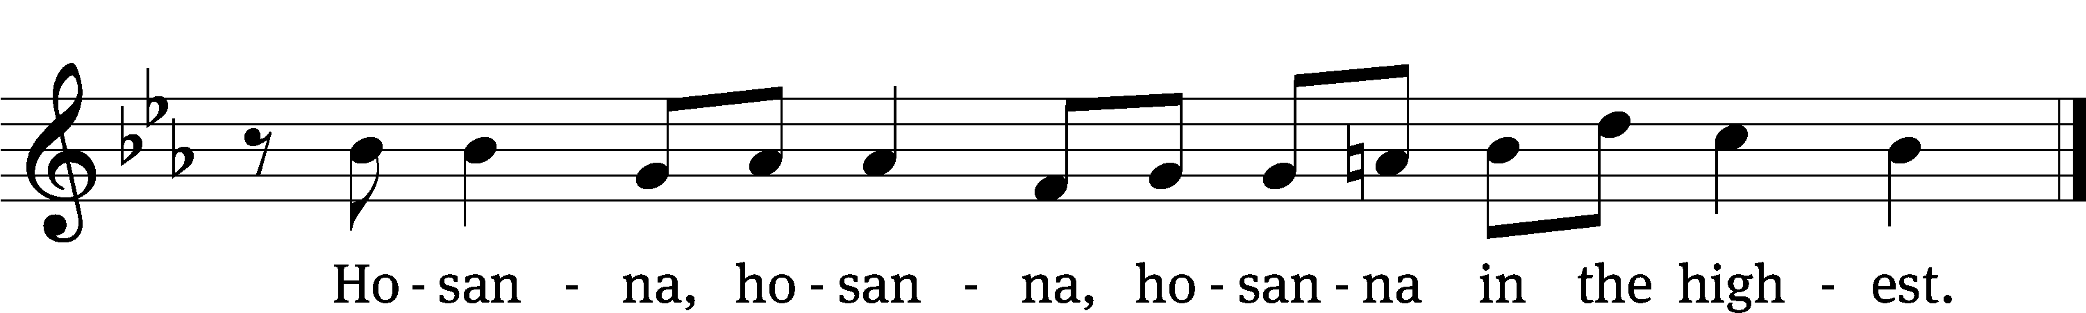

Prayer of Thanksgiving
We give thanks to you, O God, through your dear Son, Jesus Christ, whom you sent to be our Savior, our Redeemer, and the messenger of your grace. Through him you made all things; in him you are well pleased. He is the incarnate Word, conceived by the Holy Spirit and born of the Virgin Mary. To fulfill your promises, he stretched out his hands on the cross and released from eternal death all who believe in you.

As we remember Jesus’ death and resurrection, we thank you that you have gathered us together to receive your Son’s body and blood. Send us your Spirit, unite us as one, and strengthen our faith so that we may praise you in your Son, Jesus Christ. Through him, we glorify and honor you, O God our Father, with the Holy Spirit, one God, now and forever.
Amen.

Lord’s Prayer
Our Father, who art in heaven, hallowed be thy name, thy kingdom come, thy will be done on earth as it is in heaven. Give us this day our daily bread; and forgive us our trespasses, as we forgive those who trespass against us; and lead us not into temptation, but deliver us from evil. For thine is the kingdom and the power and the glory forever and ever. Amen.

Words of Institution
Our Lord Jesus Christ, on the night he was betrayed, took bread; and when he had given thanks, he broke it and gave it to his disciples, saying, “Take and eat; this is my body, which is given for you. Do this in remembrance of me.”
Then he took the cup, gave thanks, and gave it to them, saying, “Drink from it, all of you; this is my blood of the new covenant, which is poured out for you for the forgiveness of sins. Do this, whenever you drink it, in remembrance of me.”

The peace of the Lord be with you always.
Amen.
O Christ, Lamb of God CW 169
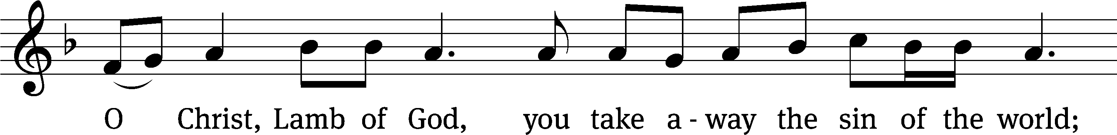
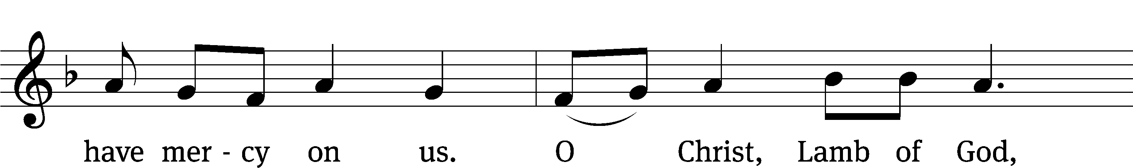
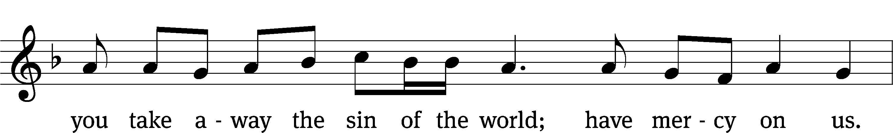
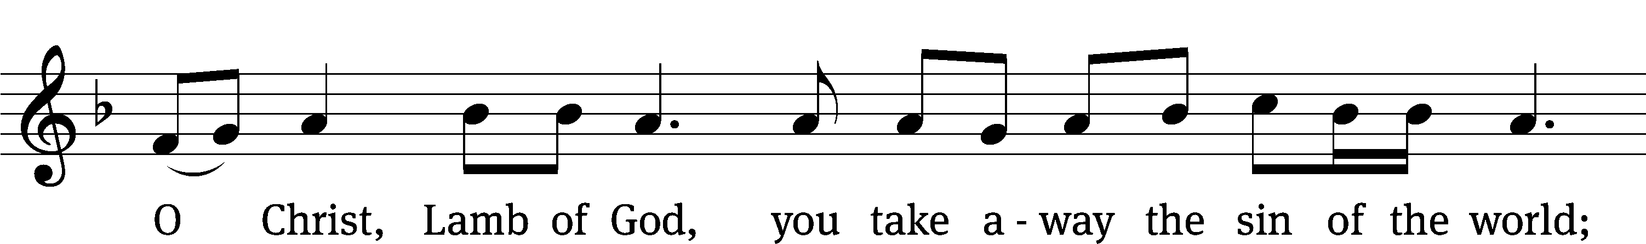
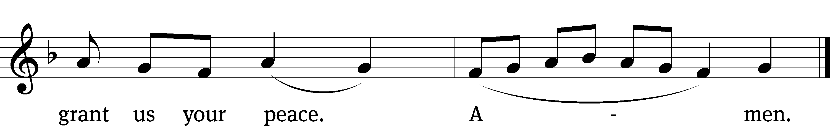
Please be seated
512 All Hail the Power of Jesus’ Name CW 512
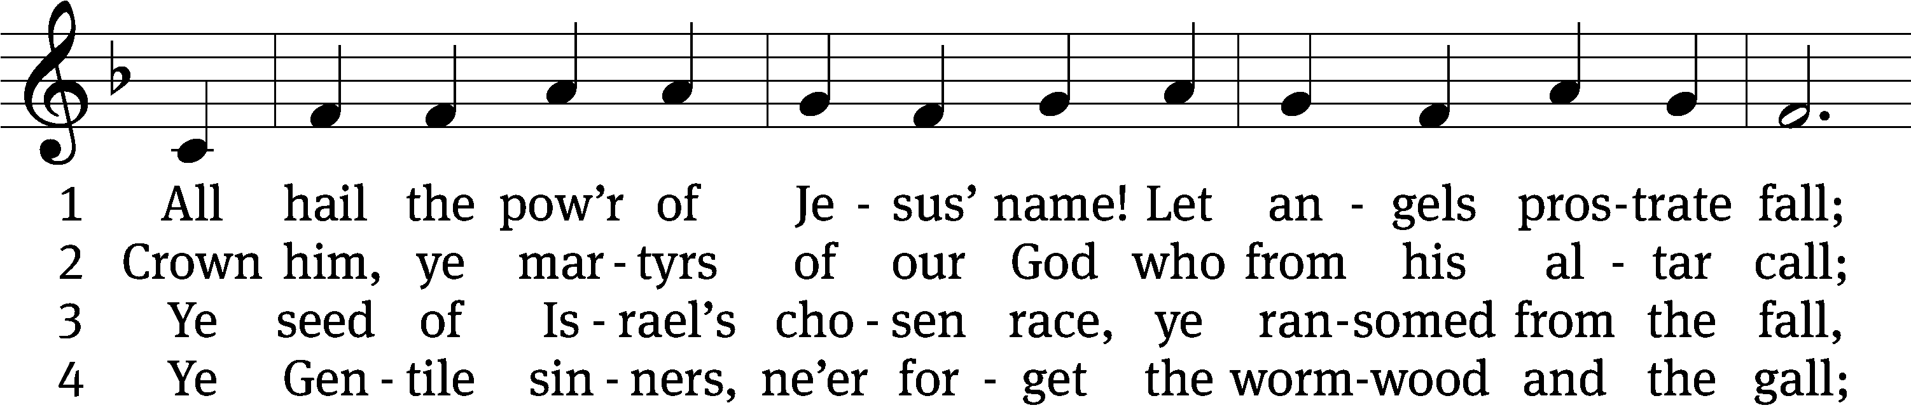
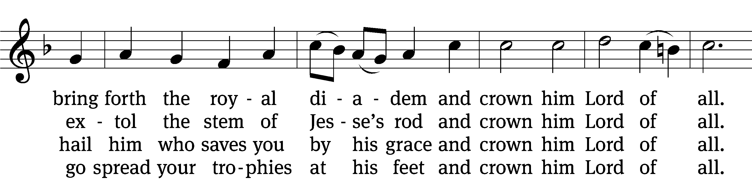
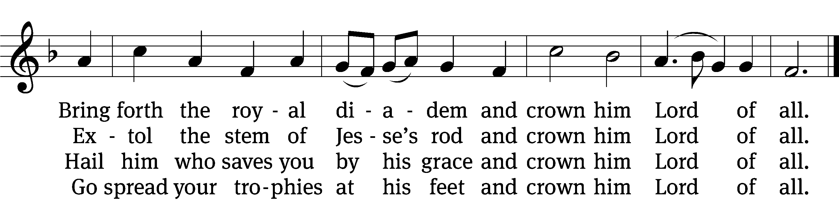

5 Let ev’ry kindred, ev’ry tribe
on this terrestrial ball
to him all majesty ascribe
and crown him Lord of all.
To him all majesty ascribe
and crown him Lord of all.

6 Oh, that with yonder sacred throng
we at his feet may fall!
We’ll join the everlasting song
and crown him Lord of all.
We’ll join the everlasting song
and crown him Lord of all.
Text (sts. 1–3): Edward Perronet, 1726–1792, abr., alt.; (sts. 4–6): A Selection of Hymns, London, 1787, alt.
Tune: Oliver Holden, 1765–1844
Text and tune: Public domain

563 My Hope Is Built on Nothing Less CW 563
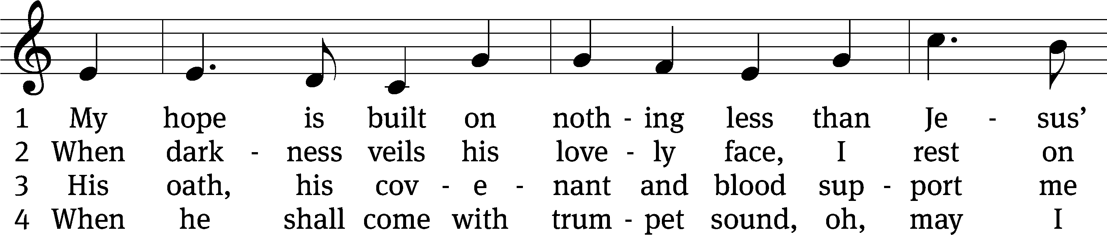
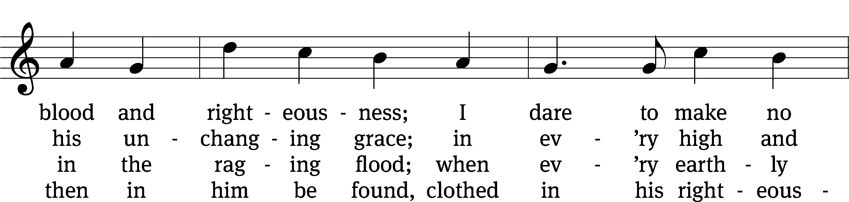
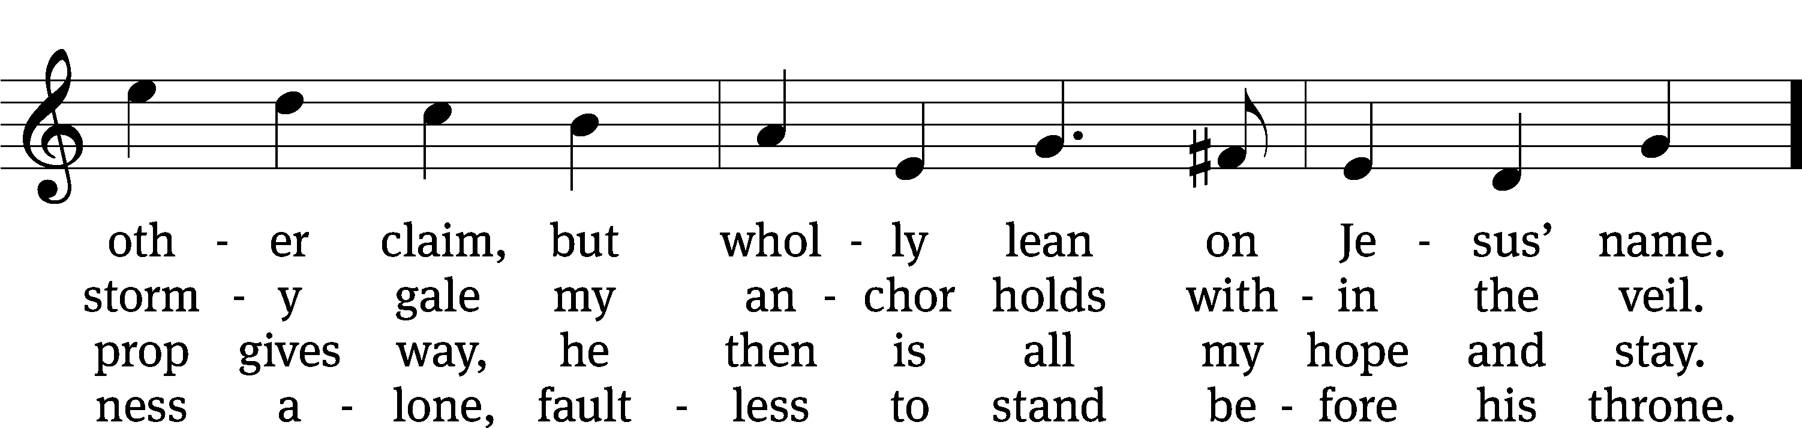
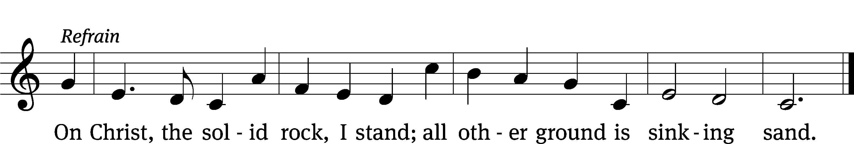
Text: Edward Mote, 1797–1874, alt.
Tune: John Stainer, 1840–1901, alt.
Text and tune: Public domain

Please stand, if you are able

Give thanks to the Lord, for he is good;
his mercy endures forever.

Whenever we eat this bread and drink this cup,
we proclaim the Lord’s death until he comes.

We give thanks, almighty God, that you have refreshed us with this saving gift. We pray that through it you will strengthen our faith in you and increase our love for one another. We ask this in the name of Jesus Christ our Lord, who lives and reigns with you and the Holy Spirit, one God, now and forever.
Amen.

Blessing
The Lord bless you and keep you.
The Lord make his face shine on you and be gracious to you.
The Lord look on you with favor and give you peace.
Amen.

358 Of the Father’s Love Begotten CW 358
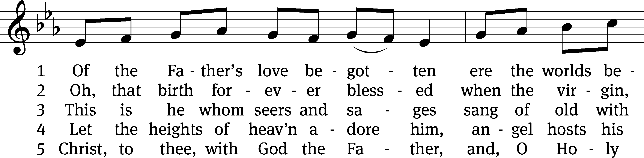
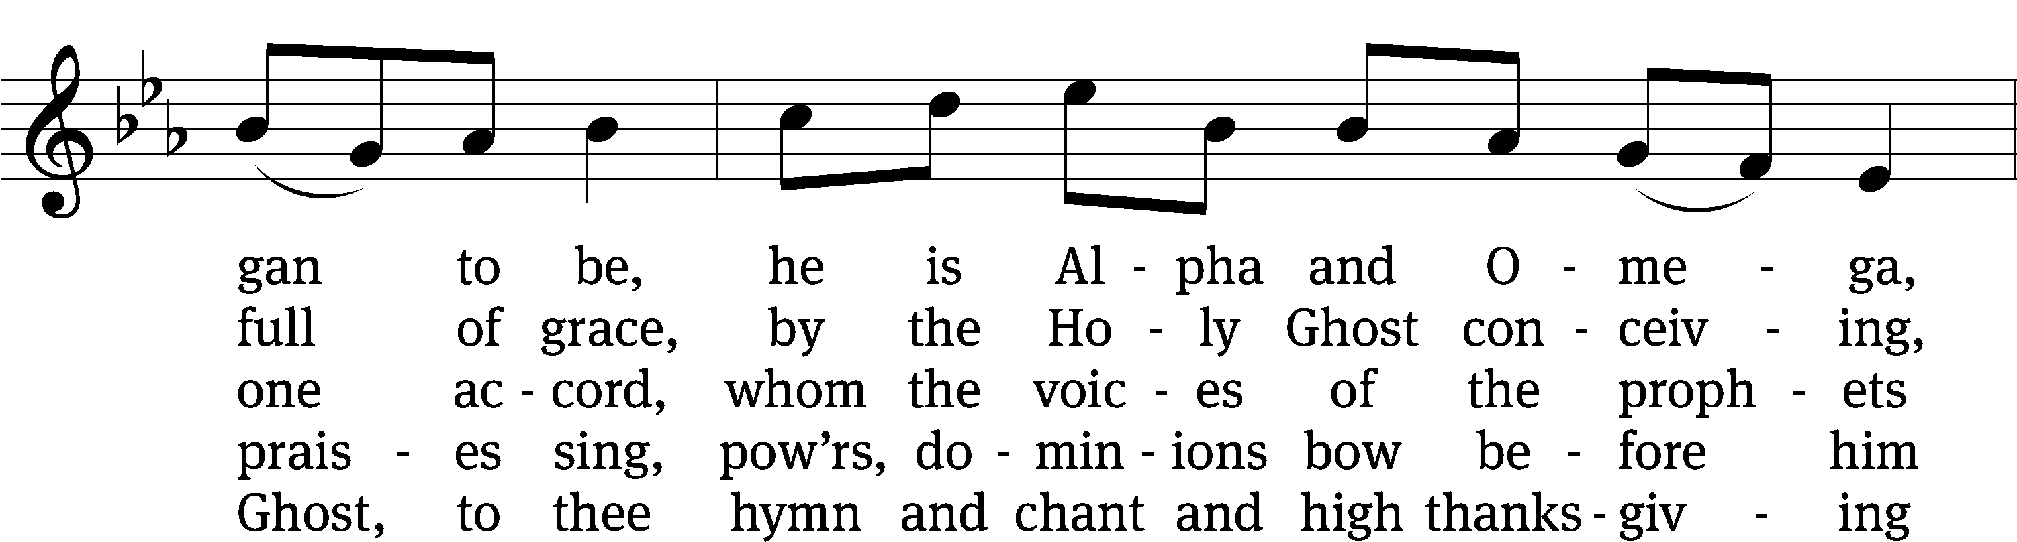
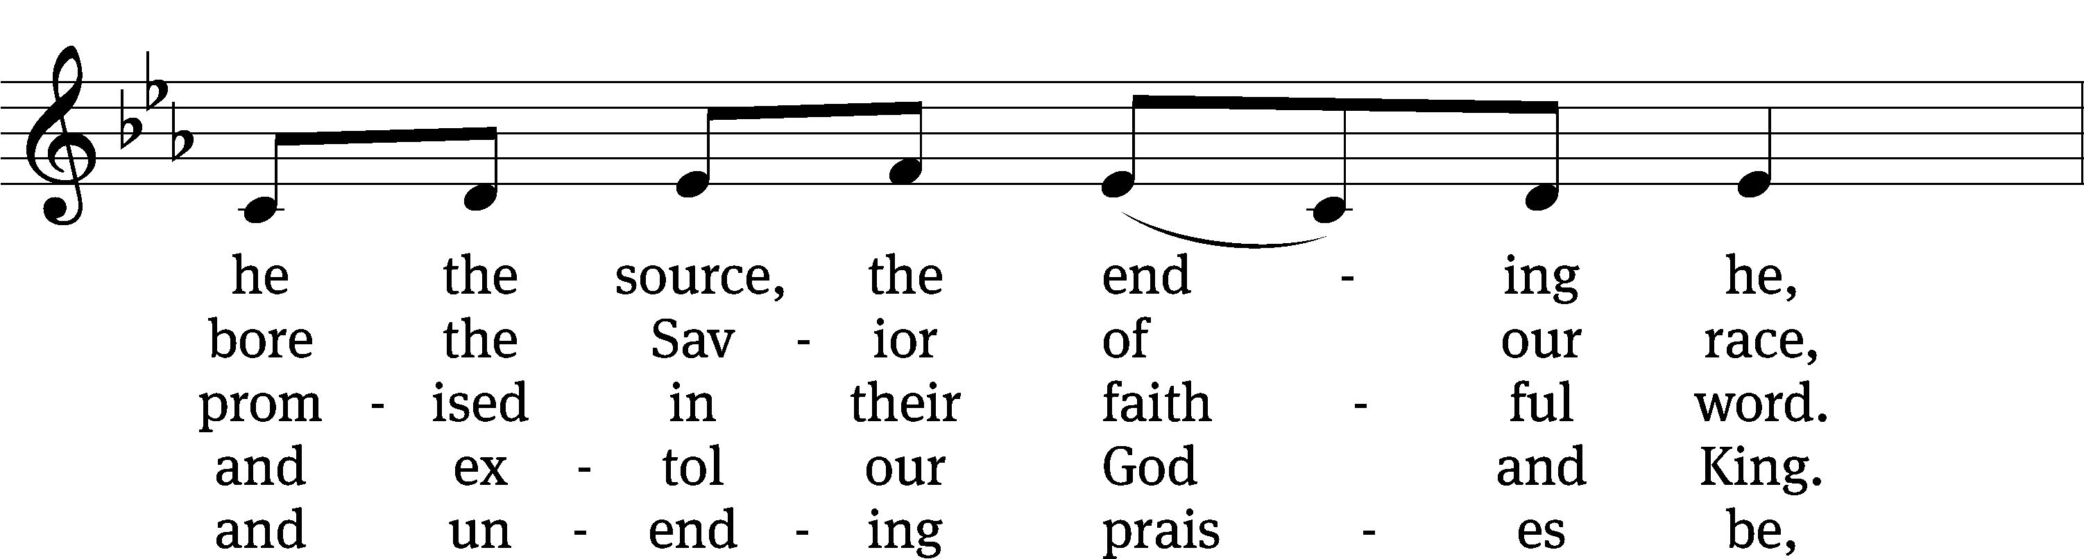
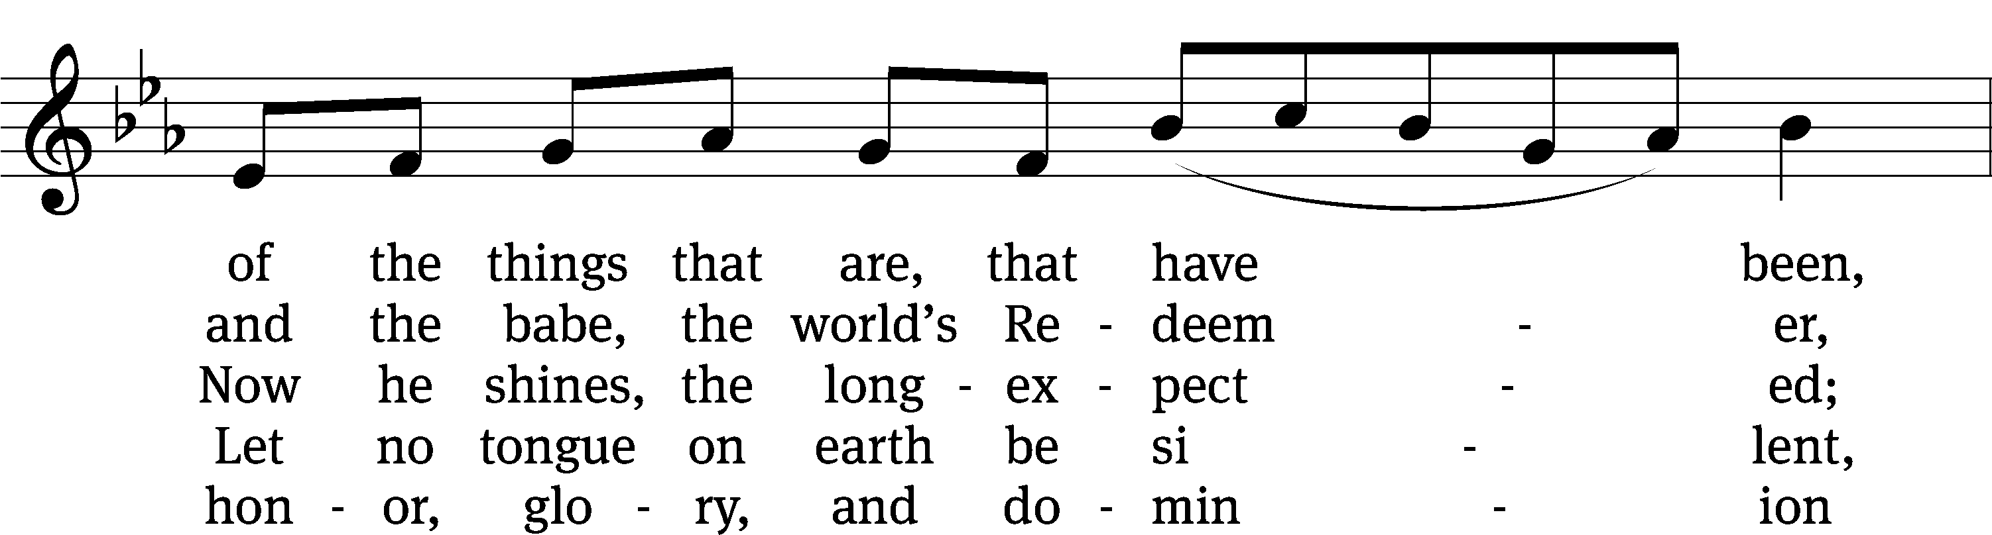
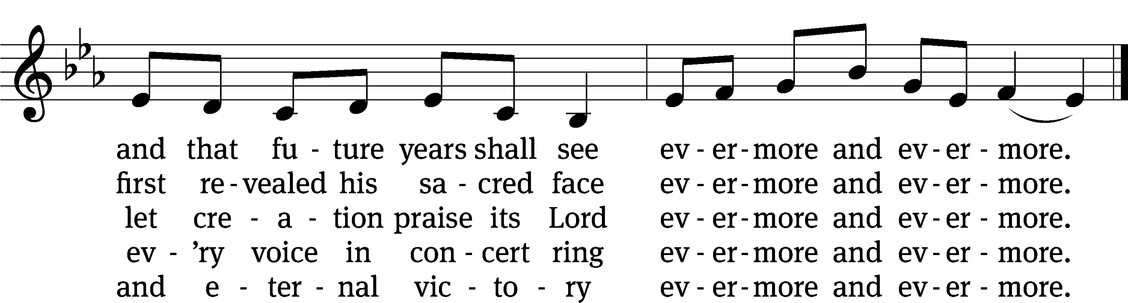
Text: Aurelius Clemens Prudentius, 348–c. 413, abr.; (sts. 1–4): tr. John Mason Neale, 1818–1866, alt.; (st. 5): tr. Henry W. Baker, 1821–1877, alt.
Tune: plainsong, 13th cent.
Text and tune: Public domain
Acknowledgments
Setting One from Christian Worship
Software distributed in partnership with Northwestern Publishing House.
Created by Christian Worship: Service Builder © 2022 Concordia Publishing House.
Serving in Worship
Officiant Pastor WilliamNatsis
Preacher Pastor Jared Natsis
Organist Marcia Marion Ackling
Deacons Robert Niethammer and Dave Stevenson

Altar Guild Sharon Boswell and Connie Marion
Videographer Ann Latowski

