THE first SUNDAY
in lent

TRINITY EVANGELICAL LUTHERAN CHURCH | Saline, Michigan
WELCOME TO WORSHIP February 18, 2024

Thank you for joining us in God’s house today! We cordially ask that our guests sign one of the guestbooks located at either the front or back entryways.

THANK OFFERING: Members of Trinity give their offering as an expression of love and thankfulness to the Lord and to help support the Lord’s work in our community and around the world. Visitors need not feel obligated to participate in this offering which supports our ministry.

Restrooms are located at the back of the upper level (the annex), and in the basement (down the back stairs of the sanctuary or annex). Handicap access is available, please ask an usher for assistance.

celebration of holy communion:
In His Word, God makes it clear that the Lord’s Supper is to be shared by people of a common proclamation of faith (1 Corinthians 11:26; 1 Corinthians 10:16-17). Without judging anyone’s hearts, we invite those who share in our confession by their membership in our congregation or another congregation of the Wisconsin Evangelical Lutheran Synod (WELS) or the Evangelical Lutheran Synod (ELS) and who are properly prepared (1 Corinthians 11;27-29) to receive the Sacrament. Page 295 in the front of Christian Worship provides a guide for preparation.

Guests, we would love to have you join us in communion fellowship in the future, and for that to be possible, we ask that you speak with one of the pastors so that we may speak with you on how that would be possible. We thank you for respecting the way we celebrate the Lord’s Supper in our congregations.

SERVICE OF WORD AND SACRAMENT

404 Jesus, Grant That Balm and Healing CW 404
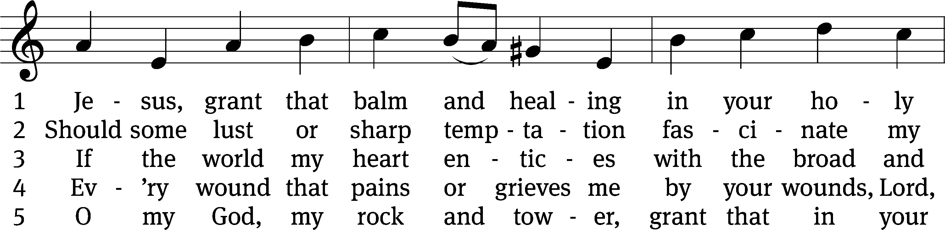
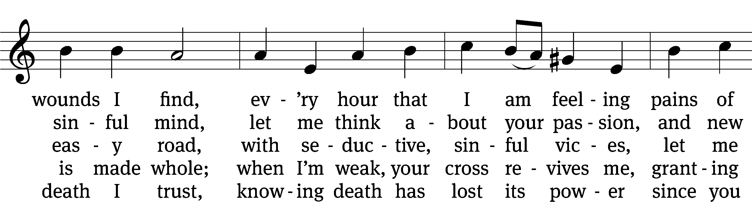
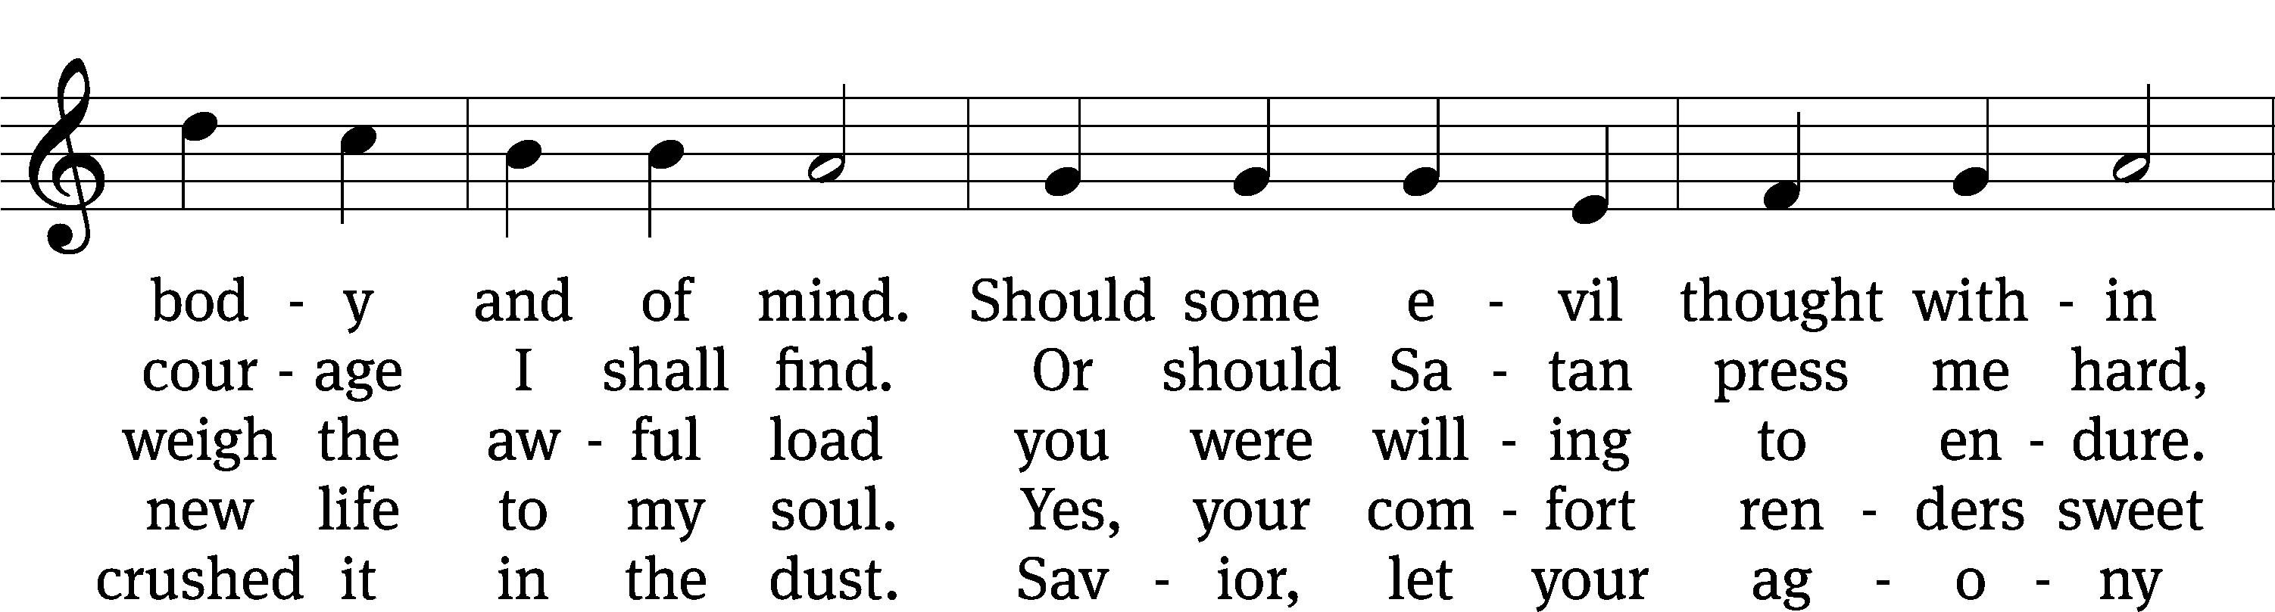
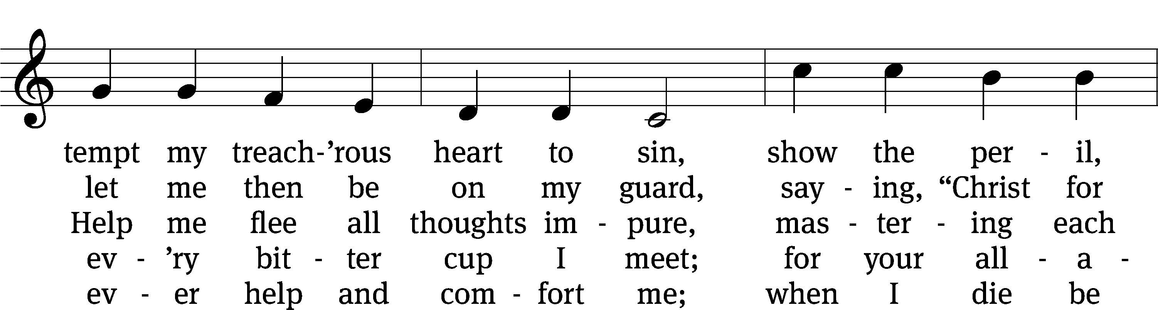
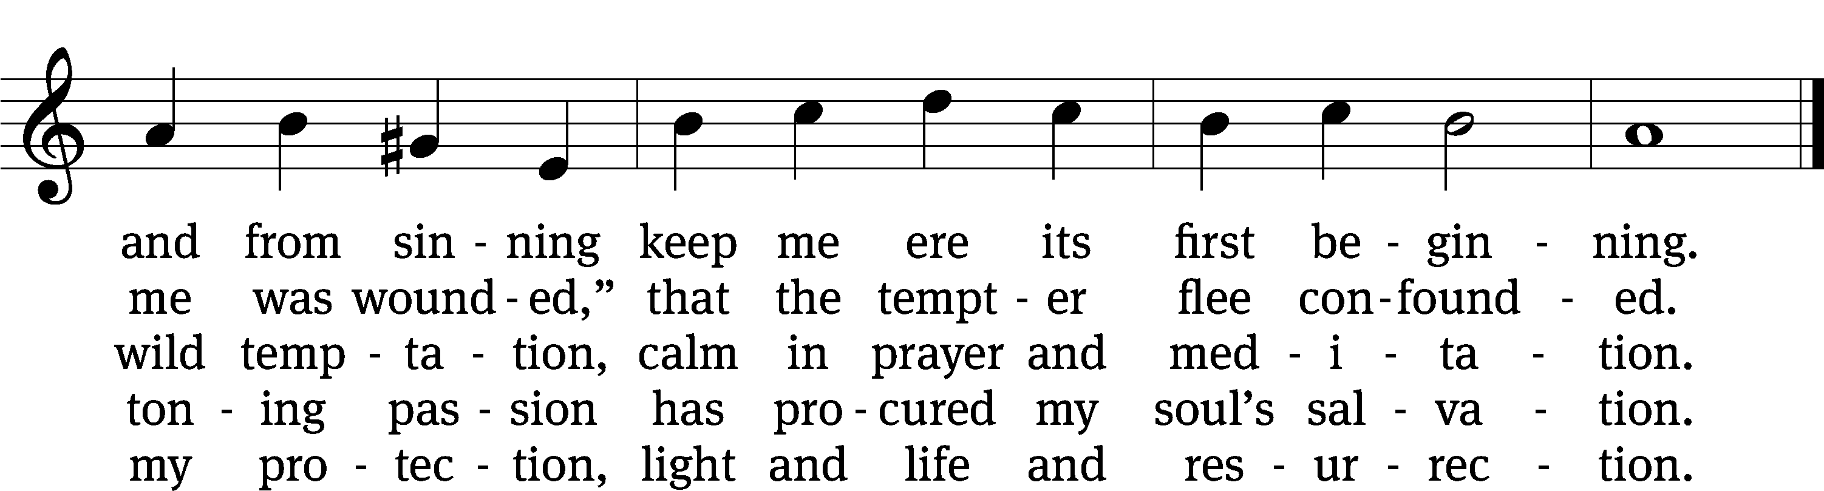
Text: tr. composite; Johann Heermann, 1585–1647, abr.
Tune: Johann B. König, 1691–1758
Text and tune: Public domain

PLEASE STAND, IF YOU ARE ABLE

invocation

M: The grace of our Lord (+) Jesus Christ and the love of God and the fellowship of the Holy Spirit be with you.
C: And also with you.

CONFESSION OF SINS
M: God invites us to come into his presence and worship him with humble and penitent hearts. Therefore, let us acknowledge our sinfulness and ask him to forgive us.
C: Holy and merciful Father, I confess that I am by nature sinful, and that I have disobeyed you in my thoughts, words, and actions. I have done what is evil and failed to do what is good. For this I deserve your punishment both now and in eternity. But I am truly sorry for my sins, and trusting in my Savior Jesus Christ, I pray: Lord, have mercy on me, a sinner.
M: God, our heavenly Father, has been merciful to us and has given his only Son to be the atoning sacrifice for our sins. Therefore, as a called servant of Christ and by his authority, I forgive you all your sins in the name of the Father and of the Son (+) and of the Holy Spirit.
C: Amen.

PRAYER AND PRAISE
LORD, HAVE MERCY

M: For all that we need in life and for the wisdom to use all your gifts with gratitude and joy, hear our prayer, O Lord.

M: For the steadfast assurance that nothing can separate us from your love and for the courage to stand firm against the assaults of Satan and every evil, hear our prayer, O Christ.

M: For the well-being of your holy Church in all the world and for those who offer here their worship and praise, hear our prayer, O Lord.

M: Merciful God, maker and preserver of life, uphold us by your power and keep us in your tender care:

M: The works of the Lord are great and glorious; his name is worthy of praise

Prayer of the day

M: Let us pray.

Mighty God and Father, our Lord Jesus walked into the wilderness to face the devil’s temptations, but he did not succumb to Satan’s lies or falter in his resolve to save the world from the prison of hell. Bolster our faith by his mighty victory that we may battle against the forces of evil with courage and confidence; through your Son, Jesus Christ our Lord, who lives and reigns with you and the Holy Spirit, one God, now and forever.

PLEASE BE SEATED

The Word
first lesson Genesis 22:1-18
22 Some time later God tested Abraham. He called to him, “Abraham!” Abraham answered, “I am here.” ² God said, “Now take your son, your only son, whom you love, Isaac, and go to the land of Moriah. Offer him there as a burnt offering on one of the mountains there, the one to which I direct you.” ³ Abraham got up early in the morning, saddled his donkey, and took two of his young men with him, along with Isaac his son. Abraham split the wood for the burnt offering. Then he set out to go to the place that God had told him about. ⁴ On the third day Abraham looked up and saw the place in the distance.
⁵ Abraham said to his young men, “Stay here with the donkey. The boy and I will go on over there. We will worship, and then we will come back to you.” ⁶ Abraham took the wood for the burnt offering and loaded it on Isaac his son. He took the firepot and the knife in his hand. The two of them went on together.⁷ Isaac spoke to Abraham his father and said, “My father?” He said, “I am here, my son.” He said, “Here are the fire and the wood, but where is the lamb for a burnt offering?” ⁸ Abraham said, “God himself will provide the lamb for a burnt offering, my son.” So the two of them went on together. ⁹ They came to the place that God had told him about. Abraham built the altar there. He arranged the wood, tied up Isaac his son, and laid him on the altar on top of the wood. ¹⁰ Abraham stretched out his hand and took the knife to slaughter his son.¹¹ The Angel of the Lord called to him from heaven, “Abraham, Abraham!” Abraham said, “I am here.” ¹² He said, “Do not lay your hand on the boy. Do not do anything to him. For now I know that you fear God, because you have not withheld your son, your only son, from me.”
¹³ Abraham looked around and saw that behind him there was a ram caught in the thicket by its horns. Abraham went and took the ram and offered it up as a burnt offering instead of his son. ¹⁴ Abraham called the name of that place “The Lord Will Provide.” So it is said to this day, “On the mountain of the Lord it will be provided.”
¹⁵ The Angel of the Lord called to Abraham a second time from heaven ¹⁶ and said, “I have sworn by myself, declares the Lord, because you have done this thing and have not withheld your son, your only son, ¹⁷ I will bless you greatly, and I will multiply your descendants greatly, like the stars of the sky and like the sand on the seashore. Your descendants will take possession of the city gates of their enemies. ¹⁸ In your seed all the nations of the earth will be blessed, because you have obeyed my voice.
25B I Lift My Soul to You Psalm 25B
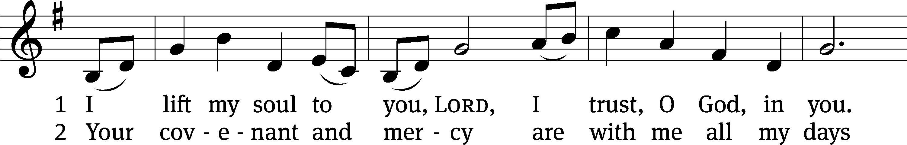
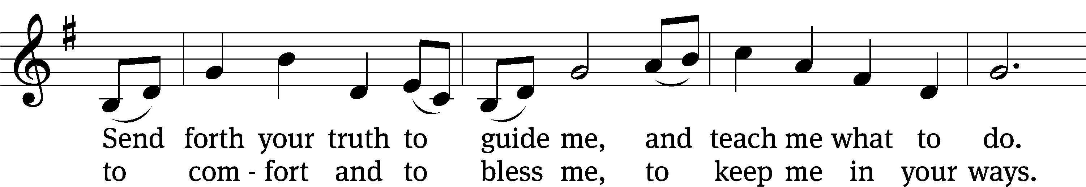
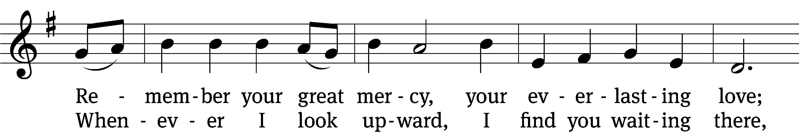
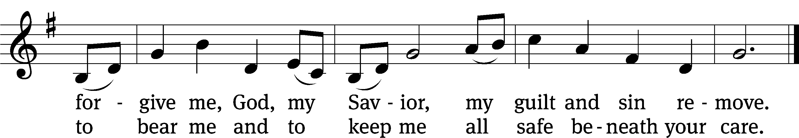
Text: para. William Miller; Jaroslav Vajda, alt.
Tune: Swedish
Text: © 1991 MorningStar Music Publishers. Used by permission: OneLicense no. 727703
Tune: Public domain

second lesson Romans 8:31-39
³¹ What then will we say about these things? If God is for us, who can be against us? ³² Indeed, he who did not spare his own Son, but gave him up for us all—how will he not also graciously give us all things along with him? ³³ Who will bring an accusation against God’s elect? God is the one who justifies! ³⁴ Who is the one who condemns? Christ Jesus, who died and, more than that, was raised to life, is the one who is at God’s right hand and who is also interceding for us! ³⁵ What will separate us from the love of Christ? Will trouble or distress or persecution or famine or nakedness or danger or sword? ³⁶ Just as it is written: For your sake we are being put to death all day long. We are considered as sheep to be slaughtered. ³⁷ No, in all these things we are more than conquerors through him who loved us. ³⁸ For I am convinced that neither death nor life, neither angels nor rulers, neither things present nor things to come, nor powerful forces, ³⁹ neither height nor depth, nor anything else in creation, will be able to separate us from the love of God in Christ Jesus our Lord.
PLEASE STAND, IF YOU ARE ABLE

VERSE OF THE DAY Hebrews 4:15
We do not have a high priest who is unable to empathize with our weaknesses; we have one who has been tempted in every way, just as we are—yet he did not sin.

GOSPEL Mark 1:12-15
¹² The Spirit immediately sent Jesus out into the wilderness. ¹³ He was in the wilderness for forty days, being tempted by Satan. He was with the wild animals, and angels were serving him.
¹⁴ After John was put in prison, Jesus went to Galilee, preaching the gospel of the kingdom of God. ¹⁵ “The time is fulfilled,” he said. “The kingdom of God has come near! Repent, and believe in the gospel.”

M: This is the Gospel of the Lord.

PLEASE BE SEATED

525 The Lamb CW 525
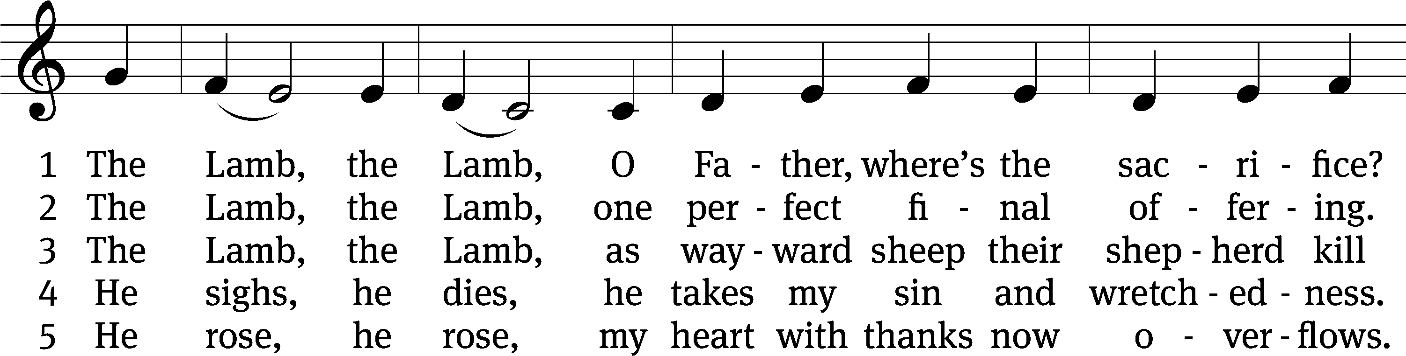
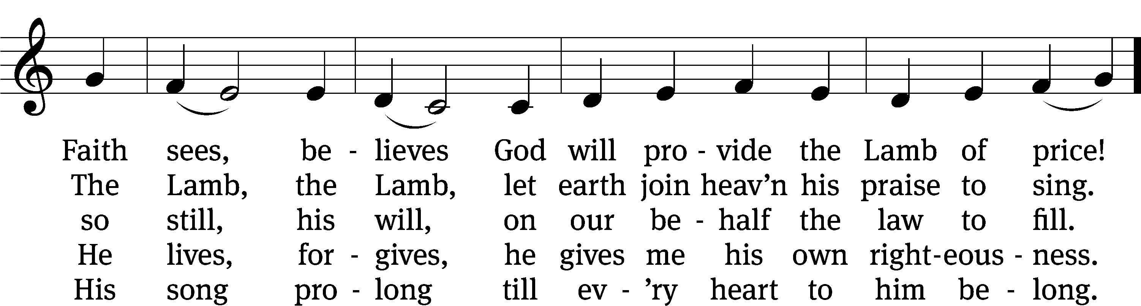
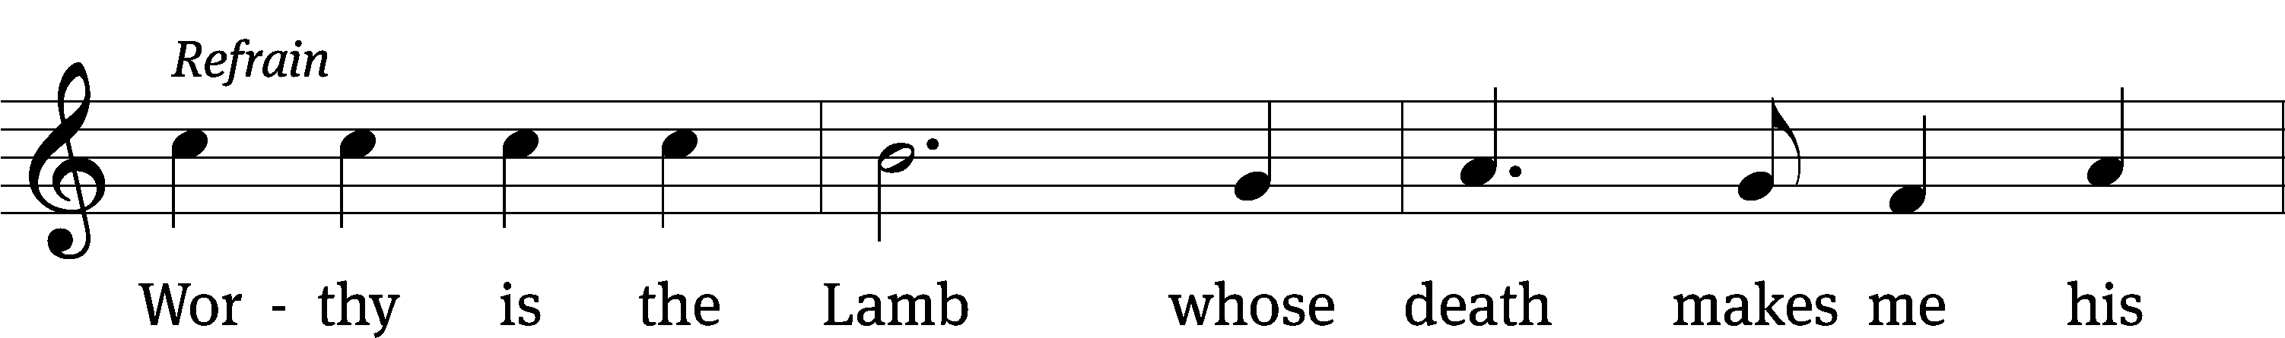
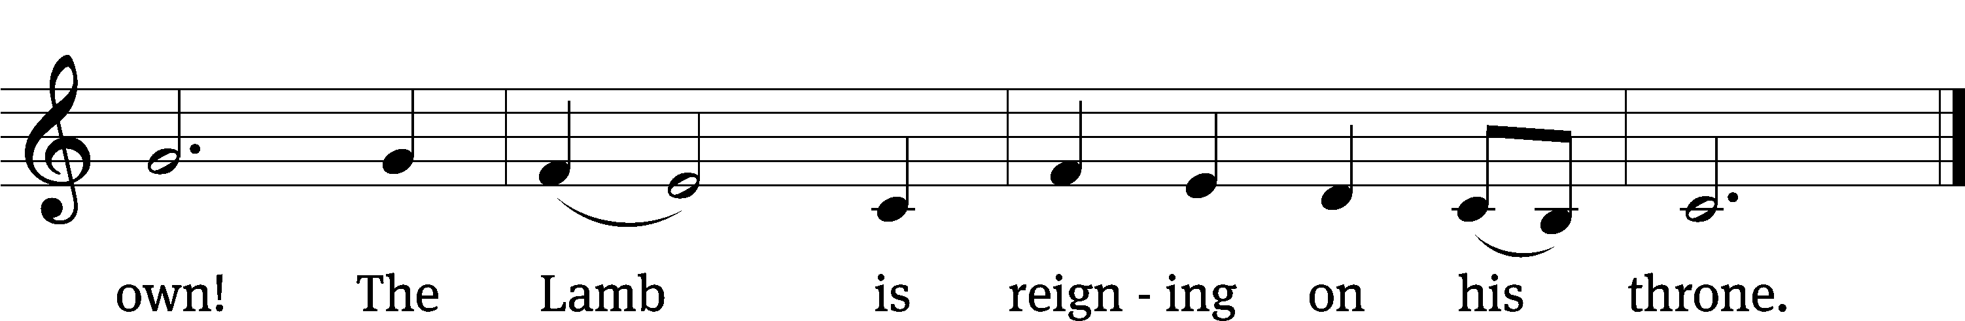
Text: Gerald P. Coleman, b. 1953
Tune: Gerald P. Coleman, b. 1953
Text and tune: © 1987 MorningStar Music Publishers, Inc. Used by permission: OneLicense no. 727703

Sermon Genesis 22:1-18

“Doing the Improbable”

please stand, if you are able

nicene creed

We believe in one God, the Father, the Almighty, maker of heaven and earth, of all that is, seen and unseen.
We believe in one Lord, Jesus Christ, the only Son of God, eternally begotten of the Father, God from God, Light from Light, true God from true God, begotten, not made, of one being with the Father. Through him all things were made. For us and for our salvation, he came down from heaven, was incarnate of the Holy Spirit and the virgin Mary, and became truly human. For our sake he was crucified under Pontius Pilate. He suffered death and was buried. On the third day he rose again in accordance with the Scriptures. He ascended into heaven and is seated at the right hand of the Father. He will come again in glory to judge the living and the dead, and his kingdom will have no end.
We believe in the Holy Spirit, the Lord, the giver of life, who proceeds from the Father and the Son, who in unity with the Father and the Son is worshiped and glorified, who has spoken through the prophets. We believe in one holy Christian and apostolic Church. We acknowledge one baptism for the forgiveness of sins. We look for the resurrection of the dead and the life of the world to come. Amen.

prayer of the church

lord’s prayer

C: Our Father, who art in heaven,
hallowed be thy name,
thy kingdom come,
thy will be done
on earth as it is in heaven.
Give us this day our daily bread;
and forgive us our trespasses,
as we forgive those
who trespass against us;
and lead us not into temptation,
but deliver us from evil.
For thine is the kingdom
and the power and the glory
forever and ever. Amen.
The Sacrament of Holy Communion
Trinity Lutheran Church follows the historic Christian practice of close communion. We ask that only members of Trinity or one of our sister congregations partake of the sacrament. If you are not a member, please see the note about Holy Communion in the beginning of the Worship Folder.

M: The Lord be with you.

M: Lift up your hearts.

M: Let us give thanks to the Lord our God.

M: Praise to the God and Father of our Lord Jesus Christ! In love he has blessed us with every spiritual blessing. He sends the Holy Spirit to testify that we are his children and to strengthen us when we are weak. Now have come the salvation and the power and the kingdom of our God and the authority of his Christ. To him who sits on the throne and to the Lamb be praise and thanks and honor and glory for ever and ever:

Holy, Holy, Holy

Words of institution
M: Our Lord Jesus Christ, on the night he was betrayed, took bread; and when he had given thanks, he broke it and gave it to his disciples, saying: “Take and eat. This is my ✙ body, which is given for you. Do this in remembrance of me.”
Then he took the cup, gave thanks, and gave it to them, saying, “Drink from it all of you; this is my ✙ blood of the new covenant, which is poured out for you for the forgiveness of sins. Do this, whenever you drink it, in remembrance of me.”
M: The peace of the Lord be with you always.

O CHRIST, LAMB OF GOD

557 Dear Christians, One and All, Rejoice CW 557
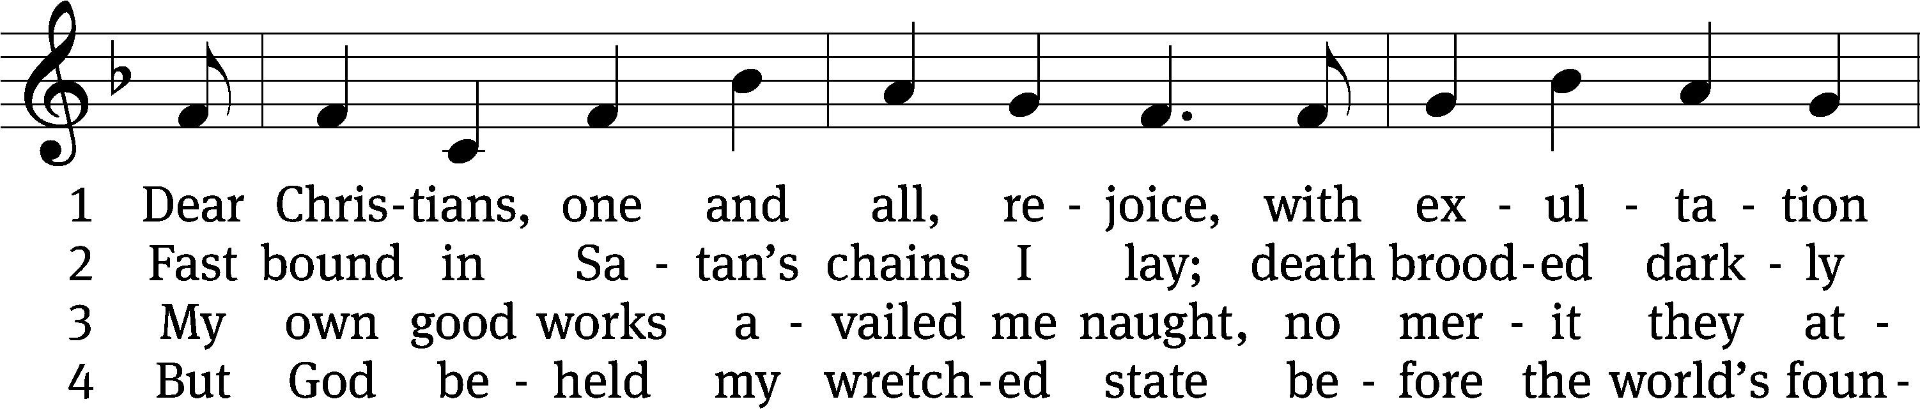
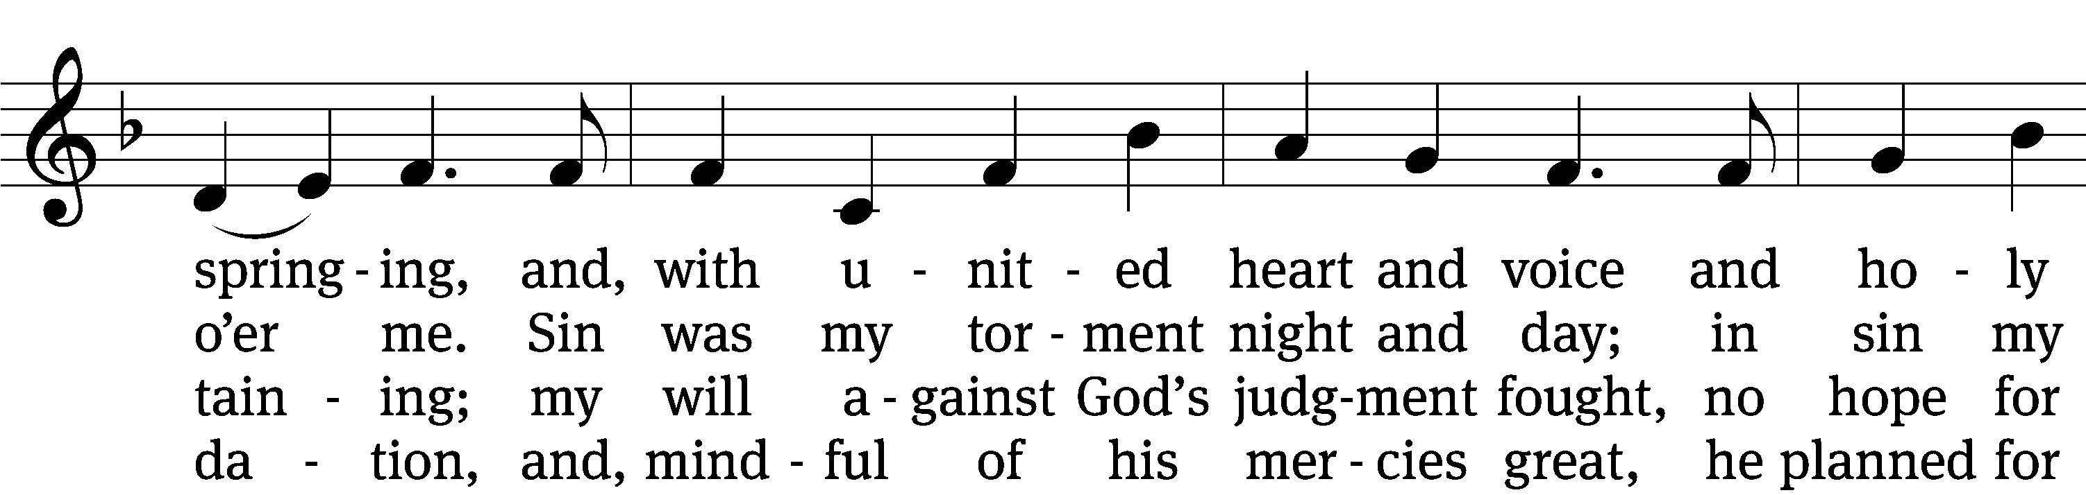
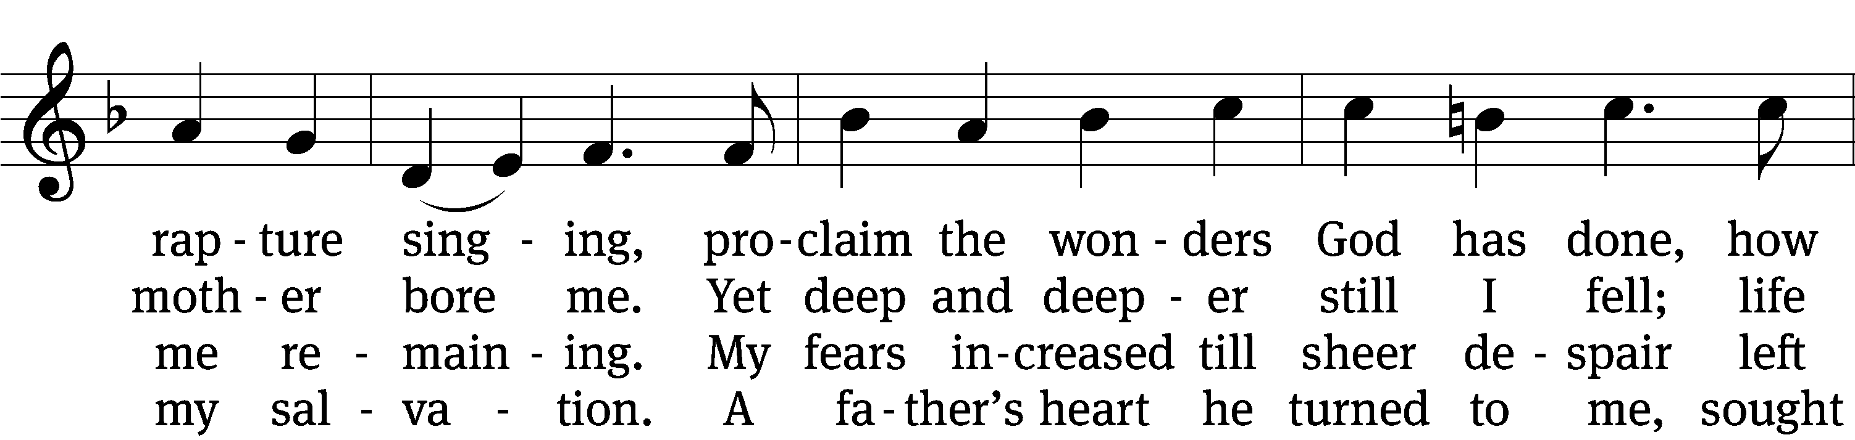
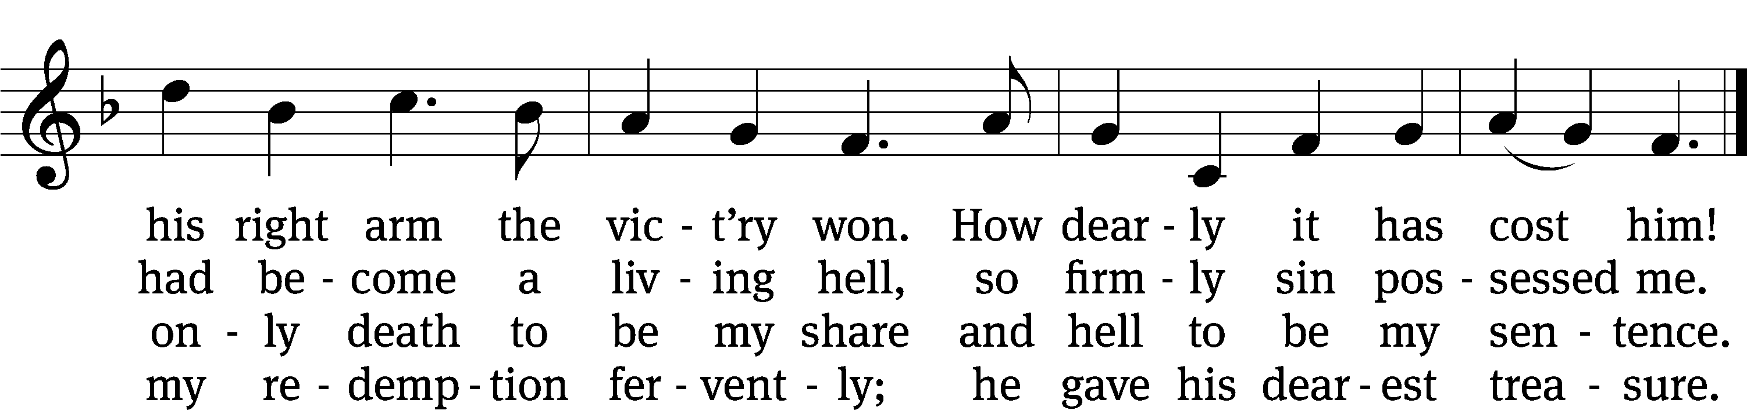

5 He spoke to his belovèd Son:
“It’s time to have compassion.
Then go, bright jewel of my crown,
and bring to all salvation.
From sin and sorrow set them free;
slay bitter death for them that they
may live with you forever.”

(Continued)
6 The Son obeyed his Father’s will,
was born of virgin mother,
and, God’s good pleasure to fulfill,
he came to be my brother.
No garb of pomp or pow’r he wore;
a servant’s form like mine he bore
to lead the devil captive.

7 To me he spoke, “Hold fast to me,
I am your rock and castle.
Your ransom I myself will be;
for you I strive and wrestle.
For I am yours, your friend divine,
and evermore you shall be mine;
the foe shall not divide us.

8 “The foe will shed my precious blood,
me of my life bereaving;
all this I suffer for your good;
be steadfast and believing.
Life will from death the vict’ry win;
my innocence shall bear your sin,
and you are blest forever.

9 “Now to my Father I depart,
the Holy Spirit sending
and, heav’nly wisdom to impart,
my help to you extending.
He will a source of comfort be,
teach you to know and follow me,
and in all truth will guide you.

10 “What I on earth have lived and taught
be all your life and teaching;
so shall my kingdom’s work be wrought
and honored in your preaching.
Take care that no one’s man-made laws
should e’er destroy the gospel’s cause;
this final word I leave you.”
Text: tr. Richard Massie, 1800–1887, alt.; Martin Luther, 1483–1546
Tune: Etlich Cristlich lider, Wittenberg, 1524
Text and tune: Public domain

PLEASE STAND, IF YOU ARE ABLE

M: Hear the prayer of your people, O Lord, that the lips which have praised you here may glorify you in the world, that the eyes which have seen the coming of your Son may long for his coming again, and that all who have received in his true body and blood the pledge of your forgiveness may be restored to live a new and holy life, through Jesus Christ, our Lord, who lives and reigns with you and the Holy Spirit, one God, now and forever.

M: Brothers and sisters, go in peace. Live in harmony with one another.
Serve the Lord with gladness.
The Lord bless you and keep you.
The Lord make his face shine on you and be gracious to you.
The Lord look on you with favor and (+) give you peace.

PLEASE BE SEATED

931 Savior, Again to Thy Dear Name We Raise CW 931
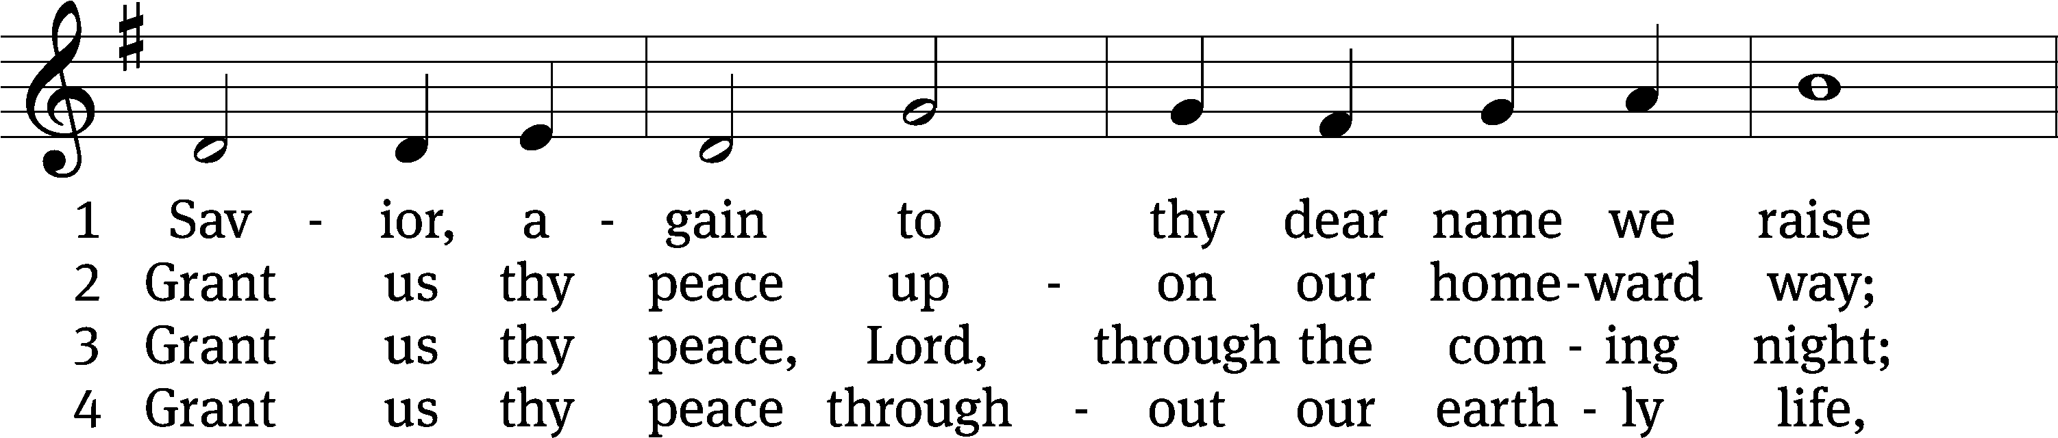
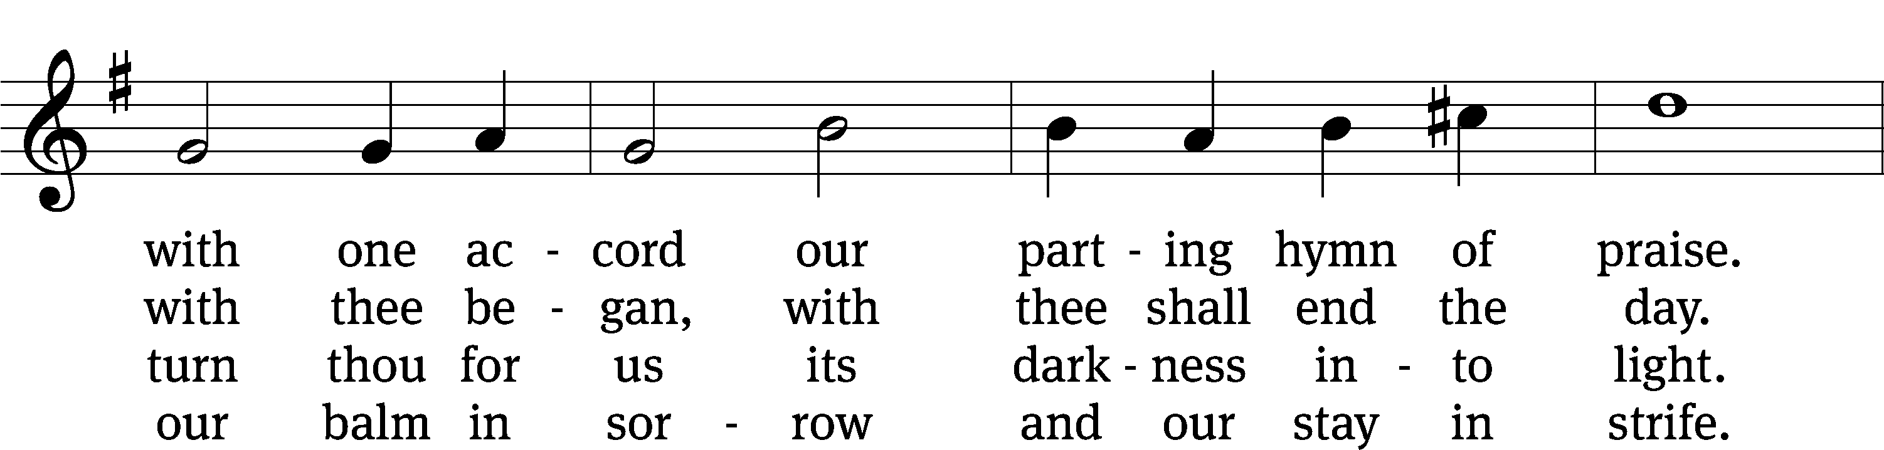
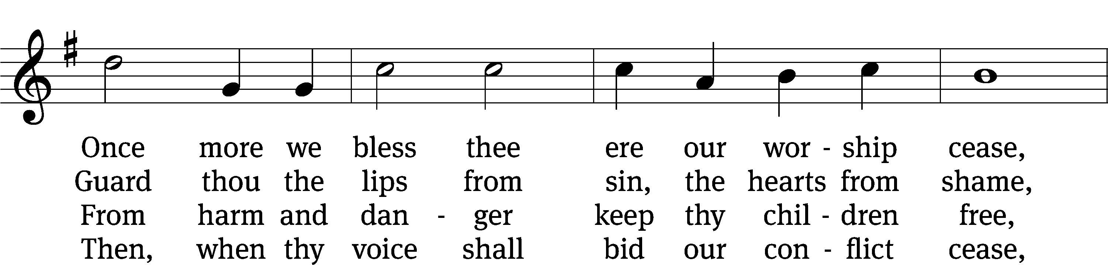
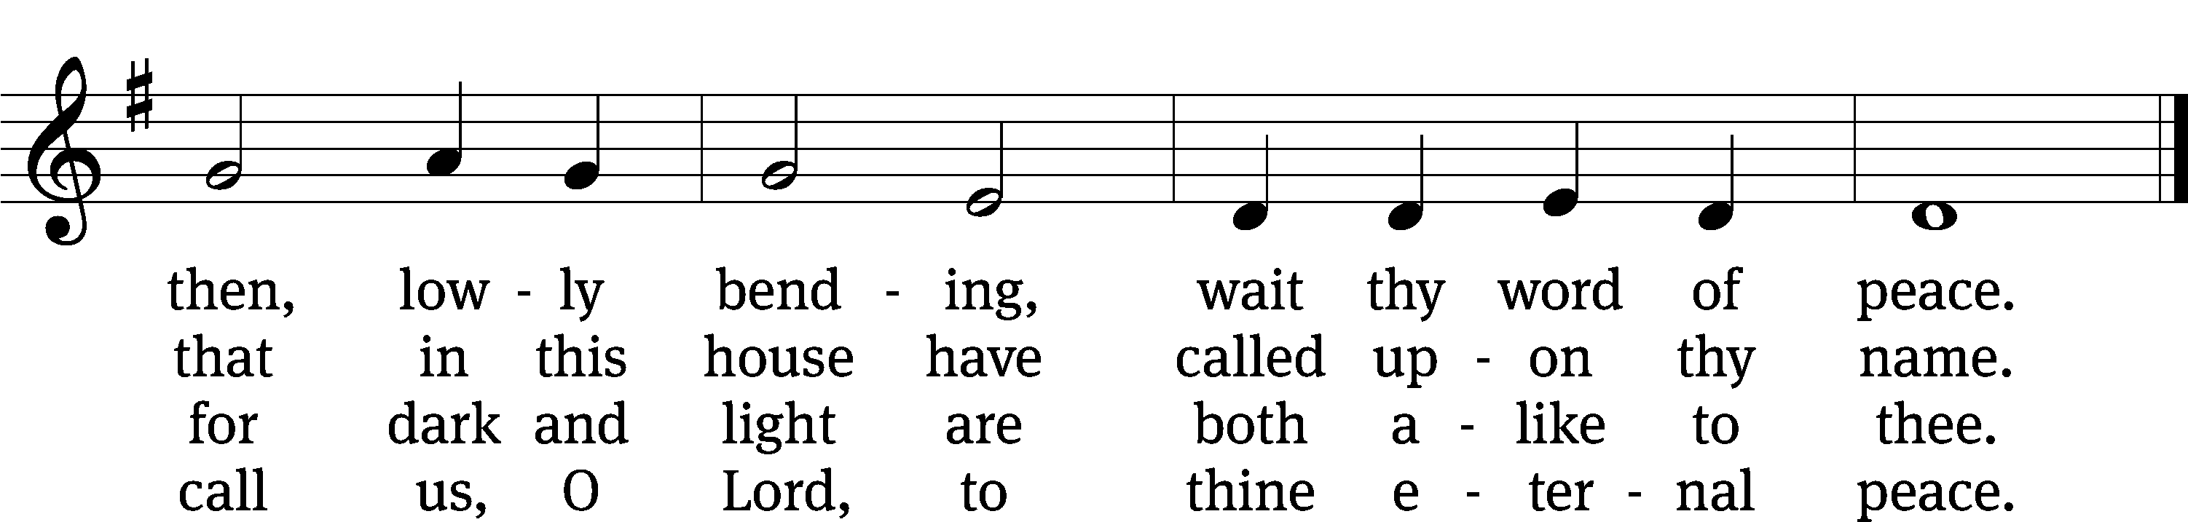
Text: John Ellerton, 1826–1893, abr.
Tune: Edward J. Hopkins, 1818–1901
Text and tune: Public domain

Serving In Worship

Officiant Pastor Natsis
Organist Sarah Hanke
Deacons (8:30) Ron Roehm and Duane Mason
(11:00) Dave Frey and Robert Niethammer
Ushers (8:30) Tim Phelps and Brian Graham
(11:00) Ron Zahn
Altar Guild Judy Lindemann and Barb Neuburger
Videographer Jeff Neuburger

Copyright information
Service of Word and Sacrament: Christian Worship. © 1993 Northwestern Publishing House. All rights reserved. Reprinted under ONE LICENSE #A-727703 and CCLI #1151741/ CSPL126093
Words and Music: All rights reserved. Reprinted/Podcast/Streamed with permission under ONE LICENSE #A-727703 and CCLI #1151741/CSPL126093

