LAST sunday aFTER EPIPHANY
THE transfiguration
TRINITY EVANGELICAL LUTHERAN CHURCH | Saline, Michigan
WELCOME TO WORSHIP February 19, 2023

Thank you for joining us in God’s house today! We cordially ask that our guests sign one of the guestbooks located at either the front or back entryways.

THANK OFFERING: Members of Trinity give their offering as an expression of love and thankfulness to the Lord and to help support the Lord’s work in our community and around the world. Visitors need not feel obligated to participate in this offering which supports our ministry.

Restrooms are located at the back of the upper level (the annex), and in the basement (down the back stairs of the sanctuary or annex). Handicap access is available, please ask an usher for assistance.

celebration of holy communion:
In His Word, God makes it clear that the Lord’s Supper is to be shared by people of a common proclamation of faith (1 Corinthians 11:26; 1 Corinthians 10:16-17). Without judging anyone’s hearts, we invite those who share in our confession by their membership in our congregation or another congregation of the Wisconsin Evangelical Lutheran Synod (WELS) or the Evangelical Lutheran Synod (ELS) and who are properly prepared (1 Corinthians 11;27-29) to receive the Sacrament. Page 295 in the front of Christian Worship provides a guide for preparation.

Guests, we would love to have you join us in communion fellowship in the future, and for that to be possible, we ask that you speak with one of the pastors so that we may speak with you on how that would be possible. We thank you for respecting the way we celebrate the Lord’s Supper in our congregations.

SERVICE OF WORD AND SACRAMENT
Instrumental Duet (11:00) “In Christ Alone”
390 Jesus, Take Us to the Mountain CW 390
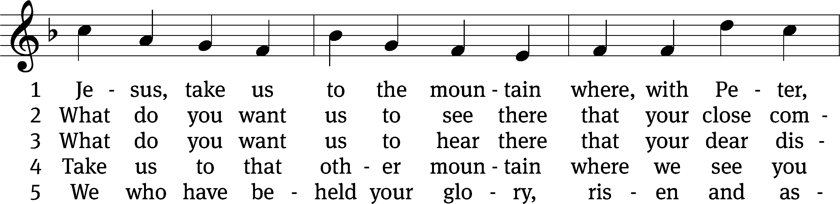
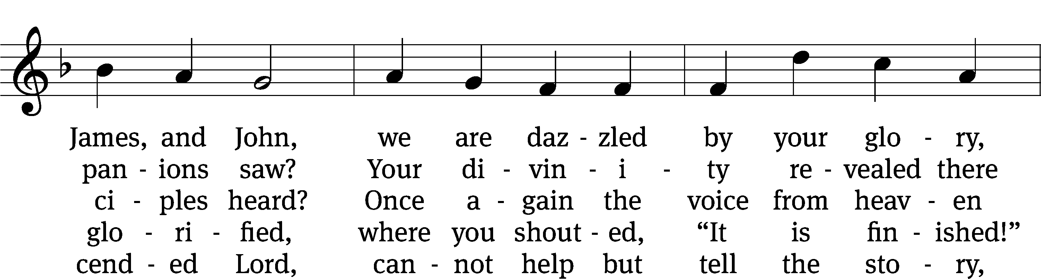
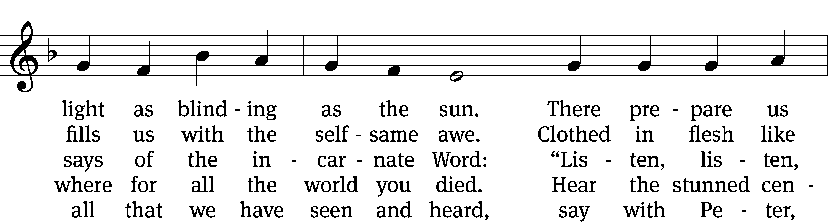
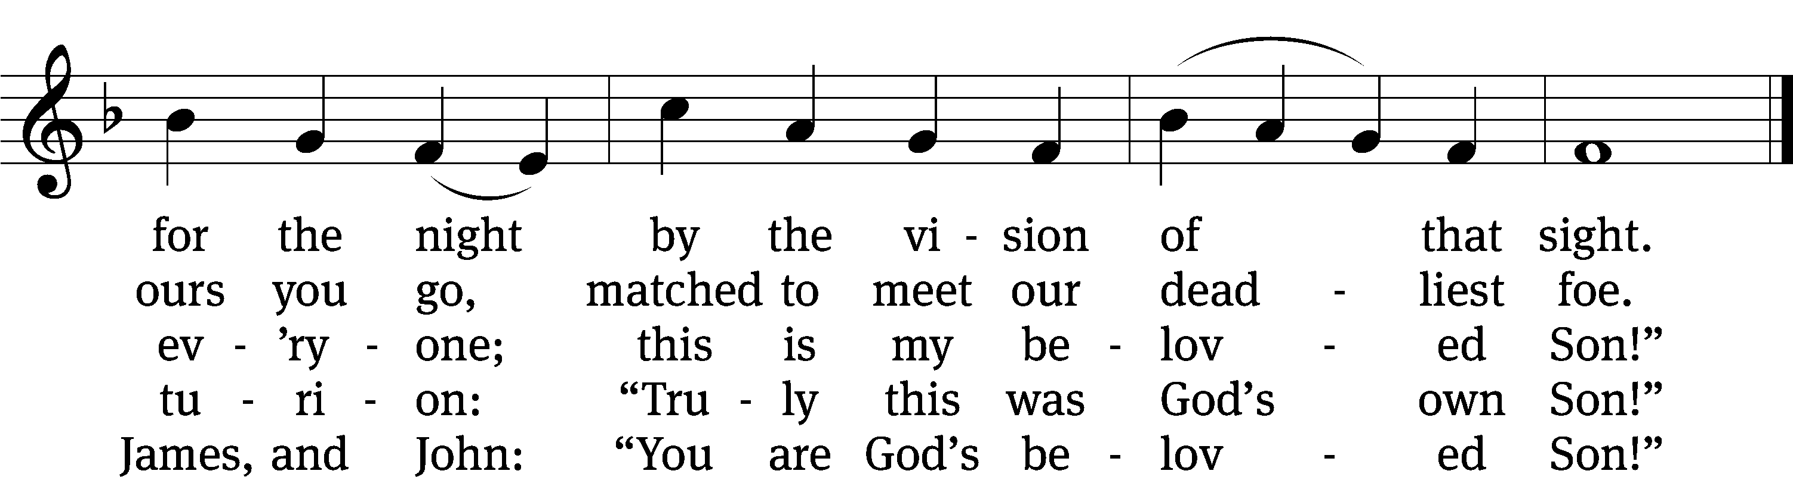
Text: Jaroslav J. Vajda, 1919–2008
Tune: Carl F. Schalk, 1929–2021
Text: © 1991 Concordia Publishing House. Used by permission: OneLicense no. 727703
Tune: © 1991 Carl F. Schalk. Used by permission: OneLicense no. 727703

PLEASE STAND, IF YOU ARE ABLE

invocation

M: The grace of our Lord (+) Jesus Christ and the love of God and the fellowship of the Holy Spirit be with you.
C: And also with you.
CONFESSION OF SINS
M: God invites us to come into his presence and worship him with humble and penitent hearts. Therefore, let us acknowledge our sinfulness and ask him to forgive us.
C: Holy and merciful Father, I confess that I am by nature sinful, and that I have disobeyed you in my thoughts, words, and actions. I have done what is evil and failed to do what is good. For this I deserve your punishment both now and in eternity. But I am truly sorry for my sins, and trusting in my Savior Jesus Christ, I pray: Lord, have mercy on me, a sinner.
M: God, our heavenly Father, has been merciful to us and has given his only Son to be the atoning sacrifice for our sins. Therefore, as a called servant of Christ and by his authority, I forgive you all your sins in the name of the Father and of the Son (+) and of the Holy Spirit.
C: Amen.
PRAYER AND PRAISE
LORD, HAVE MERCY
Kyrie
M: For all that we need in life and for the wisdom to use all your gifts with gratitude and joy, hear our prayer, O Lord.

M: For the steadfast assurance that nothing can separate us from your love and for the courage to stand firm against the assaults of Satan and every evil, hear our prayer, O Christ.

M: For the well-being of your holy Church in all the world and for those who offer here their worship and praise, hear our prayer, O Lord.

M: Merciful God, maker and preserver of life, uphold us by your power and keep us in your tender care:

M: The works of the Lord are great and glorious; his name is worthy of praise.

Prayer of the day

M: Let us pray.
The minister says the Prayer of the Day.

PLEASE BE SEATED

The Word

first lesson Exodus 24:9-18
⁹ Then Moses, Aaron, Nadab, Abihu, and seventy of the elders of Israel went up. ¹⁰ They saw the God of Israel. Under his feet they saw what looked like a pavement of sapphire as clear as the sky. ¹¹ The Lord did not lay his hand on the dignitaries of the people of Israel. They gazed at God, and they ate and drank.
¹² The Lord said to Moses, “Come up to me on the mountain. Wait there, and I will give you the stone tablets with the law and the commands that I have written, so that you can teach them.”
¹³ Moses set out with his assistant Joshua and went up onto the mountain of God. ¹⁴ He said to the elders, “Wait here for us, until we come back to you. Look, here are Aaron and Hur. They will be with you. Whoever is involved in a dispute can go to them.”
¹⁵ Moses went up onto the mountain, and the cloud covered the mountain. ¹⁶ The Glory of the Lord settled on Mount Sinai, and the cloud covered the mountain for six days. On the seventh day the Lord called to Moses out of the middle of the cloud. ¹⁷ The appearance of the Glory of the Lord looked like a devouring fire on the top of the mountain in the sight of the people of Israel. ¹⁸ Moses entered into the middle of the cloud and climbed up the mountain. Moses was on the mountain forty days and forty nights.

2D Great Are the Works of the LORD Psalm 2D
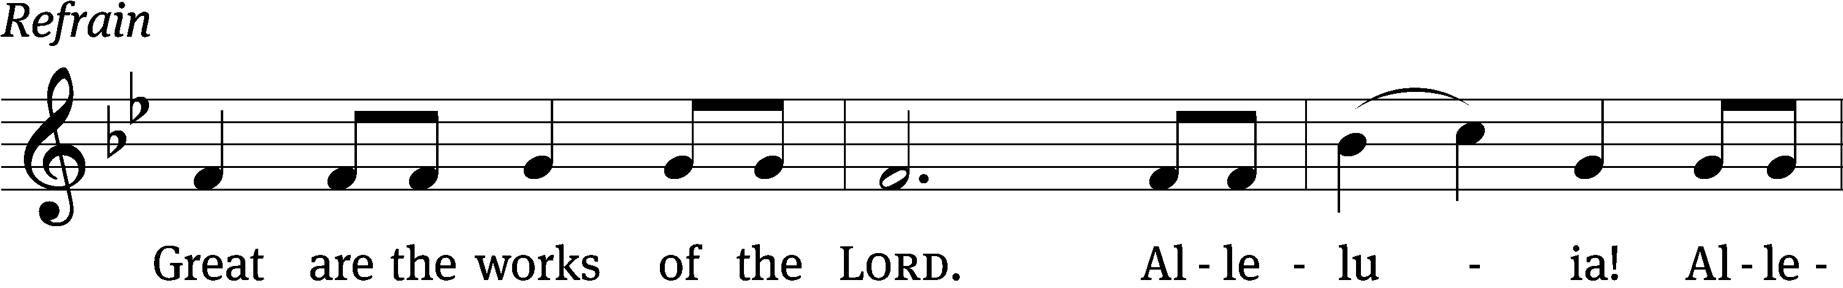
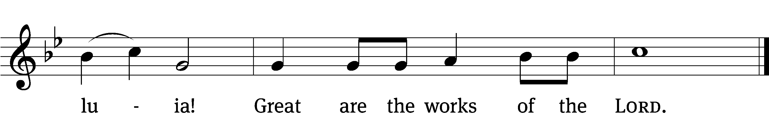

Why do the nations / conspire
and the peoples / plot in vain?
The kings of the earth rise up and the rulers band together a- / gainst the Lord
and against his A- / nointed. Refrain

The One enthroned in / heaven laughs;
the Lord / scoffs at them.
He rebukes them in his anger and terrifies them in his wrath, / saying,
“I have installed my King on Zion, my holy / mountain.” Refrain

I will proclaim the / Lord’s decree:
He said to me, “You are my Son; today I have become your / Father.”
Glory be to the Father and / to the Son
and to the Holy / Spirit,
as it was in the be- / ginning,
is now, and will be forever. / Amen. Refrain
Tune: Kermit G. Moldenhauer
Setting: Kermit G. Moldenhauer
Music: © 1993 Kermit G. Moldenhauer, admin. Northwestern Publishing House. Used by permission: OneLicense no. 727703

second lesson 2 Peter 1:16-21
¹⁶ To be sure, we were not following cunningly devised fables when we made known to you the powerful appearance of our Lord Jesus Christ, but we were eyewitnesses of his majesty. ¹⁷ For he received honor and glory from God the Father, when the voice came to him from within the Majestic Glory, saying, “This is my Son, whom I love; with him I am well pleased.” ¹⁸ We heard this voice, which came out of heaven when we were with him on the holy mountain.
¹⁹ We also have the completely reliable prophetic word. You do well to pay attention to it, as to a lamp shining in a dark place, until the day dawns and the Morning Star rises in your hearts, ²⁰ since we know this above all else: No prophecy of Scripture comes about from someone’s own interpretation. ²¹ In fact, no prophecy ever came by the will of man, but men spoke from God as they were being carried along by the Holy Spirit.

PLEASE STAND, IF YOU ARE ABLE

VERSE OF THE DAY

GOSPEL Matthew 17:1-9
¹ Six days later Jesus took with him Peter, James, and John the brother of James; and he led them up onto a high mountain by themselves. ² There he was transfigured in front of them. His face was shining like the sun. His clothing became as white as the light. ³ Just then, Moses and Elijah appeared to them, talking with Jesus.
⁴ Peter said to Jesus, “Lord, it is good for us to be here. If you want, I will make three shelters here: one for you, one for Moses, and one for Elijah.”
⁵ While he was still speaking, suddenly a bright cloud overshadowed them. Just then, a voice came out of the cloud, saying, “This is my Son, whom I love; with him I am well pleased. Listen to him.”
⁶ When the disciples heard this, they fell face down and were terrified. ⁷ Jesus approached and as he touched them, he said, “Get up, and do not be afraid.” ⁸ When they opened their eyes, they saw no one except Jesus alone. ⁹ As they were coming down the mountain, Jesus commanded them, “Do not tell anyone what you have seen until the Son of Man has been raised from the dead.”
M: This is the Gospel of the Lord.

PLEASE BE SEATED

388 Down from the Mount of Glory CW 388
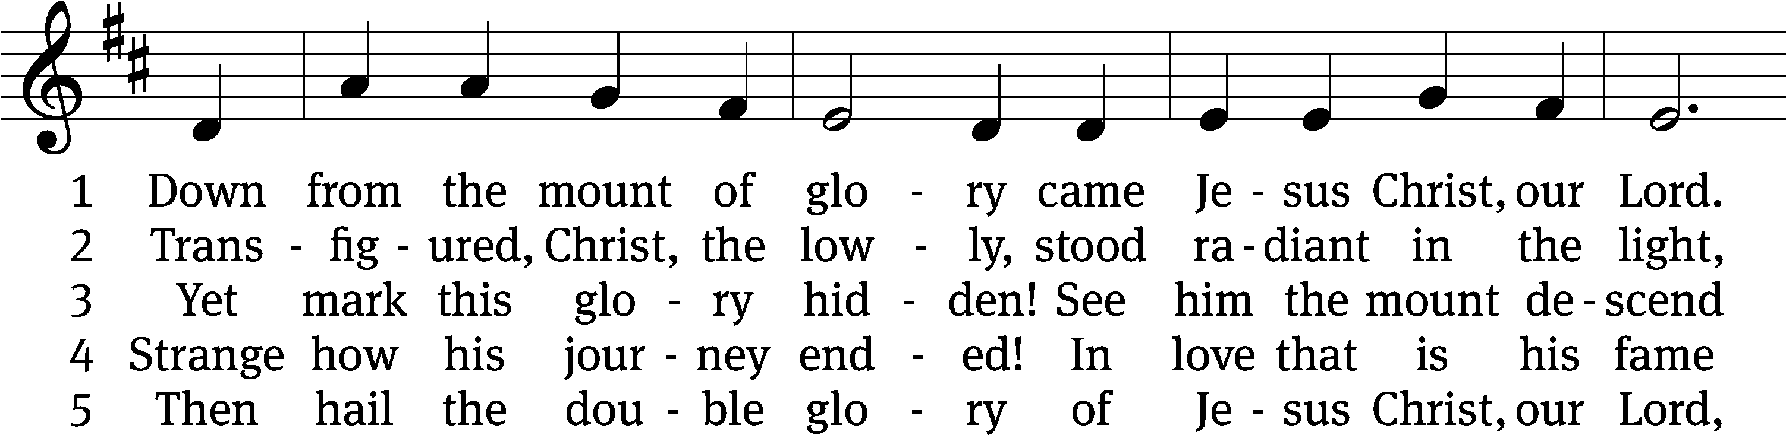
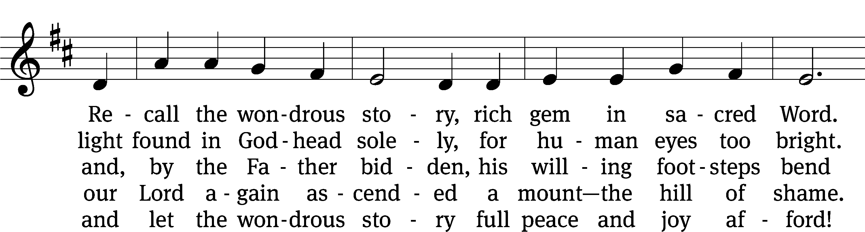
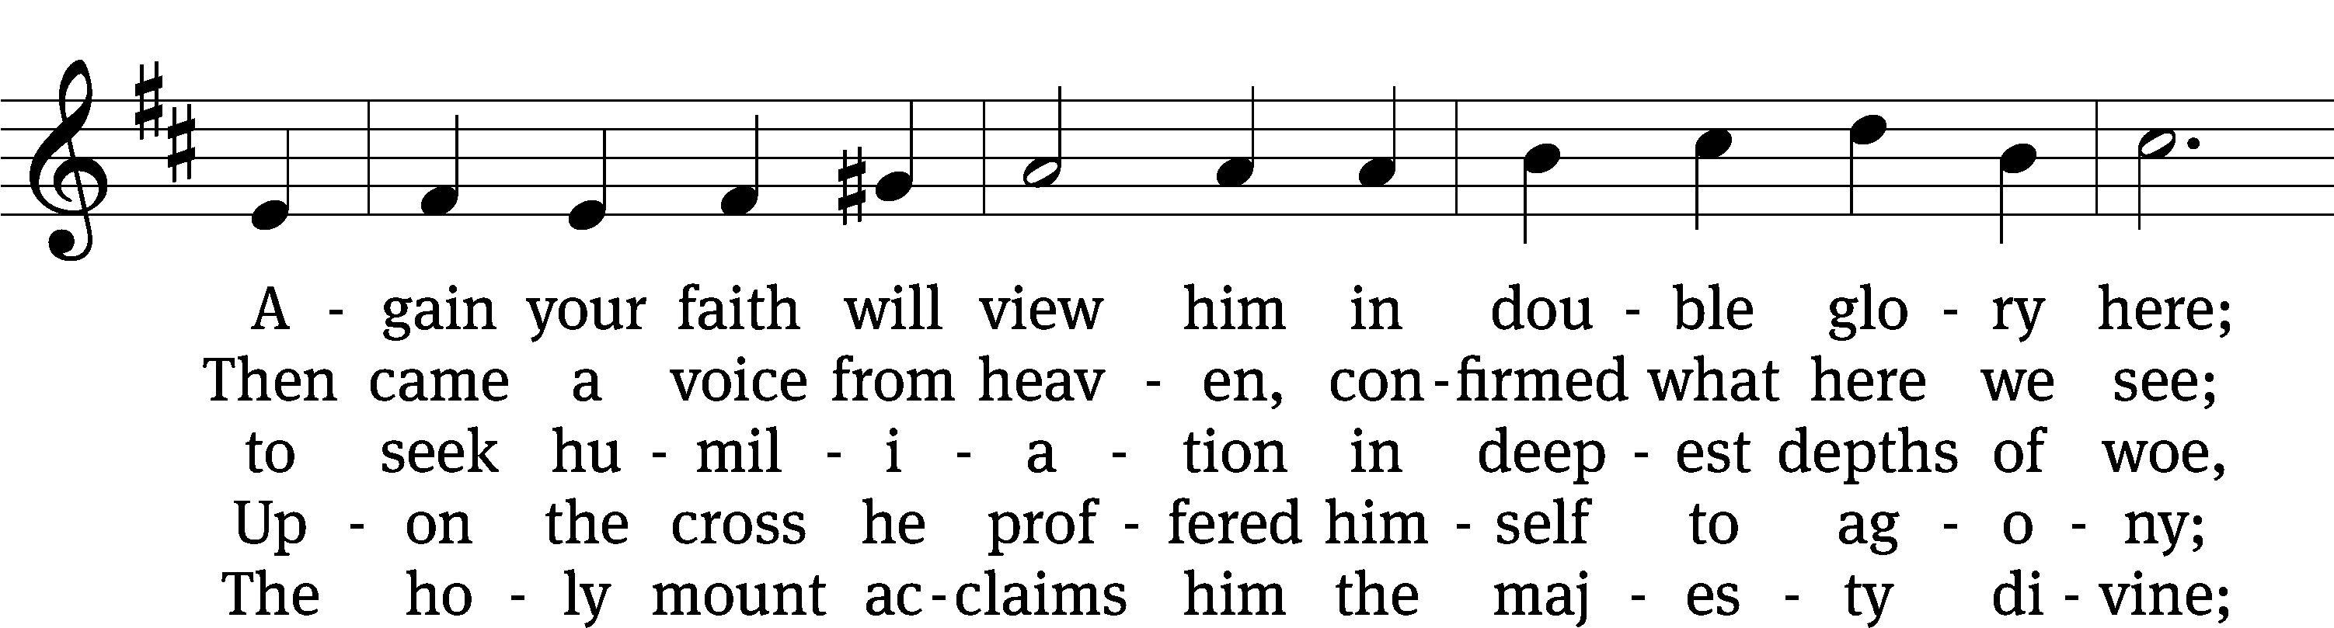
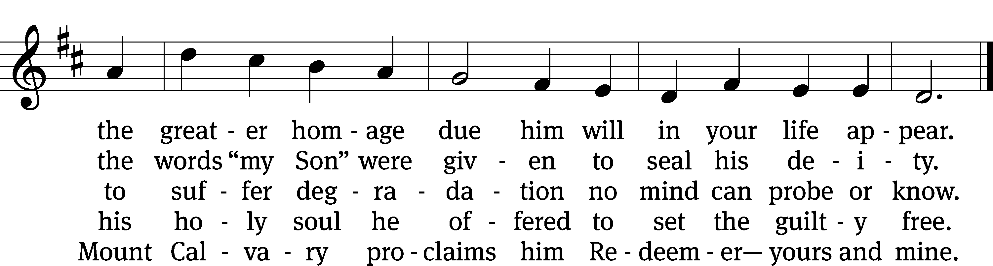
Text: Werner H. Franzmann, 1905–1996
Tune: Bartholomäus Helder, 1585–1635
Text: © 1968 Werner H. Franzmann, admin. Northwestern Publishing House. Used by permission: OneLicense no. 727703
Tune: Public domain

Sermon Matthew 17:1-9

“Jesus’ Valentine to the World”

please stand, if you are able

nicene creed
We believe in one God, the Father, the Almighty, maker of heaven and earth, of all that is, seen and unseen.
We believe in one Lord, Jesus Christ, the only Son of God, eternally begotten of the Father, God from God, Light from Light, true God from true God, begotten, not made, of one being with the Father. Through him all things were made. For us and for our salvation, he came down from heaven, was incarnate of the Holy Spirit and the virgin Mary, and became truly human. For our sake he was crucified under Pontius Pilate. He suffered death and was buried. On the third day he rose again in accordance with the Scriptures. He ascended into heaven and is seated at the right hand of the Father. He will come again in glory to judge the living and the dead, and his kingdom will have no end.
We believe in the Holy Spirit, the Lord, the giver of life, who proceeds from the Father and the Son, who in unity with the Father and the Son is worshiped and glorified, who has spoken through the prophets. We believe in one holy Christian and apostolic Church. We acknowledge one baptism for the forgiveness of sins. We look for the resurrection of the dead and the life of the world to come. Amen.

PLEASE BE SEATED

OFFERTORY – “In Christ Alone” (8:30 a.m.)

PLEASE STAND, IF YOU ARE ABLE

prayer of the church

lord’s prayer

C: Our Father, who art in heaven,
hallowed be thy name,
thy kingdom come,
thy will be done
on earth as it is in heaven.
Give us this day our daily bread;
and forgive us our trespasses,
as we forgive those
who trespass against us;
and lead us not into temptation,
but deliver us from evil.
For thine is the kingdom
and the power and the glory
forever and ever. Amen.

The Sacrament of Holy Communion
Trinity Lutheran Church follows the historic Christian practice of close communion. We ask that only members of Trinity or one of our sister congregations partake of the sacrament. If you are not a member, please see the note about Holy Communion in the beginning of the Worship Folder.

M: The Lord be with you.

M: Lift up your hearts.

M: Let us give thanks to the Lord our God.

M: Praise to the God and Father of our Lord Jesus Christ! In love he has blessed us with every spiritual blessing. He sends the Holy Spirit to testify that we are his children and to strengthen us when we are weak. Now have come the salvation and the power and the kingdom of our God and the authority of his Christ. To him who sits on the throne and to the Lamb be praise and thanks and honor and glory for ever and ever:

Holy, Holy, Holy

Words of institution
M: Our Lord Jesus Christ, on the night he was betrayed, took bread; and when he had given thanks, he broke it and gave it to his disciples, saying: “Take and eat. This is my ✙ body, which is given for you. Do this in remembrance of me.”
Then he took the cup, gave thanks, and gave it to them, saying, “Drink from it all of you; this is my ✙ blood of the new covenant, which is poured out for you for the forgiveness of sins. Do this, whenever you drink it, in remembrance of me.”
The peace of the Lord be with you always.

O CHRIST, LAMB OF GOD

Text: John Julian, 1839–1913, abr., alt.
Tune: Johann Störl’s . . . Schlag- Gesang- Und Noten-Buch, Stuttgart, 1744
Text and tune: Public domain
629 O God from God, O Light from Light CW 629
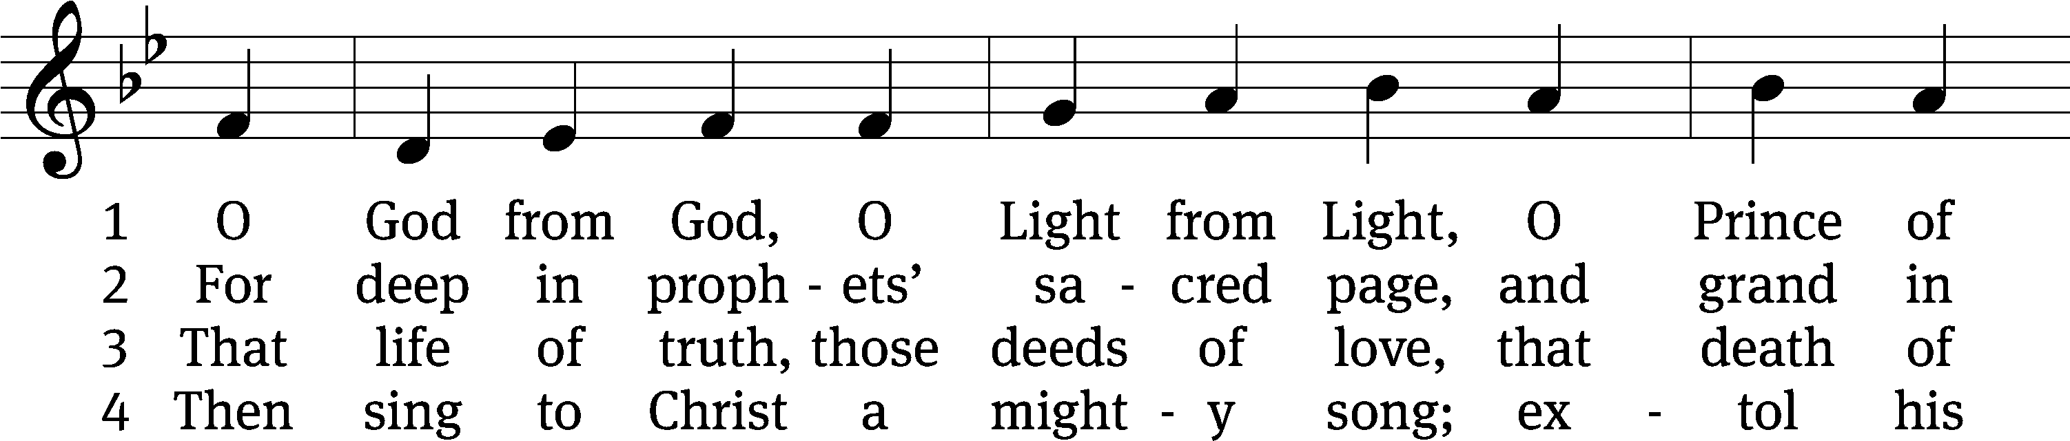
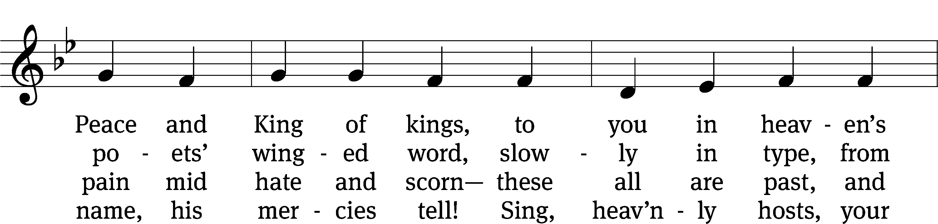
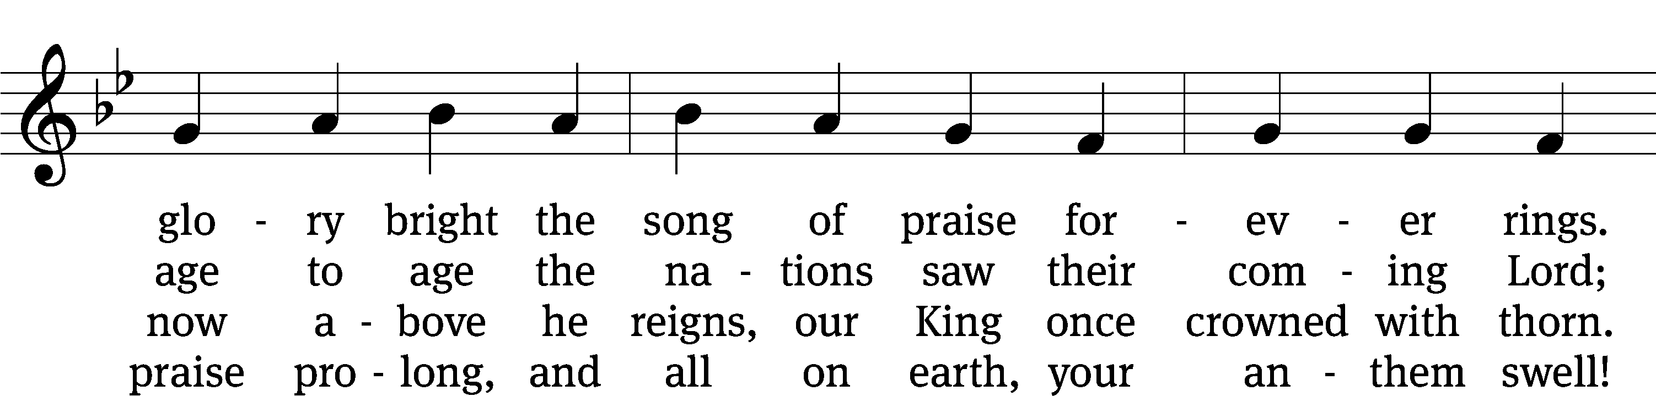
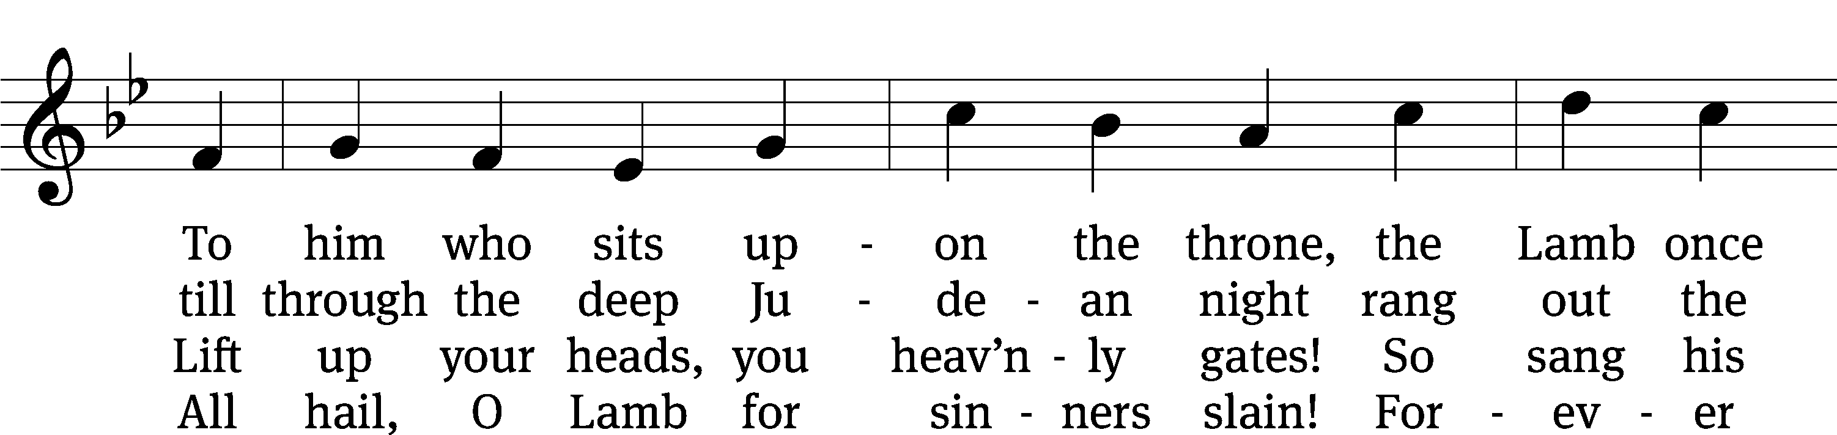
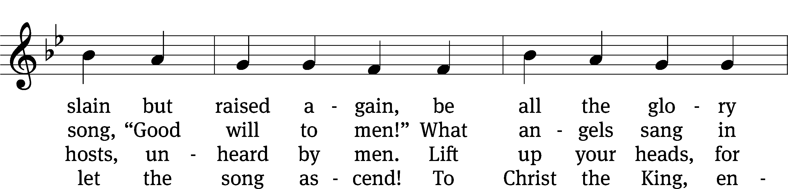
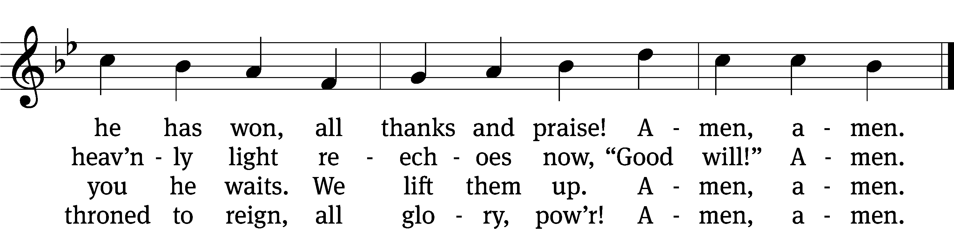
530 Praise Be to Christ CW 530
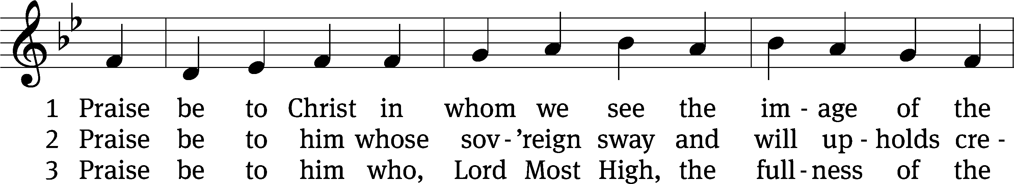
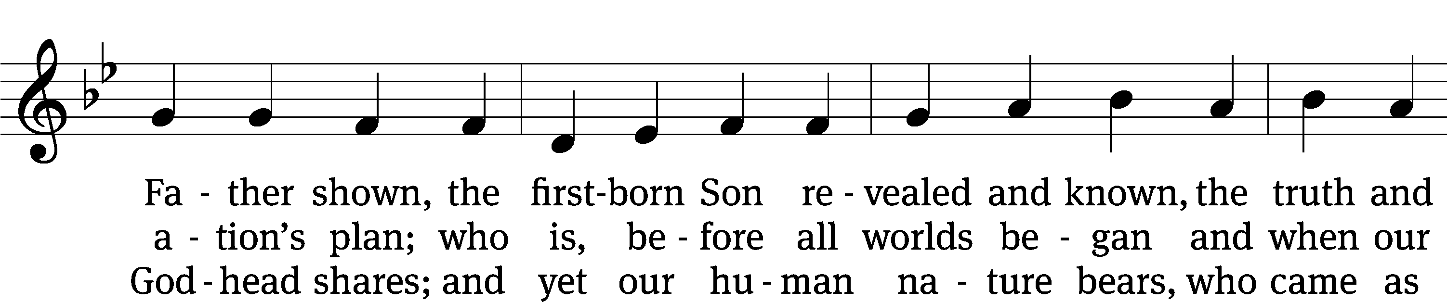
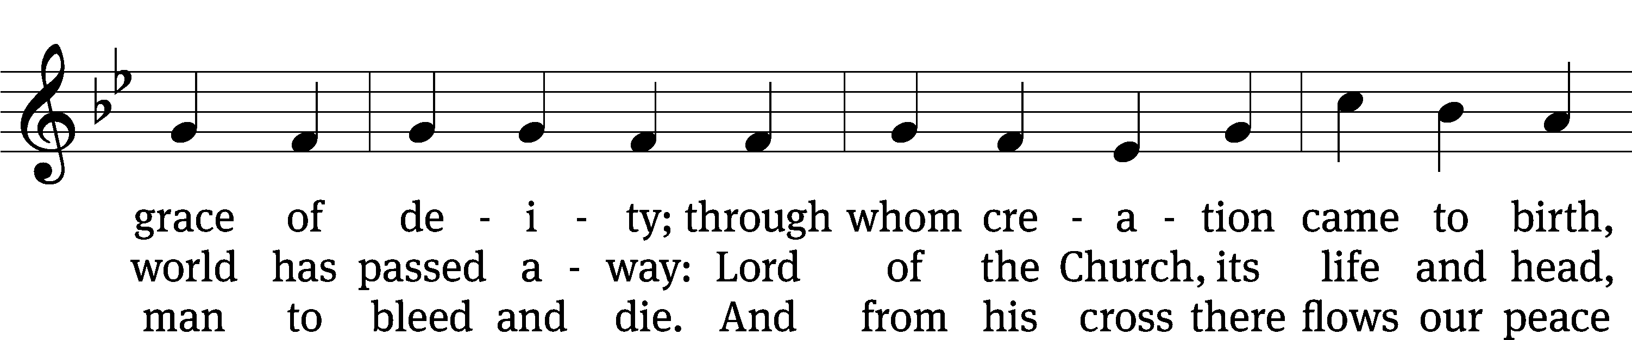
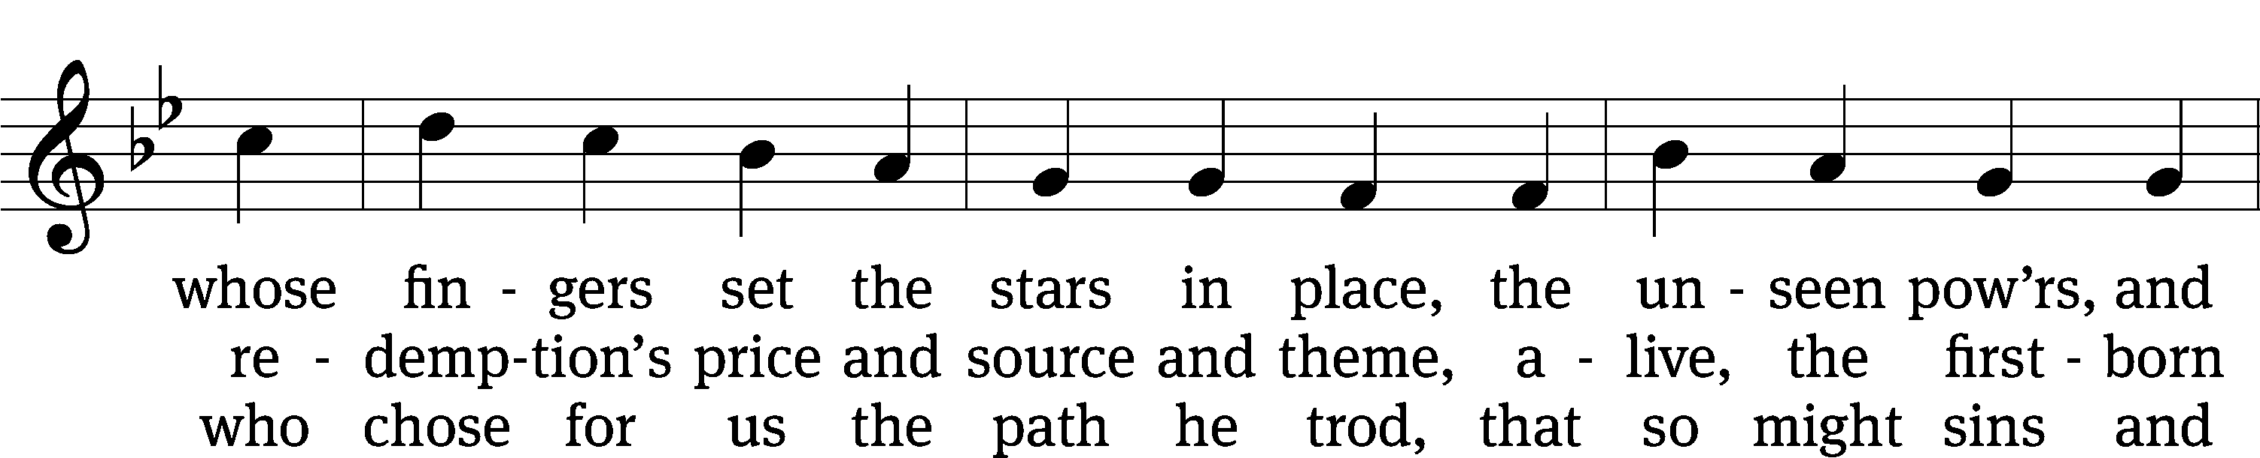
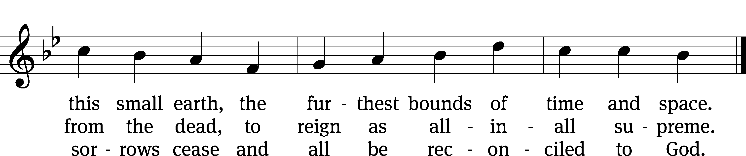
Text: Timothy Dudley-Smith, b. 1926
Tune: Johann Störl’s . . . Schlag- Gesang- Und Noten-Buch, Stuttgart, 1744
Text: © 1984 Hope Publishing Co. Used by permission: OneLicense no. 727703
Tune: Public domain

PLEASE STAND, IF YOU ARE ABLE

THANKSGIVING

M: Hear the prayer of your people, O Lord, that the lips which have praised you here may glorify you in the world, that the eyes which have seen the coming of your Son may long for his coming again, and that all who have received in his true body and blood the pledge of your forgiveness may be restored to live a new and holy life, through Jesus Christ, our Lord, who lives and reigns with you and the Holy Spirit, one God, now and forever.

M: Brothers and sisters, go in peace. Live in harmony with one another.
Serve the Lord with gladness.

The Lord bless you and keep you.
The Lord make his face shine on you and be gracious to you.
The Lord look on you with favor and (+) give you peace.

PLEASE BE SEATED

389 How Good, Lord, to Be Here CW 389
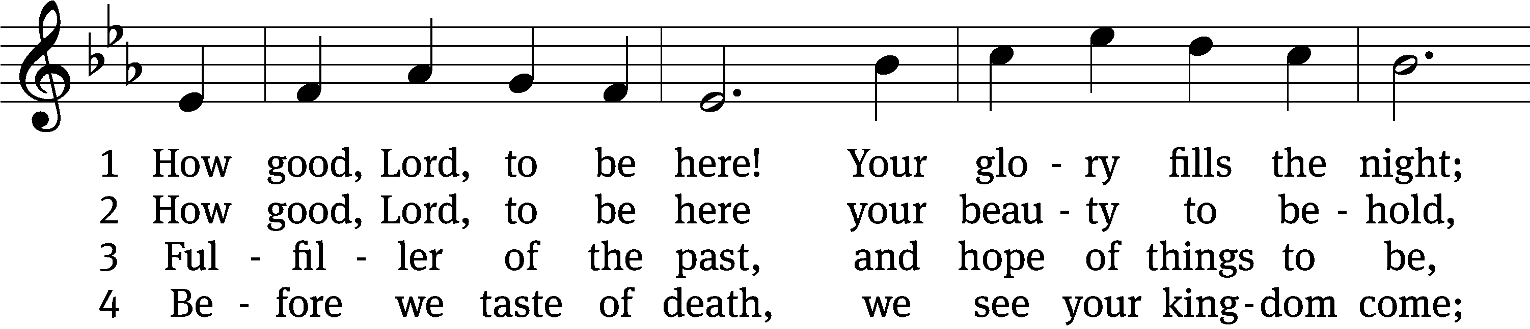
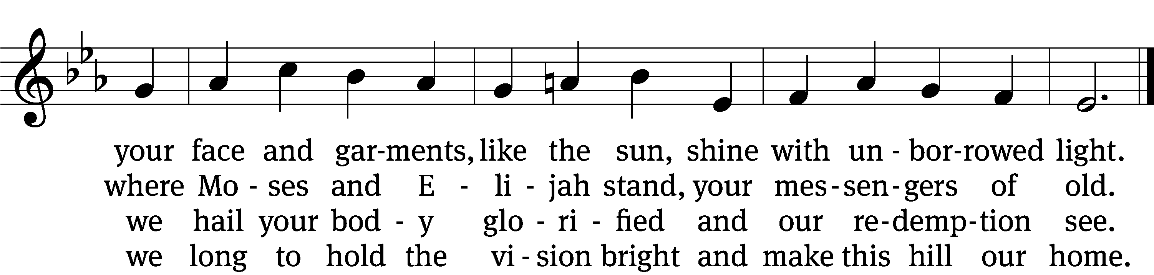

5 But you, Lord, do not stay.
With mercy resolute
you leave this glorious hill to die—
our perfect substitute.

6 How good, Lord, to be here!
Yet we may not remain;
but since you bid us leave the mount,
come with us to the plain.
Text (sts. 1–4, 6): Joseph A. Robinson, 1858–1933, alt.; (st. 5): Bryan Gerlach, b. 1954
Tune: Johann Sebastian Bach, 1685–1750, adapt.
Text (st. 5): © 2021 Northwestern Publishing House. Used by permission: OneLicense no. 727703
Text (sts. 1–4, 6) and tune: Public domain

Serving In Worship

Officiant Pastor Natsis
Organist Marcia Marion Ackling
Instrumental Duet Malory Marion and Marcia Marion Ackling
Deacons (8:30) Duane Mason and Dave Stevenson
(11:00) Jeff Neuburger and Robert Niethammer
Ushers (8:30) Tim Phelps
(11:00) Ron Zahn
Altar Guild Margaret Hoeft and Laura Lindemann
Videographer Cindy Dresch

Copyright information
Service of Word and Sacrament: Christian Worship. © 1993 Northwestern Publishing House. All rights reserved. Reprinted under ONE LICENSE #A-727703 and CCLI #1151741/ CSPL126093
Words and Music: All rights reserved. Reprinted/Podcast/Streamed with permission under ONE LICENSE #A-727703 and CCLI #1151741/CSPL126093

