The Fourth Sunday in Lent

tRINITY EVANGELICAL LUTHERAN CHURCH | Saline, Michigan
March 10, 2024

WELCOME TO WORSHIP

Thank you for joining us in God’s house today! We cordially ask that our Guests with us this morning sign one of the guestbooks located at either the front or back entryways.

THANK OFFERING: Members of Trinity give their offering as an expression of love and thankfulness to the Lord and to help support the Lord’s work in our community and around the world. Visitors need not feel obligated to participate in this offering which supports our ministry.

Restrooms are located at the back of the upper level (the annex), and in the basement (down the back stairs of the sanctuary or annex). Handicap access is available, please ask an usher for assistance.

Young Families / Toddler Bags – We are GLAD YOU BROUGHT YOUR CHILDREN to our worship service. Jesus said: “Let the little children come to me and do not hinder them, for the kingdom of God belongs to such as these.” We know that having little children in church can be a challenge, but DO NOT WORRY about it. Many of your fellow worshippers have been in your shoes and are just happy you brought your children with you. For your convenience, we have reserved the back rows of seating for parents with small children. These areas provide more flexibility for your family, as well as, easy access to move downstairs if necessary. A closed-circuit TV system allows families to continue participating in the service while downstairs. Pre-school toddler bags and children’s bulletins are available for their enjoyment. Ask an usher for one to use during the service and please return the toddler bag afterwards.

SERVICE of the word
409 Jesus, Refuge of the Weary CW 409
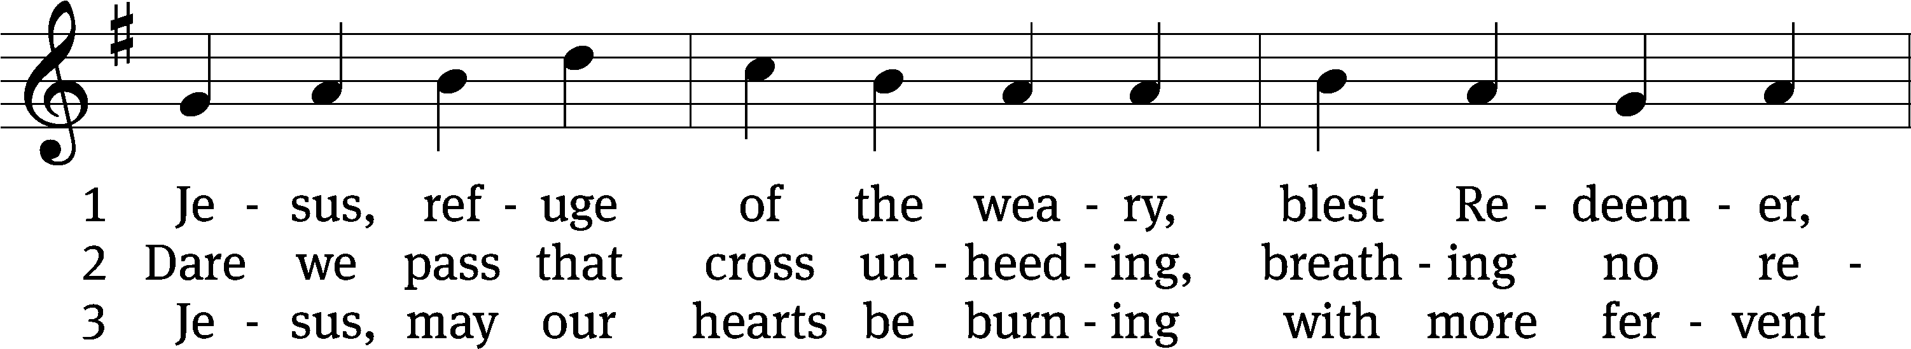
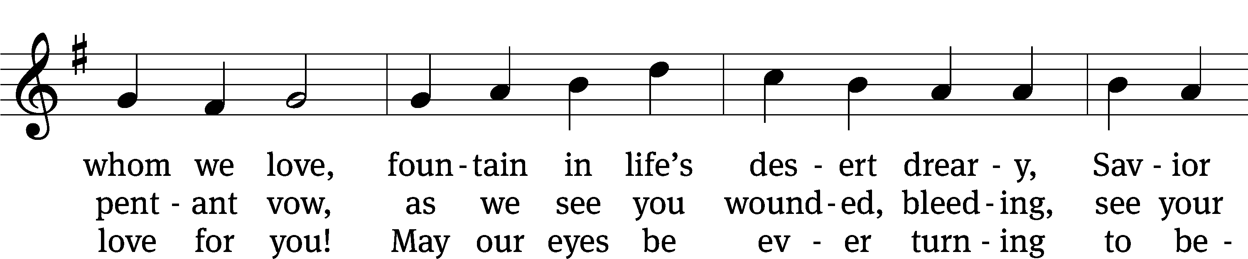
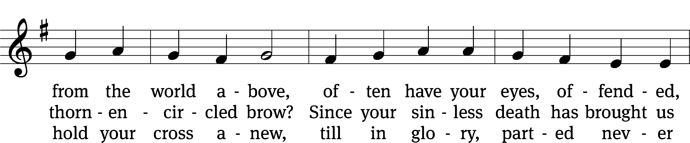
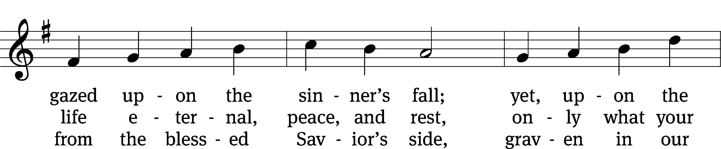
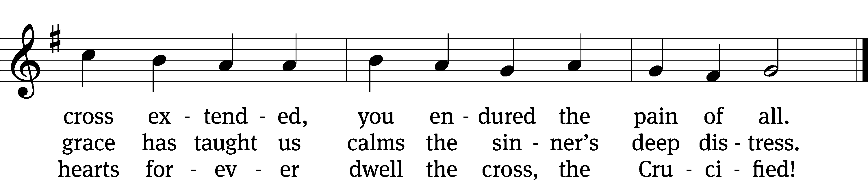
Text: tr. Jane F. Wilde, 1826–1896, alt.; Girolamo Savonarola, 1452–1498
Tune: Erbaulicher Musicalischer Christen-Schatz, Basel, 1745
Text and tune: Public domain

PLEASE STAND, IF YOU ARE ABLE

invocation
M: The grace of our Lord (+) Jesus Christ and the love of God and the fellowship of the Holy Spirit be with you.
C: And also with you.

CONFESSION OF SINS
M: We have come into the presence of God, who created us to love and serve him as his dear children. But we have disobeyed him and deserve only his wrath and punishment. Therefore, let us confess our sins to him and plead for his mercy.

C: Merciful Father in heaven, I am altogether sinful from birth. In countless ways I have sinned against you and do not deserve to be called your child. But trusting in Jesus, my Savior, I pray: Have mercy on me according to your unfailing love. Cleanse me from my sin, and take away my guilt.

M: God, our heavenly Father, has forgiven all your sins. By the perfect life and innocent death of our Lord Jesus Christ, he has removed your guilt forever. You are his own dear child. May God give you strength to live according to his will.

C: Amen.

PRAYER AND PRAISE

M: In the peace of forgiveness, let us praise the Lord.

OH, TASTE AND SEE

Prayer of the Day
Let us pray.

Grant, O merciful Lord, to your faithful people pardon and peace that they may be cleansed from all their sins and serve you with a quiet mind; through your Son, Jesus Christ our Lord, who lives and reigns with you and the Holy Spirit, one God, now and forever.

PLEASE BE SEATED

The Word

the FIRST LESSON Numbers 21:4-9
⁴ They set out from Mount Hor along the road to the Red Sea to go around the land of Edom, but the people became very impatient along the way. ⁵ The people spoke against God and against Moses, “Why have you brought us up out of Egypt to die in the wilderness? Look, there is no food! There is no water! And we are disgusted by this worthless food!”^{[a]}
⁶ The Lord sent venomous^{[b]} snakes among the people, and the snakes bit the people. As a result many people from Israel died. ⁷ The people went to Moses and said, “We have sinned, because we have spoken against the Lord and against you. Pray to the Lord to take the snakes away from us.” So Moses prayed on behalf of the people.
⁸ The Lord said to Moses, “Make a venomous snake and put it on a pole. If anyone who is bitten looks at it, he will live.” ⁹ Moses made a bronze snake and put it on the pole. If a snake had bitten anyone, if that person looked at the bronze snake, he lived.

Psalm 32B How Blest Are Those Psalm 32B
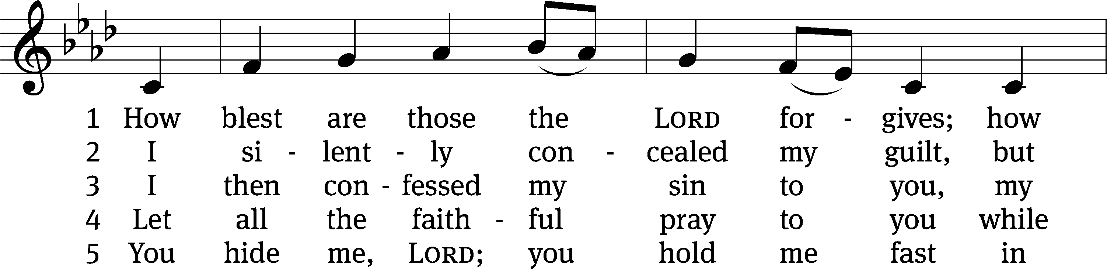
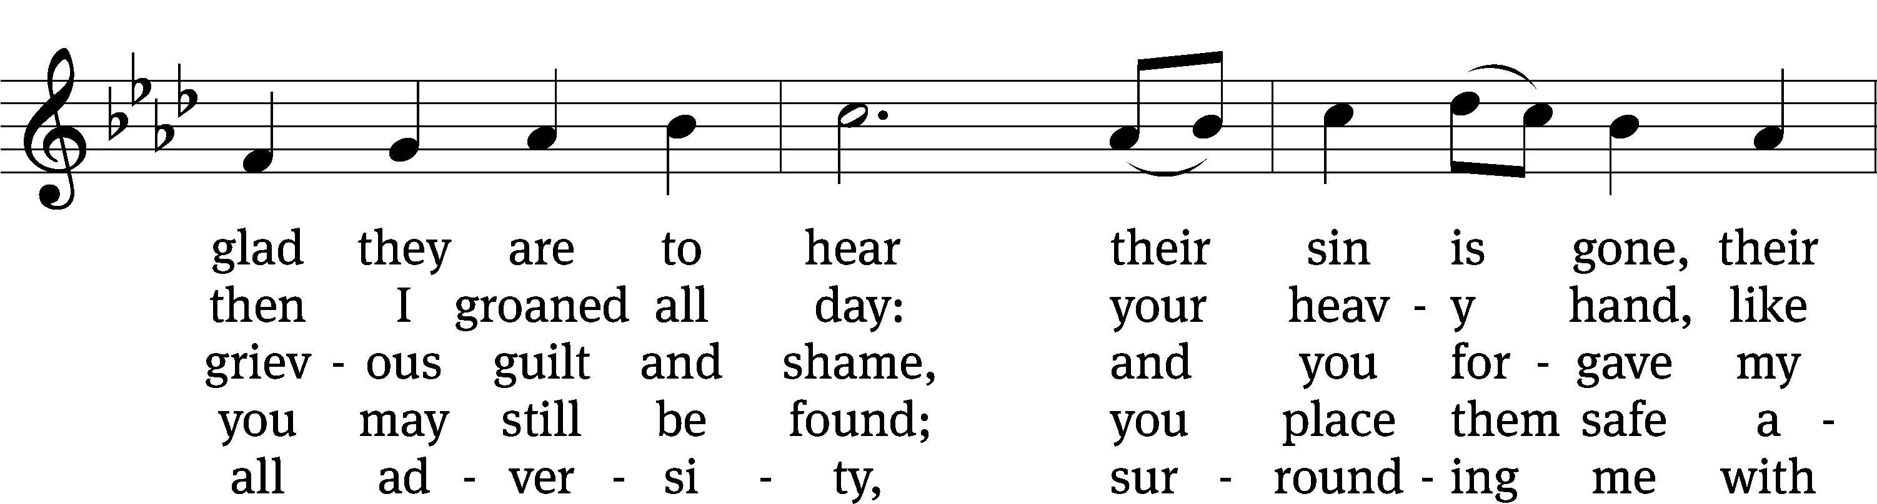
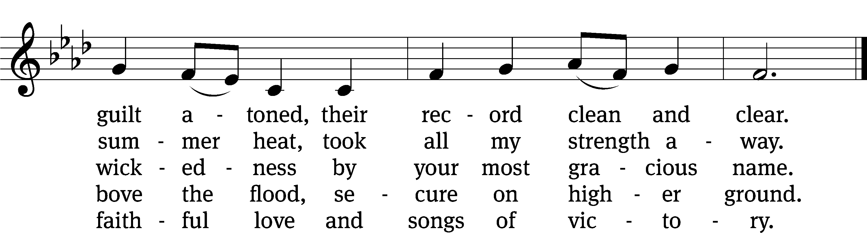
Text: Michael D. Schultz
Tune: Repository of Sacred Music, Part Second, 1813, ed. John Wyeth
Text: © 2021 Northwestern Publishing House. Used by permission: OneLicense no. 727703
Tune: Public domain

SECOND LESSON Ephesians 2:1-10
2 You were dead in your trespasses and sins, ² in which you formerly walked when you followed the ways of this present world. You were following the ruler of the domain of the air, the spirit now at work in the people who disobey. ³ Formerly, we all lived among them in the passions of our sinful flesh, as we carried out the desires of the sinful flesh and its thoughts. Like all the others, we were by nature objects of God’s wrath. ⁴ But God, because he is rich in mercy, because of the great love with which he loved us, ⁵ made us alive with Christ even when we were dead in trespasses. It is by grace you have been saved! ⁶ He also raised us up with Christ and seated us with him in the heavenly places in Christ Jesus. ⁷ He did this so that, in the coming ages, he might demonstrate the surpassing riches of his grace in kindness toward us in Christ Jesus. ⁸ Indeed, it is by grace you have been saved, through faith—and this is not from yourselves, it is the gift of God— ⁹ not by works, so that no one can boast. ¹⁰ For we are God’s workmanship, created in Christ Jesus for good works, which God prepared in advance so that we would walk in them.

PLEASE STAND, IF YOU ARE ABLE

Verse of the day John 3:16
For God so loved the world that he gave his one and only Son, that whoever believes in him shall not perish but have eternal life.

THE GOSPEL LESSON John 3:14-21
M: The Gospel according to John chapter 3, verses 14-21:
¹⁴ “Just as Moses lifted up the snake in the wilderness, so the Son of Man must be lifted up, ¹⁵ so that everyone who believes in him shall not perish but have eternal life. ¹⁶ “For God so loved the world that he gave his only-begotten Son, that whoever believes in him shall not perish, but have eternal life. ¹⁷ For God did not send his Son into the world to condemn the world, but to save the world through him. ¹⁸ The one who believes in him is not condemned, but the one who does not believe is condemned already, because he has not believed in the name of the only-begotten Son of God. ¹⁹ This is the basis for the judgment: The light has come into the world, yet people loved the darkness rather than the light, because their deeds were evil. ²⁰ In fact, everyone who practices wicked things hates the light and does not come toward the light, or else his deeds would be exposed. ²¹ But the one who does what is true comes toward the light, in order that his deeds may be seen as having been done in connection with God.”
M: This is the Gospel of the Lord.

PLEASE BE SEATED
570 God Loved the World So That He Gave CW 570
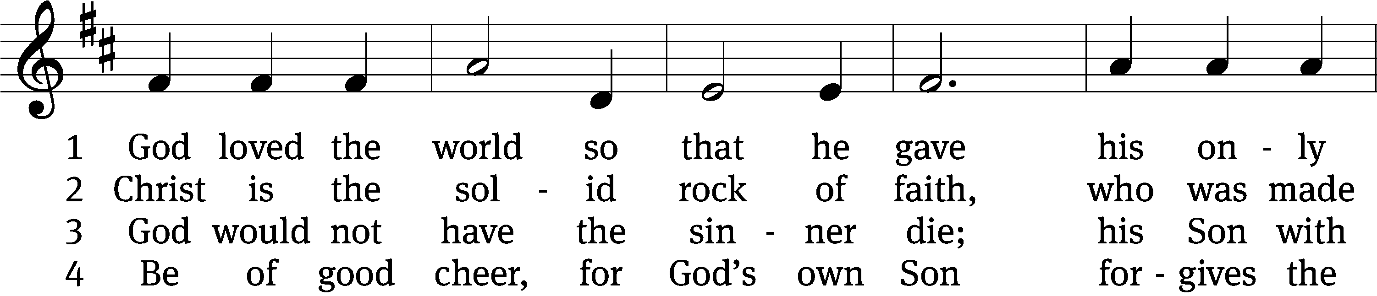
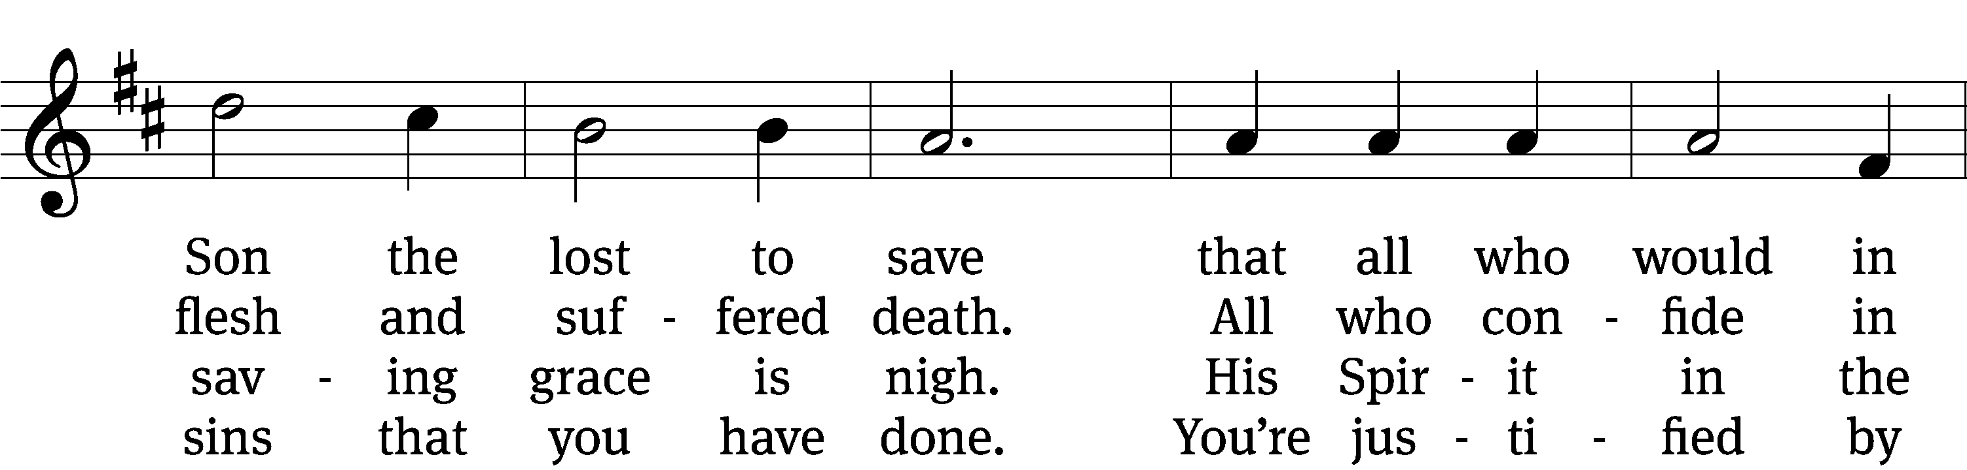
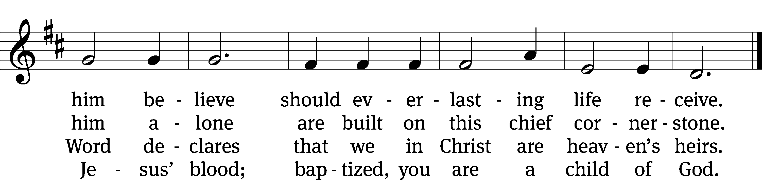

5 If you are sick, if death is near,
this truth your troubled heart can cheer:
Christ Jesus saves my soul from death;
this is the anchor of my faith!

6 Glory to God the Father, Son,
and Holy Spirit, Three in One!
To you, O blessèd Trinity,
be praise now and eternally!
Text: tr. August Crull, 1845–1923, alt.; Heiliges Lippen- und Hertzens- Opffer, Stettin, c. 1778
Tune: George J. Elvey, 1816–1893
Text and tune: Public domain

SERMON Numbers 21:4-9
“A Different Way”

PLEASE STAND, IF YOU ARE ABLE

THE APOSTLES’ CREED

I believe in God, the Father almighty,
maker of heaven and earth.
I believe in Jesus Christ, his only Son, our Lord,
who was conceived by the Holy Spirit,
born of the virgin Mary,
suffered under Pontius Pilate,
was crucified, died, and was buried.
He descended into hell.
The third day he rose again from the dead.
He ascended into heaven
and is seated at the right hand of God the Father almighty.
From there he will come to judge the living and the dead.
I believe in the Holy Spirit,
the holy Christian Church,
the communion of saints,
the forgiveness of sins,
the resurrection of the body,
and the life everlasting. Amen.

PRAYER OF THE CHURCH

THE LORD’S PRAYER

C: Our Father, who art in heaven, hallowed be thy name, thy kingdom come, thy will be done on earth as it is in heaven. Give us this day our daily bread; and forgive us our trespasses, as we forgive those who trespass against us; and lead us not into temptation, but deliver us from evil. For thine is the kingdom and the power and the glory forever and ever. Amen.

PLEASE BE SEATED
822 Pass Me Not CW 822 sts. 1–2, Ref, 3–4
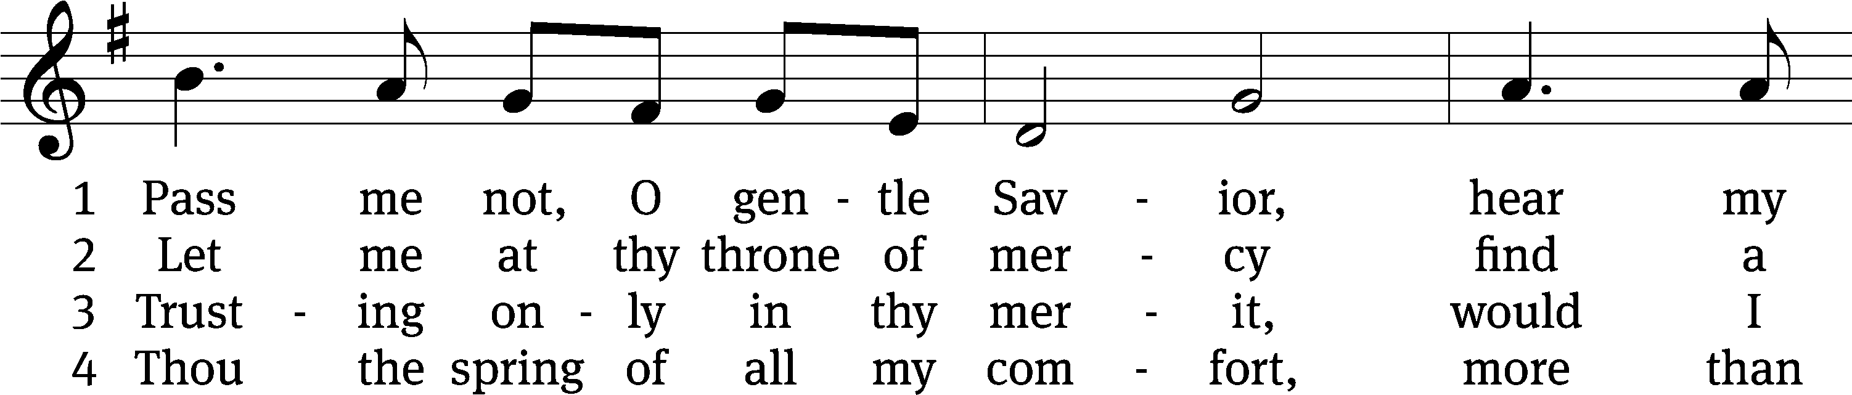
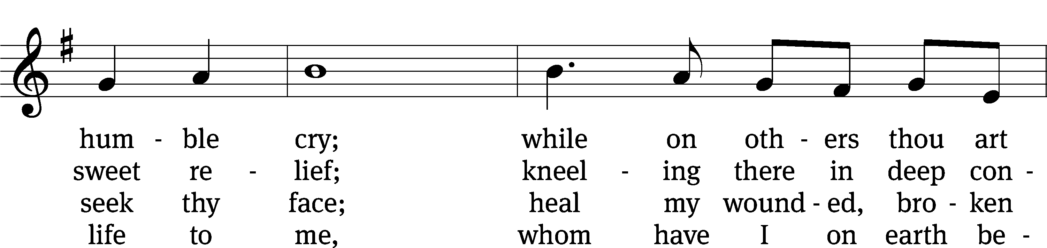
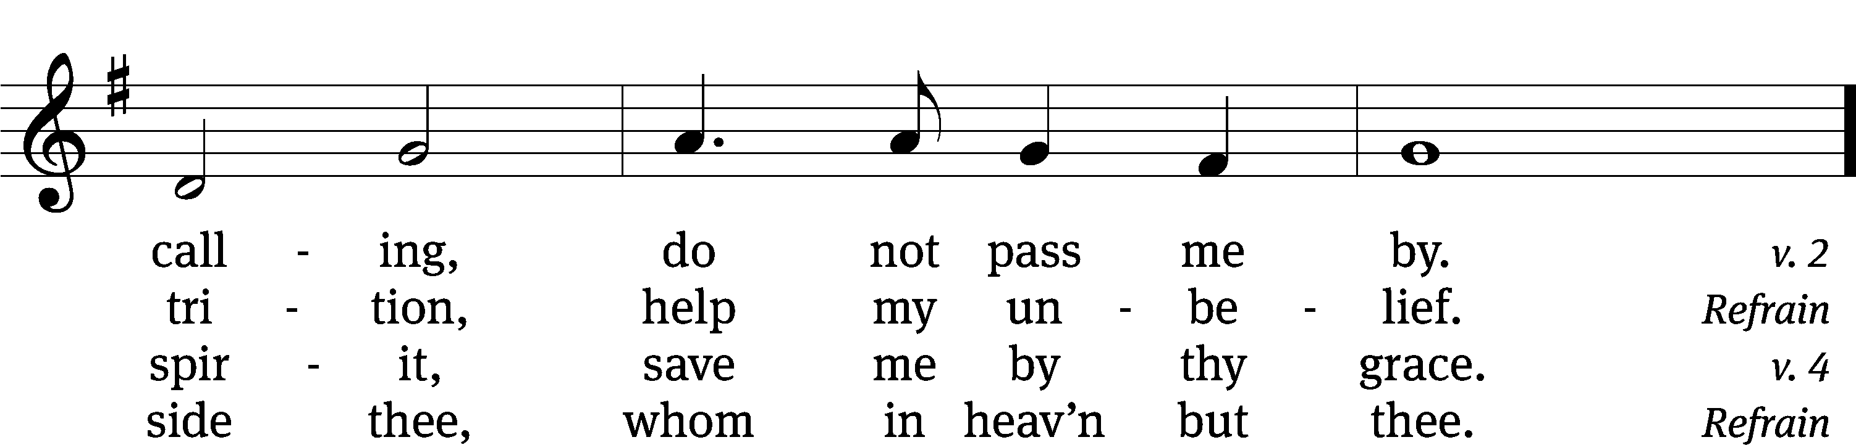
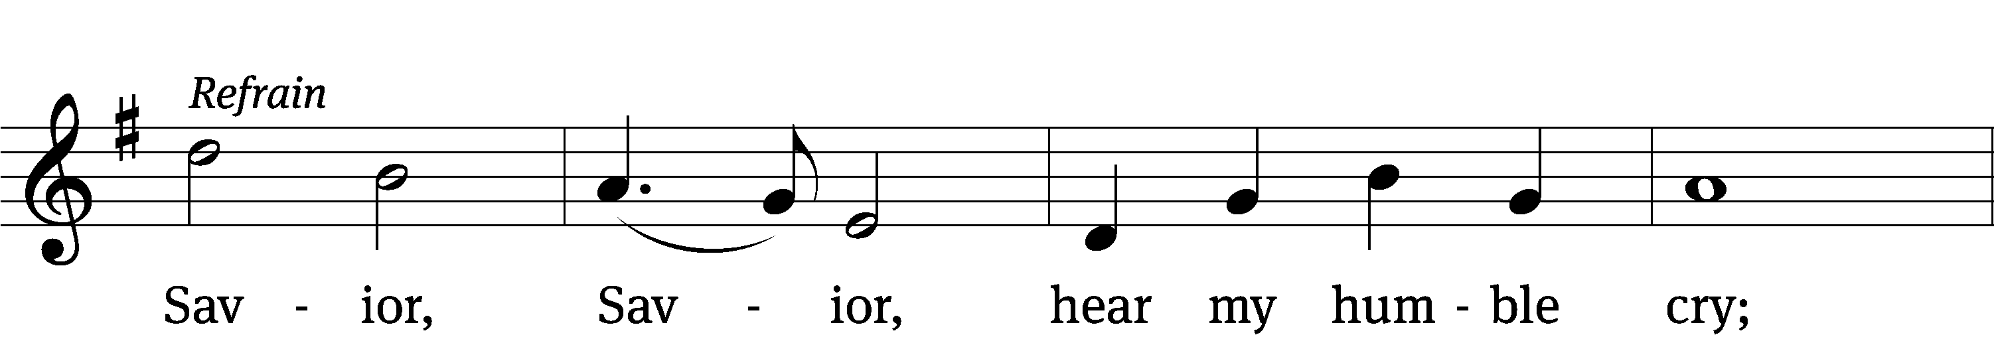
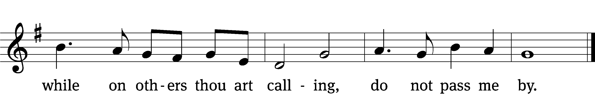
Text: Fanny J. Crosby, 1820–1915
Tune: William Doane, 1832–1915
Text and tune: Public domain

PLEASE STAND, IF YOU ARE ABLE

CLOSING PRAYER
M: Almighty God, we thank you for teaching us the things you want us to believe and do. Help us by your Holy Spirit to keep your Word in pure hearts that we may be strengthened in faith, guided in holiness, and comforted in life and in death, through Jesus Christ, our Lord, who lives and reigns with you and the Holy Spirit, one God, now and forever.

M: Brothers and sisters, go in peace. Live in harmony with one another. Serve the Lord with gladness.
The Lord bless you and keep you.
The Lord make his face shine on you and be gracious to you.
The Lord look on you with favor and (+) give you peace.

PLEASE BE SEATED

519 There Is a Redeemer CW 519
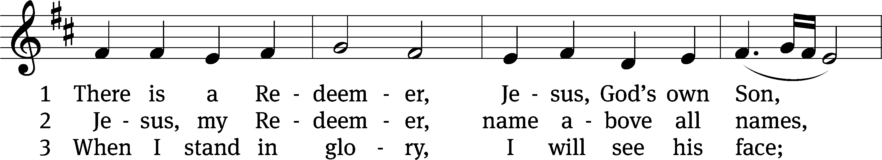
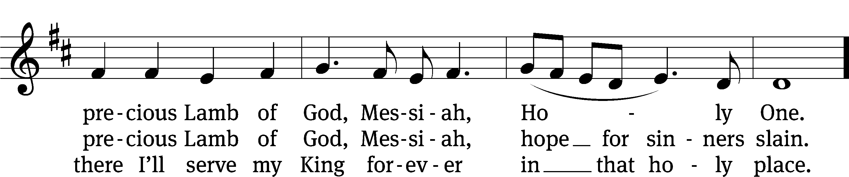
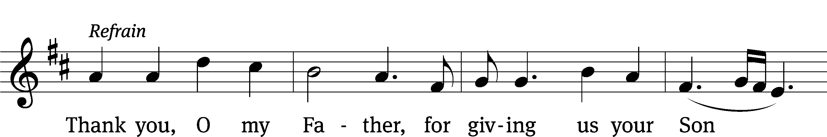
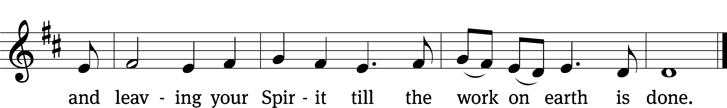
Text: Melody Green, b. 1946
Tune: Melody Green, b. 1946, alt.
Text and tune: © 1982 Birdwing Music/Ears To Hear Music/Universal Music - Brentwood Benson Publ., admin. CapitolCMGPublishing,com. Used by permission: CCLI Copyright no. 11517141

Serving In Worship
Officiant Pastor Pappenfuss
Organist Sarah Hanke
Deacons (8:30) Duane Mason and Dave Stevenson
Deacons (11:00) Robert Niethammer and Gary Knowlton
Ushers (8:30) Dale Finkbeiner and Mark Finkbeiner
Ushers (11:00) Dave Boswell and Jake Vershum
Altar Guild Ann Latowski and Jean Fiegel
Videographer Jake Vershum

Copyright information
Service of the Word: Christian Worship. © 1993 Northwestern Publishing House. All rights reserved.
Reprinted with permission under ONE LICENSE #A-727703 and CCLI #1151741/CSPL126093

Words and Music: All rights reserved. Reprinted with permission under ONE LICENSE #A-727703 and
CCLI #1151741/CSPL126093
tlcsaline.church

