THE third SUNDAY
in lent
tRINITY EVANGELICAL LUTHERAN CHURCH | Saline, Michigan
March 12, 2023

WELCOME TO WORSHIP

Thank you for joining us in God’s house today! We cordially ask that our Guests with us this morning sign one of the guestbooks located at either the front or back entryways.

THANK OFFERING: Members of Trinity give their offering as an expression of love and thankfulness to the Lord and to help support the Lord’s work in our community and around the world. Visitors need not feel obligated to participate in this offering which supports our ministry.

Restrooms are located at the back of the upper level (the annex), and in the basement (down the back stairs of the sanctuary or annex). Handicap access is available, please ask an usher for assistance.

Young Families / Toddler Bags – We are GLAD YOU BROUGHT YOUR CHILDREN to our worship service. Jesus said: “Let the little children come to me and do not hinder them, for the kingdom of God belongs to such as these.” We know that having little children in church can be a challenge, but DO NOT WORRY about it. Many of your fellow worshippers have been in your shoes and are just happy you brought your children with you. For your convenience, we have reserved the back rows of seating for parents with small children. These areas provide more flexibility for your family, as well as, easy access to move downstairs if necessary. A closed-circuit TV system allows families to continue participating in the service while downstairs. Pre-school toddler bags and children’s bulletins are available for their enjoyment. Ask an usher for one to use during the service and please return the toddler bag afterwards.

SERVICE of the word
528 Christ, the Word of God Incarnate CW 528
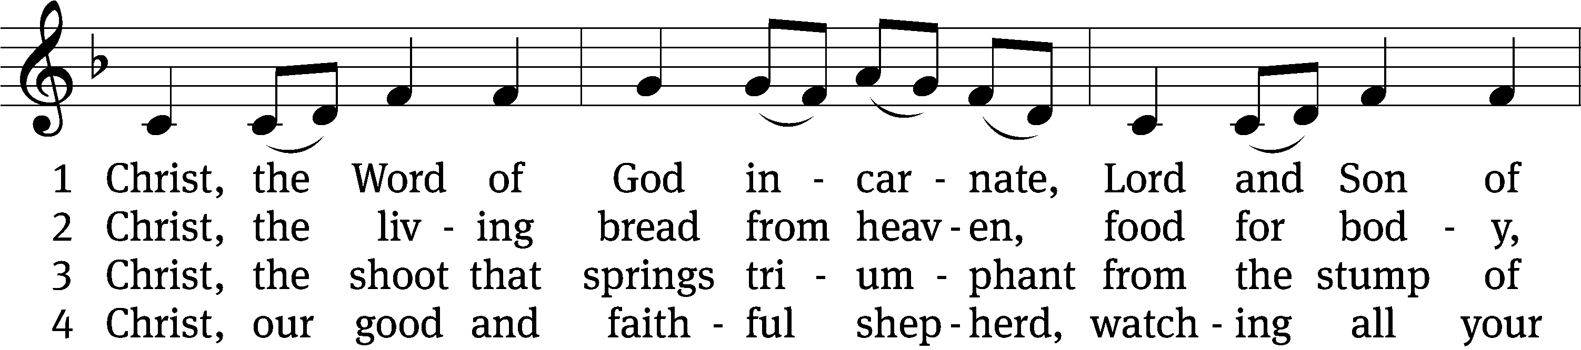
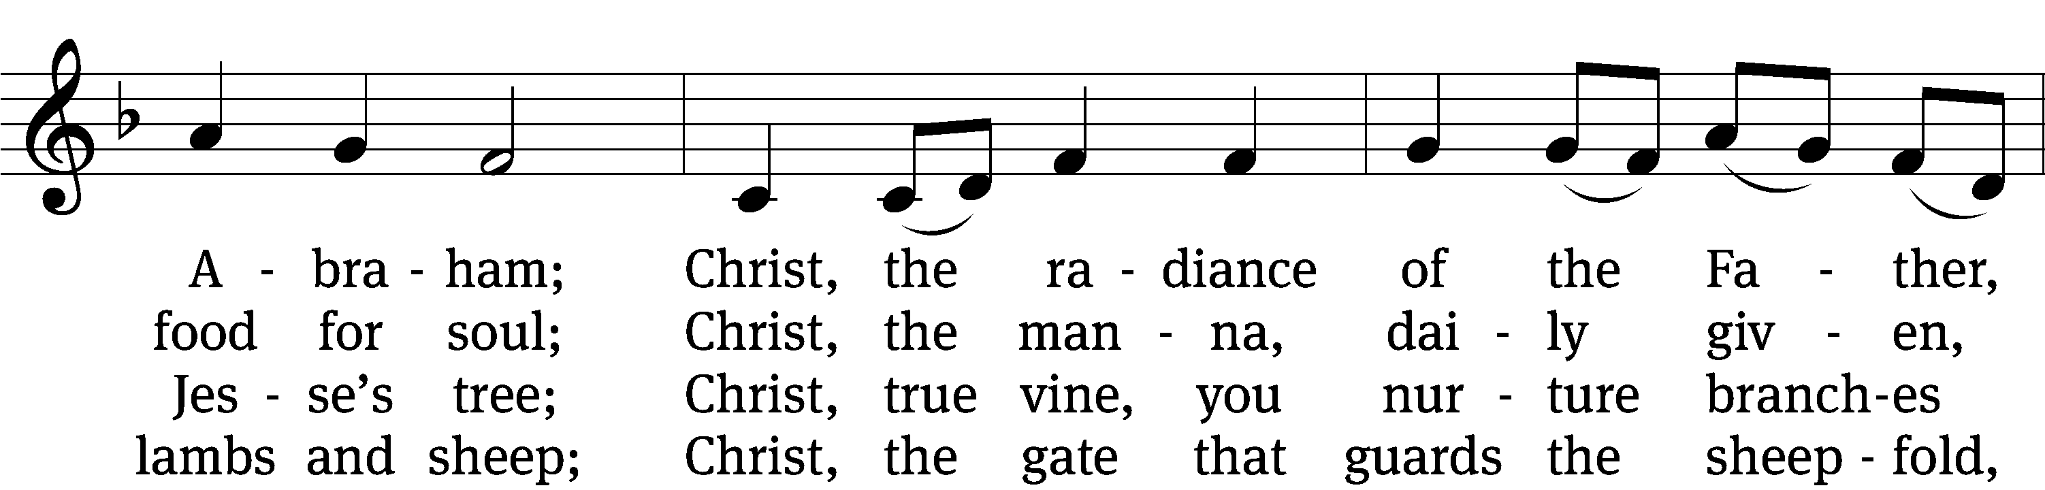
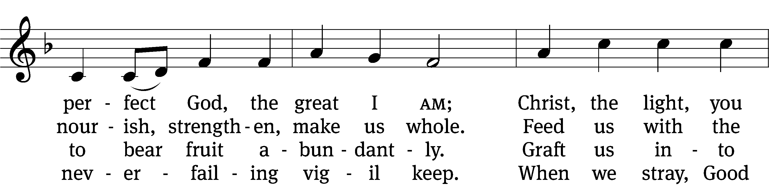
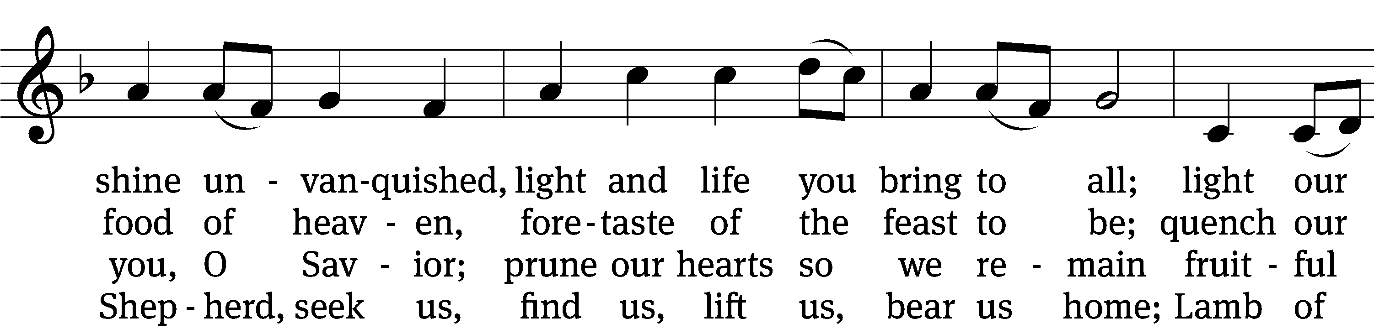
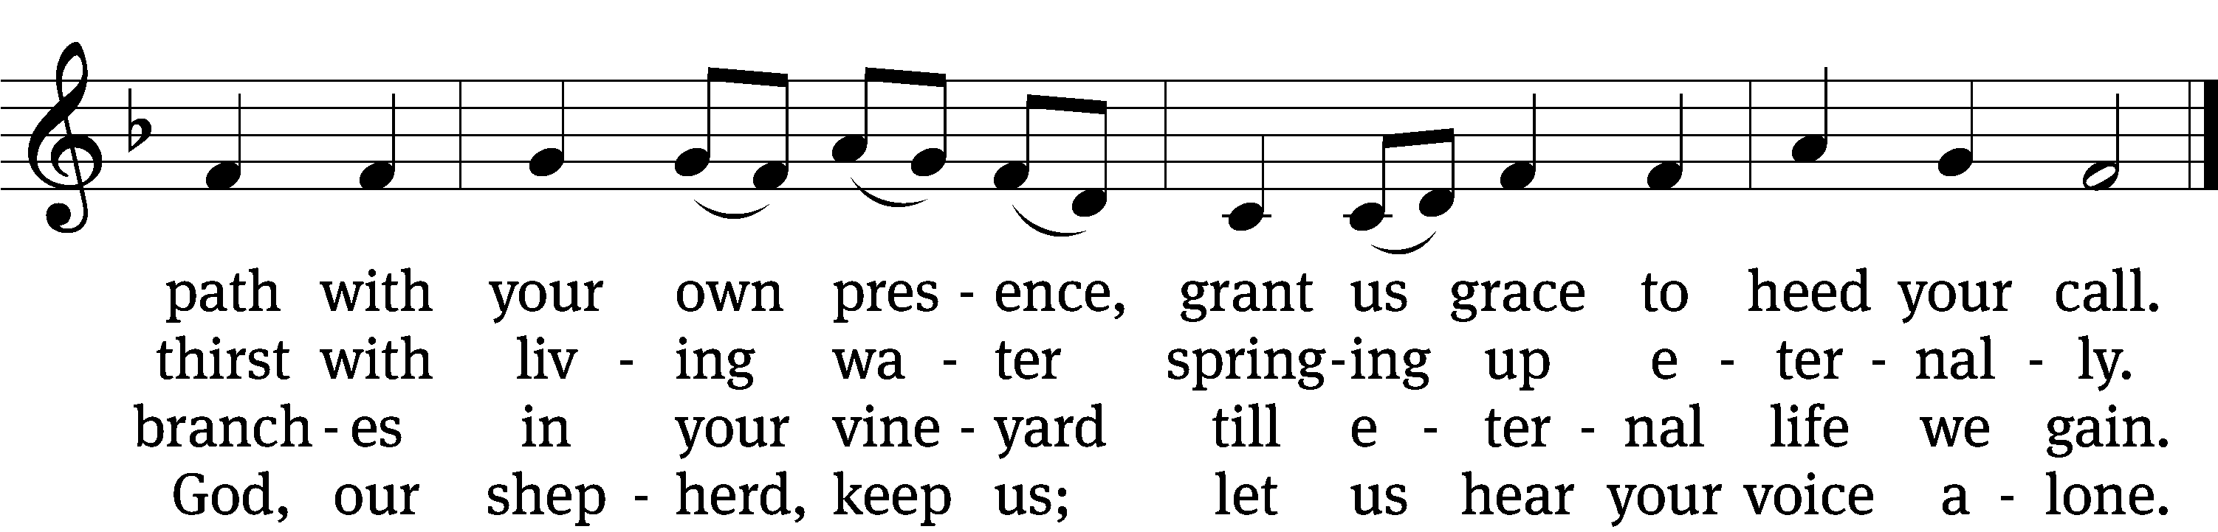

5 Christ, the way that leads unfailing
to the Father’s home on high;
Christ, the truth that frees the captive,
Christ, the life that cannot die;
mediator to the Father,
sacrifice and great High Priest:
lead us to your heav’nly mansions,
there to share your wedding feast.

6 Christ, the Alpha and Omega,
Christ, the firstborn from the dead;
Christ, the life and resurrection,
Christ, the Church’s glorious head:
praise and thanks and adoration
and unending worship be
to the Father and the Spirit
and to you eternally.
Text: Steven P. Mueller, b. 1964
Tune: Columbian Harmony, Cincinatti, 1825, ed. William Moore
Text: © 2001 Steven P. Mueller. Used by permission: OneLicense no. 727703
Tune: Public domain

PLEASE STAND, IF YOU ARE ABLE

invocation
M: The grace of our Lord (+) Jesus Christ and the love of God and the fellowship of the Holy Spirit be with you.
C: And also with you.

CONFESSION OF SINS
M: We have come into the presence of God, who created us to love and serve him as his dear children. But we have disobeyed him and deserve only his wrath and punishment. Therefore, let us confess our sins to him and plead for his mercy.

C: Merciful Father in heaven, I am altogether sinful from birth. In countless ways I have sinned against you and do not deserve to be called your child. But trusting in Jesus, my Savior, I pray: Have mercy on me according to your unfailing love. Cleanse me from my sin, and take away my guilt.

M: God, our heavenly Father, has forgiven all your sins. By the perfect life and innocent death of our Lord Jesus Christ, he has removed your guilt forever. You are his own dear child. May God give you strength to live according to his will.

C: Amen.
PRAYER AND PRAISE

M: In the peace of forgiveness, let us praise the Lord.

OH, TASTE AND SEE

PRAYER OF THE DAY

O God, whose glory it is always to have mercy, be gracious to all who have gone astray from your ways, and bring them again with penitent hearts and steadfast faith to embrace and hold fast the unchangeable truth of your Word; through your Son, Jesus Christ our Lord, who lives and reigns with you and the Holy Spirit, one God, now and forever.

PLEASE BE SEATED

The Word

the FIRST LESSON Exodus 17:1-7
¹ The entire Israelite community set out on their journey from the Wilderness of Sin as the Lord had commanded. They camped at Rephidim, but there was no water for the people to drink. ² So the people quarreled with Moses and said, “Give us water to drink.”
Moses said to them, “Why are you quarreling with me? Why are you testing the Lord?”
³ But the people were thirsty for water there, so they grumbled against Moses. They said, “Why did you ever bring us up out of Egypt to let us, our children, and our livestock die of thirst?”
⁴ Moses cried out to the Lord, “What shall I do with these people? They are almost ready to stone me!”
⁵ The Lord said to Moses, “Go in front of the people, and take the elders of Israel with you. Also take in your hand the staff with which you struck the Nile, and go. ⁶ Watch me. I will stand there in front of you on the rock in Horeb. You are to strike the rock. Water will come out of it, and the people will drink.” Moses did that in the sight of the elders of Israel. ⁷ He named the place Massah and Meribah, because the Israelites quarreled, and because they tested the Lord by saying, “Is the Lord among us or not?”
95C Come, Let Us Praise the LORD Psalm 95C
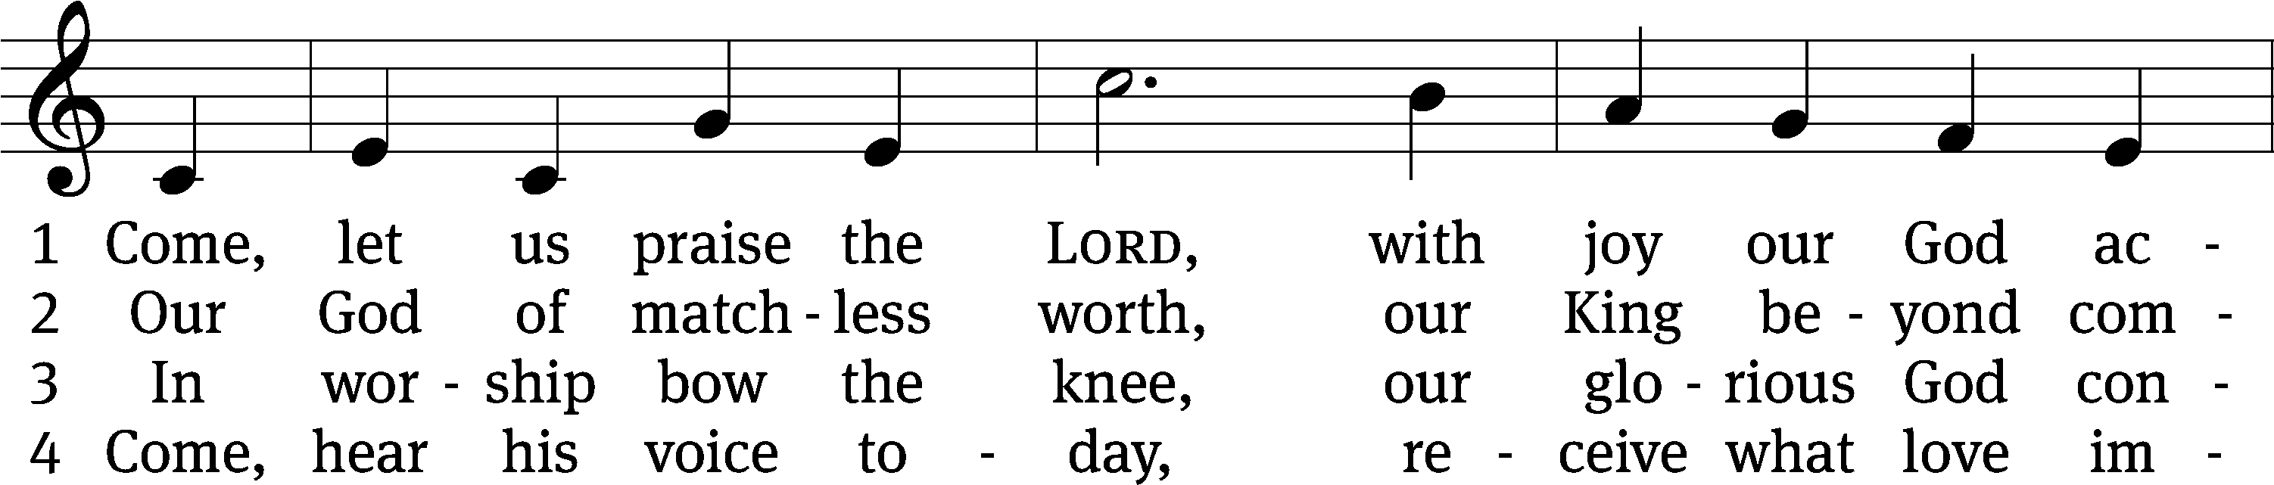
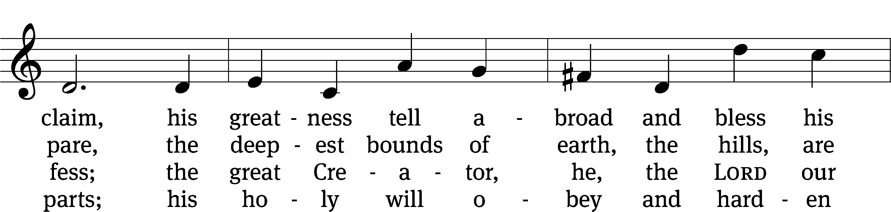
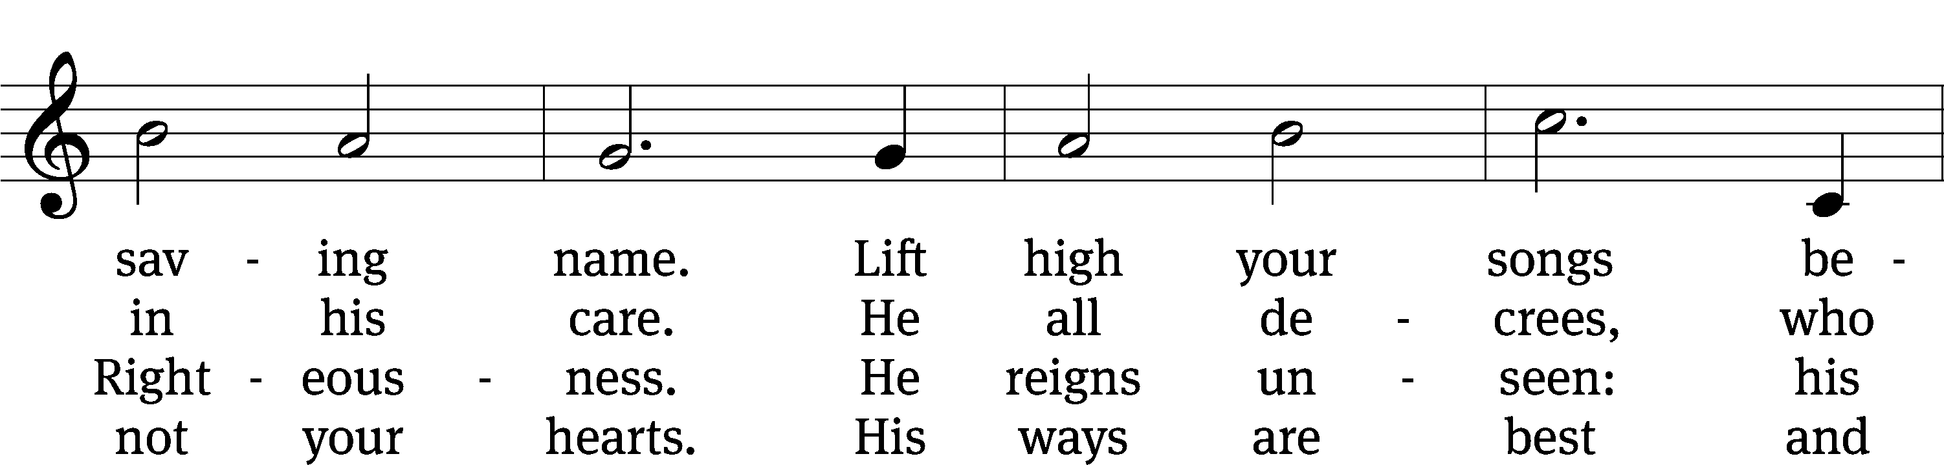
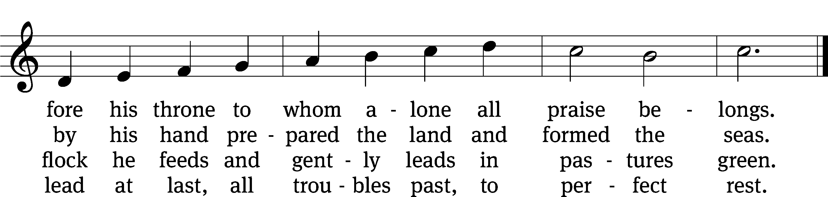
Text: Timothy Dudley-Smith
Tune: John Darwall
Text: © 1984 Hope Publishing Co. Used by permission: OneLicense no. 727703
Tune: Public domain

THE SECOND LESSON Romans 5:1-8

Therefore, since we have been justified by faith, we have peace with God through our Lord Jesus Christ. ² Through him we also have obtained access by faith into this grace in which we stand. And we rejoice confidently on the basis of our hope for the glory of God.
³ Not only this, but we also rejoice confidently in our sufferings, because we know that suffering produces patient endurance, ⁴ and patient endurance produces tested character, and tested character produces hope. ⁵ And hope will not put us to shame, because God’s love has been poured out into our hearts by the Holy Spirit, who was given to us.
⁶ For at the appointed time, while we were still helpless, Christ died for the ungodly. ⁷ It is rare indeed that someone will die for a righteous person. Perhaps someone might actually go so far as to die for a person who has been good to him. ⁸ But God shows his own love for us in this: While we were still sinners, Christ died for us.

please stand, if you are able

Verse of the day
Jesus answered, “Everyone who drinks this water will be thirsty again,
but whoever drinks the water I give them will never thirst.” John 4:13,14

THE GOSPEL LESSON John 4:5-26

M: The Gospel according to John chapter 4, verses 5-26
⁵ So he came to a town in Samaria called Sychar, near the piece of land Jacob gave to his son Joseph. ⁶ Jacob’s well was there. Then Jesus, being tired from the journey, sat down by the well. It was about the sixth hour.^{[a]}
⁷ A woman from Samaria came to draw water. Jesus said to her, “Give me a drink.” ⁸ (His disciples had gone into town to buy food.)
⁹ The Samaritan woman said to him, “How is it that you, a Jew, ask for a drink from me, a Samaritan woman?” (For Jews do not associate with Samaritans.)
¹⁰ Jesus answered her, “If you knew the gift of God and who it is that is saying to you, ‘Give me a drink,’ you would have asked him, and he would have given you living water.”
¹¹ “Sir,” she said, “you don’t even have a bucket, and the well is deep. So where do you get this living water? ¹² You are not greater than our father Jacob, are you? He gave us this well and drank from it himself, as did his sons and his animals.”
¹³ Jesus answered her, “Everyone who drinks this water will be thirsty again, ¹⁴ but whoever drinks the water I will give him will never be thirsty ever again. Rather, the water I will give him will become in him a spring of water, bubbling up to eternal life.”
¹⁵ “Sir, give me this water,” the woman said to him, “so I won’t get thirsty and have to keep coming here to draw water.”
¹⁶ Jesus told her, “Go, call your husband, and come back here.”
¹⁷ “I have no husband,” the woman answered.
Jesus said to her, “You are right when you say, ‘I have no husband.’ ¹⁸ In fact, you have had five husbands, and the man you have now is not your husband. What you have said is true.”
¹⁹ “Sir,” the woman replied, “I see that you are a prophet. ²⁰ Our fathers worshipped on this mountain, but you Jews insist that the place where we must worship is in Jerusalem.”
²¹ Jesus said to her, “Believe me, woman, a time is coming when you will not worship the Father on this mountain or in Jerusalem. ²² You Samaritans worship what you do not know. We worship what we do know, because salvation is from the Jews. ²³ But a time is coming and now is here when the real worshippers will worship the Father in spirit and in truth, for those are the kind of worshippers the Father seeks. ²⁴ God is spirit, and those who worship him must worship in spirit and in truth.”
²⁵ The woman said to him, “I know that Messiah is coming” (the one called Christ). “When he comes, he will explain everything to us.”
²⁶ Jesus said to her, “I, the one speaking to you, am he.”
M: This is the Gospel of the Lord.

PLEASE BE SEATED

703 I Heard the Voice of Jesus Say CW 703
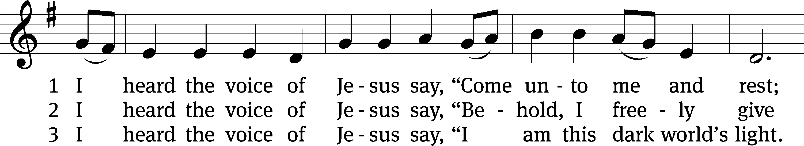
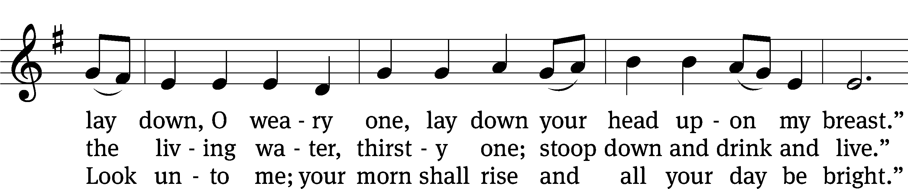
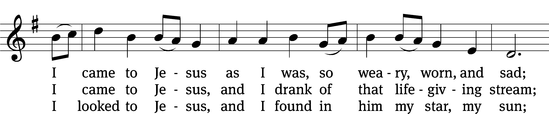
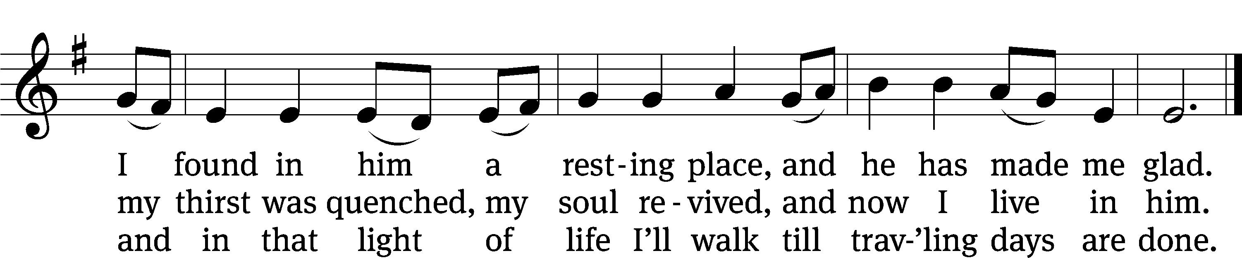
Text: Horatius Bonar, 1808–1889, alt.
Tune: English; adapt. Ralph Vaughan Williams, 1872–1958
Text and tune: Public domain

SERMON John 4:5-26
“Real Well Water”

PLEASE STAND, IF YOU ARE ABLE

THE APOSTLES’ CREED
I believe in God, the Father almighty,
maker of heaven and earth.
I believe in Jesus Christ, his only Son, our Lord,
who was conceived by the Holy Spirit,
born of the virgin Mary,
suffered under Pontius Pilate,
was crucified, died, and was buried.
He descended into hell.
The third day he rose again from the dead.
He ascended into heaven
and is seated at the right hand of God the Father almighty.
From there he will come to judge the living and the dead.
I believe in the Holy Spirit,
the holy Christian Church,
the communion of saints,
the forgiveness of sins,
the resurrection of the body,
and the life everlasting. Amen.

PRAYER OF THE CHURCH

THE LORD’S PRAYER

C: Our Father, who art in heaven, hallowed be thy name, thy kingdom come, thy will be done on earth as it is in heaven. Give us this day our daily bread; and forgive us our trespasses, as we forgive those who trespass against us; and lead us not into temptation, but deliver us from evil. For thine is the kingdom and the power and the glory forever and ever. Amen.

PLEASE BE SEATED

517 Praise the One Who Breaks the Darkness CW 517
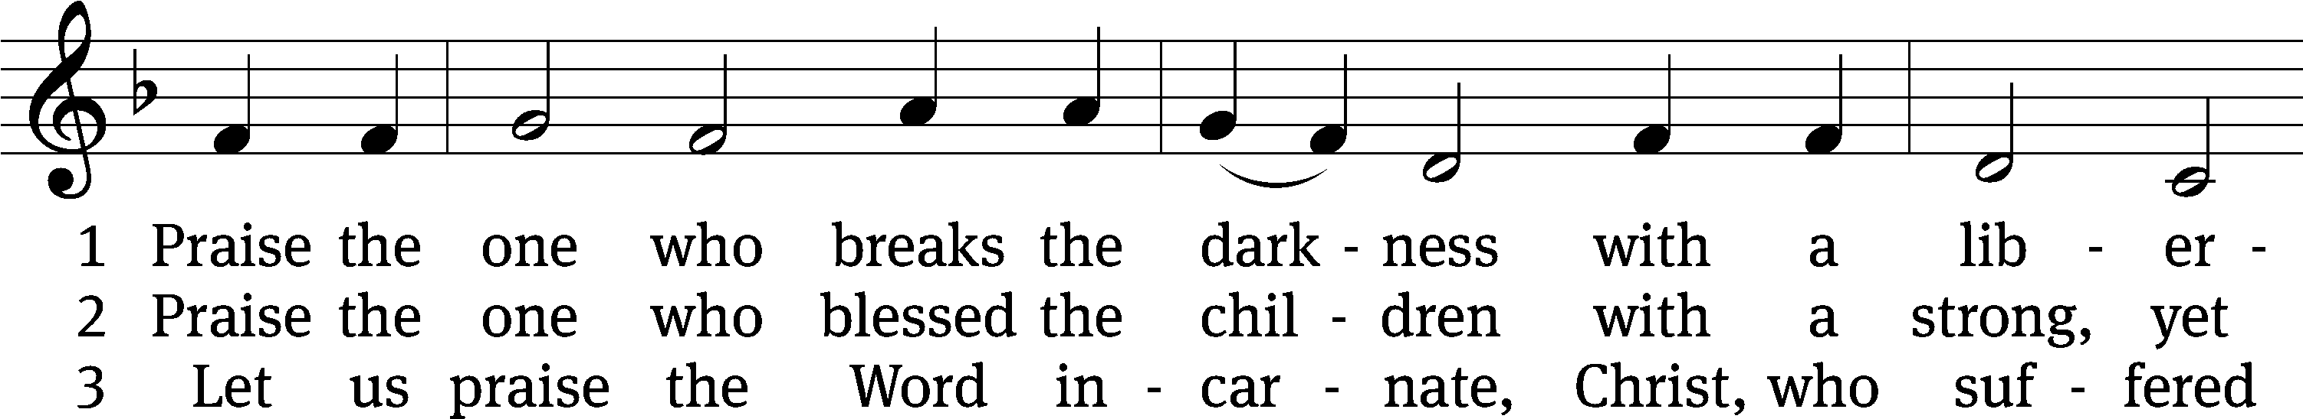
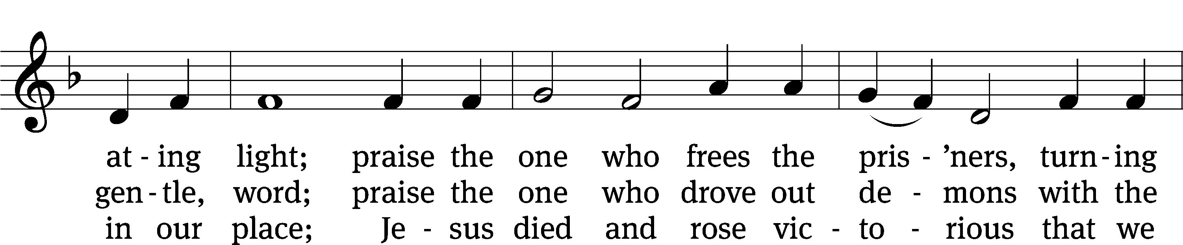
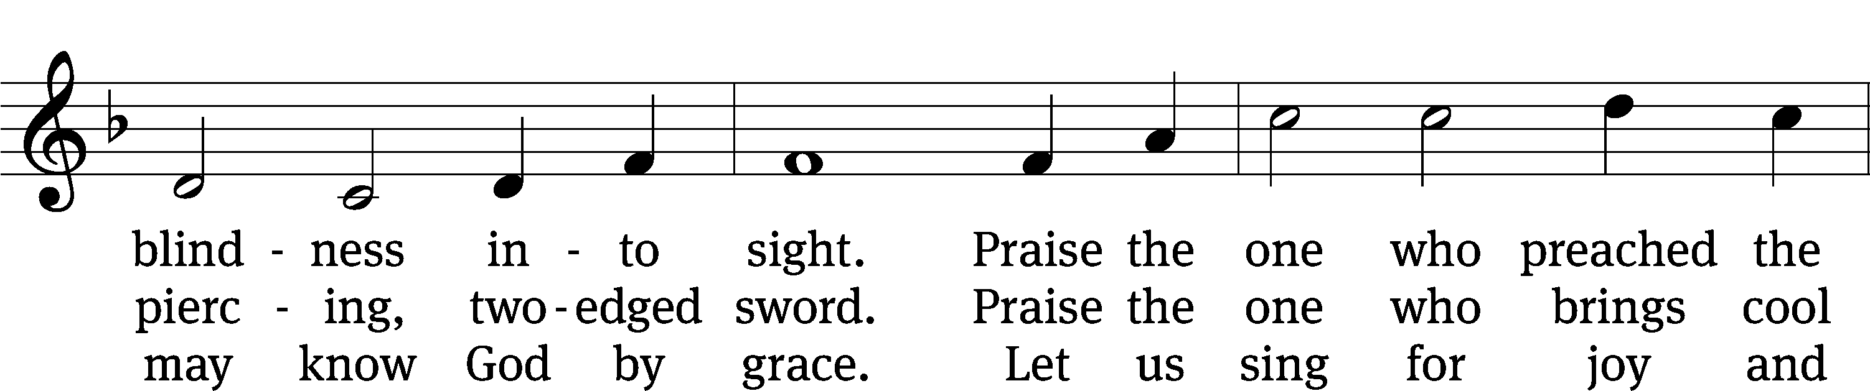
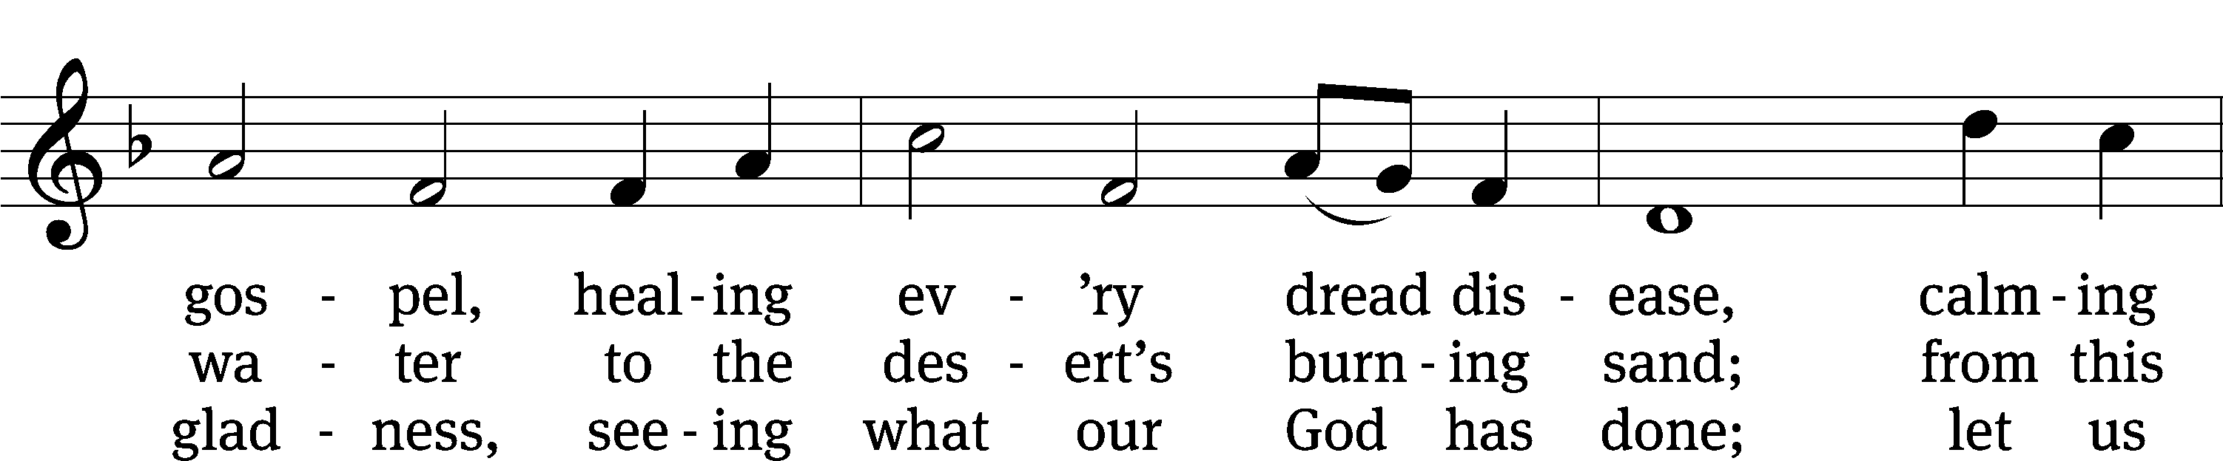
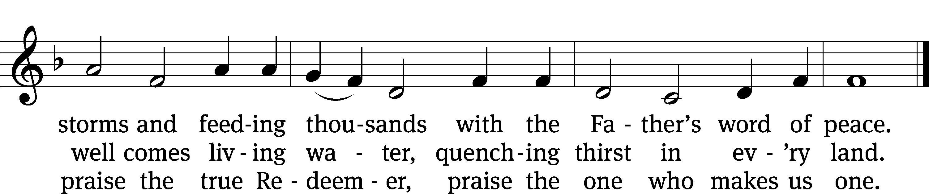
Text: Rusty Edwards, b. 1955, alt.
Tune: The Sacred Harp, Philadelphia, 1844
Text: © 1987 Hope Publishing Co. Used by permission: OneLicense no. 727703
Tune: Public domain

PLEASE STAND, IF YOU ARE ABLE

CLOSING PRAYER
M: Almighty God, we thank you for teaching us the things you want us to believe and do. Help us by your Holy Spirit to keep your Word in pure hearts that we may be strengthened in faith, guided in holiness, and comforted in life and in death, through Jesus Christ, our Lord, who lives and reigns with you and the Holy Spirit, one God, now and forever.

M: Brothers and sisters, go in peace. Live in harmony with one another. Serve the Lord with gladness.
The Lord bless you and keep you.
The Lord make his face shine on you and be gracious to you.
The Lord look on you with favor and (+) give you peace.

PLEASE BE SEATED

552 The King of Love My Shepherd Is CW 552
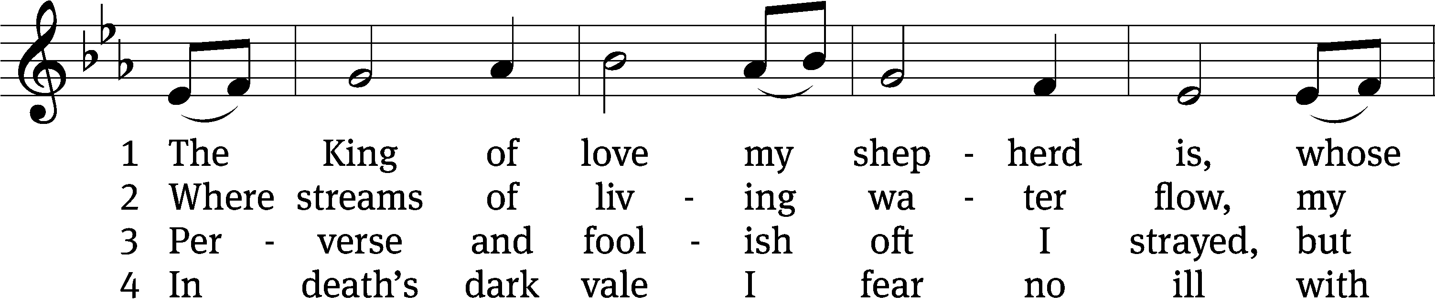
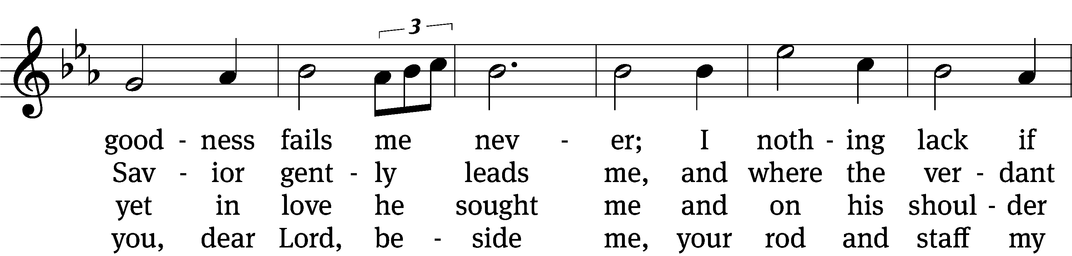
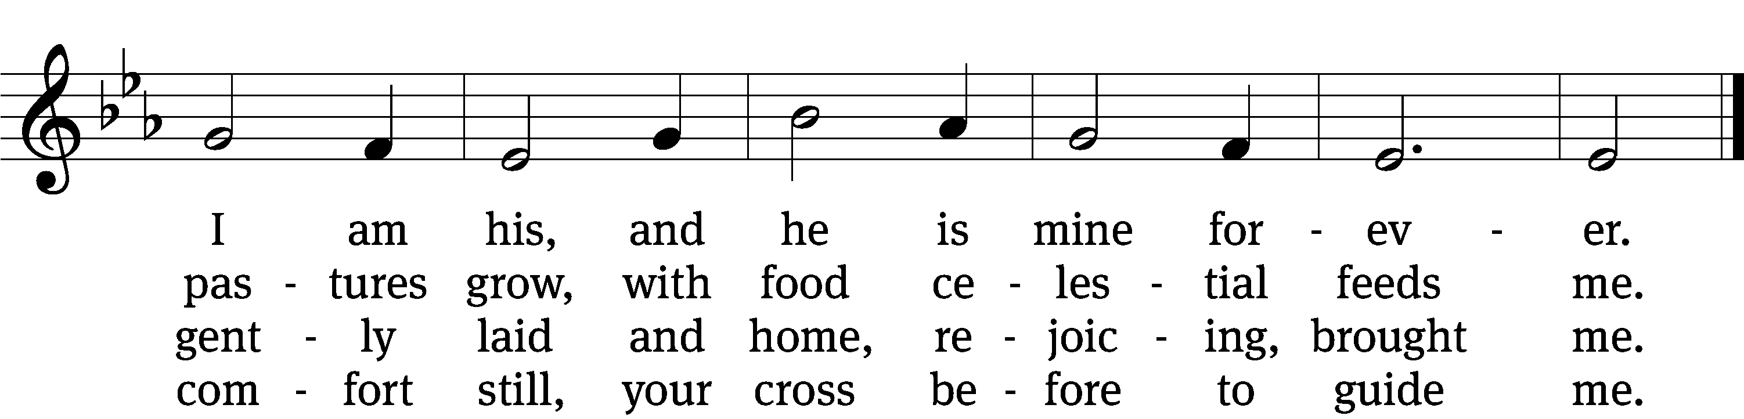

5 You spread a table in my sight,
a banquet here bestowing;
your oil of welcome, my delight;
my cup is overflowing!

6 And so through all the length of days
your goodness fails me never;
Good Shepherd, may I sing your praise
within your house forever!
Text: Henry W. Baker, 1821–1877, alt.
Tune: Irish, 18th cent.
Text and tune: Public domain

Serving In Worship
Officiant Pastor Natsis
Organist Marcia Marion Ackling
Deacons (8:30) Duane Mason and Jim Tice
(11:00) Steve Hoeft and Robert Niethammer
Ushers (8:30) Robert Newman and Henry Schneider
(11:00) Bill Barnett and Jacob Vershum
Altar Guild Jean Fiegel and Ann Latowski
Videographer Jake Vershum

Copyright information
Service of the Word: Christian Worship. © 1993 Northwestern Publishing House. All rights reserved.
Reprinted with permission under ONE LICENSE #A-727703 and CCLI #1151741/CSPL126093

Words and Music: All rights reserved. Reprinted with permission under ONE LICENSE #A-727703 and
CCLI #1151741/CSPL126093

tlcsaline.church

