The SECOND sunday
IN LENT

tRINITY EVANGELICAL LUTHERAN CHURCH | Saline, Michigan
March 13, 2022

WELCOME TO WORSHIP

Thank you for joining us in God’s house today! We cordially ask that our Guests with us this morning sign one of the guestbooks located at either the front or back entryways.

THANK OFFERING: Members of Trinity give their offering as an expression of love and thankfulness to the Lord and to help support the Lord’s work in our community and around the world. Visitors need not feel obligated to participate in this offering which supports our ministry.

Restrooms are located at the back of the upper level (the annex), and in the basement (down the back stairs of the sanctuary or annex). Handicap access is available, please ask an usher for assistance.

Young Families / Toddler Bags – We are GLAD YOU BROUGHT YOUR CHILDREN to our worship service. Jesus said: “Let the little children come to me and do not hinder them, for the kingdom of God belongs to such as these.” We know that having little children in church can be a challenge, but DO NOT WORRY about it. Many of your fellow worshippers have been in your shoes and are just happy you brought your children with you. For your convenience, we have reserved the back rows of seating for parents with small children. These areas provide more flexibility for your family, as well as, easy access to move downstairs if necessary. A closed-circuit TV system allows families to continue participating in the service while downstairs. Pre-school toddler bags and children’s bulletins are available for their enjoyment. Ask an usher for one to use during the service and please return the toddler bag afterwards.

SERVICE of the word
OPENING HYMN #397 CW
397 My Song Is Love Unknown CW 397
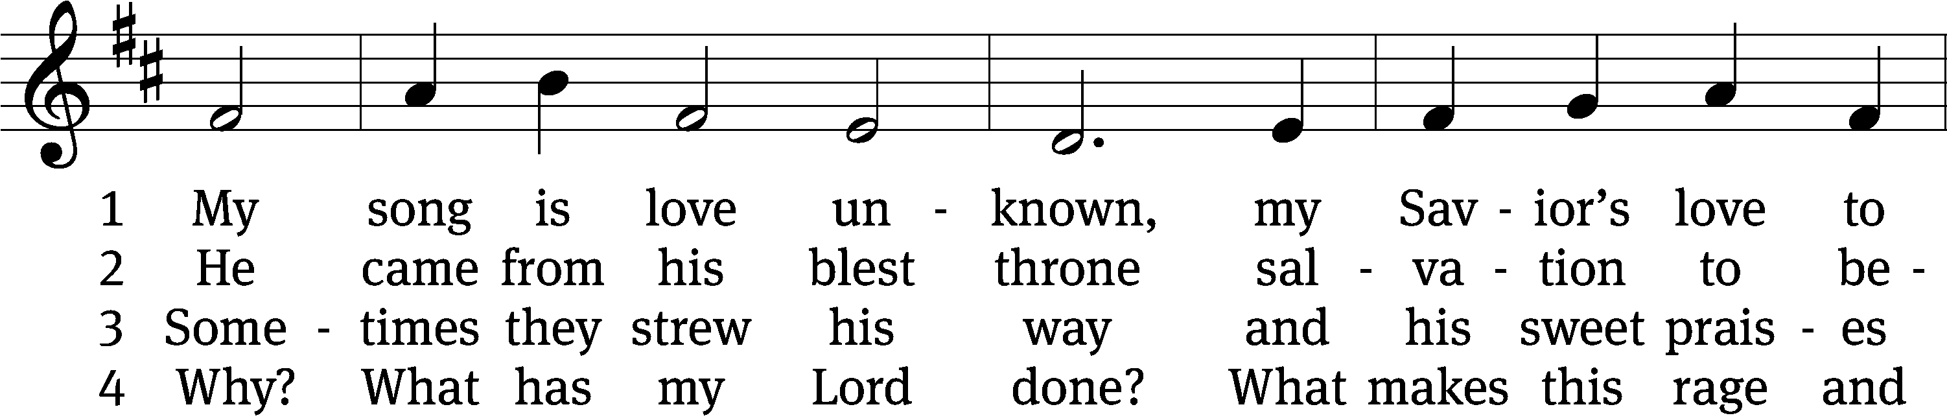
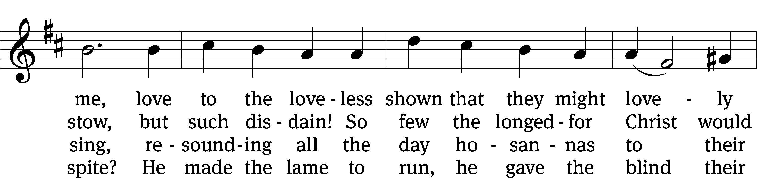
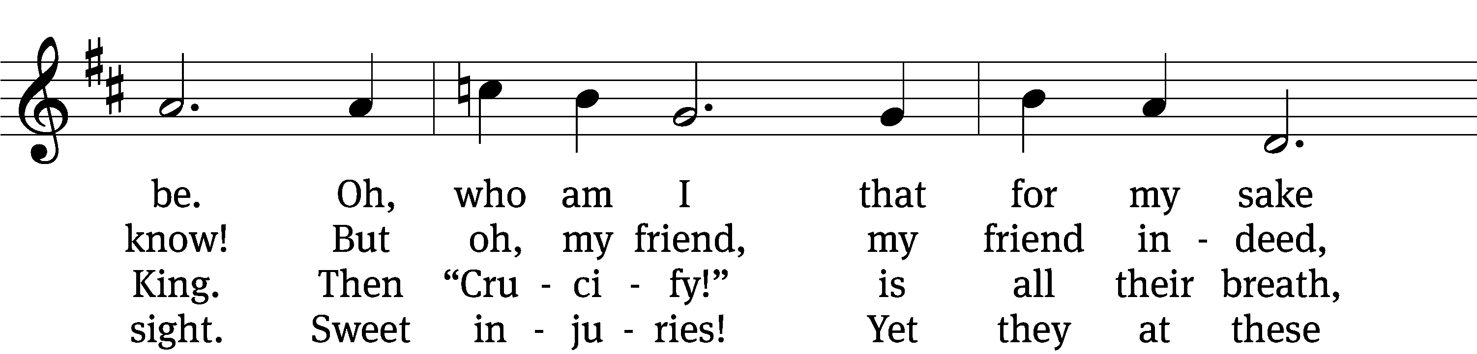
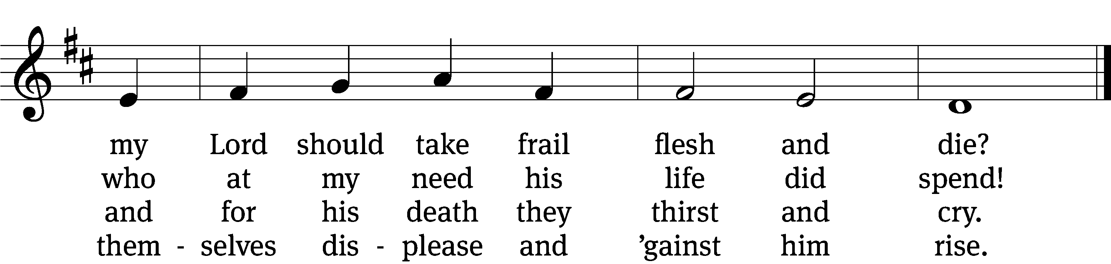

5 They rise and needs will have
my dear Lord made away.
A murderer they save,
the Prince of life they slay.
Yet cheerful he
to suff’ring goes
that he his foes
from death might free.

6 In life no house, no home
my Lord on earth might have;
in death no friendly tomb
but what a stranger gave.
What may I say?
Heav’n was his home
but mine the tomb
wherein he lay.

7 Here might I stay and sing;
no story so divine,
never was love, dear King,
never was grief like thine.
This is my friend,
in whose sweet praise
I all my days
could gladly spend!
Text: Samuel Crossman, c. 1624–1683, alt.
Tune: John N. Ireland, 1879–1962
Text and tune: Public domain

PLEASE STAND, IF YOU ARE ABLE

invocation
M: The grace of our Lord (+) Jesus Christ and the love of God and the fellowship of the Holy Spirit be with you.
C: And also with you.
CONFESSION OF SINS
M: We have come into the presence of God, who created us to love and serve him as his dear children. But we have disobeyed him and deserve only his wrath and punishment. Therefore, let us confess our sins to him and plead for his mercy.

C: Merciful Father in heaven, I am altogether sinful from birth. In countless ways I have sinned against you and do not deserve to be called your child. But trusting in Jesus, my Savior, I pray: Have mercy on me according to your unfailing love. Cleanse me from my sin, and take away my guilt.
M: God, our heavenly Father, has forgiven all your sins. By the perfect life and innocent death of our Lord Jesus Christ, he has removed your guilt forever. You are his own dear child. May God give you strength to live according to his will.

C: Amen.
PRAYER AND PRAISE

M: In the peace of forgiveness, let us praise the Lord.

OH, TASTE AND SEE

PRAYER OF THE DAY

M: Let us pray.
The minister says the Prayer of the Day.

PLEASE BE SEATED

The Word

the FIRST LESSON jeremiah 26:8-15

⁸ When Jeremiah had finished saying everything the Lord had commanded him to say to all the people, then the priests, the prophets, and all the people seized him and said, “You must die! ⁹ Why do you prophesy in the name of the Lord that this house will be like Shiloh and that this city will be desolate with no one living here?” All the people crowded around Jeremiah in the House of the Lord.
¹⁰ When the officials of Judah heard about these things, they came up from the king’s house to the House of the Lord and sat in the entrance of the New Gate of the Lord’s house.
¹¹ Then the priests and the prophets said to the officials and to all the people, “This man deserves the sentence of death because he has been prophesying against this city, as you heard with your own ears.”
¹² Then Jeremiah said to all the officials and to all the people, “The Lord sent me to prophesy against this house and against this city all the things that you have heard. ¹³ Now reform your ways and your actions, and obey the Lord your God. Then the Lord will relent and not bring about the disaster he has pronounced against you. ¹⁴ But as for me, look, I am in your hands. Do with me whatever seems good and right in your eyes. ¹⁵ But you can be certain of this. If you put me to death, you will bring innocent blood on yourselves and on this city and on those who live here, for it is true that the Lord has sent me to you to speak all these words in your hearing.”
PSALM OF THE DAY Psalm 42

THE SECOND LESSON PHILIPPIANS 3:17-4:1
¹⁷ Brothers, join together in imitating me and in paying attention to those who are walking according to the pattern we gave you. ¹⁸ To be sure, many walk as enemies of the cross of Christ. I told you about them often, and now I am saying it while weeping. ¹⁹ Their end is destruction, their god is their appetite, and their glory is in their shame. They are thinking only about earthly things. ²⁰ But our citizenship is in heaven. We are eagerly waiting for a Savior from there, the Lord Jesus Christ. ²¹ By the power that enables him to subject all things to himself, he will transform our humble bodies to be like his glorious body.
4 So then, my brothers, whom I love and long for, my joy and crown, in this way keep standing firm in the Lord, my dear friends.

Verse of the day

PLEASE Stand, if you are able

THE GOSPEL LESSON LUKE 13:31-35
M: The Gospel according to Luke chapter 13, verses 31-35
³¹ In that very hour, some Pharisees came to him and said, “Leave, and go away from here, because Herod wants to kill you.”
³² He said to them, “Go tell that fox, ‘Look, I am going to drive out demons and heal people today and tomorrow, and on the third day I will reach my goal. ³³ Nevertheless, I must go on my way today and tomorrow and the next day, because it cannot be that a prophet would be killed outside Jerusalem!’
³⁴ “Jerusalem, Jerusalem, the city that kills the prophets and stones those sent to her! How often I have wanted to gather your children together, as a hen gathers her chicks under her wings, but you were not willing! ³⁵ Look, your house is left to you desolate. I tell you, you will not see me until the time comes when you will say, ‘Blessed is he who comes in the name of the Lord!’”

M: This is the Gospel of the Lord.

PLEASE BE SEATED

SERMON HYMN ON EAGLES’ WINGS

SERMON Luke 13:31-35
“By Veiled Threat or Veiled Prophecy – Jesus is Going to Jerusalem”

PLEASE STAND, IF YOU ARE ABLE

THE APOSTLES’ CREED
I believe in God, the Father almighty,
maker of heaven and earth.
I believe in Jesus Christ, his only Son, our Lord,
who was conceived by the Holy Spirit,
born of the virgin Mary,
suffered under Pontius Pilate,
was crucified, died, and was buried.
He descended into hell.
The third day he rose again from the dead.
He ascended into heaven
and is seated at the right hand of God the Father almighty.
From there he will come to judge the living and the dead.
I believe in the Holy Spirit,
the holy Christian Church,
the communion of saints,
the forgiveness of sins,
the resurrection of the body,
and the life everlasting. Amen.

PRAYER OF THE CHURCH

THE LORD’S PRAYER

C: Our Father, who art in heaven, hallowed be thy name, thy kingdom come, thy will be done on earth as it is in heaven. Give us this day our daily bread; and forgive us our trespasses, as we forgive those who trespass against us; and lead us not into temptation, but deliver us from evil. For thine is the kingdom and the power and the glory forever and ever. Amen.

PLEASE BE SEATED
817 Lord, Thee I Love with All My Heart CW 817
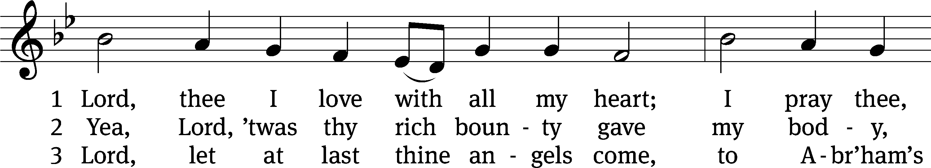
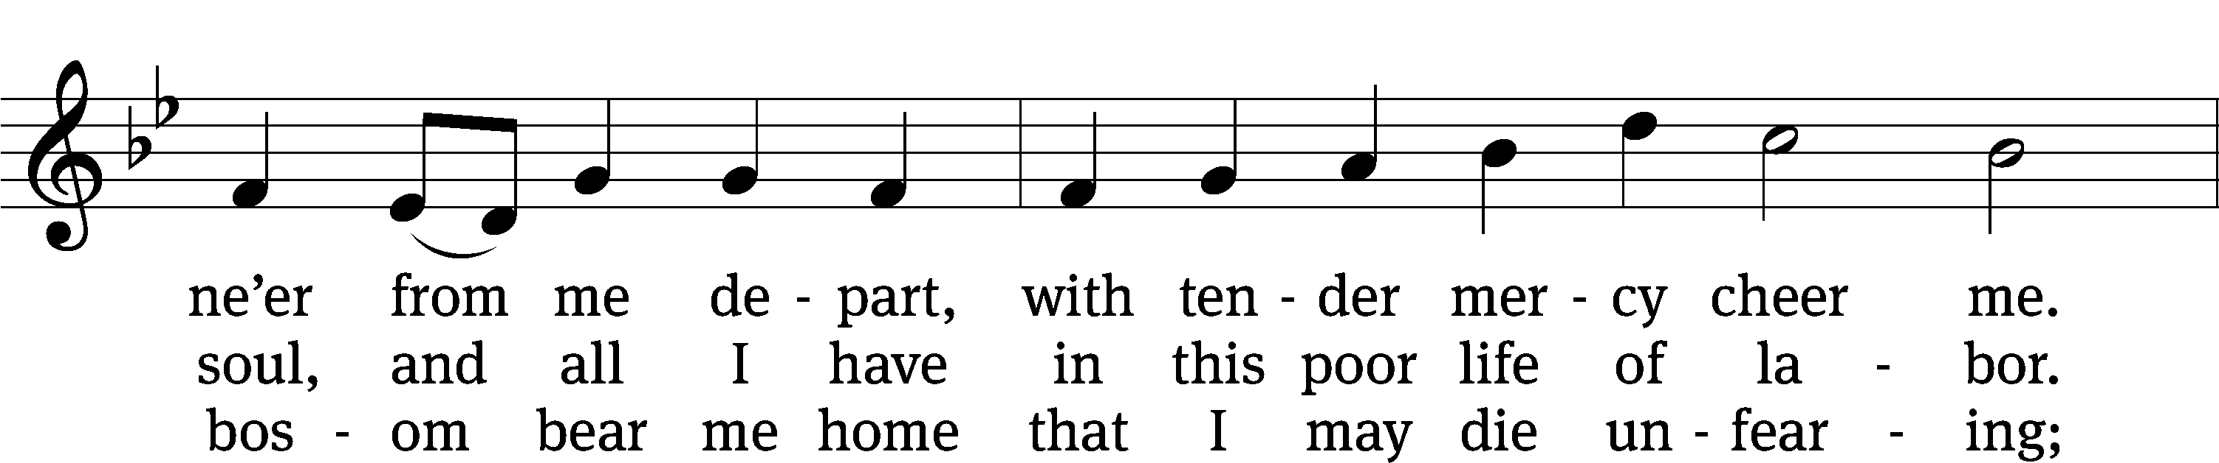
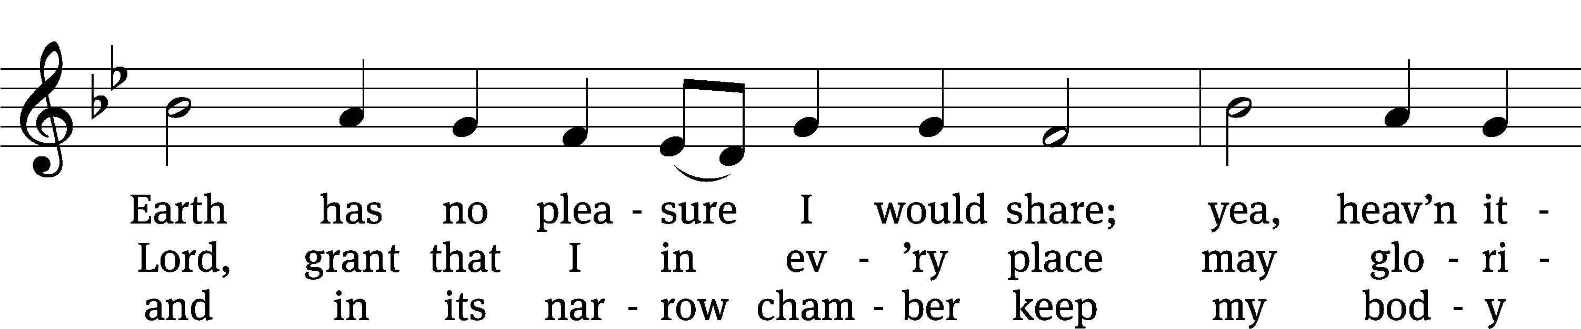
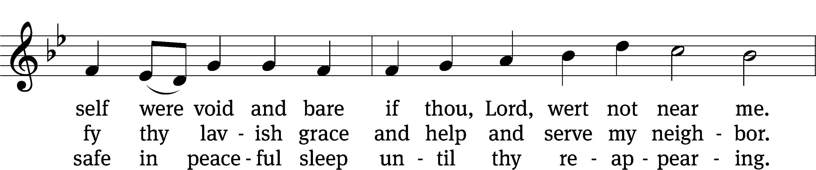
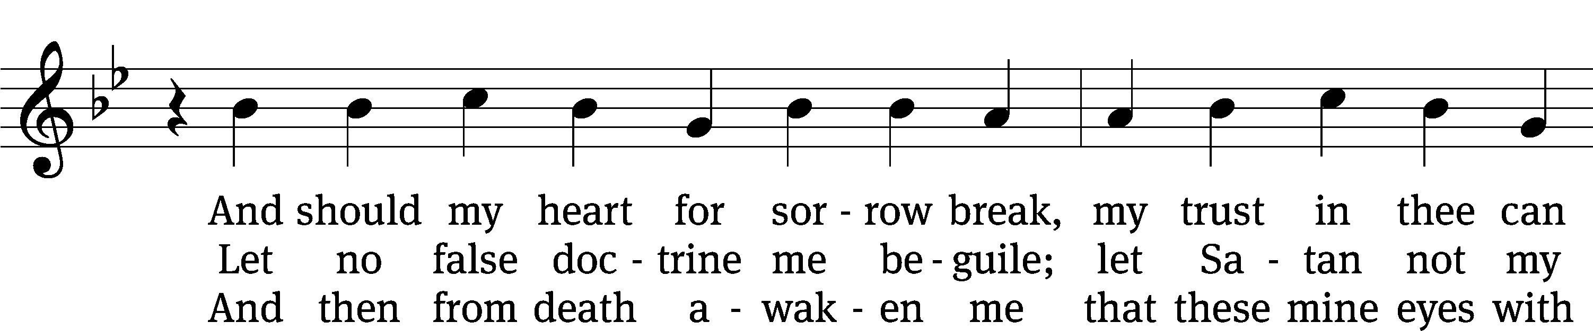
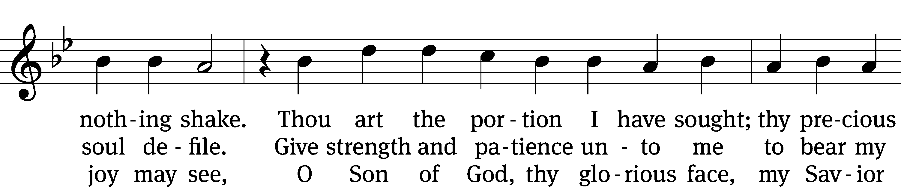
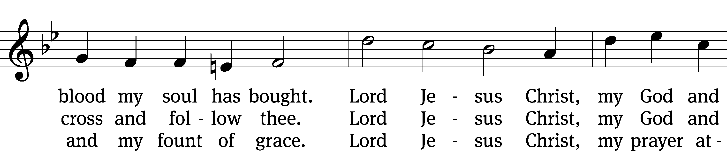
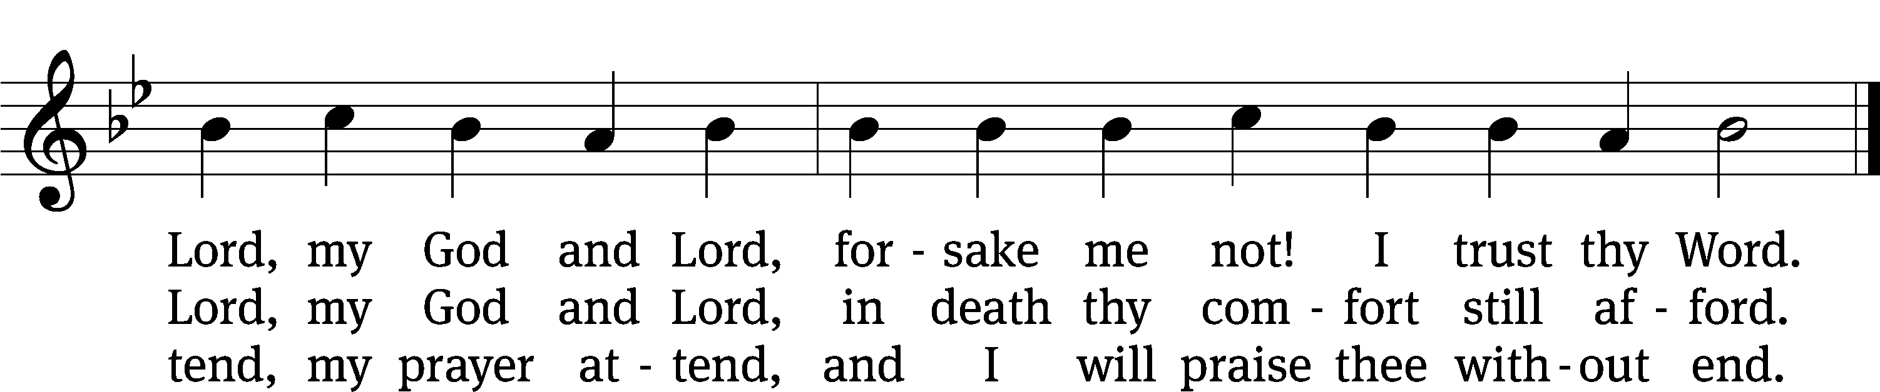
Text: tr. Catherine Winkworth, 1827–1878, alt.; Martin M. Schalling, 1532–1608
Tune: Zwey Bücher . . . Tablatur, Strassburg, 1577
Text and tune: Public domain

PLEASE STAND, IF YOU ARE ABLE

CLOSING PRAYER
M: Almighty God, we thank you for teaching us the things you want us to believe and do. Help us by your Holy Spirit to keep your Word in pure hearts that we may be strengthened in faith, guided in holiness, and comforted in life and in death, through Jesus Christ, our Lord, who lives and reigns with you and the Holy Spirit, one God, now and forever.

M: Brothers and sisters, go in peace. Live in harmony with one another. Serve the Lord with gladness.
The Lord bless you and keep you.
The Lord make his face shine on you and be gracious to you.
The Lord look on you with favor and (+) give you peace.

PLEASE BE SEATED

CLOSING HYMN #853 CW
853 I’m But a Stranger Here CW 853
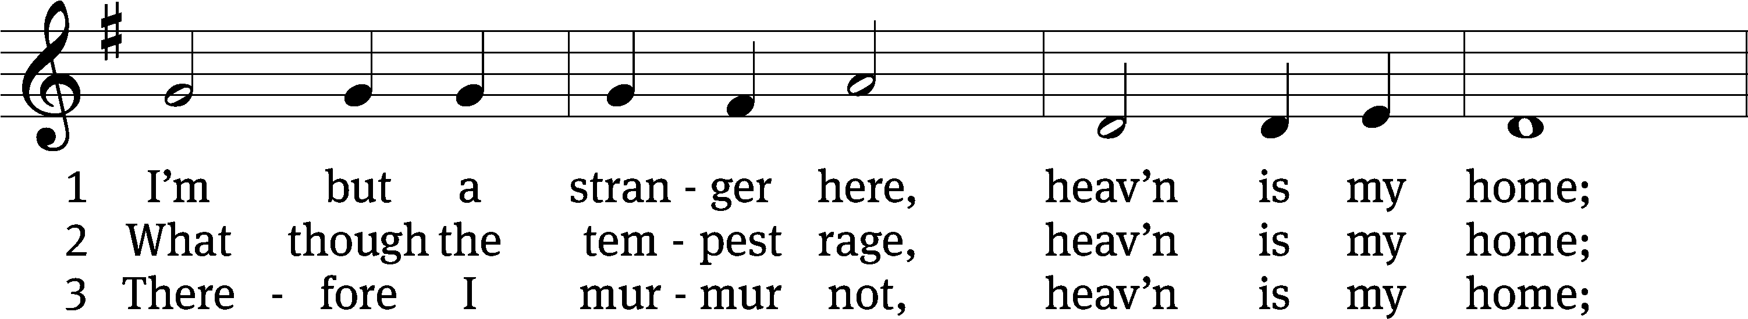
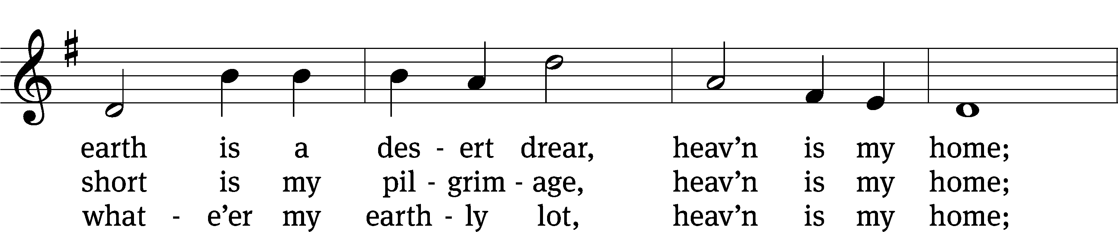
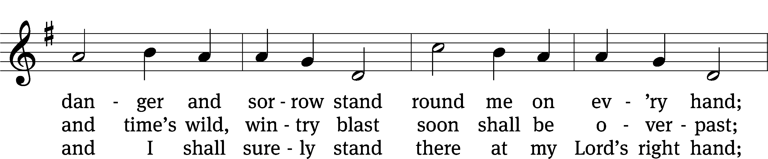
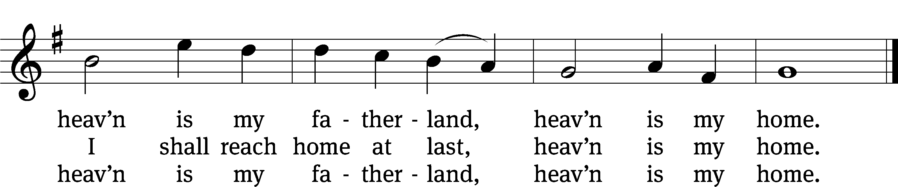
Text: Thomas R. Taylor, 1807–1835, abr.
Tune: Arthur S. Sullivan, 1842–1900
Text and tune: Public domain

Serving In Worship
Officiant Pastor William Natsis
Organist Sarah Hanke
Deacons (8:30) Jim Tice and Ed Wheeler
(11:00) Dave Frey and Jeff Neuburger
Ushers (8:30) Robert Newman and Henry Schneider
(11:00) Bill Barnett and Jake Vershum
Altar Guild Shirley Klumpp and Ann Latowski
Videographer Rick Schneider

Copyright information
Service of the Word: Christian Worship. © 1993 Northwestern Publishing House. All rights reserved.
Reprinted with permission under ONE LICENSE #A-727703 and CCLI #1151741/CSPL126093

Words and Music: All rights reserved. Reprinted with permission under ONE LICENSE #A-727703 and
CCLI #1151741/CSPL126093

tlcsaline.church

