the THIRD sunday
IN LENT

TRINITY EVANGELICAL LUTHERAN CHURCH | Saline, Michigan
WELCOME TO WORSHIP March 20, 2022

Thank you for joining us in God’s house today! We cordially ask that our guests sign one of the guestbooks located at either the front or back entryways.

THANK OFFERING: Members of Trinity give their offering as an expression of love and thankfulness to the Lord and to help support the Lord’s work in our community and around the world. Visitors need not feel obligated to participate in this offering which supports our ministry.

Restrooms are located at the back of the upper level (the annex), and in the basement (down the back stairs of the sanctuary or annex). Handicap access is available, please ask an usher for assistance.

celebration of holy communion:
In His Word, God makes it clear that the Lord’s Supper is to be shared by people of a common proclamation of faith (1 Corinthians 11:26; 1 Corinthians 10:16-17). Without judging anyone’s hearts, we invite those who share in our confession by their membership in our congregation or another congregation of the Wisconsin Evangelical Lutheran Synod (WELS) or the Evangelical Lutheran Synod (ELS) and who are properly prepared (1 Corinthians 11;27-29) to receive the Sacrament. Page 295 in the front of Christian Worship provides a guide for preparation.

Guests, we would love to have you join us in communion fellowship in the future, and for that to be possible, we ask that you speak with one of the pastors so that we may speak with you on how that would be possible. We thank you for respecting the way we celebrate the Lord’s Supper in our congregations.

SERVICE OF WORD AND SACRAMENT

bell choir (11:00 a.m.) Lenten prayer

Opening hymn CW #712
712 Delay Not! Delay Not CW 712
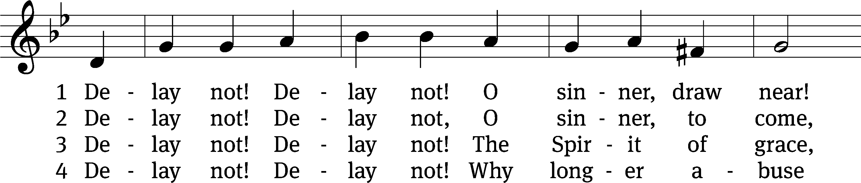
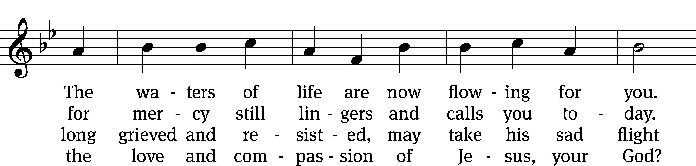
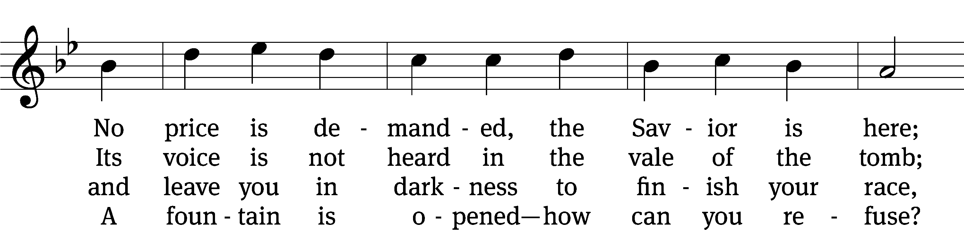
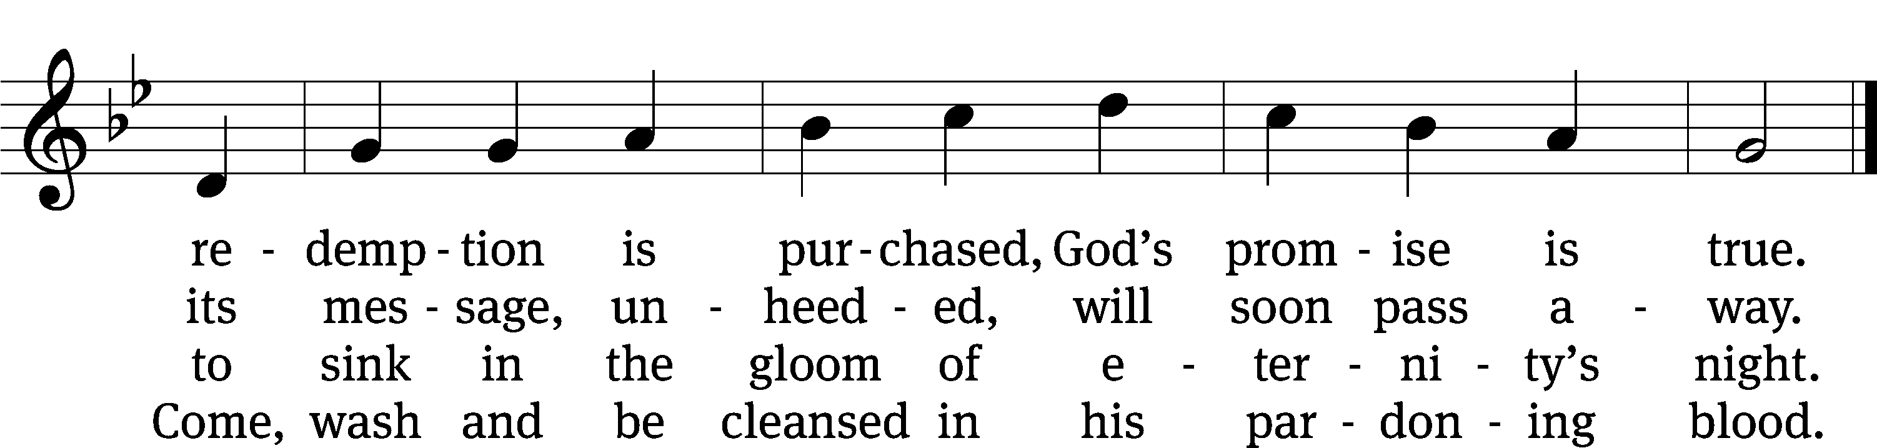
Text: Thomas Hastings, 1784–1872, alt.
Tune: Welsh, 17th cent.
Text and tune: Public domain

PLEASE STAND, IF YOU ARE ABLE

invocation

M: The grace of our Lord (+) Jesus Christ and the love of God and the fellowship of the Holy Spirit be with you.
C: And also with you.
CONFESSION OF SINS
M: God invites us to come into his presence and worship him with humble and penitent hearts. Therefore, let us acknowledge our sinfulness and ask him to forgive us.
C: Holy and merciful Father, I confess that I am by nature sinful, and that I have disobeyed you in my thoughts, words, and actions. I have done what is evil and failed to do what is good. For this I deserve your punishment both now and in eternity. But I am truly sorry for my sins, and trusting in my Savior Jesus Christ, I pray: Lord, have mercy on me, a sinner.
M: God, our heavenly Father, has been merciful to us and has given his only Son to be the atoning sacrifice for our sins. Therefore, as a called servant of Christ and by his authority, I forgive you all your sins in the name of the Father and of the Son (+) and of the Holy Spirit.
C: Amen.

PRAYER AND PRAISE

LORD, HAVE MERCY
Kyrie
M: For all that we need in life and for the wisdom to use all your gifts with gratitude and joy, hear our prayer, O Lord.

M: For the steadfast assurance that nothing can separate us from your love and for the courage to stand firm against the assaults of Satan and every evil, hear our prayer, O Christ.

M: For the well-being of your holy Church in all the world and for those who offer here their worship and praise, hear our prayer, O Lord.

M: Merciful God, maker and preserver of life, uphold us by your power and keep us in your tender care:

M: The works of the Lord are great and glorious; his name is worthy of praise.

Prayer of the day

M: Let us pray.
The minister says the Prayer of the Day.

PLEASE BE SEATED

The Word

first lesson exodus 3:1-15
Now Moses was shepherding the flock of Jethro, his father-in-law, a priest of Midian, and he led the flock to the far side of the wilderness and came to Horeb, the mountain of God. ² The Angel of the Lord appeared to him in blazing fire from within a bush. Moses saw that the bush was on fire, but the bush was not burning up. ³ So he said, “I will go over and look at this amazing sight—to find out why the bush is not burning up.”
⁴ When the Lord saw that Moses had gone over to take a look, God called to him from the middle of the bush and said, “Moses! Moses!”
Moses said, “I am here.”
⁵ The Lord said, “Do not come any closer. Take your sandals off your feet, for the place where you are standing is holy ground.” ⁶ He then said, “I am the God of your fathers, the God of Abraham, the God of Isaac, and the God of Jacob.”
Moses hid his face, because he was afraid to look at God.
⁷ The Lord said, “I have certainly seen the misery of my people in Egypt, and I have heard their cry for help because of their slave drivers. Yes, I am aware of their suffering. ⁸ So I have come down to deliver them from the hand of the Egyptians and to bring them up out of that land to a good and spacious land, to a land flowing with milk and honey, to the place of the Canaanites, the Hittites, the Amorites, the Perizzites, the Hivites, and the Jebusites. ⁹ Now indeed, the Israelites’ cry for help has come to me. Yes, I have seen how the Egyptians are oppressing them. ¹⁰ Come now, I will send you to Pharaoh to bring my people, the Israelites, out of Egypt.”
¹¹ But Moses said to God, “Who am I, that I should go to Pharaoh, and that I should bring the Israelites out of Egypt?”
¹² So he said, “I will certainly be with you. This will be the sign to you that I have sent you: When you have brought the people out of Egypt, you will serve God on this mountain.”
¹³ But Moses said to God, “If I go to the Israelites and say to them, ‘The God of your fathers has sent me to you,’ and they ask me, ‘What is his name?’ what should I say to them?”
¹⁴ So God replied to Moses, “I am who I am.” He also said, “You will say this to the Israelites: I am has sent me to you.”
¹⁵ God also told Moses, “Say this to the Israelites: ‘The Lord, the God of your fathers—the God of Abraham, the God of Isaac, and the God of Jacob—has sent me to you. This is my name forever, and this is how I am to be remembered from generation to generation.’

Psalm of the day PSALM 85
85A LORD, in Your Mercy, Hear My Prayer Psalm 85A
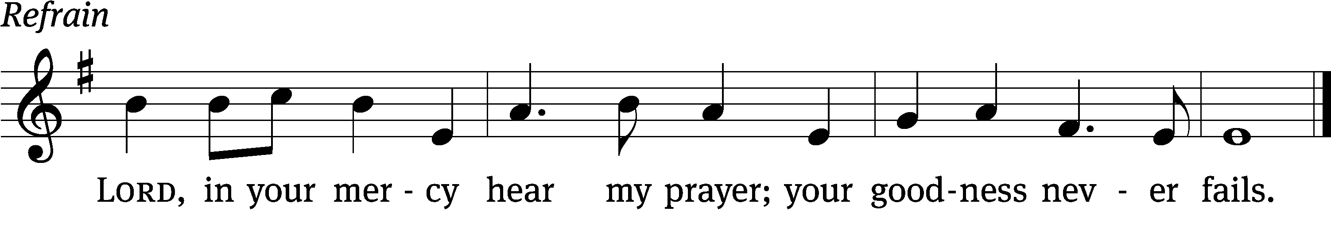

You, Lord, forgave the iniquity of your / people
and covered / all their sins.
You set aside / all your wrath
and turned from your fierce / anger.
Show us your unfailing / love, Lord,
and grant us your sal- / vation. Refrain

I will listen to what God the / Lord says;
he promises peace to his / people.
Surely his salvation is near those who / fear him,
that his glory may dwell / in our land.
Love and faithfulness meet to- / gether;
righteousness and peace kiss each / other.
Glory be to the Father and / to the Son
and to the Holy / Spirit,
as it was in the be- / ginning,
is now, and will be forever. / Amen. Refrain
Text: Hal H. Hopson
Tune: Hal H. Hopson
Text and tune: © 2008 Birnamwood/MorningStar Music Publishers. Used by permission: OneLicense no. 727703
Setting: © 1993 Kermit G. Moldenhauer, admin. Northwestern Publishing House. Used by permission: OneLicense no. 727703

second lesson 1 CORINTHIANS 10:1-13
For I do not want you to be unaware, brothers, that our fathers were all under the cloud and all passed through the sea, ² and they were all baptized into Moses in the cloud and in the sea. ³ They all ate the same spiritual food ⁴ and all drank the same spiritual drink, for they drank from the spiritual rock that accompanied them—and that rock was Christ! ⁵ Nevertheless, God was not pleased with most of them. He had them die in the wilderness.
⁶ Now these things took place as examples to warn us not to desire evil things the way they did. ⁷ Do not become idolaters like some of them—as it is written, “The people sat down to eat and drink, and got up to celebrate wildly.”^{[a]} ⁸ And let us not commit sexual immorality, as some of them did, and in one day twenty-three thousand fell. ⁹ Let us not put Christ to the test, as some of them did, and so were being destroyed by the serpents. ¹⁰ And do not grumble, as some of them grumbled, and were destroyed by the destroyer. ¹¹ All^{[b]} these things that were happening to them had meaning as examples, and they were written down to warn us, to whom the end of the ages has come.
¹² So let him who thinks he stands be careful that he does not fall. ¹³ No testing has overtaken you except ordinary testing. But God is faithful. He will not allow you to be tested beyond your ability, but when he tests you, he will also bring about the outcome that you are able to bear it.
¹⁴ Therefore, my dear friends, flee from idolatry. ¹⁵ I speak to you as to sensible people. Judge for yourselves what I am saying.

Verse of the day

(the alleluias are omitted during lent)

plEASE STAND, if you are able

gospel LUKE 13:1-9
M: The Gospel according to St. Luke chapter 13, verses 1-9
At that time there were some present who told Jesus about the Galileans whose blood Pilate had mixed with their sacrifices. ² He answered them, “Do you think that these Galileans were worse sinners than all the other Galileans because they suffered these things? ³ I tell you, no. But unless you repent, you will all perish too. ⁴ Or those eighteen who were killed when the tower in Siloam fell on them—do you think that they were worse sinners than all the people living in Jerusalem? ⁵ I tell you, no. But unless you repent, you will all perish too.”
⁶ He told them this parable: “A man had a fig tree planted in his vineyard. He came looking for fruit on it, but he did not find any. ⁷ So he said to the gardener, ‘Look, for three years now I have come looking for fruit on this fig tree, and I have found none. Cut it down. Why even let it use up the soil?’ ⁸ But the gardener replied to him, ‘Sir, leave it alone this year also, until I dig around it and put fertilizer on it. ⁹ If it produces fruit next year, fine. But if not, then cut it down.’”
M: This is the Gospel of the Lord.

PLEASE BE SEATED

SERMON HYMN CW #631
Speak, O Savior, I Am Listening CW 631
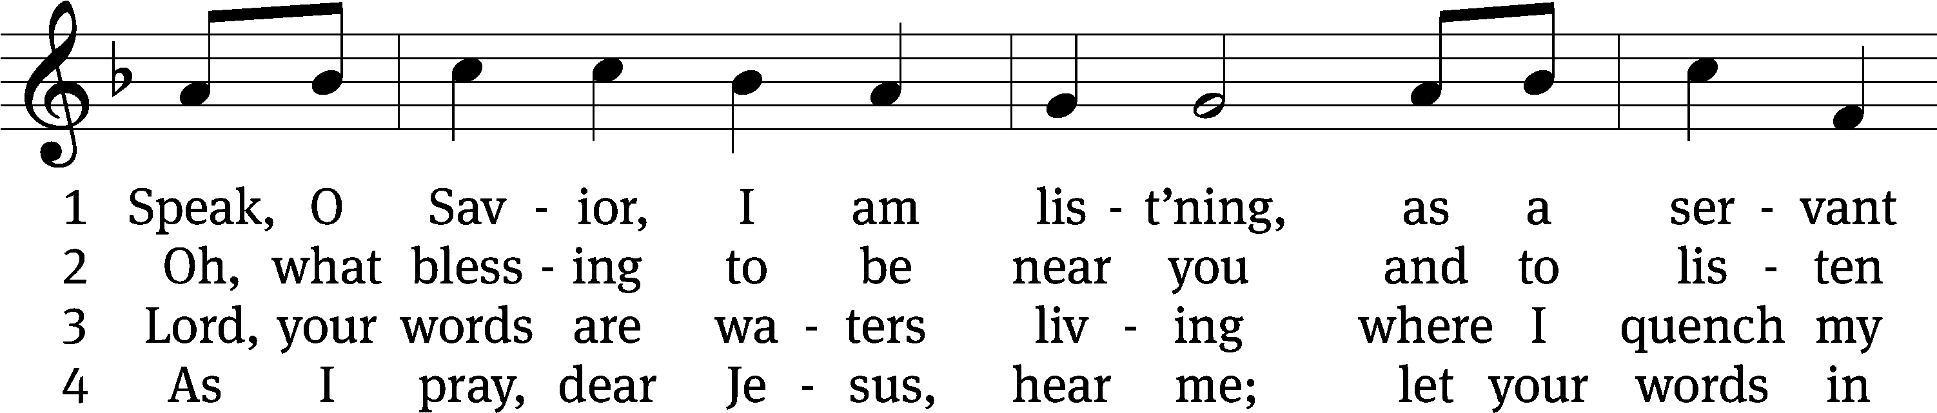
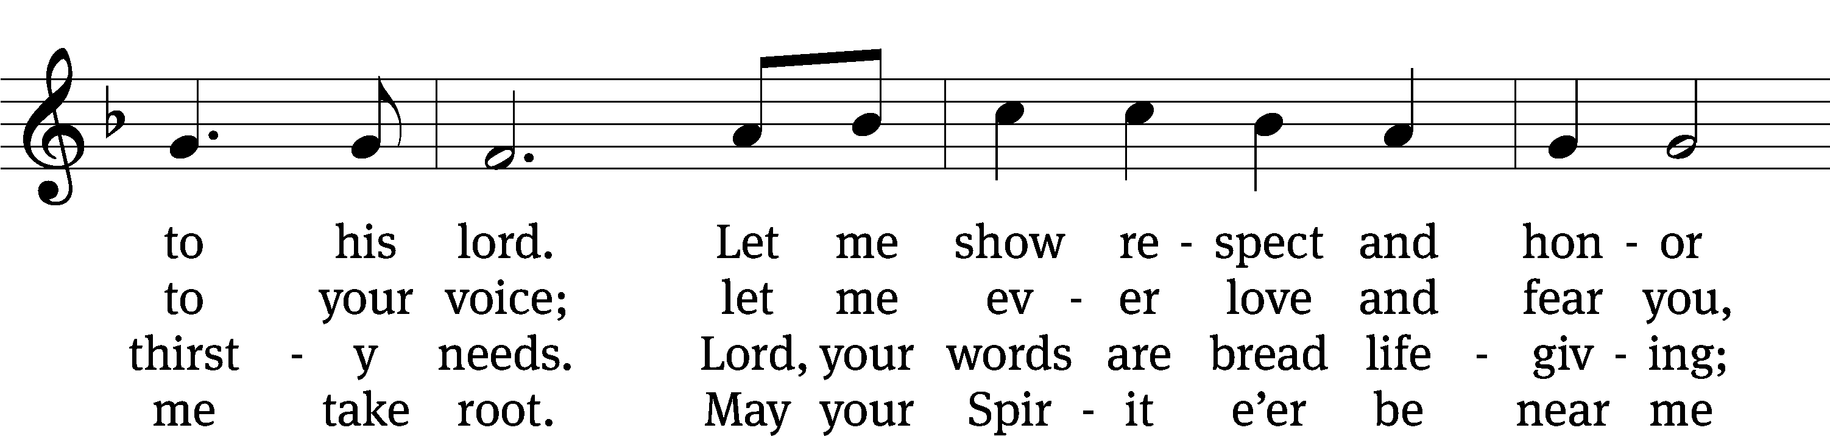
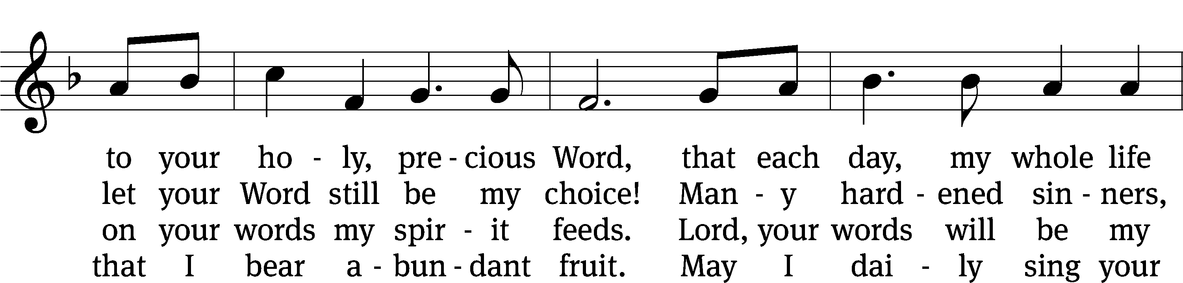
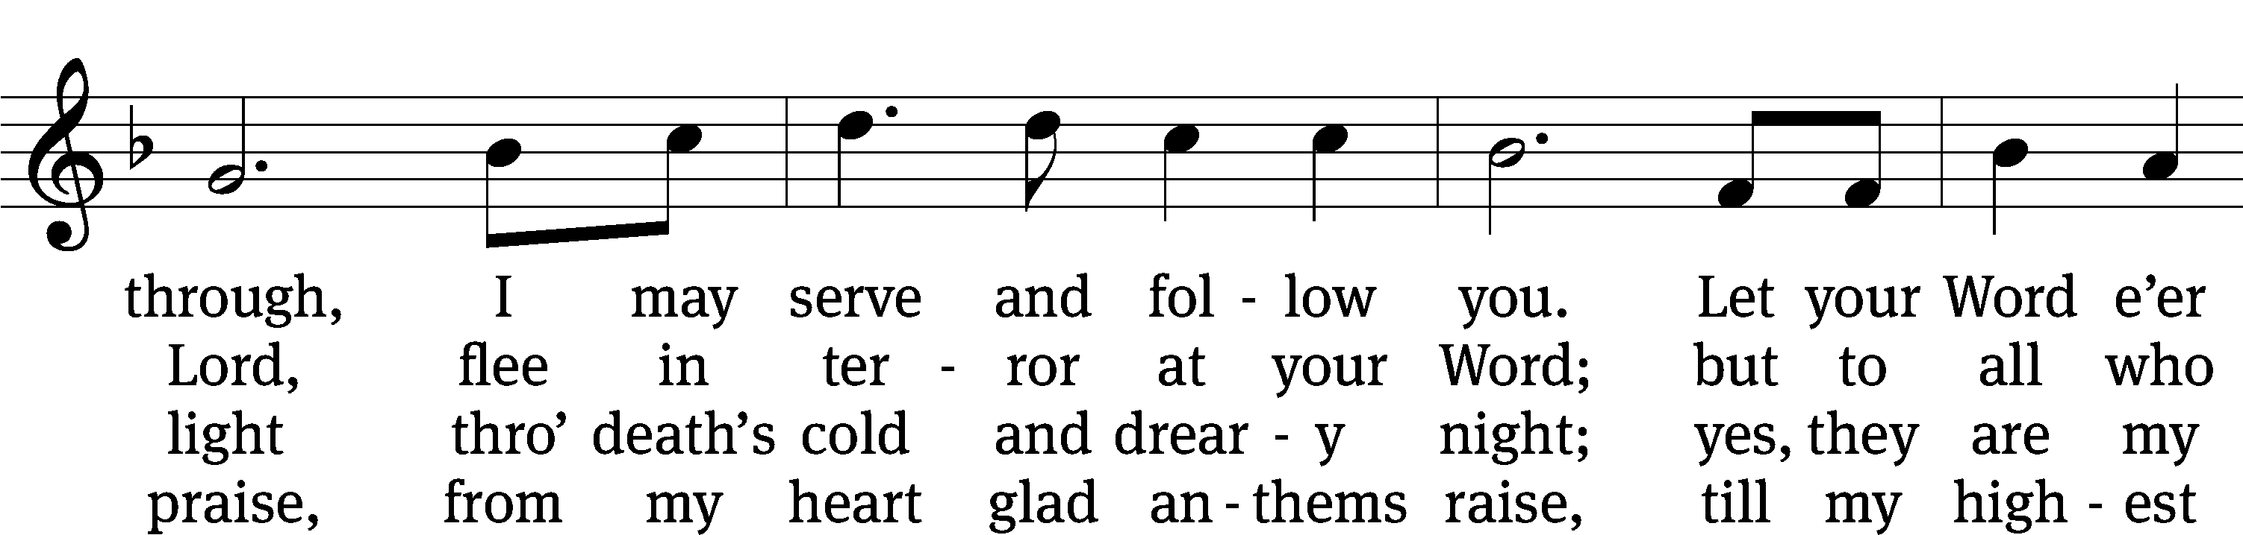
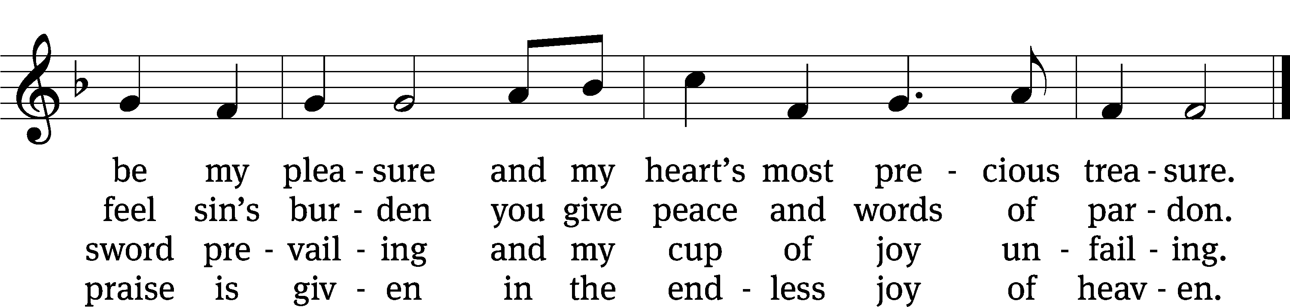
Text: Anna Sophia von Hessen-Darmstadt, 1638–1683; (sts. 1, 4): tr. Christian Worship, 1993; (sts. 2–3): tr. George A. T. Rygh, 1860–1942, alt.
Tune: Johann Schop, c. 1590–1667
Text and tune: Public domain

Sermon EXODUS 3:1-15
“On Holy Ground”

please stand, if you are able

nicene creed
We believe in one God, the Father, the Almighty, maker of heaven and earth, of all that is, seen and unseen.
We believe in one Lord, Jesus Christ, the only Son of God, eternally begotten of the Father, God from God, Light from Light, true God from true God, begotten, not made, of one being with the Father. Through him all things were made. For us and for our salvation, he came down from heaven, was incarnate of the Holy Spirit and the virgin Mary, and became truly human. For our sake he was crucified under Pontius Pilate. He suffered death and was buried. On the third day he rose again in accordance with the Scriptures. He ascended into heaven and is seated at the right hand of the Father. He will come again in glory to judge the living and the dead, and his kingdom will have no end.
We believe in the Holy Spirit, the Lord, the giver of life, who proceeds from the Father and the Son, who in unity with the Father and the Son is worshiped and glorified, who has spoken through the prophets. We believe in one holy Christian and apostolic Church. We acknowledge one baptism for the forgiveness of sins. We look for the resurrection of the dead and the life of the world to come. Amen.

PLEASE BE SEATED

offertory (bell choir – 8:30 a.m.) “Lenten Prayer”

PLEASE STAND, IF YOU ARE ABLE

prayer of the church prayer of the church

lord’s prayer

C: Our Father, who art in heaven,
hallowed be thy name,
thy kingdom come,
thy will be done
on earth as it is in heaven.
Give us this day our daily bread;
and forgive us our trespasses,
as we forgive those
who trespass against us;
and lead us not into temptation,
but deliver us from evil.
For thine is the kingdom
and the power and the glory
forever and ever. Amen.

The Sacrament of Holy Communion
Trinity Lutheran Church follows the historic Christian practice of close communion. We ask that only members of Trinity or one of our sister congregations partake of the sacrament. If you are not a member, please see the note about Holy Communion in the beginning of the Worship Folder.

M: The Lord be with you.

M: Lift up your hearts.

M: Let us give thanks to the Lord our God.

M: Praise to the God and Father of our Lord Jesus Christ! In love he has blessed us with every spiritual blessing. He made his Son to be the atoning sacrifice for our sins, and not only for ours, but also for the sins of the whole world. Now have come the salvation and the power and the kingdom of our God and the authority of his Christ. To him who sits on the throne and to the Lamb be praise and thanks and honor and glory for ever and ever:

Holy, Holy, Holy

Words of institution
M: Our Lord Jesus Christ, on the night he was betrayed, took bread; and when he had given thanks, he broke it and gave it to his disciples, saying: “Take and eat. This is my ✙ body, which is given for you. Do this in remembrance of me.”
Then he took the cup, gave thanks, and gave it to them, saying, “Drink from it all of you; this is my ✙ blood of the new covenant, which is poured out for you for the forgiveness of sins. Do this, whenever you drink it, in remembrance of me.”
The peace of the Lord be with you always.

O CHRIST, LAMB OF GOD

DISTRIBUTION HYMNS
662 Draw Near CW 662
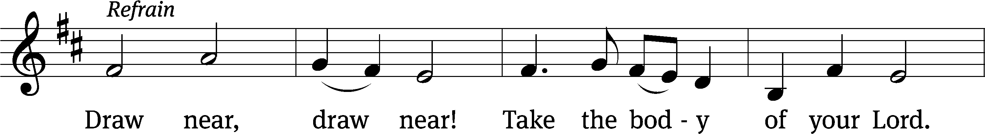
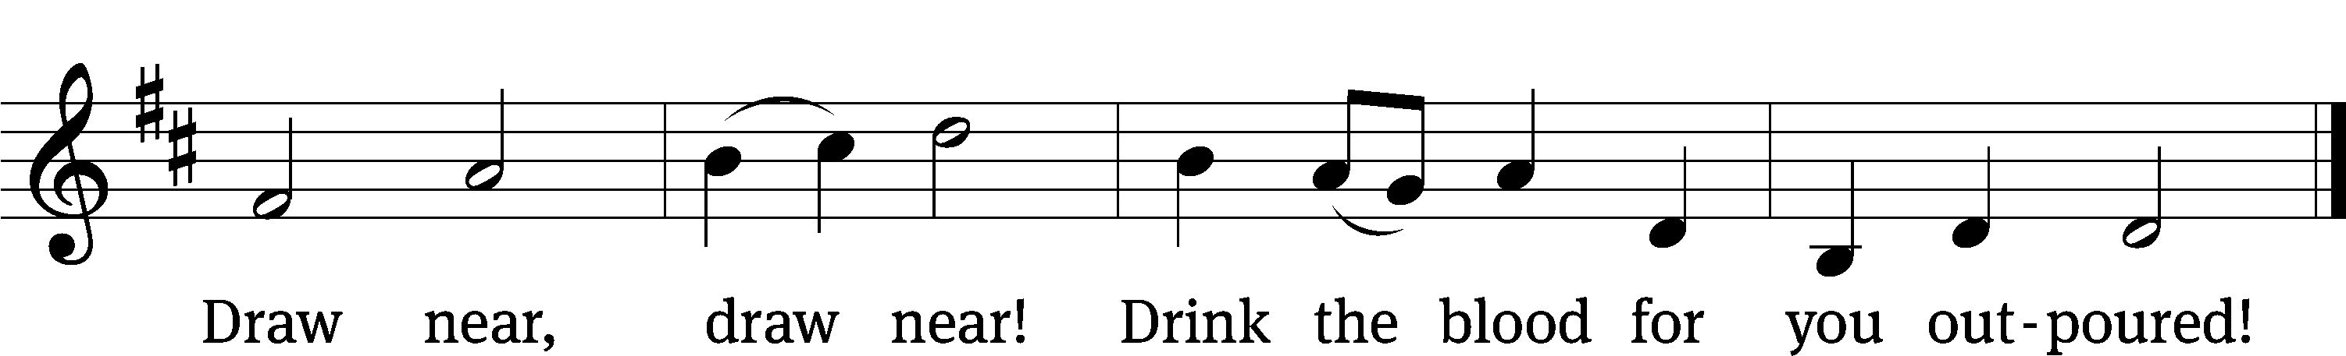
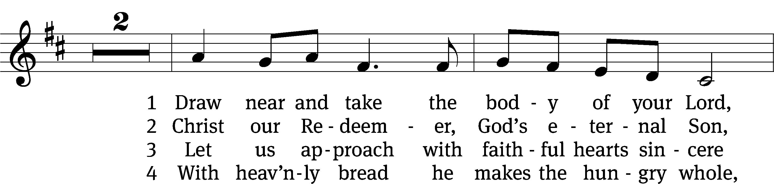
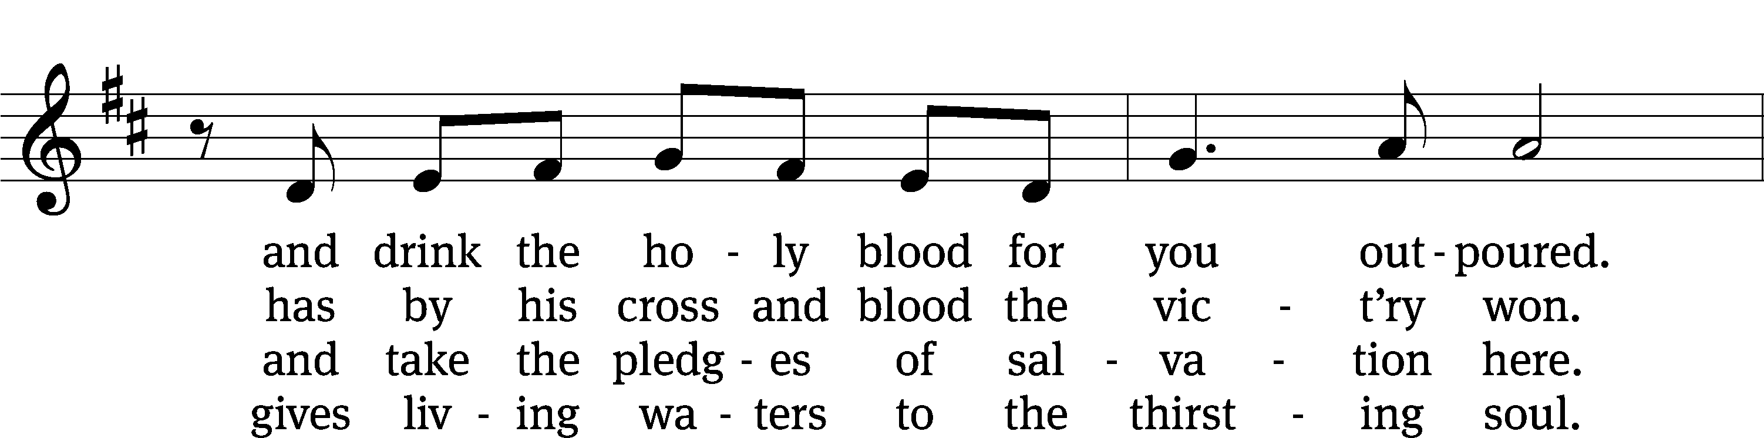
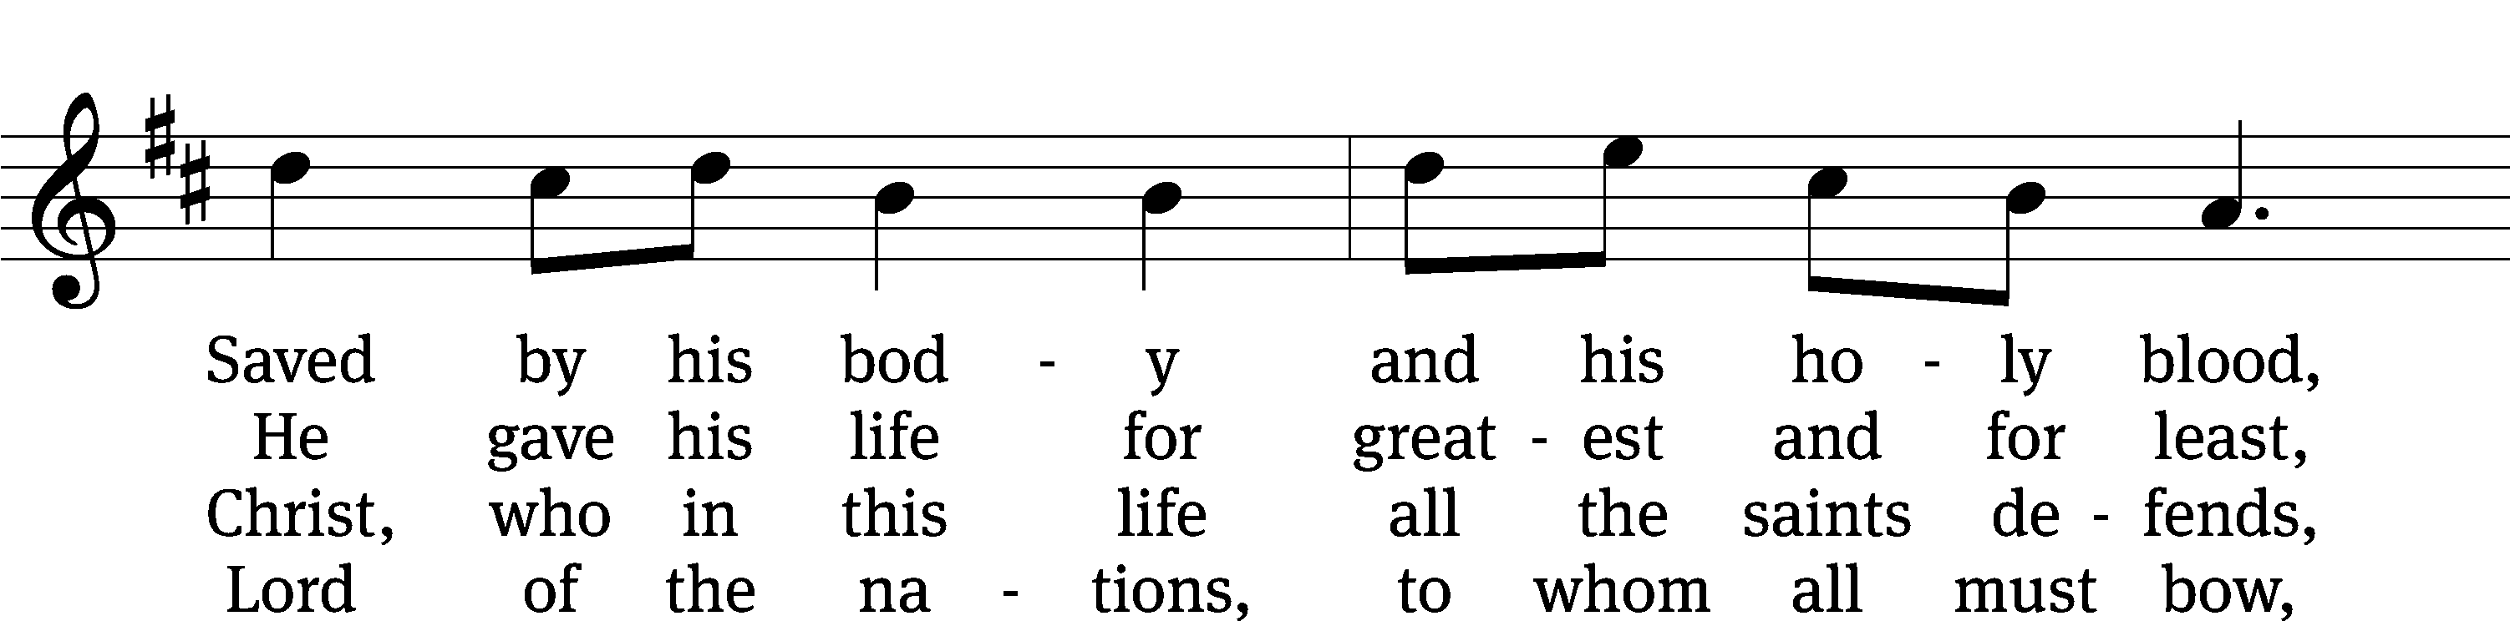
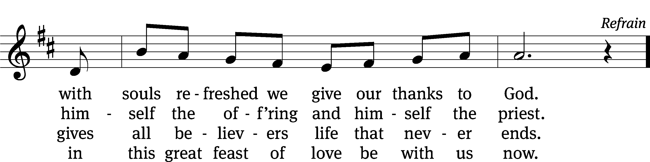

Text: tr. John Mason Neale, 1818–1866, alt.; Latin, 7th cent., abr.
Tune: Steven R. Janco, b. 1961
Text: Public domain
Tune: © 1992 World Library Publications, a division of GIA Publications, Inc. Used by permission: OneLicense no. 727703

661 Draw Near and Take the Body of the Lord CW 661
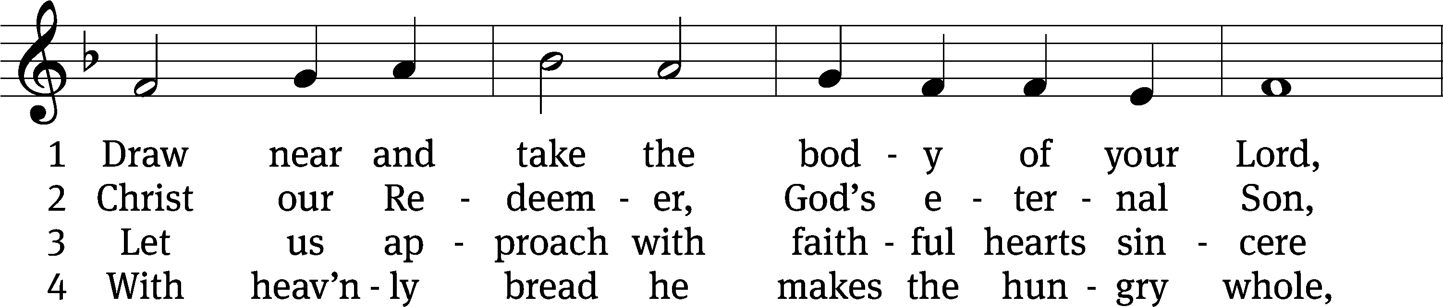
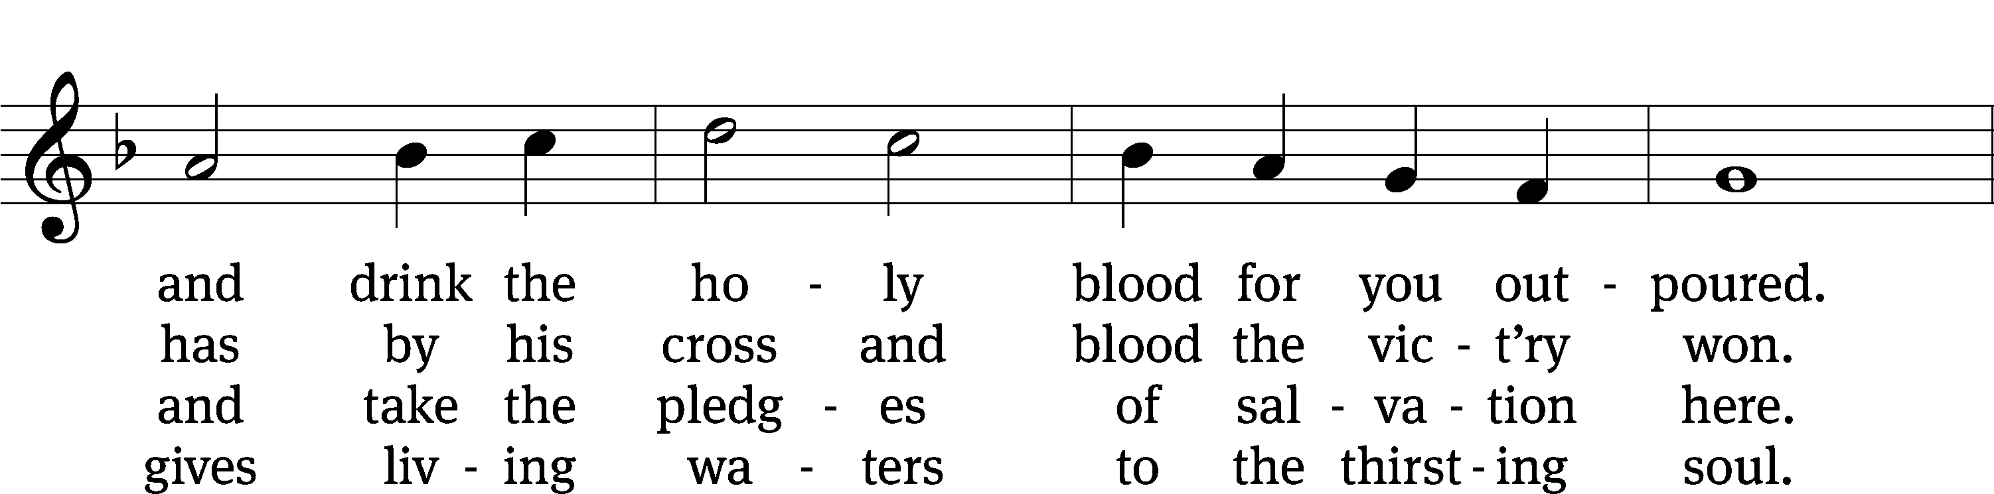
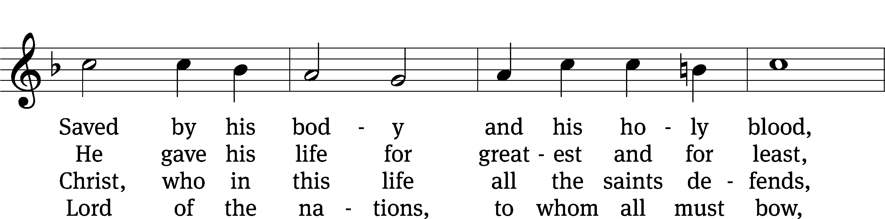
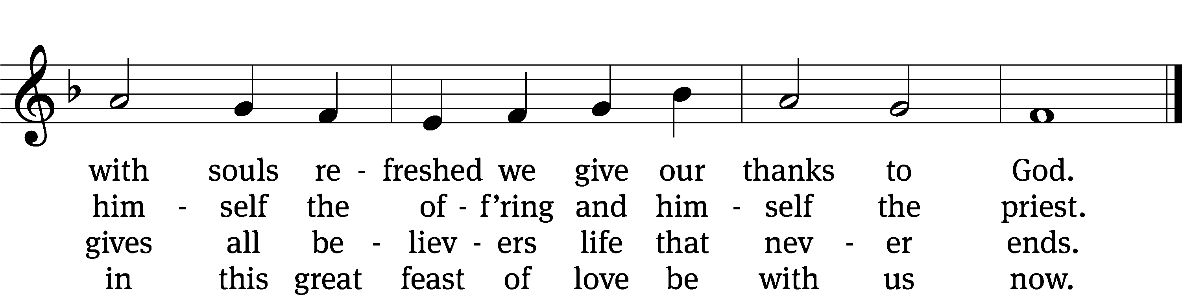
Text: tr. John Mason Neale, 1818–1866, alt.; Latin, 7th cent., abr.
Tune: Trente quatre Pseaumes de David, Geneva, 1551, ed. Louis Bourgeois
Text and tune: Public domain

THANKSGIVING

(THANK THE LORD is omitted during Lent)

PLEASE STAND, IF YOU ARE ABLE

M: Hear the prayer of your people, O Lord, that the lips which have praised you here may glorify you in the world, that the eyes which have seen the coming of your Son may long for his coming again, and that all who have received in his true body and blood the pledge of your forgiveness may be restored to live a new and holy life, through Jesus Christ, our Lord, who lives and reigns with you and the Holy Spirit, one God, now and forever.

M: Brothers and sisters, go in peace. Live in harmony with one another.
Serve the Lord with gladness.

The Lord bless you and keep you.
The Lord make his face shine on you and be gracious to you.
The Lord look on you with favor and (+) give you peace.

CLOSING HYMN CW #932

932 Sent Forth by God’s Blessing CW 932
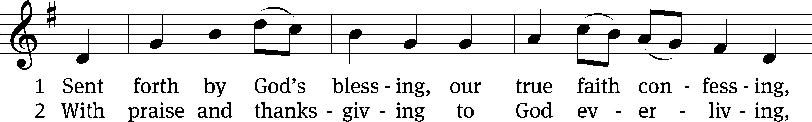
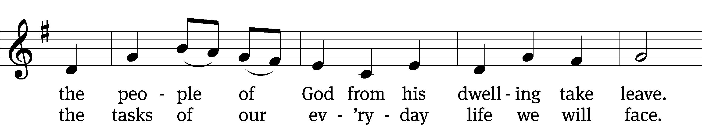
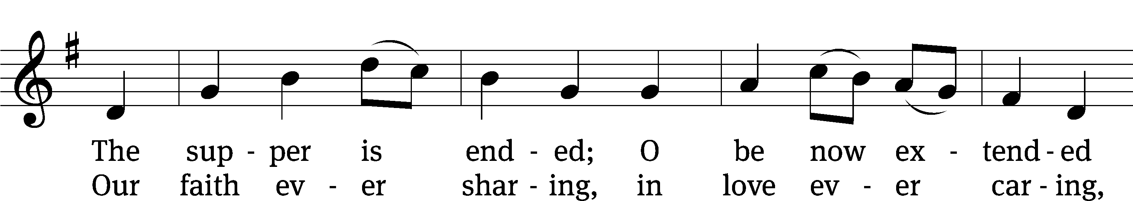
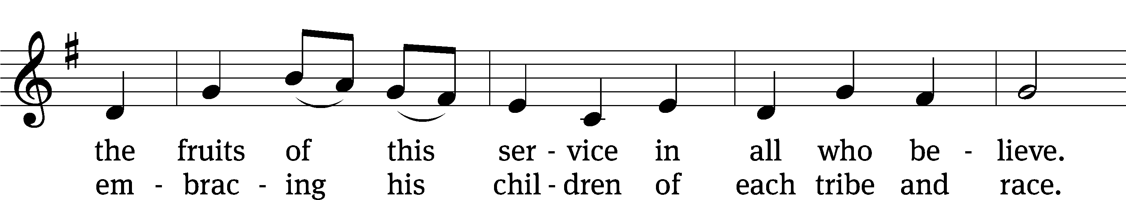
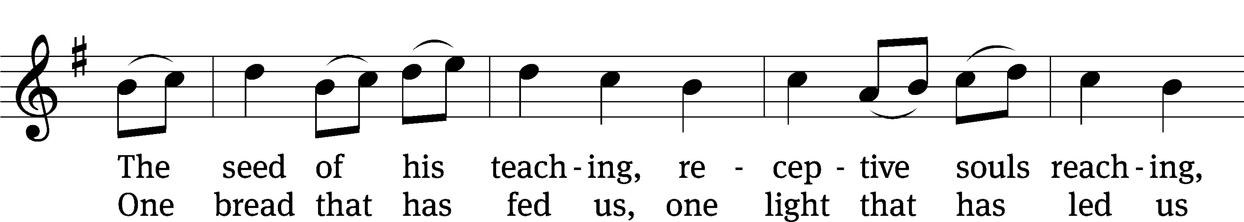
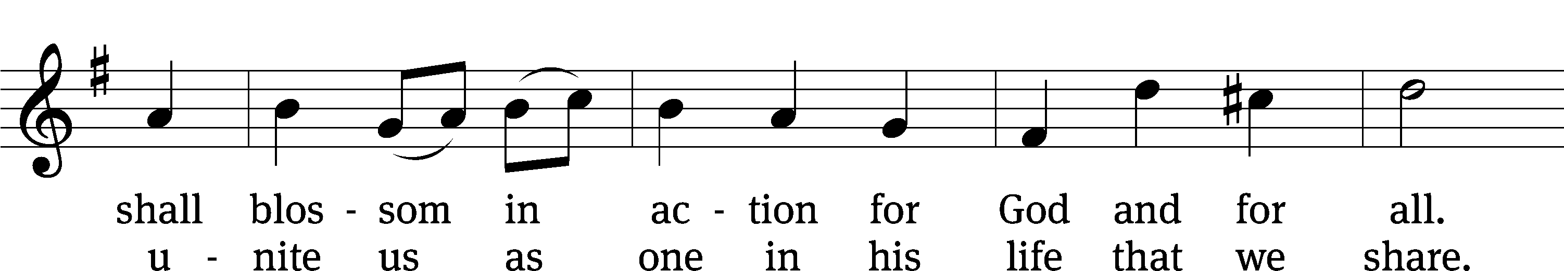
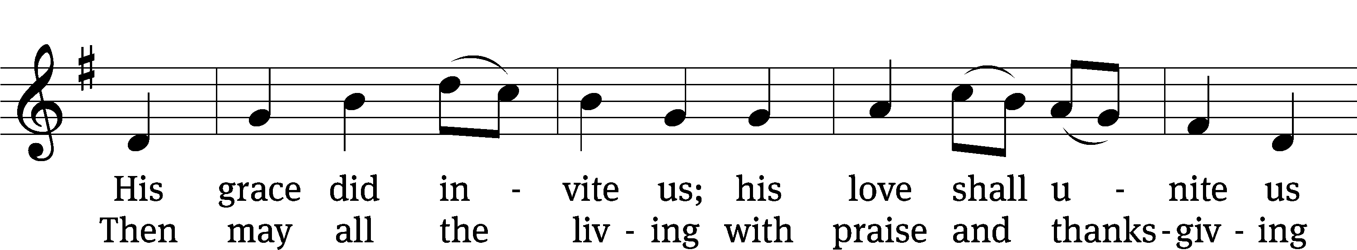
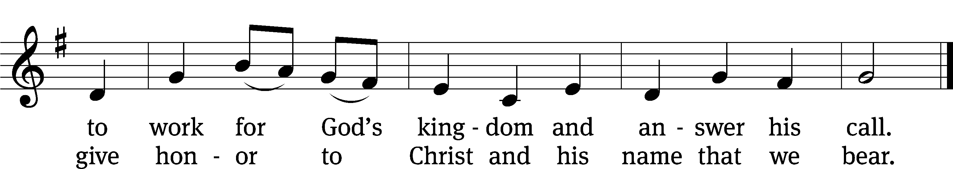
Text: Omer Westendorf, 1916–1997, alt.
Tune: Welsh
Text: © 1964 World Library Publications, a division of GIA Publications, Inc. Used by permission: OneLicense no. 727703
Tune: Public domain

Serving In Worship

Officiant Pastor Natsis
Organist Emily Wheeler
Deacons (8:30) Jim Tice and Ed Wheeler
(11:00) Dave Frey and Jeff Neuburger
Ushers (8:30) Robert Newman and Henry Schneider
(11:00) Bill Barnett and Jake Vershum
Altar Guild Shirley Klumpp and Ann Latowski
Videographer Ann Latowski

Copyright information
Service of Word and Sacrament: Christian Worship. © 1993 Northwestern Publishing House. All rights reserved. Reprinted under ONE LICENSE #A-727703 and CCLI #1151741/ CSPL126093
Words and Music: All rights reserved. Reprinted/Podcast/Streamed with permission under ONE LICENSE #A-727703 and CCLI #1151741/CSPL126093

