The fifth sunday
in lent

TRINITY EVANGELICAL LUTHERAN CHURCH | Saline, Michigan
WELCOME TO WORSHIP March 26, 2023
Thank you for joining us in God’s house today! We cordially ask that our Guests sign one of the guestbooks located at either the front or back entryways, or fill out a “Let’s Get Acquainted” card located in the hymnal pew rack and place it in the collection plate.

THANK OFFERING: Members of Trinity give their offering as an expression of love and thankfulness to the Lord and to help support the Lord’s work in our community and around the world. Visitors need not feel obligated to participate in this offering which supports our ministry.

Restrooms are located at the back of the upper level (the annex), and in the basement (down the back stairs of the sanctuary or annex). Handicap access is available, please ask an usher for assistance.

Young Families / Toddler Bags – We are GLAD YOU BROUGHT YOUR CHILDREN to our worship service. Jesus said: “Let the little children come to me and do not hinder them, for the kingdom of God belongs to such as these.” We know that having little children in church can be a challenge, but DO NOT WORRY about it. Many of your fellow worshippers have been in your shoes and are just happy you brought your children with you. For your convenience, we have reserved the back rows of seating for parents with small children. These areas provide more flexibility for your family, as well as, easy access to move downstairs if necessary. A closed-circuit TV system allows families to continue participating in the service while downstairs. Pre-school toddler bags and children’s bulletins are available for their enjoyment. Ask an usher for one to use during the service and please return the toddler bag afterwards.

the SERVICE – setting one - WITHOUT HOLY COMMUNION CW, page 154

704 Let Us Ever Walk with Jesus CW 704
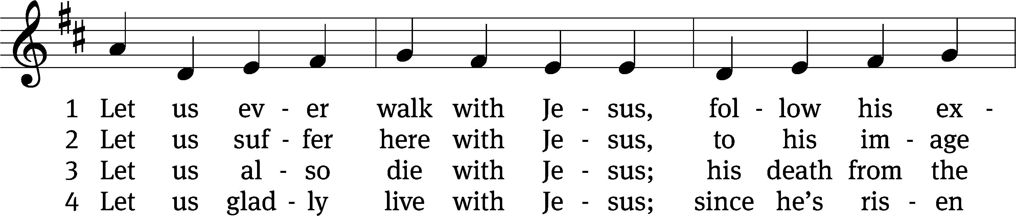
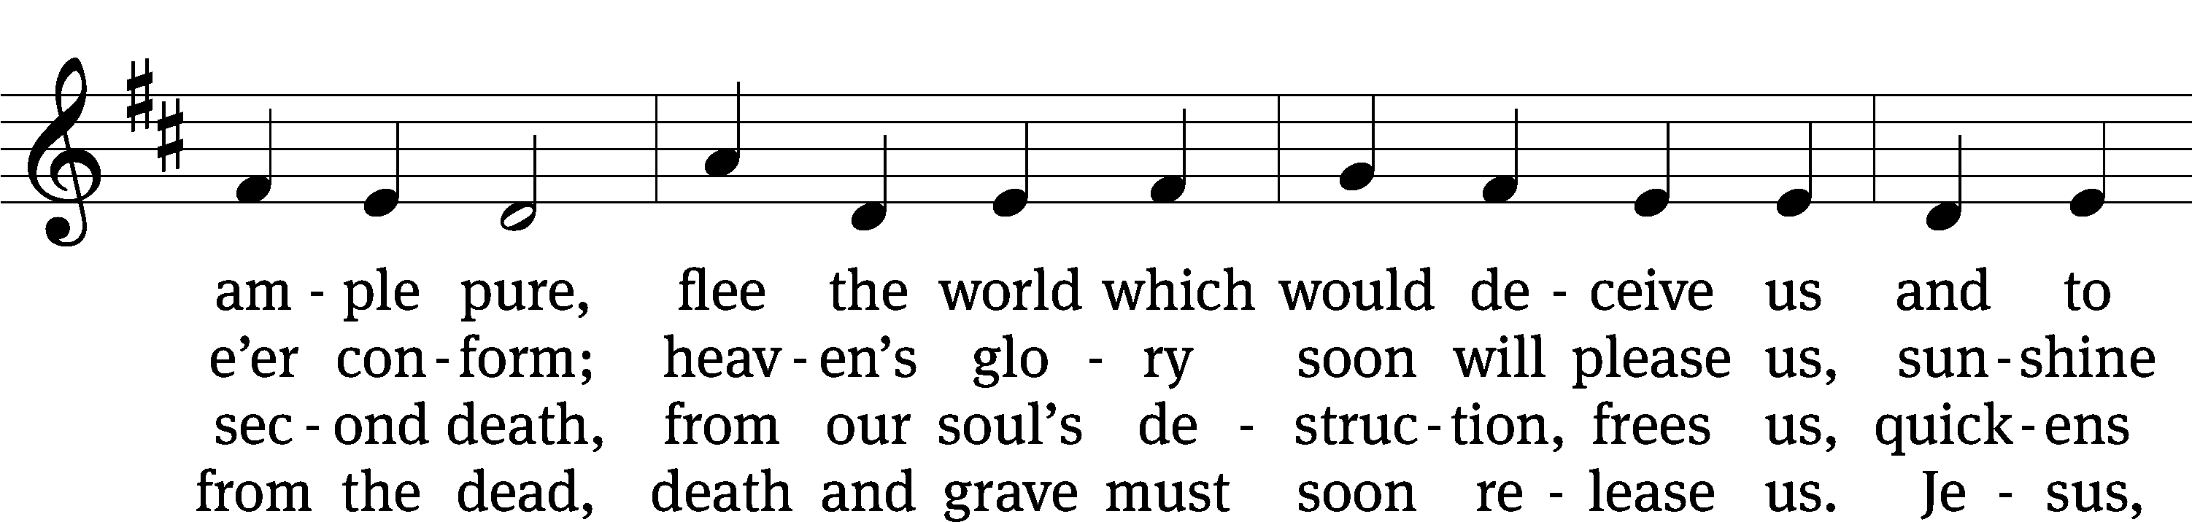
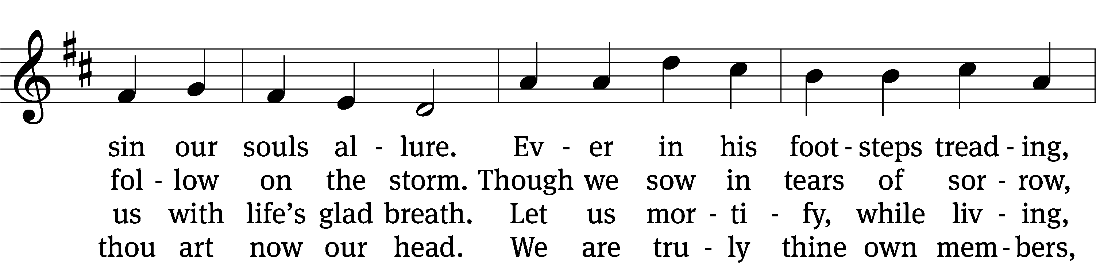
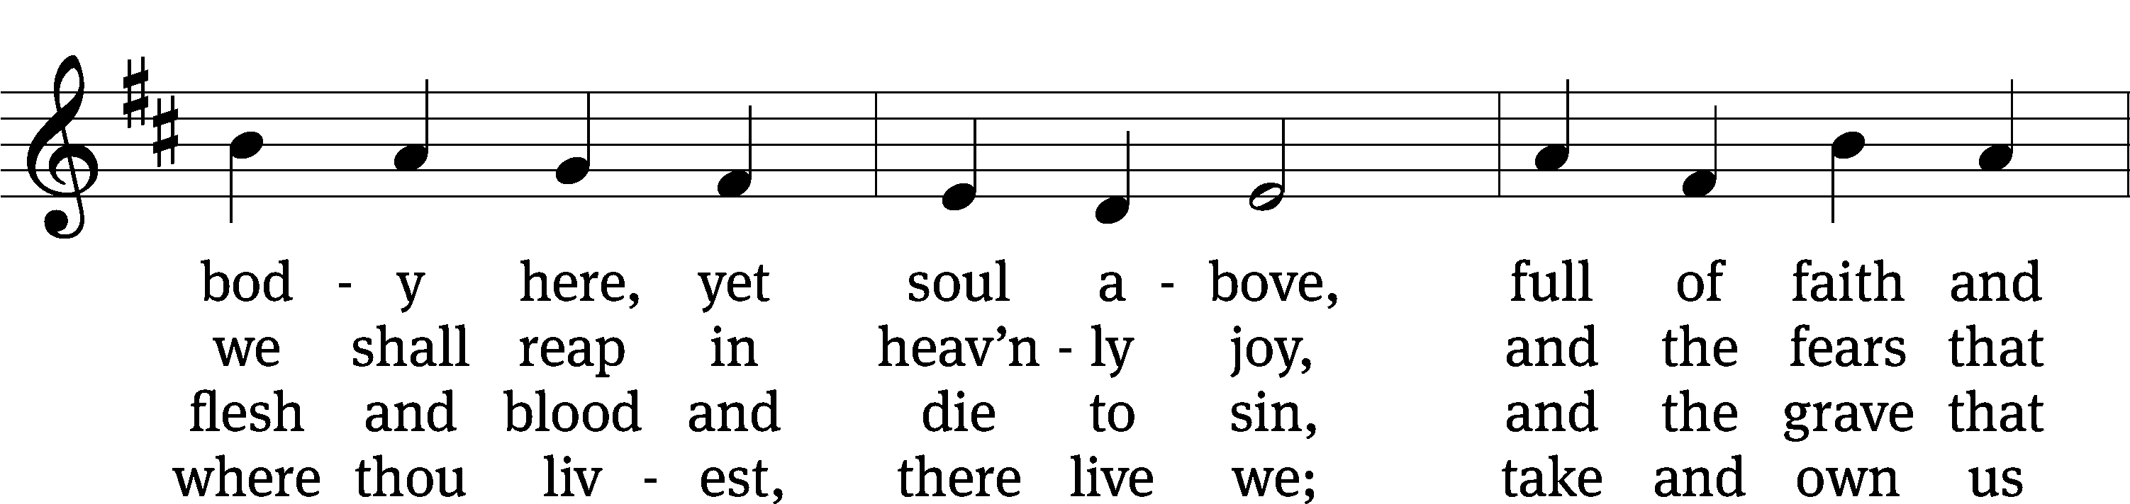
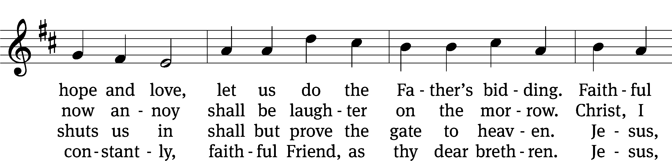
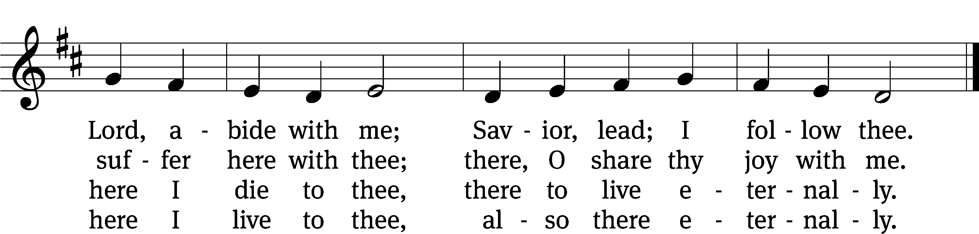
Text: tr. J. Adam Rimbach, 1871–1941, alt.; Sigmund von Birken, 1626–1681
Tune: Georg G. Boltze, 18th cent.
Text and tune: Public domain

Please stand, if you are able
Invocation
In the name of the Father and of the Son and of the Holy Spirit.
Amen.
Confession
If we claim to be without sin, we deceive ourselves and the truth is not in us.
If we confess our sins, God is faithful and just
and will forgive us our sins
and purify us from all unrighteousness.

Let us confess our sins to the Lord.
Holy God, gracious Father,
I am sinful by nature
and have sinned against you in my thoughts, words, and actions.
I have not loved you with my whole heart;
I have not loved others as I should.
I deserve your punishment both now and forever.
But Jesus, my Savior, paid for my sins
with his innocent suffering and death.
Trusting in him, I pray: God, have mercy on me, a sinner.

Our gracious Father in heaven has been merciful to us. He sent his only Son, Jesus Christ, who gave his life as the atoning sacrifice for the sins of the whole world. Therefore, as a called servant of Christ and by his authority, I forgive you all your sins in the name of the Father and of the the Son and of the Holy Spirit.
Amen.

Lord, Have Mercy
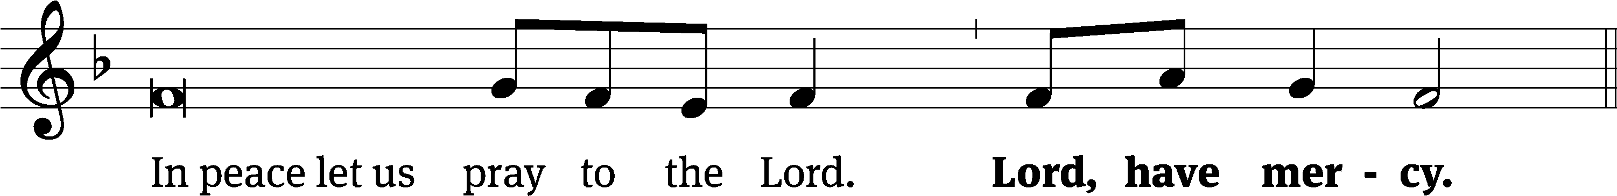
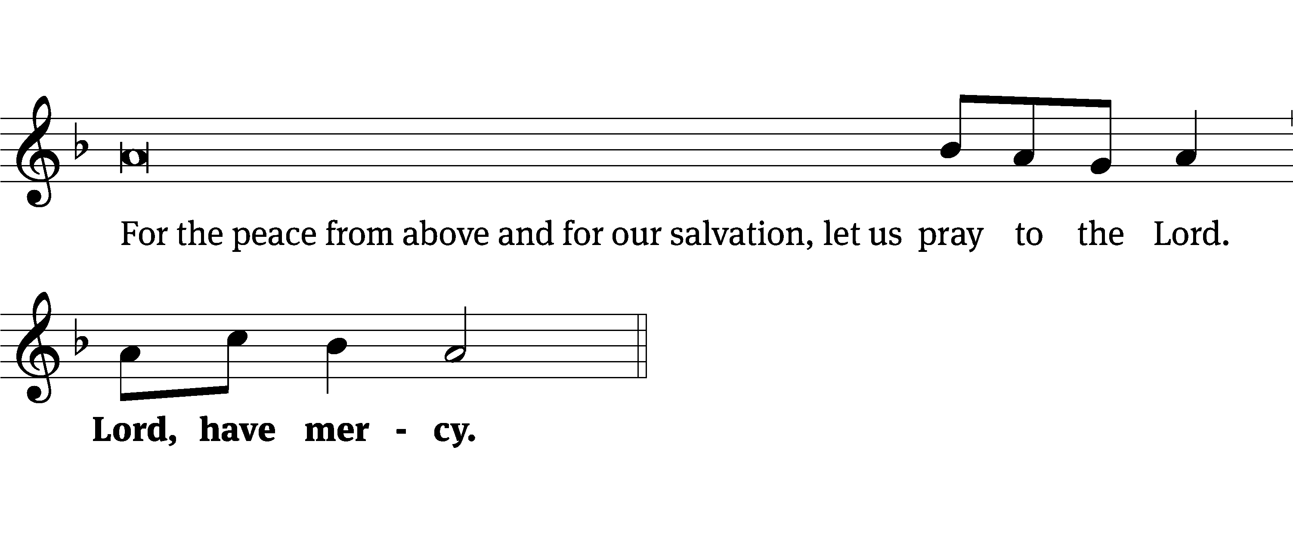
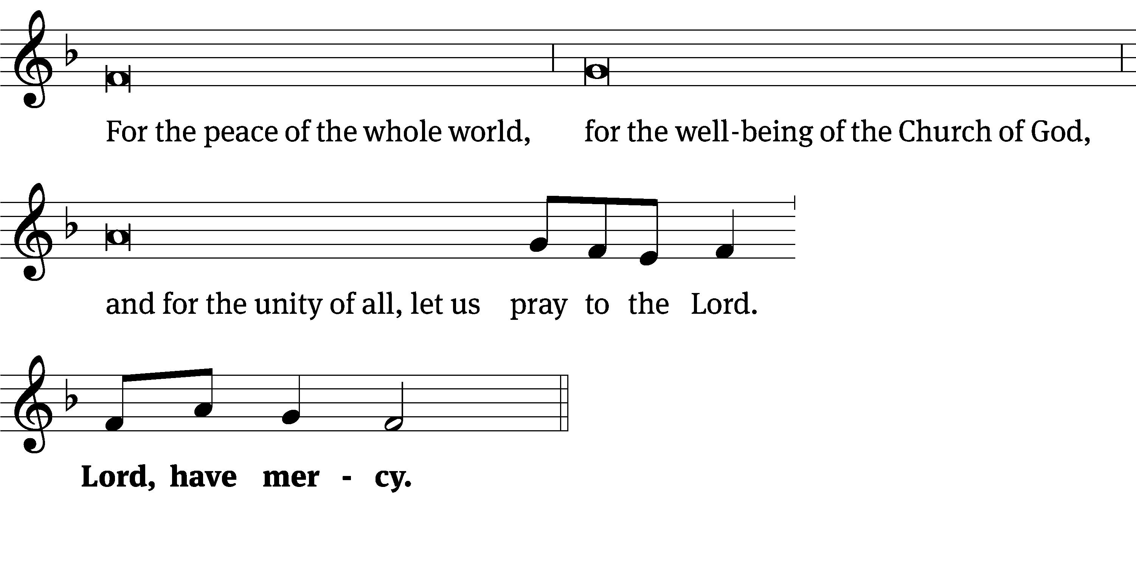
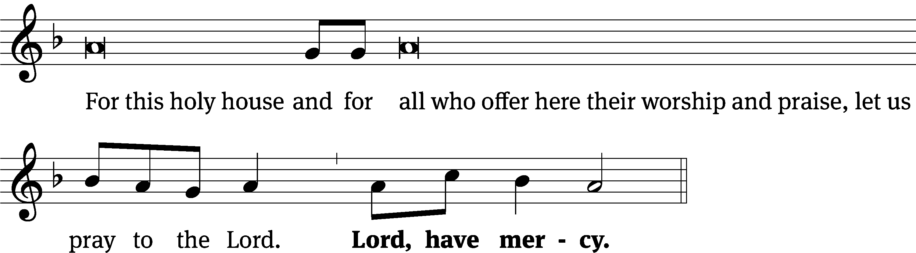
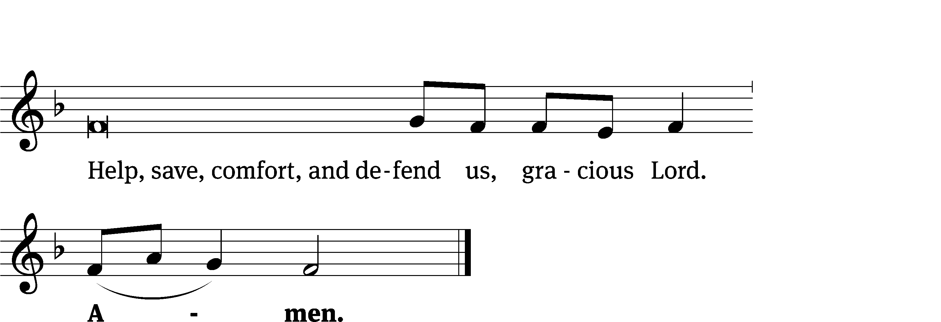
Tune: Kevin Becker
Tune: © 2021 Northwestern Publishing House. Used by permission: OneLicense no. 727703

Glory Be to God CW 157
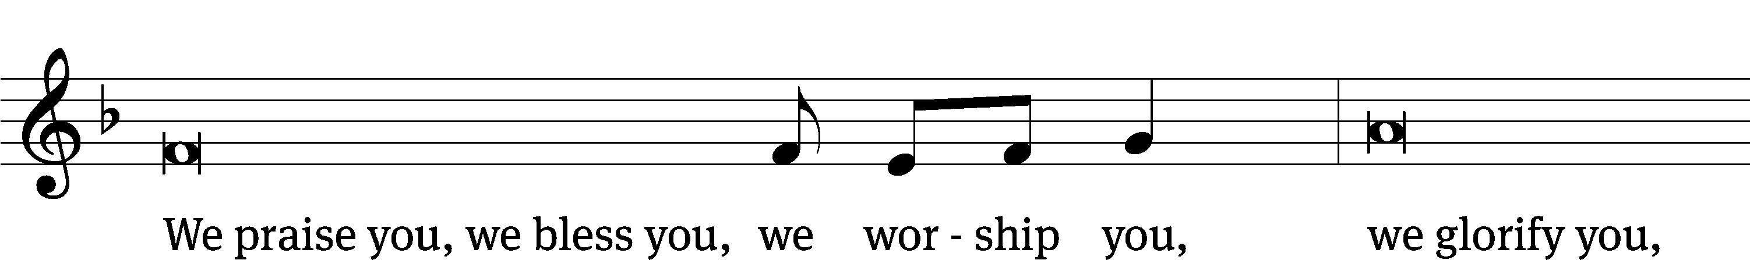
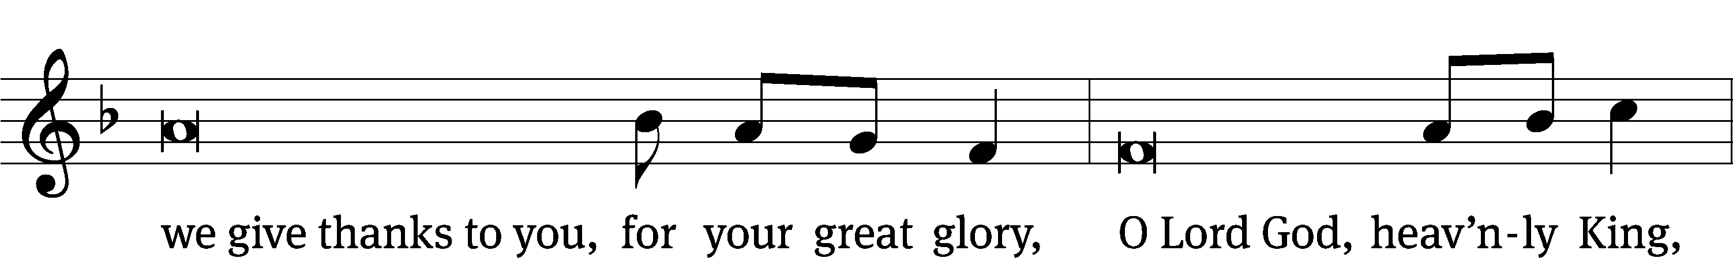
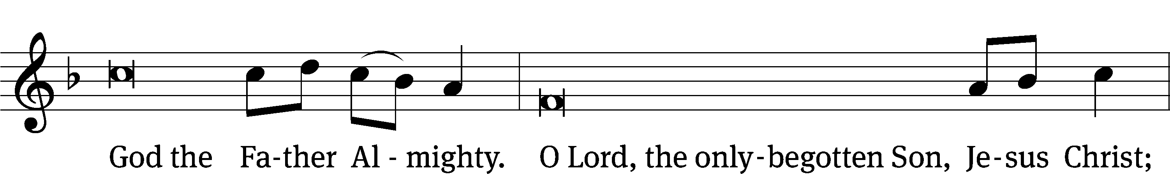
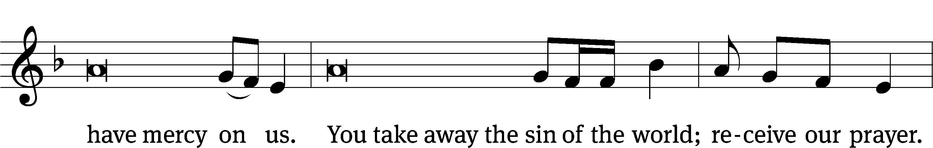
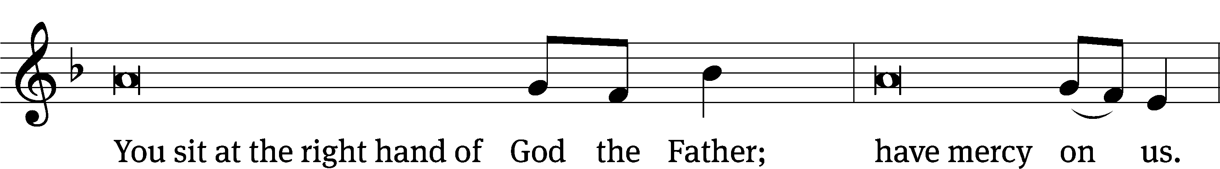
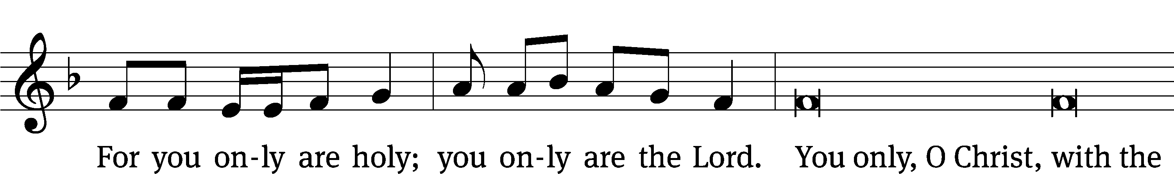
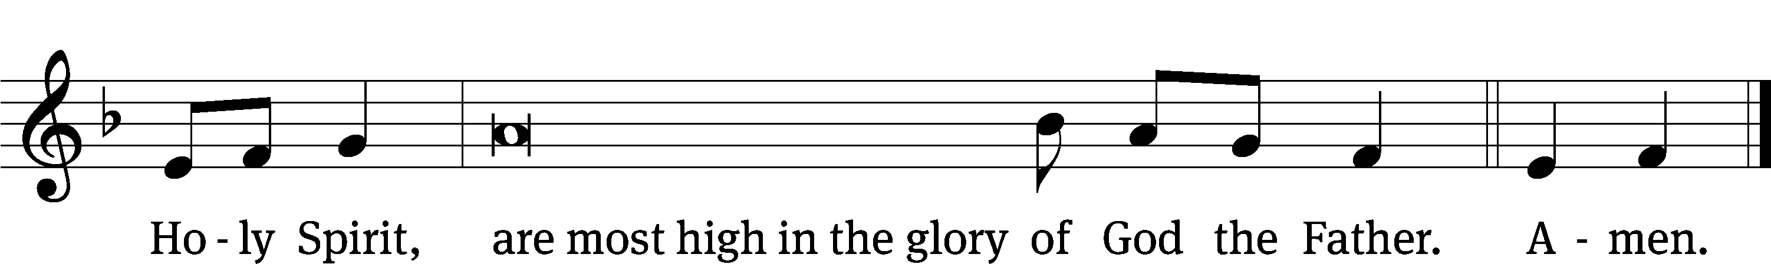

Tune: © 2021 Northwestern Publishing House. Used by permission: OneLicense no. 727703

The Lord be with you.
And also with you.
Prayer of the Day
Let us pray.

Eternal God and Father, help us to remember Jesus, who obeyed your will and bore the cross for our salvation, that through his anguish, pain, and death we may receive the forgiveness of sins, victory over the grave, and finally inherit eternal life; through your Son, Jesus Christ our Lord, who lives and reigns with you and the Holy Spirit, one God, now and forever.
Amen.

Please be seated

First Reading 2 Kings 4:17-37
¹⁷ The woman conceived, and she gave birth to a son at that same time of year, just as Elisha said to her.
¹⁸ The boy grew up, and one day he went out to his father, who was with the reapers. ¹⁹ Then he said to his father, “My head! My head!”
His father said to his servant, “Carry him to his mother.” ²⁰ So he picked him up and carried him to his mother, and the boy sat on her lap until noon. Then he died.
²¹ Then she went up and laid him on the bed of the man of God. She shut the door behind her and went out. ²² Then she called to her husband and said, “Send one of the servants to me with one of the donkeys, so that I can run to the man of God and come back.”
²³ He said, “Why are you going to him today? It’s not the new moon, and it’s not the Sabbath.”
But she said, “It’s all right.”
²⁴ Then she saddled the donkey and said to her servant, “Lead the way. Don’t slow down for me unless I tell you.”
²⁵ So she went to the man of God at Mount Carmel.
When the man of God saw her from a distance, he said to his servant Gehazi, “Look! That’s the woman from Shunem! ²⁶ Now run to meet her and say, ‘Are you all right? Is your husband all right? Is your son all right?’”
She answered, “We’re all right.”
²⁷ Then she came to the man of God at the mountain, and she grasped his feet. Gehazi stepped forward to push her away, but the man of God said, “Leave her alone, for her soul is in distress, but the Lord has hidden it from me. He has not told me.”
²⁸ Then she said, “Did I ask my lord for a son? Didn’t I say, ‘Don’t give me false hope’?”
²⁹ Then Elisha said to Gehazi, “Hike up your garments for travel, and take my staff in your hand and go! If you meet someone, do not greet him, and if someone greets you, do not answer. Put my staff on the boy’s face.”
³⁰ But the boy’s mother said, “As surely as the Lord lives and your soul lives, I will not leave you.” So he got up and followed her. ³¹ Gehazi went ahead of them and put the staff on the boy’s face. But there was no sound, and there was no response. So he went back to Elisha and told him, “The boy did not wake up.”
³² When Elisha came to the house, there the boy was—dead, lying on his bed. ³³ So he went in and he shut the door behind the two of them. Then he prayed to the Lord. ³⁴ He got up and lay down on top of the boy. He put his mouth to the boy’s mouth, his eyes to the boy’s eyes, his palms to the boy’s palms. Then he bent down over him, and the boy’s flesh became warm. ³⁵ He went back into the house and paced back and forth. Then he went up and bent down over him, and the boy sneezed seven times. Then the boy opened his eyes.
³⁶ Then Elisha called Gehazi and said, “Call the woman of Shunem!” So he called her, and she came in. He said, “Pick up your son.” ³⁷ So she came in and fell at Elisha’s feet and bowed down to the ground. Then she picked up her son and went out.

The Word of the Lord.
Thanks be to God.

Duet – “I Want to Walk with Jesus”

Second Reading Romans 8:11-19
¹¹ And if the Spirit of the one who raised Jesus from the dead dwells in you, the one who raised Christ from the dead will also make your mortal bodies alive through his Spirit, who is dwelling in you.
¹² So then, brothers, we do not owe it to the sinful flesh to live in harmony with it. ¹³ For if you live in harmony with the sinful flesh, you are going to die. But if by the Spirit you put to death the actions of the body, you will live.
¹⁴ Indeed, those who are led by the Spirit of God are sons of God. ¹⁵ For you did not receive a spirit of slavery so that you are afraid again, but you received the Spirit of adoption by whom^{[a]} we call out, “Abba, Father!” ¹⁶ The Spirit himself joins our spirit in testifying that we are God’s children.
¹⁷ Now if we are children, we are also heirs—heirs of God and fellow heirs with Christ, since we suffer with him, so that we may also be glorified with him.
¹⁸ For I conclude that our sufferings at the present time are not worth comparing with the glory that is going to be revealed to us. ¹⁹ In fact, creation is waiting with eager longing for the sons of God to be revealed.
The Word of the Lord.
Thanks be to God.
Please stand, if you are able
Gospel Acclamation John 11:25
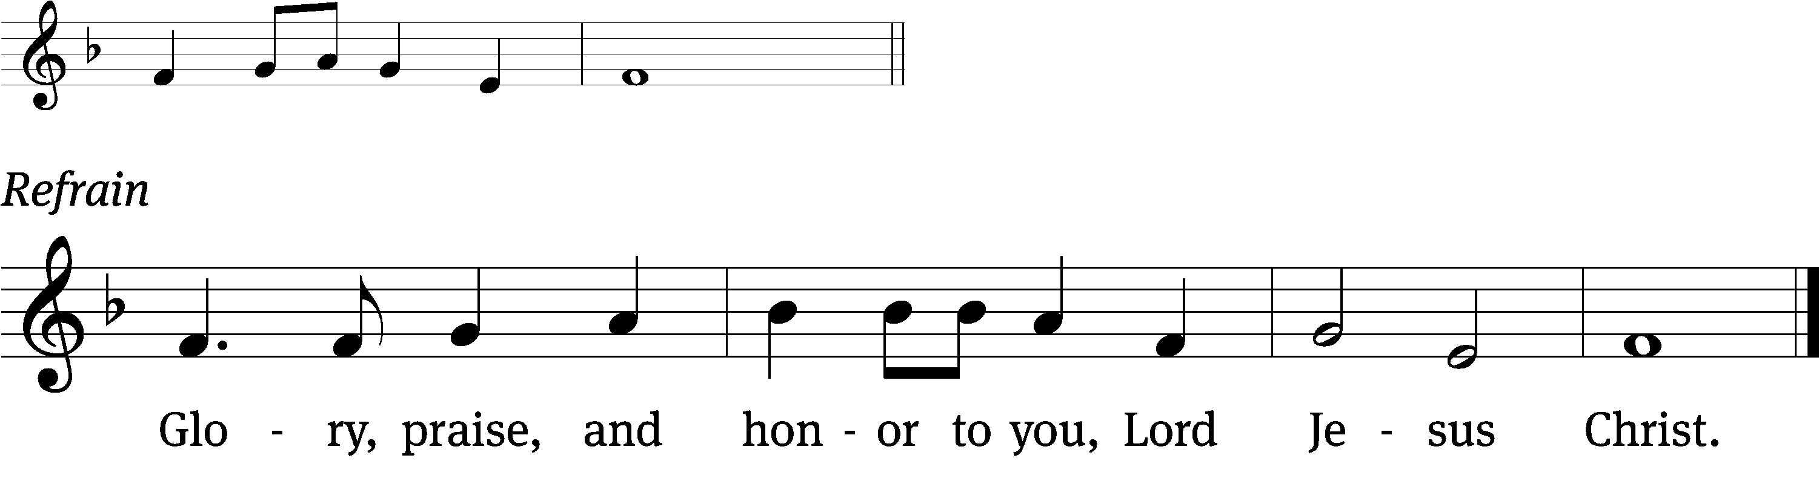
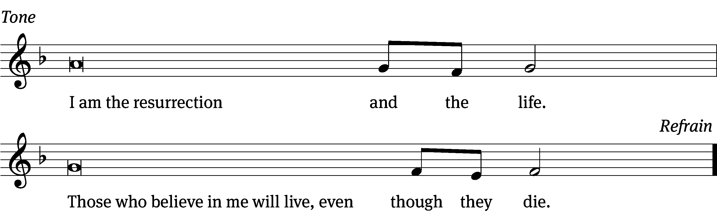
Tune: © 2021 Northwestern Publishing House. Used by permission: OneLicense no. 727703

Gospel John 11:17-27, 38-53
¹⁷ When Jesus arrived [at Bethany], he found that Lazarus had already been in the tomb for four days. ¹⁸ Bethany was near Jerusalem, about two miles away. ¹⁹ Many Jews had come to Martha and Mary to comfort them concerning their brother. ²⁰ When Martha heard that Jesus was coming, she went to meet him, while Mary was sitting in the house. ²¹ Martha said to Jesus, “Lord, if you had been here, my brother would not have died. ²² But even now I know that whatever you ask from God, God will give you.”
²³ Jesus said to her, “Your brother will rise again.”
²⁴ Martha replied, “I know that he will rise in the resurrection on the Last Day.”
²⁵ Jesus said to her, “I am the resurrection and the life. Whoever believes in me will live, even if he dies. ²⁶ And whoever lives and believes in me will never perish. Do you believe this?”
²⁷ “Yes, Lord,” she told him. “I believe that you are the Christ, the Son of God, who was to come into the world.”
³⁸ Jesus was deeply moved again as he came to the tomb. It was a cave, and a stone was lying against it. ³⁹ “Take away the stone,” he said.
Martha, the dead man’s sister, told him, “Lord, by this time there will be an odor, because it has been four days.”
⁴⁰ Jesus said to her, “Did I not tell you that if you believe, you will see the glory of God?” ⁴¹ So they took away the stone.
Jesus looked up and said, “Father, I thank you that you heard me. ⁴² I knew that you always hear me, but I said this for the benefit of the crowd standing here, so that they may believe that you sent me.” ⁴³ After he said this, he shouted with a loud voice, “Lazarus, come out!”
⁴⁴ The man who had died came out with his feet and his hands bound with strips of linen and his face wrapped with a cloth. Jesus told them, “Loose him and let him go.”
⁴⁵ Therefore many of the Jews who came to Mary and saw what Jesus did believed in him. ⁴⁶ But some of them went to the Pharisees and told them what Jesus had done. ⁴⁷ So the chief priests and the Pharisees called a meeting of the Sanhedrin. They asked, “What are we going to do, because this man is doing many miraculous signs? ⁴⁸ If we let him go on like this, everyone will believe in him. Then the Romans will come and take away both our place and our nation.”
⁴⁹ But one of them, Caiaphas, who was high priest that year, said to them, “You know nothing at all. ⁵⁰ You do not even consider that it is better for us that one man die for the people than that the whole nation perish.” ⁵¹ He did not say this on his own, but, as high priest that year, he prophesied that Jesus was going to die for the nation, ⁵² and not only for that nation, but also in order to gather into one the scattered children of God.
⁵³ So from that day on they plotted to kill him.

The Gospel of the Lord.
Praise be to you, O Christ!

Please be seated

846 I Know of a Sleep in Jesus’ Name CW 846
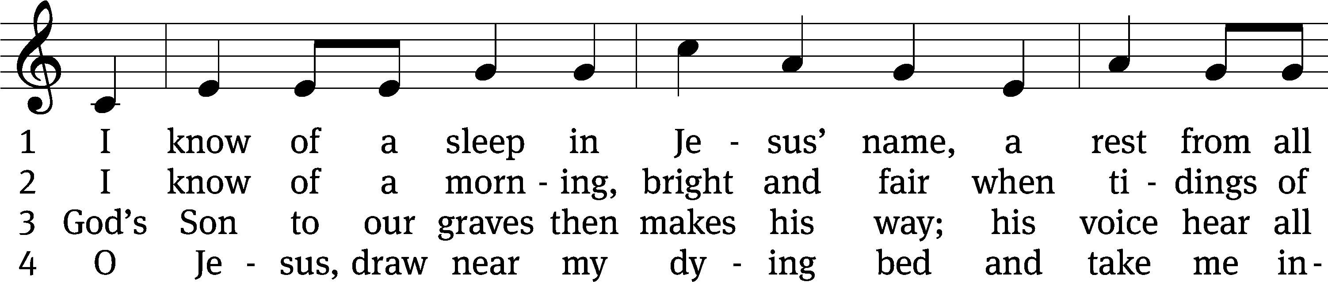
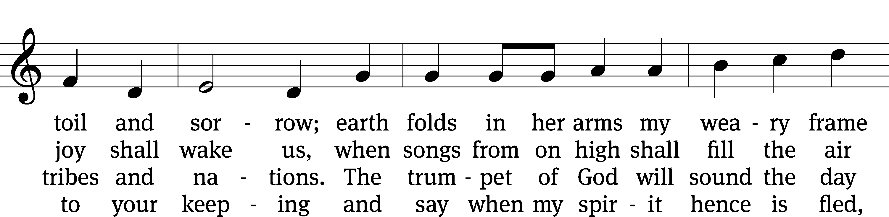
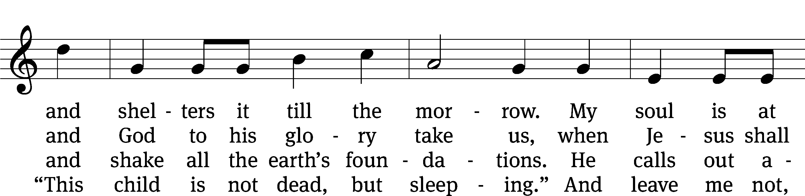
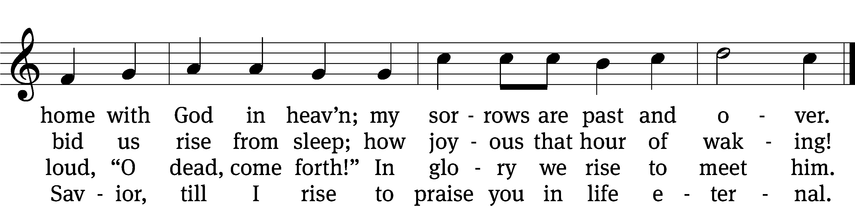
Text: tr. The Lutheran Hymnary, 1913, alt.; Magnus B. Landstad, 1802–1880, abr.
Tune: Christoph E. F. Weyse, 1774–1842
Text and tune: Public domain

Sermon John 11
“His Final Steps Led Him to a Tomb”

Please stand, if you are able

Apostles’ Creed
I believe in God, the Father Almighty,
maker of heaven and earth.

I believe in Jesus Christ, his only Son, our Lord,
who was conceived by the Holy Spirit,
born of the Virgin Mary,
suffered under Pontius Pilate,
was crucified, died, and was buried.
He descended into hell.
The third day he rose again from the dead.
He ascended into heaven
and is seated at the right hand of God the Father Almighty.
From there he will come to judge the living and the dead.

I believe in the Holy Spirit,
the holy Christian Church,
the communion of saints,
the forgiveness of sins,
the resurrection of the body,
and the life everlasting. Amen.

Prayer of the Church

Please be seated

502 Children of the Heavenly Father CW 502
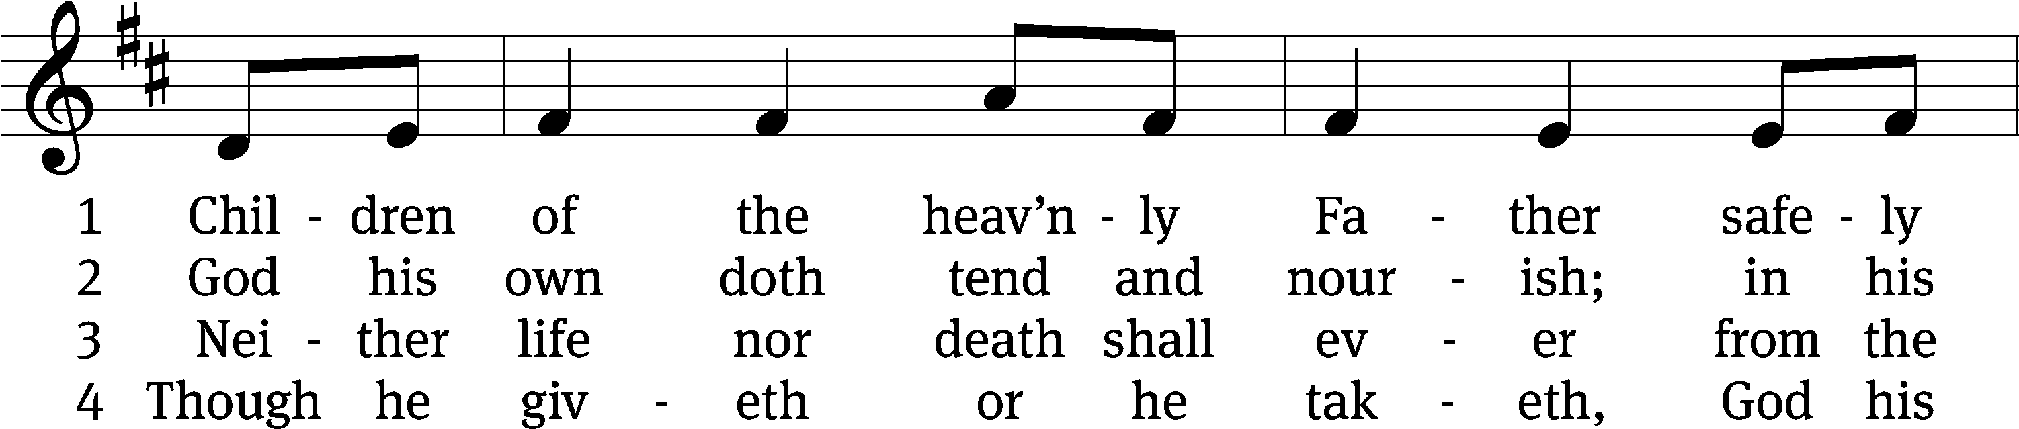
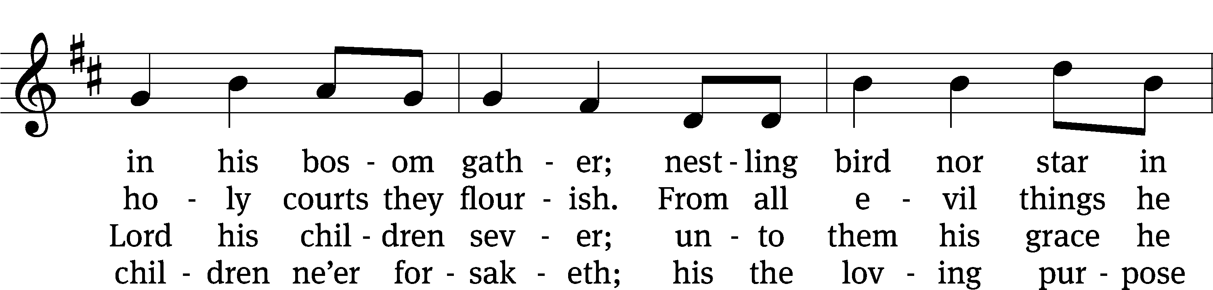
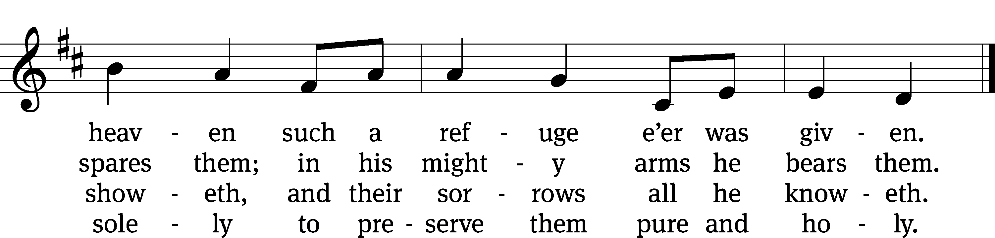
Text: tr. Ernst W. Olson, 1870–1958; Carolina Sandell Berg, 1832–1903, abr.
Tune: Lofsånger och andeliga wisor, Sweden, 1873
Text: © 1925 Board of Publication, Lutheran Church in America, admin. Augsburg Fortress. Used by permission: OneLicense no. 727703
Tune: Public domain

Please stand, if you are able

Prayer
Blessed Lord, you have given us your Holy Scriptures for our learning. May we so hear them, read, learn, and take them to heart that, being strengthened and comforted by your holy Word, we may cling to the blessed hope of everlasting life; through Jesus Christ our Lord, who lives and reigns with you and the Holy Spirit, one God, now and forever.
Amen.

Lord’s Prayer
Our Father, who art in heaven, hallowed be thy name, thy kingdom come, thy will be done on earth as it is in heaven. Give us this day our daily bread; and forgive us our trespasses, as we forgive those who trespass against us; and lead us not into temptation, but deliver us from evil. For thine is the kingdom and the power and the glory forever and ever. Amen.

Blessing
The Lord bless you and keep you.
The Lord make his face shine on you and be gracious to you.
The Lord look on you with favor and give you peace.
Amen.

Please be seated
518 Christ Be My Leader CW 518
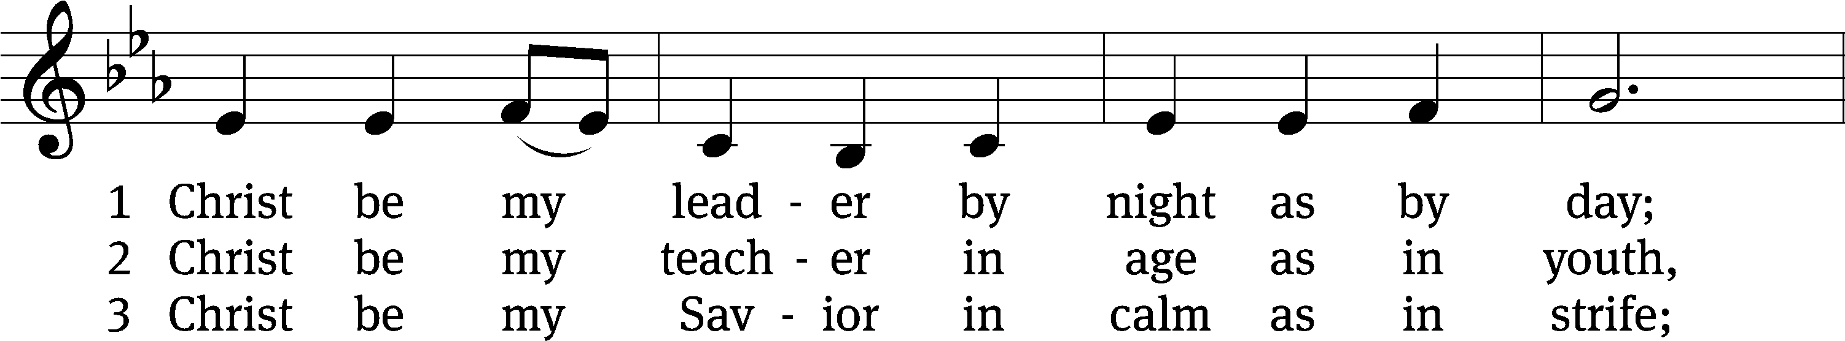
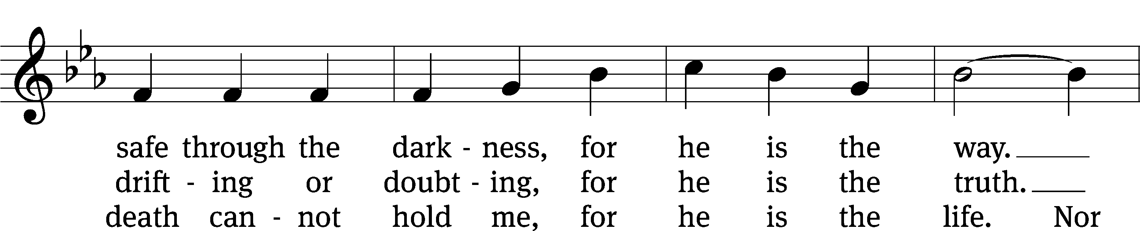
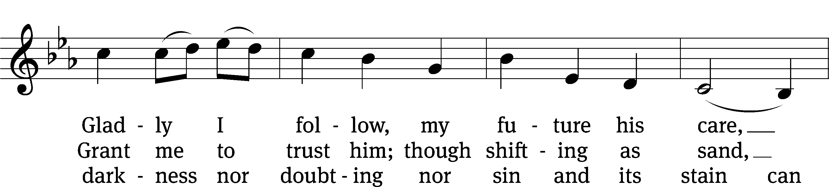
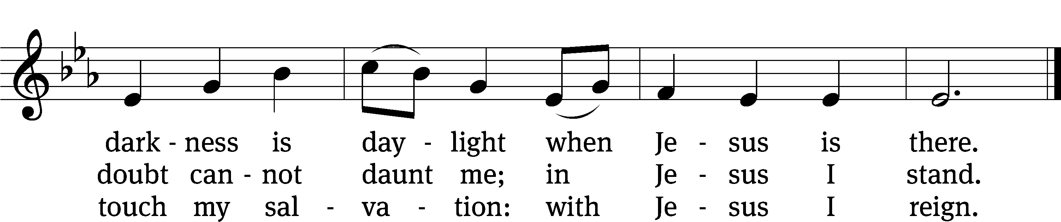
Text: Timothy Dudley-Smith, b. 1926
Tune: Irish
Text: © 1964, ren. 1992 Hope Publishing Co. Used by permission: OneLicense no. 727703
Tune: Public domain

Acknowledgments
Setting One from Christian Worship
Software distributed in partnership with Northwestern Publishing House.
Created by Christian Worship: Service Builder © 2022 Concordia Publishing House.

Serving in Worship
Officiant Pastor Natsis
Organist Sarah Hanke
Duet Diane Amerman and Cynthia Natsis
Accompanist Laura Sala
Deacons (8:30) Duane Mason and Jim Tice
(11:00) Steve Hoeft and Robert Niethammer
Ushers (8:30) Bob Newman and Henry Schneider
(11:00) Jake Vershum
Altar Guild Jean Fiegel and Ann Latowski
Videographer Jake Vershum

