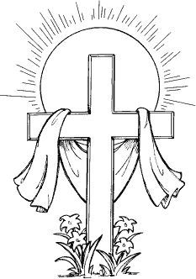

EASTER SUNDAY
THE RESURRECTION OF OUR LORD

tRINITY EVANGELICAL LUTHERAN CHURCH | Saline, Michigan
April 17, 2022

WELCOME TO WORSHIP
Thank you for joining us in God’s house today! We cordially ask that our Guests sign one of the guestbooks located at either the front or back entryways, or fill out a “Let’s Get Acquainted” card located in the hymnal pew rack and place it in the collection plate.

THANK OFFERING: Members of Trinity give their offering as an expression of love and thankfulness to the Lord and to help support the Lord’s work in our community and around the world. Visitors need not feel obligated to participate in this offering which supports our ministry.

Restrooms are located at the back of the upper level (the annex), and in the basement (down the back stairs of the sanctuary or annex). Handicap access is available, please ask an usher for assistance.

Young Families / Toddler Bags – For your convenience, we have reserved the back rows of seating for parents with small children. These areas provide more flexibility for your family, as well as, easy access to move downstairs if necessary. A closed-circuit TV system allows families to continue participating in the service while downstairs. Pre-school toddler bags are available for their enjoyment. Ask an usher for one to use during the service and please return it afterwards.

Scripture Reading for Holy Saturday

Church Bells
SENIOR CHOIR “Easter Song”

Hear the bells ringing, they’re singing that we can be born again.
Hear the bells ringing, they’re singing Christ is risen from the dead.
The angel up on the tombstone said, He is risen, just as he said.
Quickly now, go tell his disciples that Jesus Christ is no longer dead.
Joy to the world, he is risen, hallelujah! He is risen, hallelujah.
He is risen! Hallelujah, hallelujah!

Words of Welcome (Pastor)
438 Jesus Christ Is Risen Today CW 438
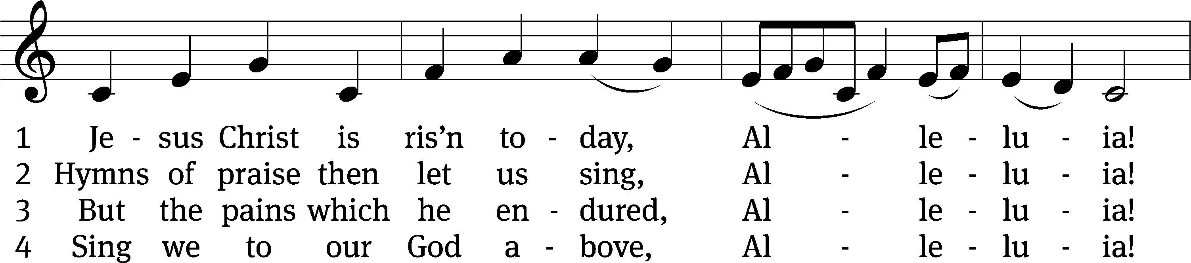
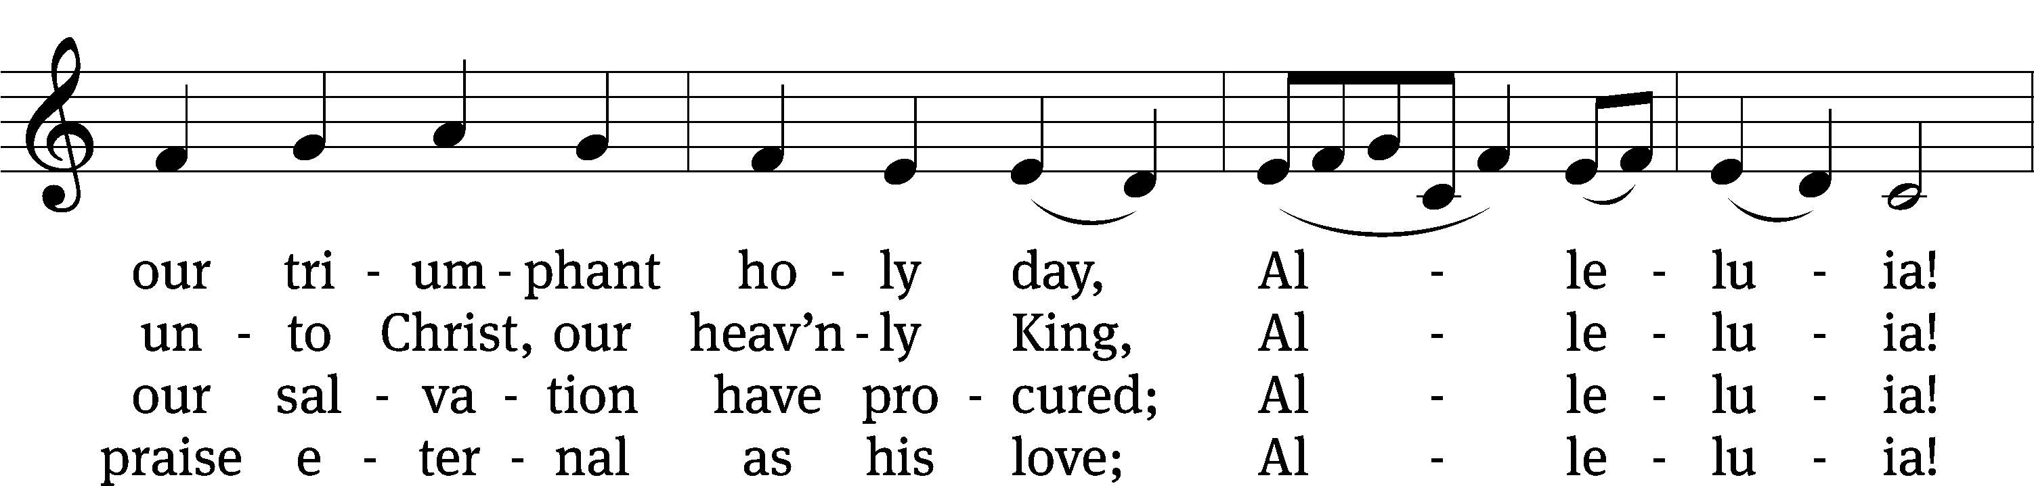
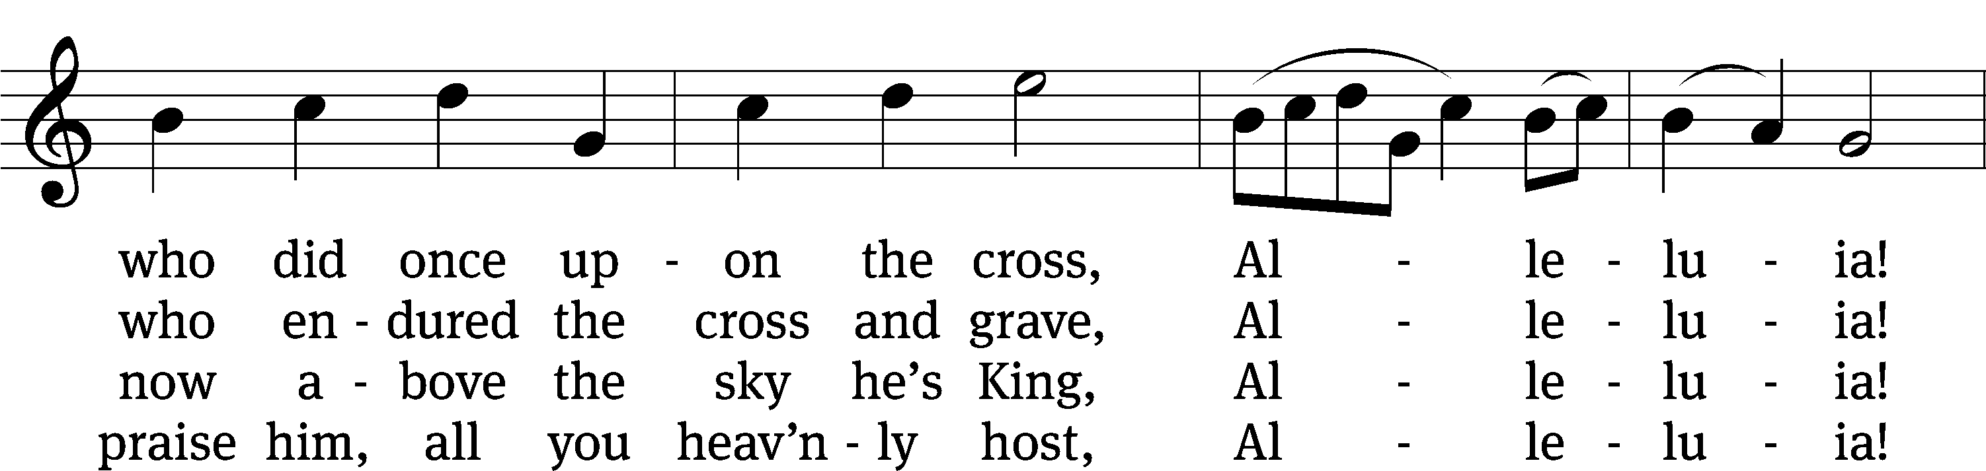
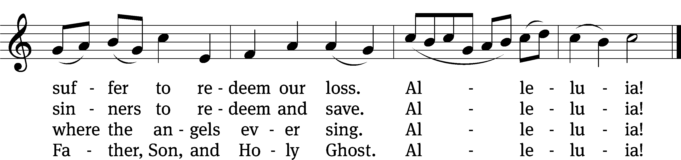

Text (sts. 1–3): tr. Lyra Davidica, 1708, alt.; (sts. 1–3): Latin, 14th cent.; (st. 4): Charles Wesley, 1707–1788
Tune: Lyra Davidica, London, 1708
Text and tune: Public domain
PLEASE STAND IF YOU ARE ABLE
M: He is risen!
C: He is risen indeed!

M: The grace of our Lord Jesus Christ and the love of God and the fellowship of the Holy Spirit be with you.
C: And also with you.

M: God invites us to come into his presence and worship him with humble and penitent hearts. Therefore, let us acknowledge our sinfulness and ask him to forgive us.
C: Holy and merciful Father, I confess that I am by nature sinful, and that I have disobeyed you in my thoughts, words, and actions. I have done what is evil and failed to do what is good. For this I deserve your punishment both now and in eternity. But I am truly sorry for my sins, and trusting in my Savior Jesus Christ, I pray: Lord, have mercy on me, a sinner.

M: God, our heavenly Father, has been merciful to us and has given his only Son to be the atoning sacrifice for our sins. Therefore, as a called servant of Christ and by his authority, I forgive you all your sins in the name of the Father and of the Son (+) and of the Holy Spirit.
C: Amen.

938 This Is the Feast CW 938 sts. Ref–5, Final Refrain
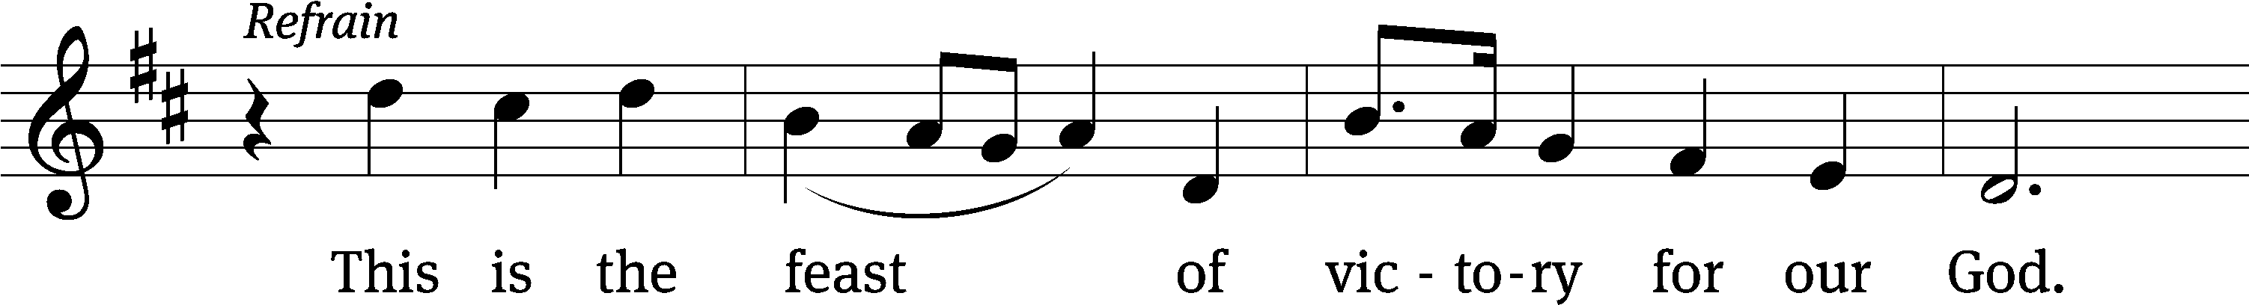
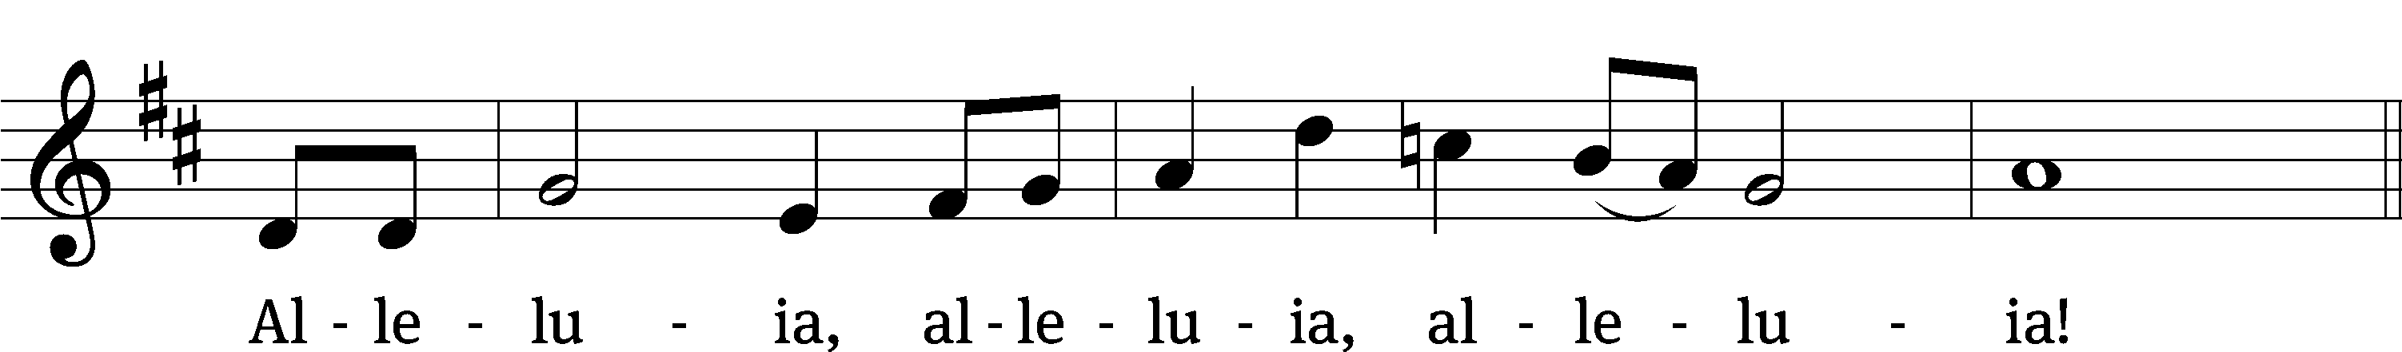

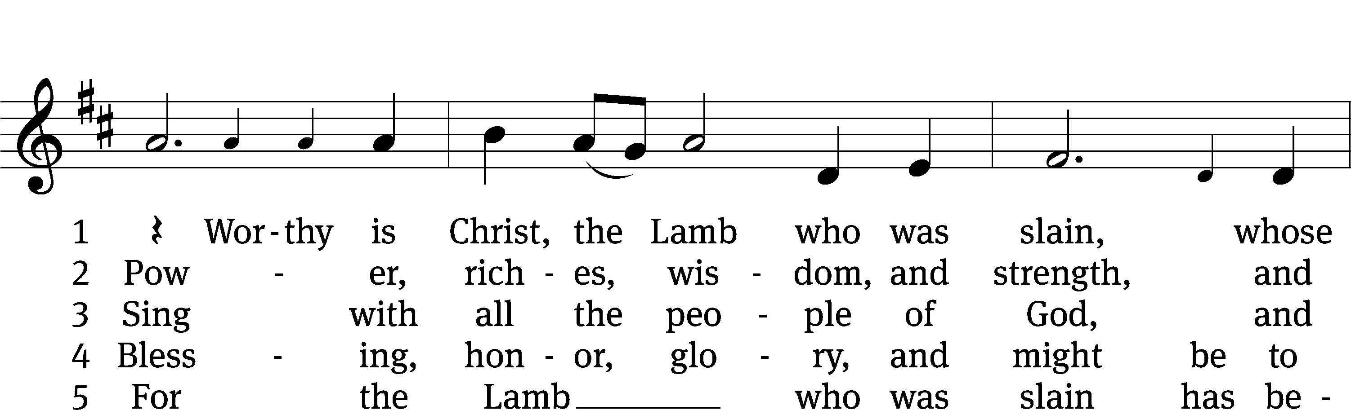
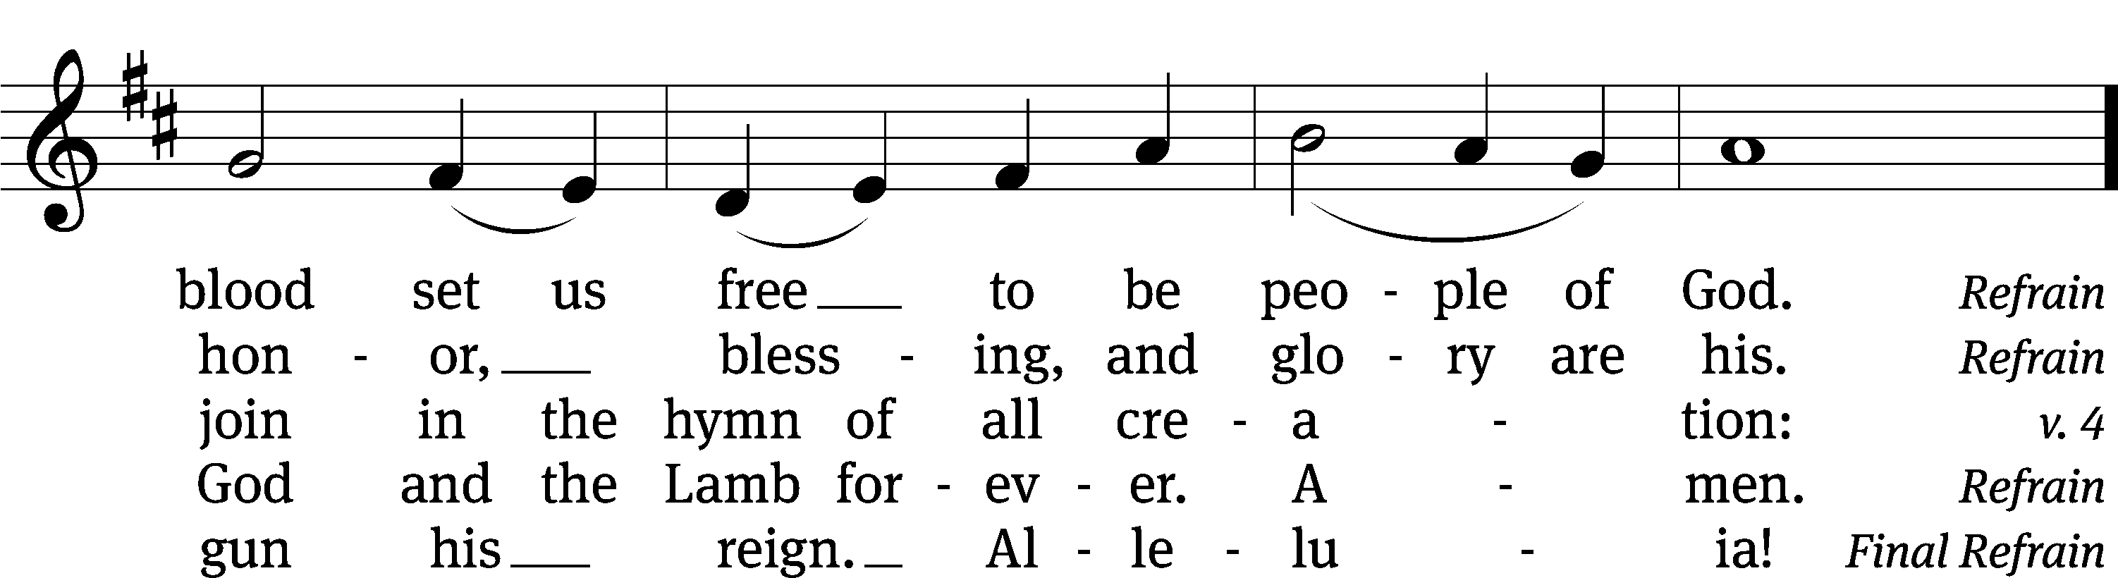
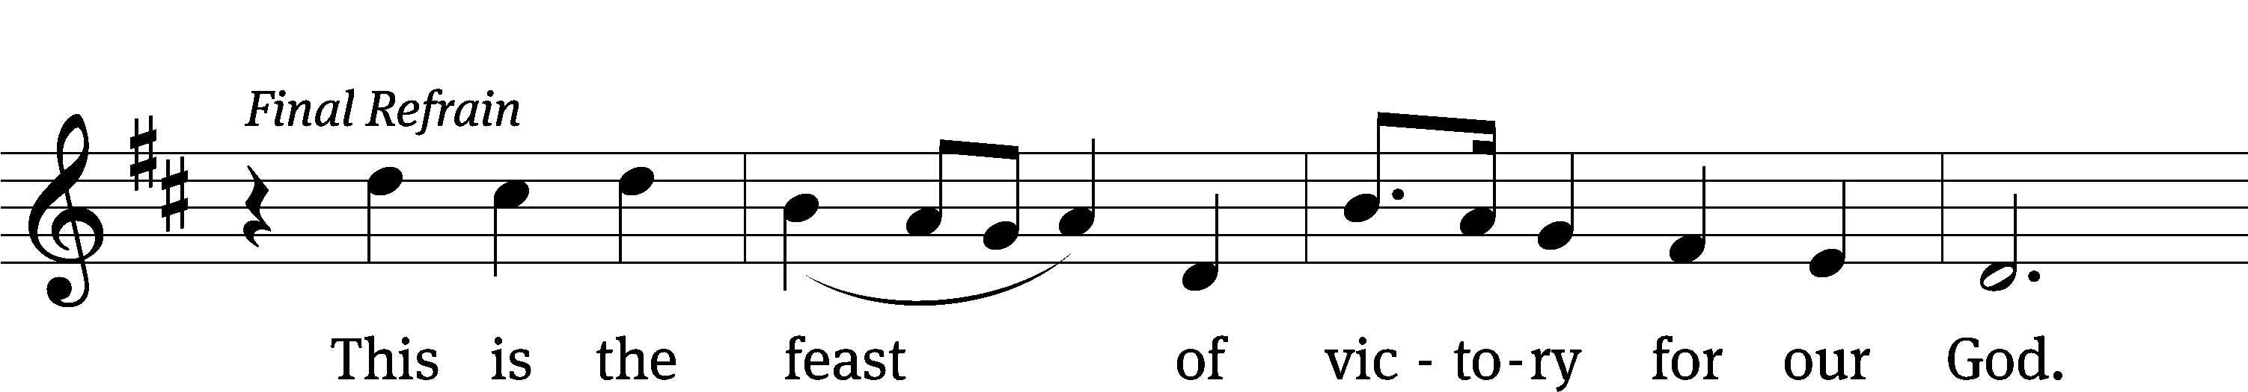
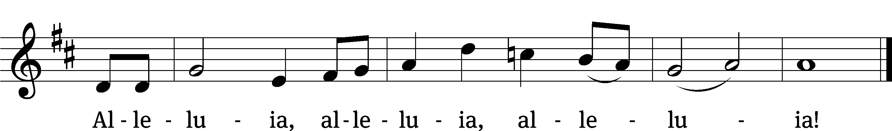

Text: Richard W. Hillert, 1923–2010; John W. Arthur, 1922–1980
Tune: Richard W. Hillert, 1923–2010
Text: © 1978 Lutheran Book of Worship, admin. Augsburg Fortress. Used by permission: OneLicense no. 727703
Tune: © 1975, 1988 Richard W. Hillert. Used by permission: OneLicense no. 727703

Prayer of the Day
O God, you made the dawn of this most holy day to shine with the glory of our Lord’s resurrection. Grant that we, who have been raised from the death of sin by your life-giving Spirit, may worship you in sincerity and truth; through Jesus Christ our Lord, who lives and reigns with you and the Holy Spirit, one God, both now and forever.

PLEASE BE SEATED

The First Lesson for Easter Compiled from the Gospels

SENIOR CHOIR “Christ Is Risen”

(Refrain) Christ is risen! Hallelujah, hallelujah!
Christ is risen, risen indeed! Hallelujah!

Love’s work is done; the battle is won.
Where now, O death, is your sting?
He rose again to rule and to reign,
Jesus, our conquering King.
(Refrain)
Lord over sin, Lord over death,
At his feet Satan must fall!
Every knee bow; all will confess
Jesus is Lord over all!
(Refrain)
Tell it abroad, “Jesus is Lord!”
Shout it and let your praise ring!
Gladly we raise our songs of praise;
Worship is our offering.
(Refrain)

The Second Lesson for Easter Compiled from the Gospels

455 Alleluia! Jesus Lives CW 455
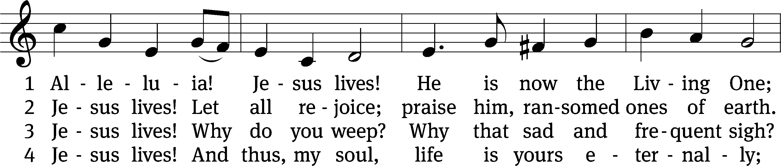
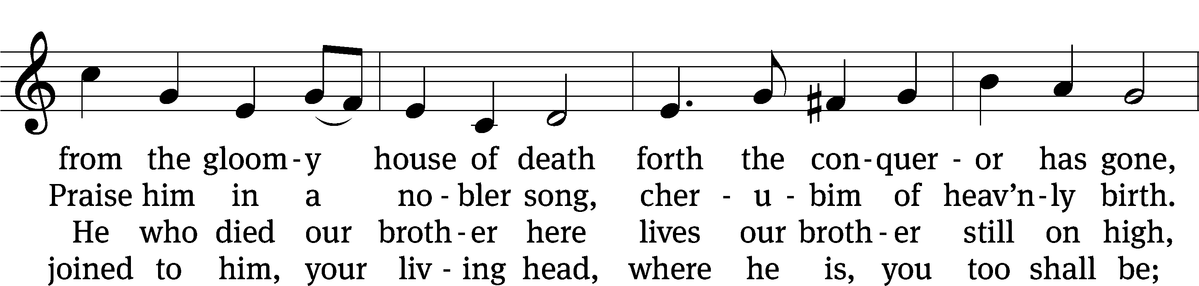
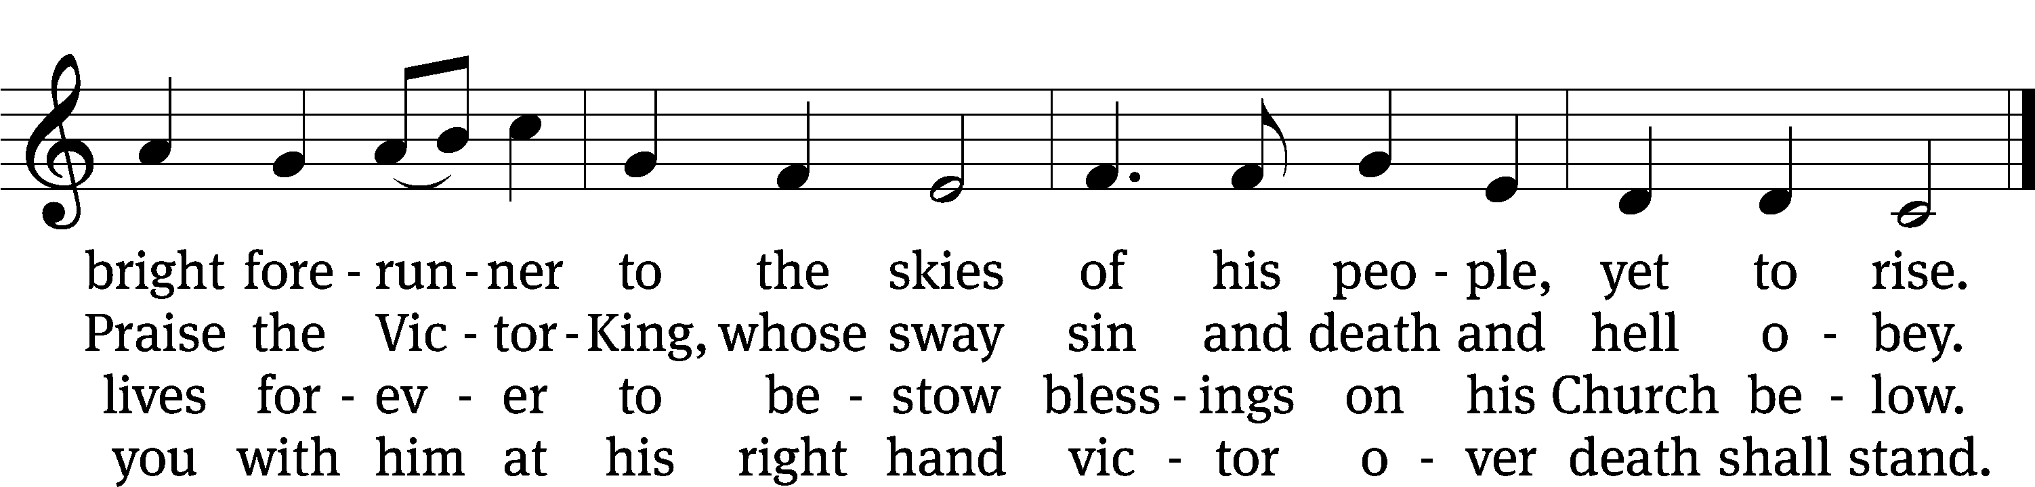

Text: tr. Jane L. Borthwick, 1813–1897, alt.; Karl B. Garve, 1763–1841, abr.
Tune: Ludvig M. Lindeman, 1812–1887
Text and tune: Public domain

The Third Lesson for Easter Compiled from the Gospels

PLEASE STAND, IF YOU ARE ABLE

SERMON HYMN - IN CHRIST ALONE (#510 IN CHRISTIAN WORSHIP)

Sermon – Text and Theme: 1 Corinthian 15:54-57

“A Forever Victory”
⁵⁴ But once this perishable body has put on imperishability, and this mortal body has put on immortality, then what is written will be fulfilled: Death is swallowed up in victory. ⁵⁵ Death, where is your sting? Grave, where is your victory? ⁵⁶ The sting of death is sin, and the power of sin is the law. ⁵⁷ But thanks be to God, who gives us the victory through our Lord Jesus Christ!
PLEASE STAND, IF YOU ARE ABLE
Nicene Creed
We believe in one God, the Father, the Almighty,
maker of heaven and earth,
of all that is,
seen and unseen.
We believe in one Lord, Jesus Christ, the only Son of God,
eternally begotten of the Father,
God from God, Light from Light, true God from true God,
begotten, not made,
of one being with the Father.
Through him all things were made.
For us and for our salvation, he came down from heaven,
was incarnate of the Holy Spirit and the Virgin Mary,
and became truly human.
For our sake he was crucified under Pontius Pilate.
He suffered death and was buried.
On the third day he rose again in accordance with the Scriptures.
He ascended into heaven
and is seated at the right hand of the Father.
He will come again in glory to judge the living and the dead,
and his kingdom will have no end.
We believe in the Holy Spirit,
the Lord, the giver of life,
who proceeds from the Father and the Son,
who in unity with the Father and the Son
is worshiped and glorified,
who has spoken through the prophets.
We believe in one holy Christian and apostolic Church.
We acknowledge one baptism for the forgiveness of sins.
We look for the resurrection of the dead
and the life of the world to come. Amen.

PLEASE BE SEATED

Offertory

PLEASE STAND IF YOU ARE ABLE
Easter Prayer

The Lord’s Prayer

C: Our Father, who art in heaven, hallowed be thy name, thy kingdom come, thy will be done on earth as it is in heaven. Give us this day our daily bread; and forgive us our trespasses, as we forgive those who trespass against us; and lead us not into temptation, but deliver us from evil. For thine is the kingdom and the power and the glory forever and ever. Amen.

M: The Lord be with you.

M: Lift up your hearts.

M: Let us give thanks to the Lord, our God.

M: It is truly good and right that we should at all times and in all places give you thanks, O Lord, holy Father, almighty and everlasting God, through Jesus Christ, our Lord, and we praise you especially for the glorious resurrection of your Son, the true Passover Lamb, who by his sacrifice took away the sins of the world and by his resurrection restored everlasting life. Therefore, with all the saints on earth and hosts of heaven, we praise your holy name and join their glorious song:

WORDS OF INSTITUTION
M: Our Lord Jesus Christ, on the night he was betrayed, took bread; and when he had given thanks, he broke it and gave it to his disciples, saying, “Take and eat; this is my body, which is given for you. Do this in remembrance of me.”
Then he took the cup, gave thanks, and gave it to them, saying, “Drink from it, all of you; this is my blood of the new covenant, which is poured out for you for the forgiveness of sins. Do this, whenever you drink it, in remembrance of me.”
M: The peace of the Lord be with you always.

PLEASE BE SEATED

DISTRIBUTION HYMNS
441 I Know That My Redeemer Lives
Text: Samuel Medley, 1739–1799, abr.
Tune: attr. John C. Hatton, 1710–1793
Text and tune: Public domain

443 Awake, My Heart, with Gladness
Text: tr. John Kelly, 1833–1890, alt.; Paul Gerhardt, 1607–1676, abr.
Tune: Johann Crüger, 1598–1662
Text and tune: Public domain
441 I Know That My Redeemer Lives CW 441
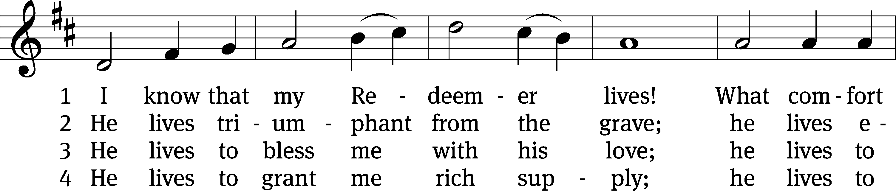
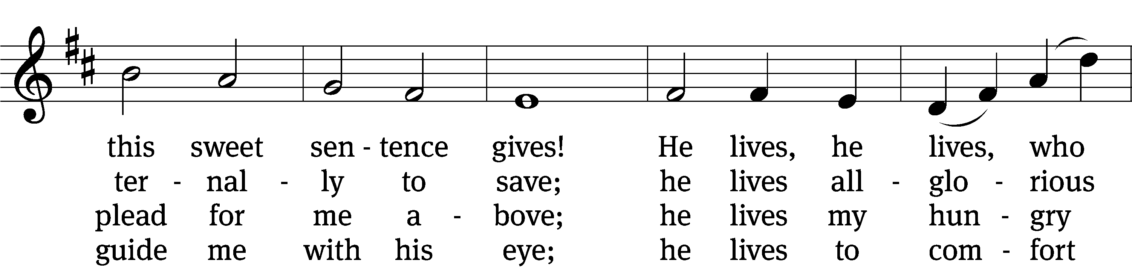
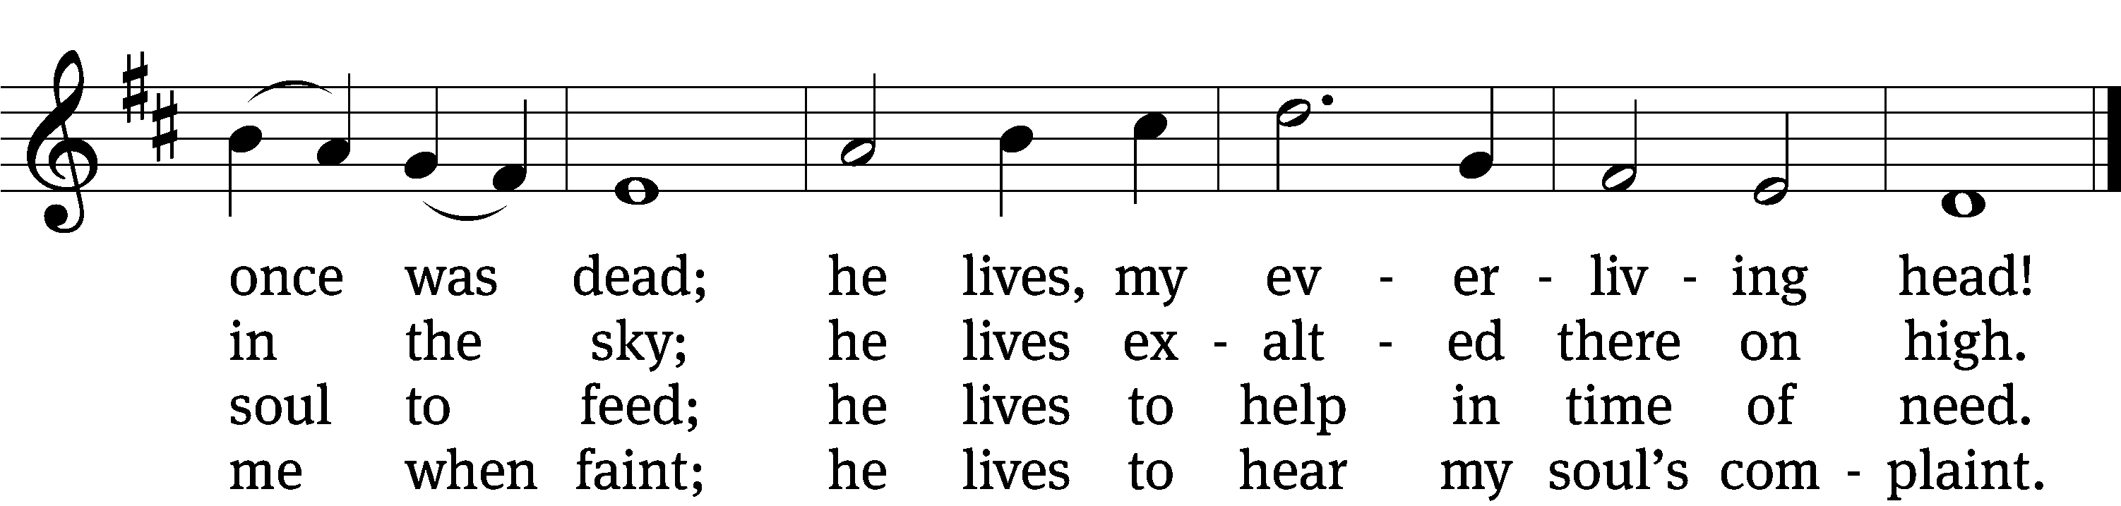

5 He lives to silence all my fears;
he lives to wipe away my tears;
he lives to calm my troubled heart;
he lives all blessings to impart.

6 He lives, my kind, wise, heav’nly friend;
he lives and loves me to the end;
he lives, and while he lives, I’ll sing;
he lives, my Prophet, Priest, and King.

7 He lives and grants me daily breath;
he lives, and I shall conquer death;
he lives my mansion to prepare;
he lives to bring me safely there.

8 He lives, all glory to his name!
He lives, my Jesus, still the same.
Oh, the sweet joy this sentence gives:
I know that my Redeemer lives!
443 Awake, My Heart, with Gladness CW 443
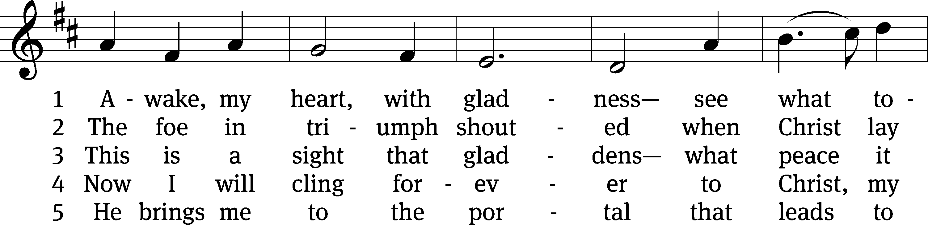
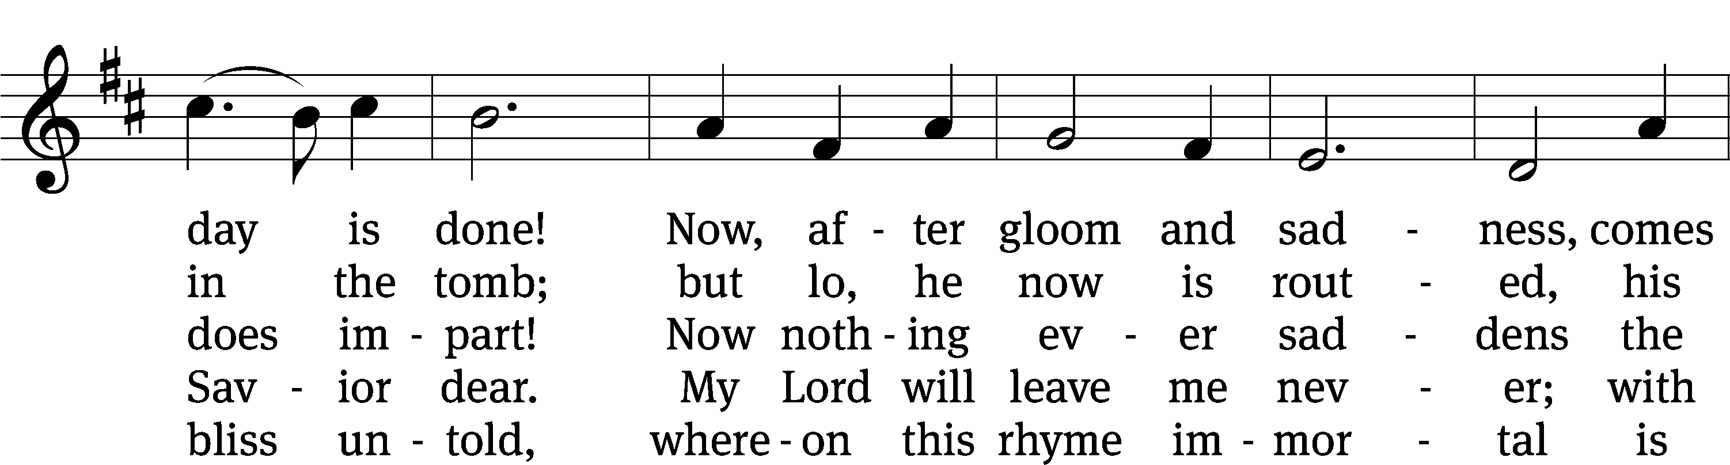
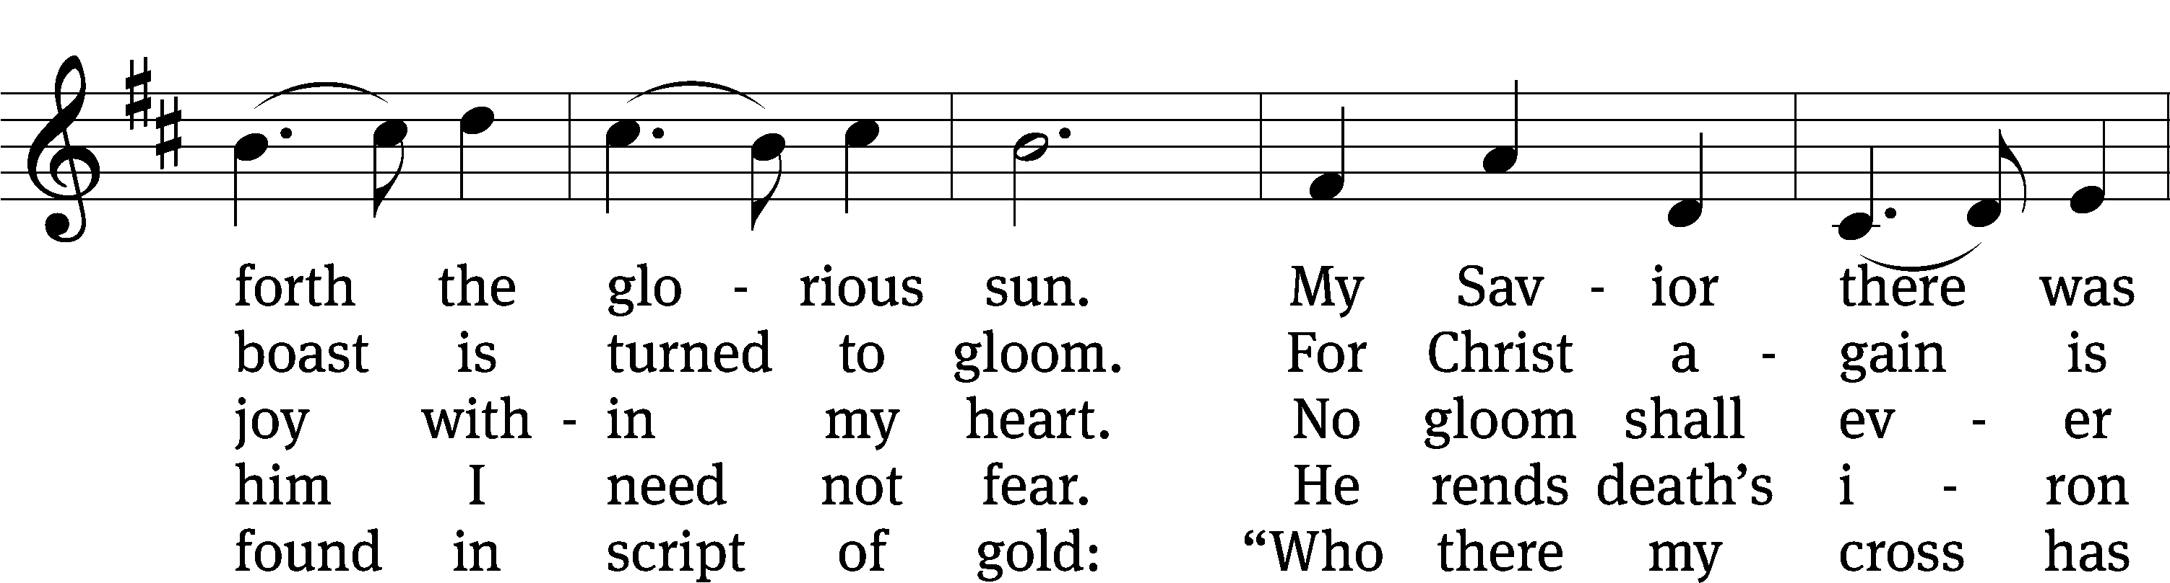
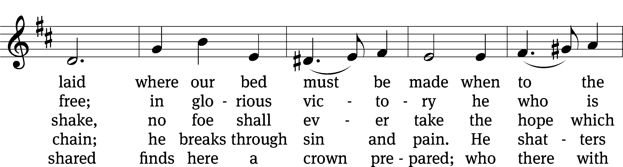
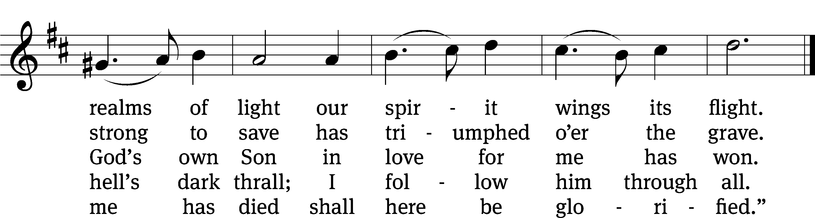

PLEASE STAND, IF YOU ARE ABLE

SONG OF SIMEON
Nunc Dimittis

M: O give thanks to the Lord, for he is good.

M: O God the Father, source of all goodness, in your loving kindness you sent your Son to share our humanity. We thank you that through him you have given us pardon and peace in this sacrament. We also pray that you will not forsake us but will rule our hearts and minds by your Holy Spirit so that we willingly serve you day after day, through Jesus Christ, our Lord, who lives and reigns with you and the Holy Spirit, one God, now and forever.

M: The Lord bless you and keep you.
The Lord make his face shine on you and be gracious to you.
The Lord look on you with favor and (+) give you peace.

BE SEATED

465 Christ the Lord Is Risen Today CW 465 sts. 1, 4–6
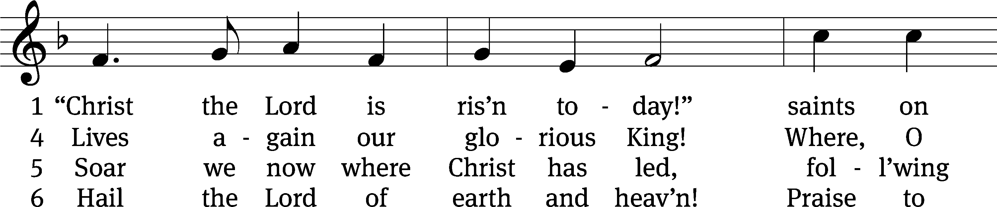
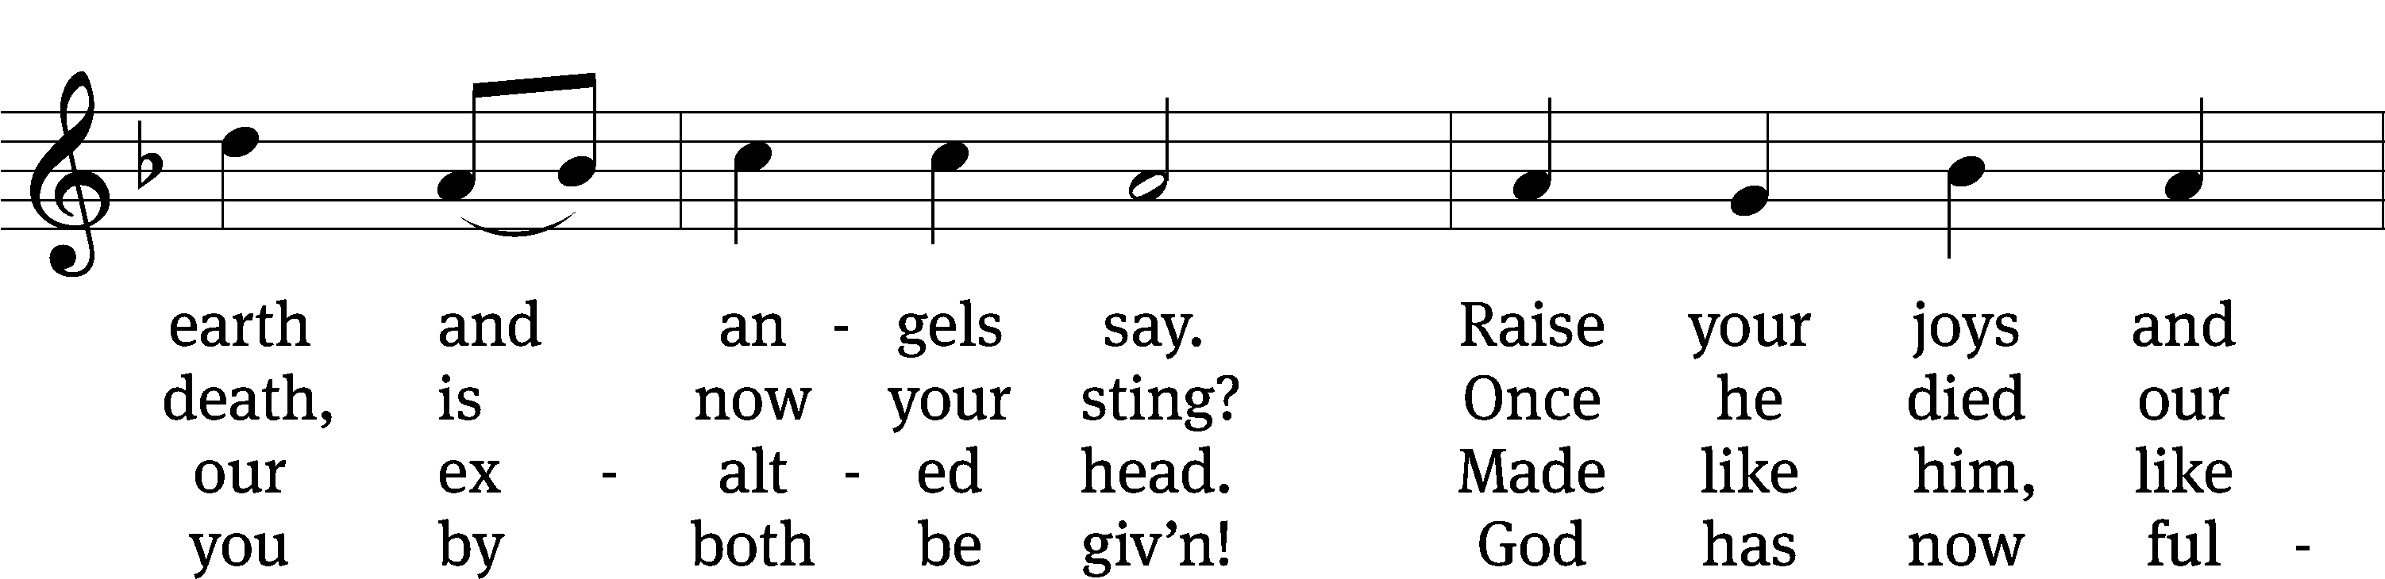
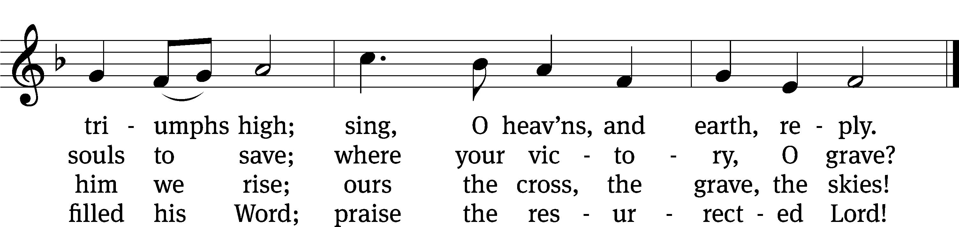
Text: Charles Wesley, 1707–1788, abr., alt.
Tune: Pierre de Corbeille, d. 1221; adapt. Richard Redhead, 1820–1901
Text and tune: Public domain

Serving In Worship
Officiant Pastor Natsis
Organist and Accompanist Sarah Hanke
Choir Director Cynthia Natsis
Trumpeter Tom Amerman
Deacons (6:30) Dave Stevenson and Jim Tice
Deacons (9:30) Steve Hoeft and Jeff Neuburger
Ushers (6:30) Dal;e Finkbeiner and Mark Finkbeiner
Ushers (9:30) Ed Sala and Al Whitley
Altar Guild Shirley Klumpp and Ann Latowski
Videographer Jake Vershum

Copyright information
Music and Liturgy reprinted under One License #A-727703 and CCLI #1151741
Music and liturgy reprinted under OneLicense.net A-717558 & CCLI 11355138

Music and liturgy reprinted under OneLicense.net A-717558 & CCLI 11355138

Music and liturgy reprinted under OneLicense.net A-717558 & CCLI 11355138

trinitylutheran-saline.org

