THE FOURTH SUNDAY
OF EASTER
tRINITY EVANGELICAL LUTHERAN CHURCH | Saline, Michigan
April 30, 2023

WELCOME TO WORSHIP

Thank you for joining us in God’s house today! We cordially ask that our Guests with us this morning sign one of the guestbooks located at either the front or back entryways.

THANK OFFERING: Members of Trinity give their offering as an expression of love and thankfulness to the Lord and to help support the Lord’s work in our community and around the world. Visitors need not feel obligated to participate in this offering which supports our ministry.

Restrooms are located at the back of the upper level (the annex), and in the basement (down the back stairs of the sanctuary or annex). Handicap access is available, please ask an usher for assistance.

Young Families / Toddler Bags – We are GLAD YOU BROUGHT YOUR CHILDREN to our worship service. Jesus said: “Let the little children come to me and do not hinder them, for the kingdom of God belongs to such as these.” We know that having little children in church can be a challenge, but DO NOT WORRY about it. Many of your fellow worshippers have been in your shoes and are just happy you brought your children with you. For your convenience, we have reserved the back rows of seating for parents with small children. These areas provide more flexibility for your family, as well as, easy access to move downstairs if necessary. A closed-circuit TV system allows families to continue participating in the service while downstairs. Pre-school toddler bags and children’s bulletins are available for their enjoyment. Ask an usher for one to use during the service and please return the toddler bag afterwards.

SERVICE of the word
Psalm 23 My Shepherd Will Supply My Need Psalm 23F
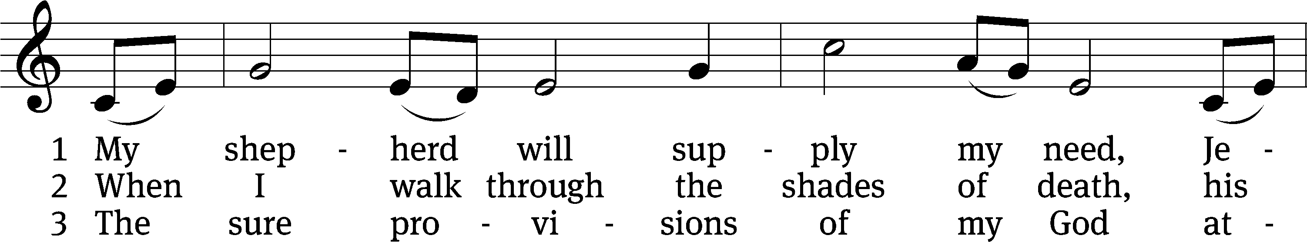
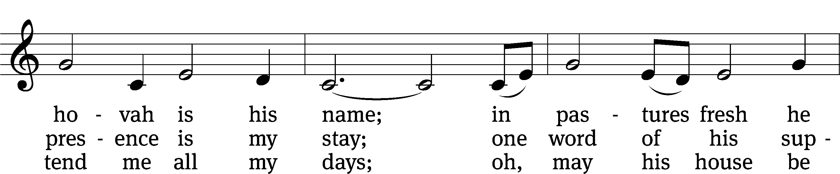
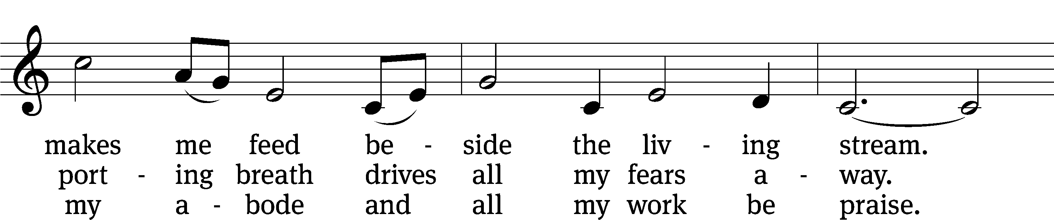
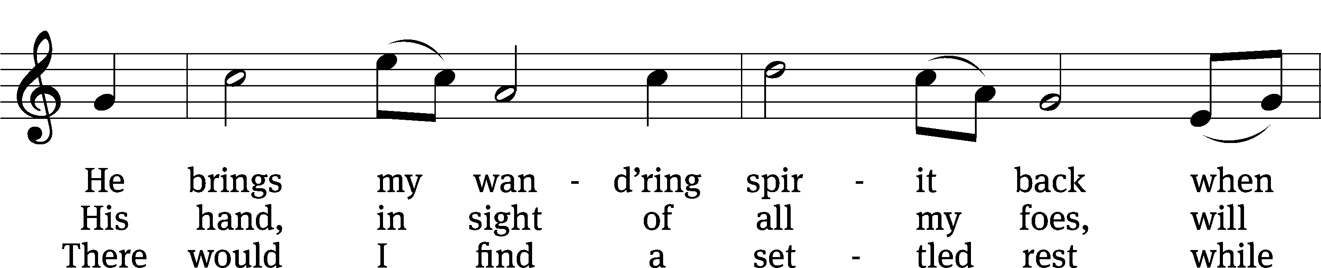
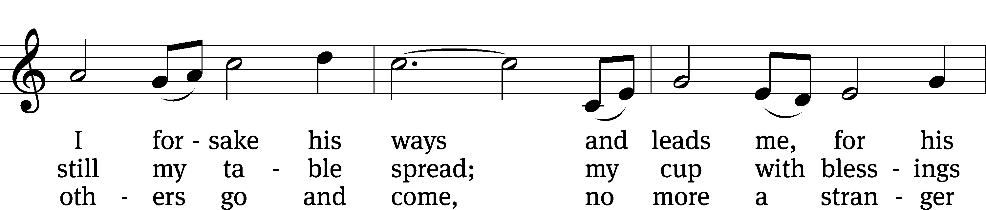
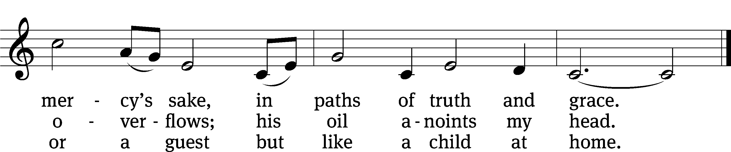
Text: Isaac Watts, alt.
Tune: Southern Harmony, 1835, ed. William Walker
Text and tune: Public domain
PLEASE STAND, IF YOU ARE ABLE

invocation
M: The grace of our Lord (+) Jesus Christ and the love of God and the fellowship of the Holy Spirit be with you.
C: And also with you.

CONFESSION OF SINS
M: We have come into the presence of God, who created us to love and serve him as his dear children. But we have disobeyed him and deserve only his wrath and punishment. Therefore, let us confess our sins to him and plead for his mercy.

C: Merciful Father in heaven, I am altogether sinful from birth. In countless ways I have sinned against you and do not deserve to be called your child. But trusting in Jesus, my Savior, I pray: Have mercy on me according to your unfailing love. Cleanse me from my sin, and take away my guilt.

M: God, our heavenly Father, has forgiven all your sins. By the perfect life and innocent death of our Lord Jesus Christ, he has removed your guilt forever. You are his own dear child. May God give you strength to live according to his will.

C: Amen.
PRAYER AND PRAISE

M: In the peace of forgiveness, let us praise the Lord.

OH, TASTE AND SEE

PRAYER OF THE DAY

Let us pray.

O Lord Jesus Christ, you are the Good Shepherd who laid down your life for the sheep. Lead us now to the still waters of your life-giving Word that we may abide in your Father’s house forevermore; for you live and reign with the Father and the Holy Spirit, one God, now and forever.

PLEASE BE SEATED

The Word

the FIRST LESSON Acts 2:42-47
⁴² They continued to hold firmly to the apostles’ teaching and to the fellowship, to the breaking of the bread, and to the prayers. ⁴³ Awe came over every soul, and many wonders and signs were being done through the apostles. ⁴⁴ All the believers were together and had everything in common. ⁴⁵ They were selling their possessions and property and were distributing the proceeds according to what anyone needed.
⁴⁶ Day after day, with one mind, they were devoted to meeting in the temple area, as they continued to break bread in their homes. They shared their food with glad and sincere hearts, ⁴⁷ as they continued praising God and being viewed favorably by all the people. Day after day the Lord added to their number those who were being saved.

CHOIR “Good Shepherd of My Soul”

Good Shepherd of my soul, come dwell within me.
Take all I am and mold your likeness in me.
Before the cross of Christ, this is my sacrifice:
A life laid down and ready to follow

The troubled find their peace in true surrender;
The prisoners their release from chains of anger.
In springs of living grace, I find a resting place
To rise refreshed, determined to follow.

I’ll walk this narrow road with Christ before me,
Where thorns and thistles grow and cords ensnare me.
Earth’s struggles overcome, heaven’s journey just begun
To search Christ’s depths and ever to follow.

THE SECOND LESSON 1 Peter 2:19-25

¹⁹ For this is favorable: if a person endures sorrows while suffering unjustly because he is conscious of God. ²⁰ For what credit is it to you if you receive a beating for sinning and patiently endure it? But if you suffer for doing good and endure it, this is favorable with God.
²¹ Indeed, you were called to do this, because Christ also suffered for you, leaving you an example so that you would follow in his steps. ²² He did not commit a sin, and no deceit was found in his mouth. ²³ When he was insulted, he did not insult in return. When he suffered, he made no threats. Instead, he entrusted himself to him who judges justly. ²⁴ He himself carried our sins in his body on the tree so that we would be dead to sins and alive to righteousness. By his wounds you were healed. ²⁵ For you were like sheep going astray, but you are now returned to the Shepherd and Overseer of your souls.

please stand, if you are able

Verse of the day
Alleluia. I am the Good Shepherd. I know my sheep and my sheep know me. Alleluia. John 10:14

THE GOSPEL LESSON John 10:1-10

M: The Gospel according to John chapter 10, verses 1-10

¹ “Amen, Amen, I tell you: Anyone who does not enter the sheep pen by the door, but climbs in by some other way, is a thief and a robber. ² The one who enters by the door is the shepherd of the sheep. ³ The doorkeeper opens the door for him, and the sheep listen to his voice. He calls his own sheep by name and leads them out. ⁴ When he has brought out all his own sheep, he walks ahead of them. The sheep follow him because they know his voice. ⁵ They will never follow a stranger, but will run away from him, because they do not know the voice of strangers.” ⁶ Jesus used this illustration in speaking to the people, but they did not understand what he was telling them.
⁷ So Jesus said again, “Amen, Amen, I tell you: I am the door for the sheep. ⁸ All who came before me were thieves and robbers, but the sheep did not listen to them. ⁹ I am the door. Whoever enters through me will be saved. He will come in and go out, and find pasture.
¹⁰ “A thief comes only to steal and kill and destroy. I came that they may have life and have it abundantly.

M: This is the Gospel of the Lord.

PLEASE BE SEATED

553 The Lord’s My Shepherd CW 553
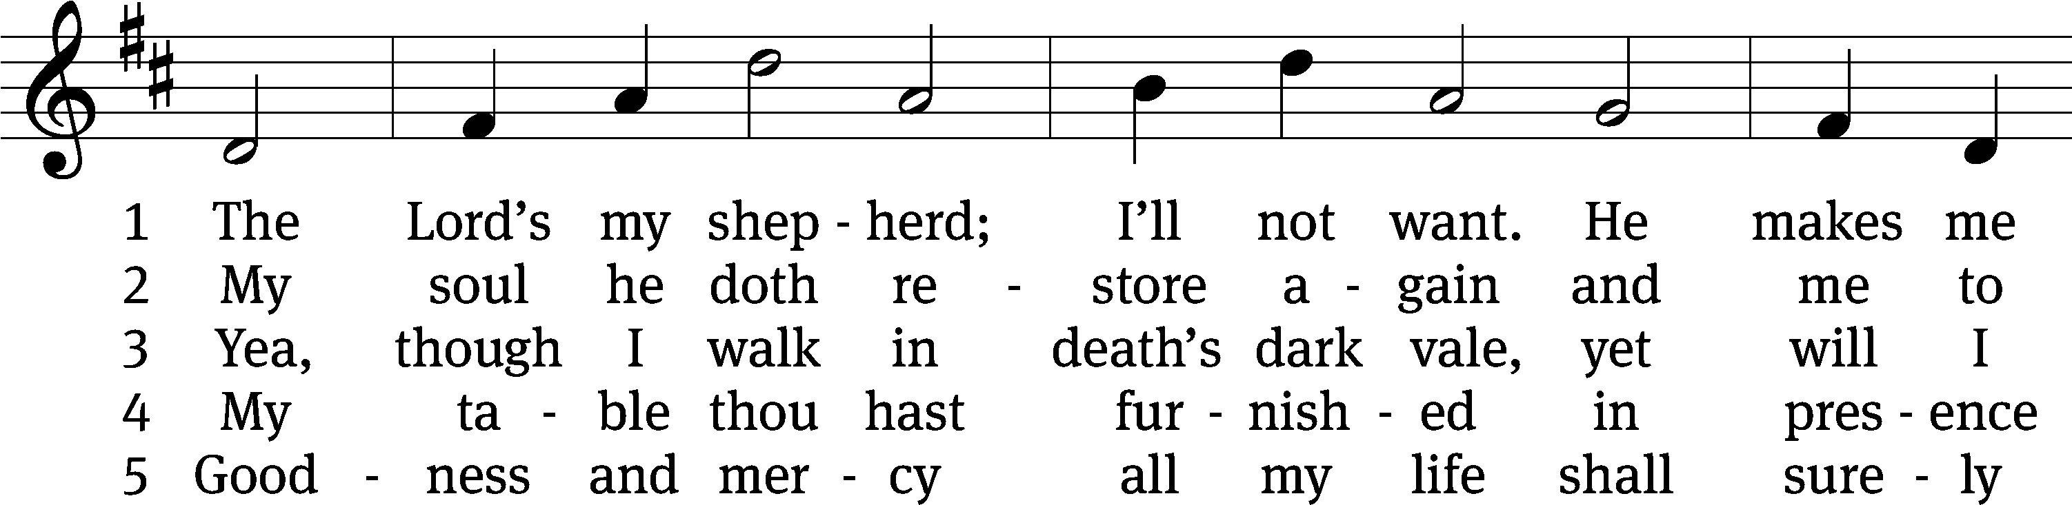
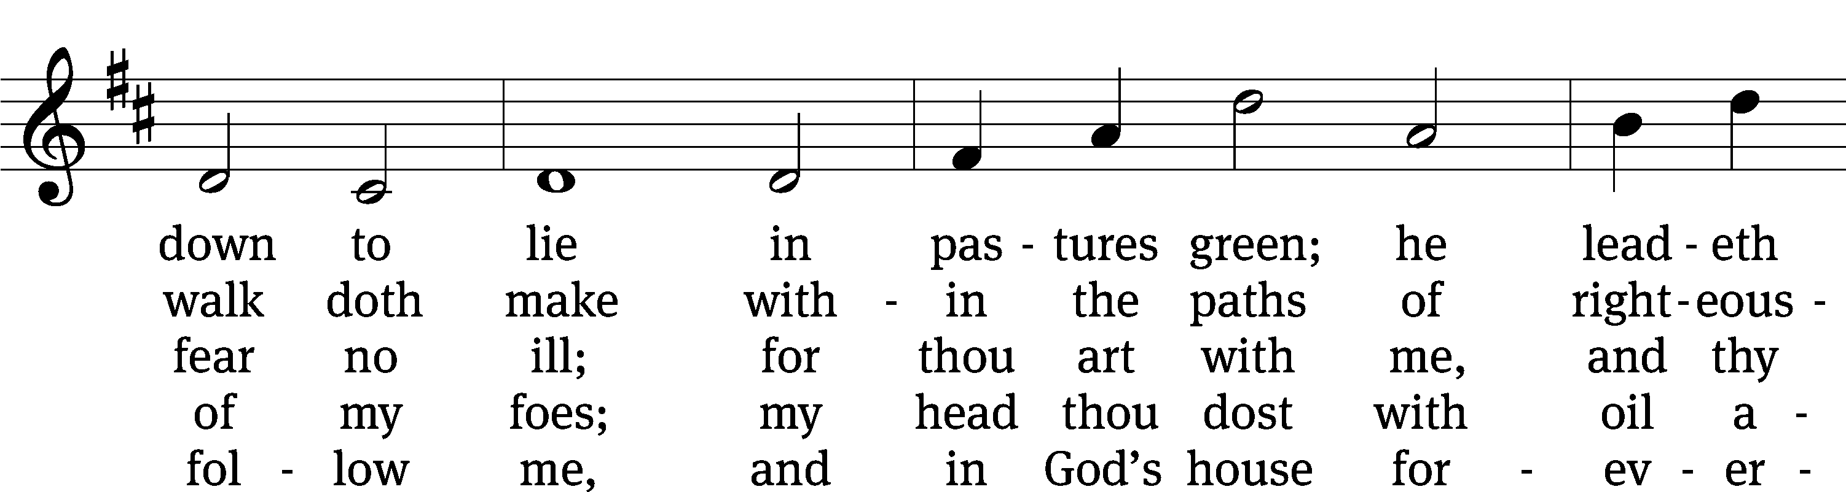
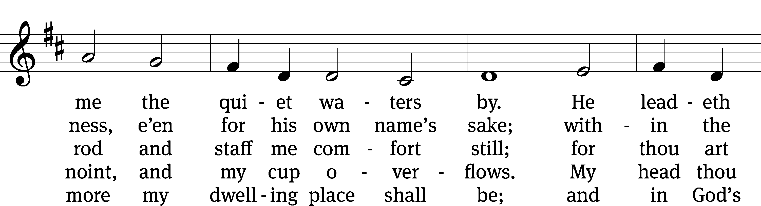
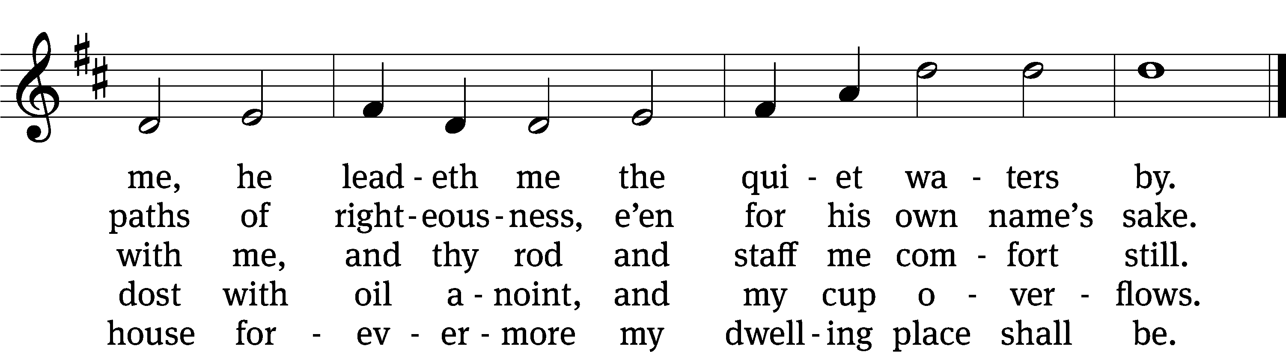
Text: The Psalms of David in Meeter, Edinburgh, 1650
Tune: James L. Macbeth Bain, 1860–1925
Text and tune: Public domain

SERMON Psalm 23
“The Lord Is My Shepherd”
¹ The Lord is my shepherd.
I lack nothing.
² He causes me to lie down in green pastures.
He leads me beside quiet waters.
³ He restores my soul.
He guides me in paths of righteousness for his name’s sake.
⁴ Even though I walk through the valley of the shadow of death,
I will fear no evil, for you are with me.
Your rod and your staff, they comfort me.
⁵ You set a table for me in the presence of my foes.
You drench my head with oil.
My cup is overflowing.
⁶ Surely goodness and mercy will pursue me all the days of my life,
and I will live in the house of the Lord forever.

PLEASE STAND, IF YOU ARE ABLE

THE APOSTLES’ CREED
I believe in God, the Father almighty,
maker of heaven and earth.
I believe in Jesus Christ, his only Son, our Lord,
who was conceived by the Holy Spirit,
born of the virgin Mary,
suffered under Pontius Pilate,
was crucified, died, and was buried.
He descended into hell.
The third day he rose again from the dead.
He ascended into heaven
and is seated at the right hand of God the Father almighty.
From there he will come to judge the living and the dead.
I believe in the Holy Spirit,
the holy Christian Church,
the communion of saints,
the forgiveness of sins,
the resurrection of the body,
and the life everlasting. Amen.
PRAYER OF THE CHURCH

THE LORD’S PRAYER

C: Our Father, who art in heaven, hallowed be thy name, thy kingdom come, thy will be done on earth as it is in heaven. Give us this day our daily bread; and forgive us our trespasses, as we forgive those who trespass against us; and lead us not into temptation, but deliver us from evil. For thine is the kingdom and the power and the glory forever and ever. Amen.

PLEASE BE SEATED

551 Jesus, Shepherd of the Sheep CW 551
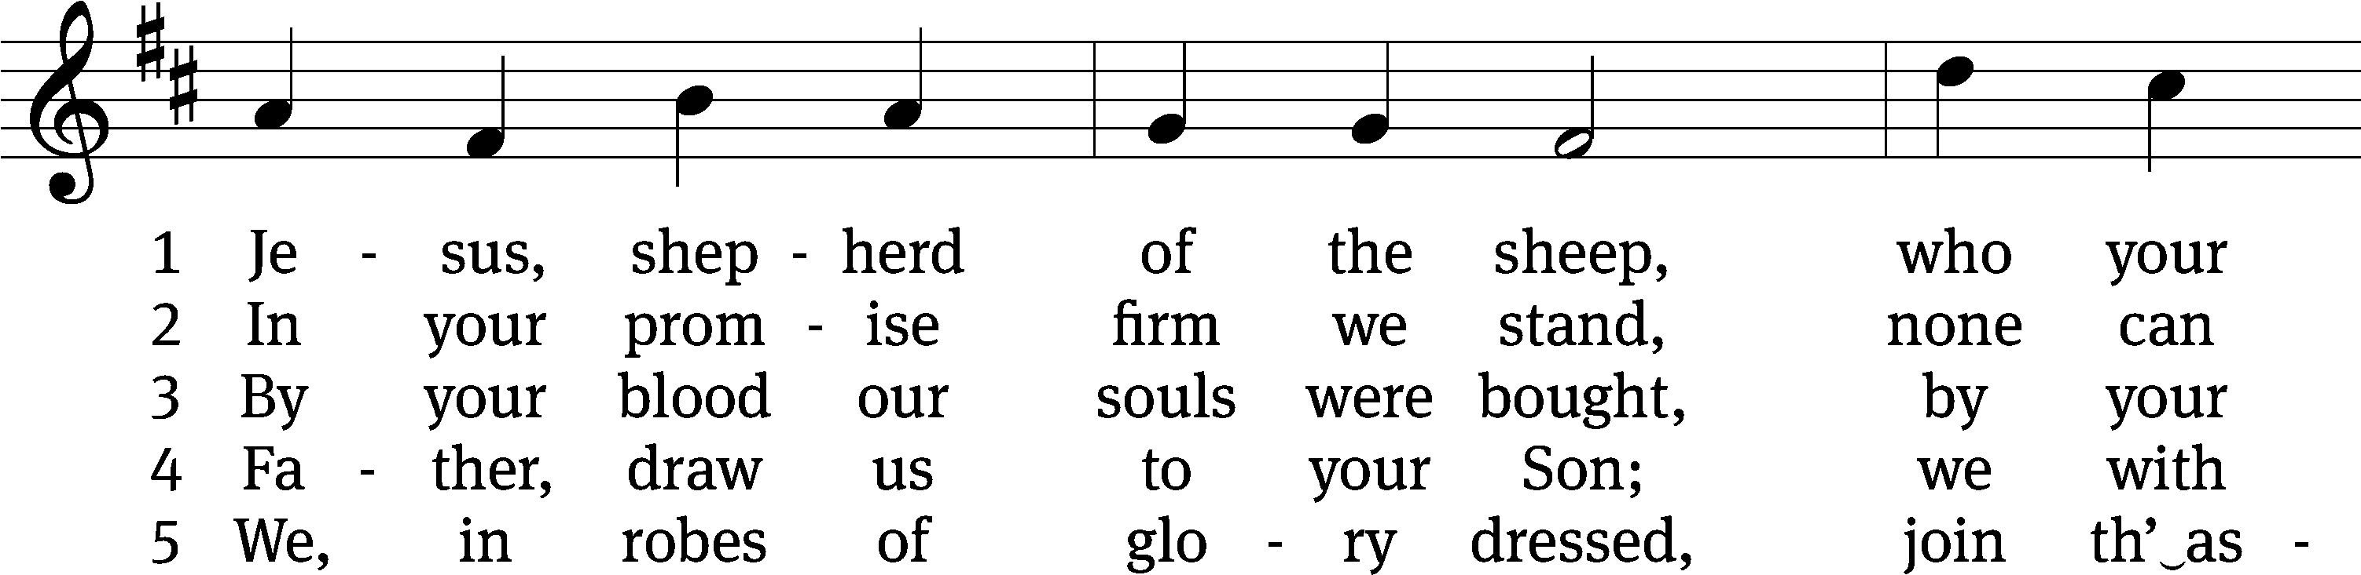
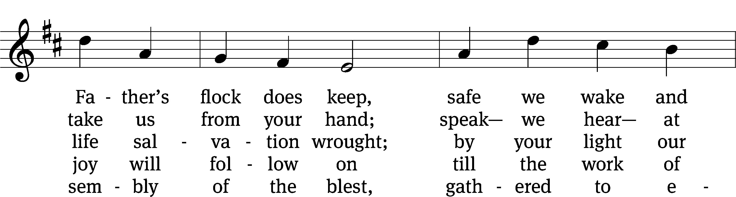
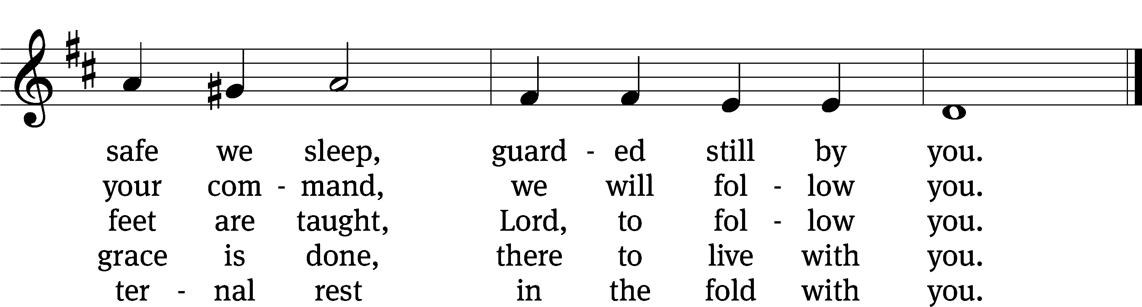
Text: Henry Cook, 1788–1868, alt.
Tune: Friedrich Filitz, 1804–1876
Text and tune: Public domain
PLEASE STAND, IF YOU ARE ABLE

CLOSING PRAYER
M: Almighty God, we thank you for teaching us the things you want us to believe and do. Help us by your Holy Spirit to keep your Word in pure hearts that we may be strengthened in faith, guided in holiness, and comforted in life and in death, through Jesus Christ, our Lord, who lives and reigns with you and the Holy Spirit, one God, now and forever.

M: Brothers and sisters, go in peace. Live in harmony with one another. Serve the Lord with gladness.
The Lord bless you and keep you.
The Lord make his face shine on you and be gracious to you.
The Lord look on you with favor and (+) give you peace.

PLEASE BE SEATED

804 I Am Jesus’ Little Lamb CW 804
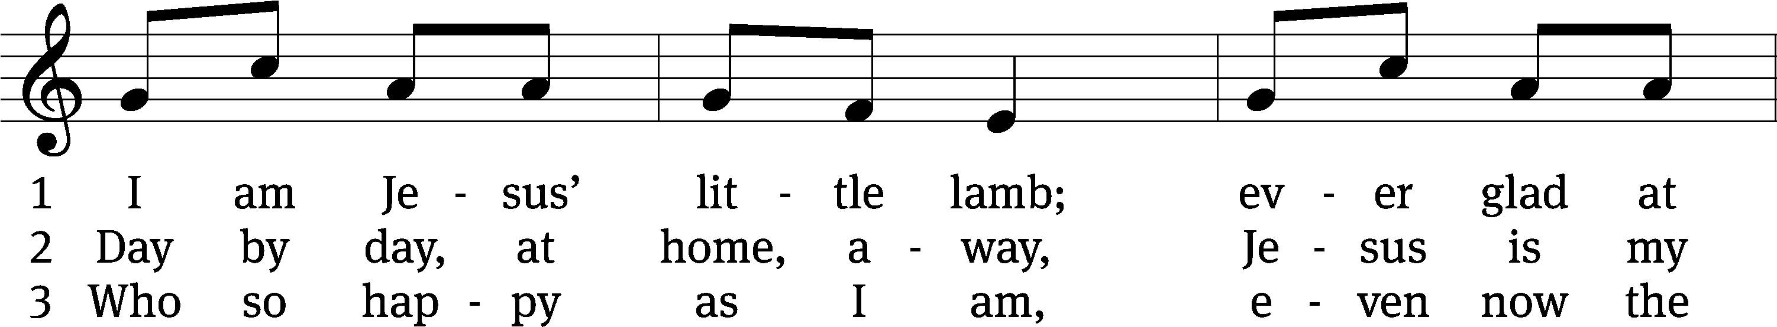
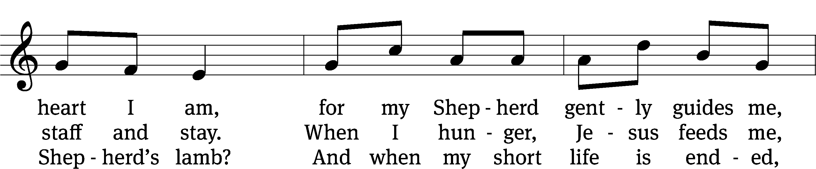
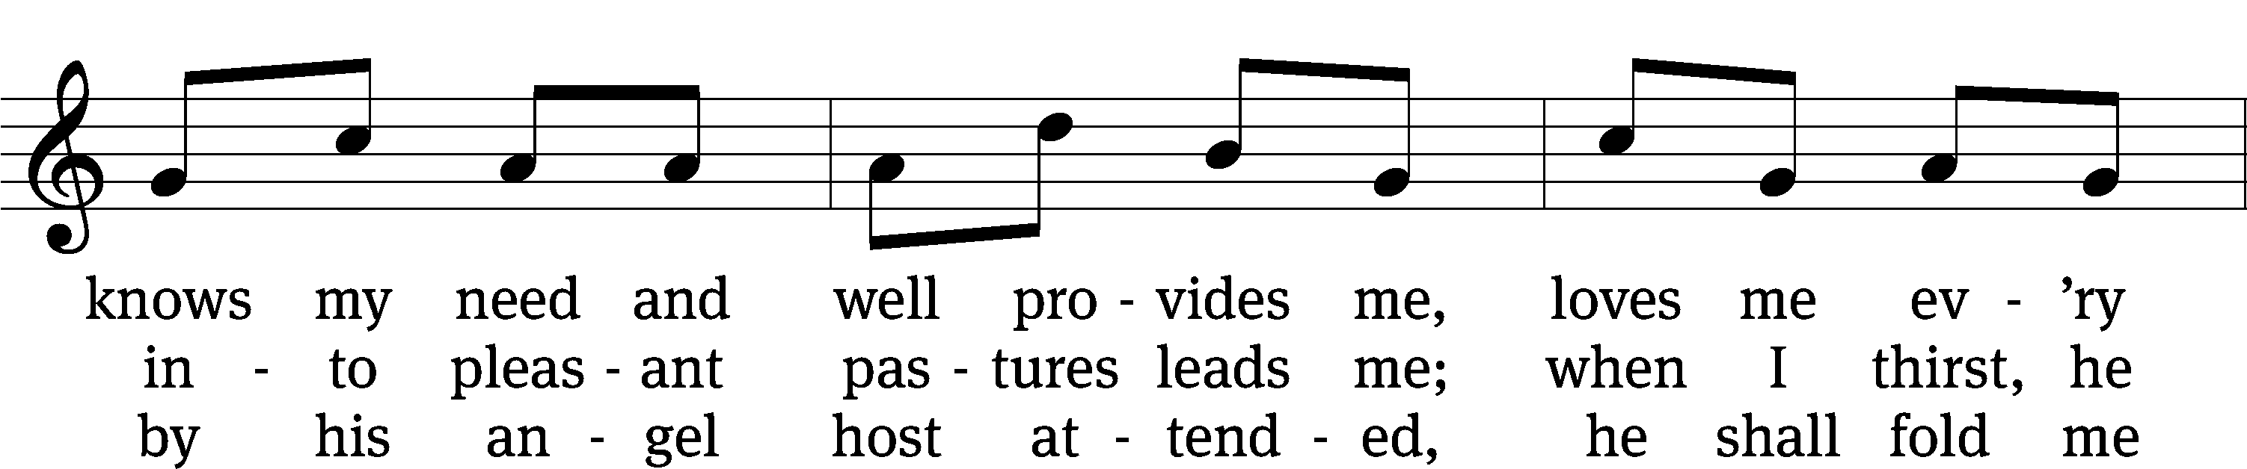
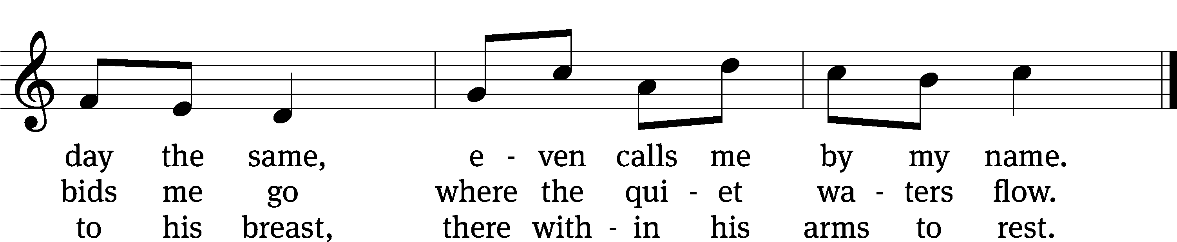
Text: tr. The Lutheran Hymnal, 1941, alt.; Henrietta L. von Hayn, 1724–1782
Tune: Choral-Buch . . . Brüder-Gemeinen, Leipzig, 1784
Text and tune: Public domain

Serving In Worship
Officiant Pastor Natsis
Organist Marcia Marion Ackling
Choir Director Cynthia Natsis
Accompanist Sarah Hanke
Deacons (8:30) Dave Stevenson and Jim Tice
(11:00) Steve Hoeft and Jeff Neuburger
Ushers (8:30) Dale Finkbeiner and Mark Finkbeiner
(11:00) Al Whitley
Altar Guild Jean Fiegel and Ann Latowski
Videographer Rick Schneider

Copyright information
Service of the Word: Christian Worship. © 1993 Northwestern Publishing House. All rights reserved.
Reprinted with permission under ONE LICENSE #A-727703 and CCLI #1151741/CSPL126093

Words and Music: All rights reserved. Reprinted with permission under ONE LICENSE #A-727703 and
CCLI #1151741/CSPL126093

tlcsaline.church

