THIRD SUNDAY OF EASTER

TRINITY EVANGELICAL LUTHERAN CHURCH | Saline, Michigan
WELCOME TO WORSHIP May 1, 2022
Thank you for joining us in God’s house today! We cordially ask that our Guests sign one of the guestbooks located at either the front or back entryways, or fill out a “Let’s Get Acquainted” card located in the hymnal pew rack and place it in the collection plate.

THANK OFFERING: Members of Trinity give their offering as an expression of love and thankfulness to the Lord and to help support the Lord’s work in our community and around the world. Visitors need not feel obligated to participate in this offering which supports our ministry.

Restrooms are located at the back of the upper level (the annex), and in the basement (down the back stairs of the sanctuary or annex). Handicap access is available, please ask an usher for assistance.

Young Families / Toddler Bags – We are GLAD YOU BROUGHT YOUR CHILDREN to our worship service. Jesus said: “Let the little children come to me and do not hinder them, for the kingdom of God belongs to such as these.” We know that having little children in church can be a challenge, but DO NOT WORRY about it. Many of your fellow worshippers have been in your shoes and are just happy you brought your children with you. For your convenience, we have reserved the back rows of seating for parents with small children. These areas provide more flexibility for your family, as well as, easy access to move downstairs if necessary. A closed-circuit TV system allows families to continue participating in the service while downstairs. Pre-school toddler bags and children’s bulletins are available for their enjoyment. Ask an usher for one to use during the service and please return the toddler bag afterwards.

celebration of holy communion:
In His Word, God makes it clear that the Lord’s Supper is to be shared by people of a common proclamation of faith (1 Corinthians 11:26; 1 Corinthians 10:16-17). Without judging anyone’s hearts, we invite those who share in our confession by their membership in our congregation or another congregation of the Wisconsin Evangelical Lutheran Synod (WELS) or the Evangelical Lutheran Synod (ELS) and who are properly prepared (1 Corinthians 11;27-29) to receive the Sacrament. Page 295 in Christian Worship provides a guide for preparation.
Guests, we would love to have you join us in communion fellowship in the future, and for that to be possible, we ask that you speak with one of the pastors so that we may speak with you on how that would be possible. We thank you for respecting the way we celebrate the Lord’s Supper in our congregations.
the SERVICE – setting one - WITH HOLY COMMUNION CW, page 154

445 He’s Risen, He’s Risen CW 445
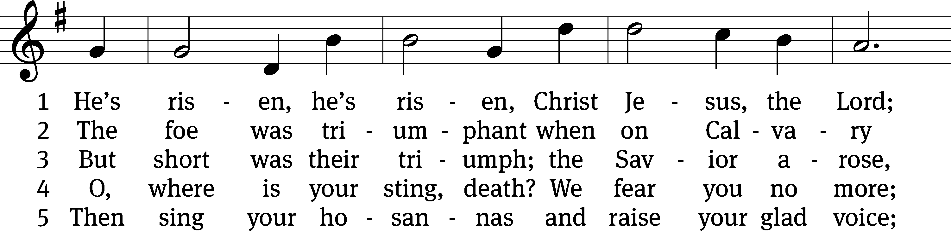
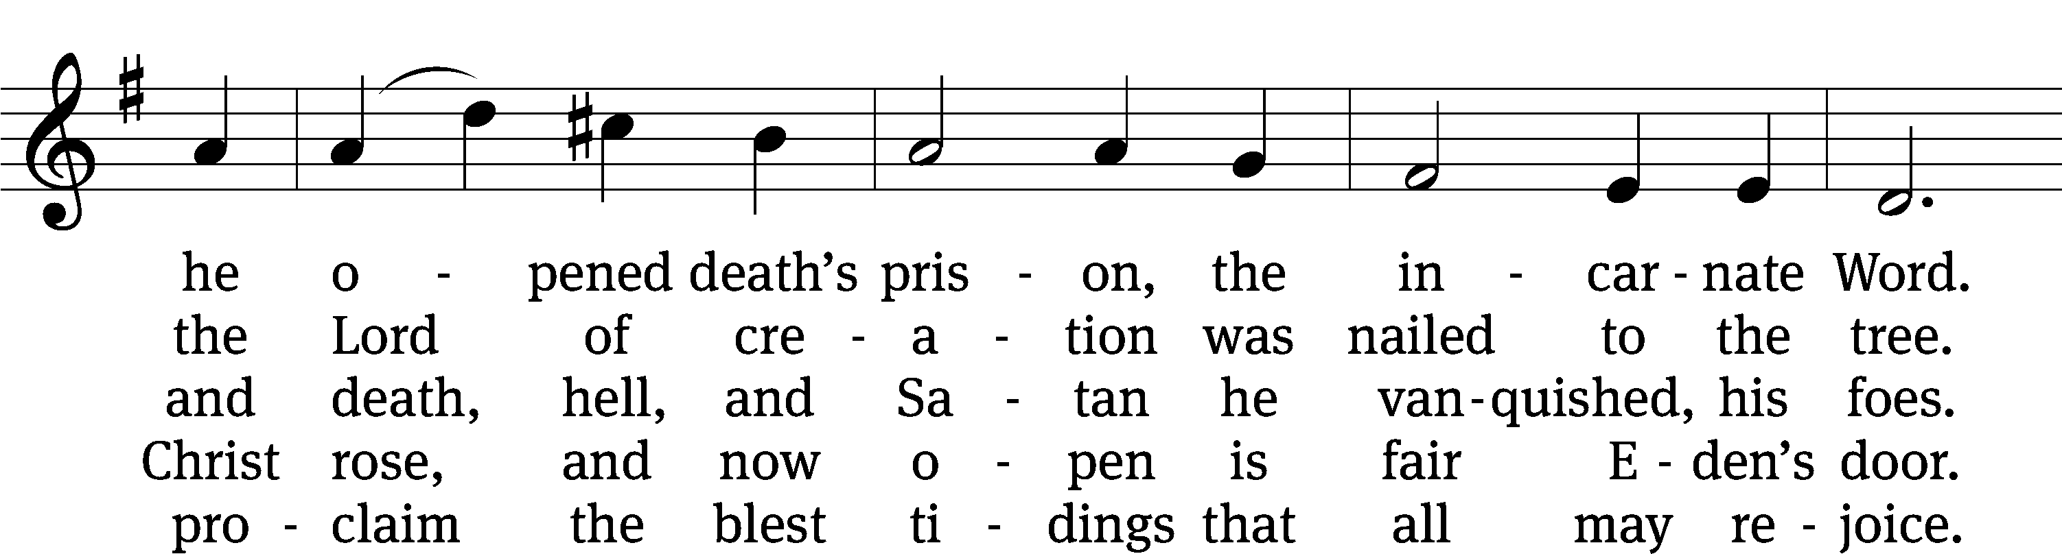
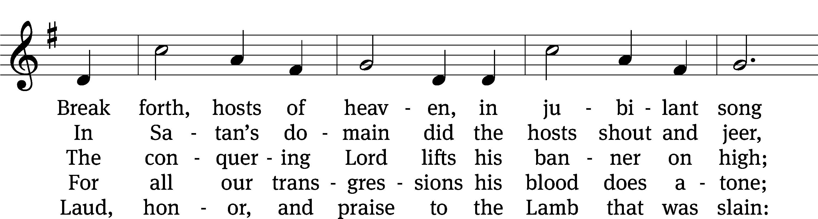
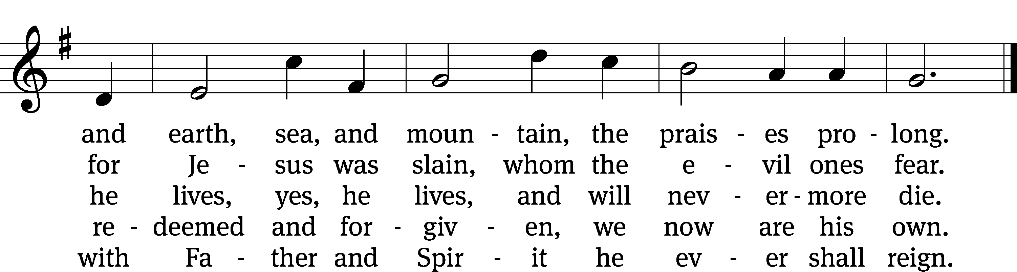
Text: tr. Anna M. Meyer, 1867–1941, alt.; C. F. W. Walther, 1811–1887, abr.
Tune: C. F. W. Walther, 1811–1887
Text: © 1941 Concordia Publishing House. Used by permission: OneLicense no. 727703
Tune: Public domain

Please stand, if you are able
Invocation
In the name of the Father and of the Son and of the Holy Spirit.
Amen.
Confession
If we claim to be without sin, we deceive ourselves and the truth is not in us.
If we confess our sins, God is faithful and just
and will forgive us our sins
and purify us from all unrighteousness.

Let us confess our sins to the Lord.
Holy God, gracious Father,
I am sinful by nature
and have sinned against you in my thoughts, words, and actions.
I have not loved you with my whole heart;
I have not loved others as I should.
I deserve your punishment both now and forever.
But Jesus, my Savior, paid for my sins
with his innocent suffering and death.
Trusting in him, I pray: God, have mercy on me, a sinner.

Our gracious Father in heaven has been merciful to us. He sent his only Son, Jesus Christ, who gave his life as the atoning sacrifice for the sins of the whole world. Therefore, as a called servant of Christ and by his authority, I forgive you all your sins in the name of the Father and of the Son and of the Holy Spirit. Amen.

Lord, Have Mercy

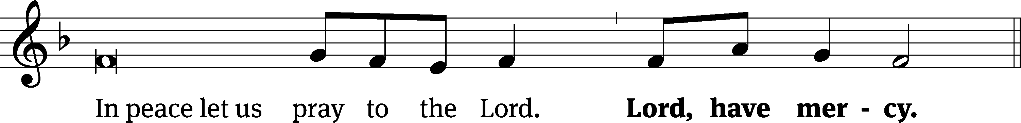
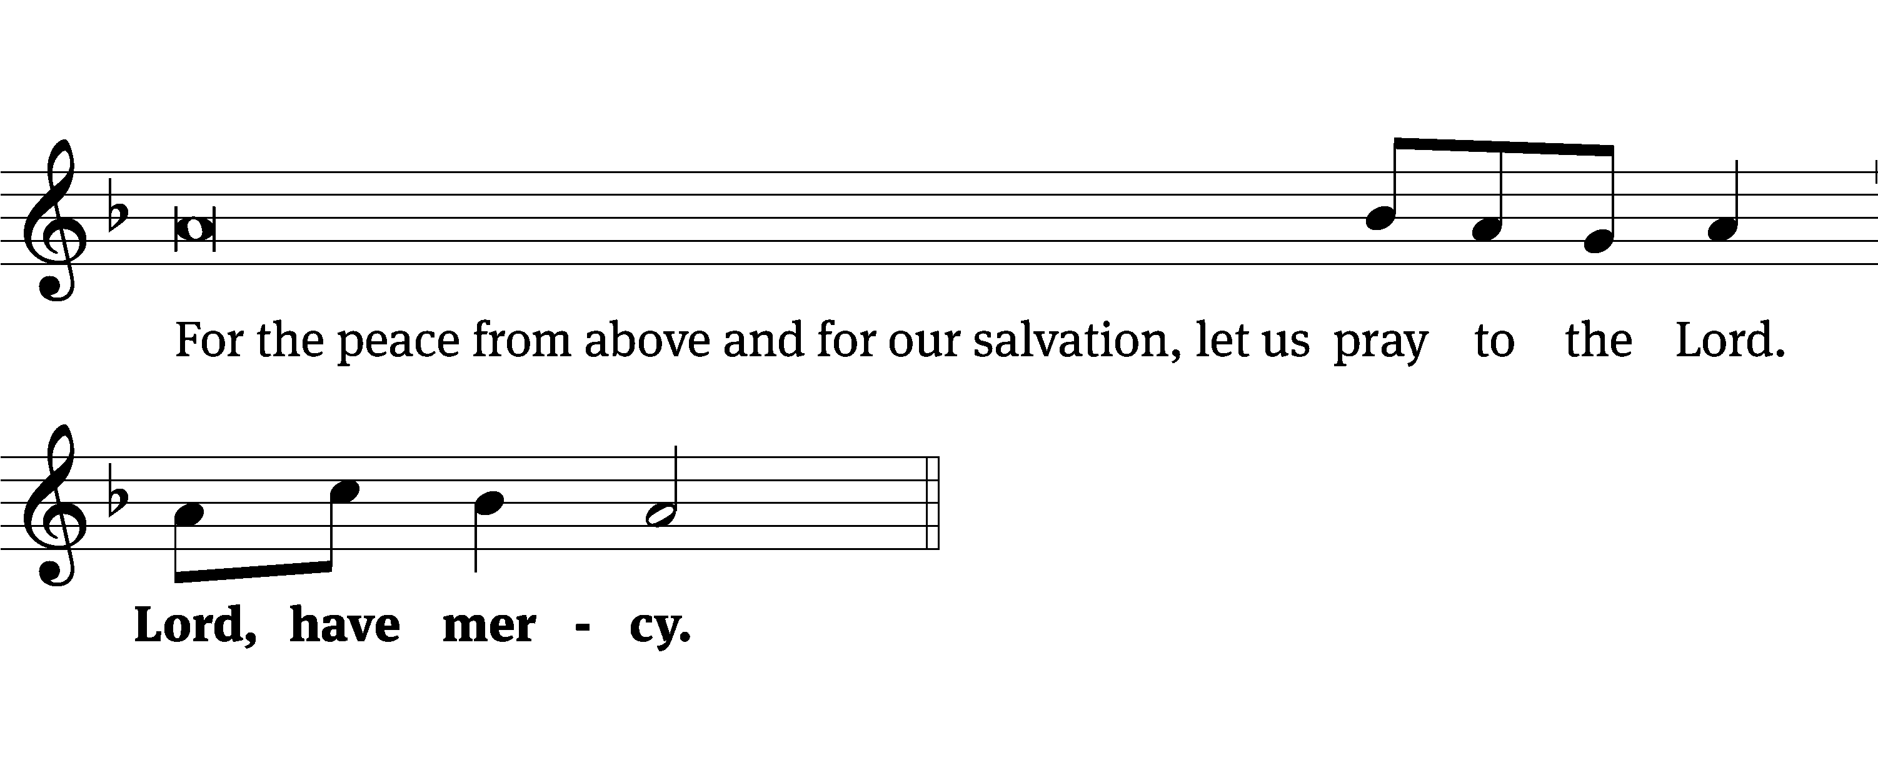
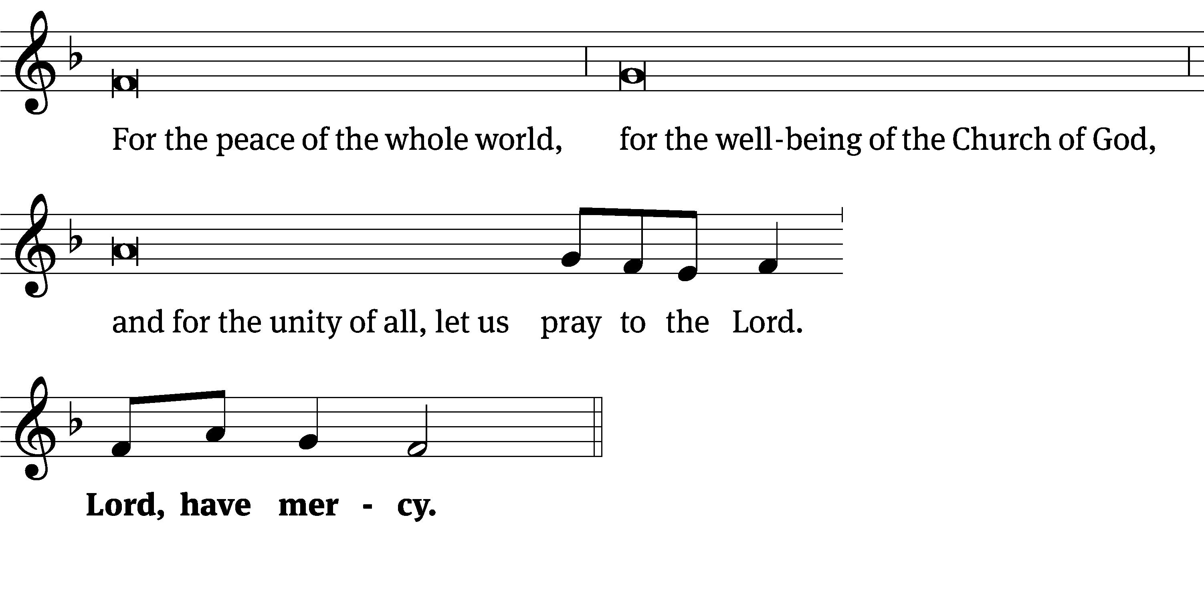
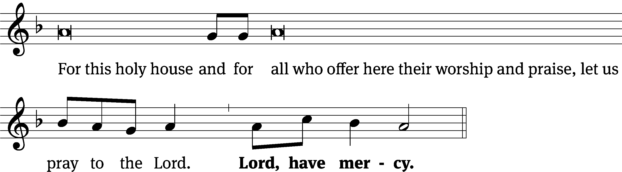
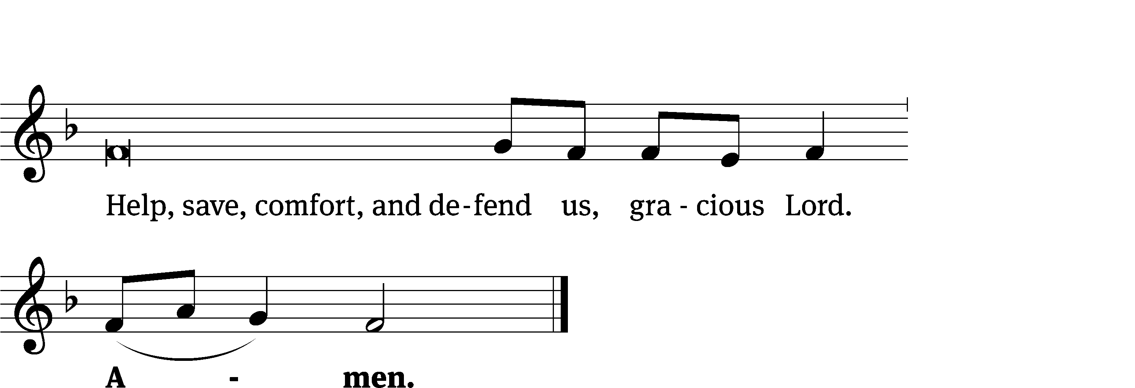
Tune: Kevin Becker
Tune: © 2021 Northwestern Publishing House. Used by permission: OneLicense no. 727703

Glory Be to God CW 157
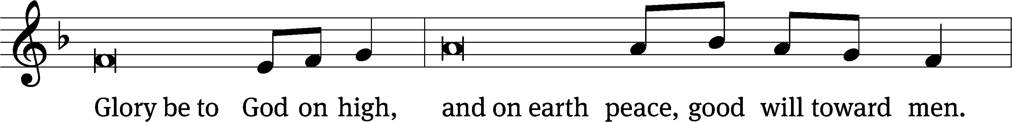
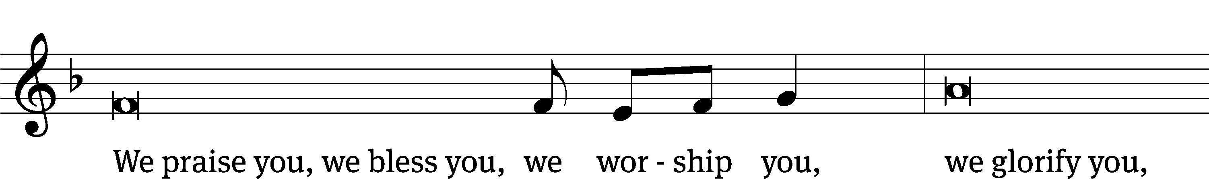
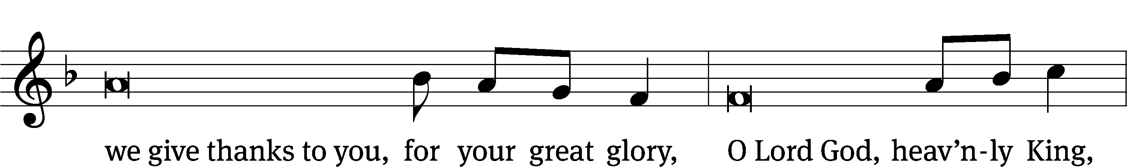
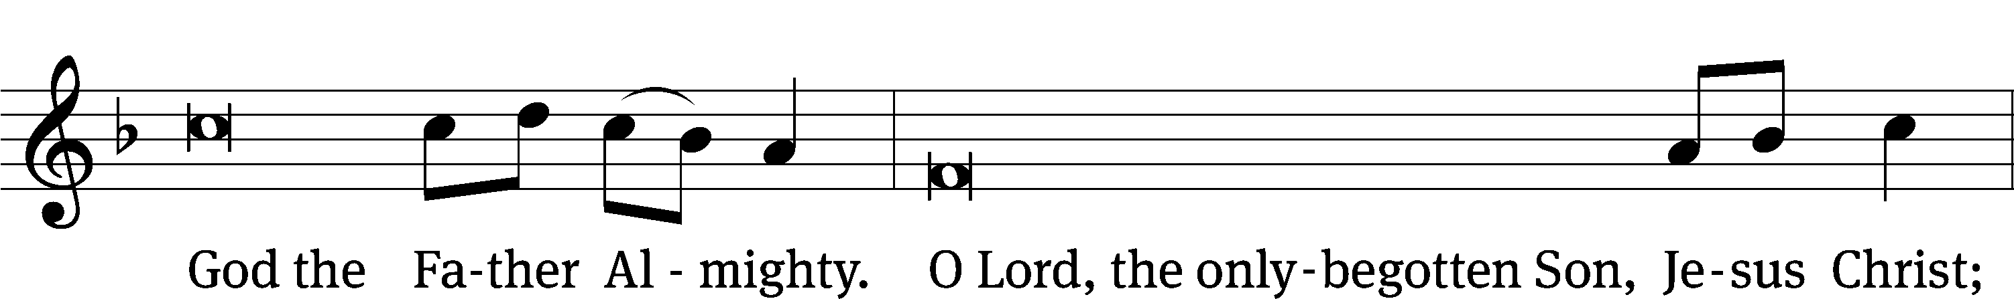
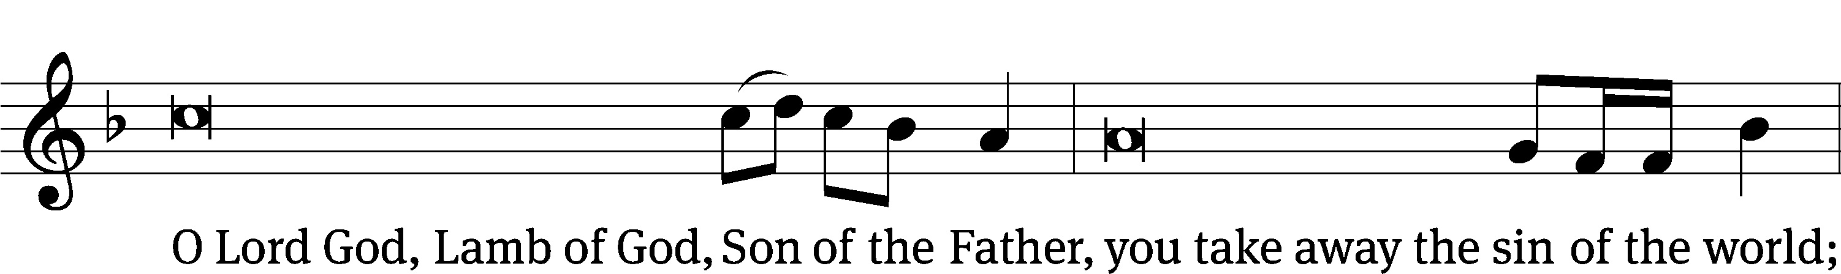
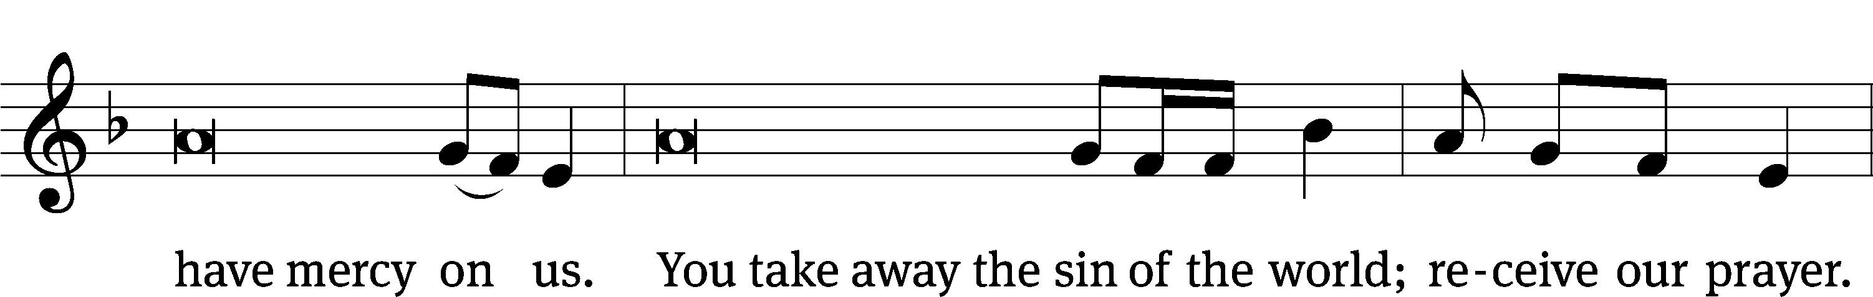
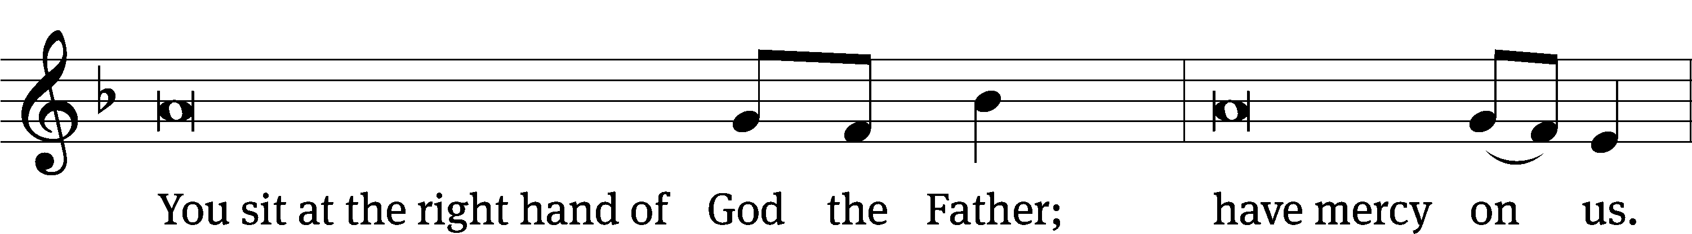
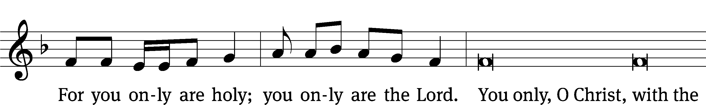
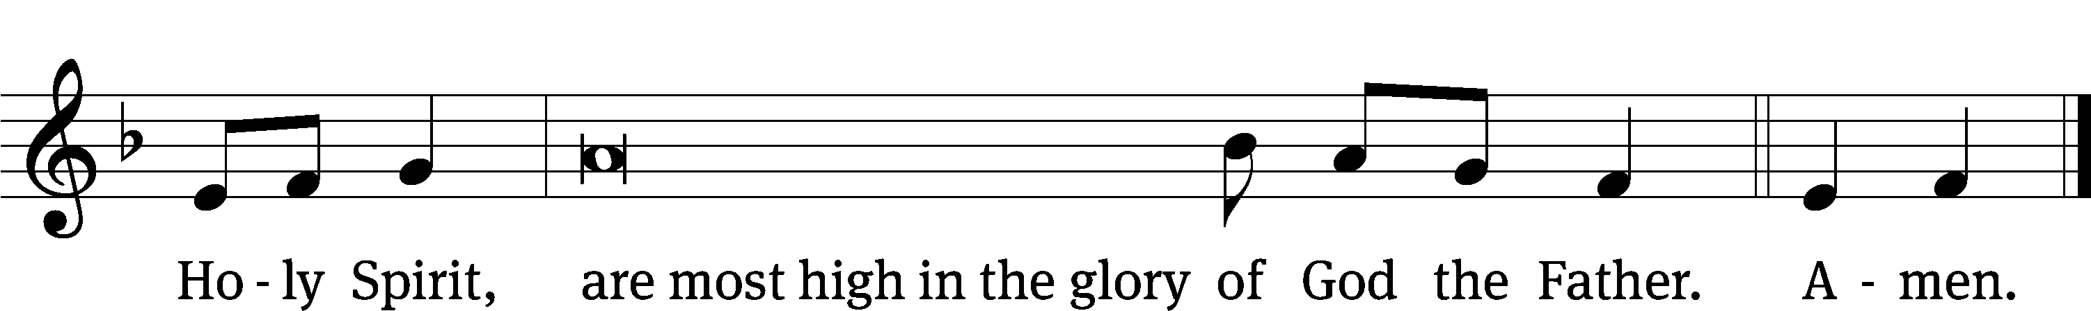

The Lord be with you.
And also with you.
Prayer of the Day
Let us pray.

O God, by the humiliation of your Son, you lifted up this fallen world from the despair of death. By his resurrection to life, grant your faithful people gladness of heart and the hope of eternal joys; through your Son, Jesus Christ our Lord, who lives and reigns with you and the Holy Spirit, one God, now and forever.
Amen.

Please be seated

First Reading Acts 9:1-22
¹ Meanwhile, Saul was still breathing out murderous threats against the disciples of the Lord. He went to the high priest ² and asked him for letters to the synagogues of Damascus, so that if he found any men or women belonging to the Way, he might bring them to Jerusalem as prisoners.
³ As he went on his way and was approaching Damascus, suddenly a light from heaven flashed around him. ⁴ He fell to the ground and heard a voice saying to him, “Saul, Saul, why are you persecuting me?”
⁵ He asked, “Who are you, Lord?”
He replied, “I am Jesus, whom you are persecuting. ⁶ But get up and go into the city, and you will be told what you need to do.”

⁷ The men traveling with him stood there speechless. They heard the voice but did not see anyone.
⁸ They raised Saul up from the ground, but when he opened his eyes, he could not see anything. They took him by the hand and led him into Damascus. ⁹ For three days he could not see, and he did not eat or drink.

¹⁰ There was a disciple in Damascus named Ananias. The Lord said to him in a vision, “Ananias!”
He answered, “Here I am, Lord.”
¹¹ The Lord told him, “Get up and go to the street called Straight, and at the house of Judas ask for a man from Tarsus named Saul. In fact, at this very moment he is praying. ¹² In a vision he has seen a man named Ananias come in and lay his hands on him so that he can regain his sight.”
¹³ Ananias answered, “Lord, I have heard from many people about this man and how much harm he did to your saints in Jerusalem. ¹⁴ And he has authority here from the chief priests to arrest all who call on your name.”
¹⁵ The Lord said to him, “Go! This man is my chosen instrument to carry my name before the Gentiles and kings and the people of Israel. ¹⁶ Indeed, I will show him how much he must suffer for my name.”

¹⁷ Ananias left and entered the house. Laying his hands on Saul, he said, “Brother Saul, the Lord Jesus, whom you saw on your way here, has sent me so that you may see again and be filled with the Holy Spirit.”
¹⁸ Immediately something like scales fell from his eyes, and he could see again. He got up and was baptized. ¹⁹ And after taking some food, he regained his strength.

Saul stayed with the disciples in Damascus for several days. ²⁰ Immediately he began to proclaim Jesus in the synagogues, saying, “He is the Son of God.”
²¹ All who heard him were amazed and said, “Isn’t this the one who raised havoc in Jerusalem among those who call on this name? Didn’t he come here for this very purpose: to bring them as prisoners to the chief priests?” ²² But Saul continued to get stronger and kept confounding the Jews who lived in Damascus by proving that Jesus is the Christ.

The Word of the Lord.
Thanks be to God.

Psalm of the Day
30D All with Joyful Exultation Psalm 30D
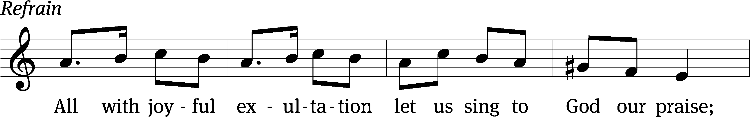
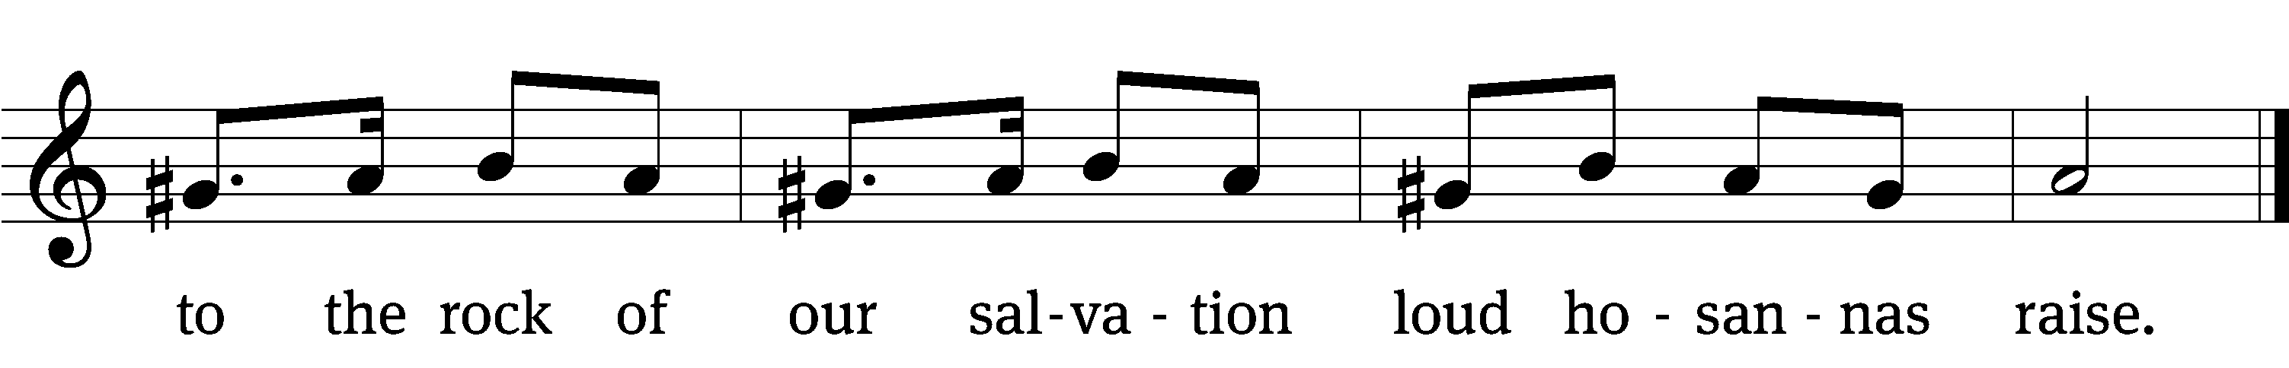
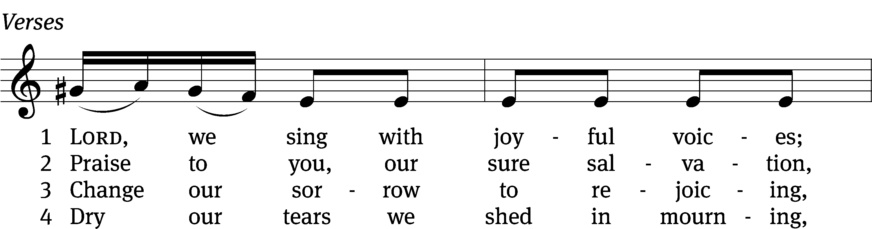
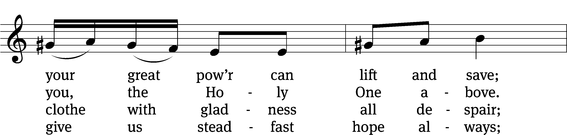
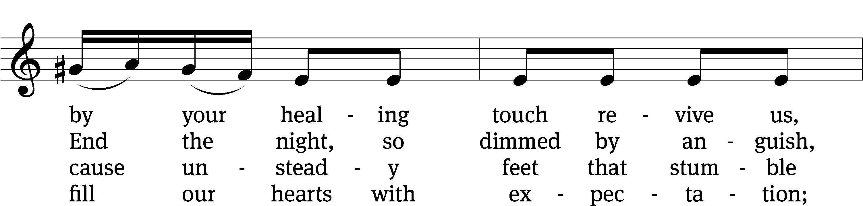
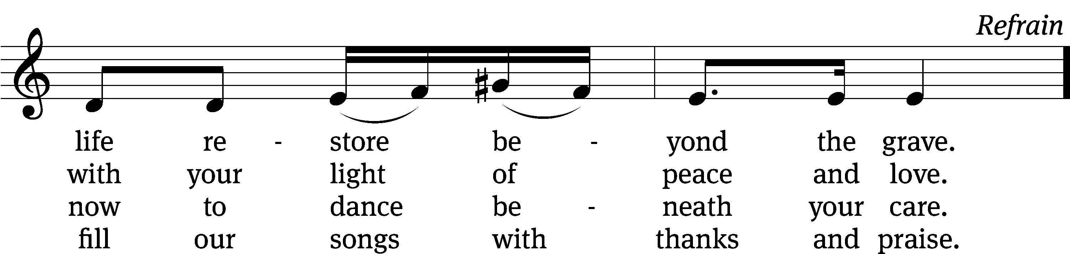
Text (sts. 1–4): Michael Morgan; (Ref): Hal H. Hopson
Tune: Hasidic
Text (sts. 1–4): © 2011 Michael Morgan, admin. Faith Alive Christian Resources; (Ref): © 2008 Birnamwood Publications, a division of MorningStar Music Publishers, Inc. Used by permission: OneLicense no. 727703
Tune: Public domain
Second Reading Revelation 5:11-14
¹¹ And I looked, and I heard the voice of many angels who were around the throne and around the living creatures and the elders. Their number was ten thousand times ten thousand, and thousands upon thousands. ¹² With a loud voice they were saying:
Worthy is the Lamb who was slain to receive
power and riches and
wisdom and strength and
honor and glory and blessing.
¹³ I also heard every creature that is in heaven and on earth and under the earth and on the sea, and all that is in them, saying:
To him who sits on the throne and to the Lamb
be blessing and honor and glory and might forever and ever.
¹⁴ The four living creatures said, “Amen,” and the elders bowed down and worshipped.

The Word of the Lord.
Thanks be to God.

Please stand, if you are able
Gospel Acclamation 2 Timothy 1:10
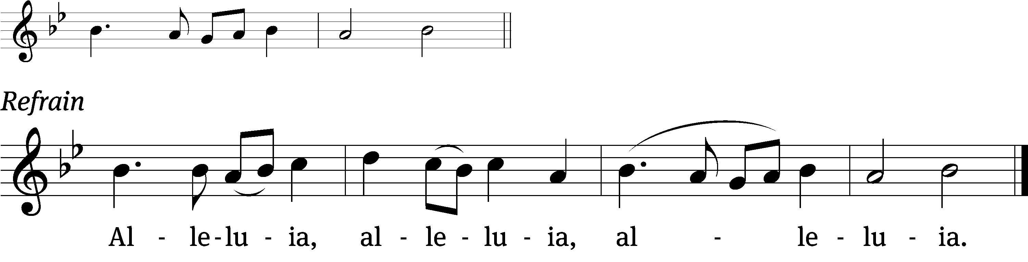
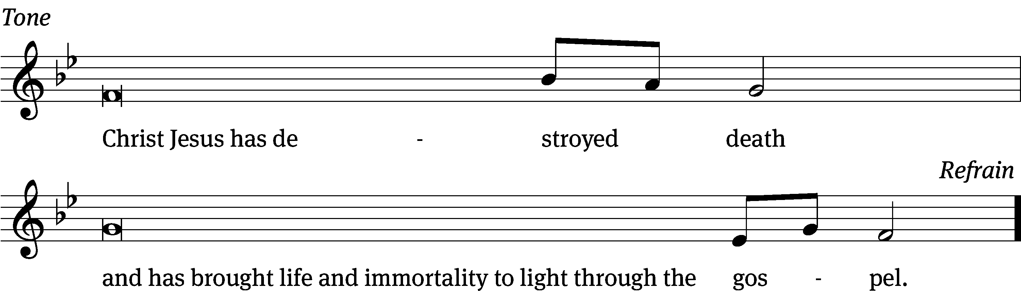
Tune: © 2021 Northwestern Publishing House. Used by permission: OneLicense no. 727703

Gospel John 21:1-14
¹ After this, Jesus showed himself again to the disciples at the Sea of Tiberias. This is how he showed himself: ² Simon Peter, Thomas (called the Twin), Nathanael from Cana in Galilee, the sons of Zebedee, and two other disciples were together. ³ Simon Peter said to them, “I’m going fishing.”
They replied, “We’ll go with you.”
They went out and got into the boat, but that night they caught nothing. ⁴ Early in the morning, Jesus was standing on the shore, but the disciples did not know it was Jesus.
⁵ Jesus called to them, “Boys, don’t you have any fish?”
“No!” they answered.
⁶ He told them, “Throw your net on the right side of the boat and you will find some.” So they cast the net out. Then they were not able to haul it in because of the large number of fish.
⁷ The disciple whom Jesus loved said to Peter, “It is the Lord!” When Simon Peter heard, “It is the Lord!” he tied his outer garment around him (for he had taken it off) and jumped into the sea. ⁸ But the other disciples came in the little boat, dragging the net full of fish, for they were not far from shore, about one hundred yards. ⁹ When they stepped out on land, they saw some bread and a charcoal fire with fish on it. ¹⁰ Jesus said to them, “Bring some of the fish you just caught.”
¹¹ So Simon Peter climbed aboard and hauled the net to land, full of large fish, 153 of them. Yet even with so many, the net was not torn.
¹² Jesus said to them, “Come, eat breakfast.”
None of the disciples dared ask him, “Who are you?” because they knew it was the Lord.
¹³ Jesus came, took the bread, and gave it to them, and also the fish. ¹⁴ This was now the third time Jesus appeared to his disciples after he was raised from the dead.
The Gospel of the Lord.
Praise be to you, O Christ!

Please be seated
716 O Christ, Who Called the Twelve CW 716
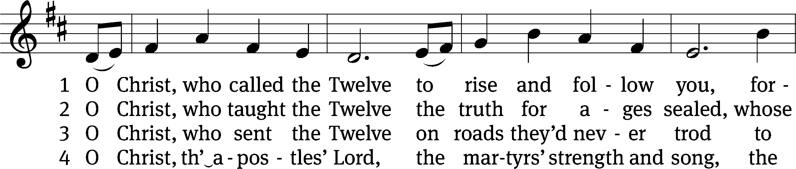
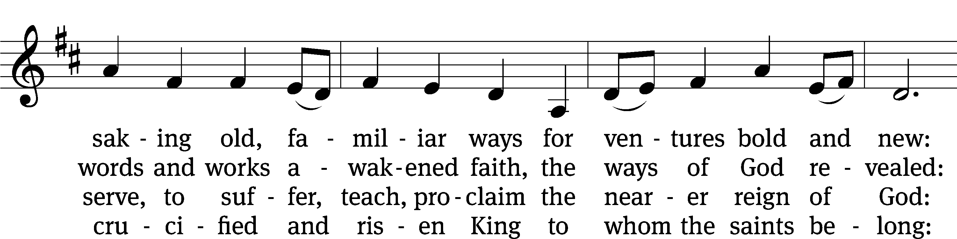
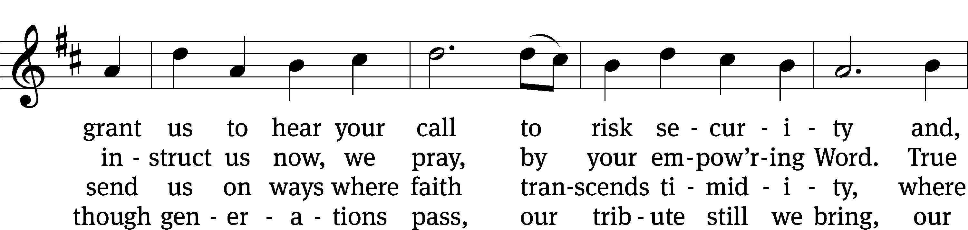
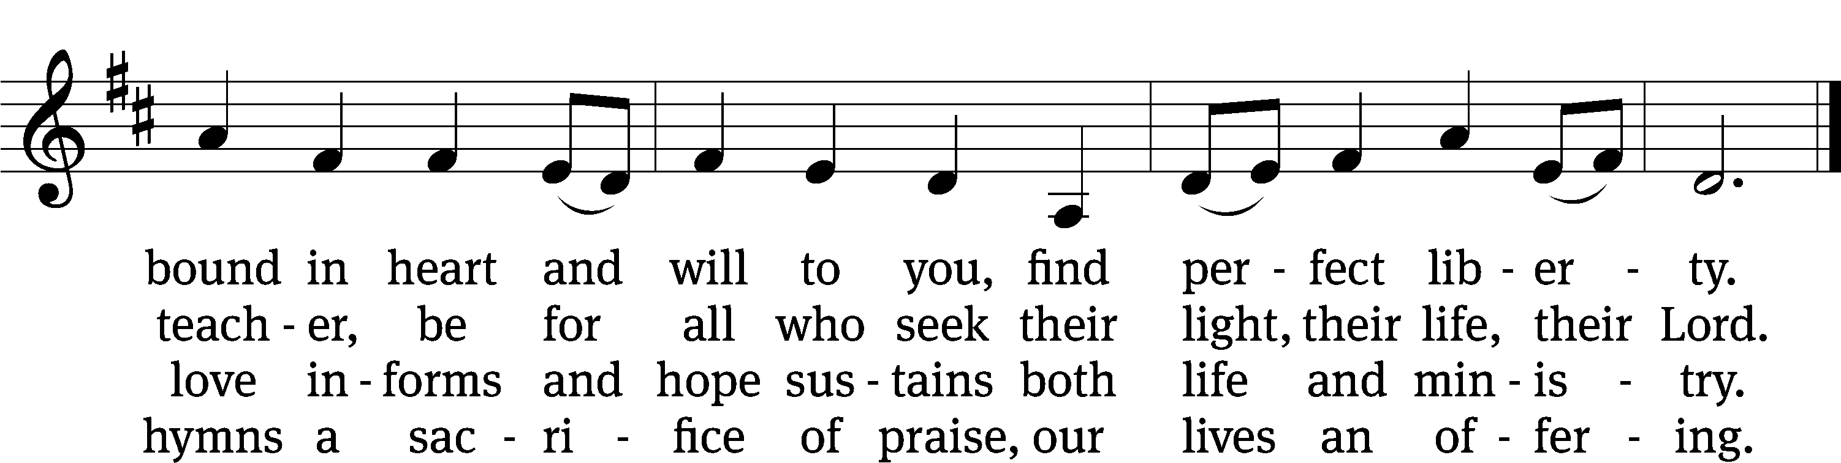
Text: Herman G. Stuempfle, Jr., 1923–2007
Tune: English; adapt. Franklin L. Sheppard, 1852–1930
Text: © 1993 GIA Publications, Inc. Used by permission: OneLicense no. 727703
Tune: Public domain

SERMON Acts 9:1-22
“The Perfect Person for the Job”

Please stand, if you are able
Nicene Creed
We believe in one God, the Father, the Almighty,
maker of heaven and earth,
of all that is,
seen and unseen.
We believe in one Lord, Jesus Christ, the only Son of God,
eternally begotten of the Father,
God from God, Light from Light, true God from true God,
begotten, not made,
of one being with the Father.
Through him all things were made.
For us and for our salvation, he came down from heaven,
was incarnate of the Holy Spirit and the Virgin Mary,
and became truly human.
For our sake he was crucified under Pontius Pilate.
He suffered death and was buried.
On the third day he rose again in accordance with the Scriptures.
He ascended into heaven
and is seated at the right hand of the Father.
He will come again in glory to judge the living and the dead,
and his kingdom will have no end.
We believe in the Holy Spirit,
the Lord, the giver of life,
who proceeds from the Father and the Son,
who in unity with the Father and the Son
is worshiped and glorified,
who has spoken through the prophets.
We believe in one holy Christian and apostolic Church.
We acknowledge one baptism for the forgiveness of sins.
We look for the resurrection of the dead
and the life of the world to come. Amen.
Offertory
Prayer of the Church

The Sacrament
Preface CW 165
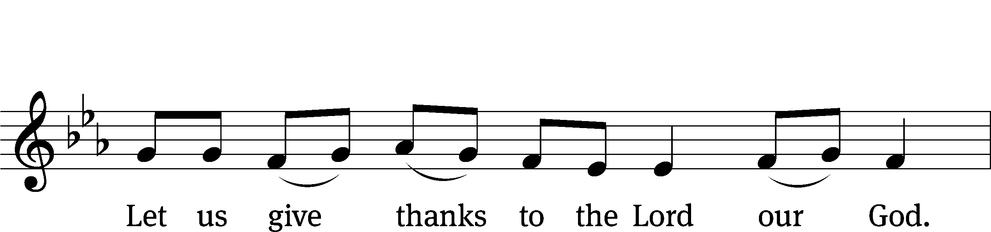
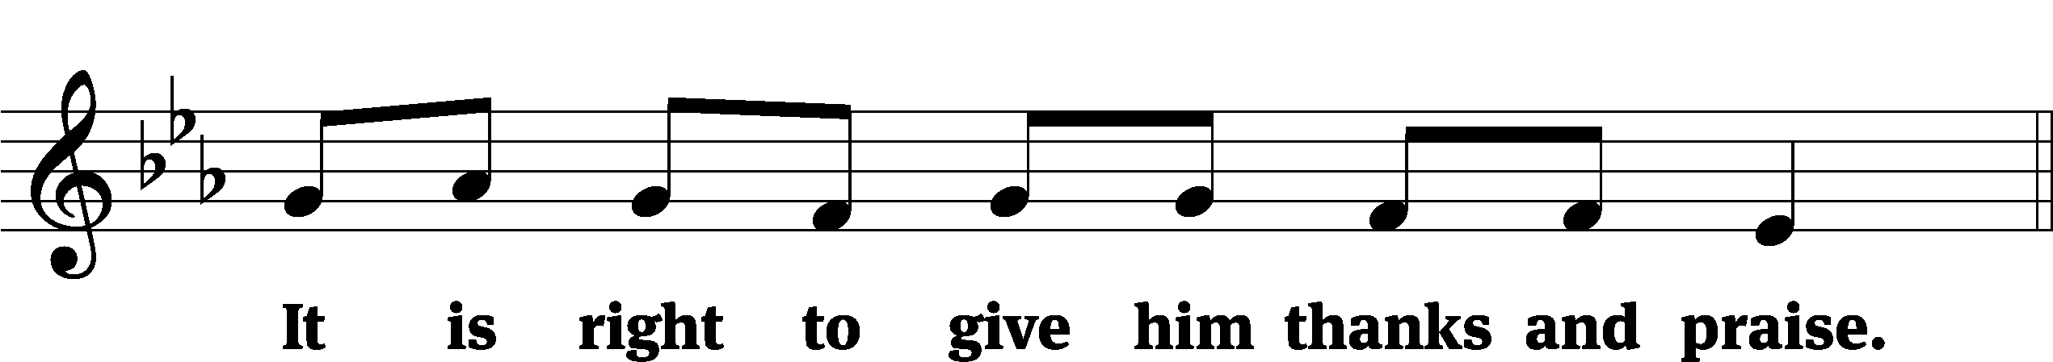

It is truly good and right that we should at all times and in all places give you thanks, O Lord, holy Father, almighty and everlasting God, through Jesus Christ our Lord, who brought the gift of salvation to all people by his death on the tree of the cross so that the devil, who overcame us by a tree, would in turn by a tree be overcome. Therefore, with all the saints on earth and hosts of heaven, we praise your holy name and join their glorious song:

Holy, Holy, Holy CW 167
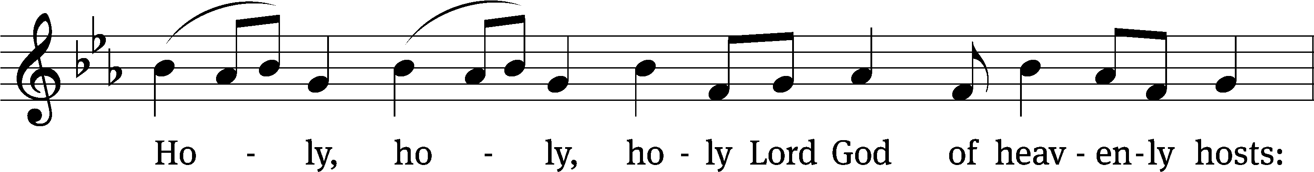
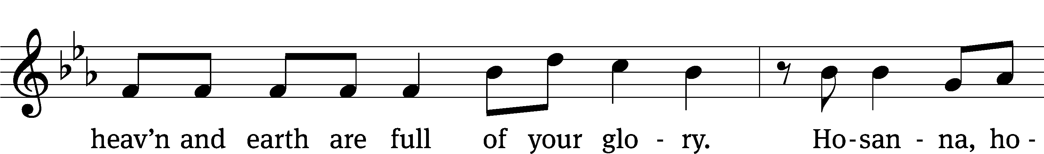
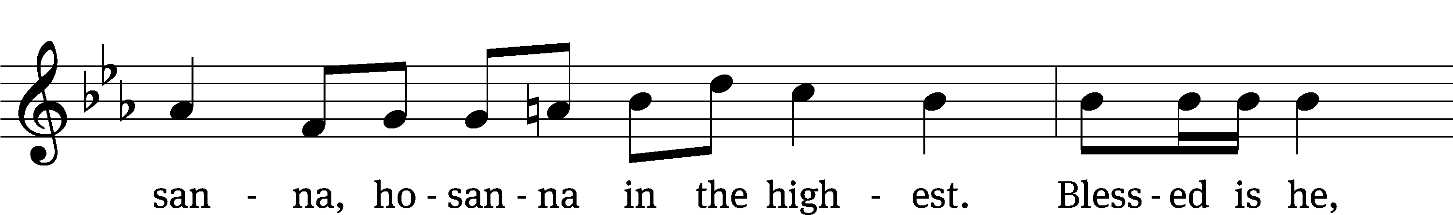
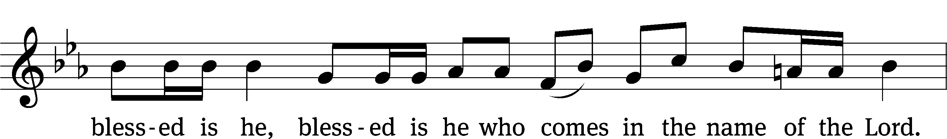
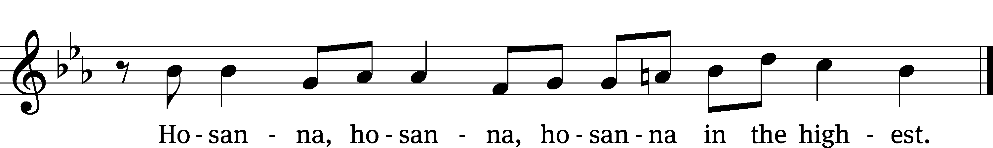

Prayer of Thanksgiving
We give thanks to you, O God, through your dear Son, Jesus Christ, whom you sent to be our Savior, our Redeemer, and the messenger of your grace. Through him you made all things; in him you are well pleased. He is the incarnate Word, conceived by the Holy Spirit and born of the Virgin Mary. To fulfill your promises, he stretched out his hands on the cross and released from eternal death all who believe in you.

As we remember Jesus’ death and resurrection, we thank you that you have gathered us together to receive your Son’s body and blood. Send us your Spirit, unite us as one, and strengthen our faith so that we may praise you in your Son, Jesus Christ. Through him, we glorify and honor you, O God our Father, with the Holy Spirit, one God, now and forever.
Amen.

Lord’s Prayer
Our Father, who art in heaven, hallowed be thy name, thy kingdom come, thy will be done on earth as it is in heaven. Give us this day our daily bread; and forgive us our trespasses, as we forgive those who trespass against us; and lead us not into temptation, but deliver us from evil. For thine is the kingdom and the power and the glory forever and ever. Amen.

Words of Institution
Our Lord Jesus Christ, on the night he was betrayed, took bread; and when he had given thanks, he broke it and gave it to his disciples, saying, “Take and eat; this is my body, which is given for you. Do this in remembrance of me.”
Then he took the cup, gave thanks, and gave it to them, saying, “Drink from it, all of you; this is my blood of the new covenant, which is poured out for you for the forgiveness of sins. Do this, whenever you drink it, in remembrance of me.”

The peace of the Lord be with you always.
Amen.
O Christ, Lamb of God CW 169
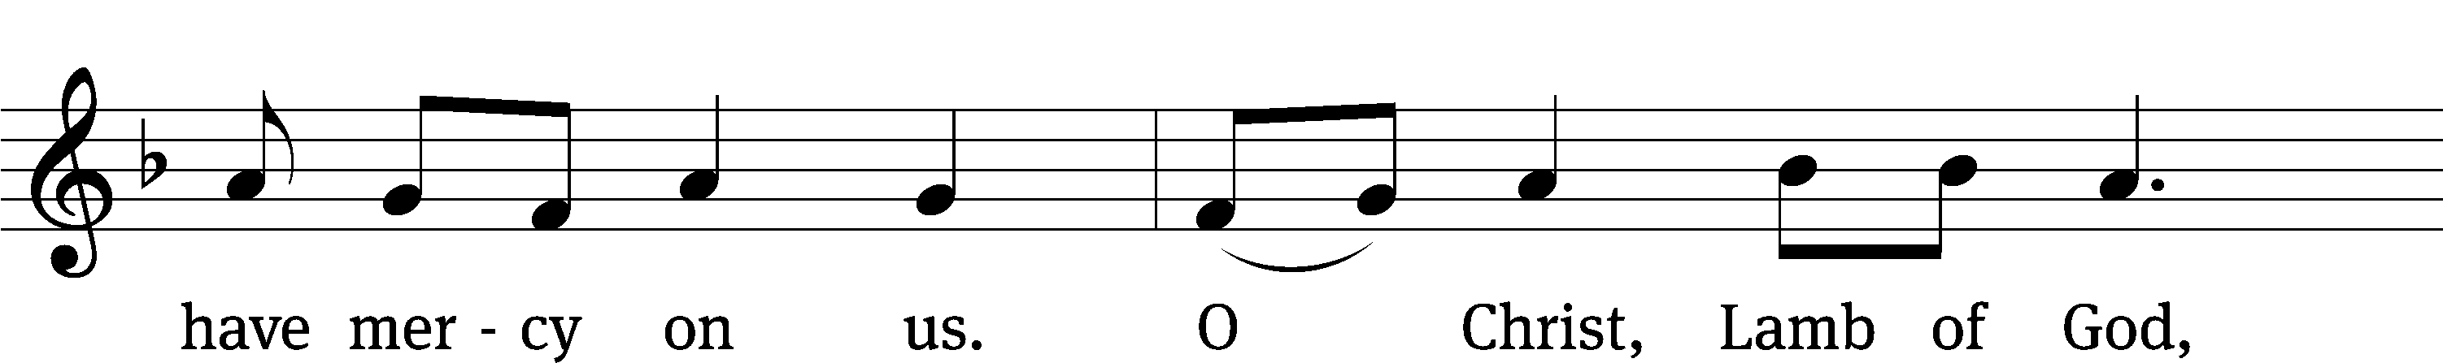
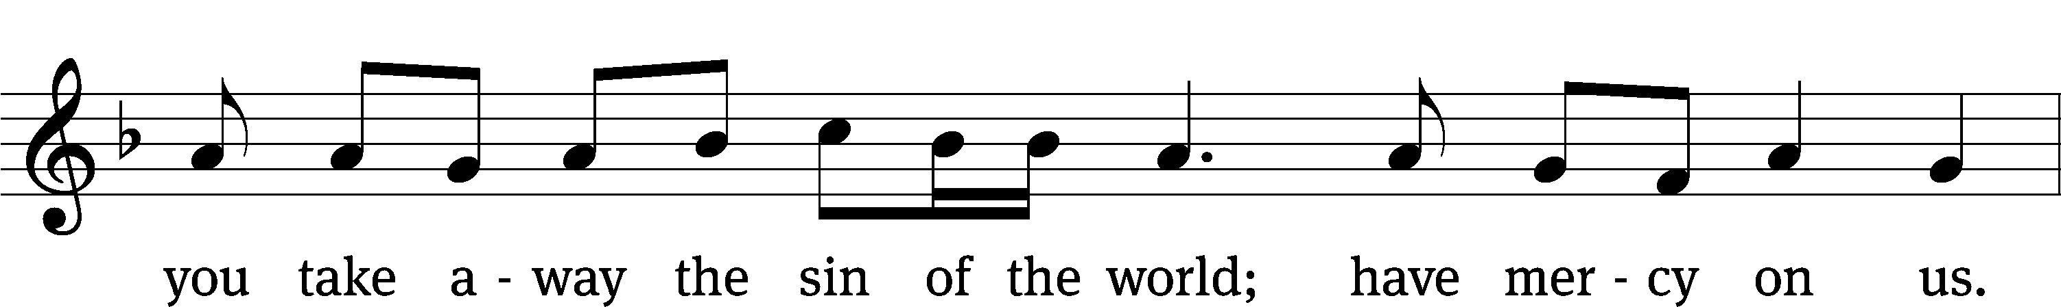
Please be seated
670 I Come, O Savior, to Your Table CW 670
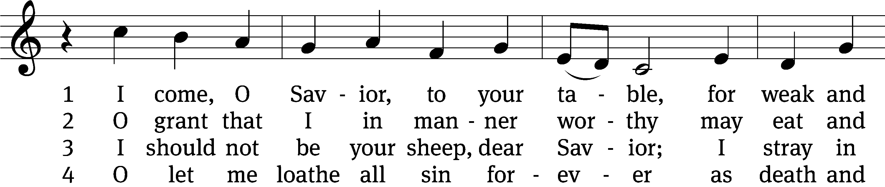
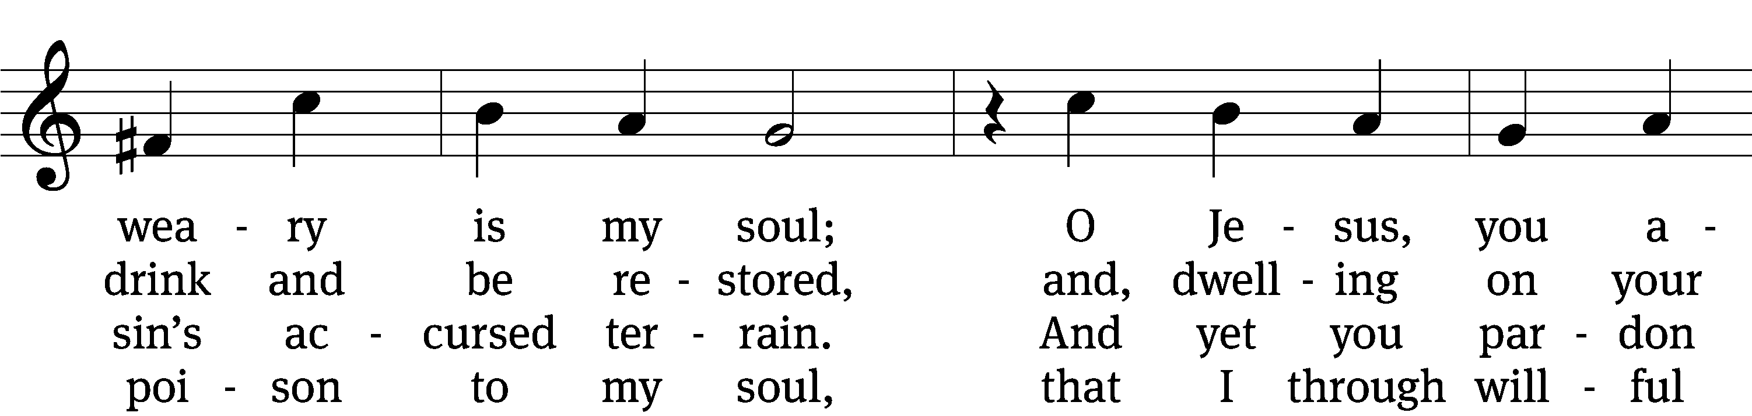
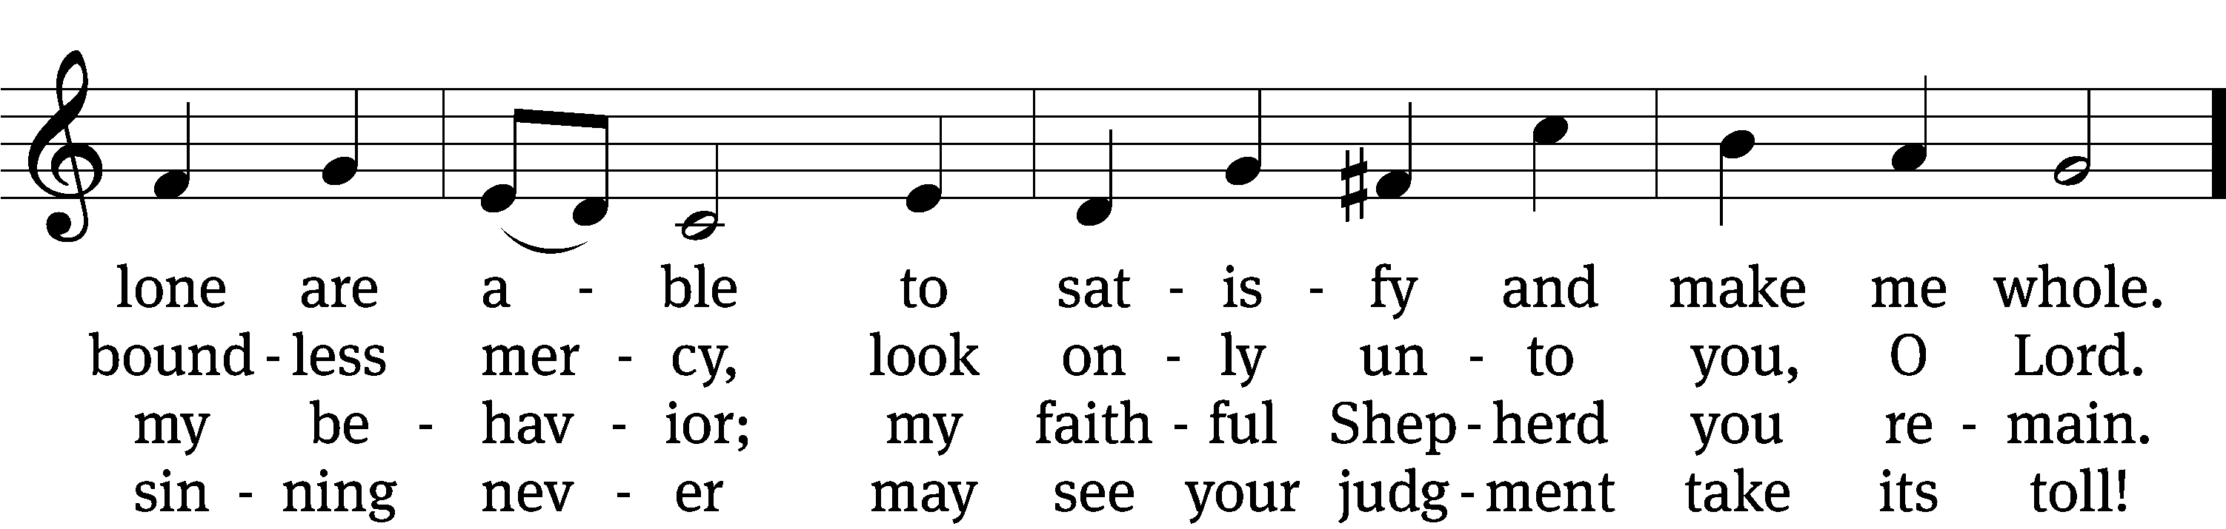
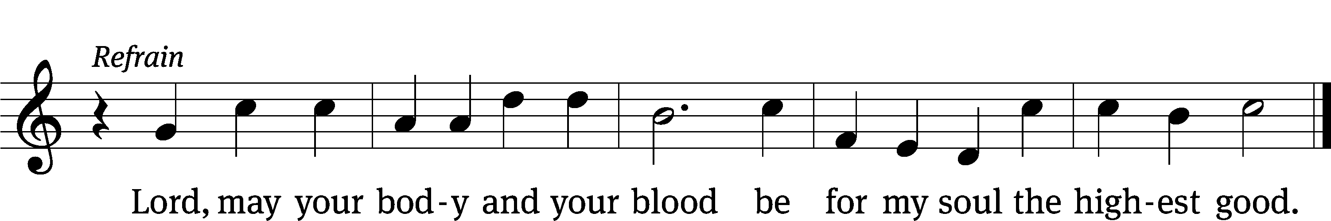

5 Your holy heart has one obsession,
one blessèd thing it burns to do—
to cleanse the sinner from transgression;
so I, a sinner, come to you. (Refrain)

6 My soul is burdened; Lord, relieve me,
by all this weight of sin oppressed!
Though sinful, yet, in grace receive me
and feed me as your grateful guest. (Refrain)

7 Within me, Lord, your vision traces
a heart of deep humility
that mourns its sin and yet embraces
the merit you have earned for me. (Refrain)

8 By faith I call your holy table
the testament of your deep love,
for by your gift I now am able
to know the heart of God above. (Refrain)

9 This meal with blessing is abounding:
to poor ones wealth, to weak ones pow’r,
to angels joy, to hell confounding,
and life for me in death’s dark hour. (Refrain)

10 My heart has now become your dwelling,
O blessèd, holy Trinity.
With angels I, your praises telling,
shall live in joy eternally. (Refrain)
Text: Friedrich C. Heyder, 1677–1754, abr.; (sts. 1, Ref, 2, 4, 8–10): tr. The Lutheran Hymnal, 1941; (sts. 3, 5–7): tr. Michael D. Schultz, b. 1963
Tune: Emskirchner Choral-Buch, Leipzig, 1756
Text (sts. 1, Ref, 2, 4, 8–10): © 1941 Concordia Publishing House; (sts. 3, 5–7): © 2021 Northwestern Publishing House. Used by permission: OneLicense no. 727703
Tune: Public domain

Please stand, if you are able

Give thanks to the Lord, for he is good;
his mercy endures forever.
Whenever we eat this bread and drink this cup,
we proclaim the Lord’s death until he comes.

We give thanks, almighty God, that you have refreshed us with this saving gift. We pray that through it you will strengthen our faith in you and increase our love for one another. We ask this in the name of Jesus Christ our Lord, who lives and reigns with you and the Holy Spirit, one God, now and forever.
Amen.

Blessing
The Lord bless you and keep you.
The Lord make his face shine on you and be gracious to you.
The Lord look on you with favor and give you peace.
Amen.
Please be seated
892 By All Your Saints Still Striving CW 892 sts. 1, 12, 3
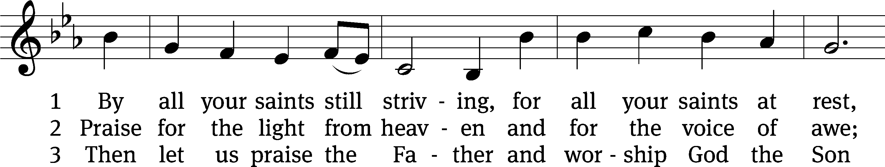
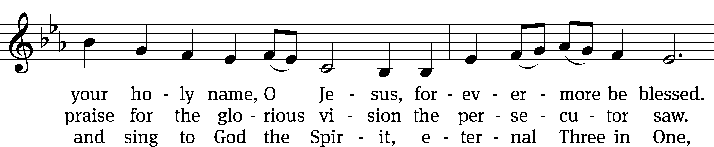
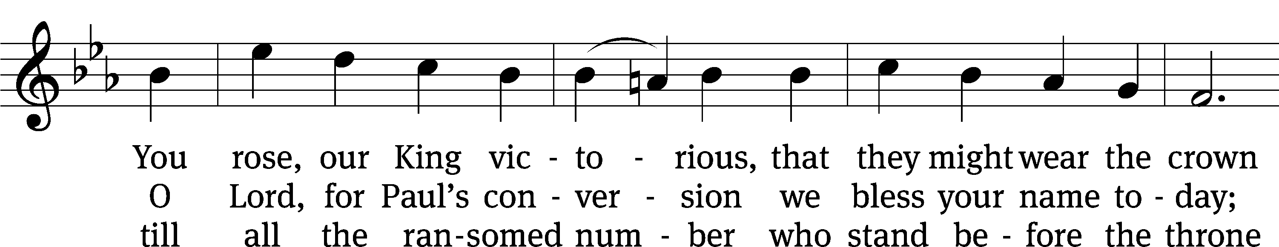
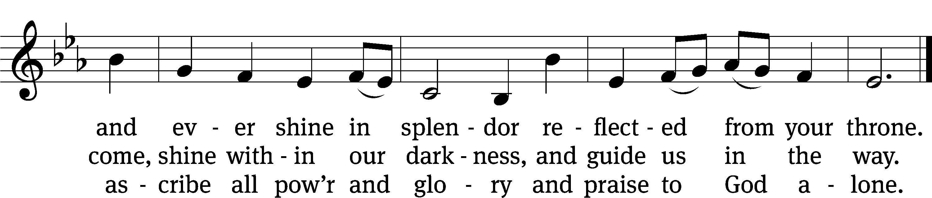

Text: Horatio Bolton Nelson, 1823–1913, alt.
Tune: Finnish
Text and tune: Public domain

Acknowledgments
Setting One from Christian Worship
Software distributed in partnership with Northwestern Publishing House.
Created by Christian Worship: Service Builder © 2022 Concordia Publishing House.

Serving in Worship
Officiant Pastor Natsis
Organist Marcia Marion Ackling
Deacons (8:30) Dave Stevenson and Ed Wheeler
(11:00) Dave Frey and Steve Hoeft
Ushers (8:30) Dale Radak
(11:00) Ron Zahn
Altar Guild Sandy Kirkpatrick and Barb Neuburger
Videographer Cindy Dresch

* * * * * * * * * * * * * * * * * * * * * * * * * *

trinitylutheran-saline.org

