THE FOURTH SUNDAY
OF EASTER
“GOOD SHEPHERD SUNDAY”

tRINITY EVANGELICAL LUTHERAN CHURCH | Saline, Michigan
May 8, 2022

WELCOME TO WORSHIP

Thank you for joining us in God’s house today! We cordially ask that our Guests with us this morning sign one of the guestbooks located at either the front or back entryways.

THANK OFFERING: Members of Trinity give their offering as an expression of love and thankfulness to the Lord and to help support the Lord’s work in our community and around the world. Visitors need not feel obligated to participate in this offering which supports our ministry.

Restrooms are located at the back of the upper level (the annex), and in the basement (down the back stairs of the sanctuary or annex). Handicap access is available, please ask an usher for assistance.

Young Families / Toddler Bags – We are GLAD YOU BROUGHT YOUR CHILDREN to our worship service. Jesus said: “Let the little children come to me and do not hinder them, for the kingdom of God belongs to such as these.” We know that having little children in church can be a challenge, but DO NOT WORRY about it. Many of your fellow worshippers have been in your shoes and are just happy you brought your children with you. For your convenience, we have reserved the back rows of seating for parents with small children. These areas provide more flexibility for your family, as well as, easy access to move downstairs if necessary. A closed-circuit TV system allows families to continue participating in the service while downstairs. Pre-school toddler bags and children’s bulletins are available for their enjoyment. Ask an usher for one to use during the service and please return the toddler bag afterwards.

SERVICE of the word

553 The Lord’s My Shepherd CW 553
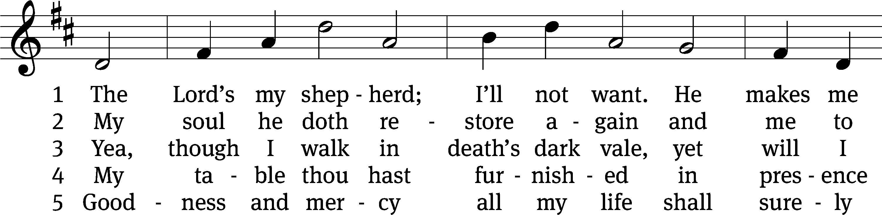
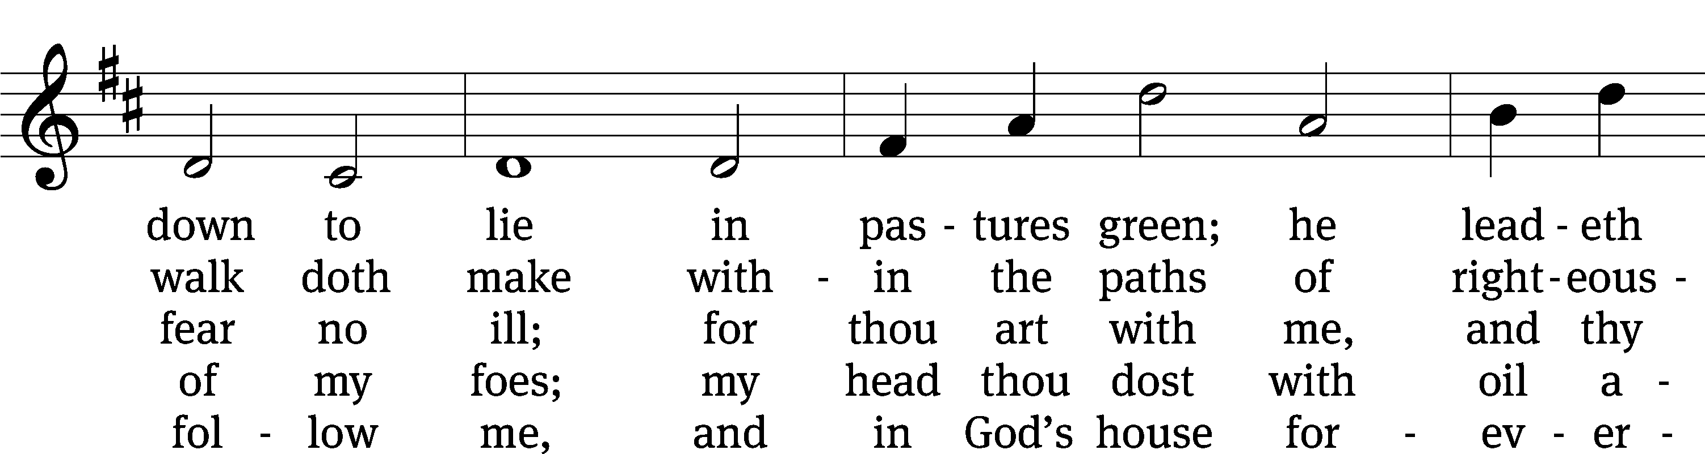
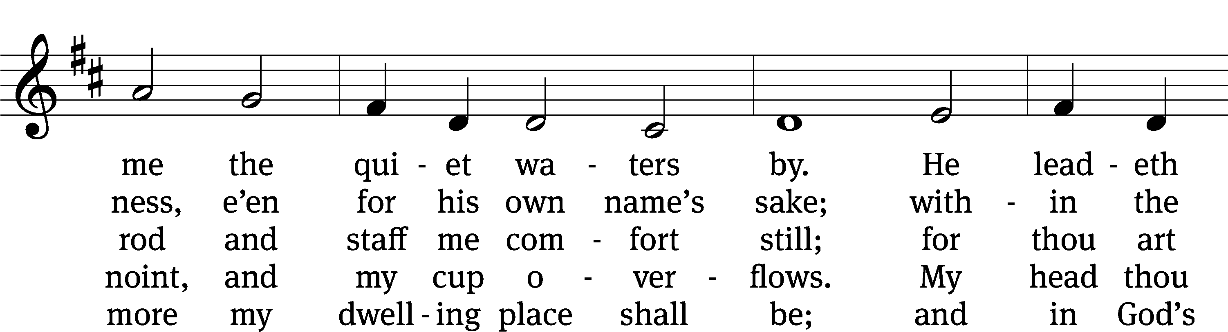
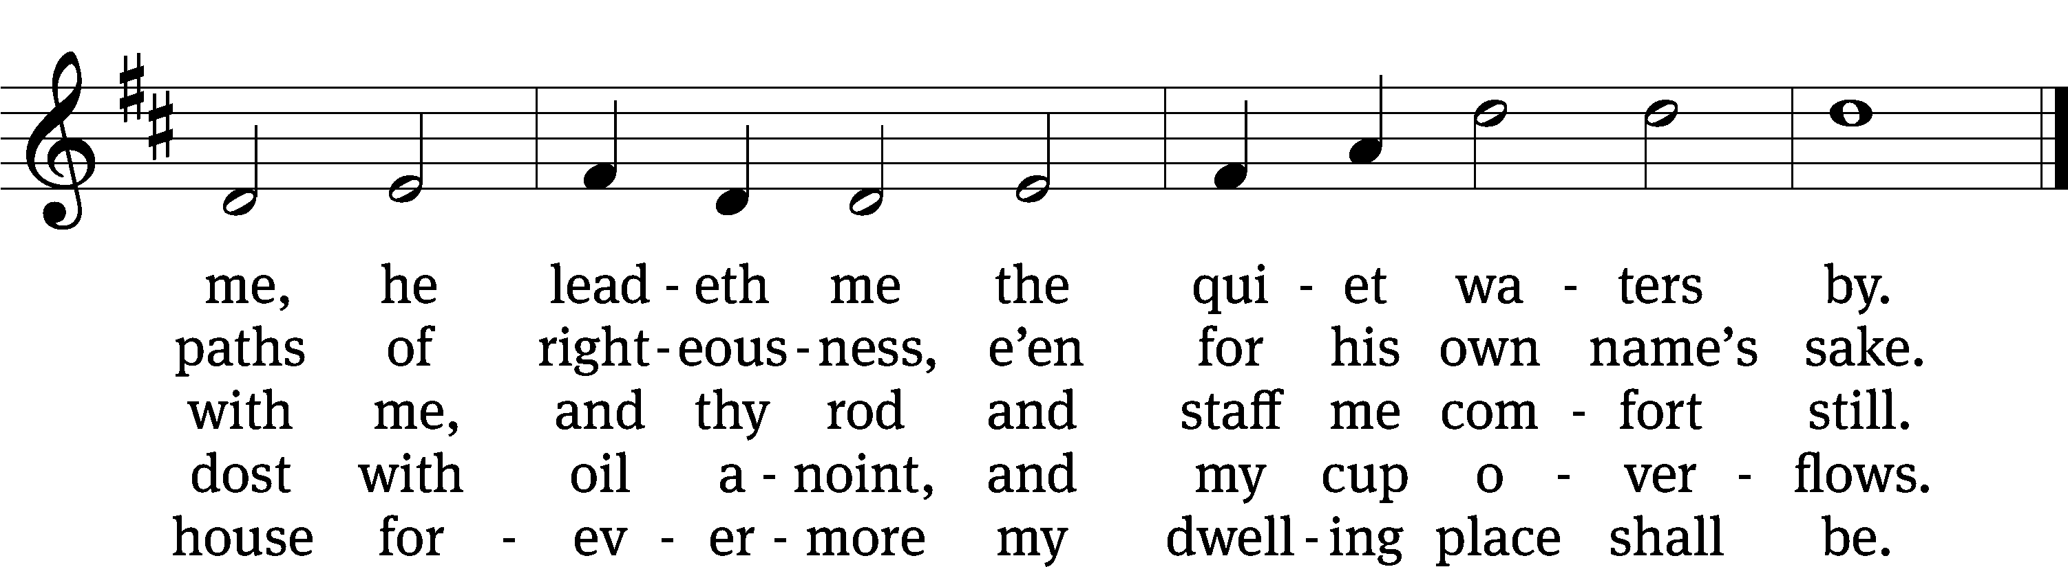

Text: The Psalms of David in Meeter, Edinburgh, 1650
Tune: James L. Macbeth Bain, 1860–1925
Text and tune: Public domain

PLEASE STAND, IF YOU ARE ABLE

invocation
M: The grace of our Lord (+) Jesus Christ and the love of God and the fellowship of the Holy Spirit be with you.
C: And also with you.
CONFESSION OF SINS
M: We have come into the presence of God, who created us to love and serve him as his dear children. But we have disobeyed him and deserve only his wrath and punishment. Therefore, let us confess our sins to him and plead for his mercy.

C: Merciful Father in heaven, I am altogether sinful from birth. In countless ways I have sinned against you and do not deserve to be called your child. But trusting in Jesus, my Savior, I pray: Have mercy on me according to your unfailing love. Cleanse me from my sin, and take away my guilt.
M: God, our heavenly Father, has forgiven all your sins. By the perfect life and innocent death of our Lord Jesus Christ, he has removed your guilt forever. You are his own dear child. May God give you strength to live according to his will.

C: Amen.
PRAYER AND PRAISE

M: In the peace of forgiveness, let us praise the Lord.

OH, TASTE AND SEE

PRAYER OF THE DAY

M: Let us pray.
The minister says the Prayer of the Day.

PLEASE BE SEATED
The Word

the FIRST LESSON aCTS 13:15-16A, 26-39
¹⁵ After the reading of the Law and the Prophets, the leaders of the synagogue sent a message to them, saying, “Gentlemen, brothers, if you have a word of encouragement for the people, say it.”
¹⁶ Then Paul stood up, motioned with his hand, and said, ²⁶ “Gentlemen, brothers, sons of Abraham’s family, and those among you who fear God, this message of salvation has been sent to you. ²⁷ The people of Jerusalem and their rulers did not recognize him, and by condemning him they fulfilled the statements of the prophets that are read every Sabbath. ²⁸ Though they found no grounds for a death sentence, they asked Pilate to have him executed. ²⁹ When they carried out everything that was written about him, they took him down from the cross and laid him in a tomb. ³⁰ But God raised him from the dead, ³¹ and for many days he was seen by those who had come up with him from Galilee to Jerusalem. These same individuals are now his witnesses to the people.
³² “We are preaching to you the good news about the promise that was made to our fathers. ³³ God has fulfilled this promise for us, their children, by raising up Jesus. As it is also written in the second Psalm:
You are my Son.
Today I have begotten you.
³⁴ “That God would raise him from the dead never again to be subject to decay, God said in this way:
I will give you the holy and sure blessings promised to David.
³⁵ “Therefore he also says in another place:
You will not let your Holy One see decay.
³⁶ “For David, after he had served God’s purpose in his own generation, fell asleep, was laid to rest with his fathers, and saw decay. ³⁷ But the One God raised did not see decay.
³⁸ “So, gentlemen, brothers, let it be known to you that through this Jesus forgiveness of sins is being proclaimed to you, also forgiveness from everything from which you could not be justified through the law of Moses. ³⁹ In this Jesus, everyone who believes is justified.”
PSALM OF THE DAY
23F My Shepherd Will Supply My Need Psalm 23F
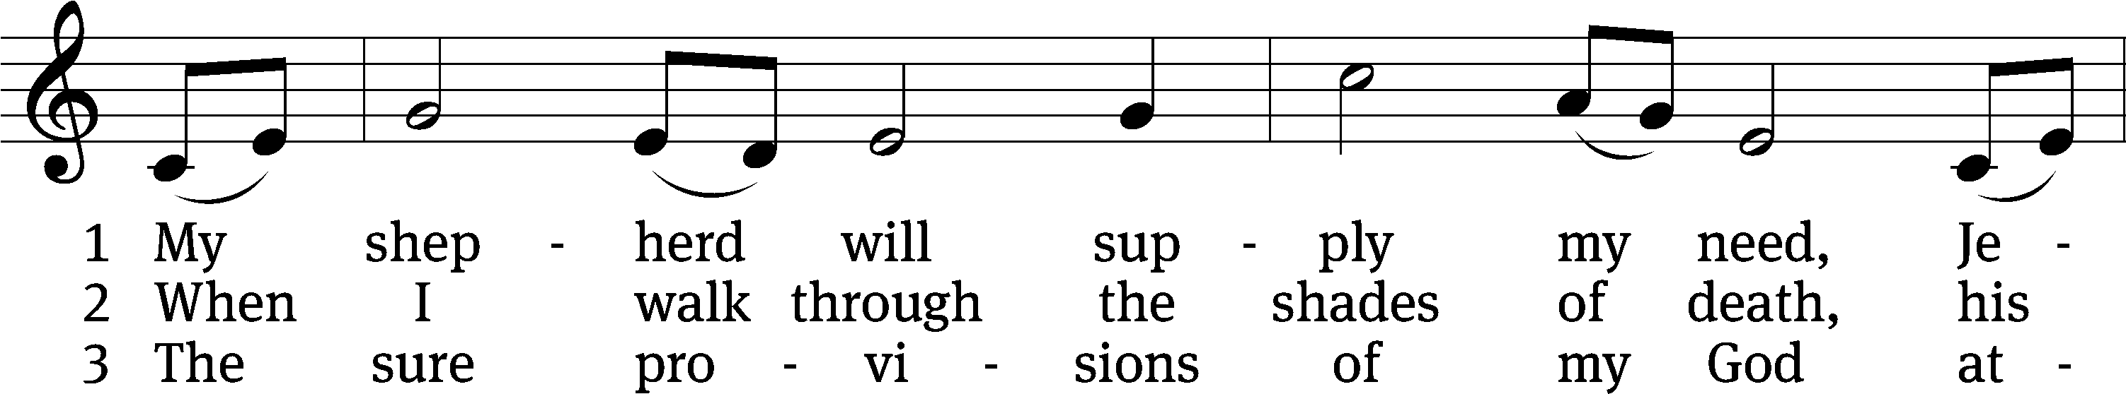
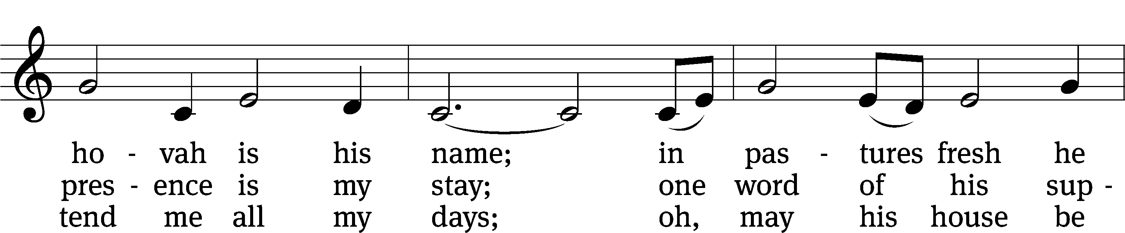
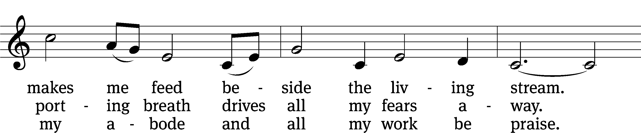
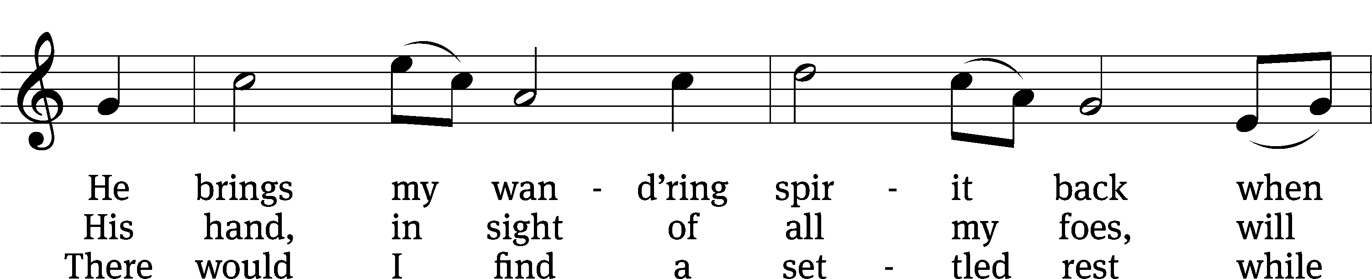
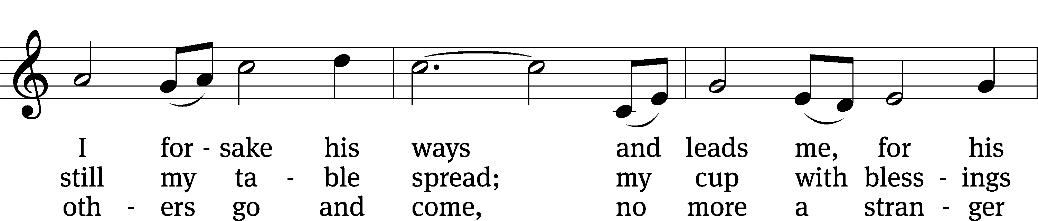
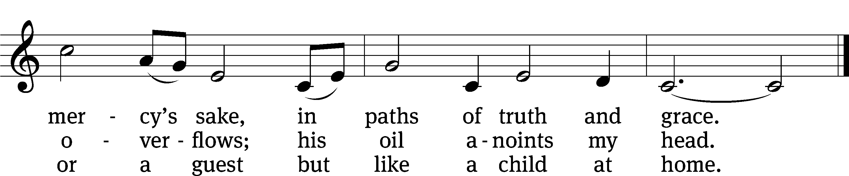

Text: Isaac Watts, alt.
Tune: Southern Harmony, 1835, ed. William Walker
Text and tune: Public domain

THE SECOND LESSON Revelation 7:9-17
⁹ After these things I looked, and there was a great multitude that no one could count, from every nation, tribe, people, and language, standing in front of the throne and of the Lamb, clothed with white robes, and with palm branches in their hands. ¹⁰ They called out with a loud voice and said:
Salvation comes from our God, who sits on the throne, and from
the Lamb.
¹¹ All the angels stood around the throne, the elders, and the four living creatures. They fell on their faces before the throne and worshipped God, ¹² saying:
Amen. Blessing and glory and wisdom and thanks and honor and
power and might belong to our God forever and ever. Amen.
¹³ One of the elders spoke to me and said, “These people dressed in white robes, who are they and where did they come from?”
And I answered him, “Sir, you know.”
¹⁴ And he said to me:
These are the ones who are coming out of the great tribulation.
They have washed their robes and made them white in the blood of
the Lamb.
¹⁵ Because of this they are in front of the throne of God,
and they serve him day and night in his temple.
He who sits on the throne will spread his tent over them.
¹⁶ They will never be hungry or thirsty ever again.
The sun will never beat upon them, nor will any scorching heat,
¹⁷ for the Lamb at the center of the throne will be their shepherd.
He will lead them to springs of living water.
And God will wipe away every tear from their eyes.

PLEASE Stand, if you are able

Verse of the day

THE GOSPEL LESSON JOHN 10:22-30
M: The Gospel according to John chapter 10, verses 22-32
²² Then the Festival of Dedication took place in Jerusalem. It was winter, ²³ and Jesus was walking in the temple area in Solomon’s Colonnade.
²⁴ So the Jews gathered around Jesus, asking, “How long will you keep us in suspense? If you are the Christ, tell us plainly.”
²⁵ Jesus answered them, “I did tell you, but you do not believe. The works I am doing in my Father’s name testify about me. ²⁶ But you do not believe, because you are not my sheep, as I said to you.^{[a]} ²⁷ My sheep hear my voice. I know them, and they follow me. ²⁸ I give them eternal life, and they will never perish. No one will snatch them out of my hand. ²⁹ My Father, who has given them to me, is greater than all. No one can snatch them out of my Father’s hand. ³⁰ I and the Father are one.”

M: This is the Gospel of the Lord.

PLEASE BE SEATED
552 The King of Love My Shepherd Is CW 552
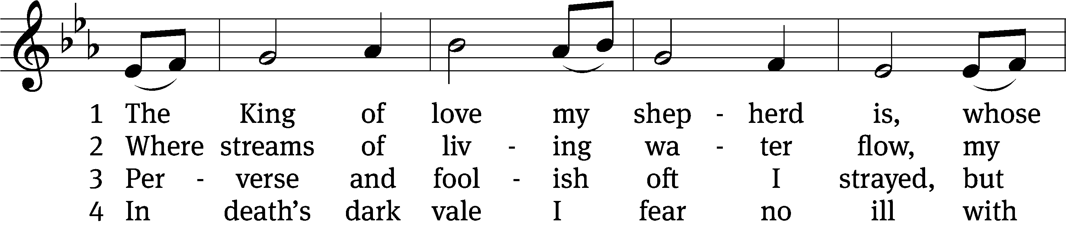
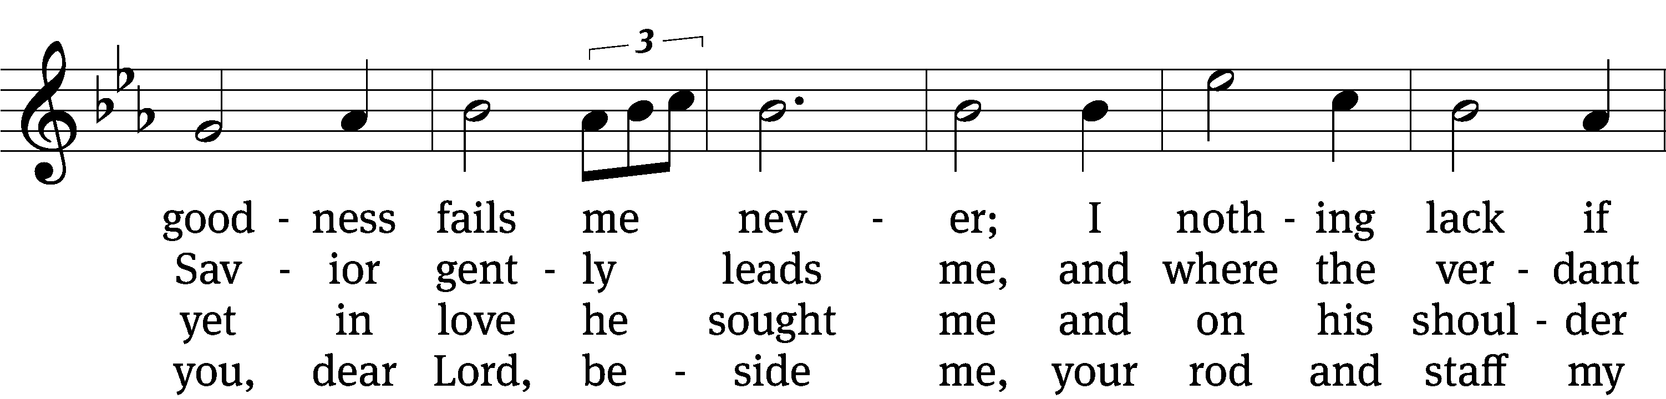
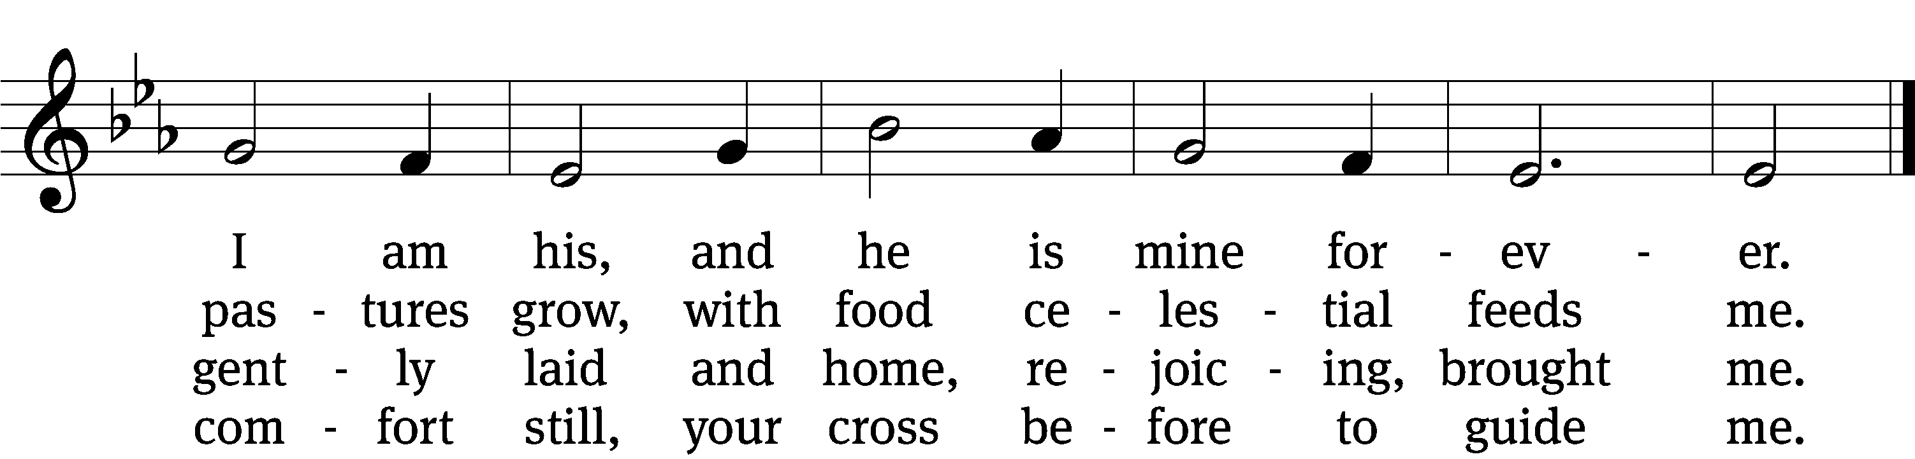

5 You spread a table in my sight,
a banquet here bestowing;
your oil of welcome, my delight;
my cup is overflowing!

6 And so through all the length of days
your goodness fails me never;
Good Shepherd, may I sing your praise
within your house forever!

Text: Henry W. Baker, 1821–1877, alt. Tune: Irish, 18th cent. Text and tune: Public domain
SERMON TEXT AND THEME John 10:1-4
“The Good Shepherd and His Sheep”

¹ “Amen, Amen, I tell you: Anyone who does not enter the sheep pen by the door, but climbs in by some other way, is a thief and a robber. ² The one who enters by the door is the shepherd of the sheep. ³ The doorkeeper opens the door for him, and the sheep listen to his voice. He calls his own sheep by name and leads them out. ⁴ When he has brought out all his own sheep, he walks ahead of them. The sheep follow him because they know his voice.

PLEASE STAND, IF YOU ARE ABLE

THE APOSTLES’ CREED
I believe in God, the Father almighty,
maker of heaven and earth.
I believe in Jesus Christ, his only Son, our Lord,
who was conceived by the Holy Spirit,
born of the virgin Mary,
suffered under Pontius Pilate,
was crucified, died, and was buried.
He descended into hell.
The third day he rose again from the dead.
He ascended into heaven
and is seated at the right hand of God the Father almighty.
From there he will come to judge the living and the dead.
I believe in the Holy Spirit,
the holy Christian Church,
the communion of saints,
the forgiveness of sins,
the resurrection of the body,
and the life everlasting. Amen.

PRAYER OF THE CHURCH

THE LORD’S PRAYER

C: Our Father, who art in heaven, hallowed be thy name, thy kingdom come, thy will be done on earth as it is in heaven. Give us this day our daily bread; and forgive us our trespasses, as we forgive those who trespass against us; and lead us not into temptation, but deliver us from evil. For thine is the kingdom and the power and the glory forever and ever. Amen.

PLEASE BE SEATED

551 Jesus, Shepherd of the Sheep CW 551
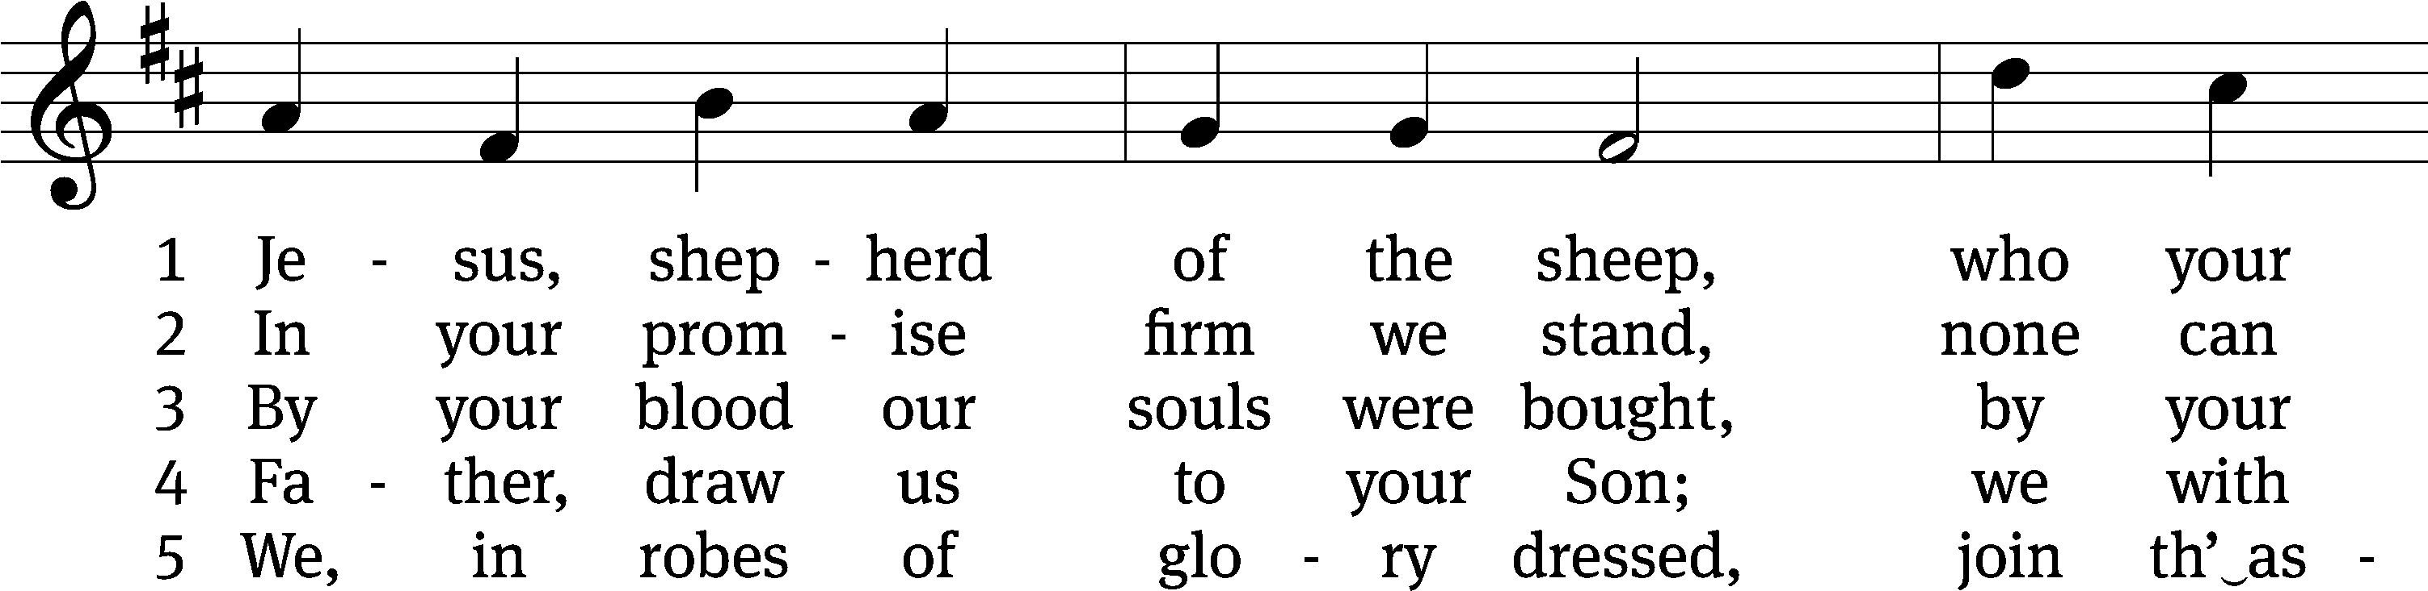
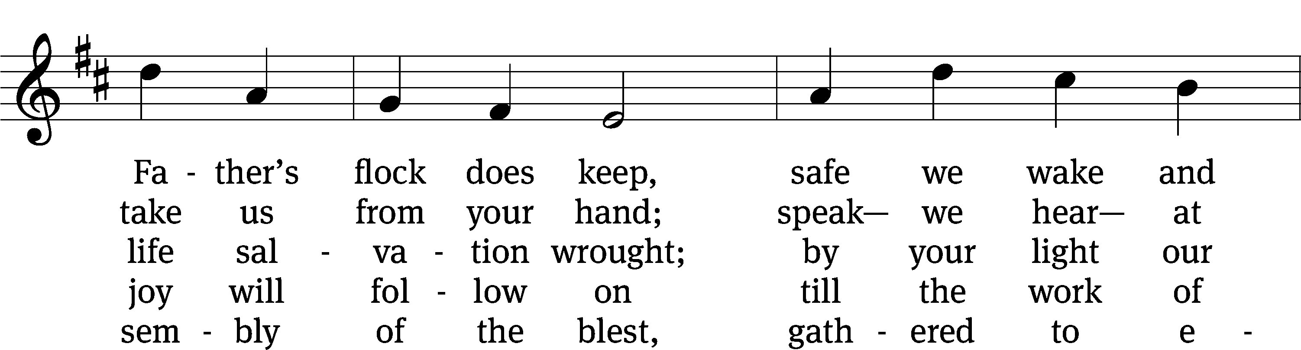
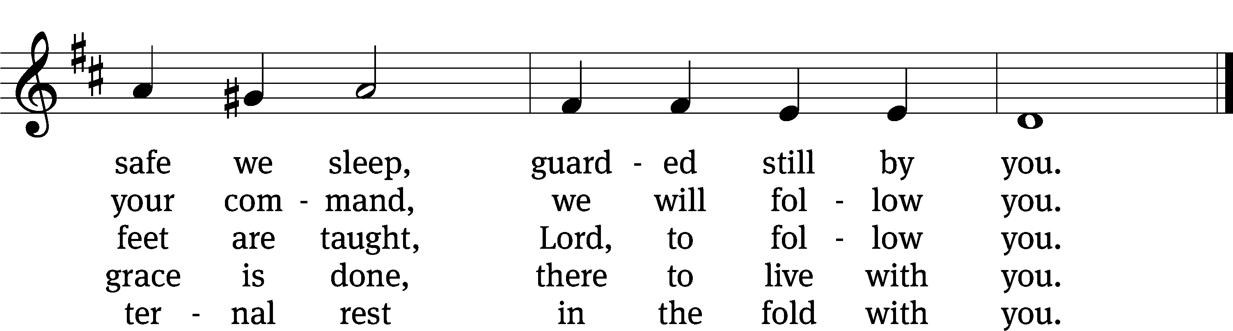

Text: Henry Cook, 1788–1868, alt.
Tune: Friedrich Filitz, 1804–1876
Text and tune: Public domain

PLEASE STAND, IF YOU ARE ABLE

CLOSING PRAYER
M: Almighty God, we thank you for teaching us the things you want us to believe and do. Help us by your Holy Spirit to keep your Word in pure hearts that we may be strengthened in faith, guided in holiness, and comforted in life and in death, through Jesus Christ, our Lord, who lives and reigns with you and the Holy Spirit, one God, now and forever.

M: Brothers and sisters, go in peace. Live in harmony with one another. Serve the Lord with gladness.
The Lord bless you and keep you.
The Lord make his face shine on you and be gracious to you.
The Lord look on you with favor and (+) give you peace.

PLEASE BE SEATED

804 I Am Jesus’ Little Lamb CW 804
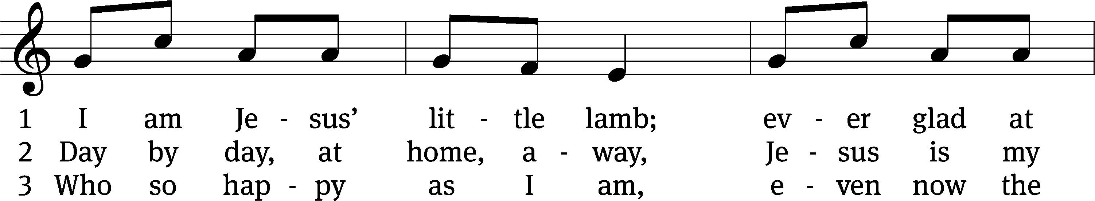
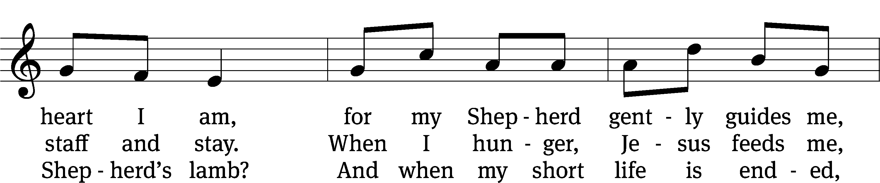
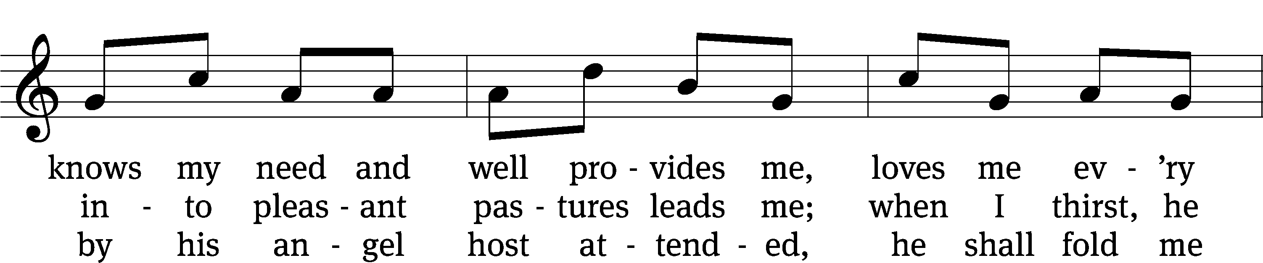
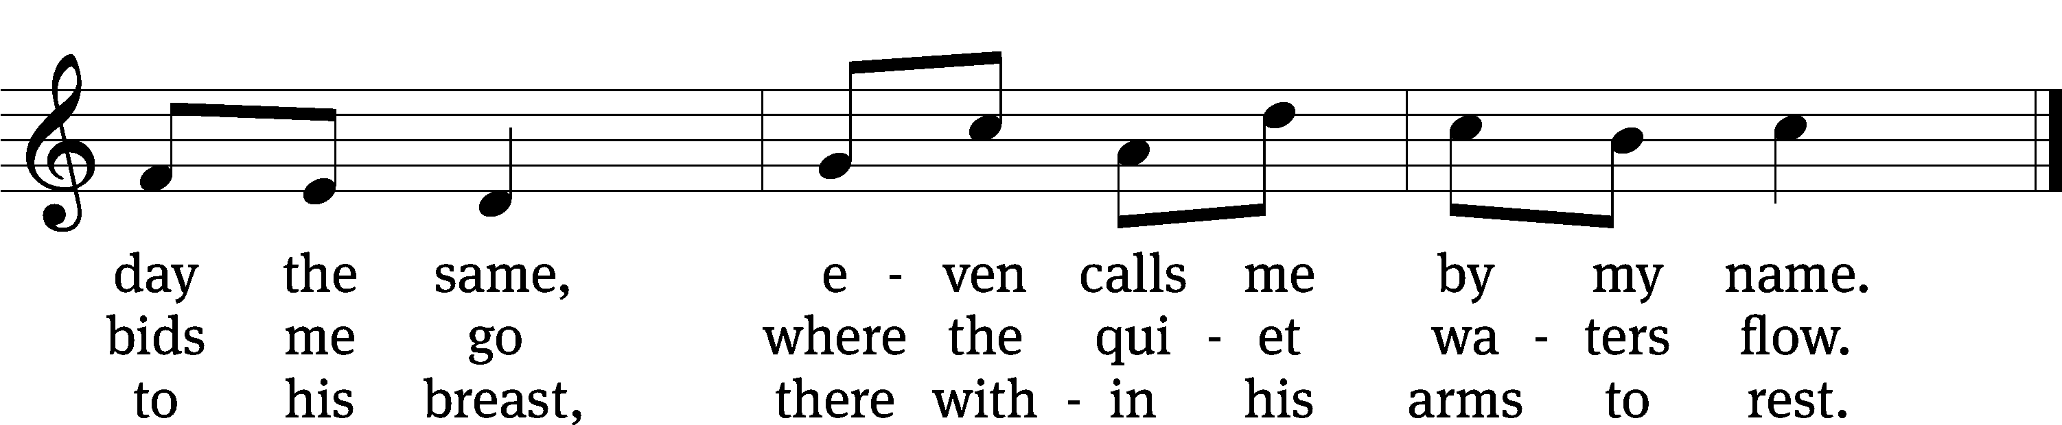
Text: tr. The Lutheran Hymnal, 1941, alt.; Henrietta L. von Hayn, 1724–1782
Tune: Choral-Buch . . . Brüder-Gemeinen, Leipzig, 1784
Text and tune: Public domain

Serving In Worship
Officiant Pastor William Natsis
Organist Sarah Hanke
Deacons (8:30) Dave Stevenson and Ed Wheeler
(11:00) Dave Frey and Steve Hoeft
Ushers (8:30) Dale Radak
(11:00) Ron Zahn
Altar Guild Sandy Kirkpatrick and Barb Neuburger
Videographer Ann Latowski

Copyright information
Service of the Word: Christian Worship. © 1993 Northwestern Publishing House. All rights reserved.
Reprinted with permission under ONE LICENSE #A-727703 and CCLI #1151741/CSPL126093

Words and Music: All rights reserved. Reprinted with permission under ONE LICENSE #A-727703 and
CCLI #1151741/CSPL126093

tlcsaline.church

