THE SIXTH SUNDAY
OF EASTER
tRINITY EVANGELICAL LUTHERAN CHURCH | Saline, Michigan
May 14, 2023

WELCOME TO WORSHIP

Thank you for joining us in God’s house today! We cordially ask that our Guests with us this morning sign one of the guestbooks located at either the front or back entryways.

THANK OFFERING: Members of Trinity give their offering as an expression of love and thankfulness to the Lord and to help support the Lord’s work in our community and around the world. Visitors need not feel obligated to participate in this offering which supports our ministry.

Restrooms are located at the back of the upper level (the annex), and in the basement (down the back stairs of the sanctuary or annex). Handicap access is available, please ask an usher for assistance.

Young Families / Toddler Bags – We are GLAD YOU BROUGHT YOUR CHILDREN to our worship service. Jesus said: “Let the little children come to me and do not hinder them, for the kingdom of God belongs to such as these.” We know that having little children in church can be a challenge, but DO NOT WORRY about it. Many of your fellow worshippers have been in your shoes and are just happy you brought your children with you. For your convenience, we have reserved the back rows of seating for parents with small children. These areas provide more flexibility for your family, as well as, easy access to move downstairs if necessary. A closed-circuit TV system allows families to continue participating in the service while downstairs. Pre-school toddler bags and children’s bulletins are available for their enjoyment. Ask an usher for one to use during the service and please return the toddler bag afterwards.

SERVICE of the word
BELL CHOIR (11:00) “Jesus Loves Me”
520 Oh, for a Thousand Tongues to Sing CW 520
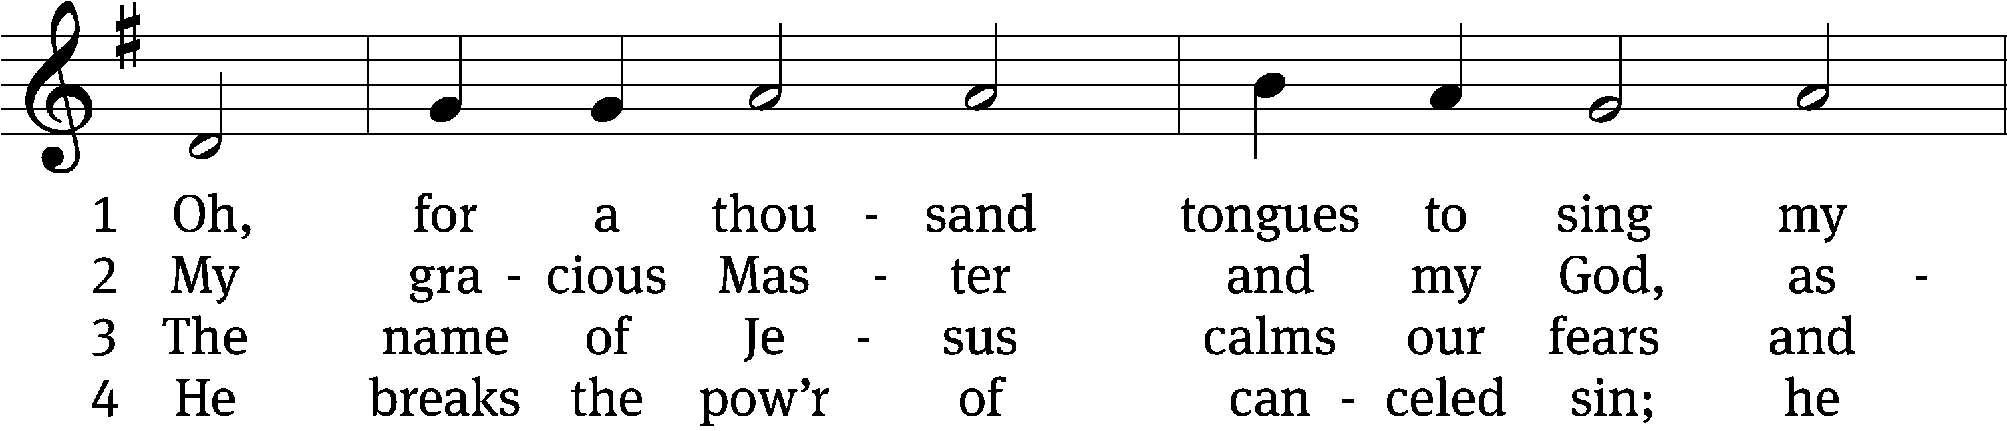
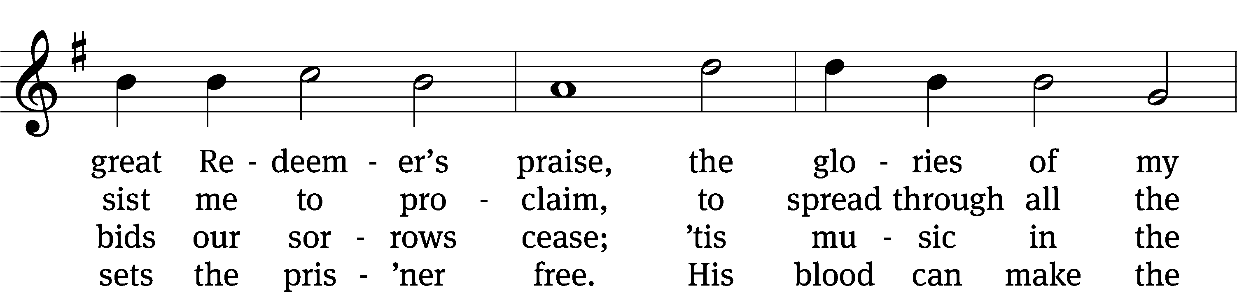
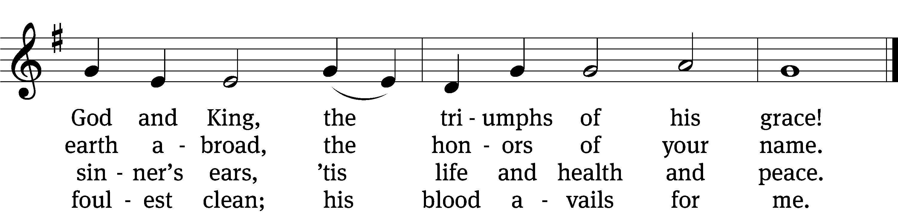

5 See all your sins on Jesus laid;
the Lamb of God was slain.
His life was once an off’ring made
that you might live again.

6 To God all glory, praise, and love
be ever, ever giv’n
by saints below and saints above,
the Church in earth and heav’n.
Text: Charles Wesley, 1707–1788, alt.
Tune: Carl G. Gläser, 1784–1829
Text and tune: Public domain

PLEASE STAND, IF YOU ARE ABLE

invocation
M: The grace of our Lord (+) Jesus Christ and the love of God and the fellowship of the Holy Spirit be with you.
C: And also with you.

CONFESSION OF SINS
M: We have come into the presence of God, who created us to love and serve him as his dear children. But we have disobeyed him and deserve only his wrath and punishment. Therefore, let us confess our sins to him and plead for his mercy.

C: Merciful Father in heaven, I am altogether sinful from birth. In countless ways I have sinned against you and do not deserve to be called your child. But trusting in Jesus, my Savior, I pray: Have mercy on me according to your unfailing love. Cleanse me from my sin, and take away my guilt.

M: God, our heavenly Father, has forgiven all your sins. By the perfect life and innocent death of our Lord Jesus Christ, he has removed your guilt forever. You are his own dear child. May God give you strength to live according to his will.

C: Amen.
PRAYER AND PRAISE

M: In the peace of forgiveness, let us praise the Lord.

OH, TASTE AND SEE

PRAYER OF THE DAY

Let us pray.

O God, you are the giver of everything good. Inspire us, your humble servants, to long for what is right and, through your gracious guidance, accomplish it to your glory; through your Son, Jesus Christ our Lord, who lives and reigns with you and the Holy Spirit, one God, now and forever.

PLEASE BE SEATED

The Word

the FIRST LESSON Acts 17:22-31
²² Then Paul stood up in front of the council of the Areopagus and said, “Men of Athens, I see that you are very religious in every way. ²³ For as I was walking around and carefully observing your objects of worship, I even found an altar on which had been inscribed, ‘To an unknown god.’ Now what you worship as unknown—this is what I am going to proclaim to you.
²⁴ “The God who made the world and everything in it is the Lord of heaven and earth and does not live in temples made with hands. ²⁵ Neither is he served by human hands, as if he needed anything, since he himself gives all people life and breath and everything they have. ²⁶ From one man, he made every nation of mankind to live over the entire face of the earth. He determined the appointed times and the boundaries where they would live. ²⁷ He did this so they would seek God and perhaps reach out for him and find him, though he is not far from each one of us. ²⁸ ‘For in him we live and move and have our being.’ As some of your own poets have said, ‘Indeed, we are also his offspring.”
²⁹ “Therefore, since we are God’s offspring, we should not think that the divine being is like gold or silver or stone, an image formed by human skill and planning. ³⁰ Although God overlooked the times of ignorance, he is now commanding all people everywhere to repent, ³¹ because he has set a day on which he is going to judge the world in righteousness by the man he appointed. He provided proof of this to everyone by raising him from the dead.”

PSALM 66

Refrain
Shout with joy to God, all the earth!*
Sing the glory of his name; make his praise glorious!
Praise our God, O peoples,*
let the sound of his praise be heard.
He has preserved our lives*
and kept our feet from slipping.
Refrain
Come and listen, all you who fear God;*
let me tell you what he has done for me.
If I had cherished sin in my heart,*
the Lord would not have listened;
but God has surely listened*
and heard my voice in prayer.
Glory be to the Father and to the Son*
and to the Holy Spirit,
as it was in the beginning,*
is now, and will be forever. Amen.
Refrain

Refrain Tune: Steven Warner. © 1983 GIA Publications, Inc., Chicago, IL, www.giamusic.com. All rights reserved. Used by permission.

THE SECOND LESSON 1 Peter 3:13-22
¹³ Who will harm you if you are eager to do what is good? ¹⁴ But even if you should happen to suffer because of righteousness, you are blessed. Do not be afraid of what they fear, and do not be troubled. ¹⁵ But regard the Lord, the Christ, as holy in your hearts. Always be prepared to give an answer to everyone who asks you to give a reason for the hope that is in you. ¹⁶ But speak with gentleness and respect, while maintaining a clear conscience, so that those who attack your good way of life in Christ may be put to shame because they slandered you as evildoers.
¹⁷ Indeed, it is better, if it is God’s will, to suffer for doing good than for doing evil, ¹⁸ because Christ also suffered once for sins in our place, the righteous for the unrighteous, to bring you to God. He was put to death in flesh but was made alive in spirit, ¹⁹ in which he also went and made an announcement to the spirits in prison. ²⁰ These spirits disobeyed long ago, when God’s patience was waiting in the days of Noah while the ark was being built. In this ark a few, that is, eight souls, were saved by water. ²¹ And corresponding to that, baptism now saves you—not the removal of dirt from the body but the guarantee of a good conscience before God through the resurrection of Jesus Christ. ²² He went to heaven and is at the right hand of God, with angels, authorities, and powers made subject to him.

please stand, if you are able

Verse of the day
Alleluia. If you love me, keep my commands.
And I will ask the Father, and he will give you another Advocate to help you. Alleluia.
John 14:15-16

THE GOSPEL LESSON John 14:15-21

M: The Gospel according to John chapter 14, verses 15-21

¹⁵ “If you love me, hold on to my commands. ¹⁶ I will ask the Father, and he will give you another Counselor to be with you forever. ¹⁷ He is the Spirit of truth, whom the world cannot receive because it does not see him or know him. You know him because he stays with you and will be in you.
¹⁸ “I will not leave you as orphans; I am coming to you. ¹⁹ In a little while the world will see me no longer, but you will see me. Because I live, you also will live. ²⁰ In that day you will know that I am in my Father, and you in me, and I in you. ²¹ The one who has my commands and holds on to them is the one who loves me. And the one who loves me will be loved by my Father. I too will love him and show myself to him.”

M: This is the Gospel of the Lord.

PLEASE BE SEATED

583 God Loves Me Dearly CW 583
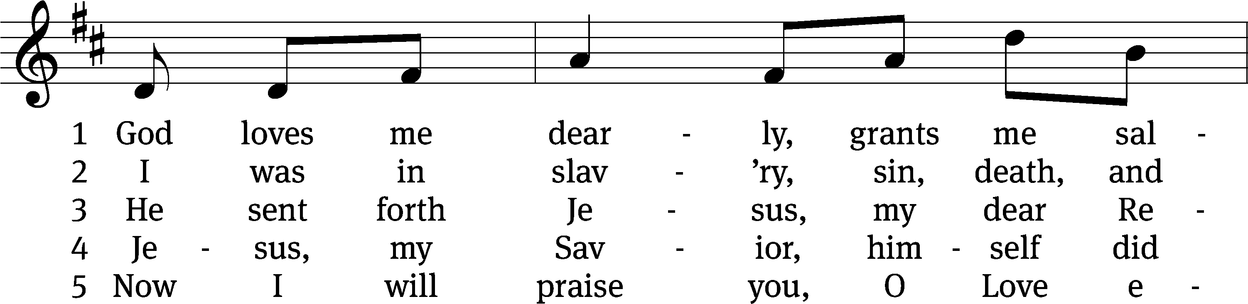
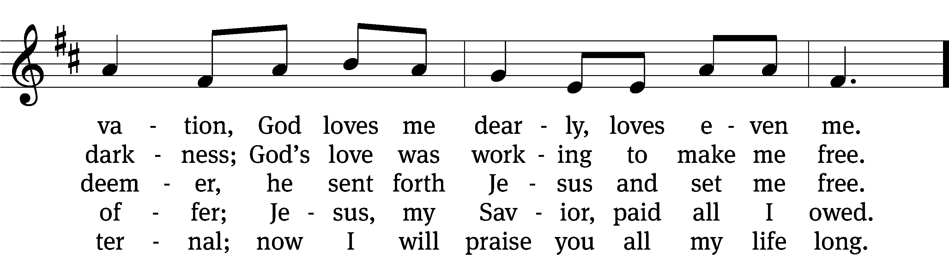
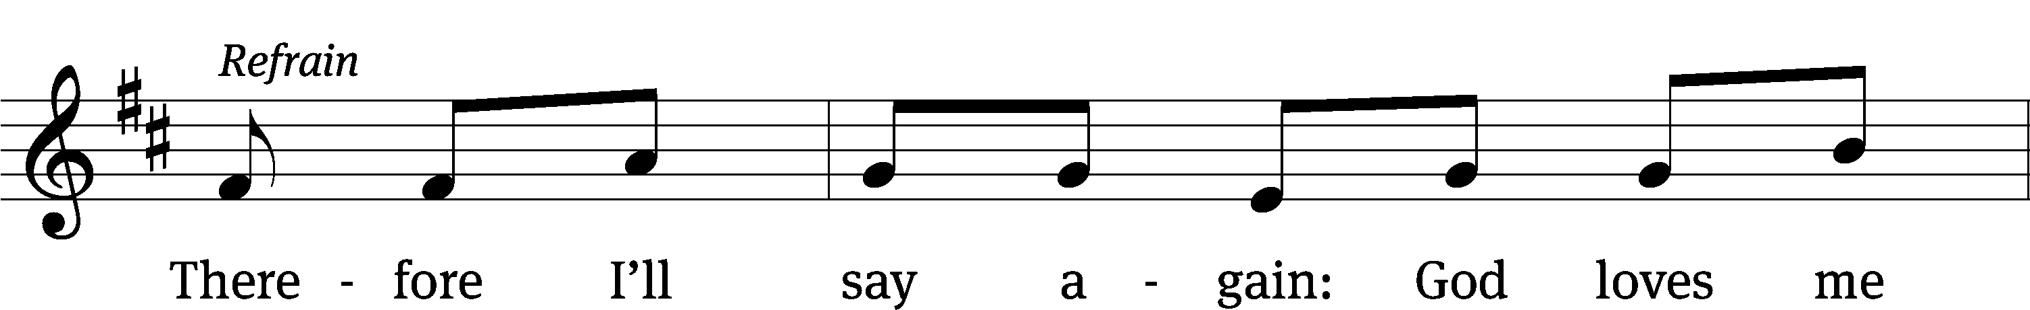
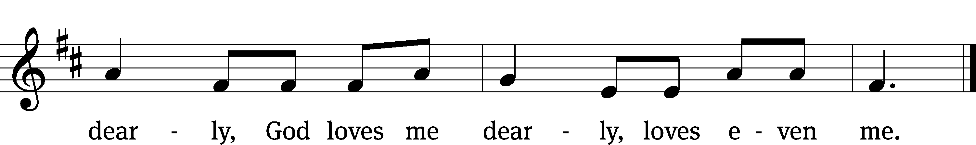
Text: August Rische, 1819–1906
Tune: German
Text and tune: Public domain

SERMON John 15:9-17
“Love, Me”
⁹ “As the Father has loved me, so also I have loved you. Remain in my love. ¹⁰ If you hold on to my commands, you will remain in my love, just as I have held on to my Father’s commands and remain in his love. ¹¹ I have told you these things so that my joy would continue to be in you and that your joy would be complete. ¹² This is my command: Love one another as I have loved you. ¹³ No one has greater love than this: that someone lays down his life for his friends. ¹⁴ You are my friends if you continue to do the things I instruct you. ¹⁵ I no longer call you servants, because a servant does not know what his master is doing. But I have called you friends, because everything that I heard from my Father, I have made known to you. ¹⁶ You did not choose me, but I chose you and appointed you to go and bear fruit, fruit that will endure, so that the Father will give you whatever you ask in my name. ¹⁷ These things I am instructing you, so that you love one another.
PLEASE STAND, IF YOU ARE ABLE

THE APOSTLES’ CREED

I believe in God, the Father almighty,
maker of heaven and earth.
I believe in Jesus Christ, his only Son, our Lord,
who was conceived by the Holy Spirit,
born of the virgin Mary,
suffered under Pontius Pilate,
was crucified, died, and was buried.
He descended into hell.
The third day he rose again from the dead.
He ascended into heaven
and is seated at the right hand of God the Father almighty.
From there he will come to judge the living and the dead.
I believe in the Holy Spirit,
the holy Christian Church,
the communion of saints,
the forgiveness of sins,
the resurrection of the body,
and the life everlasting. Amen.

PLEASE BE SEATED

BELL CHOIR (8:30) “Jesus Loves Me”

PLEASE STAND, IF YOU ARE ABLE

PRAYER OF THE CHURCH

THE LORD’S PRAYER

C: Our Father, who art in heaven, hallowed be thy name, thy kingdom come, thy will be done on earth as it is in heaven. Give us this day our daily bread; and forgive us our trespasses, as we forgive those who trespass against us; and lead us not into temptation, but deliver us from evil. For thine is the kingdom and the power and the glory forever and ever. Amen.

729 Son of God, Eternal Savior CW 729
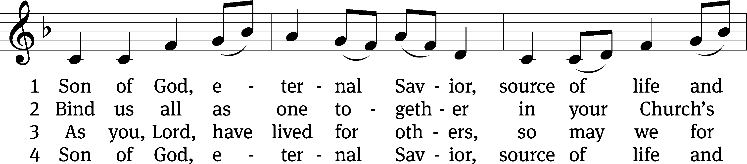
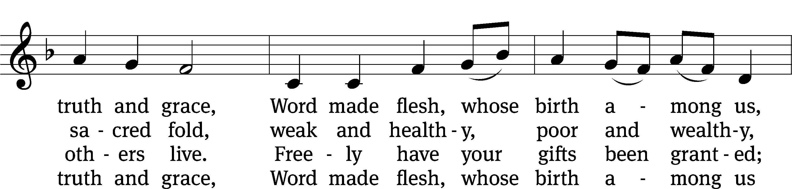
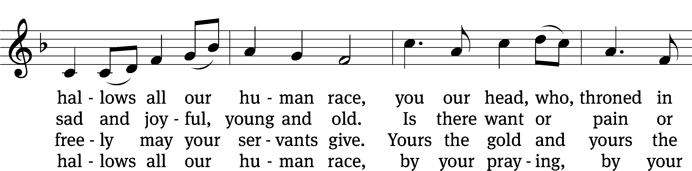
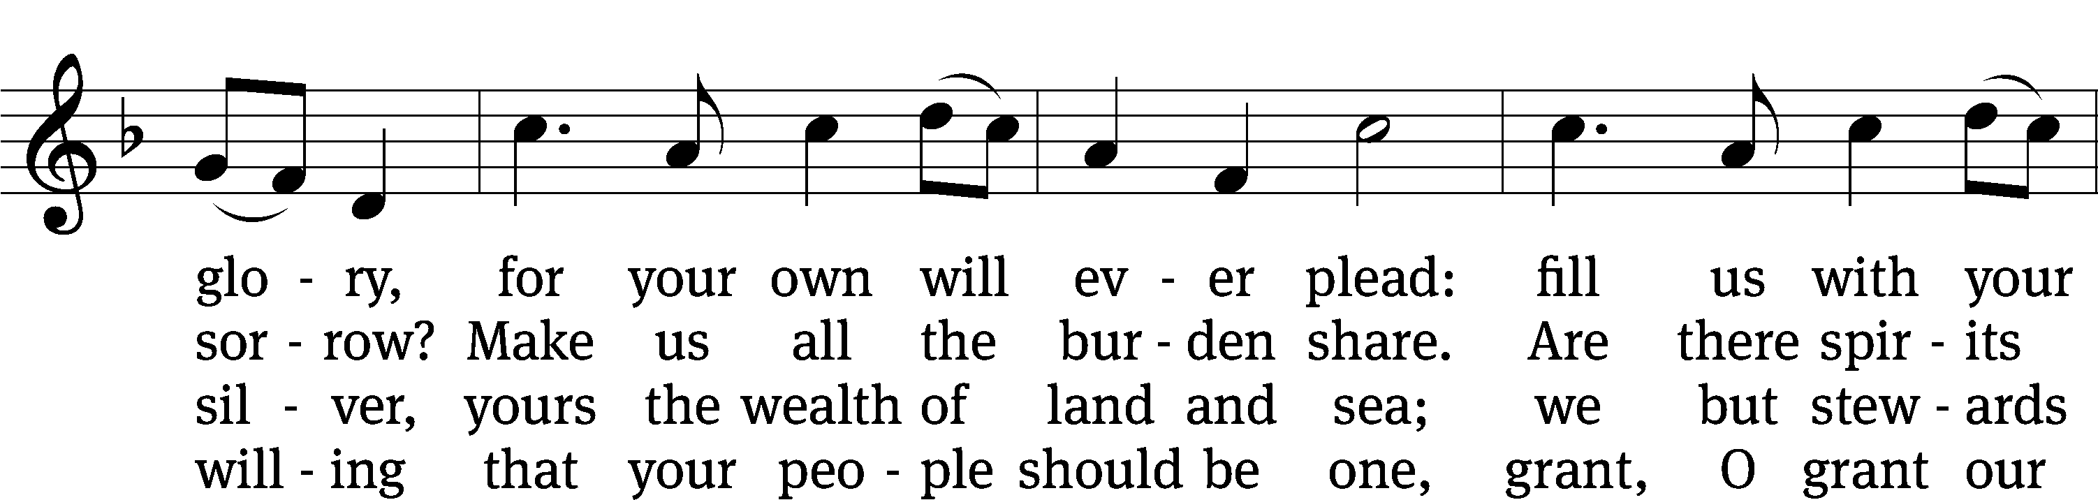
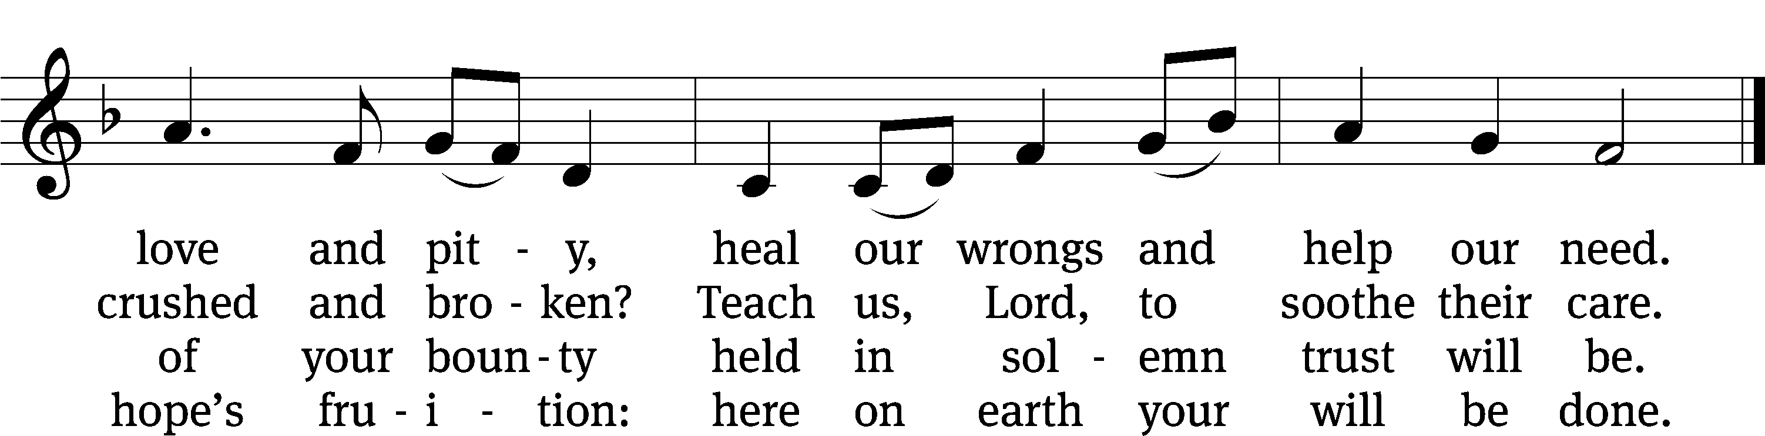
Text: Somerset T. C. Lowry, 1855–1932, abr., alt.
Tune: The Revivalist, Troy, 1868, ed. Joseph Hillman
Text and tune: Public domain

PLEASE STAND, IF YOU ARE ABLE

CLOSING PRAYER
M: Almighty God, we thank you for teaching us the things you want us to believe and do. Help us by your Holy Spirit to keep your Word in pure hearts that we may be strengthened in faith, guided in holiness, and comforted in life and in death, through Jesus Christ, our Lord, who lives and reigns with you and the Holy Spirit, one God, now and forever.

M: Brothers and sisters, go in peace. Live in harmony with one another. Serve the Lord with gladness.
The Lord bless you and keep you.
The Lord make his face shine on you and be gracious to you.
The Lord look on you with favor and (+) give you peace.

PLEASE BE SEATED

726 Love in Christ Is Strong and Living CW 726
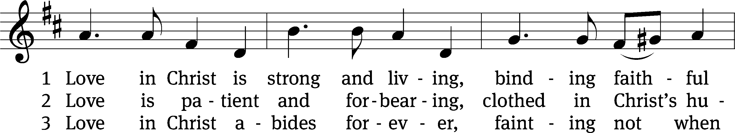
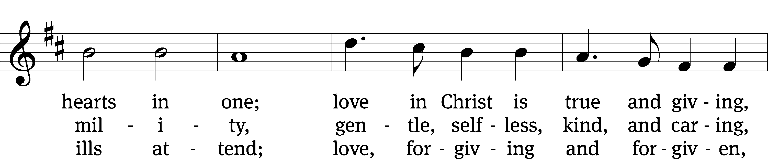
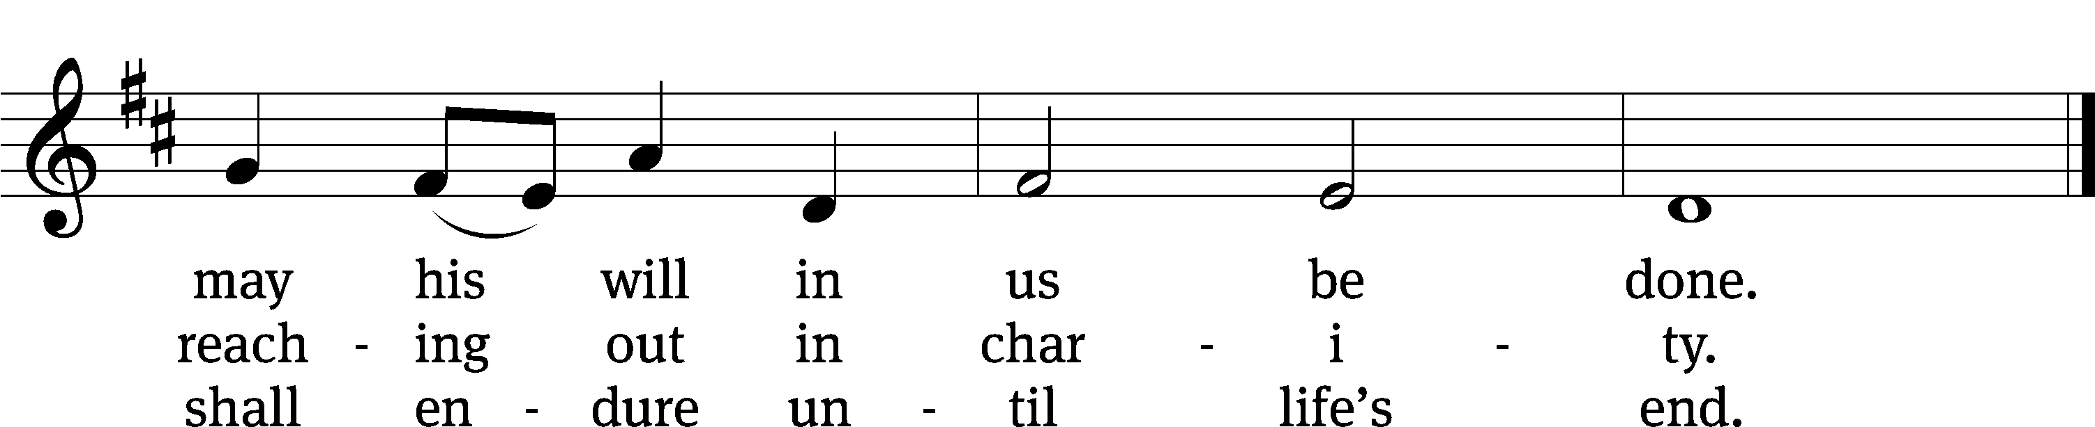
Text: Dorothy R. Schultz, b. 1934
Tune: Ralph C. Schultz, b. 1932
Text and tune: © 1980 Concordia Publishing House. Used by permission: OneLicense no. 727703

Serving In Worship
Officiant Pastor Natsis
Organist Sarah Hanke
Bell Choir Director Meg Nortley
Deacons (8:30) Duane Mason and Dave Stevenson
(11:00) Jeff Neuburger and Robert Niethammer
Ushers (8:30) Tim Phelps
(11:00) Ron Zahn
Altar Guild Sandy Kirkpatrick and Barb Neuburger
Videographer Ann Latowski

Copyright information
Service of the Word: Christian Worship. © 1993 Northwestern Publishing House. All rights reserved.
Reprinted with permission under ONE LICENSE #A-727703 and CCLI #1151741/CSPL126093

Words and Music: All rights reserved. Reprinted with permission under ONE LICENSE #A-727703 and
CCLI #1151741/CSPL126093
tlcsaline.church

