THE ELEVENth SUNDAY
after pentecost
tRINITY EVANGELICAL LUTHERAN CHURCH | Saline, Michigan
August 10/13, 2023

WELCOME TO WORSHIP

Thank you for joining us in God’s house today! We cordially ask that our Guests with us this morning sign one of the guestbooks located at either the front or back entryways.

THANK OFFERING: Members of Trinity give their offering as an expression of love and thankfulness to the Lord and to help support the Lord’s work in our community and around the world. Visitors need not feel obligated to participate in this offering which supports our ministry.

Restrooms are located at the back of the upper level (the annex), and in the basement (down the back stairs of the sanctuary or annex). Handicap access is available, please ask an usher for assistance.

Young Families / Toddler Bags – We are GLAD YOU BROUGHT YOUR CHILDREN to our worship service. Jesus said: “Let the little children come to me and do not hinder them, for the kingdom of God belongs to such as these.” We know that having little children in church can be a challenge, but DO NOT WORRY about it. Many of your fellow worshippers have been in your shoes and are just happy you brought your children with you. For your convenience, we have reserved the back rows of seating for parents with small children. These areas provide more flexibility for your family, as well as, easy access to move downstairs if necessary. A closed-circuit TV system allows families to continue participating in the service while downstairs. Pre-school toddler bags and children’s bulletins are available for their enjoyment. Ask an usher for one to use during the service and please return the toddler bag afterwards.

SERVICE of the word
847 Be Still, My Soul CW 847
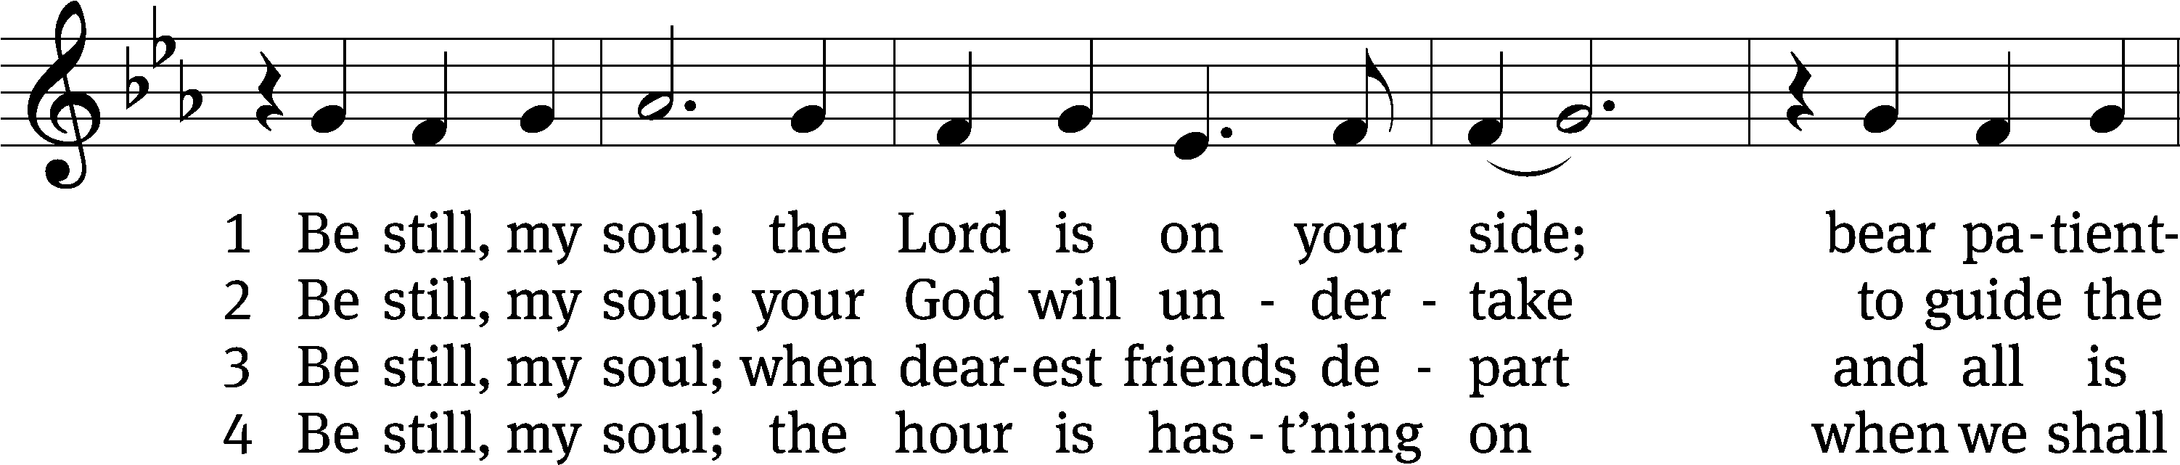
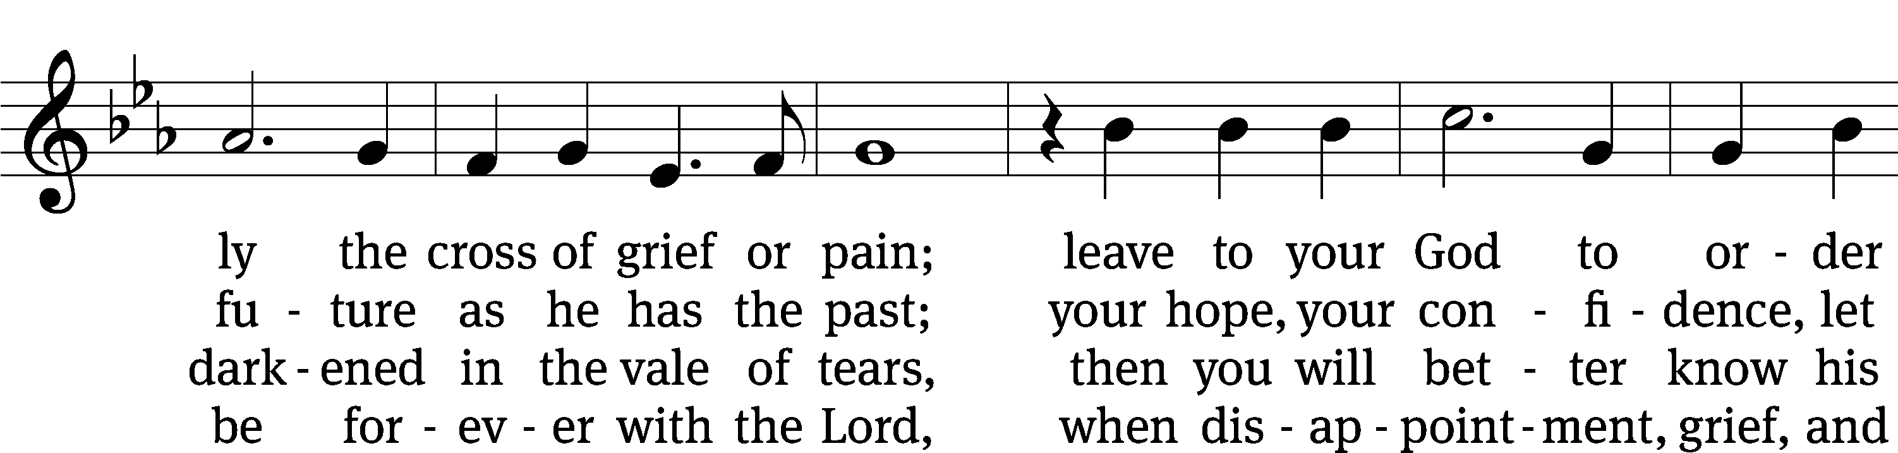
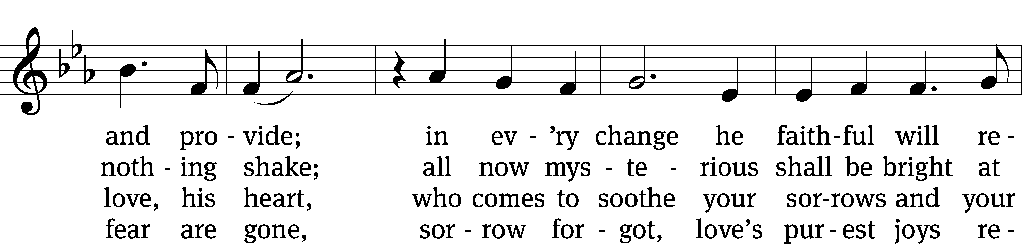
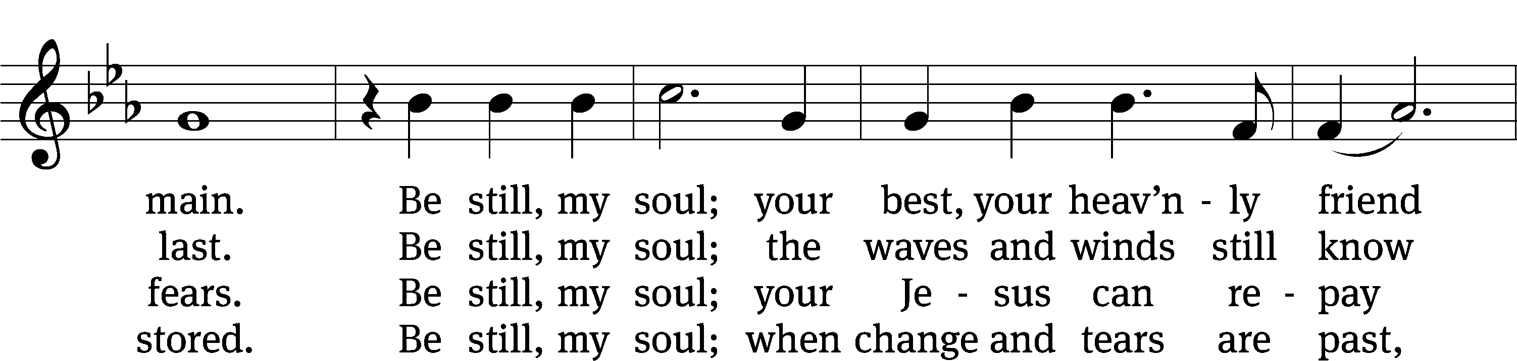
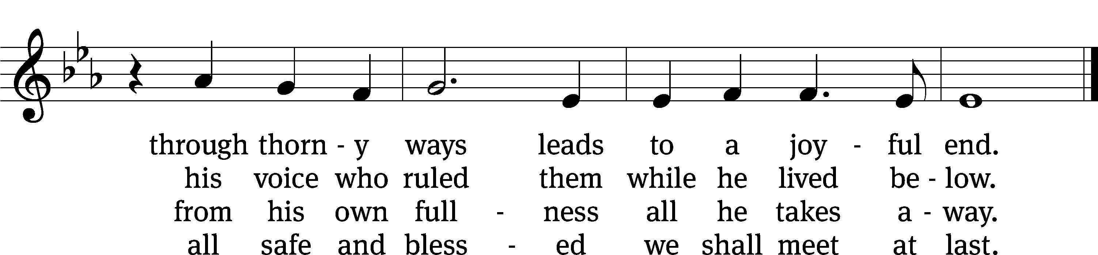
Text: tr. Jane L Borthwick, 1813–1897, alt.; Catharina A. von Schlegel, 1697–1752, abr.
Tune: Jean Sibelius, 1865–1957, adapt.
Text and tune: Public domain

PLEASE STAND, IF YOU ARE ABLE

invocation
M: The grace of our Lord (+) Jesus Christ and the love of God and the fellowship of the Holy Spirit be with you.
C: And also with you.
CONFESSION OF SINS
M: We have come into the presence of God, who created us to love and serve him as his dear children. But we have disobeyed him and deserve only his wrath and punishment. Therefore, let us confess our sins to him and plead for his mercy.

C: Merciful Father in heaven, I am altogether sinful from birth. In countless ways I have sinned against you and do not deserve to be called your child. But trusting in Jesus, my Savior, I pray: Have mercy on me according to your unfailing love. Cleanse me from my sin, and take away my guilt.

M: God, our heavenly Father, has forgiven all your sins. By the perfect life and innocent death of our Lord Jesus Christ, he has removed your guilt forever. You are his own dear child. May God give you strength to live according to his will.

C: Amen.
PRAYER AND PRAISE

M: In the peace of forgiveness, let us praise the Lord.

OH, TASTE AND SEE

PRAYER OF THE DAY

Let us pray.

Almighty and most merciful God, preserve us from all harm and danger that we, being ready in both body and soul, may cheerfully accomplish what you want done; through your Son, Jesus Christ our Lord, who lives and reigns with you and the Holy Spirit, one God, now and forever.

PLEASE BE SEATED
The Word

the FIRST LESSON 1 Kings 19:9-18
⁹ He came to a cave and spent the night there.
Then the word of the Lord suddenly came to him, saying, “Why are you here, Elijah?”
¹⁰ He said, “I have been very zealous for the Lord, the God of Armies, but the people of Israel have abandoned your covenant. They have torn down your altars and killed your prophets with the sword. I alone am left, and they are seeking to take my life.”
¹¹ Then the Lord said, “Go out and stand on the mountain in the presence of the Lord, for the Lord is passing by.” Then a great and powerful wind tore the mountains and shattered rocks before the Lord, but the Lord was not in the wind.
After the wind came an earthquake, but the Lord was not in the earthquake.
¹² After the earthquake there was a fire, but the Lord was not in the fire.
After the fire there was a soft, whispering voice.
¹³ When Elijah heard it, he wrapped his face in his cloak, and he went out and stood at the entrance to the cave. Then a voice came to him and said, “Why are you here, Elijah?”
¹⁴ He said, “I have been very zealous for the Lord, the God of Armies, but the people of Israel have abandoned your covenant. They have torn down your altars and killed your prophets with the sword. I alone am left, and they are seeking to take my life.”
¹⁵ Then the Lord said to him, “Go back the way you came and go to the Wilderness of Damascus. When you get there, you are to anoint Hazael as king over Aram. ¹⁶ You will also anoint Jehu son of Nimshi as king over Israel and Elisha son of Shaphat from Abel Meholah as prophet in your place. ¹⁷ Whoever escapes the sword of Hazael, Jehu will kill, and whoever escapes the sword of Jehu, Elisha will kill. ¹⁸ But I have preserved in Israel seven thousand whose knees have not bent to Baal and whose lips have not kissed him.”

73C My Feet Had Almost Slipped Psalm 73C
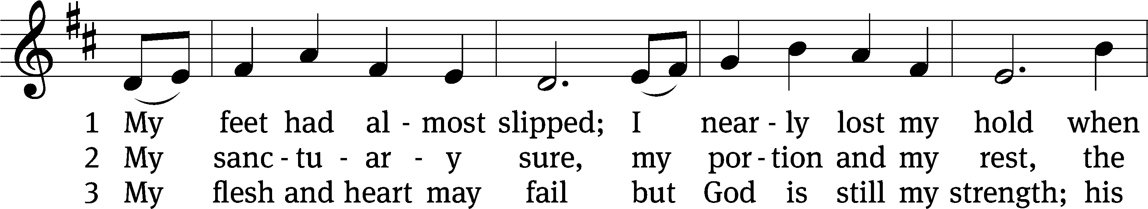
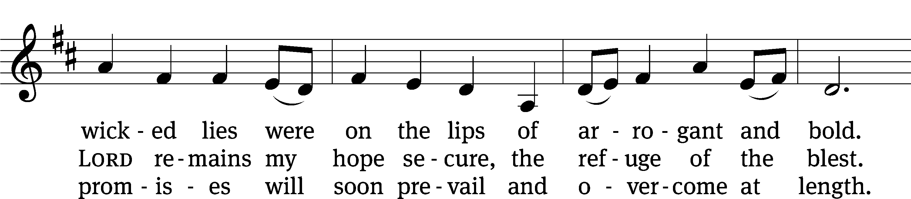
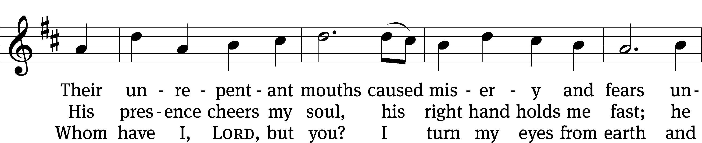
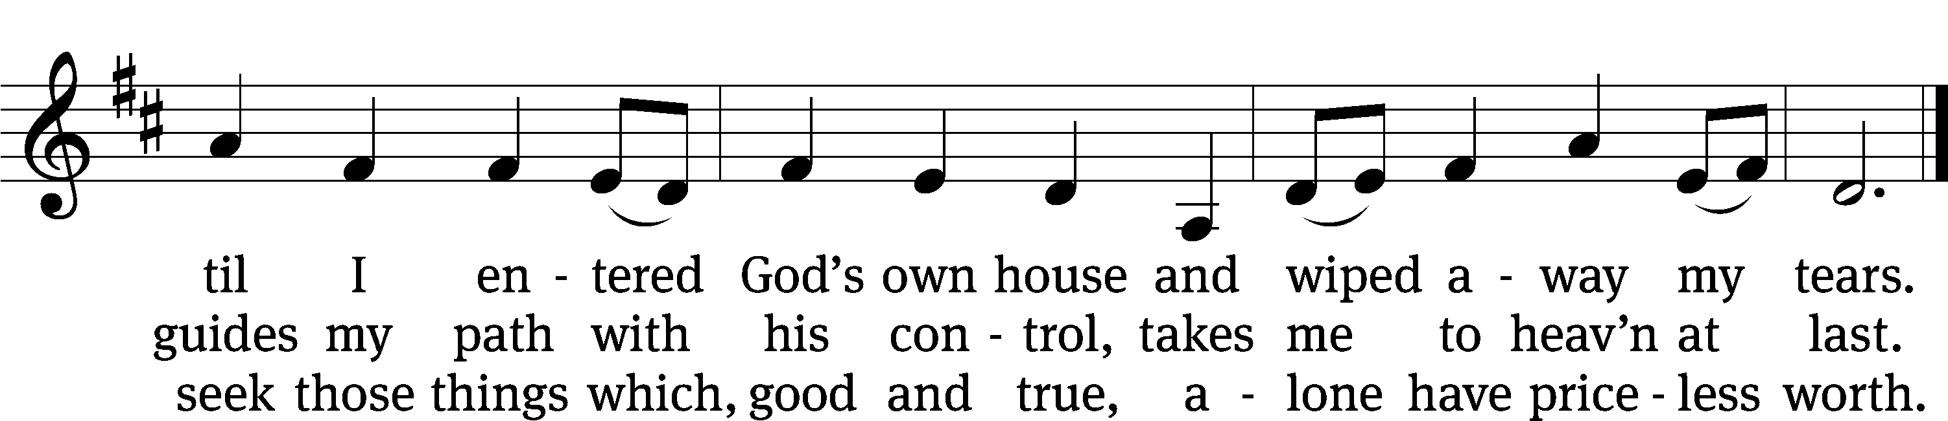
Text: Paul Prange
Tune: adapt. Franklin L. Sheppard; English
Text: © 2021 Paul Prange, admin. Northwestern Publishing House. Used by permission: OneLicense no. 727703
Tune: Public domain

SECOND LESSON Romans 8:28-39
²⁸ We know that all things work together for the good of those who love God, for those who are called according to his purpose, ²⁹ because those God foreknew, he also predestined to be conformed to the image of his Son, so that he would be the firstborn among many brothers. ³⁰ And those he predestined, he also called. Those he called, he also justified. And those he justified, he also glorified.
³¹ What then will we say about these things? If God is for us, who can be against us? ³² Indeed, he who did not spare his own Son, but gave him up for us all—how will he not also graciously give us all things along with him?
³³ Who will bring an accusation against God’s elect? God is the one who justifies! ³⁴ Who is the one who condemns? Christ Jesus, who died and, more than that, was raised to life, is the one who is at God’s right hand and who is also interceding for us! ³⁵ What will separate us from the love of Christ? Will trouble or distress or persecution or famine or nakedness or danger or sword? ³⁶ Just as it is written:
For your sake we are being put to death all day long.
We are considered as sheep to be slaughtered.
³⁷ No, in all these things we are more than conquerors through him who loved us.
³⁸ For I am convinced that neither death nor life, neither angels nor rulers, neither things present nor things to come, nor powerful forces, ³⁹ neither height nor depth, nor anything else in creation, will be able to separate us from the love of God in Christ Jesus our Lord.

please stand, if you are able

Verse of the day Hebrews 11:1
Alleluia. Faith is being sure about what we hope for,
being convinced about things we do not see. Alleluia.

THE GOSPEL LESSON Matthew 14:22-33

M: The Gospel according to Matthew chapter 14, verses 22-33

²² Immediately Jesus urged the disciples to get into the boat and to go ahead of him to the other side, while he dismissed the crowd. ²³ After he had dismissed the crowd, he went up onto the mountain by himself to pray. When evening came, he was there alone. ²⁴ By then the boat was quite a distance from shore, being pounded by the waves because the wind was against it. ²⁵ In the fourth watch of the night,^{[a]} Jesus came toward them, walking on the sea. ²⁶ When the disciples saw him walking on the sea, they were terrified and cried out in fear, “It’s a ghost!” ²⁷ But Jesus spoke to them at once, saying, “Take heart! It is I! Do not be afraid.”
²⁸ Peter answered him and said, “Lord, if it is you, command me to come to you on the water.”
²⁹ Jesus said, “Come!”
Peter stepped down from the boat, walked on the water, and went toward Jesus. ³⁰ But when he saw the strong wind, he was afraid. As he began to sink, he cried out, “Lord, save me!”
³¹ Immediately Jesus stretched out his hand, took hold of him, and said to him, “You of little faith, why did you doubt?” ³² When they got into the boat, the wind stopped. ³³ Those who were in the boat worshipped him, saying, “Truly you are the Son of God!”

M: This is the Gospel of the Lord.

PLEASE BE SEATED

984 A Vicious Storm, A Raging Sea CW 984
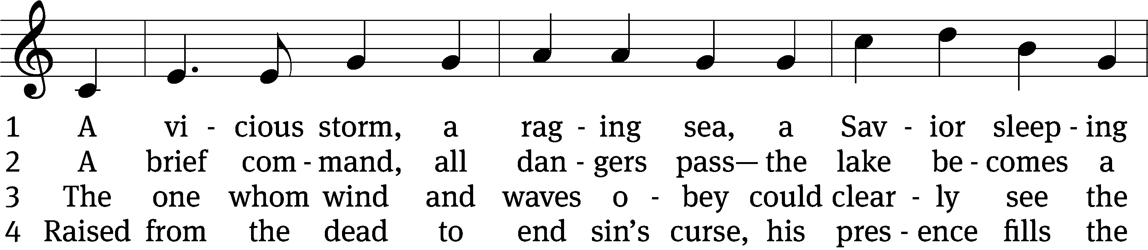
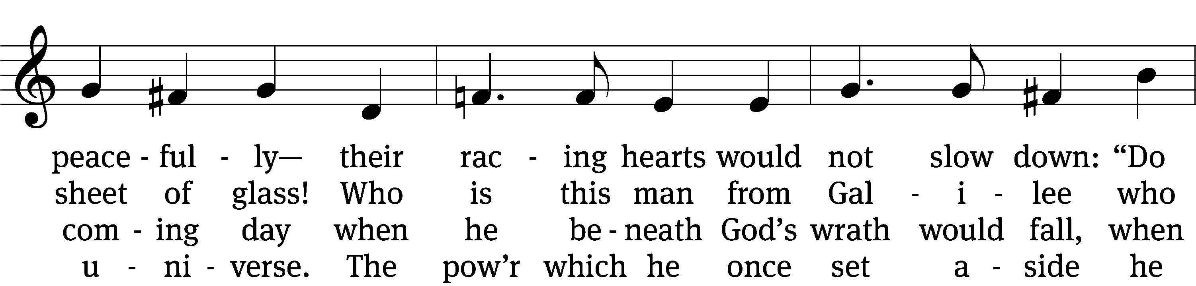
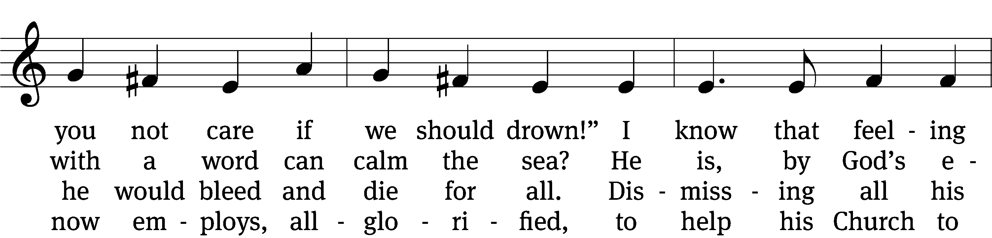
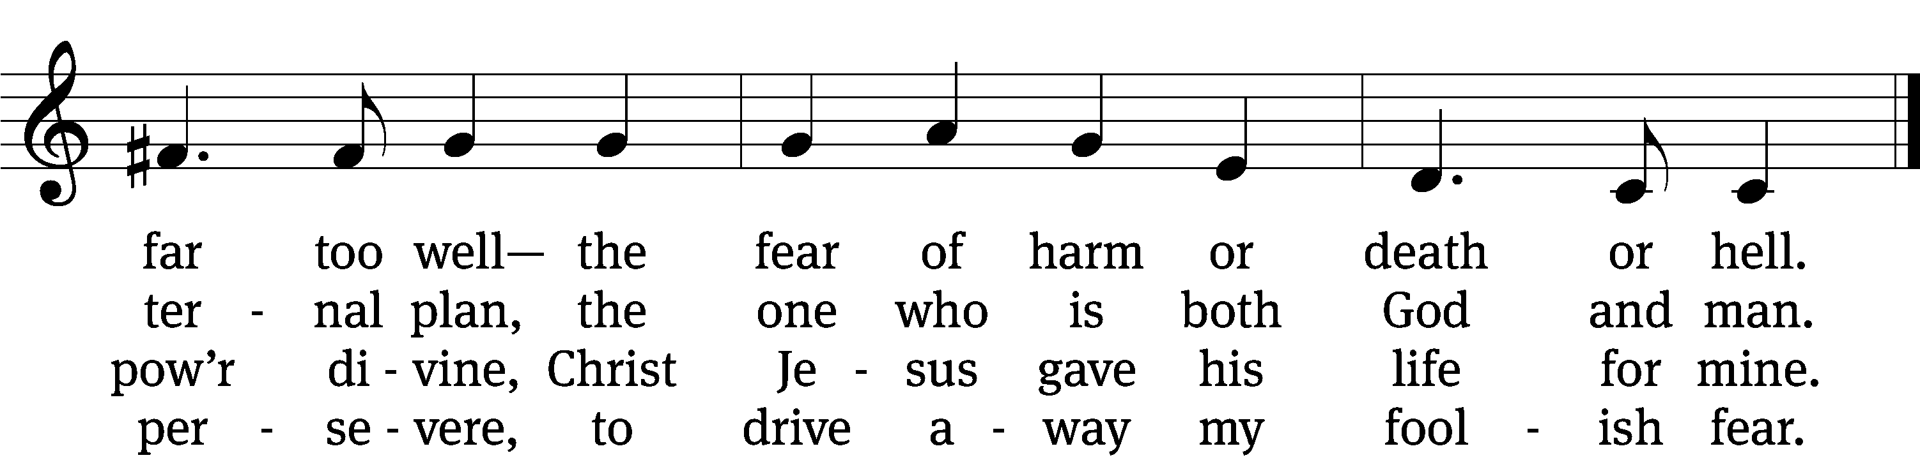

5 A boat, a storm, adrift again, 6 Lord Jesus Christ, when storms arise
they marshaled all their strength in vain. on you alone I’ll fix my eyes.
They saw the Lord; “A ghost!” they cried, Through Word and water, bread and
and, sinking fast, one almost died. wine,
But he who walked out on the sea I hear you saying, “You are mine!”
saved them from great catastrophe. Your promises are strong to quell
all fear of harm and death and hell.

Text: Michael D. Schultz, b. 1963
Tune: John B. Dykes, 1823–1876
Text: © 2009 Michael D. Schultz, admin. Northwestern Publishing House. Used by permission: OneLicense no. 727703
Tune: Public domain

SERMON Matthew 14:25-31
“Where’s Your Faith”

PLEASE STAND, IF YOU ARE ABLE

THE APOSTLES’ CREED

I believe in God, the Father almighty,
maker of heaven and earth.
I believe in Jesus Christ, his only Son, our Lord,
who was conceived by the Holy Spirit,
born of the virgin Mary,
suffered under Pontius Pilate,
was crucified, died, and was buried.
He descended into hell.
The third day he rose again from the dead.
He ascended into heaven
and is seated at the right hand of God the Father almighty.
From there he will come to judge the living and the dead.
I believe in the Holy Spirit,
the holy Christian Church,
the communion of saints,
the forgiveness of sins,
the resurrection of the body,
and the life everlasting. Amen.

PRAYER OF THE CHURCH

THE LORD’S PRAYER

C: Our Father, who art in heaven, hallowed be thy name, thy kingdom come, thy will be done on earth as it is in heaven. Give us this day our daily bread; and forgive us our trespasses, as we forgive those who trespass against us; and lead us not into temptation, but deliver us from evil. For thine is the kingdom and the power and the glory forever and ever. Amen.
812 Christ, the Sure and Steady Anchor CW 812
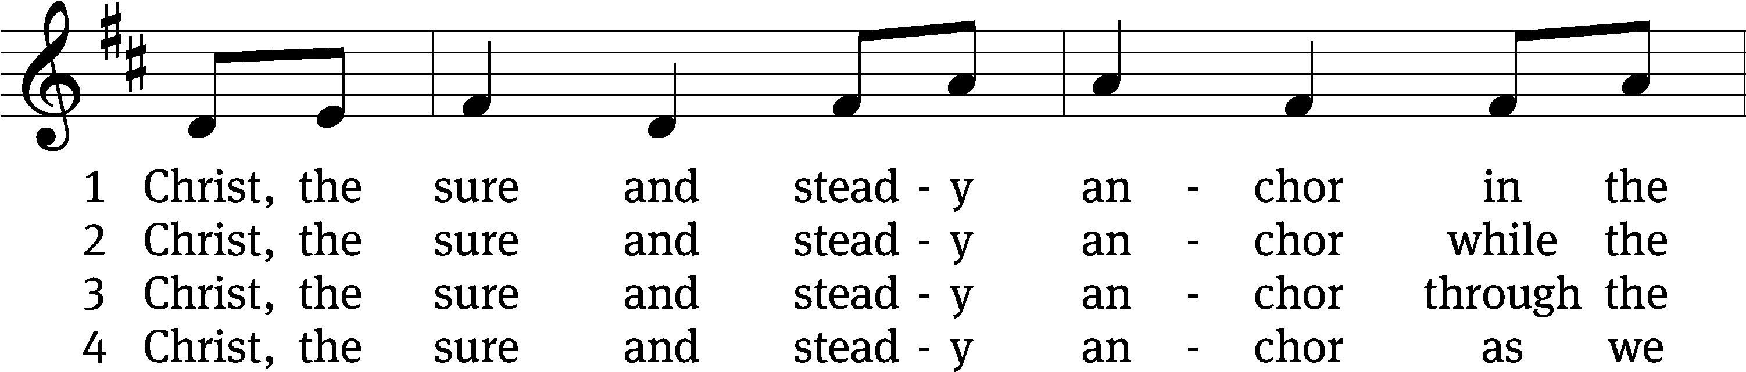
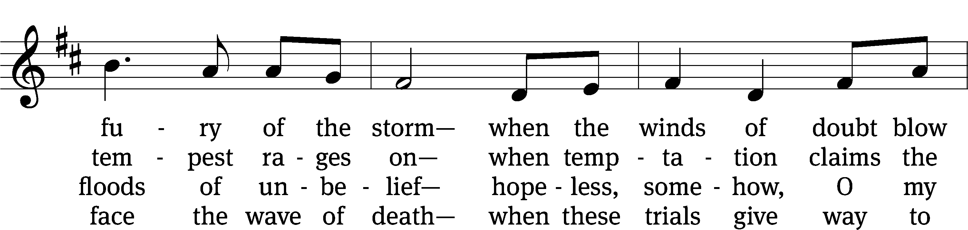
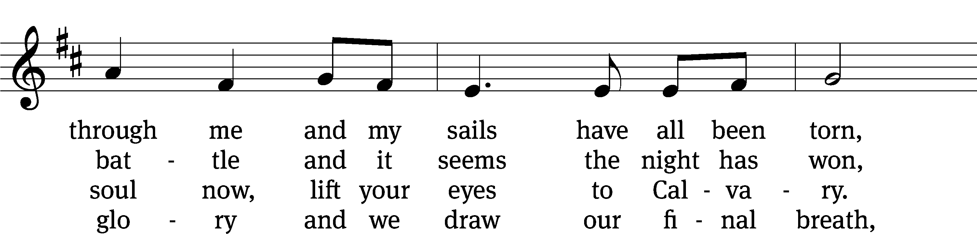
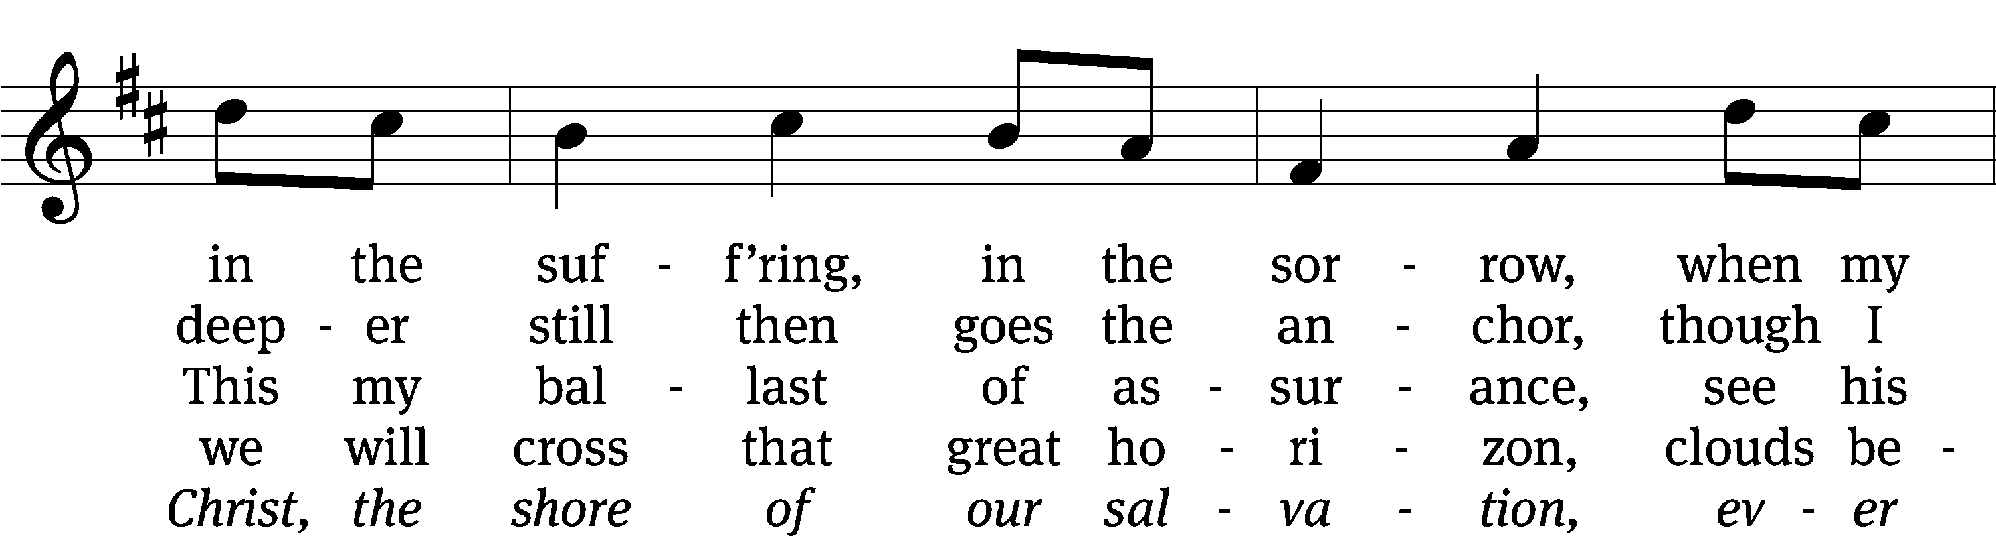
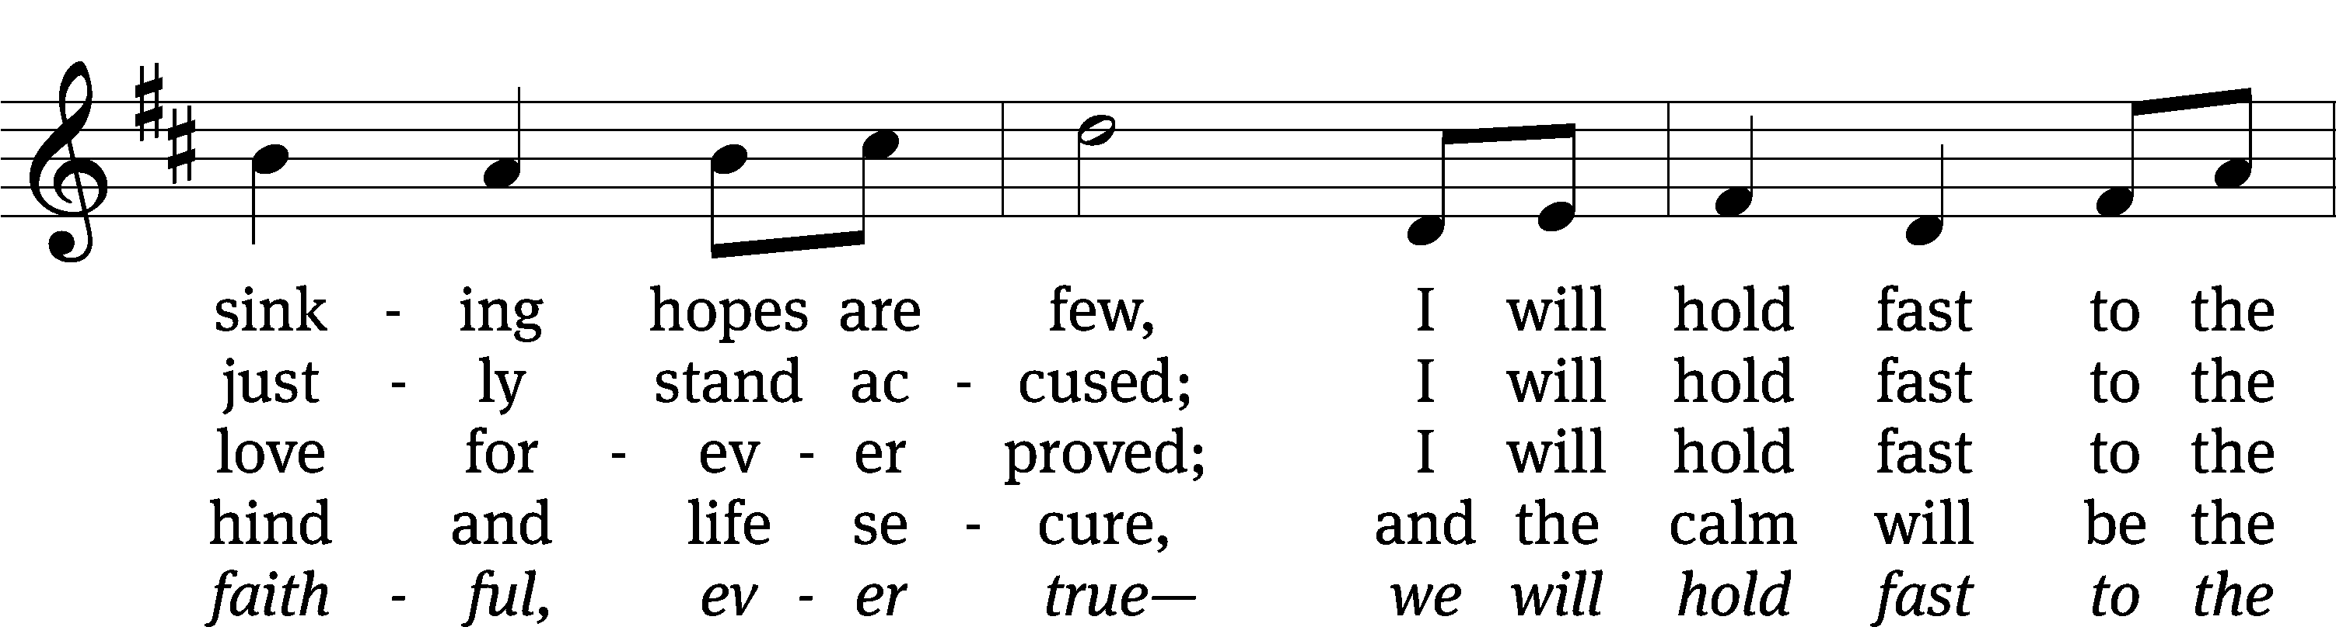
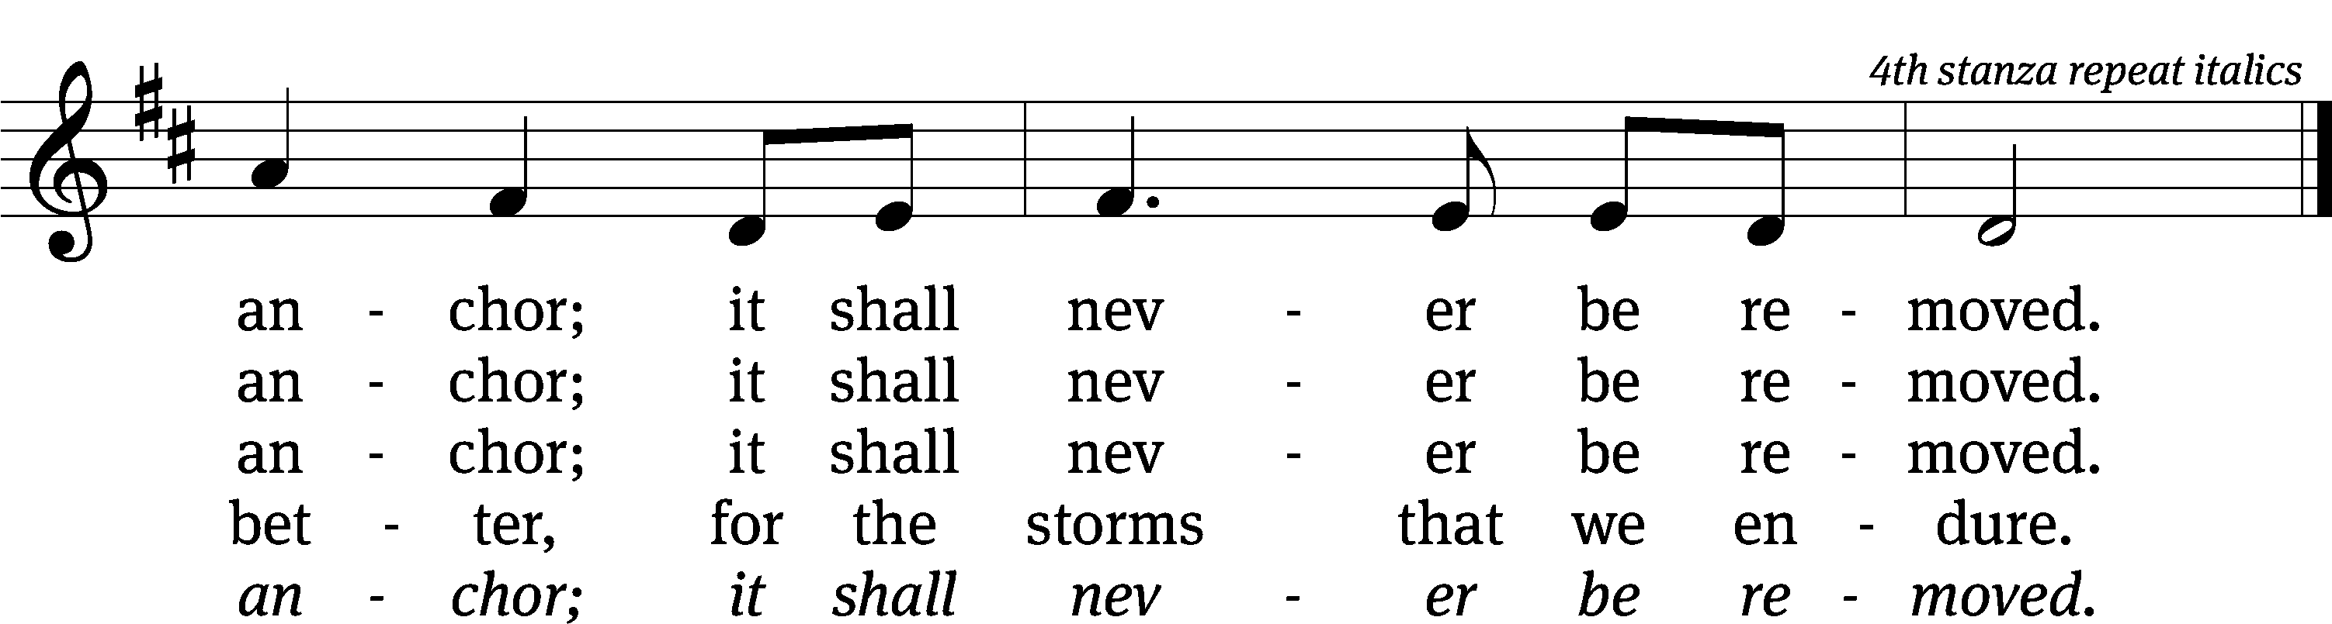
Text: Matt Papa, b. 1983; Matt Boswell, b. 1979
Tune: Matt Papa, b. 1983; Matt Boswell, b. 1979
Text and tune: © 2016 Getty Music Songs, Messenger Hymns, and Love Your Enemies Publishing, admin. MusicServices.org. Used by permission: OneLicense no. 727703

PLEASE STAND, IF YOU ARE ABLE

CLOSING PRAYER
M: Almighty God, we thank you for teaching us the things you want us to believe and do. Help us by your Holy Spirit to keep your Word in pure hearts that we may be strengthened in faith, guided in holiness, and comforted in life and in death, through Jesus Christ, our Lord, who lives and reigns with you and the Holy Spirit, one God, now and forever.

M: Brothers and sisters, go in peace. Live in harmony with one another. Serve the Lord with gladness.
The Lord bless you and keep you.
The Lord make his face shine on you and be gracious to you.
The Lord look on you with favor and (+) give you peace.

PLEASE BE SEATED

433 (CW93) Jesus, Savior, Pilot Me

Serving In Worship
Officiant Pastor Natsis
Organist Sarah Hanke
Deacons (Thursday) Duane Mason and Dave Stevenson
(Sunday) Jeff Neuburger and Robert Niethammer
Ushers (Thursday) Tim Phelps
(Sunday) Ron Zahn
Altar Guild Marcia Marion Ackling and Scott Ackling
Videographer Jake Vershum

Copyright information
Service of the Word: Christian Worship. © 1993 Northwestern Publishing House. All rights reserved.
Reprinted with permission under ONE LICENSE #A-727703 and CCLI #1151741/CSPL126093

Words and Music: All rights reserved. Reprinted with permission under ONE LICENSE #A-727703 and
CCLI #1151741/CSPL126093
tlcsaline.church

