THE FOURTENTH SUNDAY
AFTER PENTECOST
TRINITY EVANGELICAL LUTHERAN CHURCH | Saline, Michigan
WELCOME TO WORSHIP August 31/September 3, 2023
Thank you for joining us in God’s house today! We cordially ask that our Guests sign one of the guestbooks located at either the front or back entryways, or fill out a “Let’s Get Acquainted” card located in the hymnal pew rack and place it in the collection plate.

Thank Offering: Members of Trinity give their offering as an expression of love and thankfulness to the Lord and to help support the Lord’s work in our community and around the world. Visitors need not feel obligated to participate in this offering .

Restrooms are located at the back of the upper level (the annex), and in the basement (down the back stairs of the sanctuary or annex). Handicap access is available, please ask an usher for assistance.

Young Families / Toddler Bags – We are GLAD YOU BROUGHT YOUR CHILDREN to our worship service. Jesus said: “Let the little children come to me and do not hinder them, for the kingdom of God belongs to such as these.” We know that having little children in church can be a challenge, but DO NOT WORRY about it. Many of your fellow worshippers have been in your shoes and are just happy you brought your children with you. For your convenience, we have reserved the back rows of seating for parents with small children. These areas provide more flexibility for your family, as well as, easy access to move downstairs if necessary. A closed-circuit TV system allows families to continue participating in the service while downstairs. Pre-school toddler bags and children’s bulletins are available for their enjoyment. Ask an usher for one to use during the service and please return the toddler bag afterwards.

Holy Communion – In His Word, God makes it clear that the Lord’s Supper is to be shared by people of a common proclamation of faith (1 Corinthians 11:26; 1 Corinthians 10:16-17). Without judging anyone’s hearts, we invite those who share in our confession by their membership in our congregation or another congregation of the Wisconsin Evangelical Lutheran Synod (WELS) or the Evangelical Lutheran Synod (ELS) and who are properly prepared (1 Corinthians 11;27-29) to receive the Sacrament. Page 295 in Christian Worship provides a guide for preparation.
Guests, we would love to have you join us in communion fellowship in the future, and for that to be possible, we ask that you speak with one of the pastors so that we may speak with you on how that would be possible. We thank you for respecting the way we celebrate the Lord’s Supper in our congregations.

the SERVICE – setting one - WITH HOLY COMMUNION CW, page 154
831 Why Should Cross and Trial Grieve Me CW 831
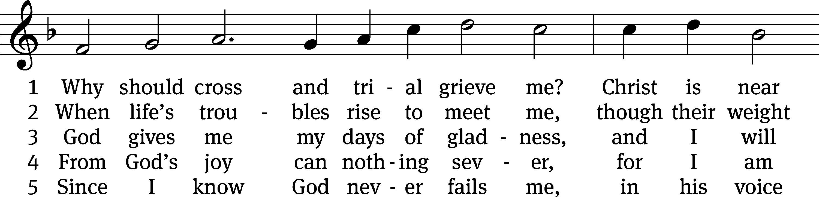
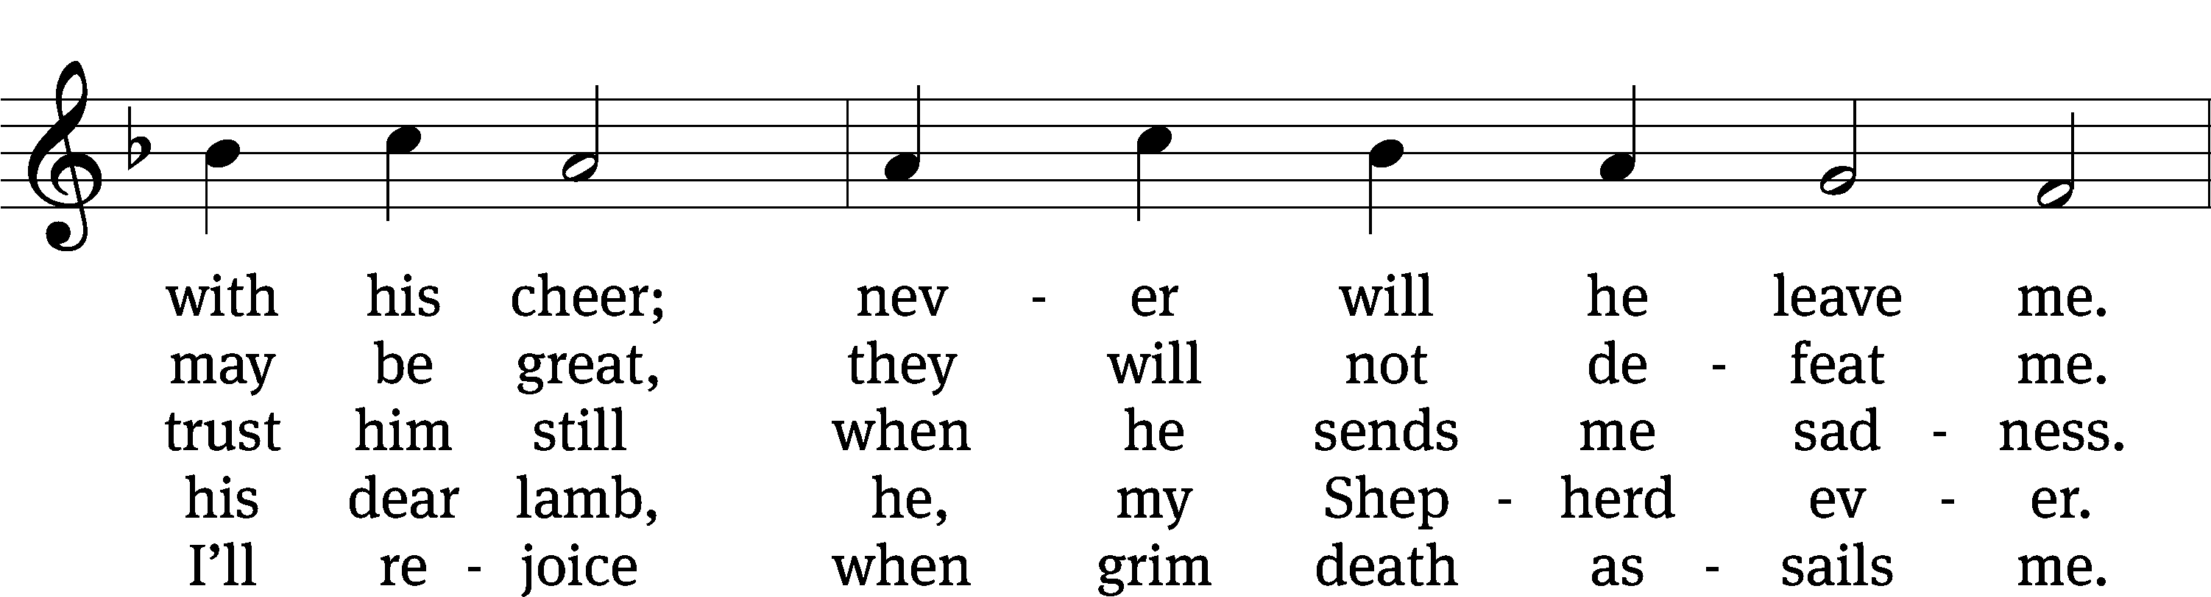
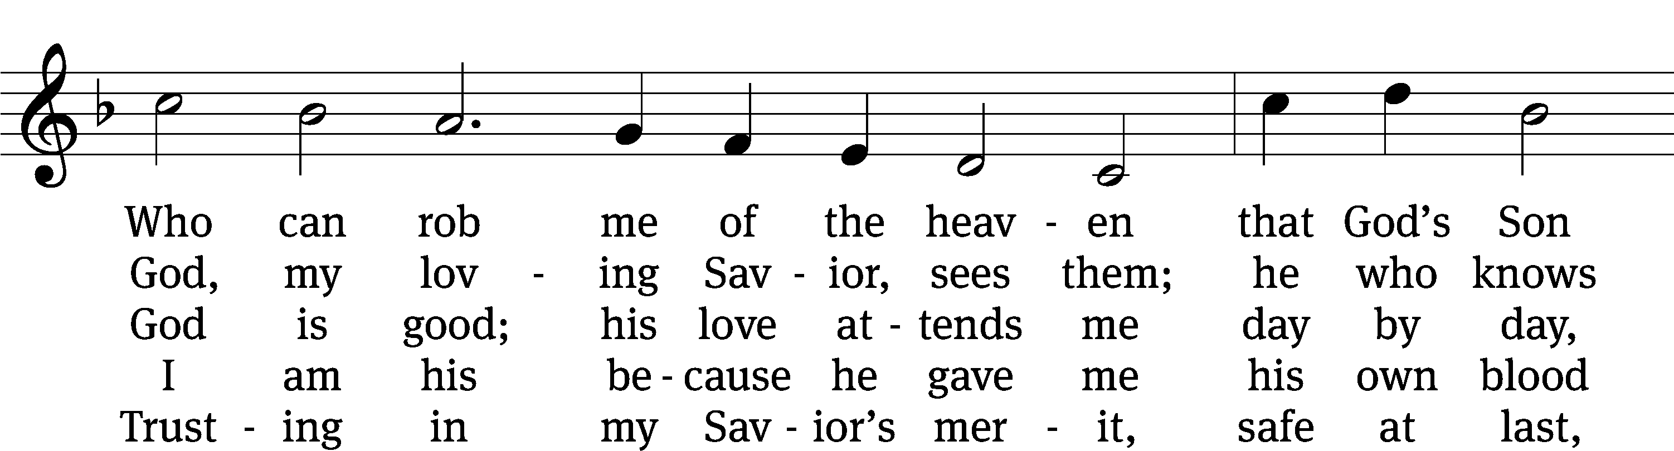
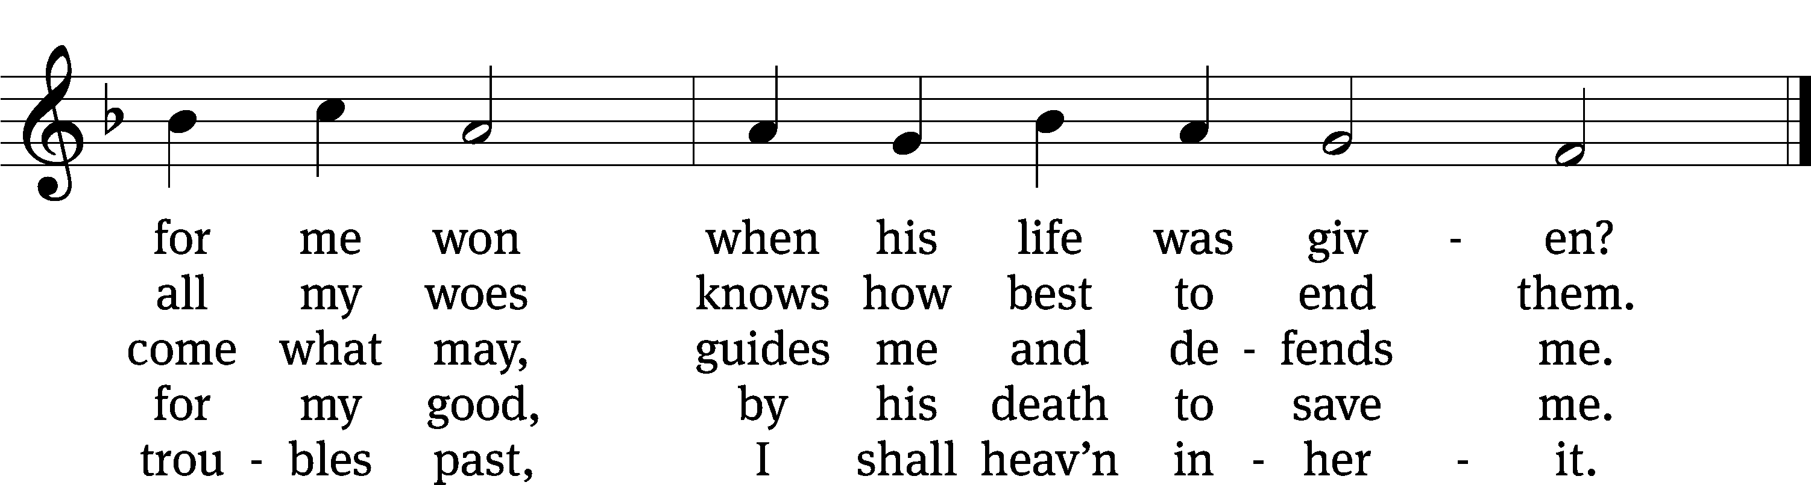
Text: Paul Gerhardt, 1607–1676, abr.; (sts. 1–3): tr. Christian Worship, 1993; (st. 4): tr. Stephen P. Starke, b. 1955; (st. 5): tr. Harlyn J. Kuschel, b. 1945
Tune: Johann G. Ebeling, 1637–1676
Text (st. 4): © 2004 Stephen P. Starke, admin. Concordia Publishing House; (st. 5): © 1993 Harlyn J. Kuschel, admin. Northwestern Publishing House. Used by permission: OneLicense no. 727703
Text (sts. 1–3) and tune: Public domain

Please stand, if you are able
Invocation
In the name of the Father and of the Son and of the Holy Spirit.
Amen.
Confession
If we claim to be without sin, we deceive ourselves and the truth is not in us.
If we confess our sins, God is faithful and just
and will forgive us our sins
and purify us from all unrighteousness.

Let us confess our sins to the Lord.
Holy God, gracious Father,
I am sinful by nature
and have sinned against you in my thoughts, words, and actions.
I have not loved you with my whole heart;
I have not loved others as I should.
I deserve your punishment both now and forever.
But Jesus, my Savior, paid for my sins
with his innocent suffering and death.
Trusting in him, I pray: God, have mercy on me, a sinner.

Our gracious Father in heaven has been merciful to us. He sent his only Son, Jesus Christ, who gave his life as the atoning sacrifice for the sins of the whole world. Therefore, as a called servant of Christ and by his authority, I forgive you all your sins in the name of the Father and of the Son and of the Holy Spirit.
Amen.

Lord, Have Mercy

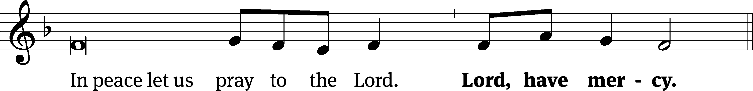
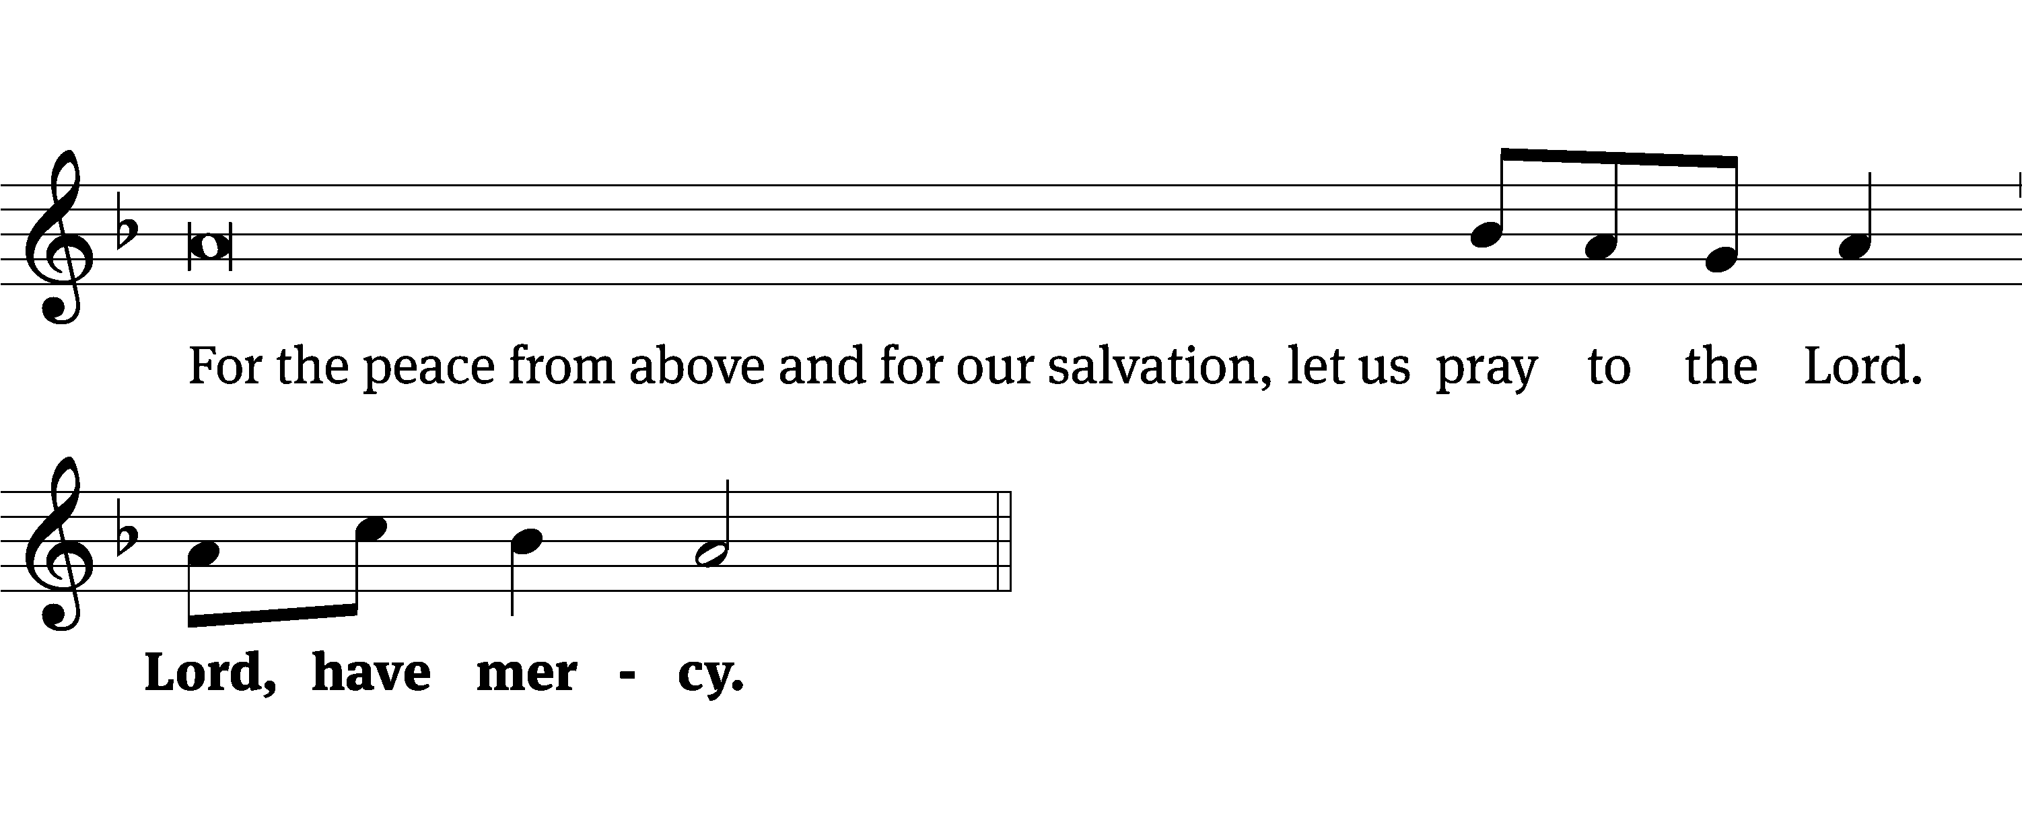
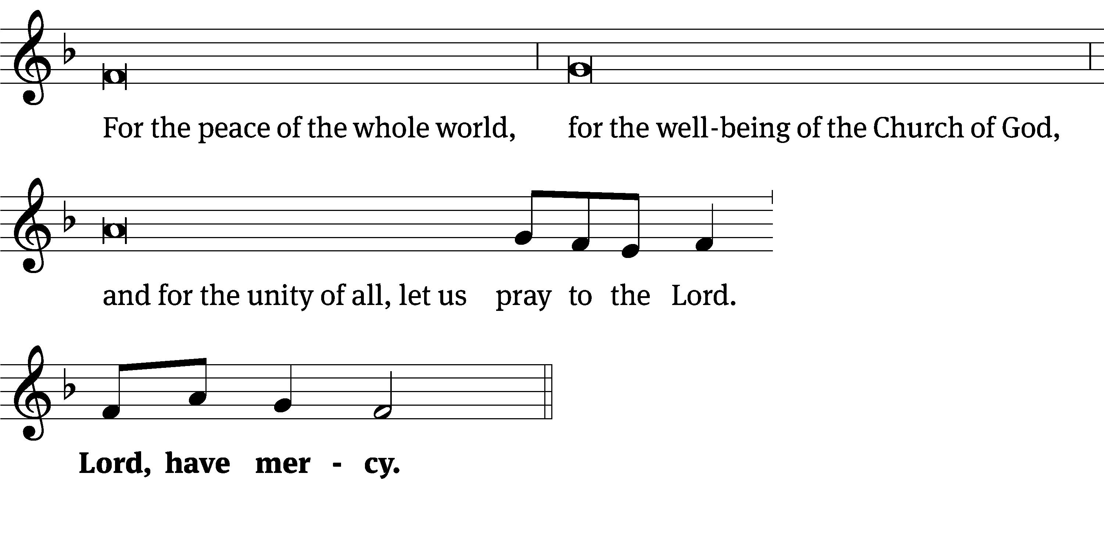
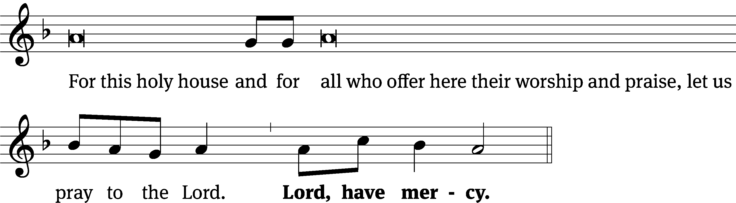
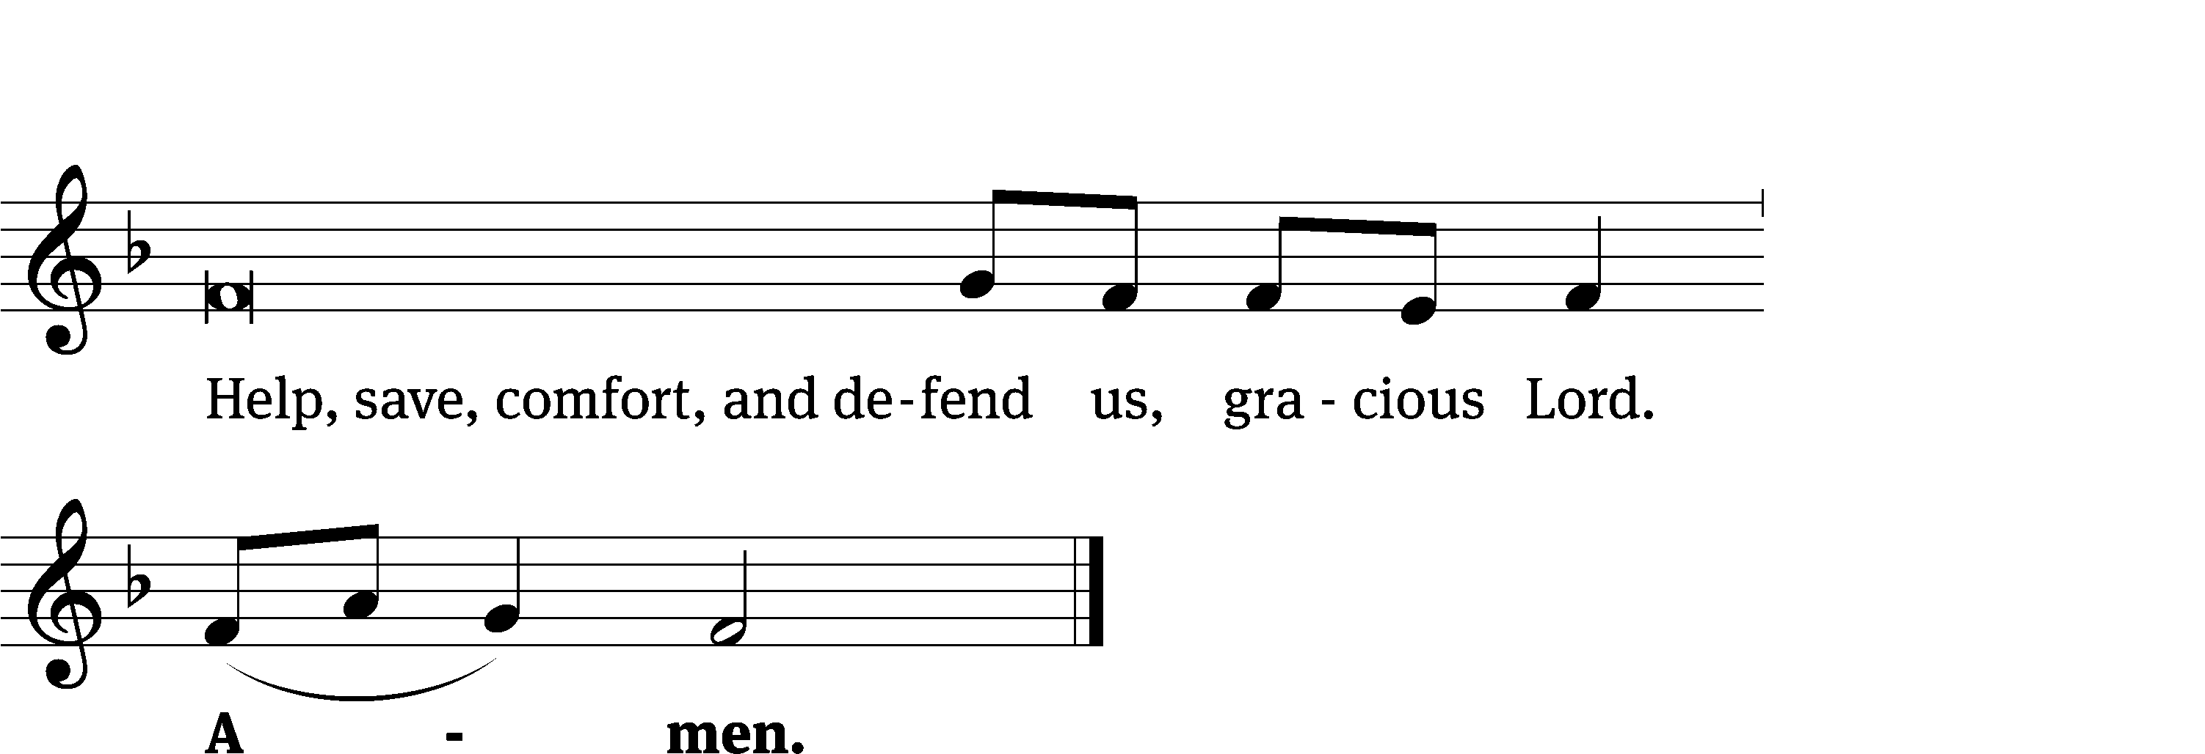
Glory Be to God on High CW 157
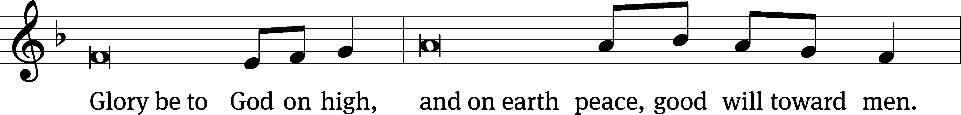
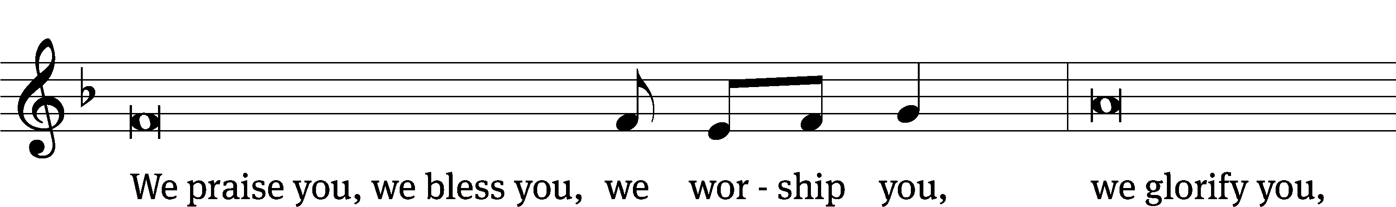
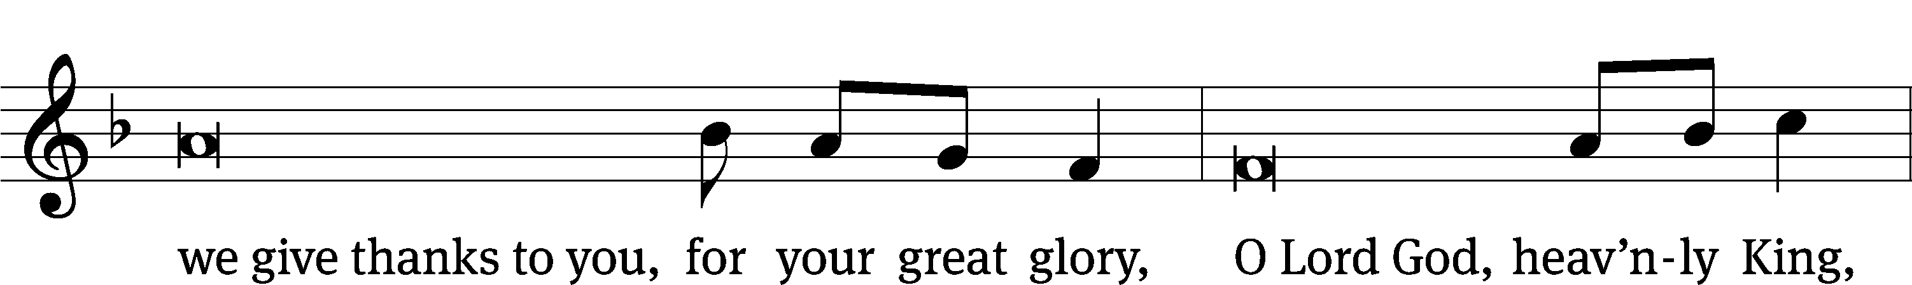
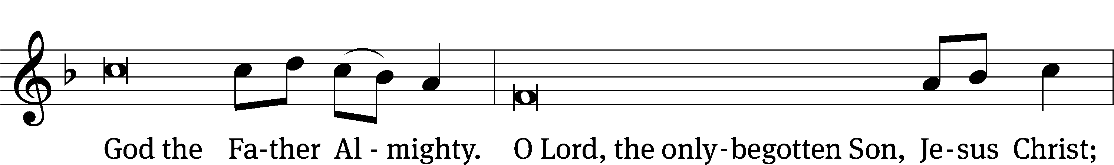
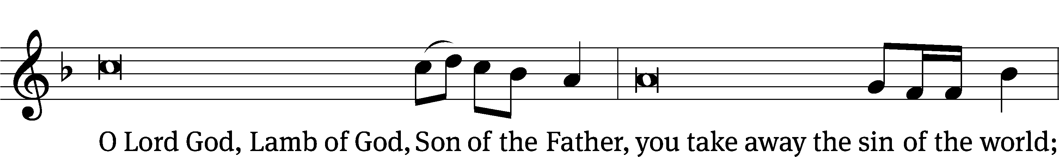
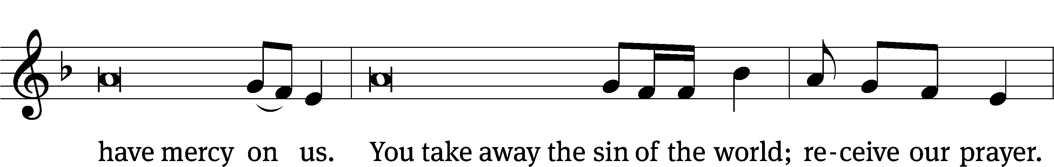
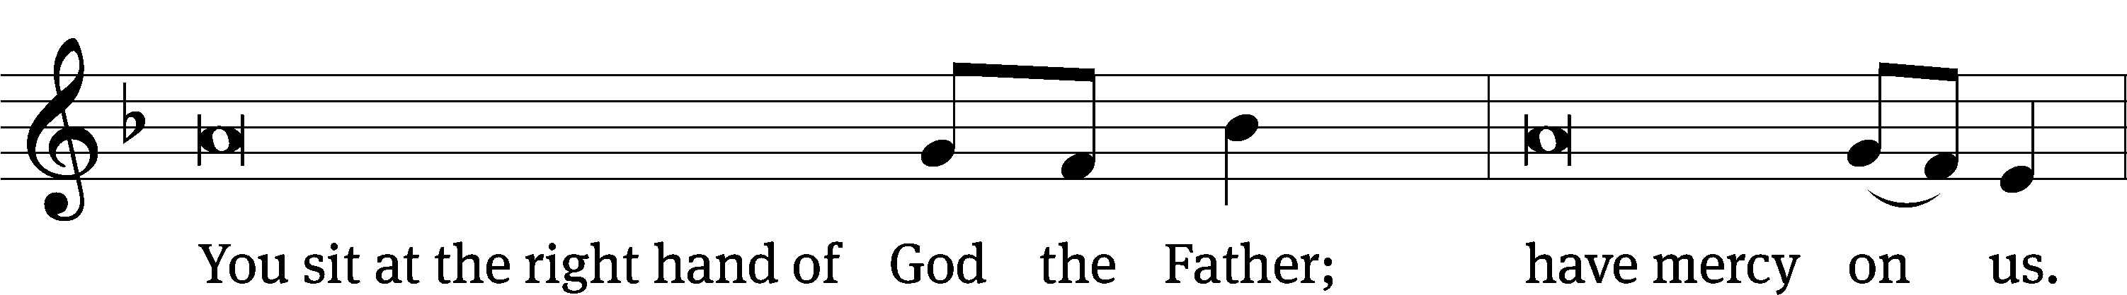
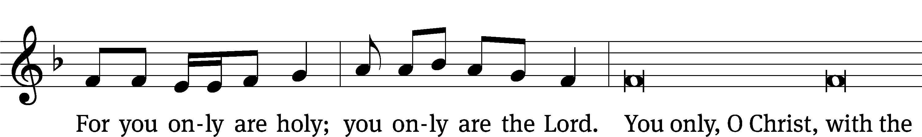
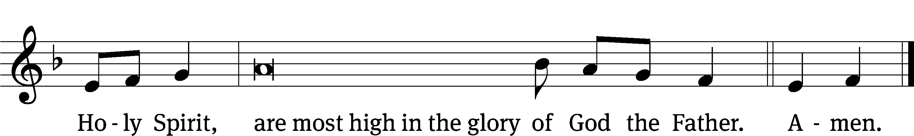

The Lord be with you.
And also with you.
Prayer of the Day
Let us pray.

Almighty God, your Son willingly endured the agony and shame of the cross for our redemption. Grant us courage to take up our cross daily and follow him wherever he leads; through your Son, Jesus Christ our Lord, who lives and reigns with you and the Holy Spirit, one God, now and forever.
Amen.

Please be seated

First Reading Jeremiah 15:15-21

¹⁵ O Lord, you understand.
Remember me and care for me.
Take vengeance for me on those who persecute me.
You are slow to anger.
Do not take me away.
Keep in mind that for your sake I bear disgrace.
¹⁶ Your words came to me, and I devoured them.
Your words became my joy,
the delight of my heart,
because I bear your name,
O Lord God of Armies.
¹⁷ I did not sit with the band of partygoers,
nor did I celebrate with them.
I sat alone, because your hand was upon me.
You filled me with indignation.
¹⁸ Why is my pain unending?
Why is my wound incurable, refusing to heal?
Will you be as deceptive as an intermittent stream to me,
like a source of water that a person can’t depend on?
¹⁹ Therefore this is what the Lord says.
If you repent, I will take you back,
so that you may stand before me.
If what you say is worthwhile and not worthless,
you will be my spokesman.
They must turn to you,
but you must not turn to them.
²⁰ I will make you like a bronze wall to this people.
They will fight against you,
but they will not overcome you,
because I am with you to save you
and to rescue you, declares the Lord.
²¹ I will rescue you from the hand of the wicked,
and I will deliver you from the grasp of the ruthless.

The Word of the Lord.
Thanks be to God.
31E Surely It Is God Who Saves Me Psalm 31E
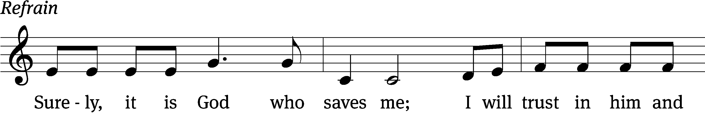
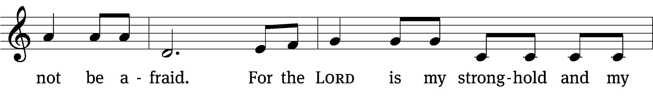
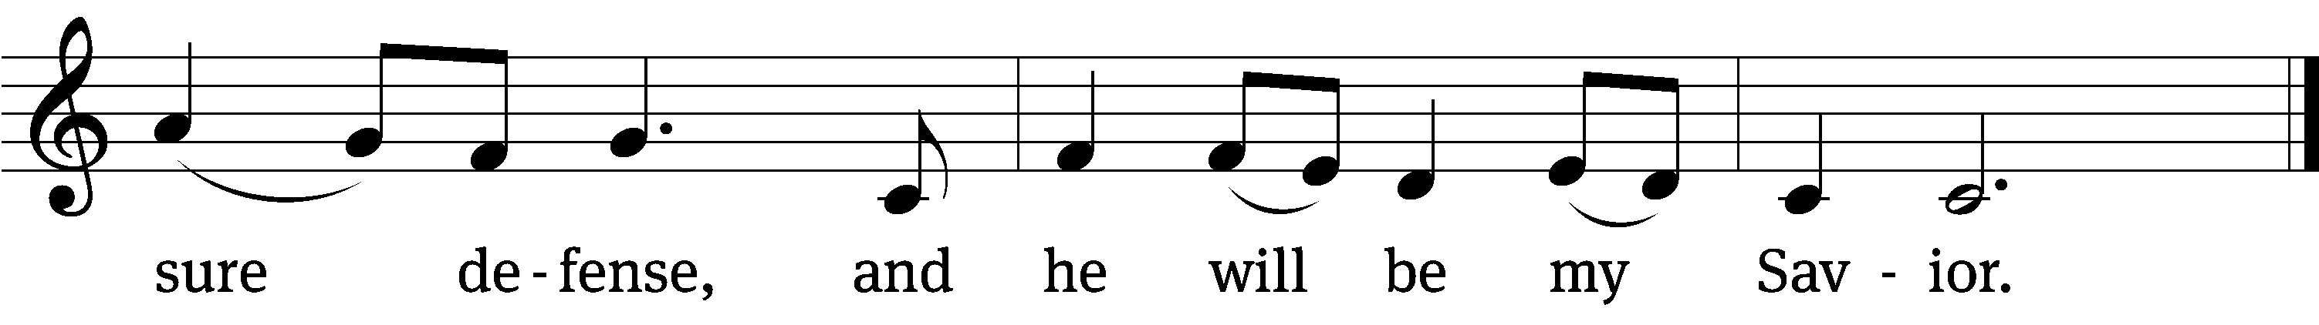

In you, Lord, I have taken / refuge;
let me never be / put to shame.
Be my rock of / refuge,
a strong fortress to / save me.
Into your hands I commit my / spirit;
deliver me, Lord, my / faithful God. Refrain

My times are / in your hands;
save me in your un- / failing love.
How abundant are the / good things
that you have stored up for those who / fear you.
Be strong and / take heart,
all you who hope / in the Lord.
Glory be to the Father and / to the Son
and to the Holy / Spirit,
as it was in the be- / ginning,
is now, and will be forever. / Amen. Refrain
Text: The Draft Proposed Book of Common Prayer
Tune: Jack Noble White
Text: © 1976 Charles Mortimer Guilbert, custodian of the Standard Book of Common Prayer. Used by permission: OneLicense no. 727703
Tune: © 1976 Jubilate Music Group. Used by permission: OneLicense no. 727703
Setting: © 1993 Northwestern Publishing House, admin. Kermit G. Moldenhauer. Used by permission: OneLicense no. 727703

Second Reading Romans 8:18-25
¹⁸ For I conclude that our sufferings at the present time are not worth comparing with the glory that is going to be revealed to us. ¹⁹ In fact, creation is waiting with eager longing for the sons of God to be revealed. ²⁰ For creation was subjected to futility, not by its own will, but by the will of the one who subjected it, in the hope ²¹ that even creation itself will be set free from slavery to corruption, in order to share in the glorious freedom of the children of God.
²² For we know that all of creation is groaning with birth pains right up to the present time. ²³ And not only creation, but also we ourselves, who have the firstfruits of the Spirit,^{[a]} groan inwardly while we eagerly await our adoption as sons, the redemption of our body. ²⁴ Indeed, it was for this hope we were saved. But hope that is seen is not hope, because who hopes for what he already sees? ²⁵ But if we hope for something we do not see, we eagerly wait for it with patient endurance.

The Word of the Lord.
Thanks be to God.
Please stand, if you are able
Gospel Acclamation Mark 8:34
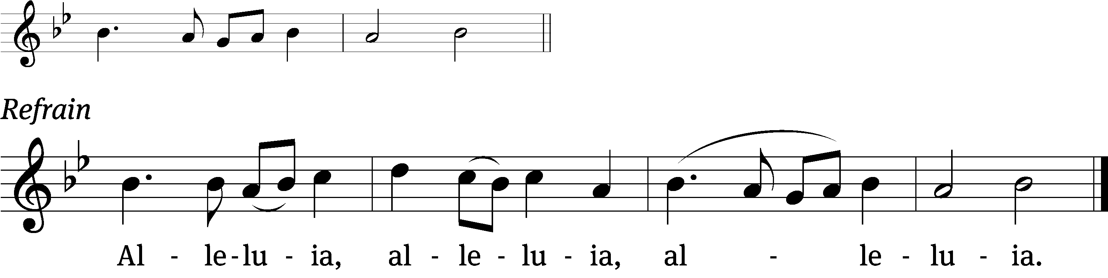
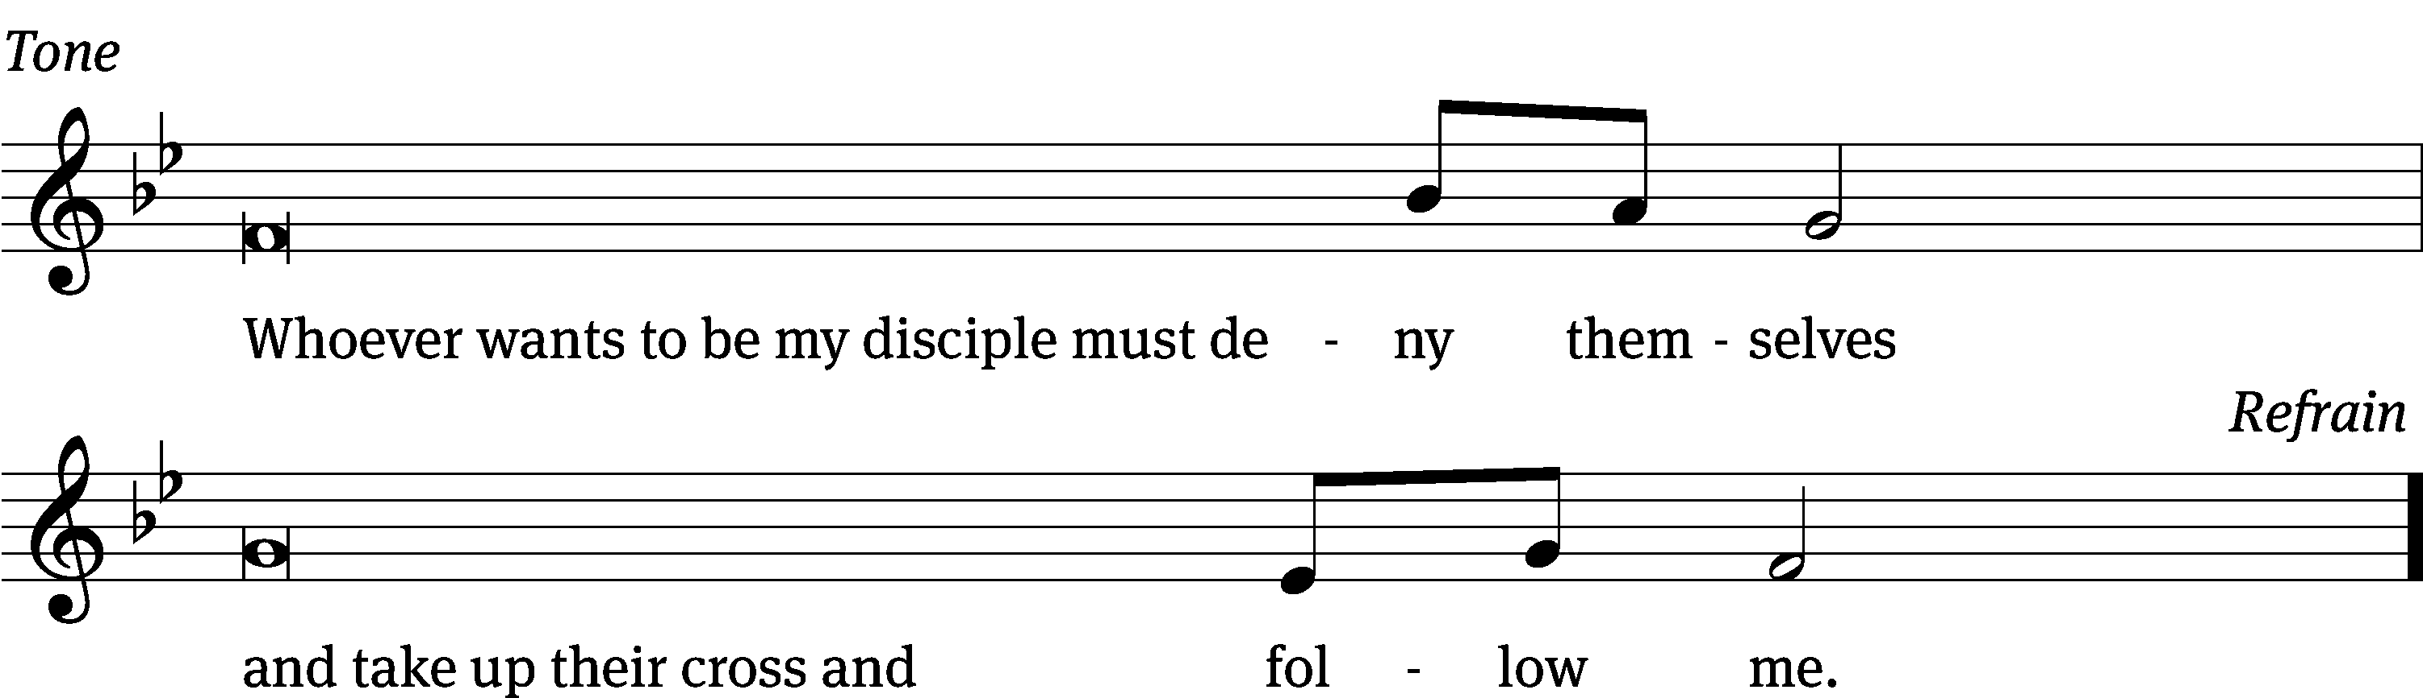
Tune: © 2021 Northwestern Publishing House. Used by permission: OneLicense no. 727703

Gospel Matthew 16:21-26
²¹ From that time, Jesus began to show his disciples that he had to go to Jerusalem and suffer many things from the elders, chief priests, and experts in the law, and be killed, and on the third day be raised again.
²² Peter took him aside and began to rebuke him, saying, “May you receive mercy, Lord! This will never happen to you.”
²³ But Jesus turned and said to Peter, “Get behind me, Satan! You are a snare to me because you are not thinking the things of God, but the things of men.”
²⁴ Then Jesus said to his disciples, “If anyone wants to follow me, let him deny himself, take up his cross, and follow me. ²⁵ In fact whoever wants to save his life will lose it, and whoever loses his life for my sake will find it. ²⁶ After all, what will it benefit a person if he gains the whole world, but forfeits his soul? Or what can a person give in exchange for his soul?
The Gospel of the Lord.
Praise be to you, O Christ!

Please be seated

799 I Leave All Things to God’s Direction CW 799
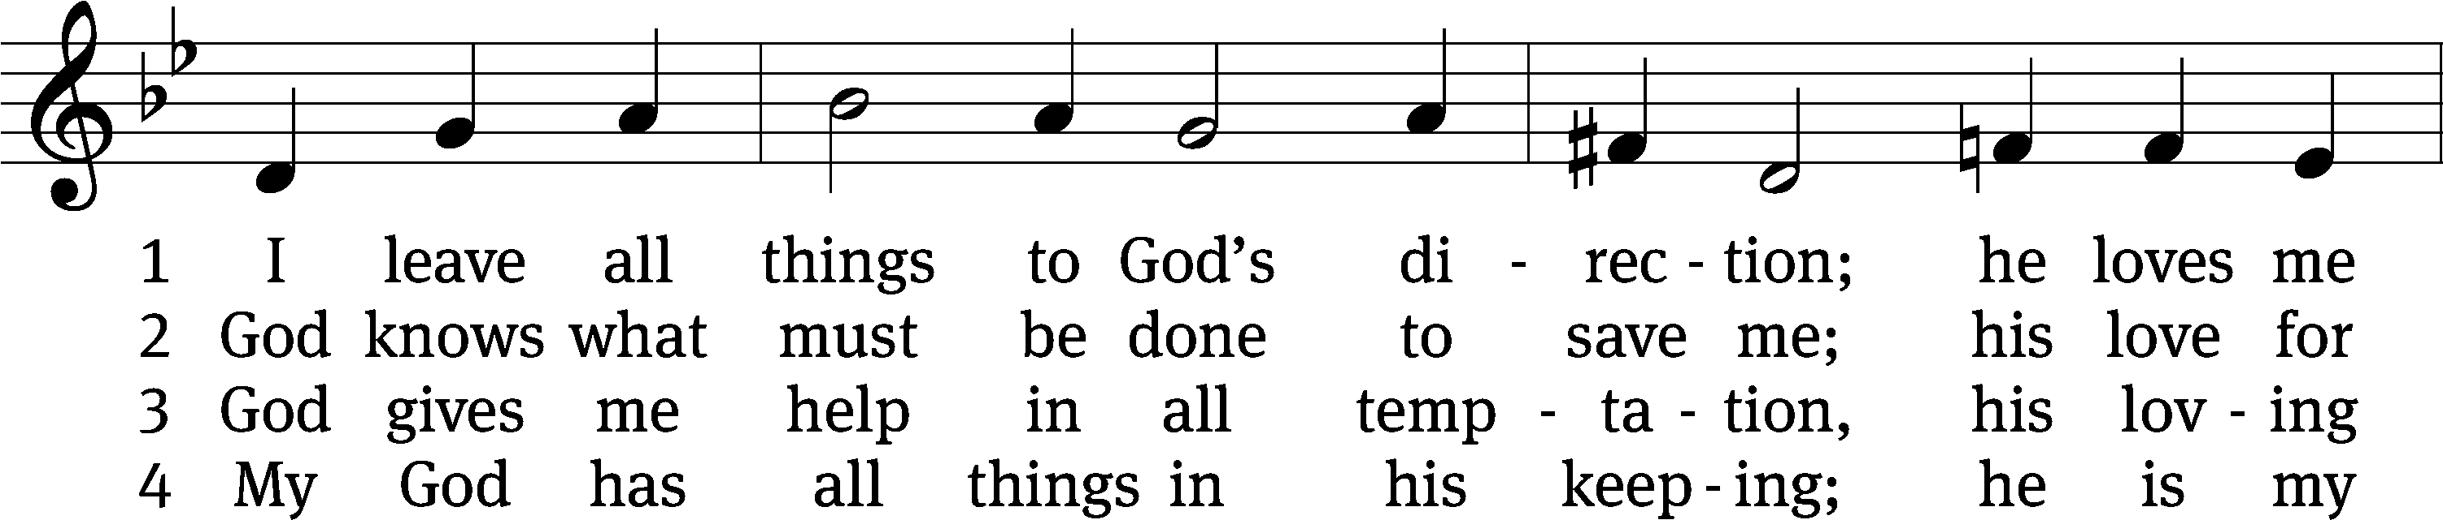
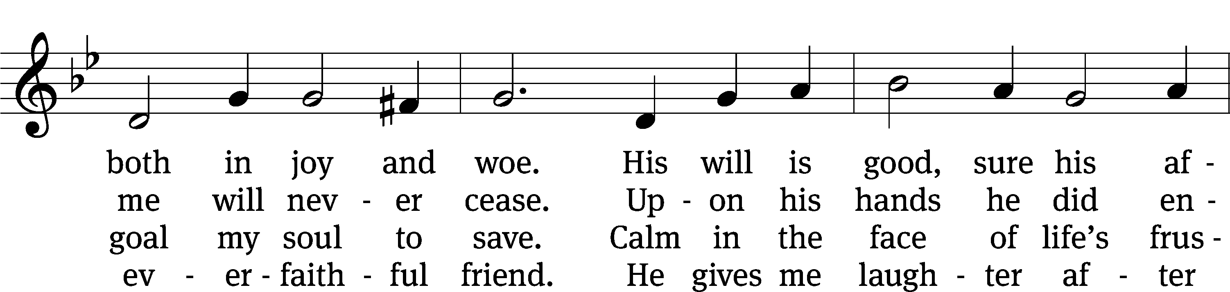
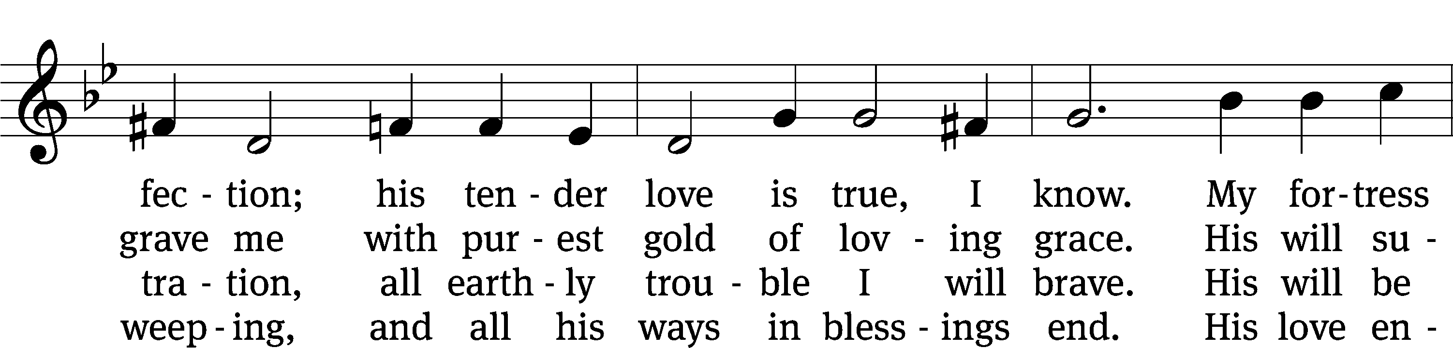
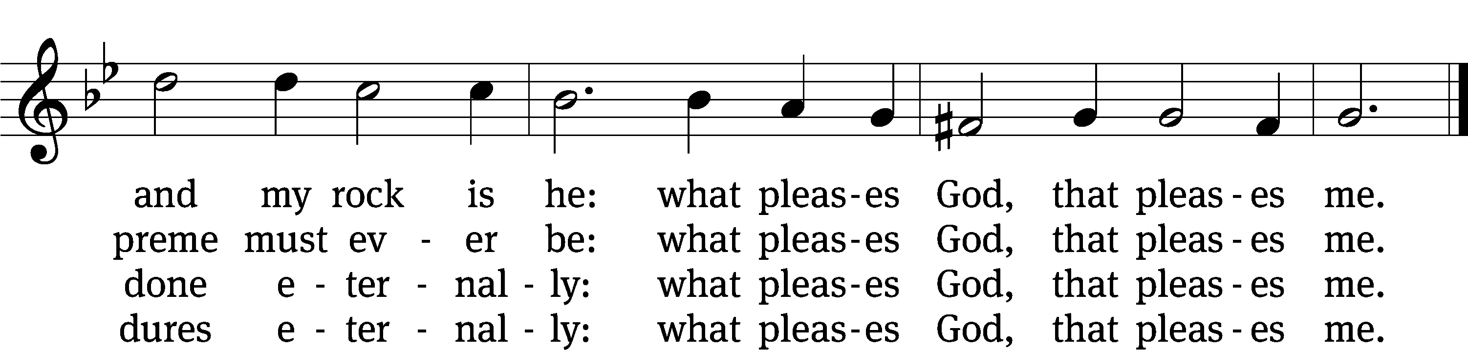
Text: tr. August Crull, 1845–1923, alt.; Salomo Franck, 1659–1725, abr.
Tune: Georg C. Neumark, 1621–1681
Text and tune: Public domain

SERMON Matthew 16:21-26
“My Way…Or God’s”

Please stand, if you are able

nicene creed
We believe in one God, the Father, the Almighty, maker of heaven and earth, of all that is, seen and unseen.
We believe in one Lord, Jesus Christ, the only Son of God, eternally begotten of the Father, God from God, Light from Light, true God from true God, begotten, not made, of one being with the Father. Through him all things were made. For us and for our salvation, he came down from heaven, was incarnate of the Holy Spirit and the virgin Mary, and became truly human. For our sake he was crucified under Pontius Pilate. He suffered death and was buried. On the third day he rose again in accordance with the Scriptures. He ascended into heaven and is seated at the right hand of the Father. He will come again in glory to judge the living and the dead, and his kingdom will have no end.
We believe in the Holy Spirit, the Lord, the giver of life, who proceeds from the Father and the Son, who in unity with the Father and the Son is worshiped and glorified, who has spoken through the prophets. We believe in one holy Christian and apostolic Church. We acknowledge one baptism for the forgiveness of sins. We look for the resurrection of the dead and the life of the world to come. Amen.

Prayer of the Church

The Sacrament
Preface CW 165
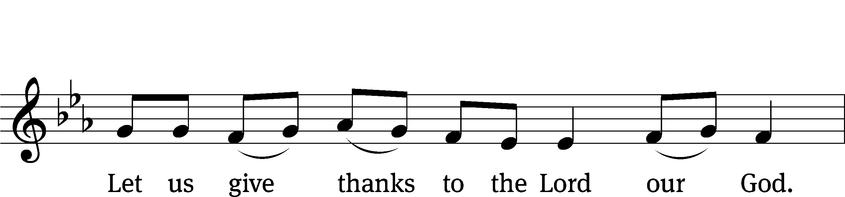
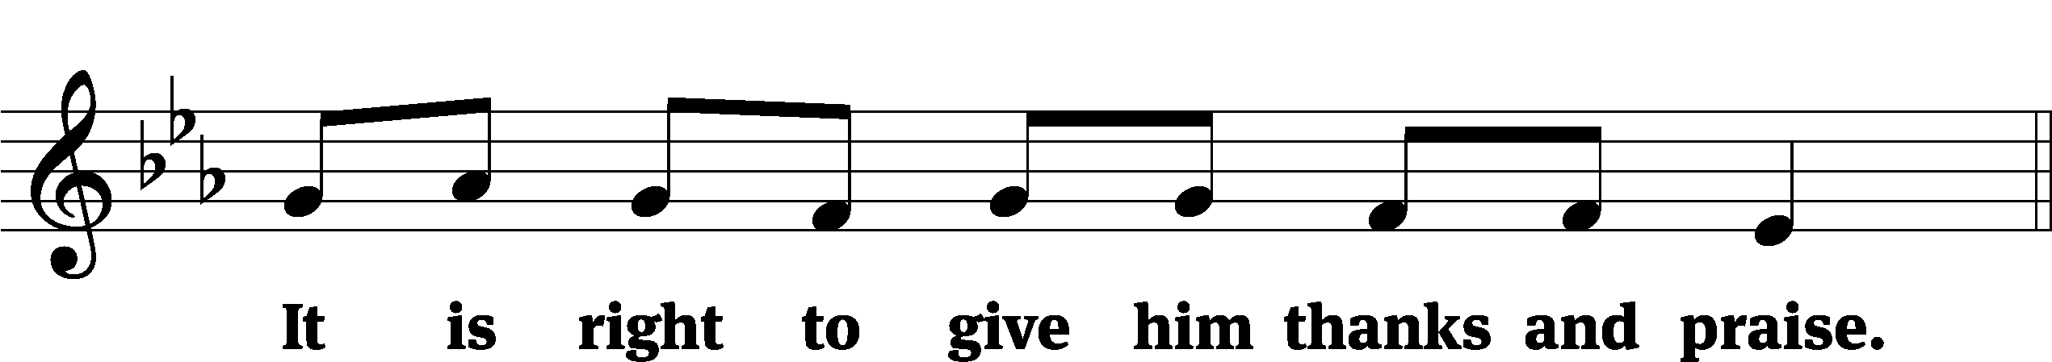

It is truly good and right that we should at all times and in all places give you thanks, O Lord, holy Father, almighty and everlasting God, through Jesus Christ our Lord, who by his willing sacrifice on the cross took away the sins of the world and by his glorious resurrection restored everlasting life. Therefore, with all the saints on earth and hosts of heaven, we praise your holy name and join their glorious song:

Holy, Holy, Holy CW 167
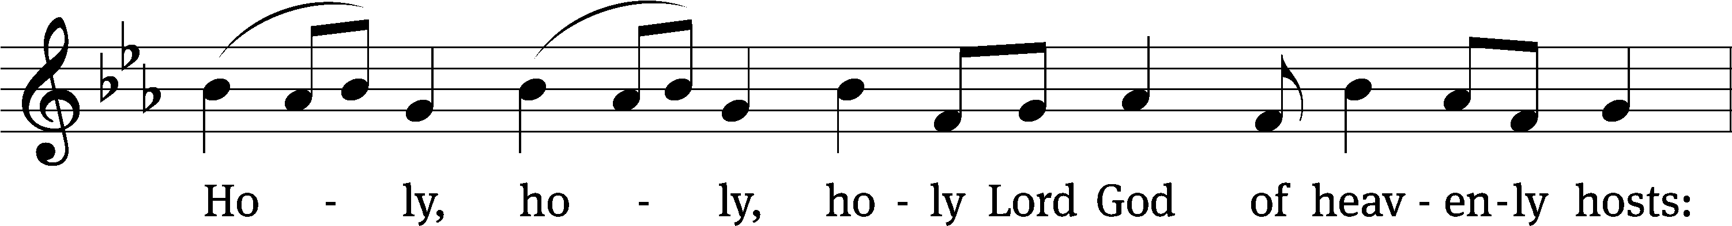
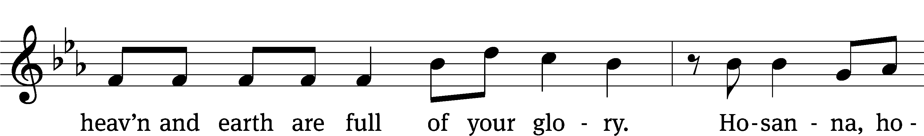
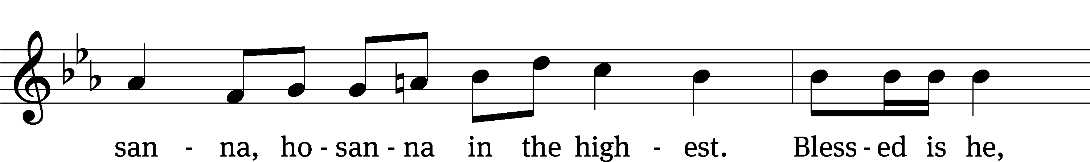
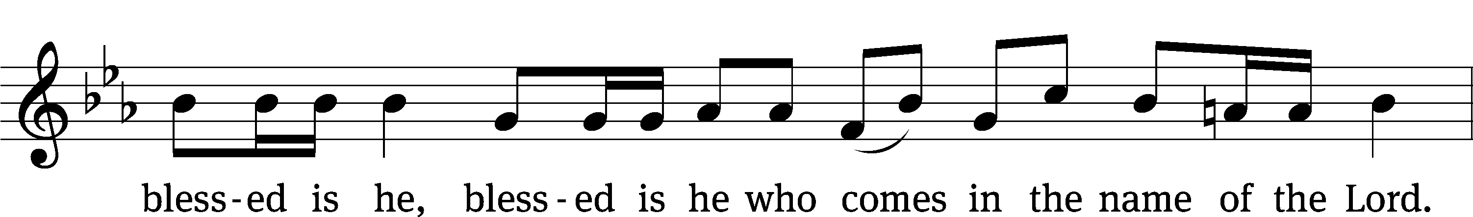
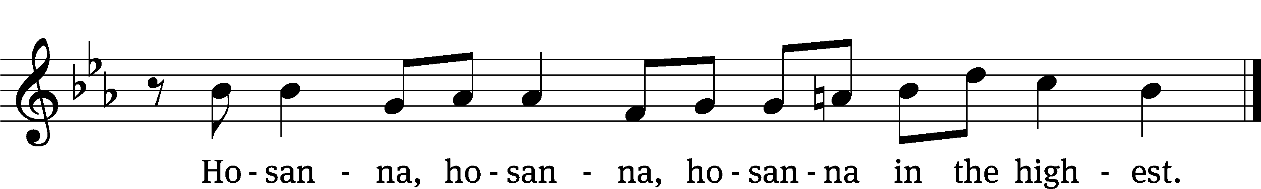

Prayer of Thanksgiving
We give thanks to you, O God, through your dear Son, Jesus Christ, whom you sent to be our Savior, our Redeemer, and the messenger of your grace. Through him you made all things; in him you are well pleased. He is the incarnate Word, conceived by the Holy Spirit and born of the Virgin Mary. To fulfill your promises, he stretched out his hands on the cross and released from eternal death all who believe in you.

As we remember Jesus’ death and resurrection, we thank you that you have gathered us together to receive your Son’s body and blood. Send us your Spirit, unite us as one, and strengthen our faith so that we may praise you in your Son, Jesus Christ. Through him, we glorify and honor you, O God our Father, with the Holy Spirit, one God, now and forever.
Amen.

Lord’s Prayer
Our Father, who art in heaven, hallowed be thy name, thy kingdom come, thy will be done on earth as it is in heaven. Give us this day our daily bread; and forgive us our trespasses, as we forgive those who trespass against us; and lead us not into temptation, but deliver us from evil. For thine is the kingdom and the power and the glory forever and ever. Amen.

Words of Institution
Our Lord Jesus Christ, on the night he was betrayed, took bread; and when he had given thanks, he broke it and gave it to his disciples, saying, “Take and eat; this is my body, which is given for you. Do this in remembrance of me.”
Then he took the cup, gave thanks, and gave it to them, saying, “Drink from it, all of you; this is my blood of the new covenant, which is poured out for you for the forgiveness of sins. Do this, whenever you drink it, in remembrance of me.”

The peace of the Lord be with you always.
Amen.
O Christ, Lamb of God CW 169
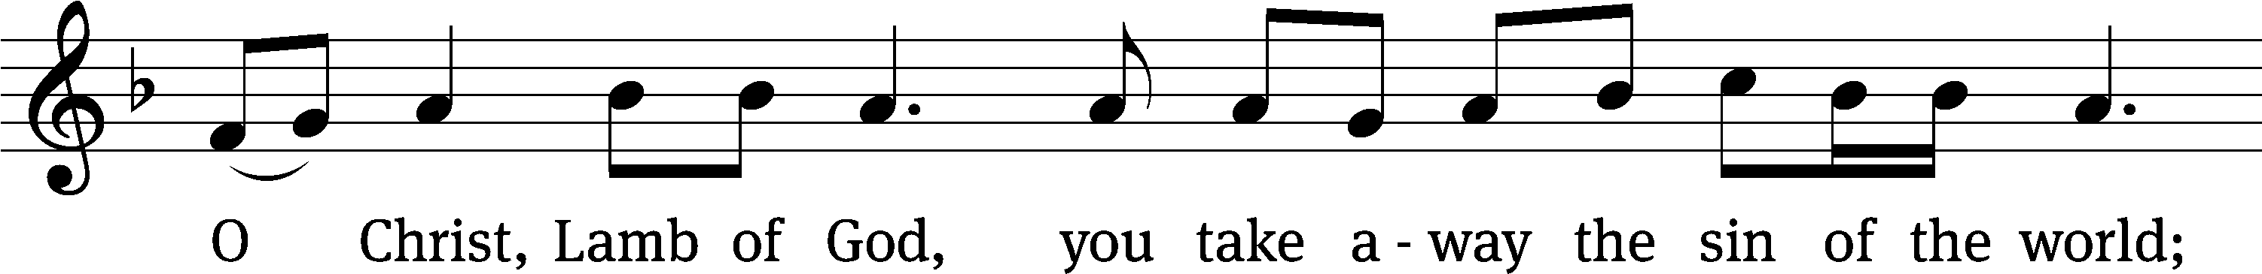
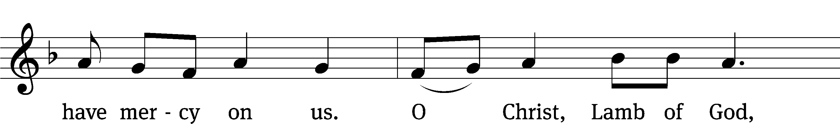
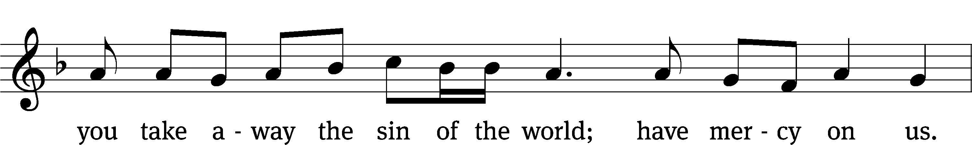
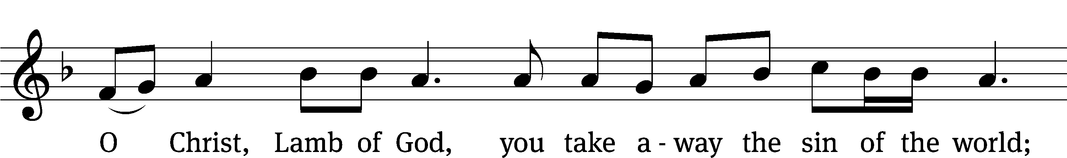
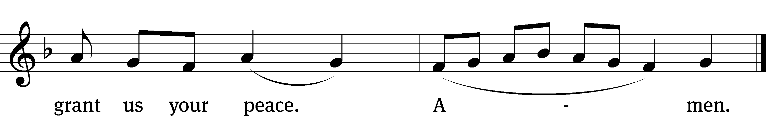
Please be seated
694 Jesus, I My Cross Have Taken CW 694
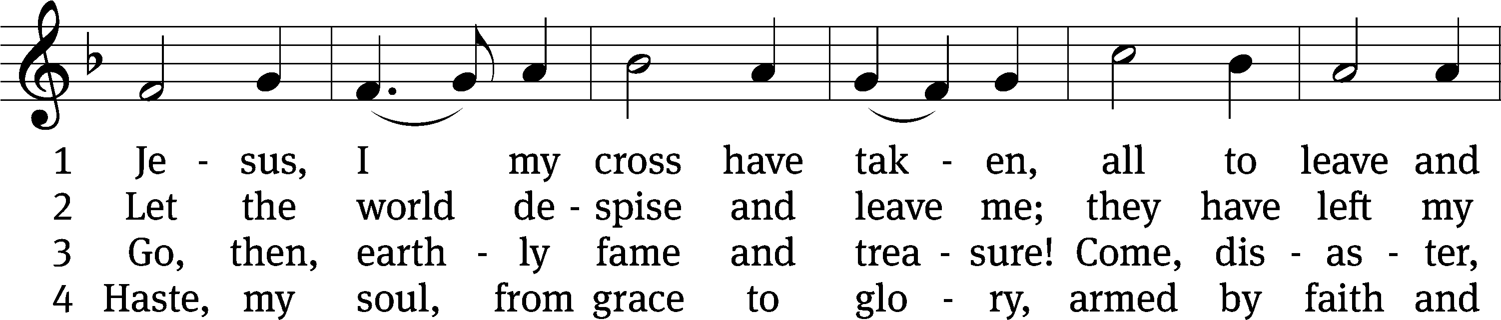
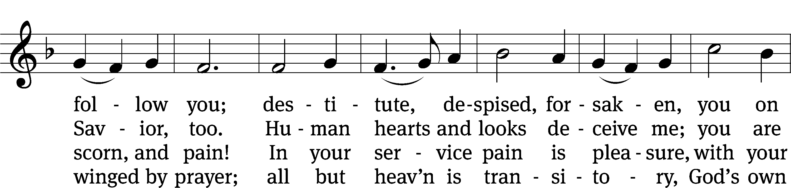
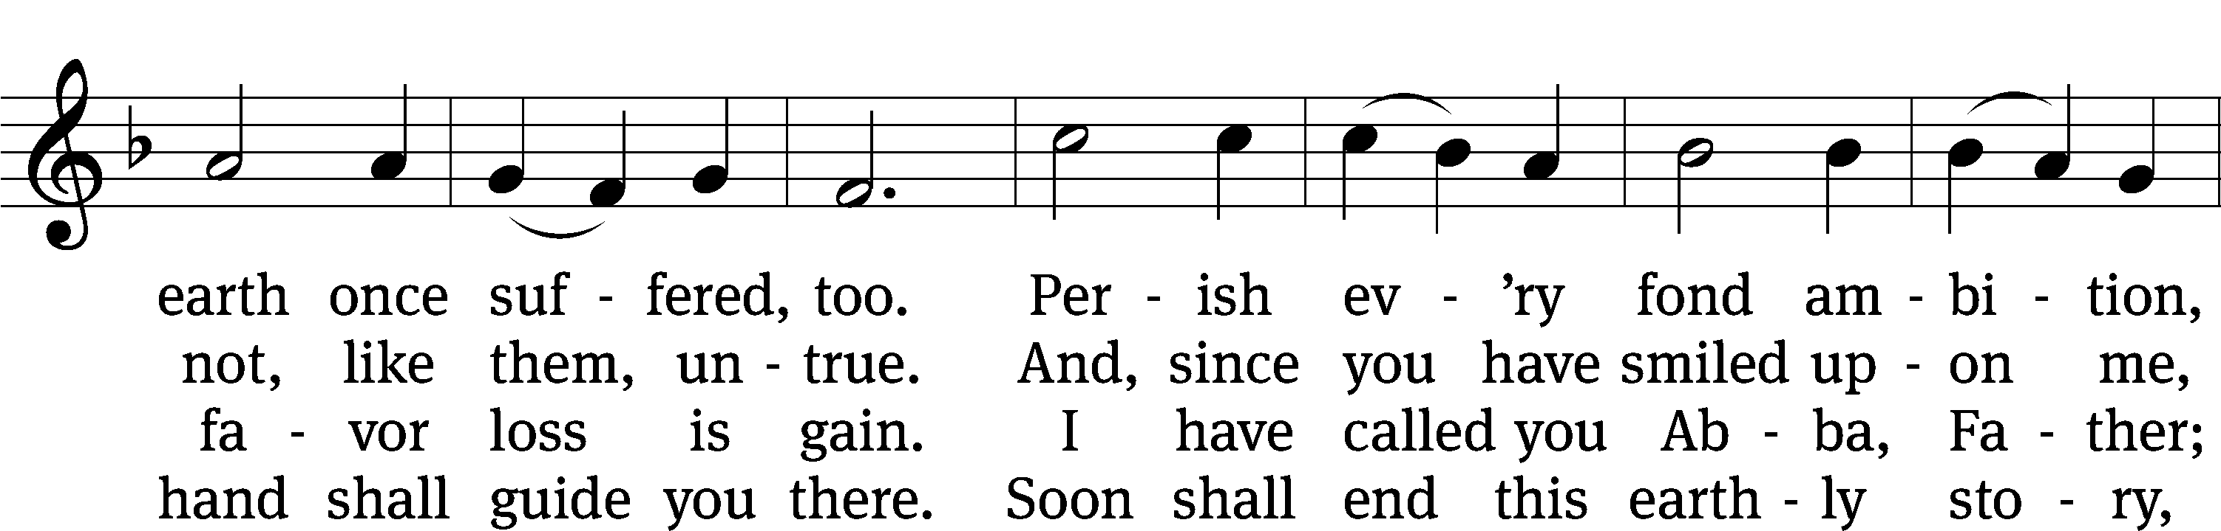
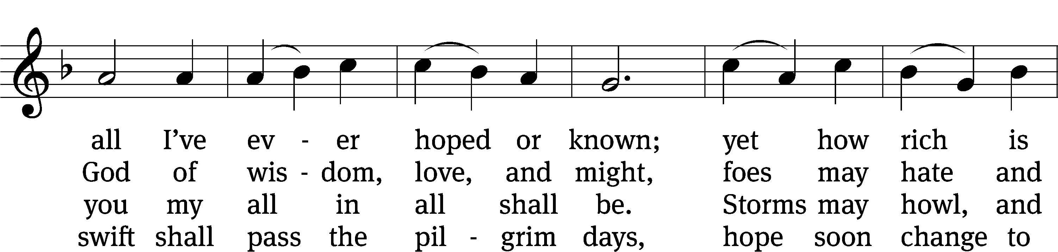
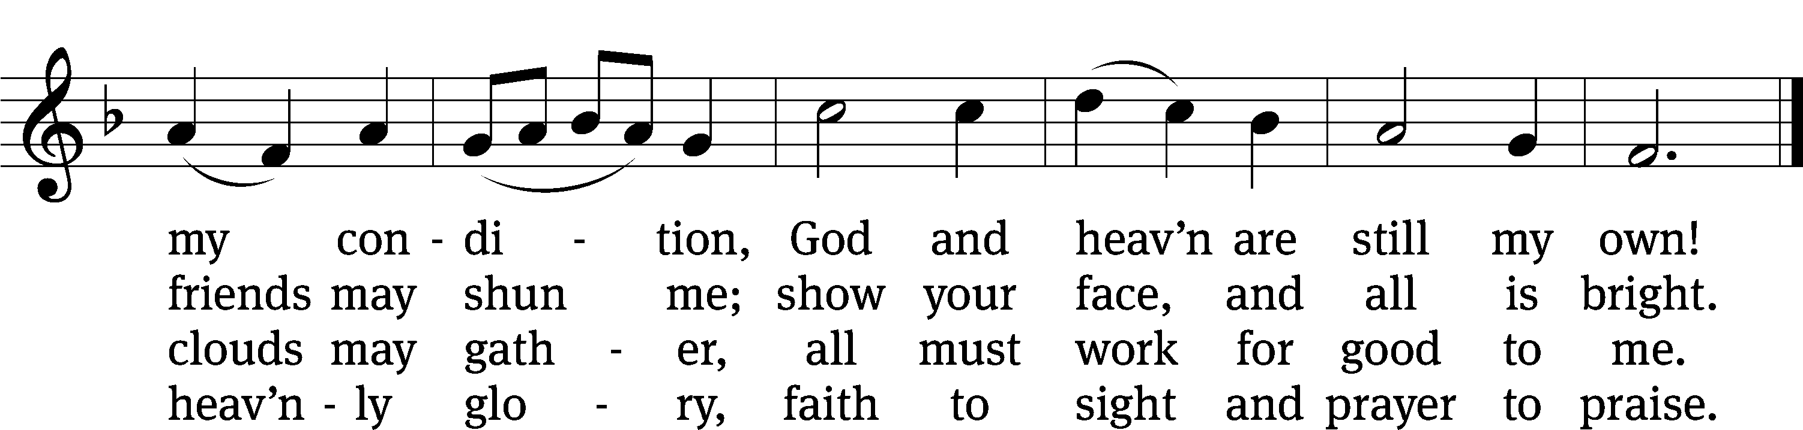
Text: Henry Francis Lyte, 1793–1847, abr., alt.
Tune: Rowland H. Prichard, 1811–1887
Text and tune: Public domain

767 Lord of Glory, You Have Bought Us CW 767
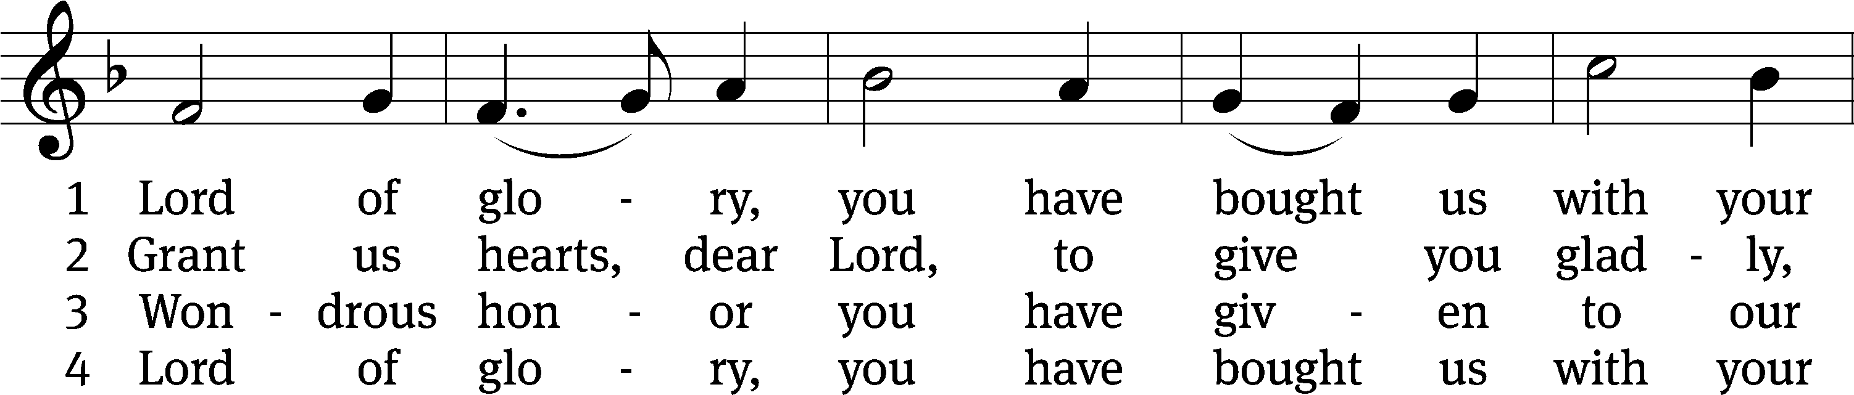
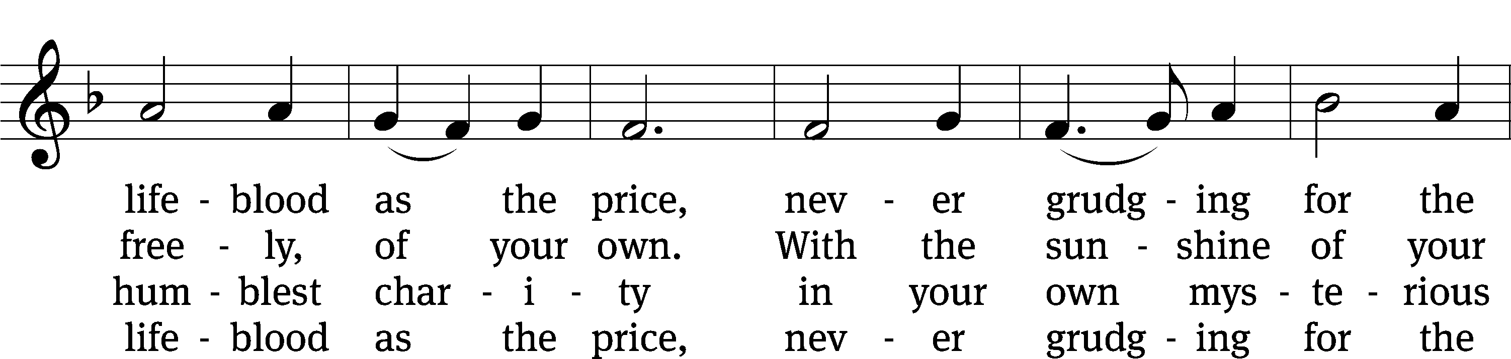
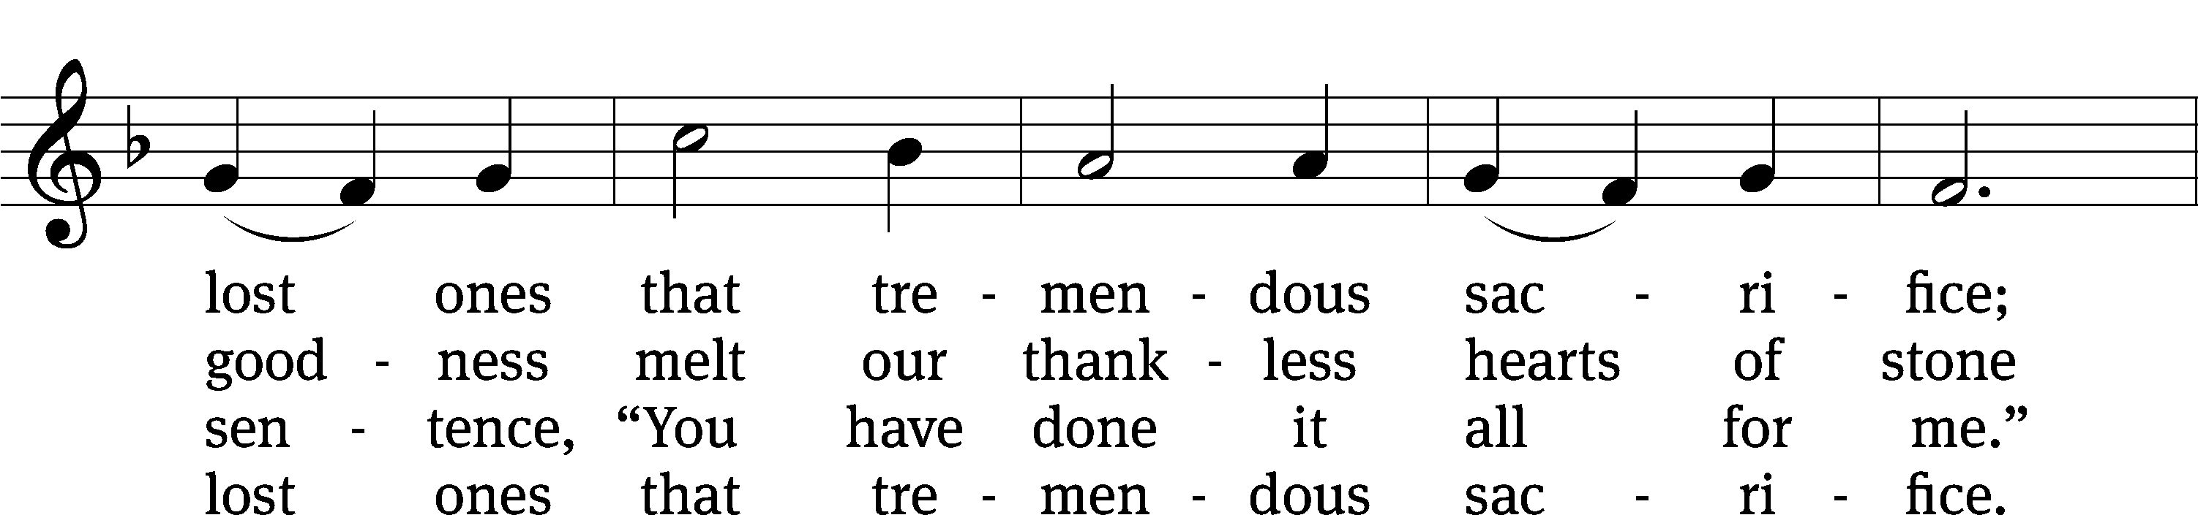
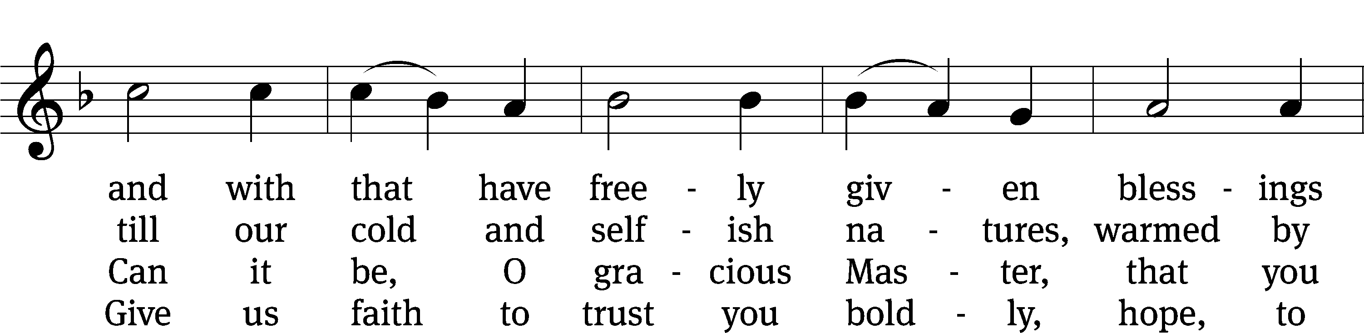
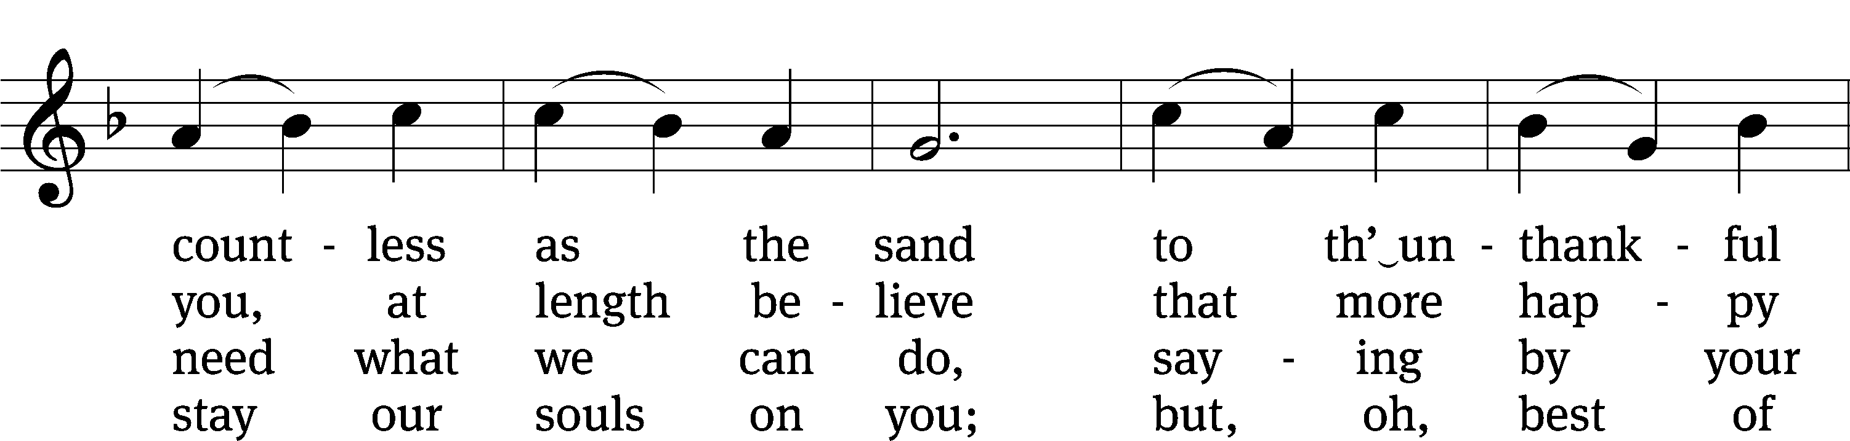
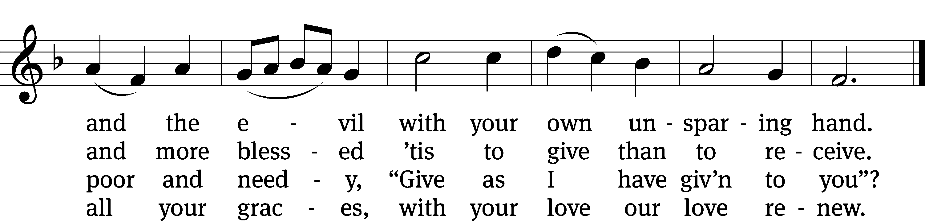
Please stand, if you are able

Give thanks to the Lord, for he is good;
his mercy endures forever.

Whenever we eat this bread and drink this cup,
we proclaim the Lord’s death until he comes.

We give thanks, almighty God, that you have refreshed us with this saving gift. We pray that through it you will strengthen our faith in you and increase our love for one another. We ask this in the name of Jesus Christ our Lord, who lives and reigns with you and the Holy Spirit, one God, now and forever.
Amen.

Blessing
The Lord bless you and keep you.
The Lord make his face shine on you and be gracious to you.
The Lord look on you with favor and give you peace.
Amen.

Please be seated

529 In the Cross of Christ I Glory CW 529
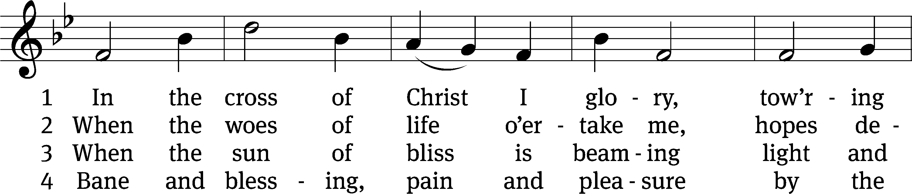
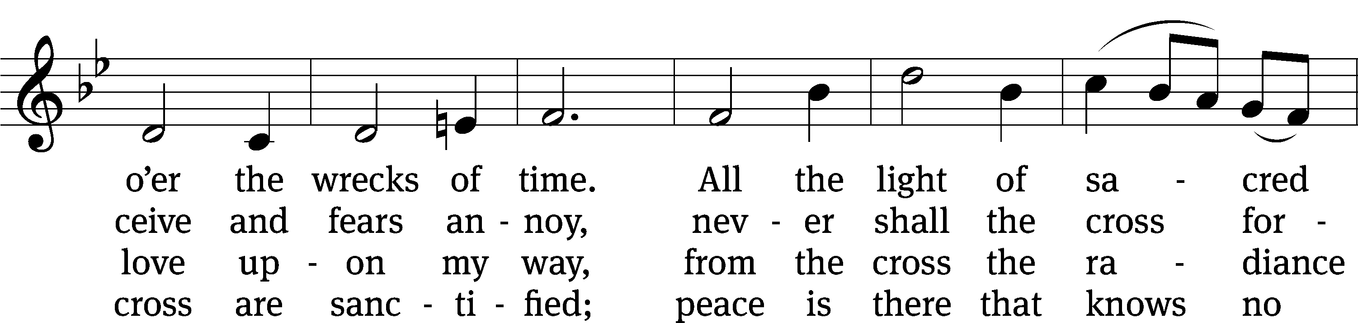
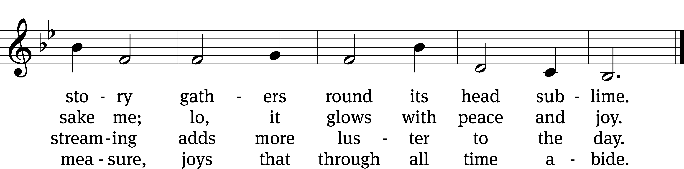
Text: John Bowring, 1792–1872
Tune: Ithamar Conkey, 1815–1867
Text and tune: Public domain

Acknowledgments
Setting One from Christian Worship
Software distributed in partnership with Northwestern Publishing House.
Created by Christian Worship: Service Builder © 2022 Concordia Publishing House.
Serving in Worship
Officiant Pastor William Natsis
Organist Sarah Hanke
Deacons (Thursday) Steve Hoeft and Jim Tice
Deacons (Sunday) Duane Mason and Robert Niethammer
Ushers (Thursday) Robert Newman and Henry Schneider
Ushers (Sunday) Dave Boswell and Jake Vershum
Altar Guild Marcia Marion Ackling and Judy Lindemann
Videographer Ann Latowski

