MISSION FESTIVAL:
the SIXTEENth sunday
AFTER PENTECOST

TRINITY EVANGELICAL LUTHERAN CHURCH | Saline, Michigan
WELCOME TO WORSHIP September 25, 2022
Thank you for joining us in God’s house today! We cordially ask that our Guests sign one of the guestbooks located at either the front or back entryways, or fill out a “Let’s Get Acquainted” card located in the hymnal pew rack and place it in the collection plate.

THANK OFFERING: Members of Trinity give their offering as an expression of love and thankfulness to the Lord and to help support the Lord’s work in our community and around the world. Visitors need not feel obligated to participate in this offering which supports our ministry.

Restrooms are located at the back of the upper level (the annex), and in the basement (down the back stairs of the sanctuary or annex). Handicap access is available, please ask an usher for assistance.

Young Families / Toddler Bags – We are GLAD YOU BROUGHT YOUR CHILDREN to our worship service. Jesus said: “Let the little children come to me and do not hinder them, for the kingdom of God belongs to such as these.” We know that having little children in church can be a challenge, but DO NOT WORRY about it. Many of your fellow worshippers have been in your shoes and are just happy you brought your children with you. For your convenience, we have reserved the back rows of seating for parents with small children. These areas provide more flexibility for your family, as well as, easy access to move downstairs if necessary. A closed-circuit TV system allows families to continue participating in the service while downstairs. Pre-school toddler bags and children’s bulletins are available for their enjoyment. Ask an usher for one to use during the service and please return the toddler bag afterwards.

the SERVICE – setting one - WITHOUT HOLY COMMUNION CW, page 154

745 Hark, the Voice of Jesus Crying CW 745
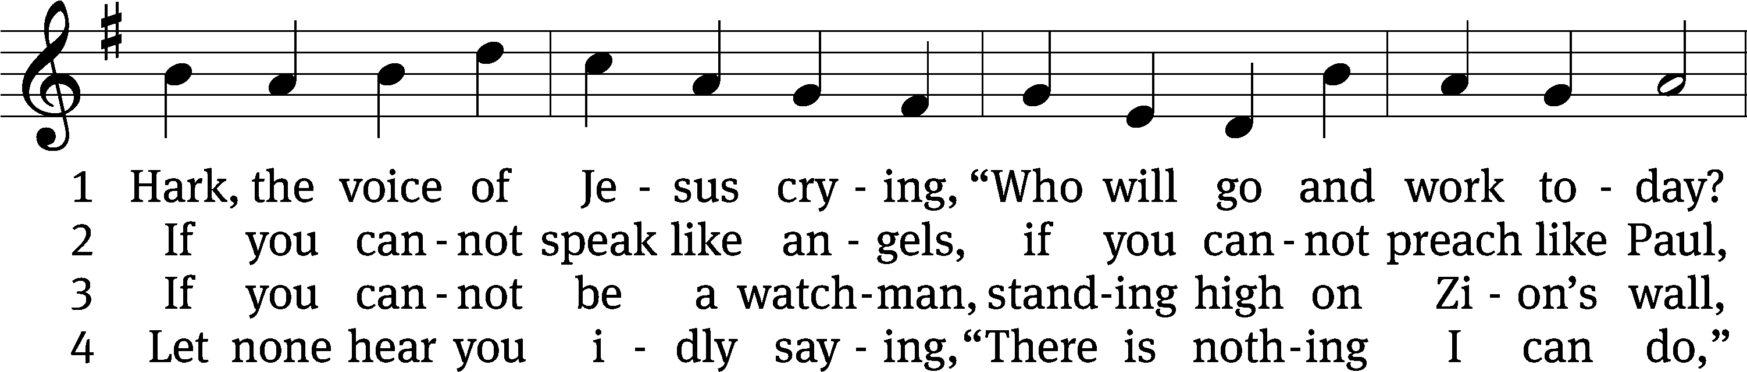
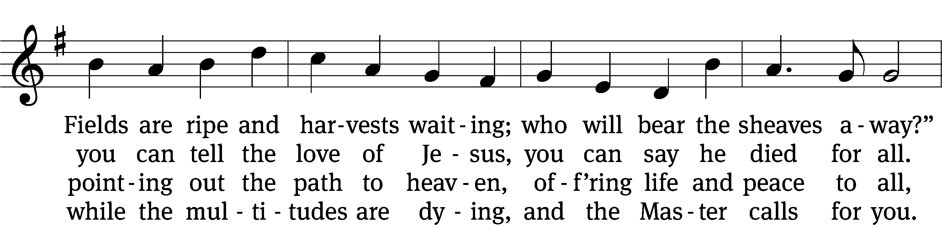
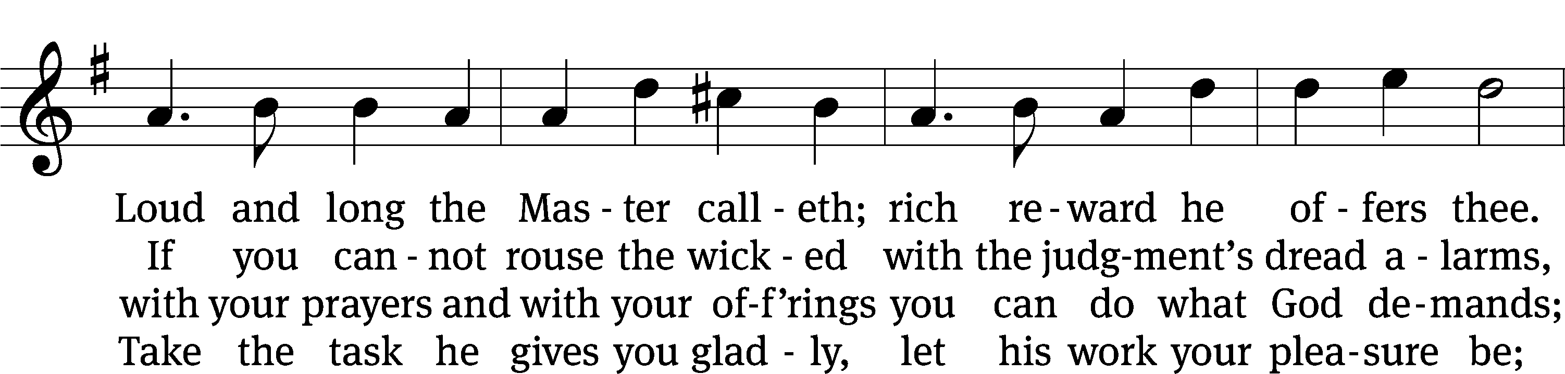
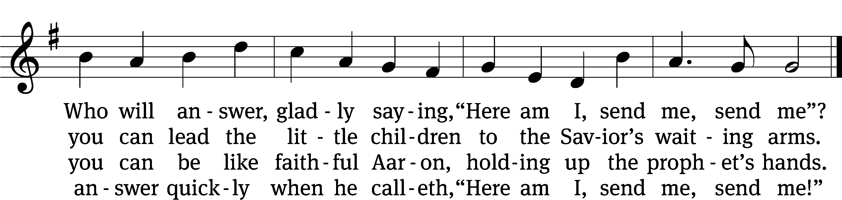
Text (sts. 1–2, 4): Daniel March, 1816–1909, sts. 1,2,4, abr., alt
Tune: Joseph Barnby, 1838–1896
Text and tune: Public domain

Please stand, if you are able
Invocation
In the name of the Father and of the Son and of the Holy Spirit.
Amen.
Confession
If we claim to be without sin, we deceive ourselves and the truth is not in us.
If we confess our sins, God is faithful and just
and will forgive us our sins
and purify us from all unrighteousness.

Let us confess our sins to the Lord.
Holy God, gracious Father,
I am sinful by nature
and have sinned against you in my thoughts, words, and actions.
I have not loved you with my whole heart;
I have not loved others as I should.
I deserve your punishment both now and forever.
But Jesus, my Savior, paid for my sins
with his innocent suffering and death.
Trusting in him, I pray: God, have mercy on me, a sinner.

Our gracious Father in heaven has been merciful to us. He sent his only Son, Jesus Christ, who gave his life as the atoning sacrifice for the sins of the whole world. Therefore, as a called servant of Christ and by his authority, I forgive you all your sins in the name of the Father and of the the Son and of the Holy Spirit.
Amen.

Lord, Have Mercy

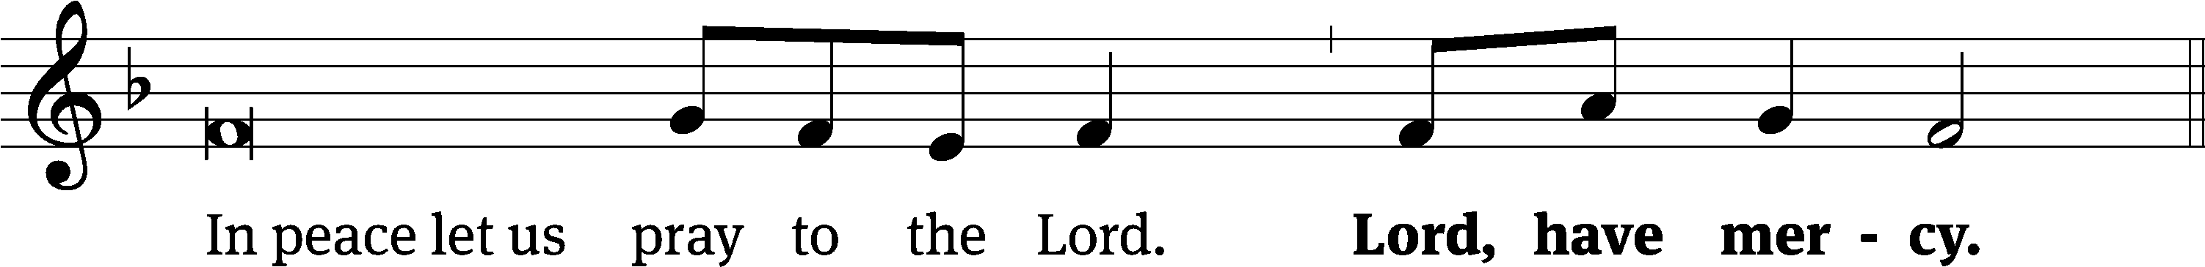
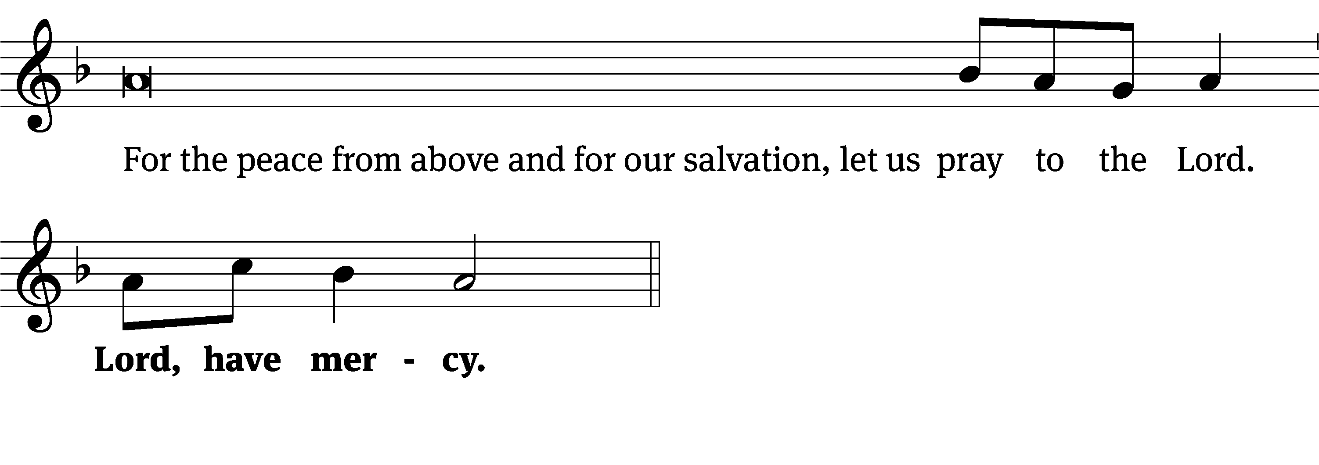
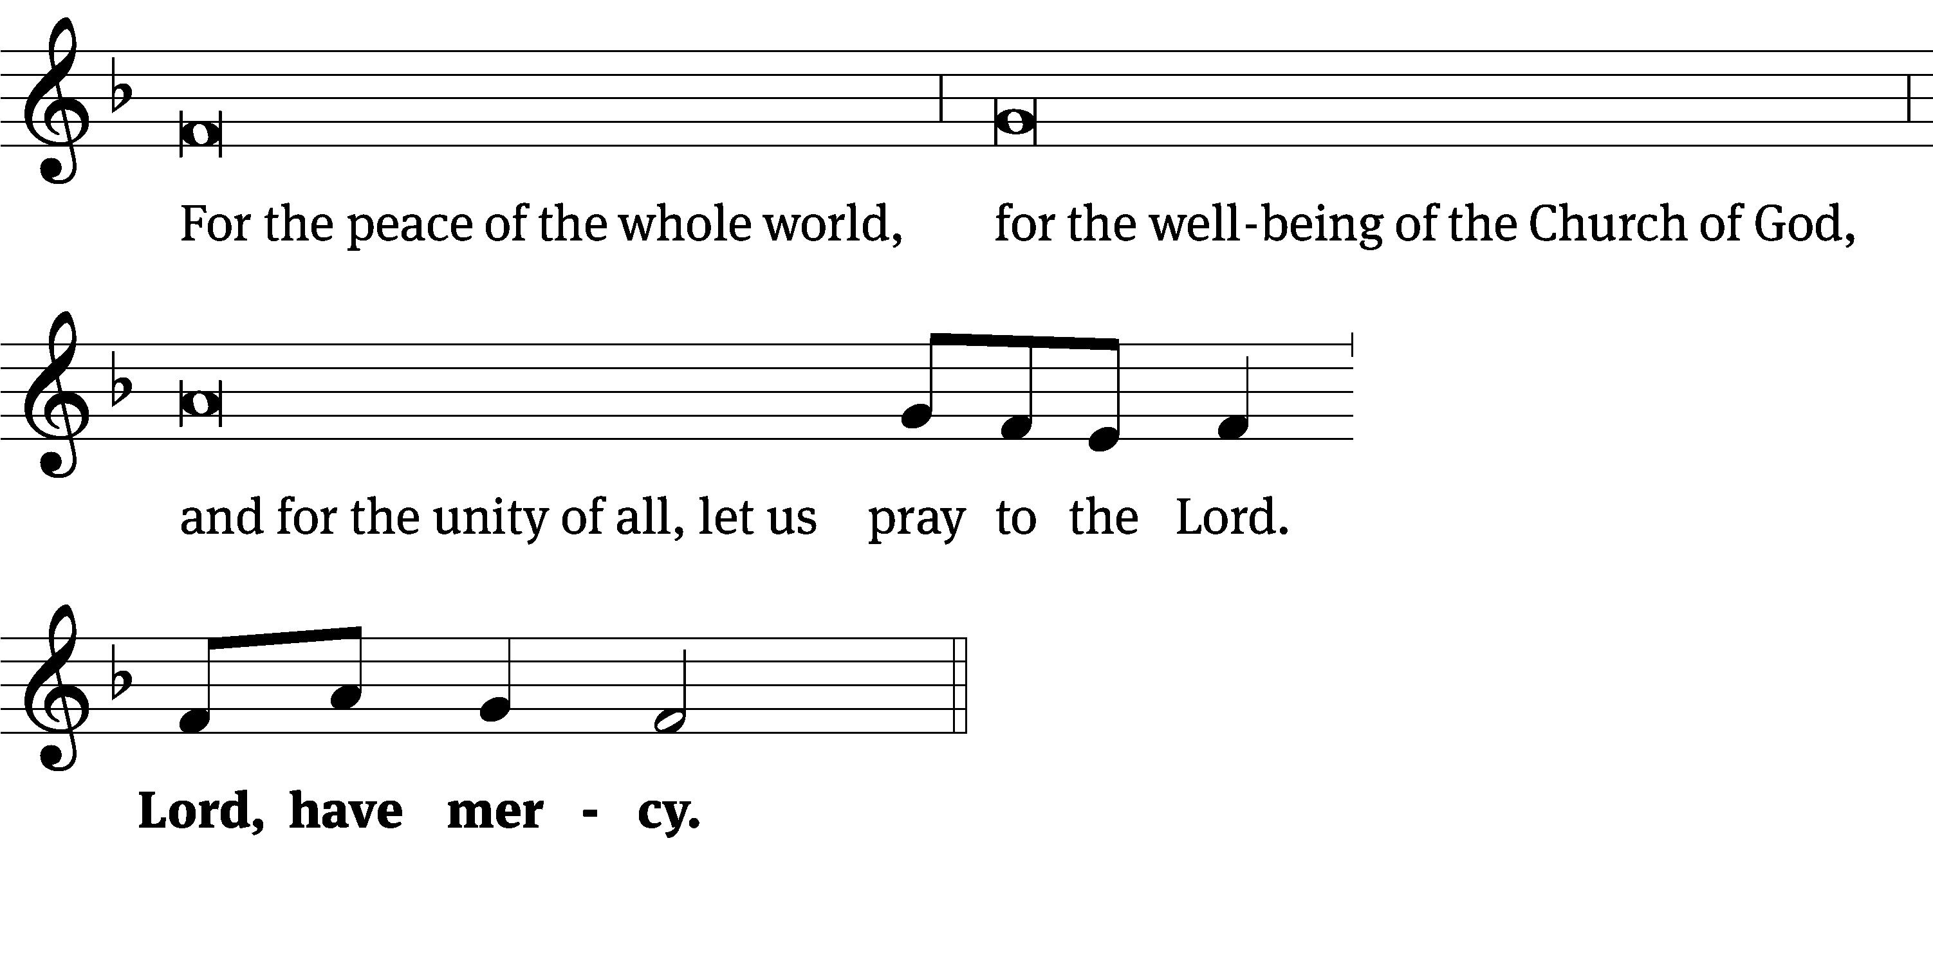
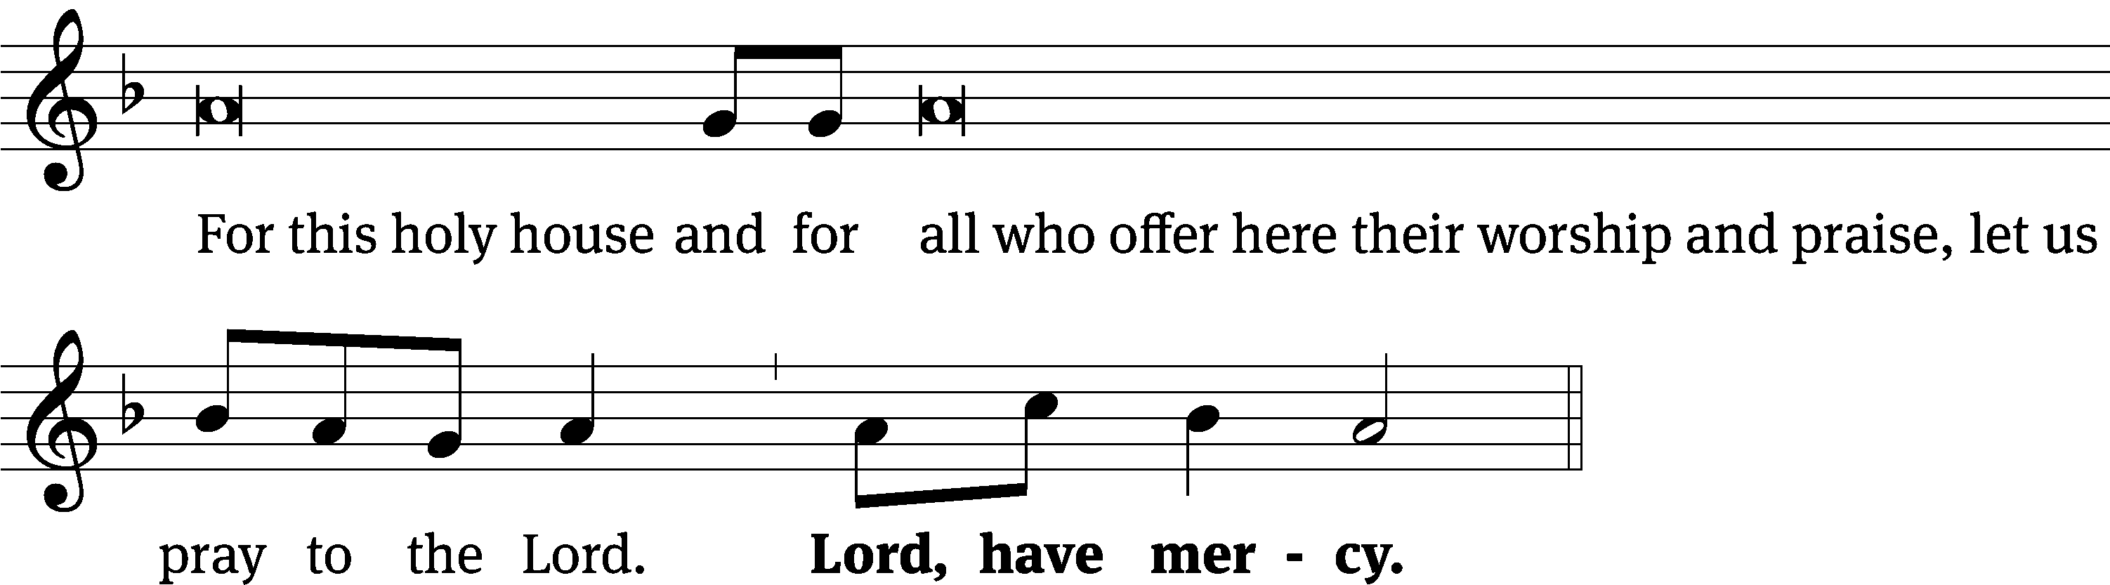
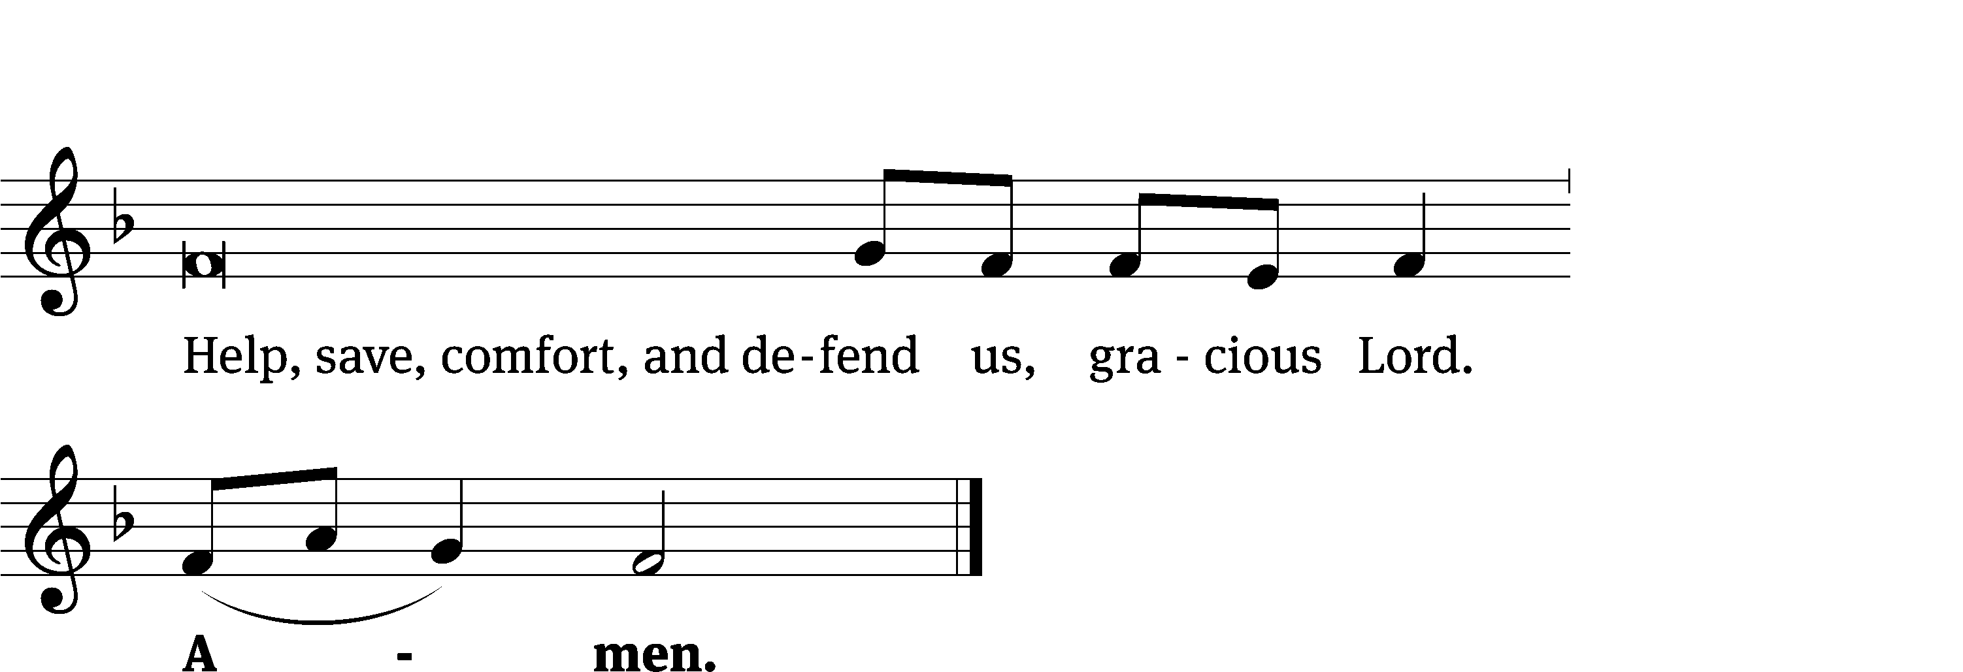
Glory Be to God CW 157
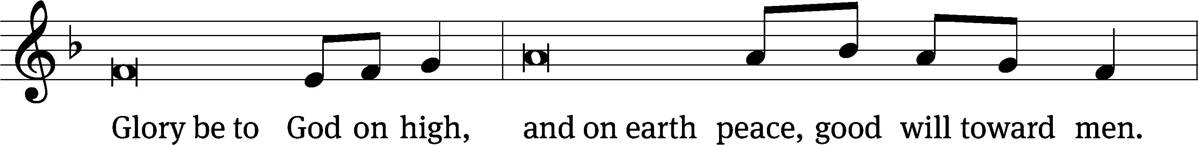
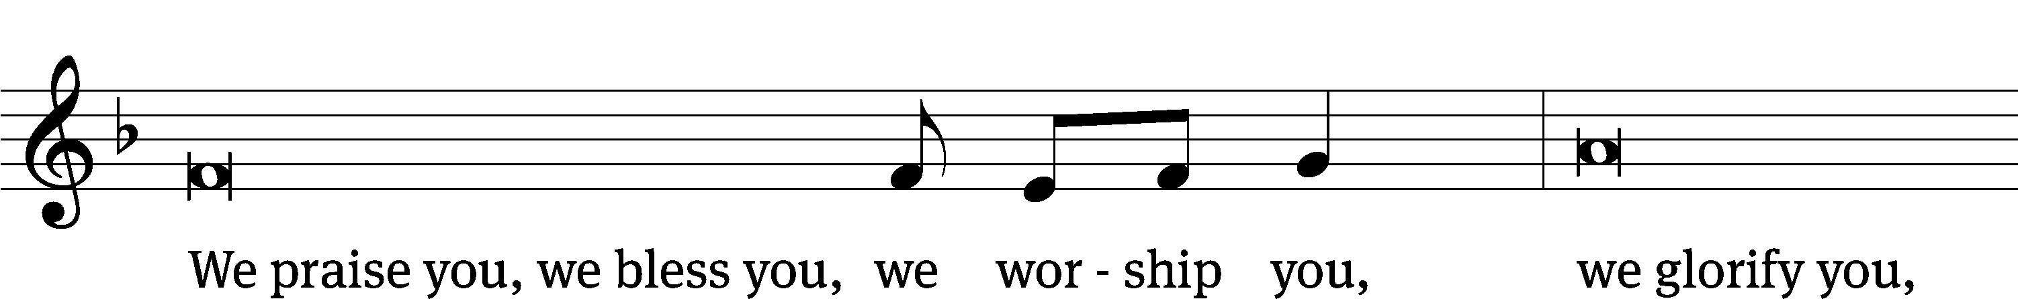
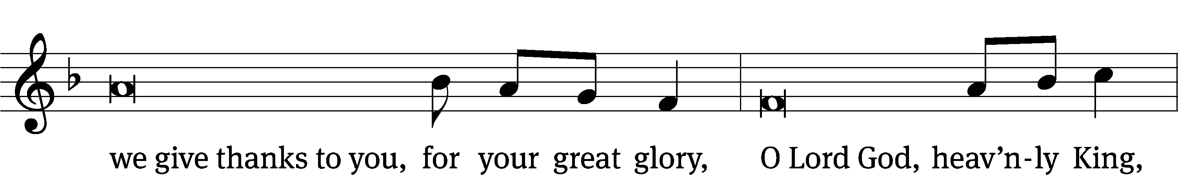
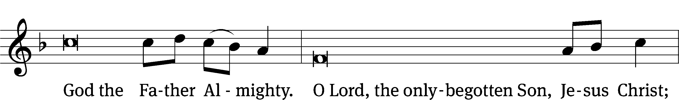
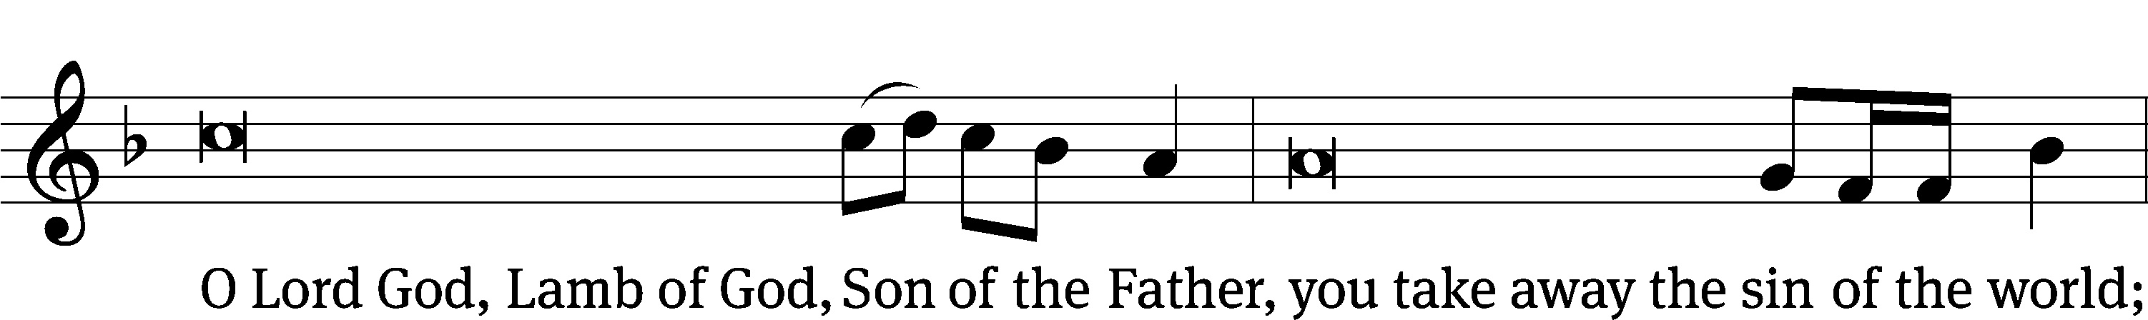
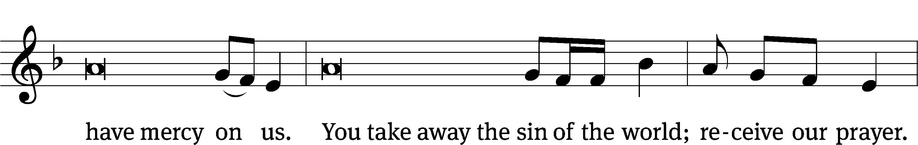
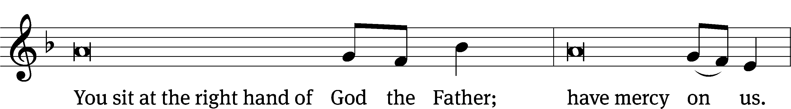
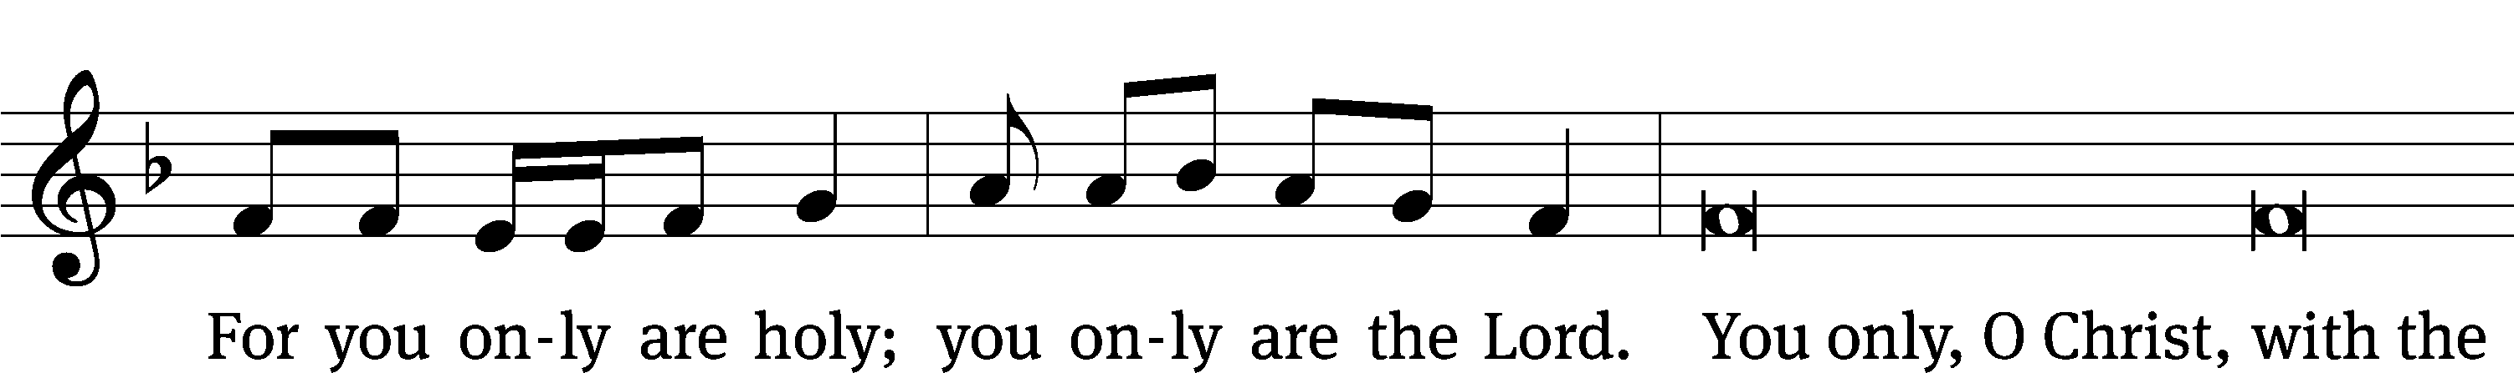
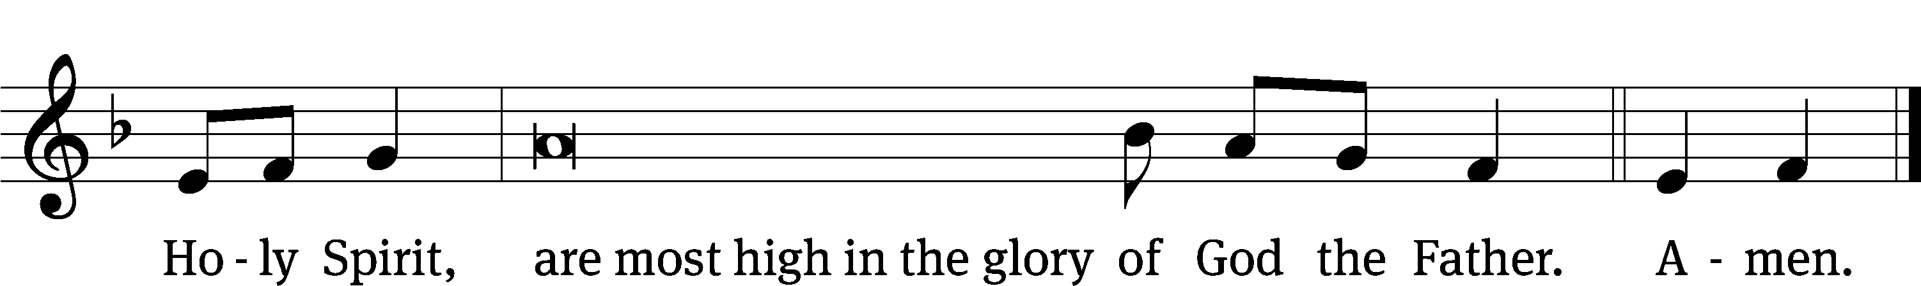

Tune: © 2021 Northwestern Publishing House. Used by permission: OneLicense no. 727703
The Lord be with you.
And also with you.
Prayer of the Day
Let us pray.

Merciful Father, your kindness caused the light of the gospel to shine among us. Use us now as instruments of your love to reach out with the message of salvation to others. Bless those who labor in the mission fields of our nation and grant success to their witness that many may be freed from sin; through Jesus Christ our Lord, who lives and reigns with you and the Holy Spirit, one God, now and forever.
Amen.

Please be seated

First Reading Jonah 3:1-10
¹ Then the word of the Lord came to Jonah a second time: ² “Get up. Go to Nineveh, the great city, and preach to it the message that I tell you.”
³ So Jonah set out and went to Nineveh just as the word of the Lord had commanded. Now Nineveh was a great city to God. It required a three-day walk. ⁴ Jonah walked through the city for a day, and he called out, “Forty more days and Nineveh is going to be overthrown!”
⁵ The men of Nineveh believed God. They proclaimed a fast and put on sackcloth, from the greatest of them to the least. ⁶ When word reached the king of Nineveh, he got up from his throne, took off his royal robe, covered himself with sackcloth, and sat in ashes. ⁷ Then he issued a proclamation in Nineveh.
By the decree of the king and his leading officials: Do not let people or animals, herds or flocks, taste anything. Do not let them eat food or drink water. ⁸ Instead, let people and animals be covered with sackcloth. Let everyone call fervently to God. Let them turn from their evil way and from the violence that is in their hands. ⁹ Who knows? God may turn and relent. He may turn from his burning anger so that we will not perish.
¹⁰ When God saw their actions, that they had turned from their evil way, God relented from the disaster which he said he would bring on them, and he did not carry it out.
The Word of the Lord.
Thanks be to God.

Senior Choir “Every Nation, Every Tribe”
Kila taifa, kila kabila.
Ev’ry nation, ev’ry tribe,
Precious children in his eyes.
Strangers all through race or tongue,
God’s desire to make us one.
Oh, love relentless, deep and wide,
For ev’ry nation, ev’ry tribe.

Kila taifa, kila kabila.

Ev’ry people, ev’ry clan,
Perfect pieces of God’s plan.
Each unique in heart and mind,
Tapestry of Love’s design!
Oh, love relentless, deep and wide,
For ev’ry nation, ev’ry tribe.

Kila taifa, kila kabila.

My gracious master and my God,
Assist me to proclaim,
To spread through all the earth abroad
The honors of your name.

Kila taifa, kila kabila.

Ev’ry daughter, ev’ry son,
Celebrate what God has done!
Came to earth to break our fall,
Oh, sacrificed one life for all.
Oh, love relentless, deep and wide,
For ev’ry nation, ev’ry tribe.

Sing alleluia, sing alleluia!
Ev’ry nation and ev’ry tribe.
Second Reading Romans 10:8-15
⁸ But what does it say? “The word is near you, in your mouth and in your heart,” that is, the word of faith that we are proclaiming. ⁹ Certainly, if you confess with your mouth that Jesus is Lord and believe in your heart that God raised him from the dead, you will be saved. ¹⁰ For it is with the heart a person believes, resulting in righteousness, and it is with the mouth that a person confesses, resulting in salvation. ¹¹ For Scripture says, “Everyone who believes in him will not be put to shame.”
¹² So there is no distinction between Jew and Greek, because the same Lord is Lord of all, who gives generously to all who call on him. ¹³ Yes, “Everyone who calls on the name of the Lord will be saved.”
¹⁴ So then, how can they call on the one they have not believed in? And how can they believe in the one about whom they have not heard? And how can they hear without a preacher? ¹⁵ And how can they preach unless they are sent? Just as it is written, “How beautiful are the feet of those who preach the good news of peace, who preach the gospel of good things!”
The Word of the Lord.
Thanks be to God.

Please stand, if you are able
Gospel Acclamation Isaiah 52:9
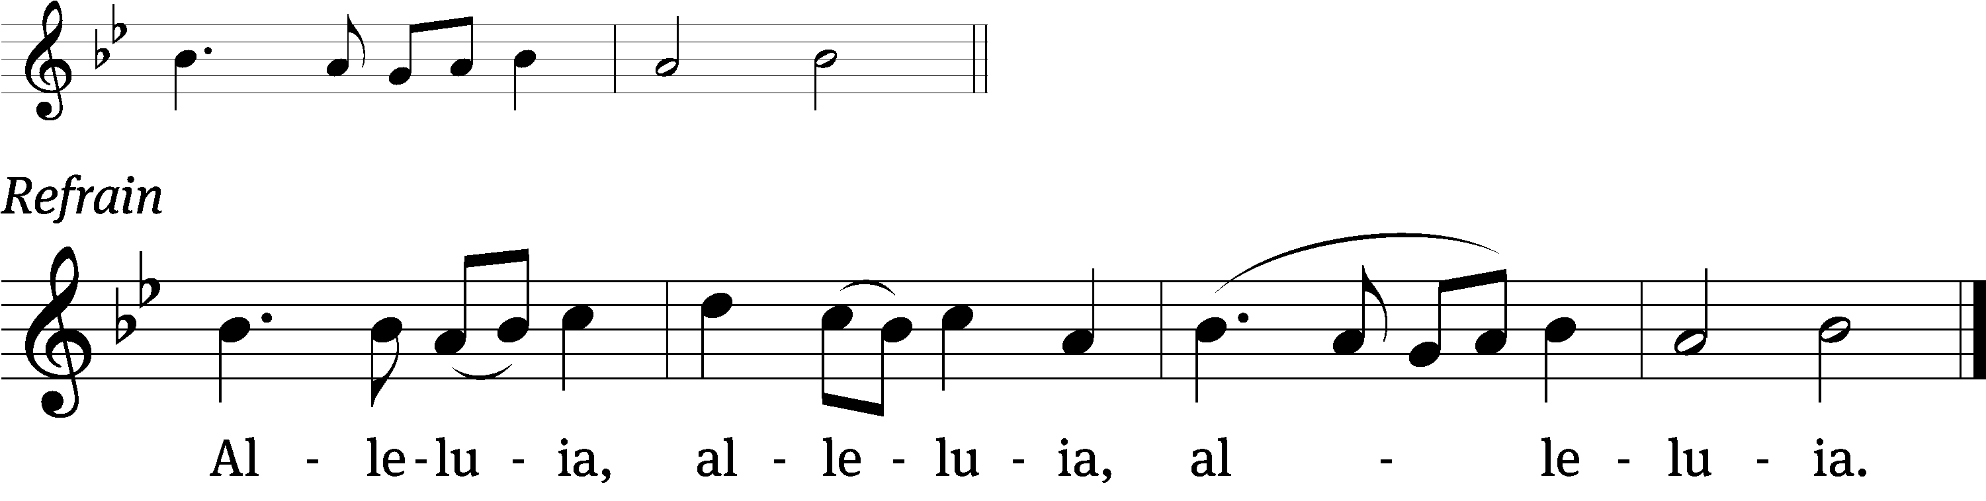

How beautiful on the mountains are the feet of those who bring good news,
Who proclaim salvation.

Refrain
Tune: © 2021 Northwestern Publishing House. Used by permission: OneLicense no. 727703

Gospel Matthew 9:35-38
³⁵ Jesus traveled through all the towns and villages, teaching in their synagogues, preaching the gospel of the kingdom, and healing every disease and every sickness.
³⁶ When he saw the crowds, he was moved with compassion for them, because they were troubled and downcast, like sheep without a shepherd. ³⁷ Then he said to his disciples, “The harvest is plentiful, but the workers are few. ³⁸ Therefore pray that the Lord of the harvest will send out workers into his harvest.”

The Gospel of the Lord.
Praise be to you, O Christ!

Please be seated

902 Spread Abroad, O Mighty Word CW 902
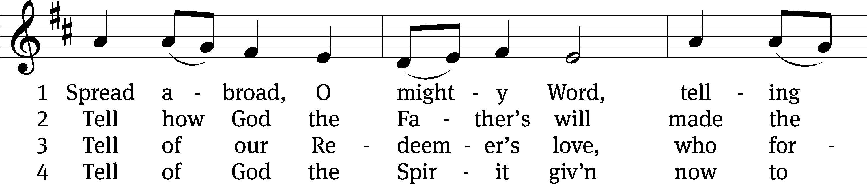
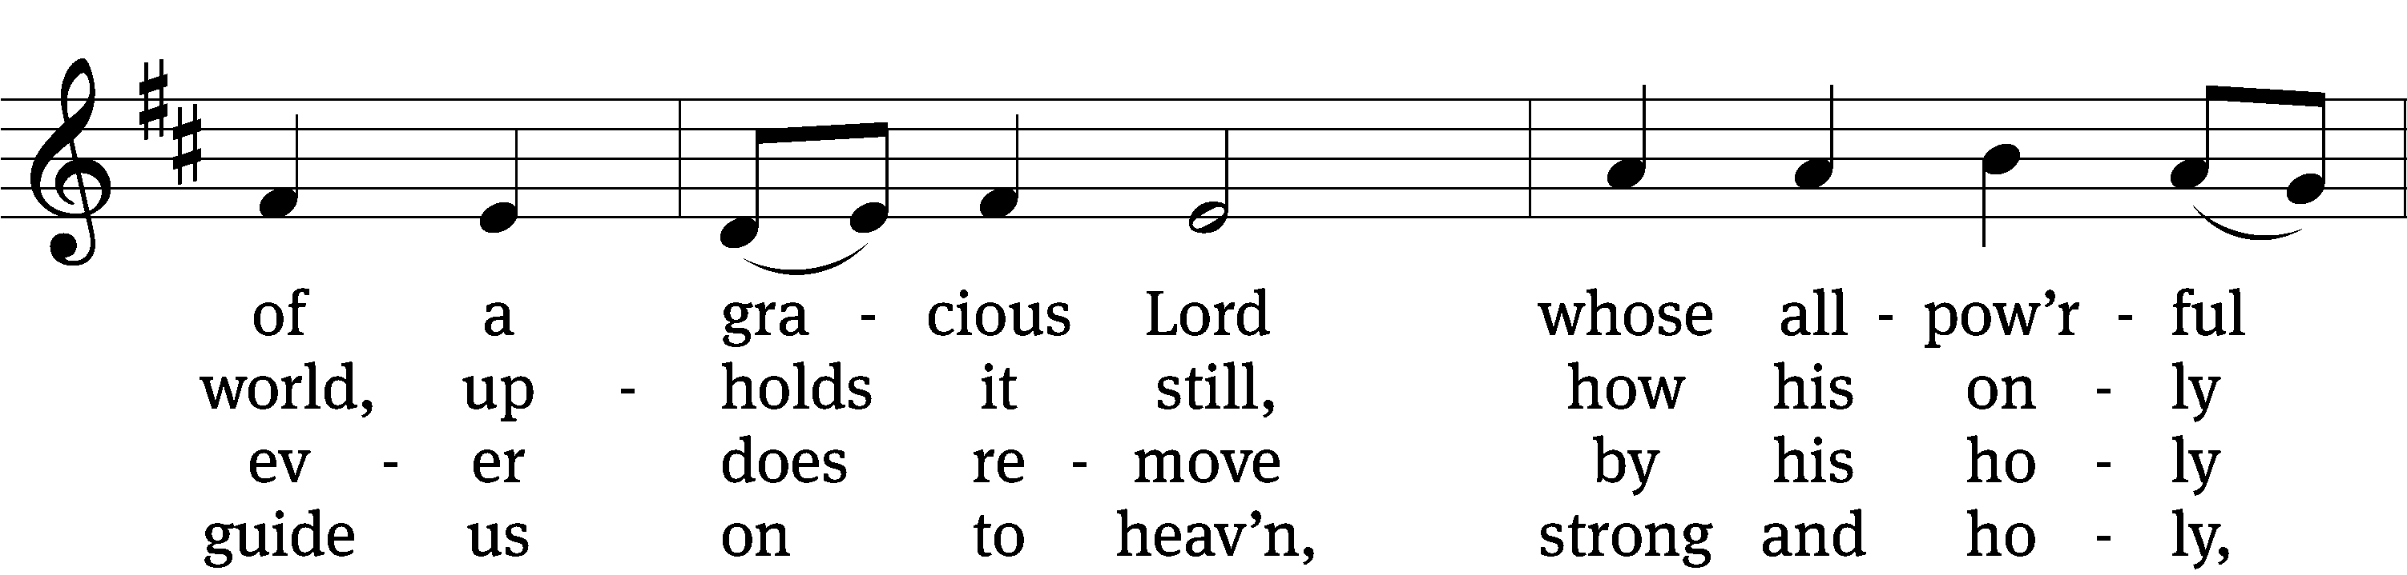
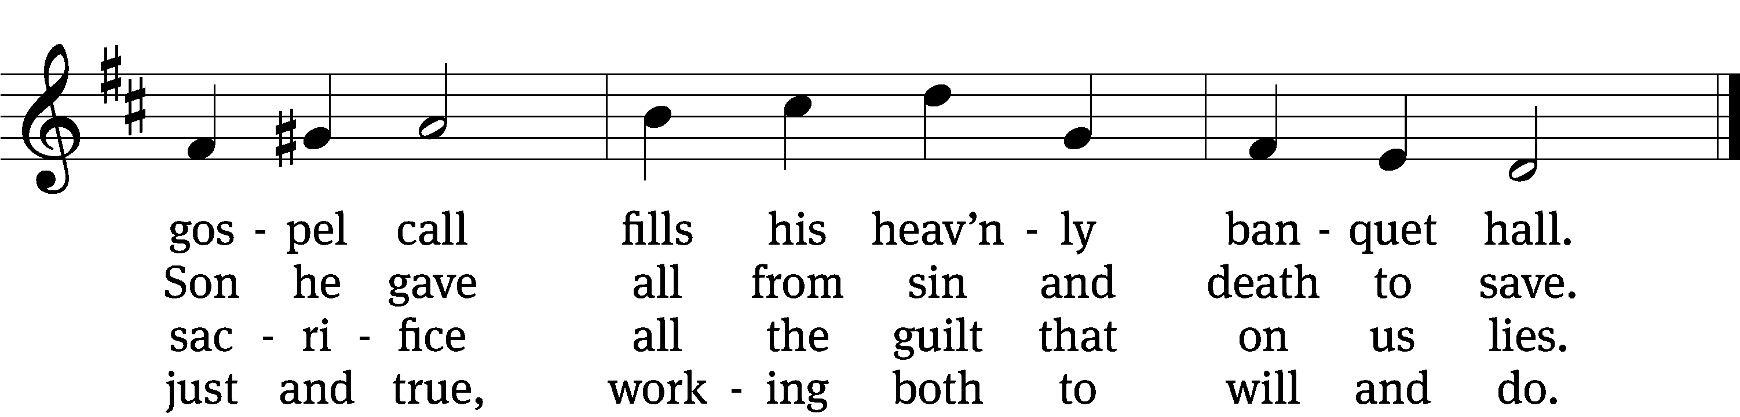
5 Spread abroad! Ripe fields of grain
all throughout the world remain,
but the reapers still are few;
great the work they have to do.

6 Lord of harvest, great and kind,
rouse to action heart and mind;
let the gath’ring nations all
see your light and heed your call.
Text: Jonathan F. Bahnmeier, 1774–1841, abr.
Tune: Erbaulicher Musicalischer Christen-Schatz, Basel, 1745, alt.
Text and tune: Public domain

Sermon Romans 10:8-15
“The Word Is Near You”

Please stand, if you are able
Apostles’ Creed
I believe in God, the Father Almighty,
maker of heaven and earth.

I believe in Jesus Christ, his only Son, our Lord,
who was conceived by the Holy Spirit,
born of the Virgin Mary,
suffered under Pontius Pilate,
was crucified, died, and was buried.
He descended into hell.
The third day he rose again from the dead.
He ascended into heaven
and is seated at the right hand of God the Father Almighty.
From there he will come to judge the living and the dead.

I believe in the Holy Spirit,
the holy Christian Church,
the communion of saints,
the forgiveness of sins,
the resurrection of the body,
and the life everlasting. Amen.
Prayer of the Church

Eternal God and Father, we give you thanks for the blessings we share as members of your holy Church, for your gracious Word and sacraments, for opportunities to worship and to grow in faith and knowledge, for occasions to serve and be served, for fellowship with believers in our congregation and in our synod.
Help us to rejoice in these blessings, dear Lord, and to use them faithfully.
Jesus Christ, Lord of the Church, you give grace to your people by calling us to be your witnesses in the world. Open our eyes to see the great and noble mission that lies before us. In the hurting eyes of the lonely, in the pained eyes of the sick, and in the searching eyes of the lost, help us to see your face, O Jesus, and to serve others as we would serve you.
Awaken us to the opportunities you give to proclaim your message of love.
Holy Spirit, giver of life, through Word and sacrament bestow on us the wisdom and power we need to witness clearly and to act boldly. Help us to speak the truth in love, to give the reason for the hope we have, and to conduct ourselves with gentleness and respect.
Set our hearts on fire as we work and witness for Christ.
Hear us, Lord, as we pray for a family member, an acquaintance, a neighbor, or a friend who does not believe in you, or whose faith is weak or troubled.
Silent prayer.
Bless the Church with men and women who are willing to proclaim your Word in places where we cannot go. Keep them and their loved ones in your care, and let nothing hinder their work. By the power of the gospel, restore their spirits each day, so that they do not lose heart as they serve us and others.
Move us to support them with our sincere prayers and generous offerings.
Special prayers and intercessions may follow.
Wherever your Word is proclaimed, O Lord, grant it success. Let your kingdom come to us and others, so that we and many more might join the assembly of saints and angels to sing your praise forever.
Savior of all, hear our prayer and help us in our mission. Amen.

Please be seated
907 How Shall They Hear, Who Have Not Heard CW 907
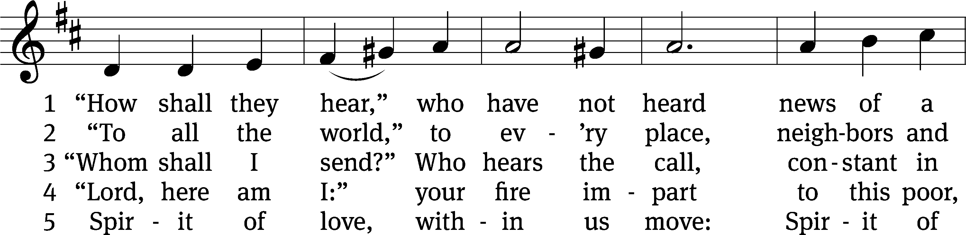
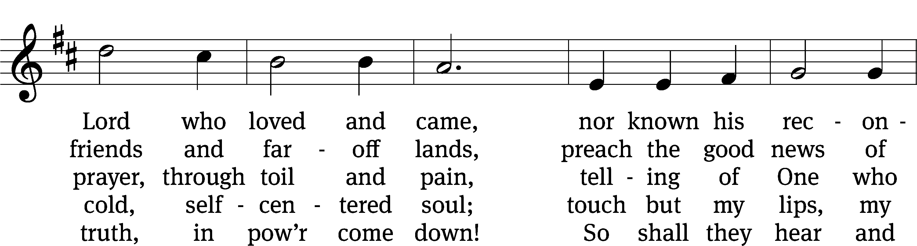
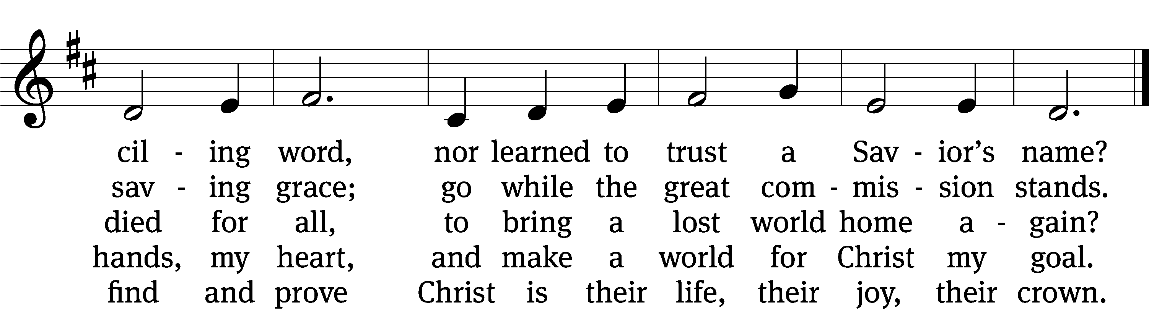
Text: Timothy Dudley-Smith, b. 1926
Tune: Georg Joseph, 17th cent., adapt.
Text: © 1984 Hope Publishing Co. Used by permission: OneLicense no. 727703
Tune: Public domain

Please stand, if you are able

Prayer
Blessed Lord, you have given us your Holy Scriptures for our learning. May we so hear them, read, learn, and take them to heart that, being strengthened and comforted by your holy Word, we may cling to the blessed hope of everlasting life; through Jesus Christ our Lord, who lives and reigns with you and the Holy Spirit, one God, now and forever.
Amen.

Lord’s Prayer
Our Father, who art in heaven, hallowed be thy name, thy kingdom come, thy will be done on earth as it is in heaven. Give us this day our daily bread; and forgive us our trespasses, as we forgive those who trespass against us; and lead us not into temptation, but deliver us from evil. For thine is the kingdom and the power and the glory forever and ever. Amen.

Blessing
The Lord bless you and keep you.
The Lord make his face shine on you and be gracious to you.
The Lord look on you with favor and give you peace.
Amen.

Please be seated
900 Lift High the Cross CW 900
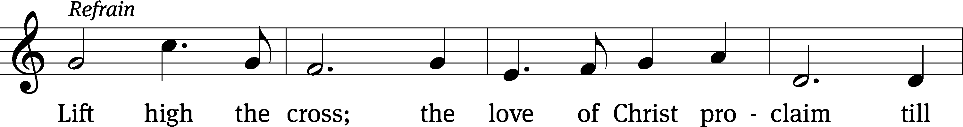
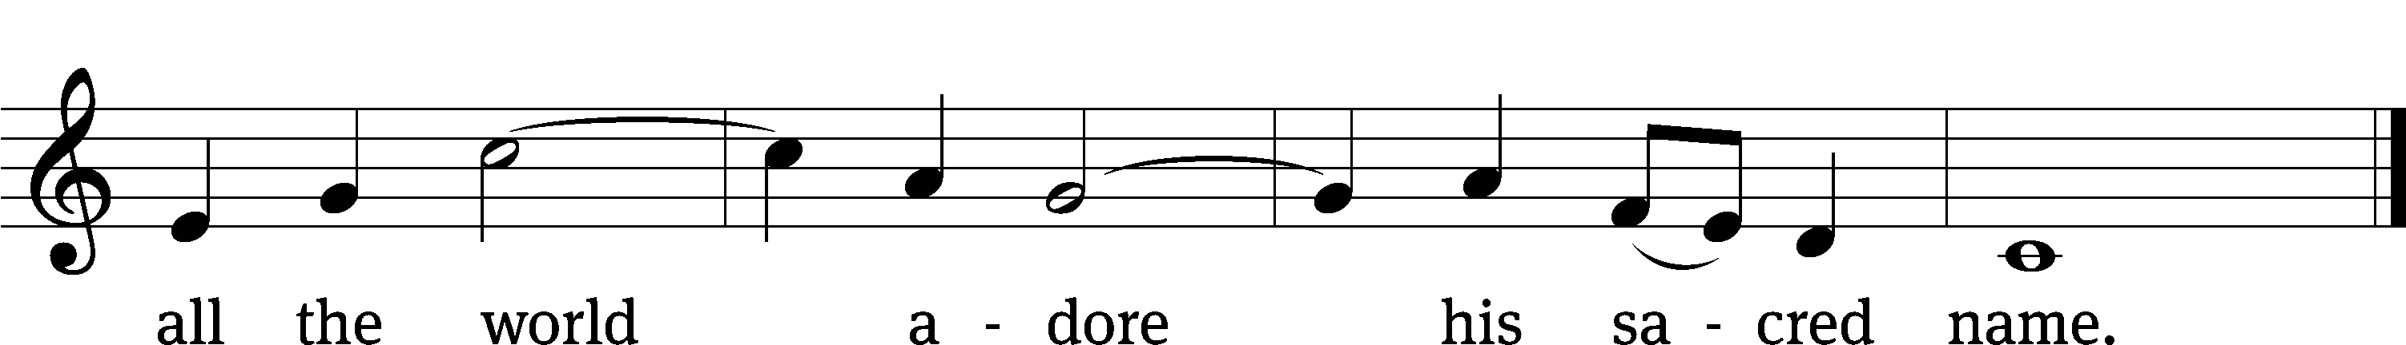
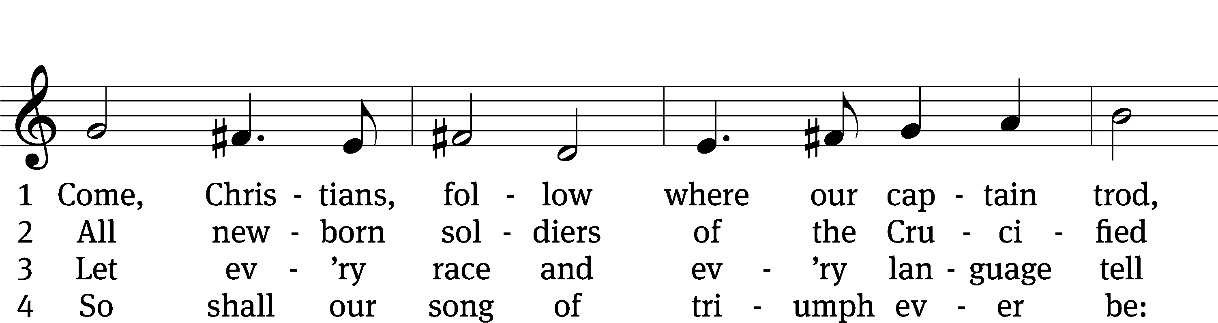
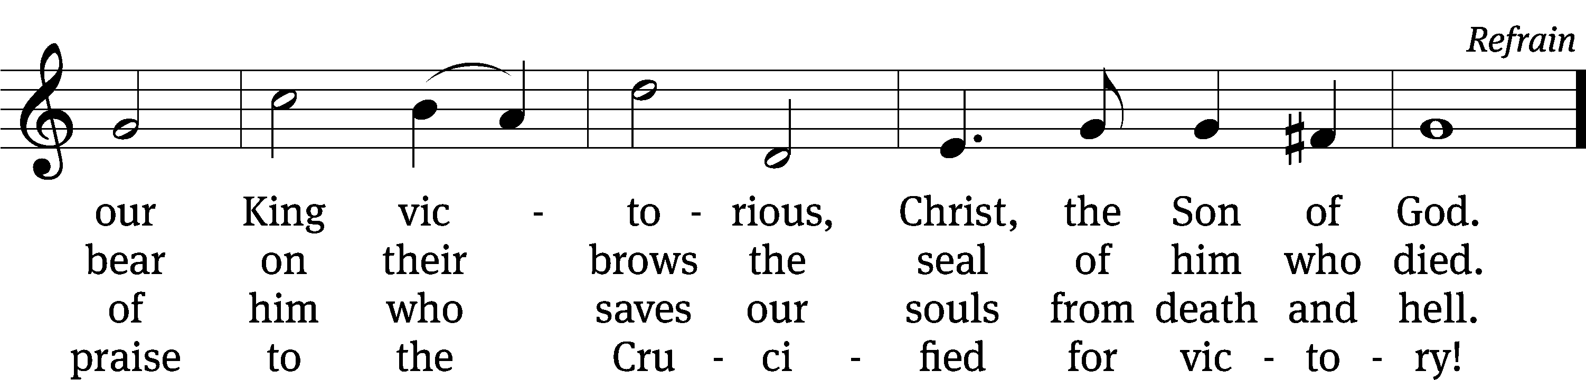
Text: rev. Michael R. Newbolt, 1874–1956, alt.; George W. Kitchin, 1827–1912
Tune: Sydney H. Nicholson, 1875–1947
Text and tune: © 1974 Hope Publishing Co. Used by permission: OneLicense no. 727703

Acknowledgments
Setting One from Christian Worship
Software distributed in partnership with Northwestern Publishing House.
Created by Christian Worship: Service Builder © 2022 Concordia Publishing House.

Serving in Worship
Officiant Pastor Natsis
Preacher Pastor Paul Wilde
Organist Marcia Marion Ackling
Deacons (8:30) Dave Frey and Jim Tice
(11:00) Jeff Neuburger and Ed Wheeler
Ushers (8:30) Bob Newman and Henry Schneider
(11:00) Bill Barnett and Jacob Vershum
Altar Guild Marcia Marion Ackling and Judy Lindemann
Videographer Ann Latowski

