THE TWENTIEth SUNDAY
AFTER PENTECOST

TRINITY EVANGELICAL LUTHERAN CHURCH | Saline, Michigan
WELCOME TO WORSHIP October 15, 2023

Thank you for joining us in God’s house today! We cordially ask that our guests sign one of the guestbooks located at either the front or back entryways.

THANK OFFERING: Members of Trinity give their offering as an expression of love and thankfulness to the Lord and to help support the Lord’s work in our community and around the world. Visitors need not feel obligated to participate in this offering which supports our ministry.

Restrooms are located at the back of the upper level (the annex), and in the basement (down the back stairs of the sanctuary or annex). Handicap access is available, please ask an usher for assistance.

celebration of holy communion:
In His Word, God makes it clear that the Lord’s Supper is to be shared by people of a common proclamation of faith (1 Corinthians 11:26; 1 Corinthians 10:16-17). Without judging anyone’s hearts, we invite those who share in our confession by their membership in our congregation or another congregation of the Wisconsin Evangelical Lutheran Synod (WELS) or the Evangelical Lutheran Synod (ELS) and who are properly prepared (1 Corinthians 11;27-29) to receive the Sacrament. Page 295 in the front of Christian Worship provides a guide for preparation.

Guests, we would love to have you join us in communion fellowship in the future, and for that to be possible, we ask that you speak with one of the pastors so that we may speak with you on how that would be possible. We thank you for respecting the way we celebrate the Lord’s Supper in our congregations.

SERVICE OF WORD AND SACRAMENT
568 His Robes for Mine CW 568
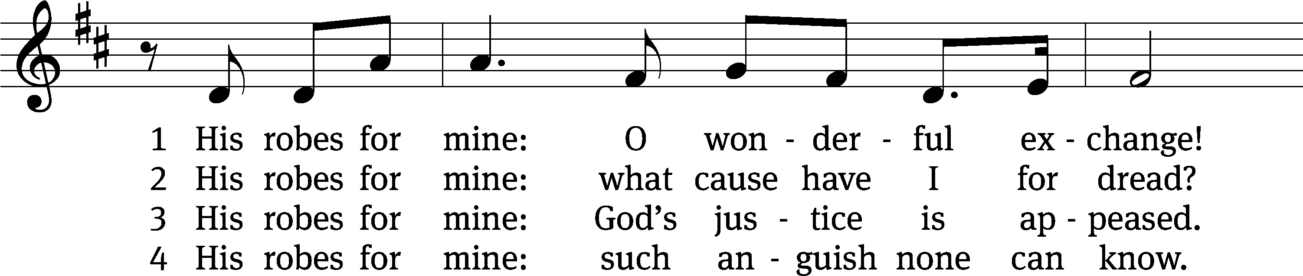
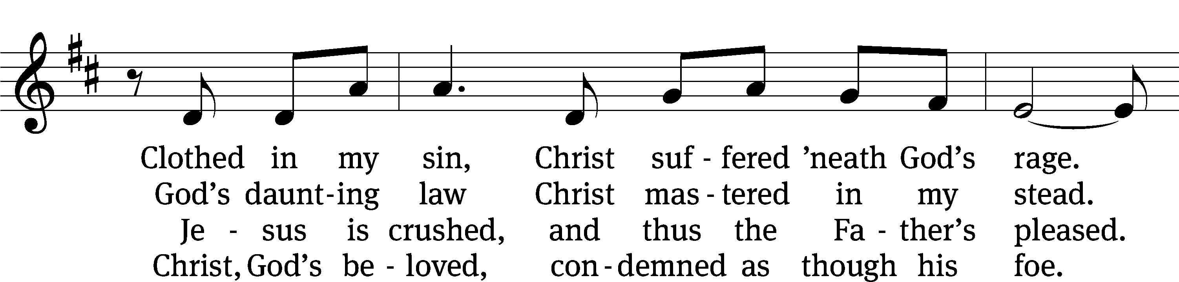
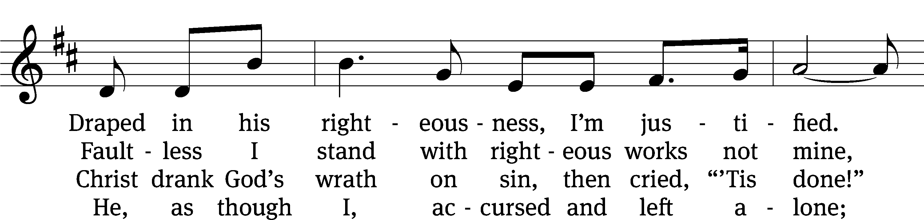
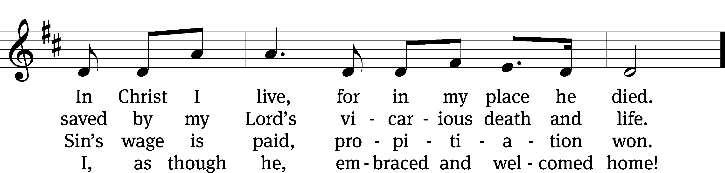
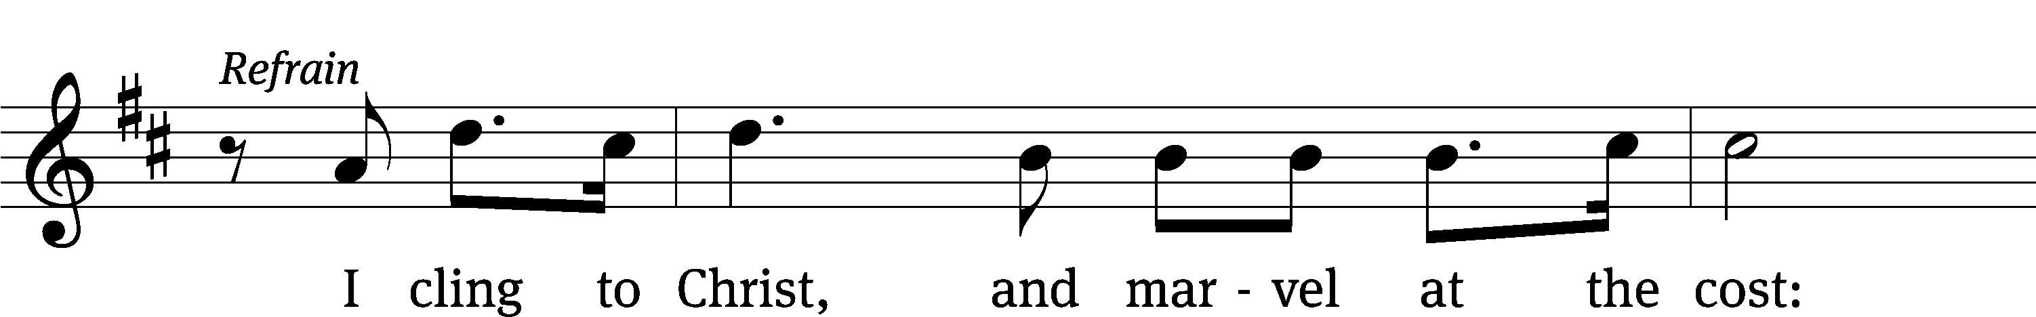
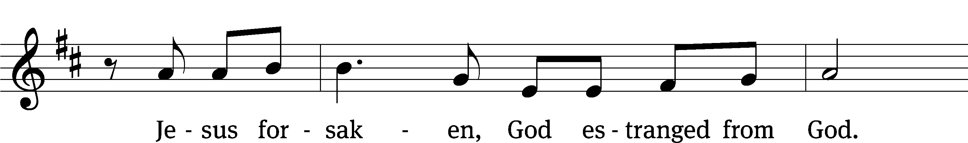
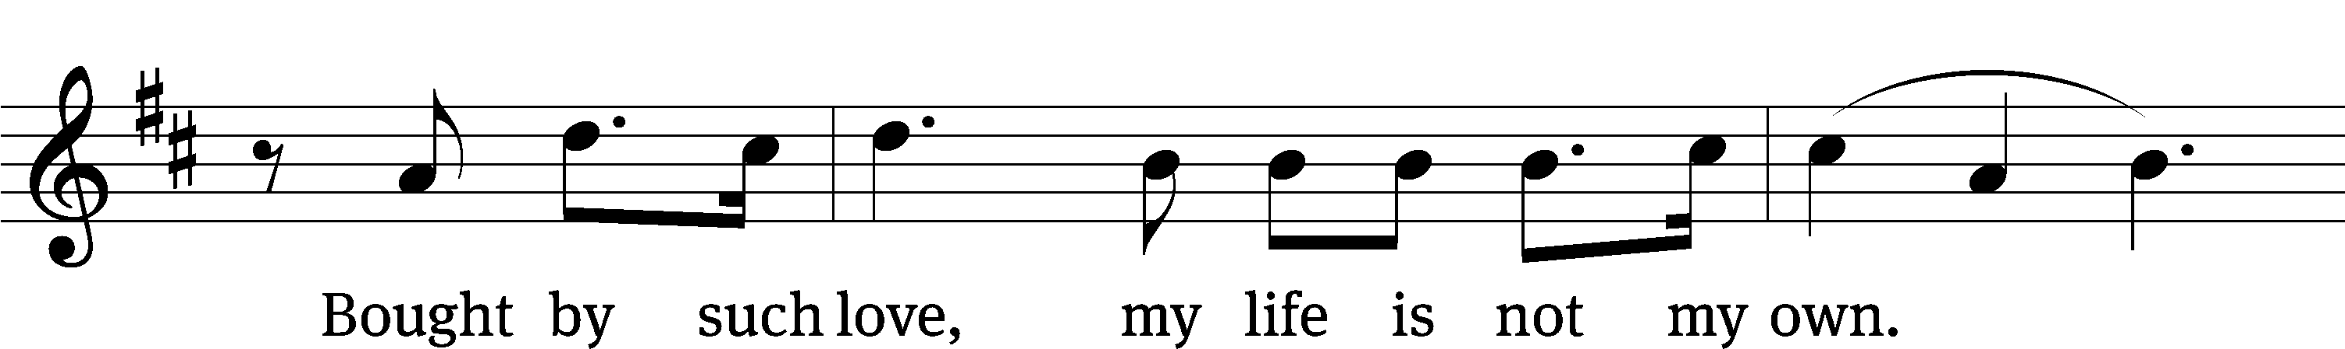
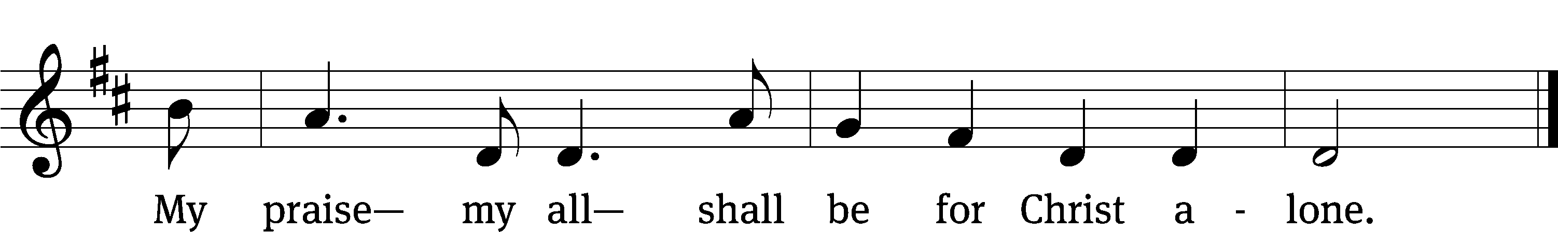
Text: Chris Anderson, b. 1971
Tune: Greg Habegger, b. 1973
Text and tune: © 2008 Church Works Media. Used by permission: OneLicense no. 727703

PLEASE STAND, IF YOU ARE ABLE

invocation

M: The grace of our Lord (+) Jesus Christ and the love of God and the fellowship of the Holy Spirit be with you.
C: And also with you.
CONFESSION OF SINS
M: God invites us to come into his presence and worship him with humble and penitent hearts. Therefore, let us acknowledge our sinfulness and ask him to forgive us.
C: Holy and merciful Father, I confess that I am by nature sinful, and that I have disobeyed you in my thoughts, words, and actions. I have done what is evil and failed to do what is good. For this I deserve your punishment both now and in eternity. But I am truly sorry for my sins, and trusting in my Savior Jesus Christ, I pray: Lord, have mercy on me, a sinner.
M: God, our heavenly Father, has been merciful to us and has given his only Son to be the atoning sacrifice for our sins. Therefore, as a called servant of Christ and by his authority, I forgive you all your sins in the name of the Father and of the Son (+) and of the Holy Spirit.
C: Amen.
PRAYER AND PRAISE
LORD, HAVE MERCY
Kyrie
M: For all that we need in life and for the wisdom to use all your gifts with gratitude and joy, hear our prayer, O Lord.

M: For the steadfast assurance that nothing can separate us from your love and for the courage to stand firm against the assaults of Satan and every evil, hear our prayer, O Christ.

M: For the well-being of your holy Church in all the world and for those who offer here their worship and praise, hear our prayer, O Lord.

M: Merciful God, maker and preserver of life, uphold us by your power and keep us in your tender care:

M: The works of the Lord are great and glorious; his name is worthy of praise.

Prayer of the day

M: Let us pray.

Almighty God, you invite us to trust in you for our salvation. Deal with us not in the severity of your judgment but by the greatness of your mercy; through your Son, Jesus Christ our Lord, who lives and reigns with you and the Holy Spirit, one God, now and forever.

PLEASE BE SEATED

The Word

first lesson Isaiah 25:6-9
⁶ On this mountain
the Lord of Armies will prepare for all peoples
a banquet of rich food,
a banquet of aged wines,
with the best cuts of meat,
and with the finest wines.
⁷ On this mountain
he will destroy the shroud that covers all peoples,
the burial cloth stretched over all nations.
⁸ He has swallowed up death forever!
The Lord God will wipe away the tears from every face.
He will take away the shame of his people throughout the earth.
For the Lord has spoken.
⁹ On that day it will be said,
“Look, here is our God!
We waited for him, and he saved us!
This is the Lord!
We waited for him.
Let us be glad and rejoice in his salvation!”

CHOIR “Be Still, My Soul”

Be still, my soul; the Lord is on your side;

Bear patiently the cross of grief or pain;

Leave to your God to order and provide;

In ev’ry change he faithful will remain.

Be still, my soul, your best, your heavenly friend

Through thorny ways leads to a joyful end.

Be still, my soul; your God will undertake

To guide the future as he has the past.

Your hope, your confidence, let nothing shake;

All now mysterious shall be bright at last.

Be still, my soul: the waves and winds still know

His voice who ruled them while he lived below.

Be still, my soul; though dearest friends depart

And all is darkened in the vale of tears;

Then you will better know his love, his heart,

Who comes to soothe your sorrows and your fears.

Be still, my soul; your Jesus can repay

From his own fullness all he takes away.

Be still, my soul; the hour is hastening on

When we shall be forever with the Lord.

When disappointment, grief, and fear are gone,

Sorrow forgot, love’s purest joys restored.

Be still, my soul, when change and tears are past,

All safe and blessed we shall meet at last.

Be still, my soul; the Lord is on your side.

second lesson Romans 1:16-17
¹⁶ For I am not ashamed of the gospel, because it is the power of God for salvation to everyone who believes—to the Jew first, and also to the Greek. ¹⁷ For in the gospel a righteousness from God is revealed by faith, for faith, just as it is written, “The righteous will live by faith.”

PLEASE STAND, IF YOU ARE ABLE

VERSE OF THE DAY Isaiah 25:6
Alleluia. On this mountain, the Lord Almighty will prepare
A feast of rich food for all peoples. Alleluia.

GOSPEL Matthew 22:1-14
¹ Jesus spoke to them again in parables. He said, ² “The kingdom of heaven is like a certain king who prepared a wedding banquet for his son. ³ He sent out his servants to summon those who were invited to the wedding banquet, but they did not want to come.
⁴ “Then he sent out other servants and said, ‘Tell those who are invited: Look, I have prepared my dinner. My oxen and my fattened cattle have been butchered, and everything is ready. Come to the wedding banquet!’
⁵ “But those who were invited paid no attention and went off, one to his own farm, another to his business. ⁶ The rest seized the king’s servants, mistreated them, and killed them. ⁷ As a result, the king was very angry. He sent his army and killed those murderers and burned their town.
⁸ “Then he said to his servants, ‘The wedding banquet is ready, but those who were invited were not worthy. ⁹ So go to the main crossroads and invite as many as you find to the wedding banquet.’ ¹⁰ Those servants went out to the roads and gathered together everyone they found, both good and bad, and the wedding hall was filled with guests. ¹¹ But when the king came in to see the guests, he saw a man there who was not wearing wedding clothes. ¹² He said to him, ‘Friend, how did you get in here without wearing wedding clothes?’ The man was speechless. ¹³ Then the king told the servants, ‘Tie him hand and foot and throw him into the outer darkness where there will be weeping and gnashing of teeth.’ ¹⁴ For many are called, but few are chosen.”

M: This is the Gospel of the Lord.

PLEASE BE SEATED

902 Spread Abroad, O Mighty Word CW 902
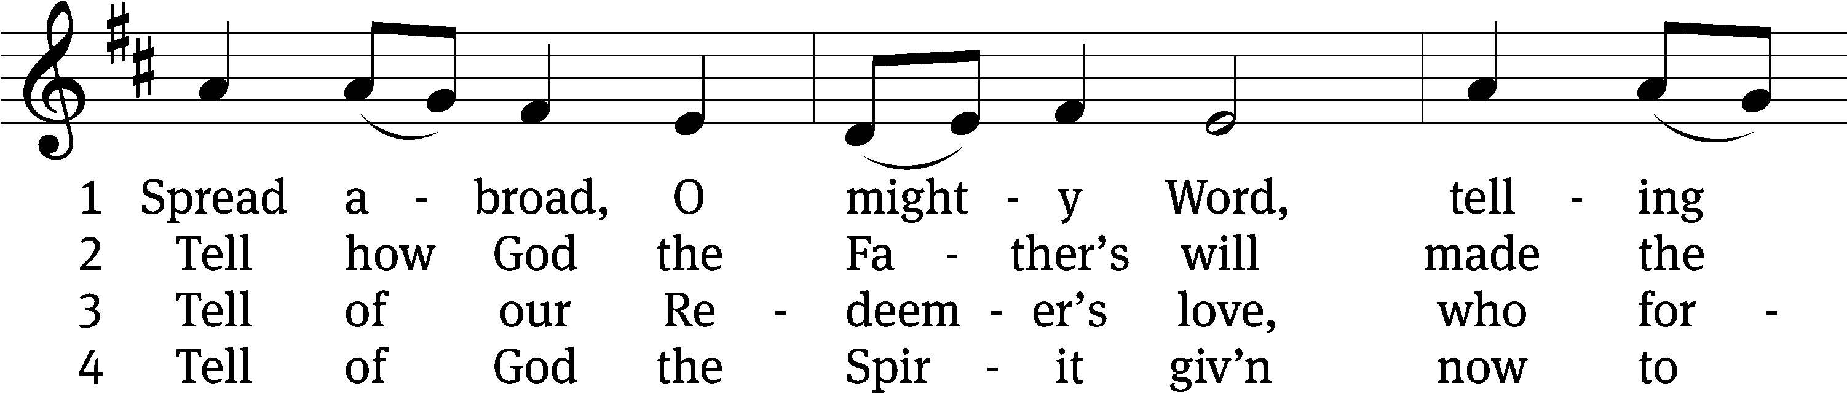
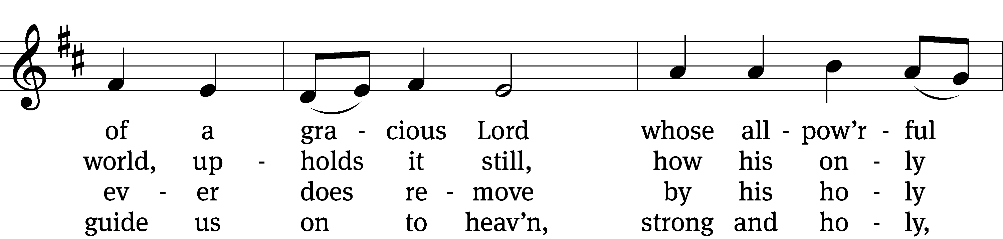
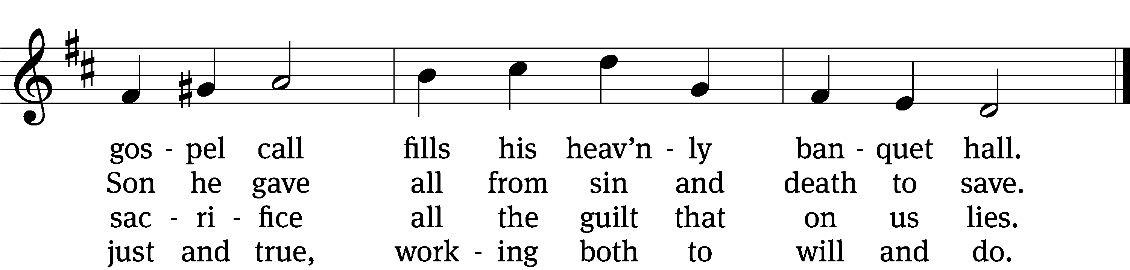

5 Spread abroad! Ripe fields of grain
all throughout the world remain,
but the reapers still are few;
great the work they have to do.

6 Lord of harvest, great and kind,
rouse to action heart and mind;
let the gath’ring nations all
see your light and heed your call.
Text: tr. composite; Jonathan F. Bahnmeier, 1774–1841, abr.
Tune: Erbaulicher Musicalischer Christen-Schatz, Basel, 1745, alt.
Text and tune: Public domain

Sermon Matthew 22:1-14

“God’s Wedding Invitation”

please stand, if you are able

nicene creed
We believe in one God, the Father, the Almighty, maker of heaven and earth, of all that is, seen and unseen.
We believe in one Lord, Jesus Christ, the only Son of God, eternally begotten of the Father, God from God, Light from Light, true God from true God, begotten, not made, of one being with the Father. Through him all things were made. For us and for our salvation, he came down from heaven, was incarnate of the Holy Spirit and the virgin Mary, and became truly human. For our sake he was crucified under Pontius Pilate. He suffered death and was buried. On the third day he rose again in accordance with the Scriptures. He ascended into heaven and is seated at the right hand of the Father. He will come again in glory to judge the living and the dead, and his kingdom will have no end.
We believe in the Holy Spirit, the Lord, the giver of life, who proceeds from the Father and the Son, who in unity with the Father and the Son is worshiped and glorified, who has spoken through the prophets. We believe in one holy Christian and apostolic Church. We acknowledge one baptism for the forgiveness of sins. We look for the resurrection of the dead and the life of the world to come. Amen.

prayer of the church

lord’s prayer

C: Our Father, who art in heaven,
hallowed be thy name,
thy kingdom come,
thy will be done
on earth as it is in heaven.
Give us this day our daily bread;
and forgive us our trespasses,
as we forgive those
who trespass against us;
and lead us not into temptation,
but deliver us from evil.
For thine is the kingdom
and the power and the glory
forever and ever. Amen.

The Sacrament of Holy Communion
Trinity Lutheran Church follows the historic Christian practice of close communion. We ask that only members of Trinity or one of our sister congregations partake of the sacrament. If you are not a member, please see the note about Holy Communion in the beginning of the Worship Folder.

M: The Lord be with you.

M: Lift up your hearts.

M: Let us give thanks to the Lord our God.

M: Praise to the God and Father of our Lord Jesus Christ! In love he has blessed us with every spiritual blessing. He sends the Holy Spirit to testify that we are his children and to strengthen us when we are weak. Now have come the salvation and the power and the kingdom of our God and the authority of his Christ. To him who sits on the throne and to the Lamb be praise and thanks and honor and glory for ever and ever:

Holy, Holy, Holy

Words of institution
M: Our Lord Jesus Christ, on the night he was betrayed, took bread; and when he had given thanks, he broke it and gave it to his disciples, saying: “Take and eat. This is my ✙ body, which is given for you. Do this in remembrance of me.”
Then he took the cup, gave thanks, and gave it to them, saying, “Drink from it all of you; this is my ✙ blood of the new covenant, which is poured out for you for the forgiveness of sins. Do this, whenever you drink it, in remembrance of me.”
M: The peace of the Lord be with you always.

O CHRIST, LAMB OF GOD

PLEASE BE SEATED

668 Jesus Comes Today with Healing CW 668
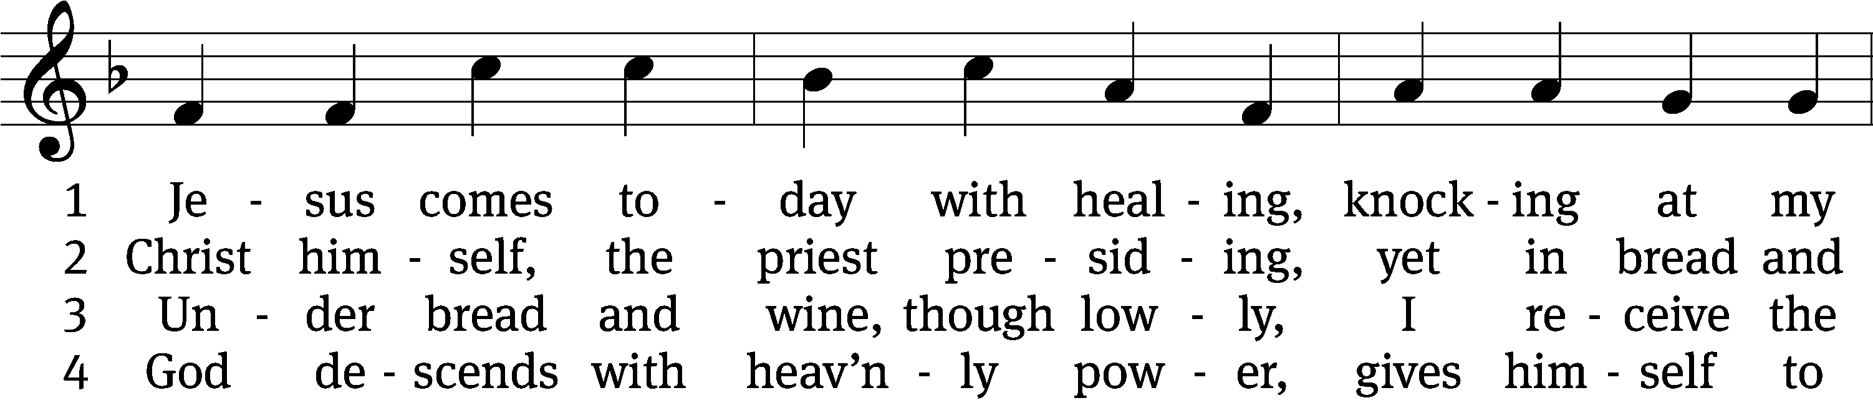
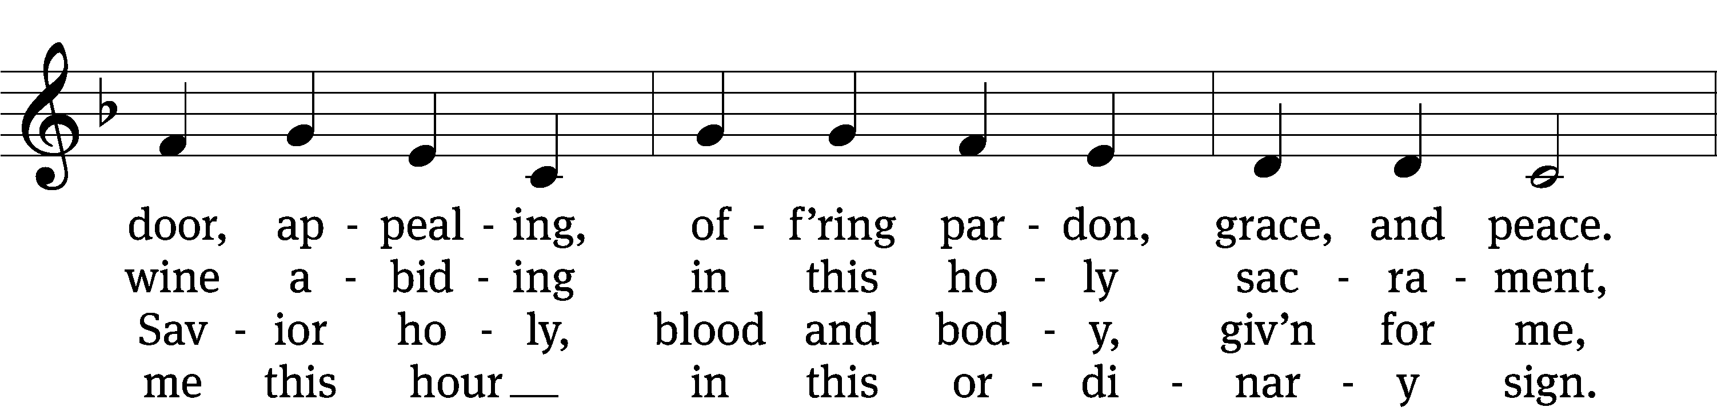
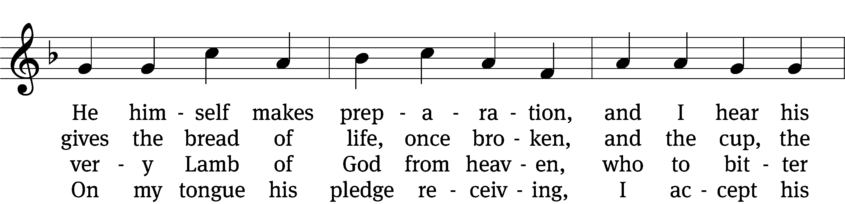
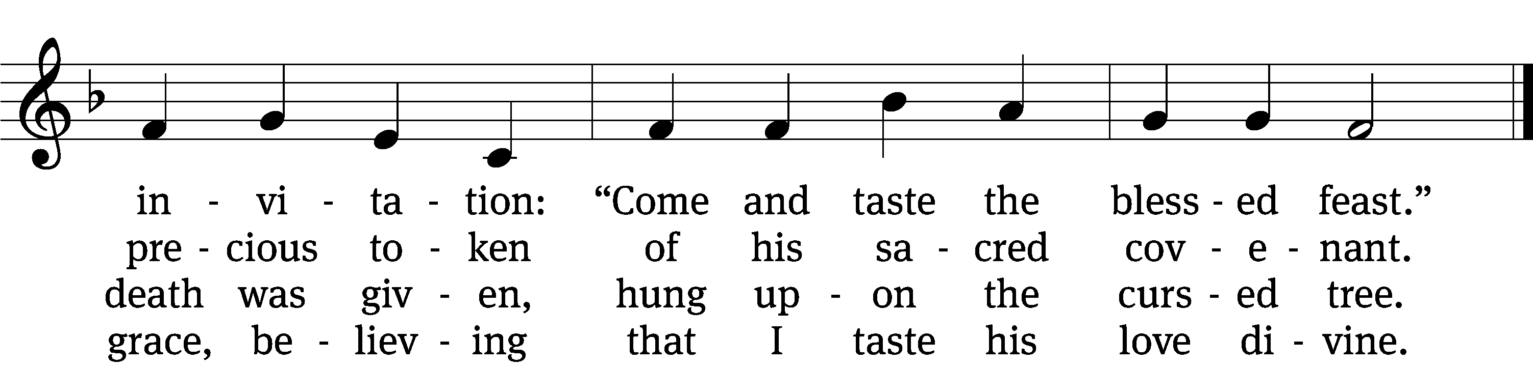

5 Let me praise God’s boundless favor, 6 Now have I found consolation,
whose own feast of love I savor, comfort in my tribulation,
bidden by his gracious call. balm to heal the troubled soul.
Wedding garments he provides me, God, my shield from ev’ry terror,
with a robe of white he hides me, cleanses me from sin and error,
fits me for the royal hall. makes my wounded spirit whole.

Text: tr. David W. Rogner, b. 1960; Heinrich Puchta, 1808–1858
Tune: adapt. Johann Balthasar König, 1691–1758; Johann Löhner, 1645–1705
Text: © 2003 David W. Rogner. Used by permission: OneLicense no. 727703
Tune: Public domain
660 Here, O My Lord, I See You Face to Face CW 660
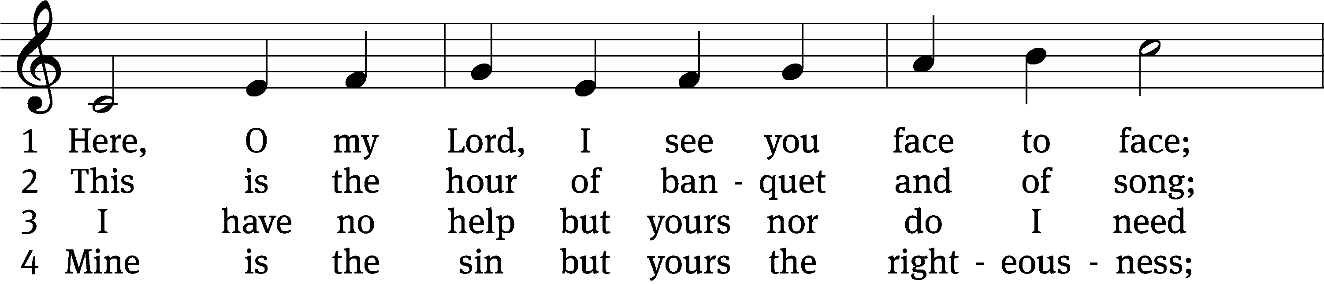
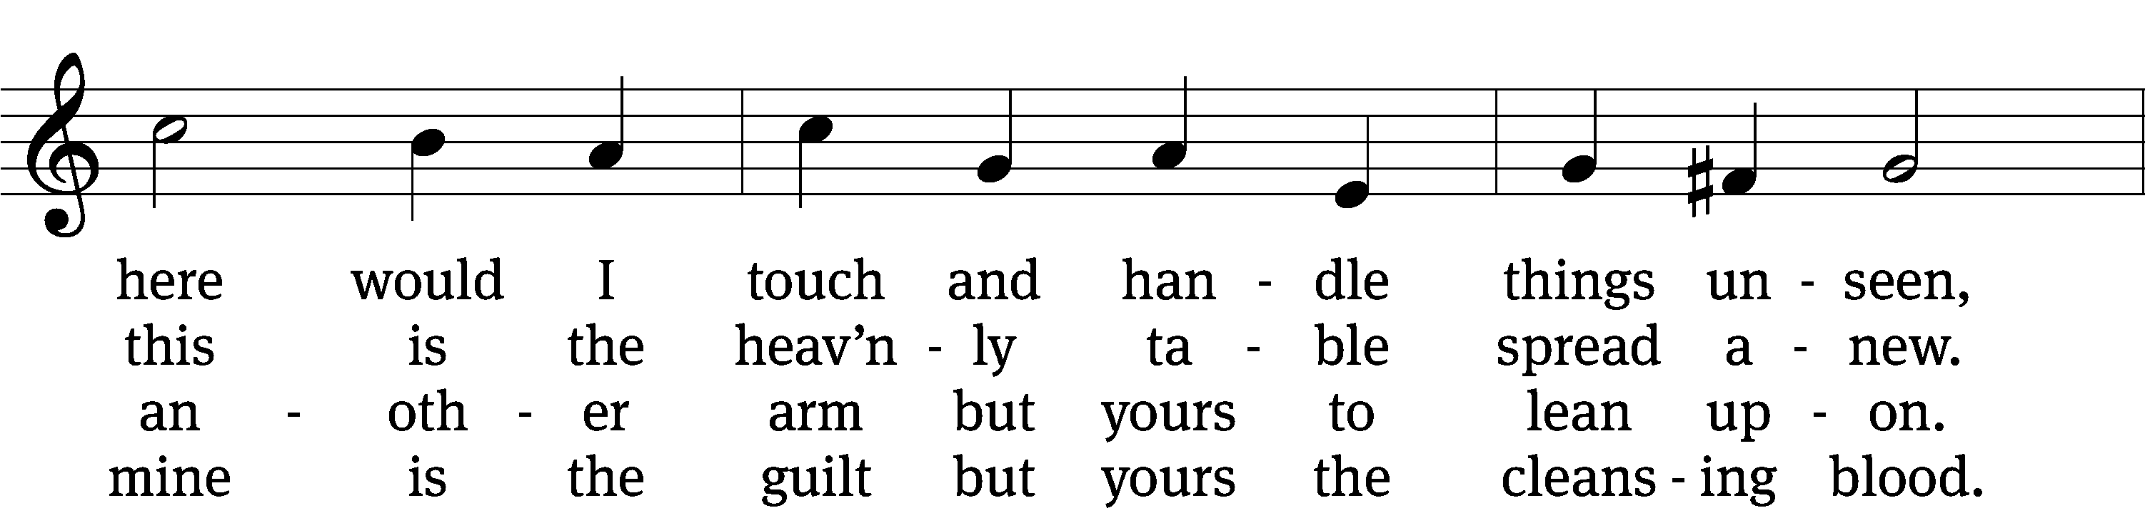
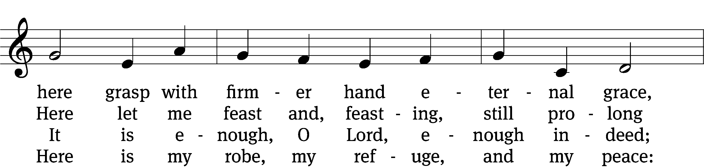
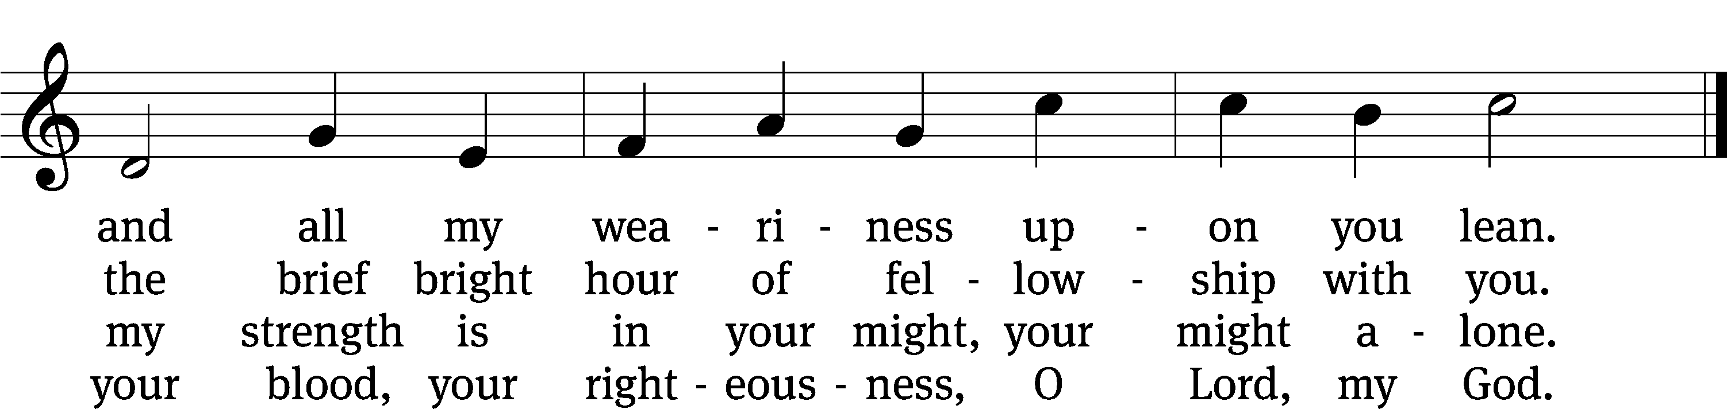

5 Too soon we rise; the vessels disappear;
the feast, though not the love, is past and gone.
The bread and wine remove, but you are here,
nearer than ever, still my shield and sun.

6 Feast after feast thus comes and passes by,
yet, passing, points to that glad feast above,
giving sweet foretaste of the festal joy,
the Lamb’s great marriage feast of bliss and love.
Text: Horatius Bonar, 1808–1889, abr., alt.
Tune: Henry Lawes, 1595–1662
Text and tune: Public domain

PLEASE STAND, IF YOU ARE ABLE

M: Hear the prayer of your people, O Lord, that the lips which have praised you here may glorify you in the world, that the eyes which have seen the coming of your Son may long for his coming again, and that all who have received in his true body and blood the pledge of your forgiveness may be restored to live a new and holy life, through Jesus Christ, our Lord, who lives and reigns with you and the Holy Spirit, one God, now and forever.

M: Brothers and sisters, go in peace. Live in harmony with one another.
Serve the Lord with gladness.
The Lord bless you and keep you.
The Lord make his face shine on you and be gracious to you.
The Lord look on you with favor and (+) give you peace.

PLEASE BE SEATED

927 Lord, Dismiss Us with Your Blessing CW 927
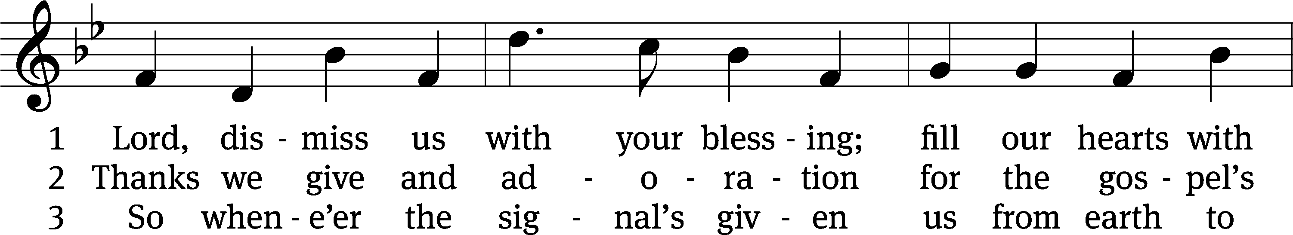
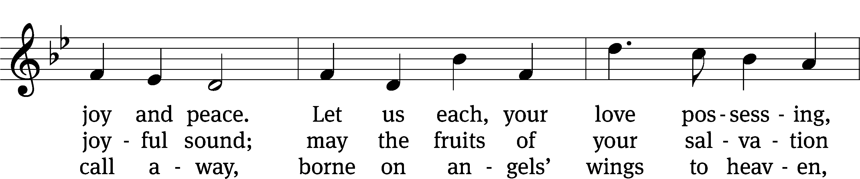
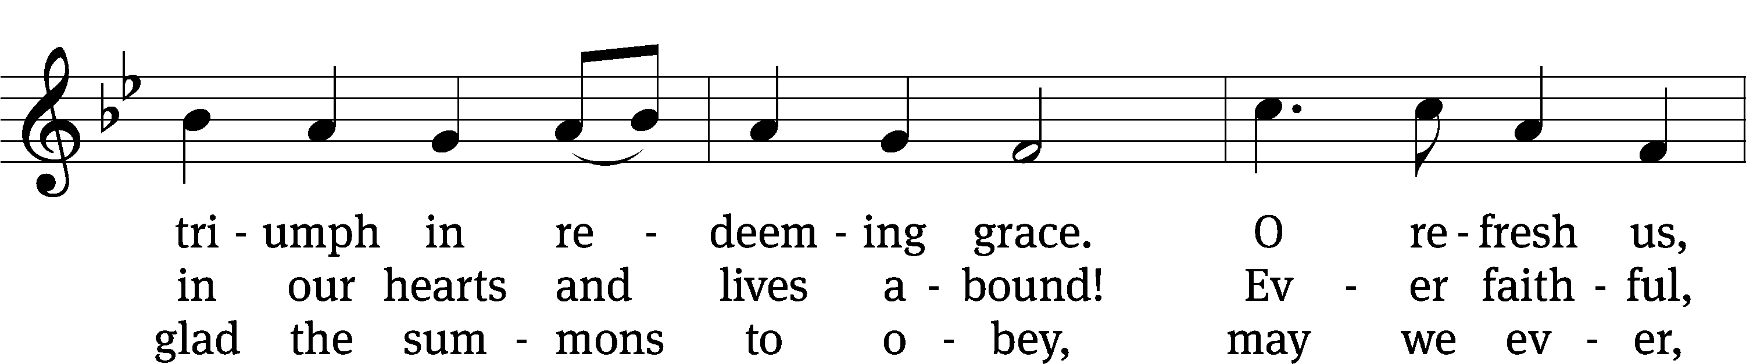
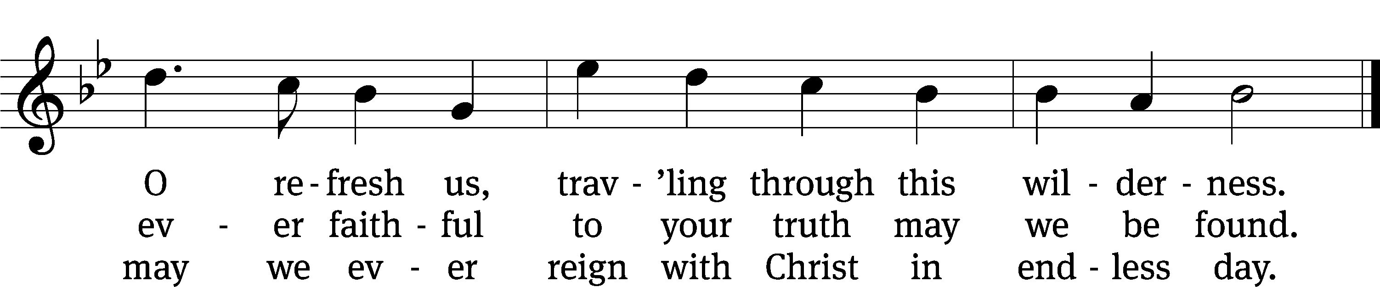
Text: attr. John Fawcett, 1740–1817, alt.
Tune: Henry T. Smart, 1813–1879
Text and tune: Public domain

Serving In Worship

Officiant Pastor William Natsis
Organist Marcia Marion Ackling
Choir Director Cynthia Natsis
Accompanist Laura Sala
Deacons (8:30) Dave Stevenson and Jim Tice
(11:00) Steve Hoeft and Jeff Neuburger
Ushers (8:30) Dale Finkbeiner and Mark Finkbeiner
(11:00) Ed Sala and All Whitley
Altar Guild Barb Neuburger and Karen Tice
Videographer Rick Schneider

Copyright information
Service of Word and Sacrament: Christian Worship. © 1993 Northwestern Publishing House. All rights reserved. Reprinted under ONE LICENSE #A-727703 and CCLI #1151741/ CSPL126093
Words and Music: All rights reserved. Reprinted/Podcast/Streamed with permission under ONE LICENSE #A-727703 and CCLI #1151741/CSPL126093

