the NINEteENTH sunday
AFTER PENTECOST

TRINITY EVANGELICAL LUTHERAN CHURCH | Saline, Michigan
WELCOME TO WORSHIP October 16, 2022

Thank you for joining us in God’s house today! We cordially ask that our guests sign one of the guestbooks located at either the front or back entryways.

THANK OFFERING: Members of Trinity give their offering as an expression of love and thankfulness to the Lord and to help support the Lord’s work in our community and around the world. Visitors need not feel obligated to participate in this offering which supports our ministry.

Restrooms are located at the back of the upper level (the annex), and in the basement (down the back stairs of the sanctuary or annex). Handicap access is available, please ask an usher for assistance.

celebration of holy communion:
In His Word, God makes it clear that the Lord’s Supper is to be shared by people of a common proclamation of faith (1 Corinthians 11:26; 1 Corinthians 10:16-17). Without judging anyone’s hearts, we invite those who share in our confession by their membership in our congregation or another congregation of the Wisconsin Evangelical Lutheran Synod (WELS) or the Evangelical Lutheran Synod (ELS) and who are properly prepared (1 Corinthians 11;27-29) to receive the Sacrament. Page 295 in the front of Christian Worship provides a guide for preparation.

Guests, we would love to have you join us in communion fellowship in the future, and for that to be possible, we ask that you speak with one of the pastors so that we may speak with you on how that would be possible. We thank you for respecting the way we celebrate the Lord’s Supper in our congregations.

SERVICE OF WORD AND SACRAMENT

721 What a Friend We Have in Jesus CW 721
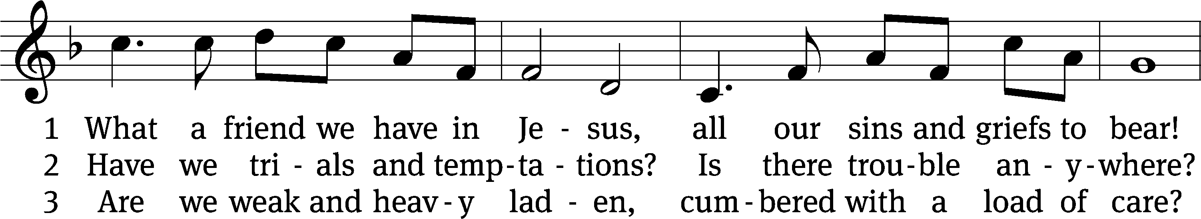
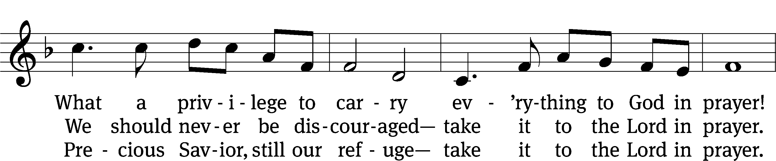
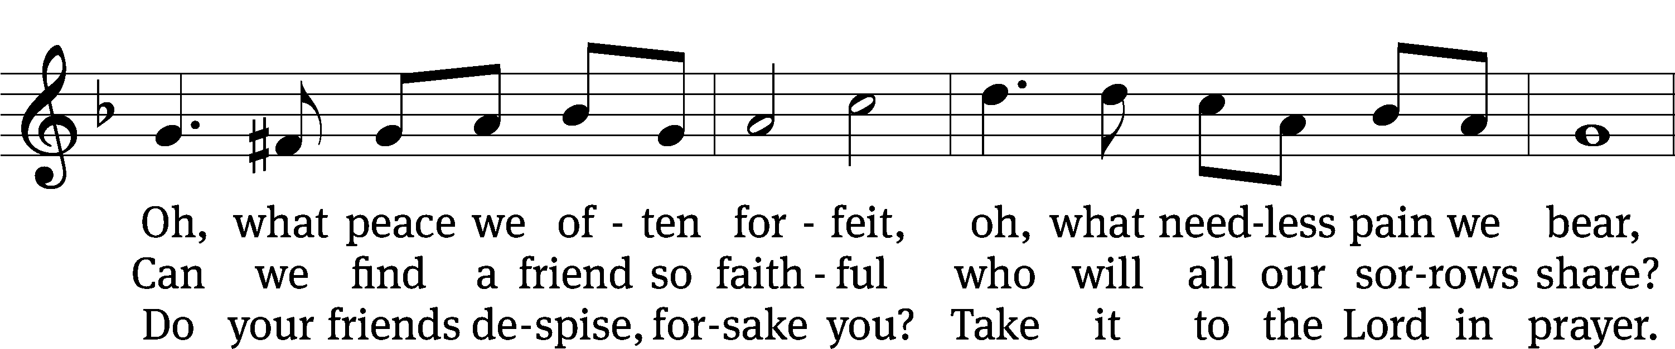
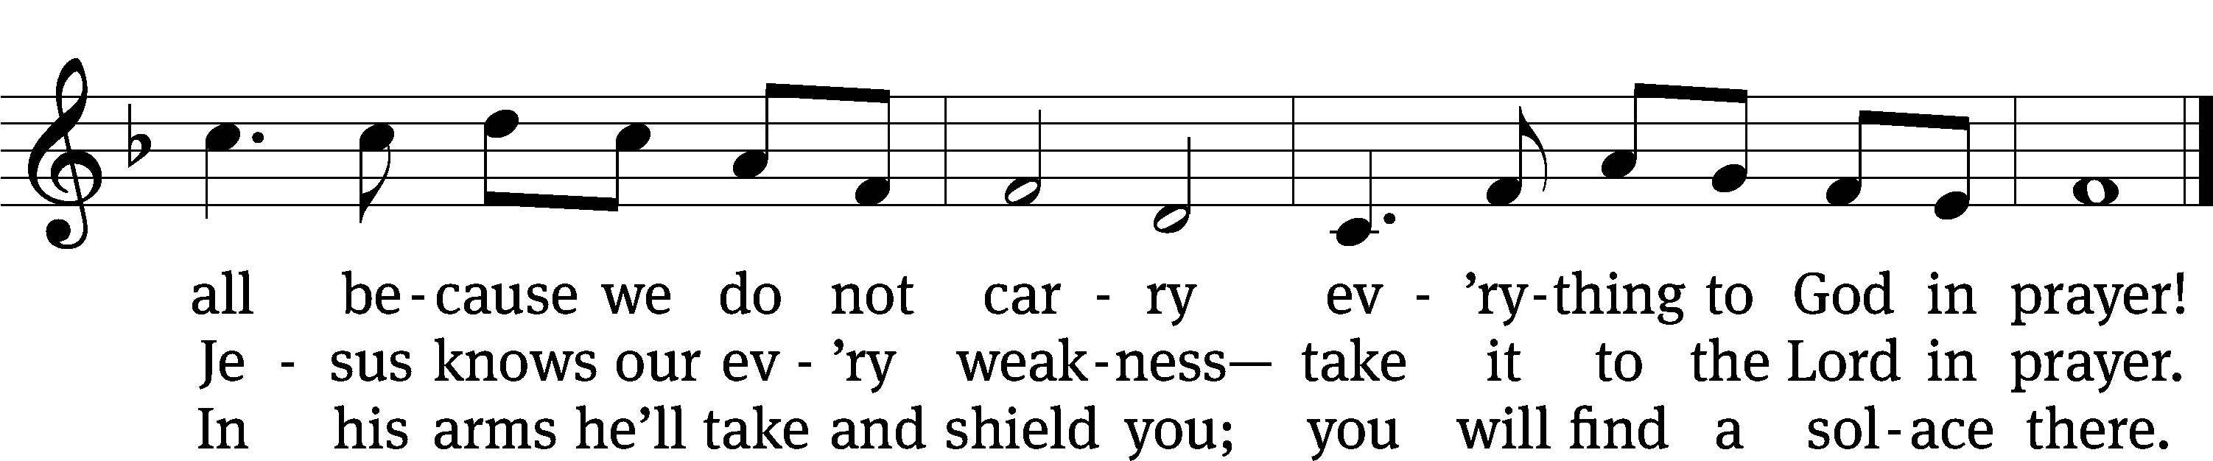
Text: Joseph M. Scriven, 1819–1886, alt.
Tune: Charles C. Converse, 1832–1918
Text and tune: Public domain

PLEASE STAND, IF YOU ARE ABLE

invocation

M: The grace of our Lord (+) Jesus Christ and the love of God and the fellowship of the Holy Spirit be with you.
C: And also with you.
CONFESSION OF SINS
M: God invites us to come into his presence and worship him with humble and penitent hearts. Therefore, let us acknowledge our sinfulness and ask him to forgive us.
C: Holy and merciful Father, I confess that I am by nature sinful, and that I have disobeyed you in my thoughts, words, and actions. I have done what is evil and failed to do what is good. For this I deserve your punishment both now and in eternity. But I am truly sorry for my sins, and trusting in my Savior Jesus Christ, I pray: Lord, have mercy on me, a sinner.
M: God, our heavenly Father, has been merciful to us and has given his only Son to be the atoning sacrifice for our sins. Therefore, as a called servant of Christ and by his authority, I forgive you all your sins in the name of the Father and of the Son (+) and of the Holy Spirit.
C: Amen.

PRAYER AND PRAISE

LORD, HAVE MERCY
Kyrie
M: For all that we need in life and for the wisdom to use all your gifts with gratitude and joy, hear our prayer, O Lord.

M: For the steadfast assurance that nothing can separate us from your love and for the courage to stand firm against the assaults of Satan and every evil, hear our prayer, O Christ.

M: For the well-being of your holy Church in all the world and for those who offer here their worship and praise, hear our prayer, O Lord.

M: Merciful God, maker and preserver of life, uphold us by your power and keep us in your tender care:

M: The works of the Lord are great and glorious; his name is worthy of praise.

Prayer of the day

M: Let us pray.
The minister says the Prayer of the Day.

PLEASE BE SEATED

The Word

first lesson Genesis 32:22-30
²² [Jacob] got up that night and took his two wives, his two maids, and his eleven sons, and crossed over the ford of the Jabbok. ²³ He took them and sent them across the stream, and he also sent his possessions across. ²⁴ Jacob was left alone, and he wrestled with a man there until daybreak. ²⁵ When the man saw that he could not defeat him, he touched the socket of his thigh, and the socket of Jacob’s thigh was dislocated as he wrestled. ²⁶ The man said, “Let me go. It’s daybreak.”
Jacob said, “I will not let you go unless you bless me.”
²⁷ Then he said to him, “What is your name?”
He said, “Jacob.”
²⁸ Then he said, “Your name will no longer be Jacob, but Israel, because you have fought with God and with men, and you have won.”
²⁹ Jacob asked him, “Please tell me your name.”
He said, “Why do you ask what my name is?” Then he blessed him there.
³⁰ Jacob named the place Peniel, because he said, “I have seen God face-to-face, and my life has been spared.”

Senior Choir “I Will Sing unto the Lord”
I will sing unto the Lord, for he has triumphed gloriously,
I will sing unto the Lord, for he has triumphed gloriously,
I will sing, I will sing unto the Lord.

I will sing unto the Lord, for he has triumphed gloriously,
I will sing unto the Lord, for he has triumphed gloriously,
I will sing, sing, sing, unto the Lord.

The Lord is my strength and song, and he is become my salvation.
The Lord is my strength and song, and he is become my salvation.
I will exalt him, I will exalt him

I will sing unto the Lord, for he has triumphed gloriously,
I will sing unto the Lord, for he has triumphed gloriously,
I will sing, I will sing unto the Lord.

I will sing unto the Lord, for he has triumphed gloriously,
I will sing unto the Lord, for he has triumphed gloriously,
I will sing, sing, sing, unto the Lord.

I will sing.

second lesson 1 John 5:13-15
¹³ I have written these things to you who believe in the name of the Son of God so that you may know that you have eternal life.
¹⁴ This is the confidence that we have before him: that if we ask anything according to his will, he hears us. ¹⁵ And if we know that he hears us—whatever we ask—we also know that we receive the things we have asked from him.

PLEASE STAND, IF YOU ARE ABLE

VERSE OF THE DAY

GOSPEL LUKE 18:1-8
¹ Jesus told them a parable about the need to always pray and not lose heart: ² “There was a judge in a certain town who did not fear God and did not care about people. ³ There was a widow in that town, and she kept going to him, saying, ‘Give me justice from my adversary!’ ⁴ For some time he refused, but after a while he said to himself, ‘Even though I do not fear God or care about people, ⁵ yet because this widow keeps bothering me, I will give her justice so that she will not wear me out with her endless pleading.’”
⁶ The Lord said, “Listen to what the unjust judge says. ⁷ Will not God give justice to his chosen ones, who are crying out to him day and night? Will he put off helping them? ⁸ I tell you that he will give them justice quickly. However, when the Son of Man comes, will he find faith on the earth?”

M: This is the Gospel of the Lord.

PLEASE BE SEATED

723 When in the Hour of Utmost Need CW 723
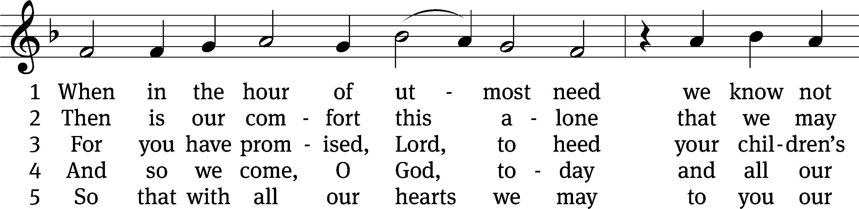
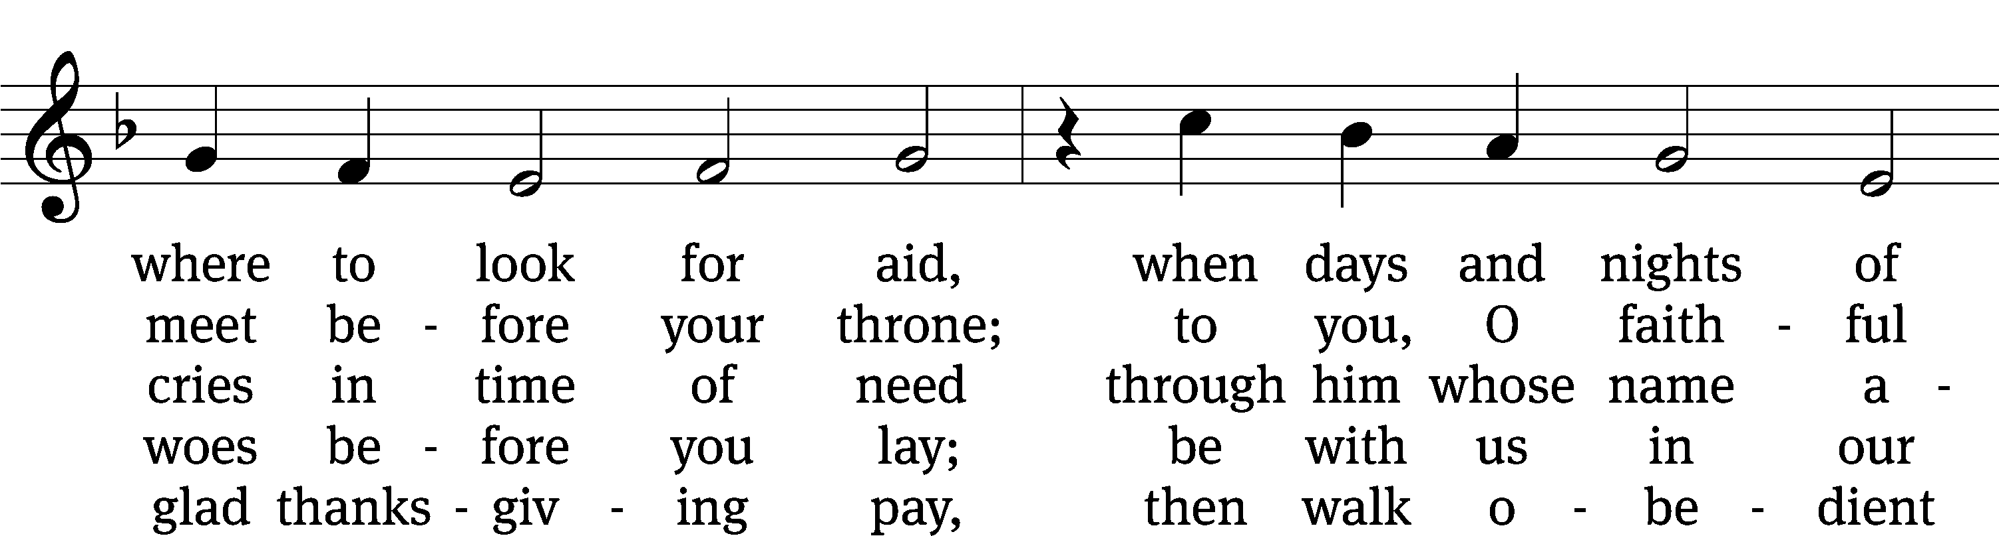
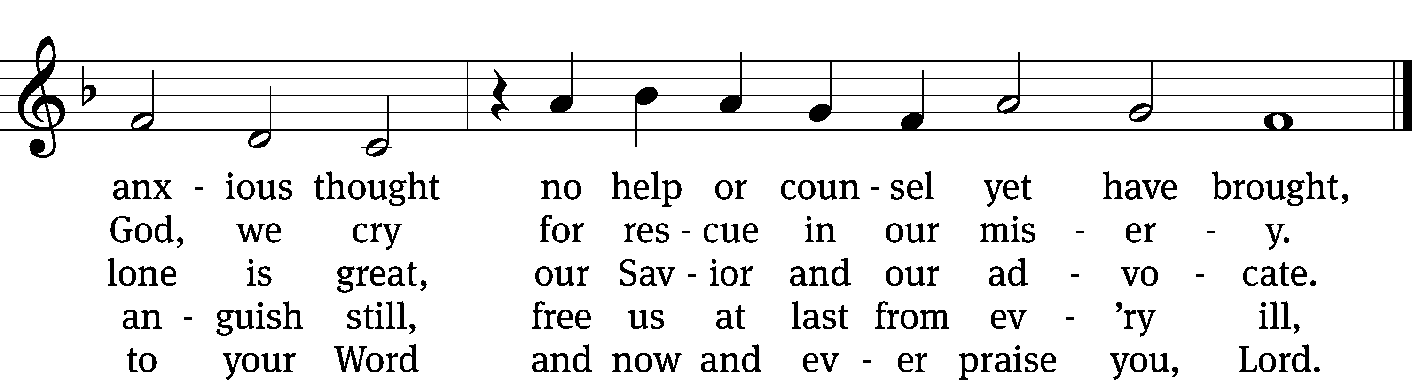
Text: tr. Catherine Winkworth, 1827–1878, alt.; Paul Eber, 1511–1569, abr.
Tune: Louis Bourgeois, c. 1510–c. 1561
Text and tune: Public domain

Sermon ONE BY ONE (Part Three)

please stand, if you are able

nicene creed
We believe in one God, the Father, the Almighty, maker of heaven and earth, of all that is, seen and unseen.
We believe in one Lord, Jesus Christ, the only Son of God, eternally begotten of the Father, God from God, Light from Light, true God from true God, begotten, not made, of one being with the Father. Through him all things were made. For us and for our salvation, he came down from heaven, was incarnate of the Holy Spirit and the virgin Mary, and became truly human. For our sake he was crucified under Pontius Pilate. He suffered death and was buried. On the third day he rose again in accordance with the Scriptures. He ascended into heaven and is seated at the right hand of the Father. He will come again in glory to judge the living and the dead, and his kingdom will have no end.
We believe in the Holy Spirit, the Lord, the giver of life, who proceeds from the Father and the Son, who in unity with the Father and the Son is worshiped and glorified, who has spoken through the prophets. We believe in one holy Christian and apostolic Church. We acknowledge one baptism for the forgiveness of sins. We look for the resurrection of the dead and the life of the world to come. Amen.

PLEASE BE SEATED

offertory

PLEASE STAND, IF YOU ARE ABLE

prayer of the church

lord’s prayer

C: Our Father, who art in heaven,
hallowed be thy name,
thy kingdom come,
thy will be done
on earth as it is in heaven.
Give us this day our daily bread;
and forgive us our trespasses,
as we forgive those
who trespass against us;
and lead us not into temptation,
but deliver us from evil.
For thine is the kingdom
and the power and the glory
forever and ever. Amen.

The Sacrament of Holy Communion
Trinity Lutheran Church follows the historic Christian practice of close communion. We ask that only members of Trinity or one of our sister congregations partake of the sacrament. If you are not a member, please see the note about Holy Communion in the beginning of the Worship Folder.

M: The Lord be with you.

M: Lift up your hearts.

M: Let us give thanks to the Lord our God.

M: Praise to the God and Father of our Lord Jesus Christ! In love he has blessed us with every spiritual blessing. He sends the Holy Spirit to testify that we are his children and to strengthen us when we are weak. Now have come the salvation and the power and the kingdom of our God and the authority of his Christ. To him who sits on the throne and to the Lamb be praise and thanks and honor and glory for ever and ever:

Holy, Holy, Holy

Words of institution
M: Our Lord Jesus Christ, on the night he was betrayed, took bread; and when he had given thanks, he broke it and gave it to his disciples, saying: “Take and eat. This is my ✙ body, which is given for you. Do this in remembrance of me.”
Then he took the cup, gave thanks, and gave it to them, saying, “Drink from it all of you; this is my ✙ blood of the new covenant, which is poured out for you for the forgiveness of sins. Do this, whenever you drink it, in remembrance of me.”
The peace of the Lord be with you always.

O CHRIST, LAMB OF GOD

776 With the Lord Begin Your Task CW 776
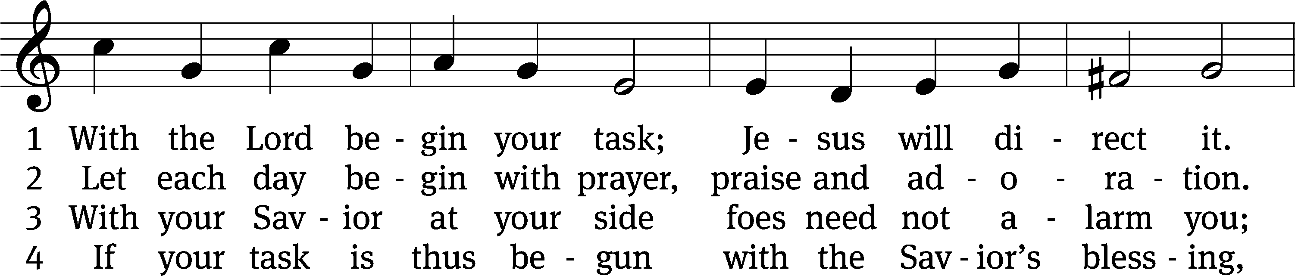
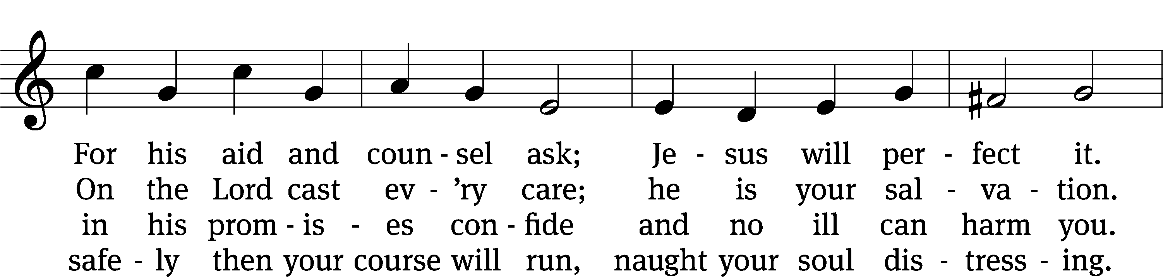
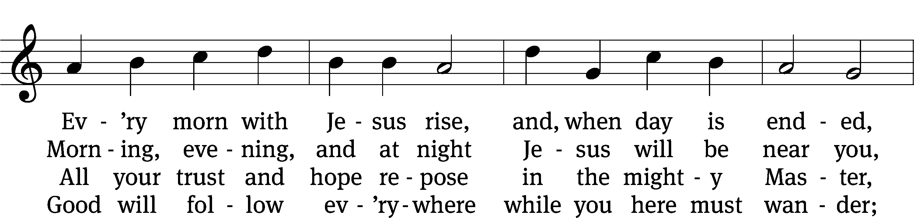
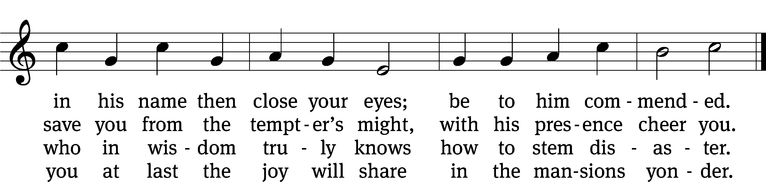
Text: tr. W. Gustave Polack, 1890–1950, alt.; Morgen- und Abend-segen, Waldenburg, 1734, abr.
Tune: Peter Frank, 1616–1675
Text: © 1941 Concordia Publishing House. Used by permission: OneLicense no. 727703
Tune: Public domain

873 Rise, My Soul, to Watch and Pray CW 873
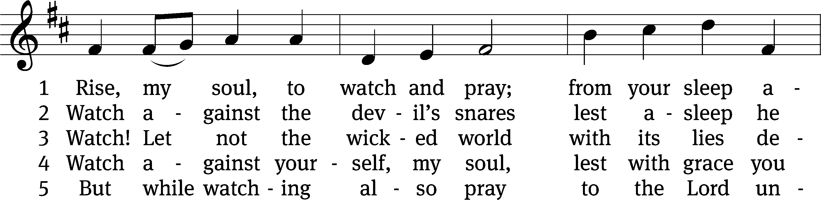
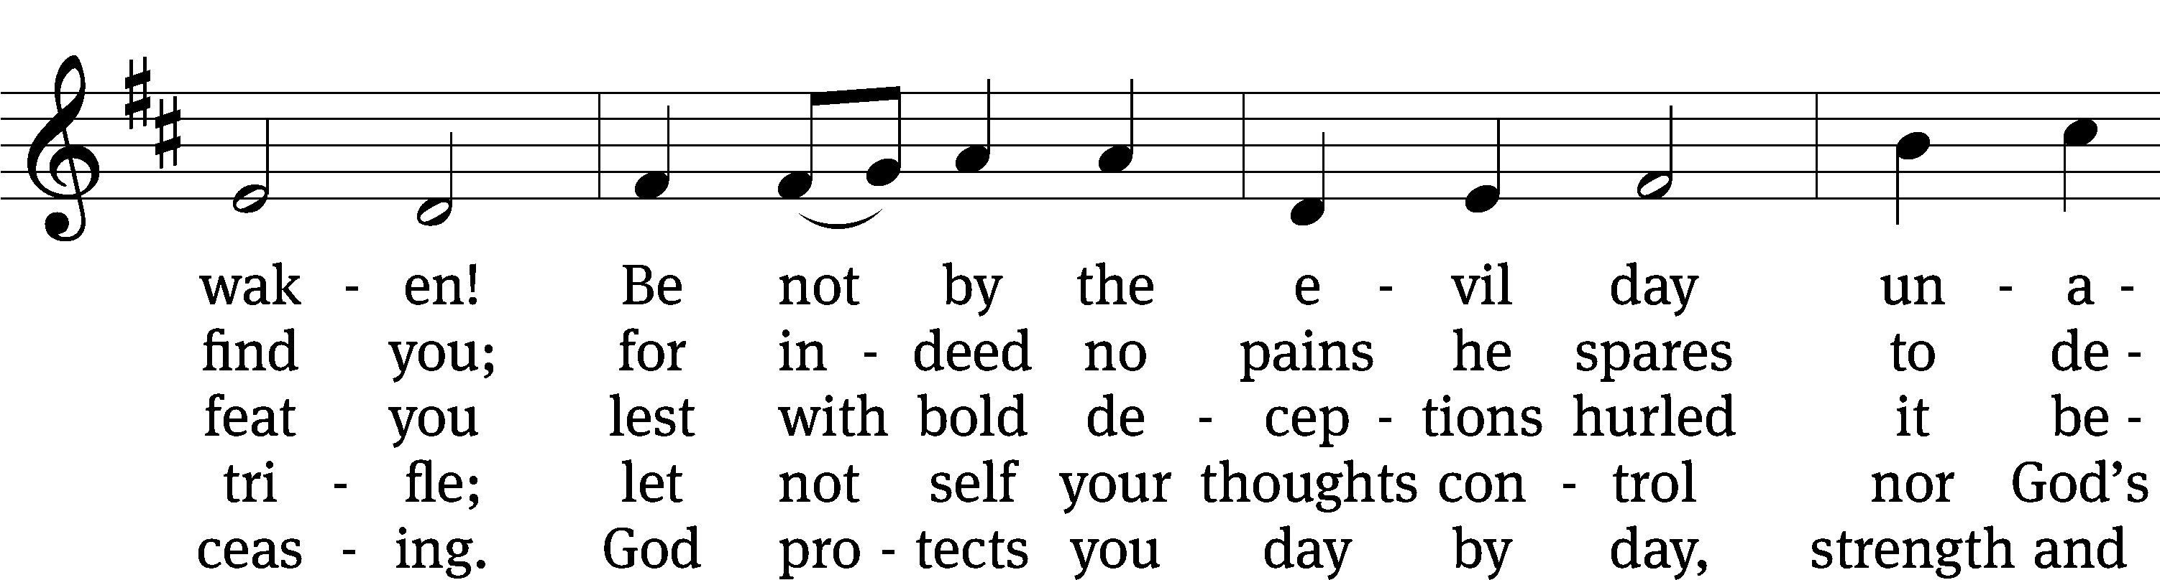
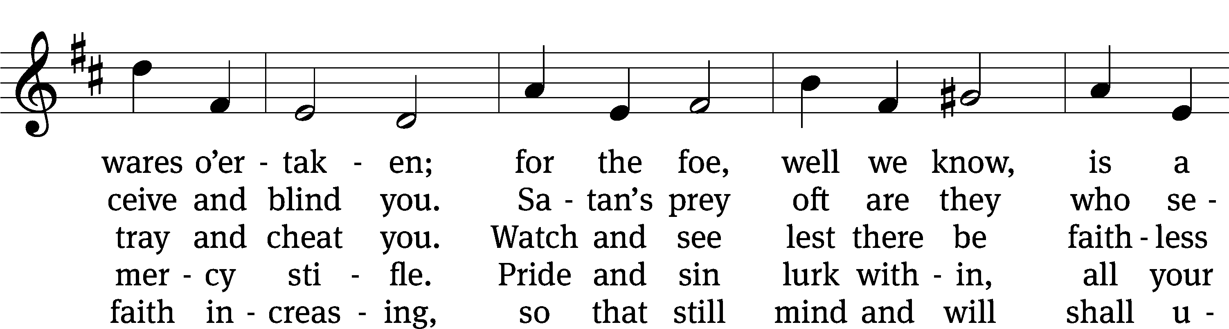
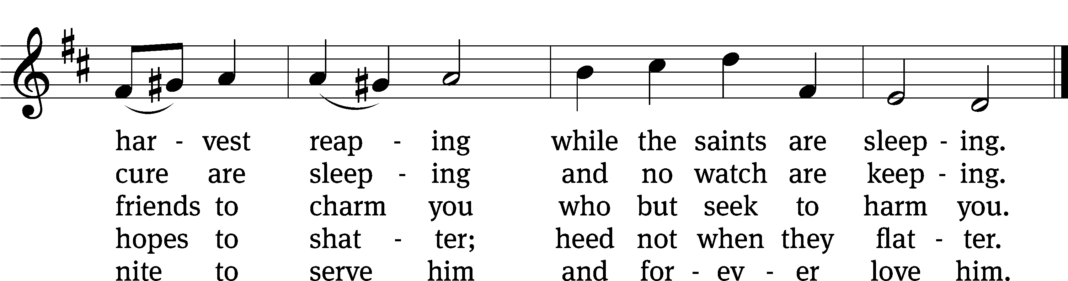
Text: Johann B. Freystein, 1671–1718, abr.; (sts. 1, 3–5): tr. Catherine Winkworth, 1827–1878, alt.; (st. 2): tr. Evangelical Lutheran Hymn-book, 1907, alt.
Tune: adapt. William H. Monk, 1823–1889; Hundert . . . geistlicher Arien, Dresden, 1694
Text and tune: Public domain

PLEASE STAND, IF YOU ARE ABLE

THANKSGIVING

M: Hear the prayer of your people, O Lord, that the lips which have praised you here may glorify you in the world, that the eyes which have seen the coming of your Son may long for his coming again, and that all who have received in his true body and blood the pledge of your forgiveness may be restored to live a new and holy life, through Jesus Christ, our Lord, who lives and reigns with you and the Holy Spirit, one God, now and forever.

M: Brothers and sisters, go in peace. Live in harmony with one another.
Serve the Lord with gladness.

The Lord bless you and keep you.
The Lord make his face shine on you and be gracious to you.
The Lord look on you with favor and (+) give you peace.

PLEASE BE SEATED
927 Lord, Dismiss Us with Your Blessing CW 927
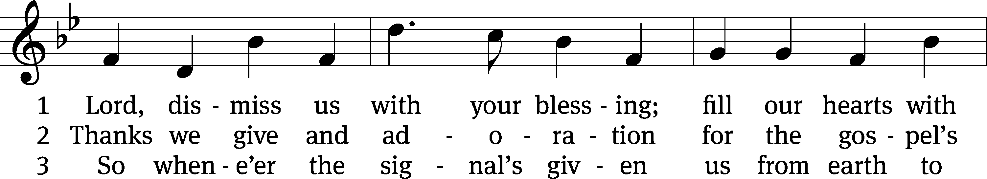
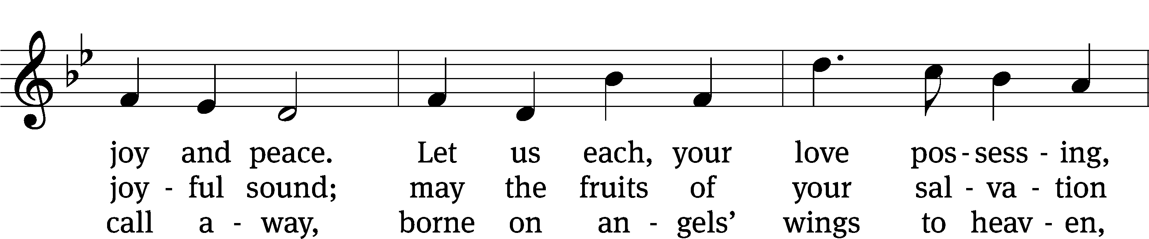
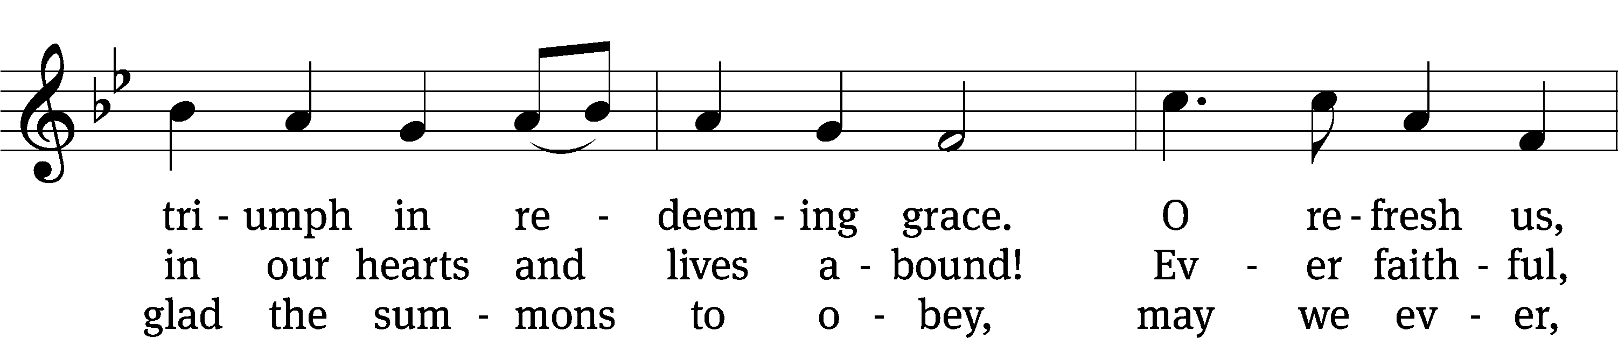
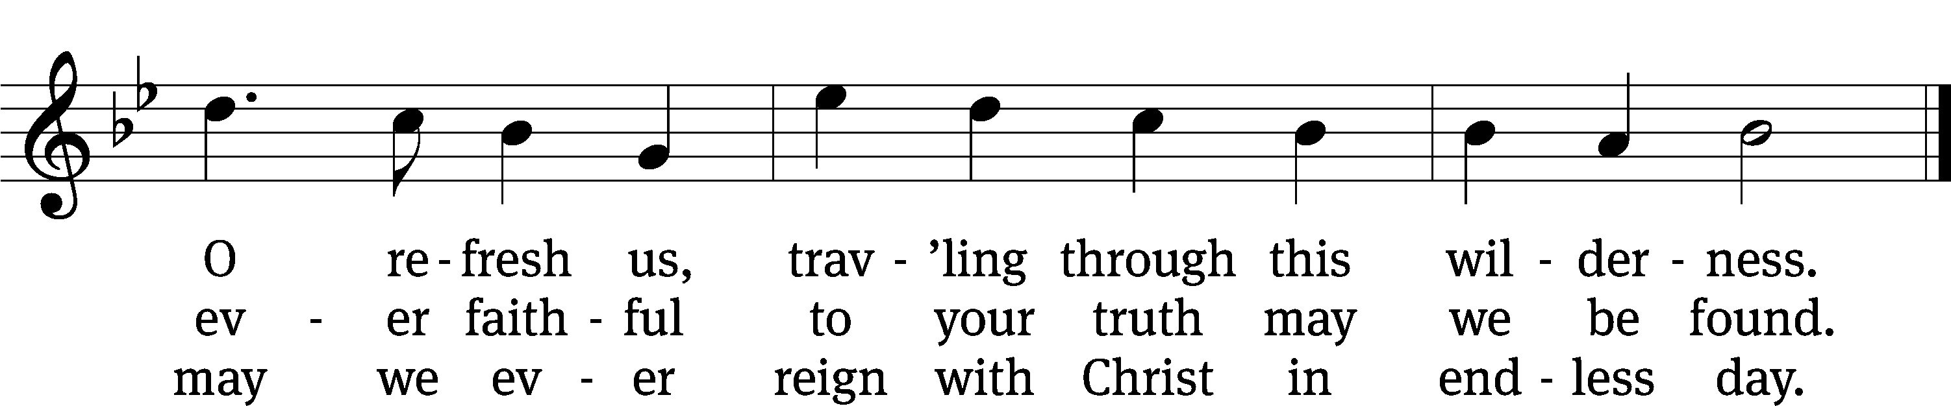
Text: attr. John Fawcett, 1740–1817, alt.
Tune: Henry T. Smart, 1813–1879
Text and tune: Public domain

Serving In Worship

Officiant Pastor Natsis
Organist Marcia Marion Ackling
Instrumentalist Malory Marion
Choir Director Cynthia Natsis
Accompanist Sarah Hanke
Deacons (8:30) Dave Stevenson and Jim Tice
(11:00) Steve Hoeft and Jeff Neuburger
Ushers (8:30) Dale Finkbeiner and Mark Finkbeiner
(11:00) Ed Sala and Al Whitley
Altar Guild Sandy Kirkpatrick and Barb Neuburger
Videographer Cindy Dresch

Copyright information
Service of Word and Sacrament: Christian Worship. © 1993 Northwestern Publishing House. All rights reserved. Reprinted under ONE LICENSE #A-727703 and CCLI #1151741/ CSPL126093
Words and Music: All rights reserved. Reprinted/Podcast/Streamed with permission under ONE LICENSE #A-727703 and CCLI #1151741/CSPL126093

