THE second SUNDAY IN ADVENT

TRINITY EVANGELICAL LUTHERAN CHURCH | Saline, Michigan
WELCOME TO WORSHIP December 4, 2022
Thank you for joining us in God’s house today! We cordially ask that our Guests sign one of the guestbooks located at either the front or back entryways, or fill out a “Let’s Get Acquainted” card located in the hymnal pew rack and place it in the collection plate.

THANK OFFERING: Members of Trinity give their offering as an expression of love and thankfulness to the Lord and to help support the Lord’s work in our community and around the world. Visitors need not feel obligated to participate in this offering which supports our ministry.

Restrooms are located at the back of the upper level (the annex), and in the basement (down the back stairs of the sanctuary or annex). Handicap access is available, please ask an usher for assistance.

Young Families / Toddler Bags – We are GLAD YOU BROUGHT YOUR CHILDREN to our worship service. Jesus said: “Let the little children come to me and do not hinder them, for the kingdom of God belongs to such as these.” We know that having little children in church can be a challenge, but DO NOT WORRY about it. Many of your fellow worshippers have been in your shoes and are just happy you brought your children with you. For your convenience, we have reserved the back rows of seating for parents with small children. These areas provide more flexibility for your family, as well as, easy access to move downstairs if necessary. A closed-circuit TV system allows families to continue participating in the service while downstairs. Pre-school toddler bags and children’s bulletins are available for their enjoyment. Ask an usher for one to use during the service and please return the toddler bag afterwards.

celebration of holy communion:
In His Word, God makes it clear that the Lord’s Supper is to be shared by people of a common proclamation of faith (1 Corinthians 11:26; 1 Corinthians 10:16-17). Without judging anyone’s hearts, we invite those who share in our confession by their membership in our congregation or another congregation of the Wisconsin Evangelical Lutheran Synod (WELS) or the Evangelical Lutheran Synod (ELS) and who are properly prepared (1 Corinthians 11;27-29) to receive the Sacrament. Page 295 in Christian Worship provides a guide for preparation.
Guests, we would love to have you join us in communion fellowship in the future, and for that to be possible, we ask that you speak with one of the pastors so that we may speak with you on how that would be possible. We thank you for respecting the way we celebrate the Lord’s Supper in our congregations.
the SERVICE – setting one - WITH HOLY COMMUNION CW, page 154

315 Let the Earth Now Praise the Lord CW 315
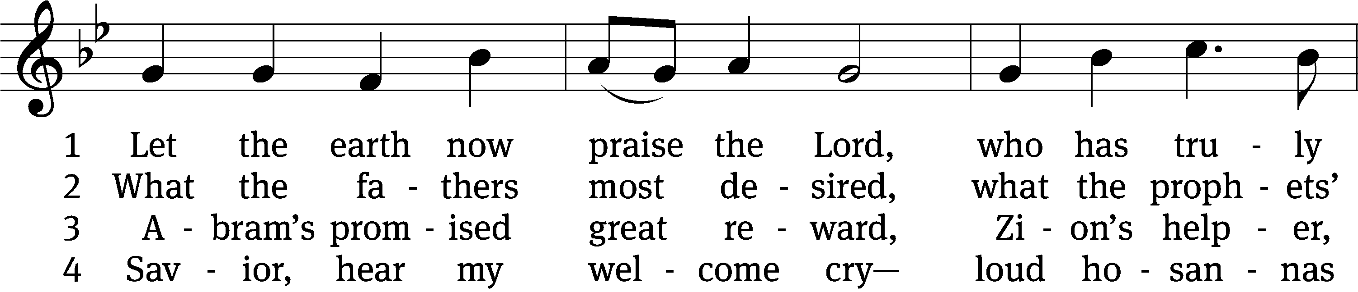
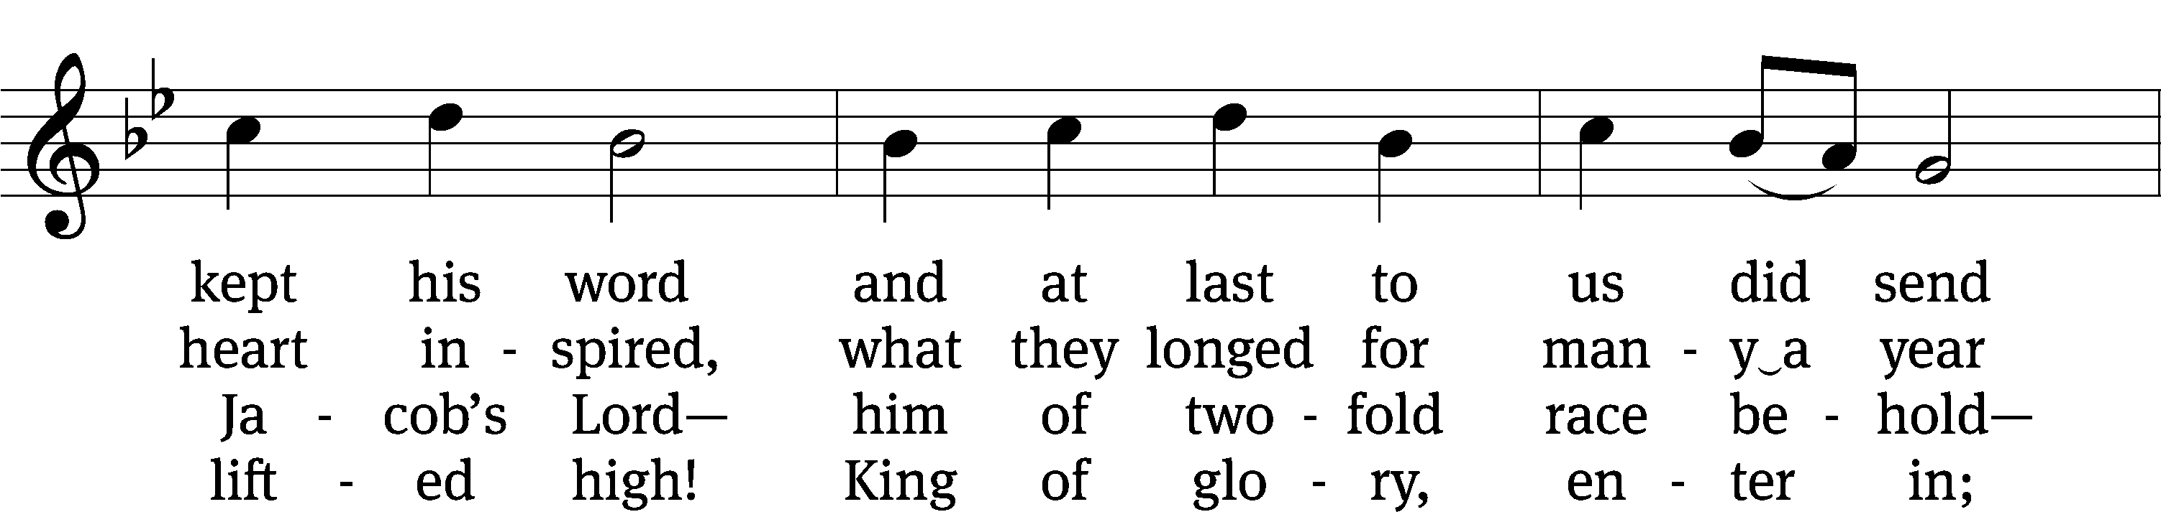
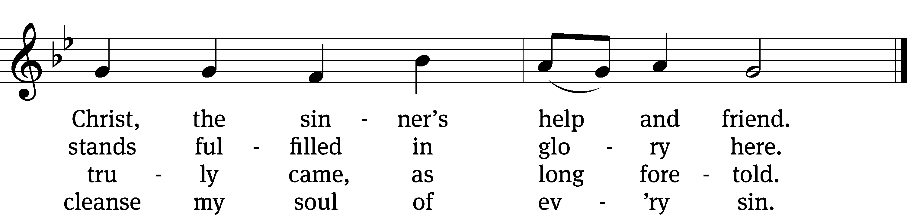

5 Crush for me the serpent’s head
that, set free from doubt and dread,
I may cling to you in faith,
safely kept through life and death,

6 And, when you shall come again
as a glorious king to reign,
I with joy may see your face,
freely ransomed by your grace.
Text: Heinrich Held, 1620–1659, abr.; (sts. 1–3, 5–6): tr. Catherine Winkworth, 1827–1878, alt.; (st. 4): tr. Christian Worship, 2021
Tune: Geystliche gesangk Buchleyn, Wittenberg, 1524, ed. Johann Walter
Text (st. 4): © 2021 Northwestern Publishing House. Used by permission: OneLicense no. 727703
Text (sts. 1–3, 5–6) and tune: Public domain

Please stand, if you are able
Invocation
In the name of the Father and of the Son and of the Holy Spirit.
Amen.
Confession
If we claim to be without sin, we deceive ourselves and the truth is not in us.
If we confess our sins, God is faithful and just
and will forgive us our sins
and purify us from all unrighteousness.

Let us confess our sins to the Lord.
Holy God, gracious Father,
I am sinful by nature
and have sinned against you in my thoughts, words, and actions.
I have not loved you with my whole heart;
I have not loved others as I should.
I deserve your punishment both now and forever.
But Jesus, my Savior, paid for my sins
with his innocent suffering and death.
Trusting in him, I pray: God, have mercy on me, a sinner.

Our gracious Father in heaven has been merciful to us. He sent his only Son, Jesus Christ, who gave his life as the atoning sacrifice for the sins of the whole world. Therefore, as a called servant of Christ and by his authority, I forgive you all your sins in the name of the Father and of the Son and of the Holy Spirit.
Amen.

Lord, Have Mercy

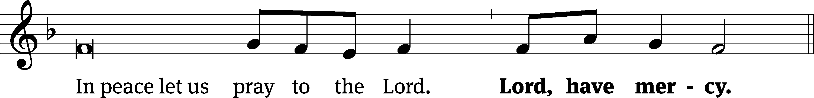
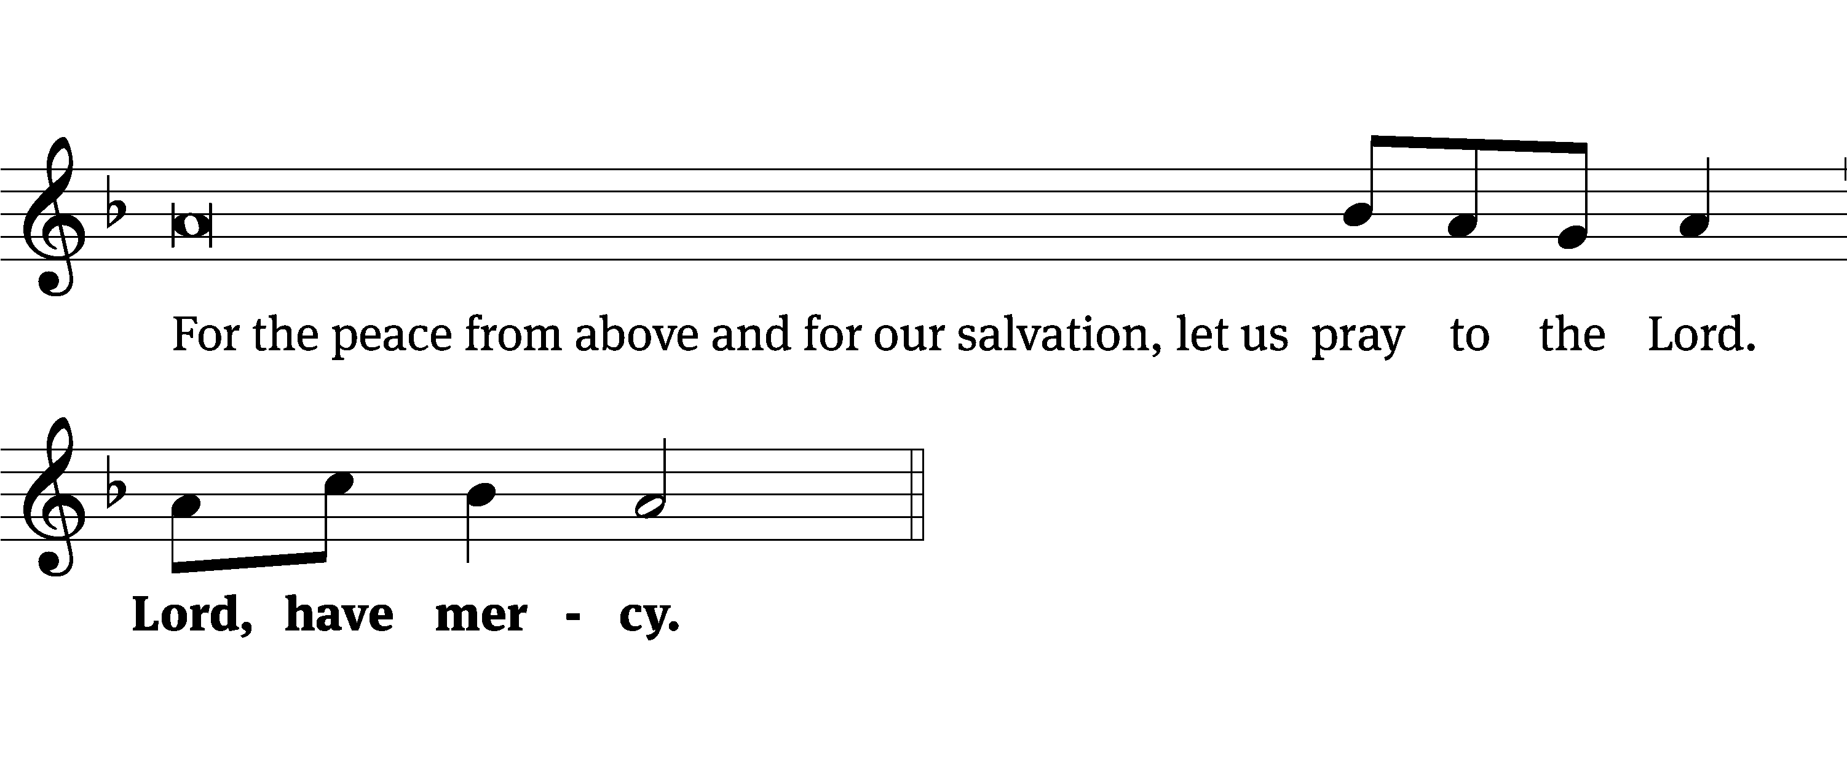
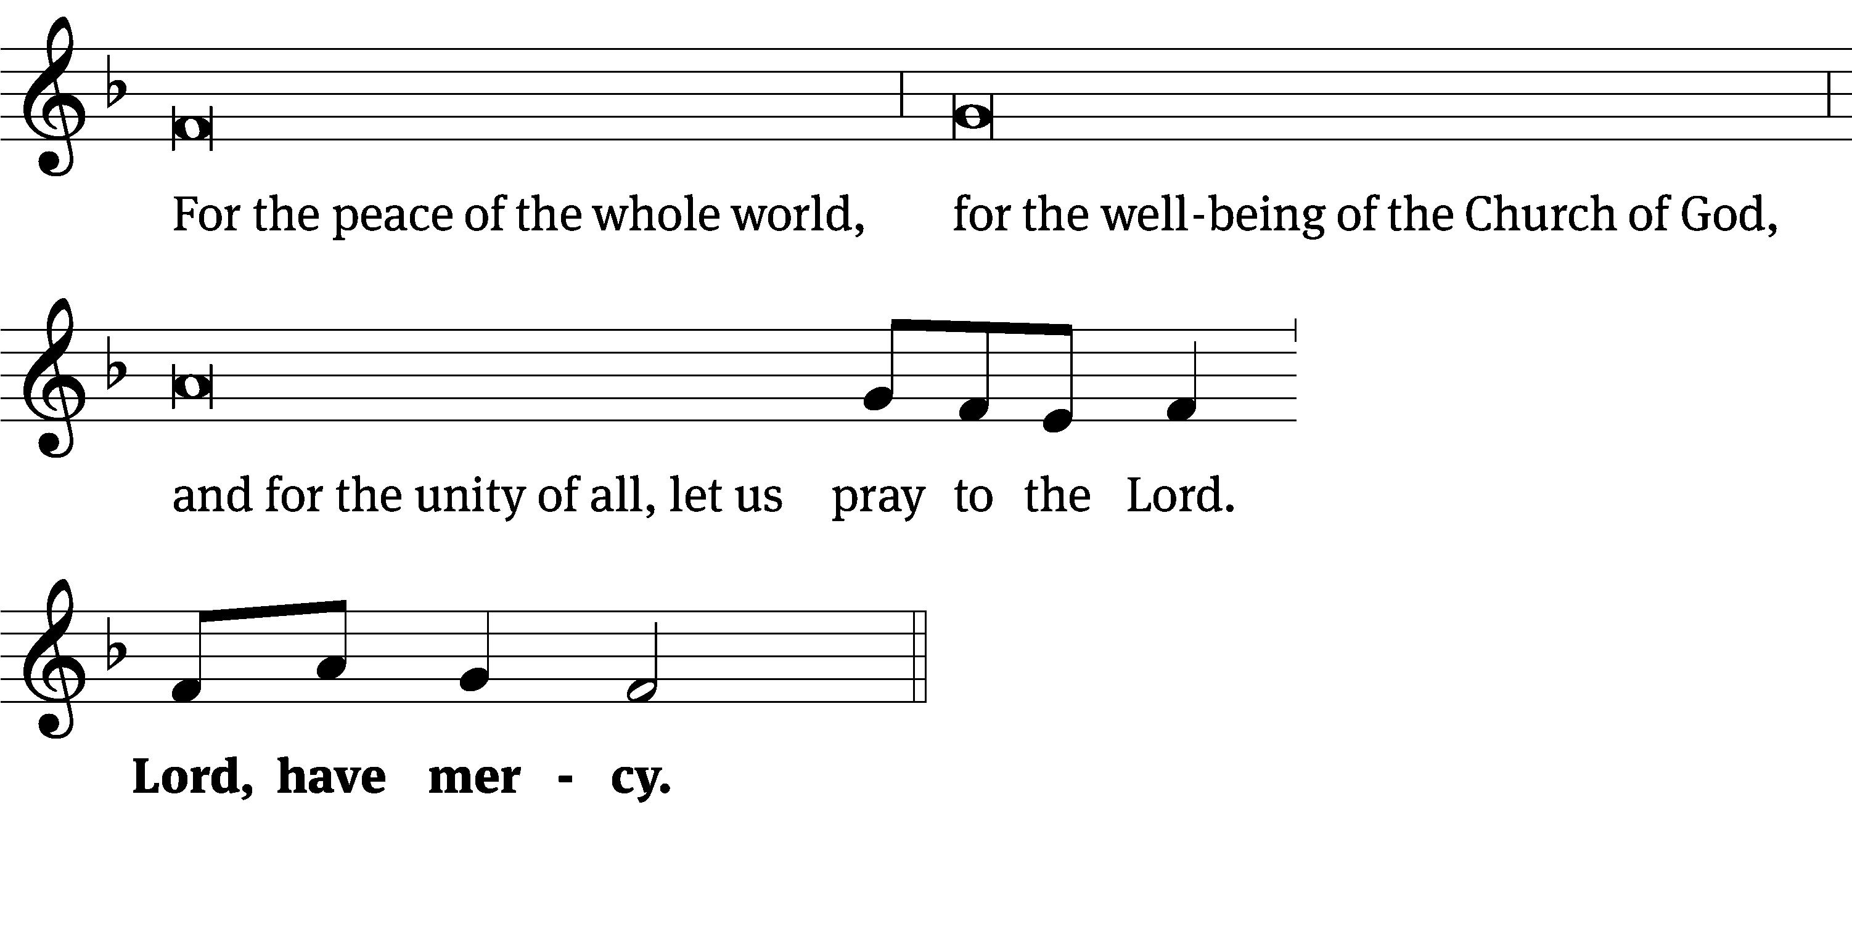
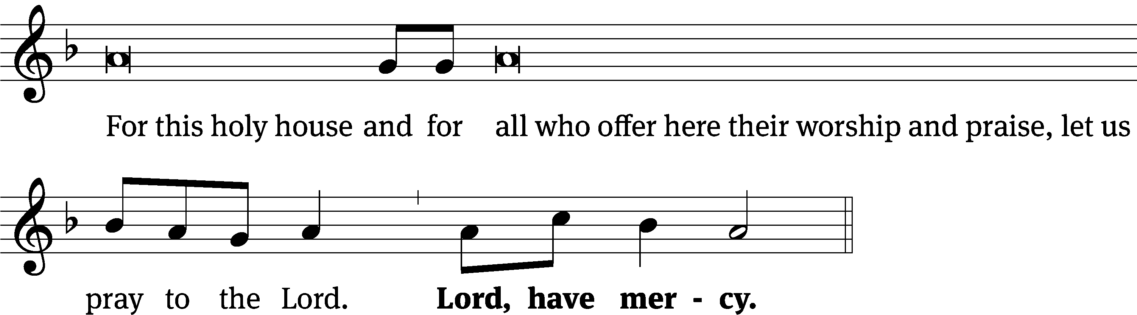
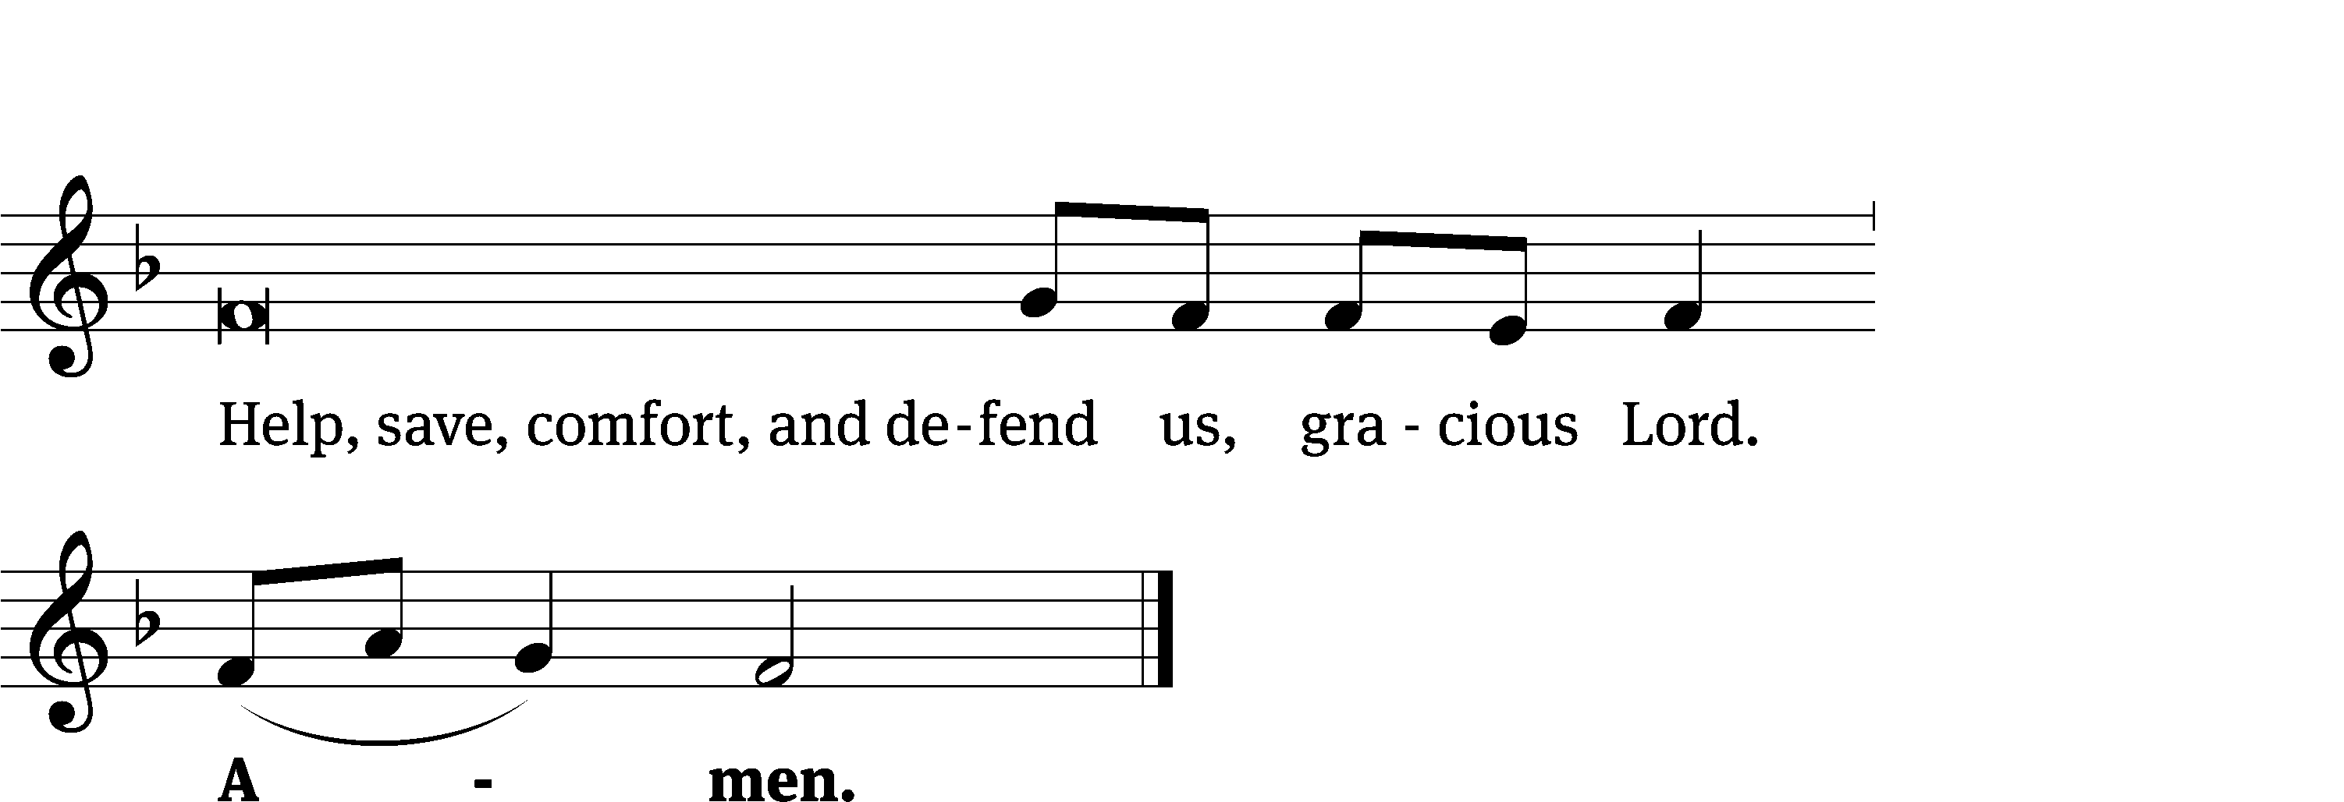
Glory Be to God CW 157
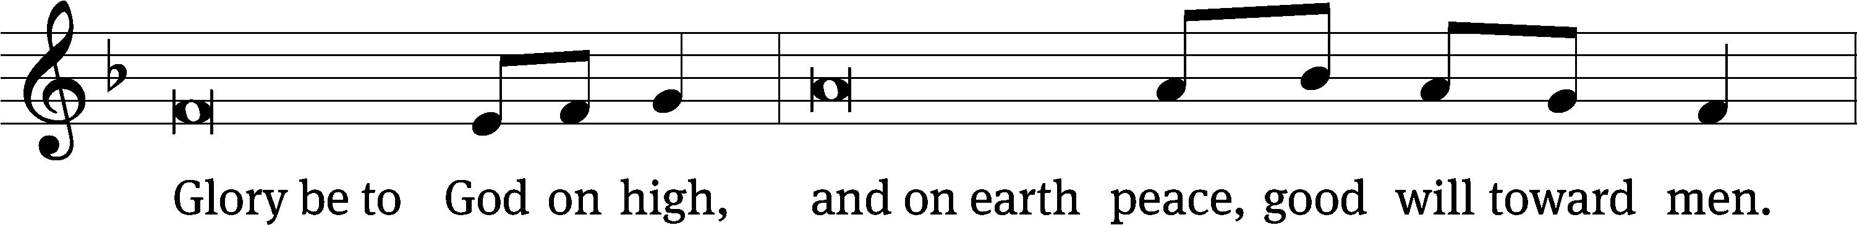
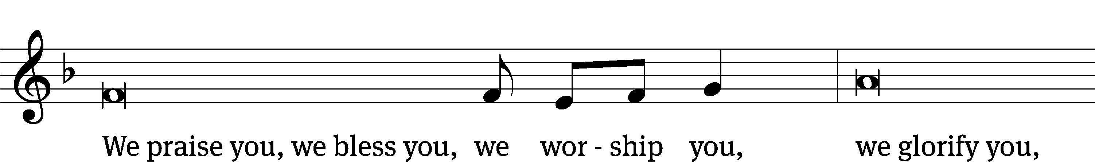
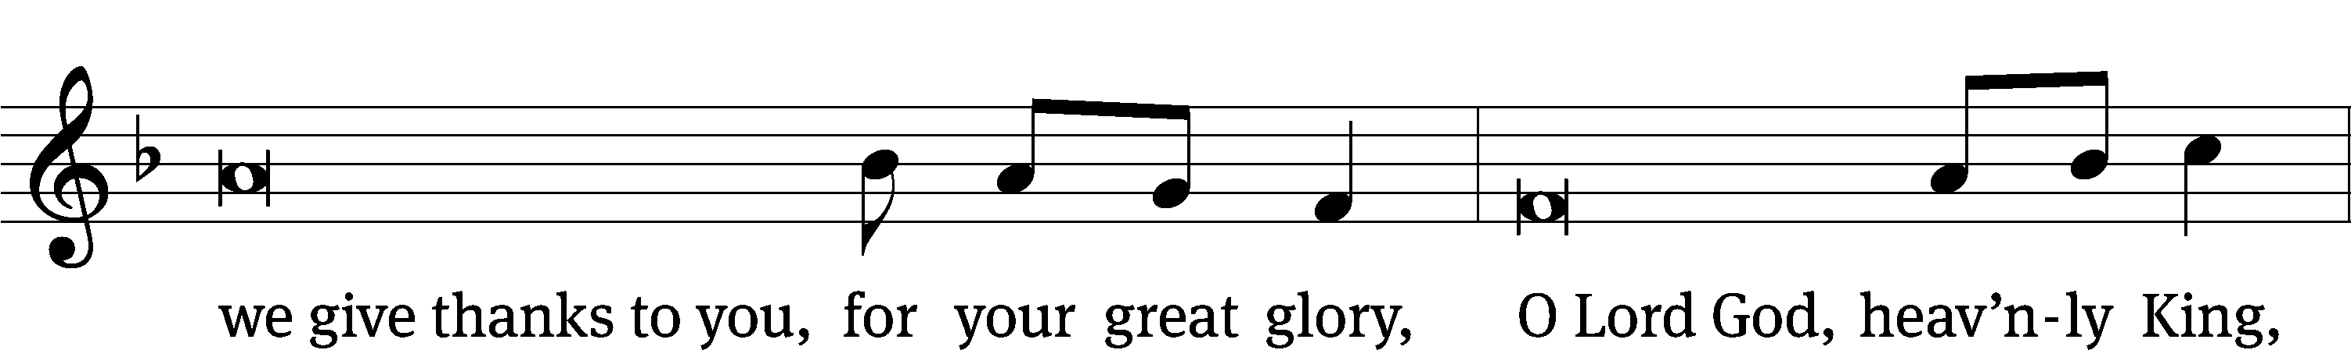
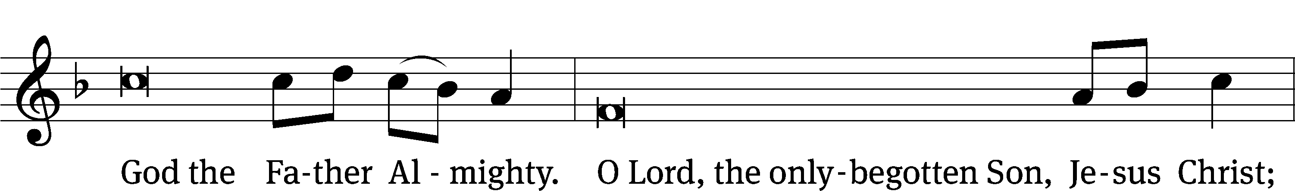
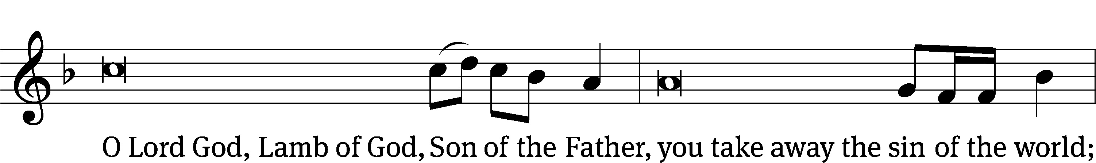
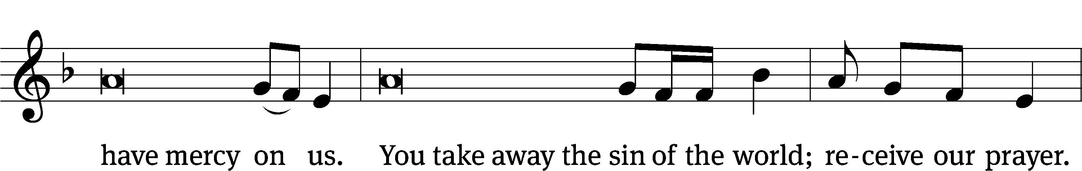
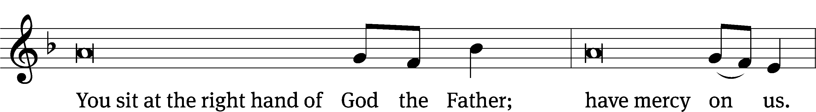
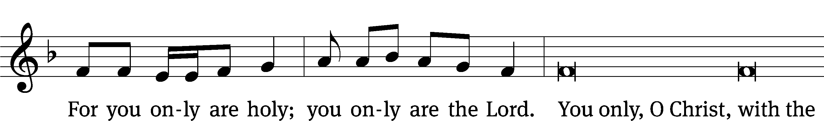
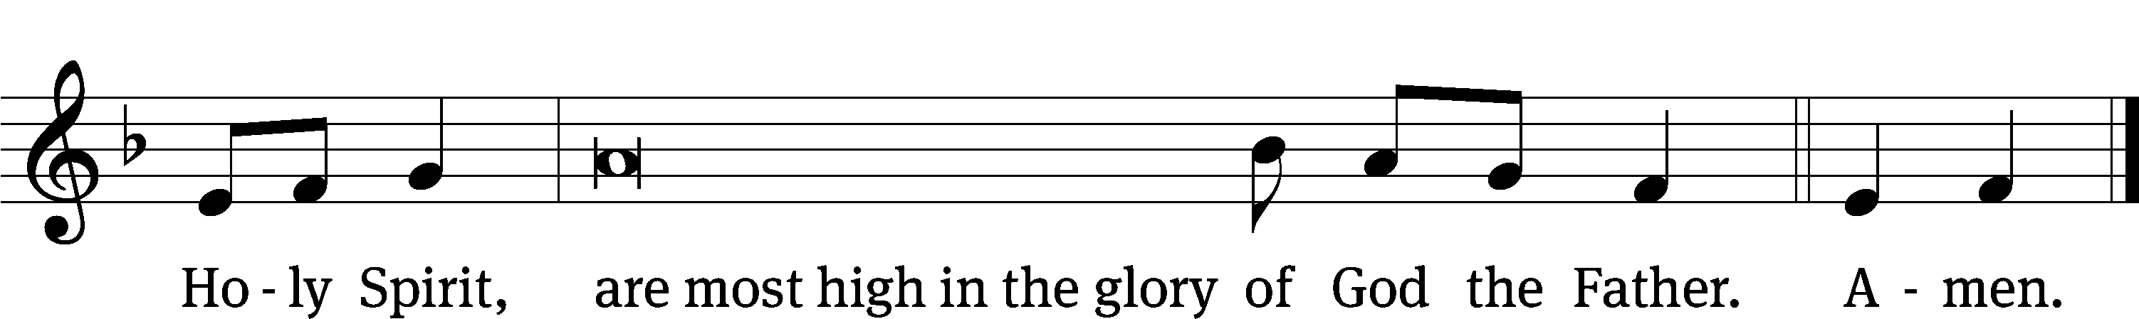

The Lord be with you.
And also with you.
Prayer of the Day
Let us pray.

Stir up our hearts, O Lord, to prepare the way for your only Son. By his coming, give us strength in our conflicts, and shed light on our path through the darkness of this world; through your Son, Jesus Christ our Lord, who lives and reigns with you and the Holy Spirit, one God, now and forever.
Amen.

Please be seated

First Reading Isaiah 11:1-10

¹ A shoot will come up from the stump of Jesse;
from his roots a Branch will bear fruit.
² The Spirit of the Lord will rest on him—
the Spirit of wisdom and of understanding,
the Spirit of counsel and of might,
the Spirit of the knowledge and fear of the Lord—
³ and he will delight in the fear of the Lord.
He will not judge by what he sees with his eyes,
or decide by what he hears with his ears;
⁴ but with righteousness he will judge the needy,
with justice he will give decisions for the poor of the earth.
He will strike the earth with the rod of his mouth;
with the breath of his lips he will slay the wicked.
⁵ Righteousness will be his belt
and faithfulness the sash around his waist.
⁶ The wolf will live with the lamb,
the leopard will lie down with the goat,
the calf and the lion and the yearling^{[a]} together;
and a little child will lead them.
⁷ The cow will feed with the bear,
their young will lie down together,
and the lion will eat straw like the ox.
⁸ The infant will play near the cobra’s den,
and the young child will put its hand into the viper’s nest.
⁹ They will neither harm nor destroy
on all my holy mountain,
for the earth will be filled with the knowledge of the Lord
as the waters cover the sea.
¹⁰ In that day the Root of Jesse will stand as a banner for the peoples; the nations will rally to him, and his resting place will be glorious.
The Word of the Lord.
Thanks be to God.
Psalm of the Day Psalm 130B
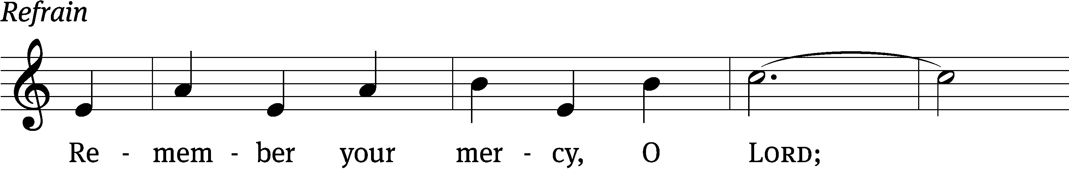

Out of the depths I cry to / you, Lord;
Lord, / hear my voice.
Let your ears be at- / tentive
to my cry for / mercy.
If you, Lord, kept a record of sins, Lord, / who could stand?
But with you there is forgiveness, so that we can, with reverence, / serve you. Refrain

I wait for the Lord, my whole / being waits,
and in his word I / put my hope.
I wait for the Lord more than watchmen wait for the / morning,
more than watchmen wait for the / morning.
Israel, put your hope / in the Lord,
for with the Lord is unfailing love and with him is full re- / demption.
He himself will redeem / Israel
from / all their sins.
Glory be to the Father and / to the Son
and to the Holy / Spirit,
as it was in the be- / ginning,
is now, and will be forever. / Amen. Refrain
Tune: Michael Joncas
Tune: © 1986 GIA Publications, Inc. Used by permission: OneLicense no. 727703
Setting: © 1993 Kermit G. Moldenhauer, admin. Northwestern Publishing House. Used by permission: OneLicense no. 727703

Second Reading Romans 15:4-13
⁴ For everything that was written in the past was written to teach us, so that through the endurance taught in the Scriptures and the encouragement they provide we might have hope.
⁵ May the God who gives endurance and encouragement give you the same attitude of mind toward each other that Christ Jesus had, ⁶ so that with one mind and one voice you may glorify the God and Father of our Lord Jesus Christ.
⁷ Accept one another, then, just as Christ accepted you, in order to bring praise to God. ⁸ For I tell you that Christ has become a servant of the Jews^{[a]} on behalf of God’s truth, so that the promises made to the patriarchs might be confirmed ⁹ and, moreover, that the Gentiles might glorify God for his mercy. As it is written:
“Therefore I will praise you among the Gentiles;
I will sing the praises of your name.”^{[b]}
¹⁰ Again, it says,
“Rejoice, you Gentiles, with his people.”^{[c]}
¹¹ And again,
“Praise the Lord, all you Gentiles;
let all the peoples extol him.”^{[d]}
¹² And again, Isaiah says,
“The Root of Jesse will spring up,
one who will arise to rule over the nations;
in him the Gentiles will hope.”^{[e]}
¹³ May the God of hope fill you with all joy and peace as you trust in him, so that you may overflow with hope by the power of the Holy Spirit.

The Word of the Lord.
Thanks be to God.

Please stand, if you are able

Gospel Acclamation Luke 3:4,6
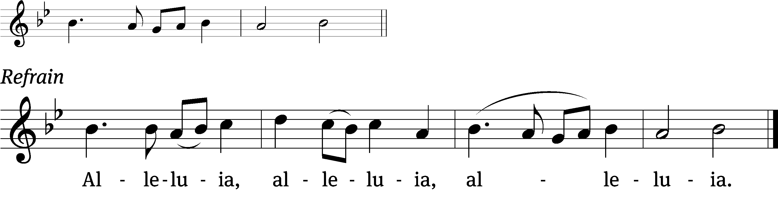
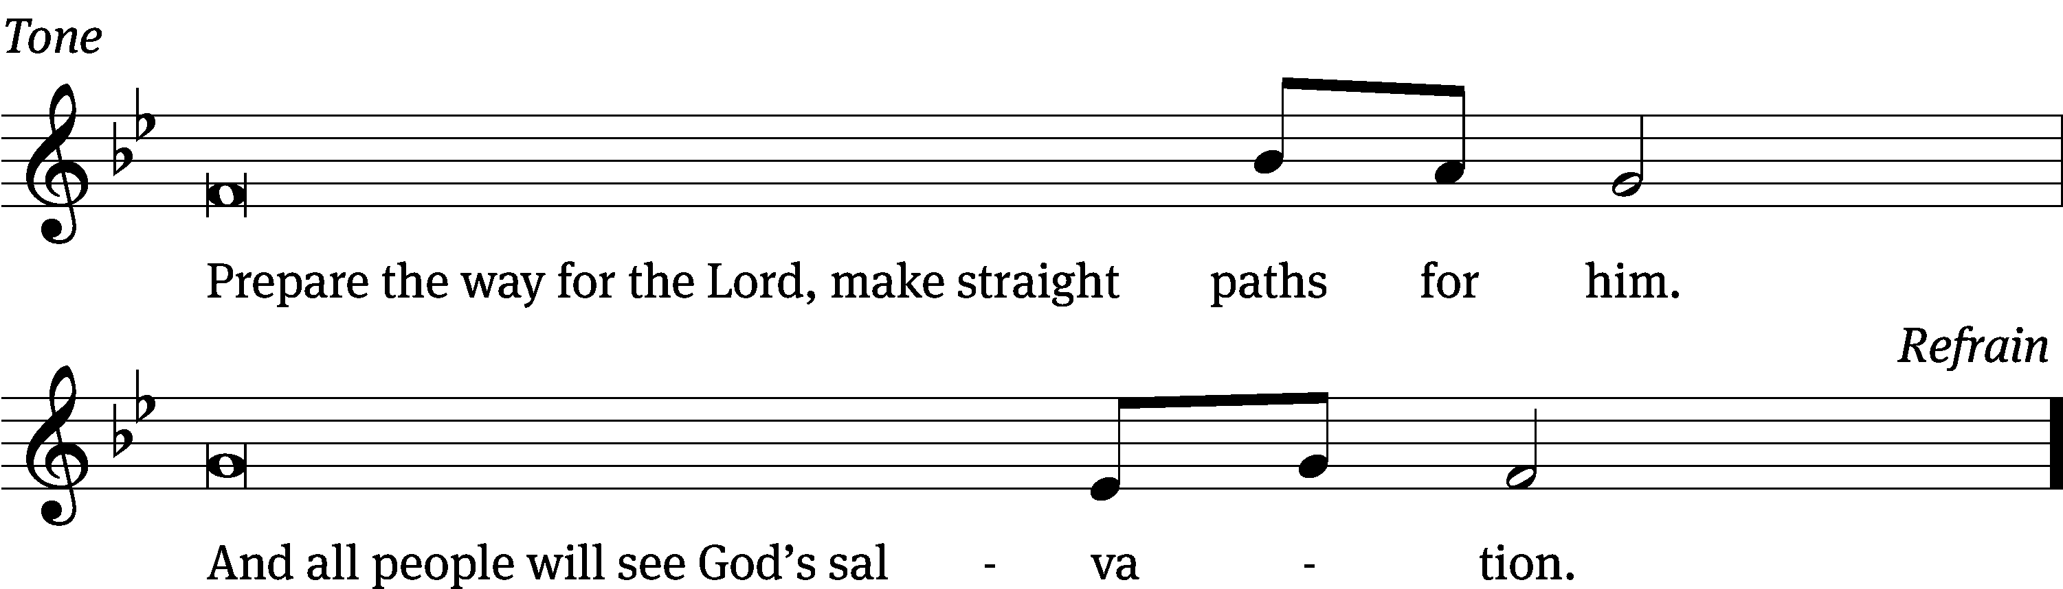
Tune: © 2021 Northwestern Publishing House. Used by permission: OneLicense no. 727703

Gospel Matthew 3:1-12
¹ In those days John the Baptist came, preaching in the wilderness of Judea ² and saying, “Repent, for the kingdom of heaven has come near.” ³ This is he who was spoken of through the prophet Isaiah:
“A voice of one calling in the wilderness,
‘Prepare the way for the Lord,
make straight paths for him.’”
⁴ John’s clothes were made of camel’s hair, and he had a leather belt around his waist. His food was locusts and wild honey. ⁵ People went out to him from Jerusalem and all Judea and the whole region of the Jordan. ⁶ Confessing their sins, they were baptized by him in the Jordan River.
⁷ But when he saw many of the Pharisees and Sadducees coming to where he was baptizing, he said to them: “You brood of vipers! Who warned you to flee from the coming wrath? ⁸ Produce fruit in keeping with repentance. ⁹ And do not think you can say to yourselves, ‘We have Abraham as our father.’ I tell you that out of these stones God can raise up children for Abraham. ¹⁰ The ax is already at the root of the trees, and every tree that does not produce good fruit will be cut down and thrown into the fire.
¹¹ “I baptize you with water for repentance. But after me comes one who is more powerful than I, whose sandals I am not worthy to carry. He will baptize you with the Holy Spirit and fire. ¹² His winnowing fork is in his hand, and he will clear his threshing floor, gathering his wheat into the barn and burning up the chaff with unquenchable fire.”

The Gospel of the Lord.
Praise be to you, O Christ!

Please be seated

360 Behold, a Branch Is Growing CW 360
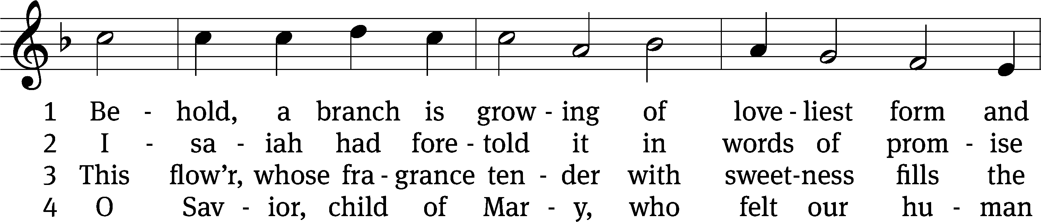
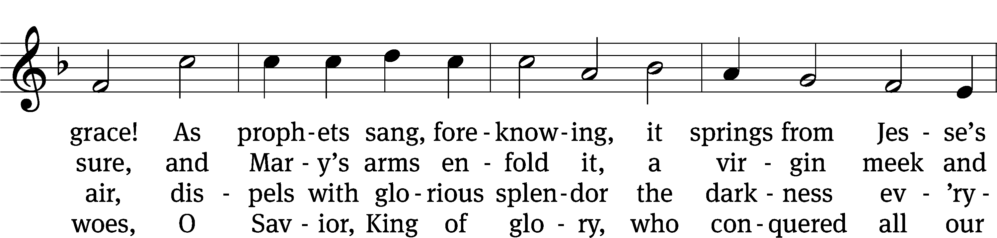
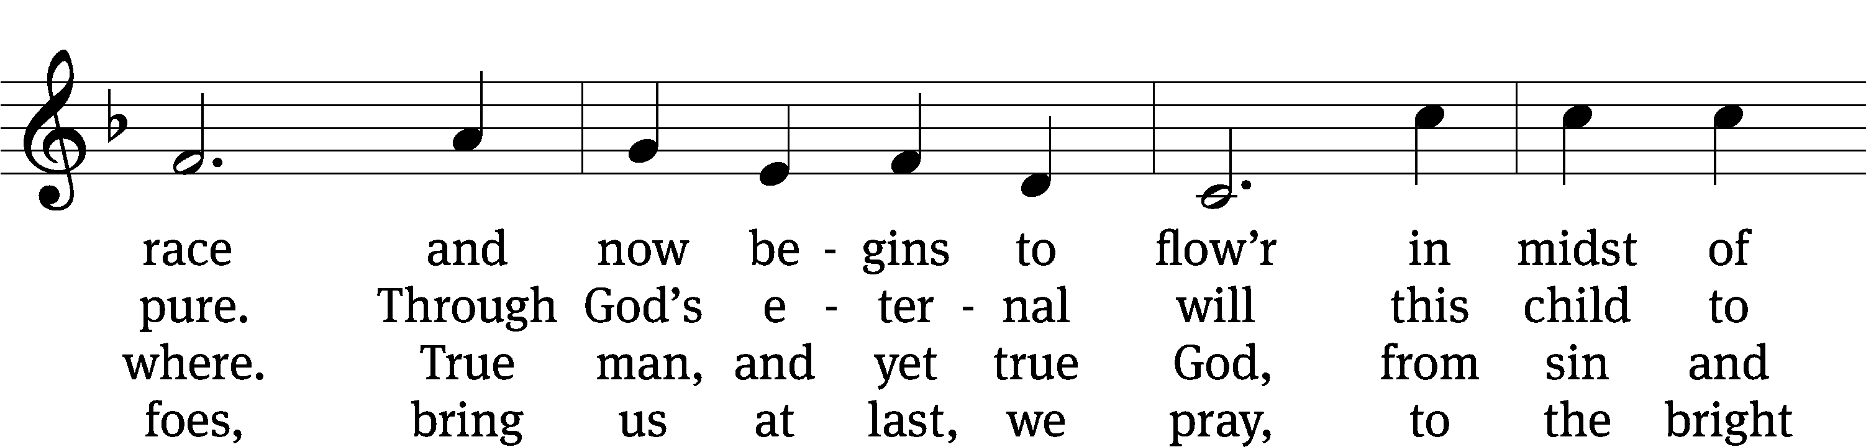
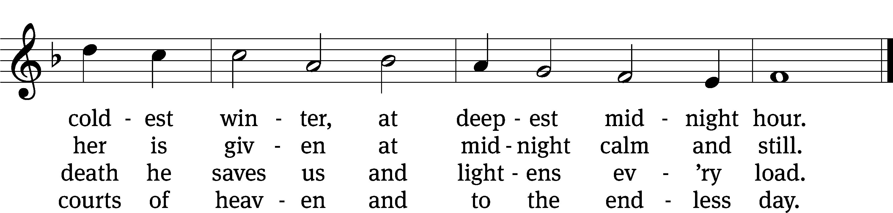
Text: German, 16th cent.; (sts. 1–3): tr. Harriet R. K. Spaeth, 1845–1925; (st. 4): John C. Mattes, 1876–1948, alt.
Tune: Alte Catholische Geistliche Kirchengeseng, Köln, 1599
Text and tune: Public domain

SERMON Isaiah 11:1-10
“The Stump of Jesse”

Please stand, if you are able

Nicene Creed
We believe in one God, the Father, the Almighty,
maker of heaven and earth,
of all that is,
seen and unseen.
We believe in one Lord, Jesus Christ, the only Son of God,
eternally begotten of the Father,
God from God, Light from Light, true God from true God,
begotten, not made,
of one being with the Father.
Through him all things were made.
For us and for our salvation, he came down from heaven,
was incarnate of the Holy Spirit and the Virgin Mary,
and became truly human.
For our sake he was crucified under Pontius Pilate.
He suffered death and was buried.
On the third day he rose again in accordance with the Scriptures.
He ascended into heaven
and is seated at the right hand of the Father.
He will come again in glory to judge the living and the dead,
and his kingdom will have no end.
We believe in the Holy Spirit,
the Lord, the giver of life,
who proceeds from the Father and the Son,
who in unity with the Father and the Son
is worshiped and glorified,
who has spoken through the prophets.
We believe in one holy Christian and apostolic Church.
We acknowledge one baptism for the forgiveness of sins.
We look for the resurrection of the dead
and the life of the world to come. Amen.

Offertory (Duet) “Nun komm, der Heiden Heiland”
Prayer of the Church

The Sacrament
Preface CW 165
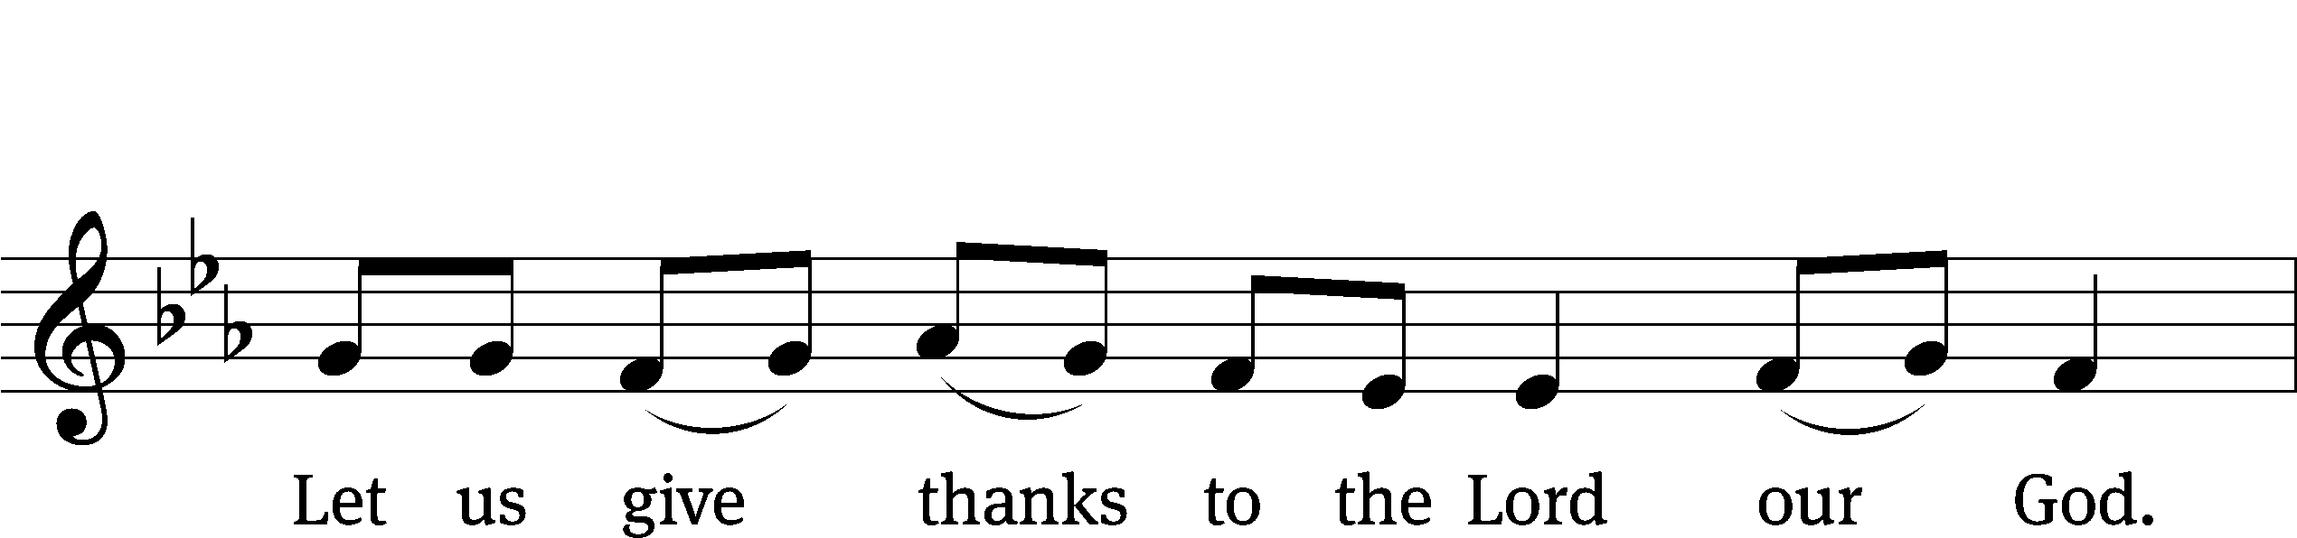

It is truly good and right that we should at all times and in all places give you thanks, O Lord, holy Father, almighty and everlasting God, through Jesus Christ our Lord, who promised that wherever two or three come together in his name, there he is with them to shepherd his flock until he comes again in glory. Therefore, with all the saints on earth and hosts of heaven, we praise your holy name and join their glorious song:
Holy, Holy, Holy CW 167
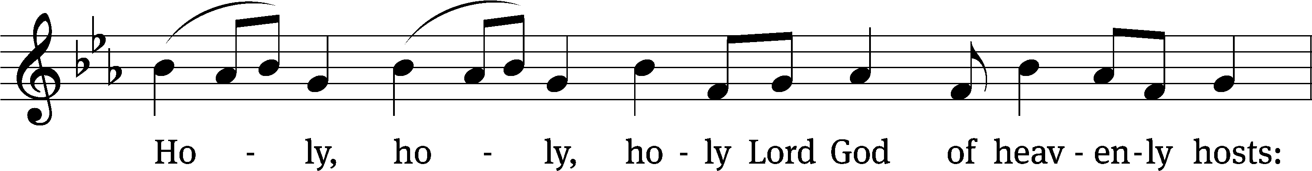
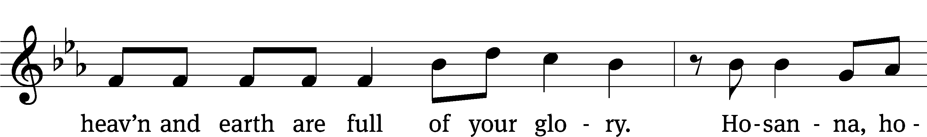
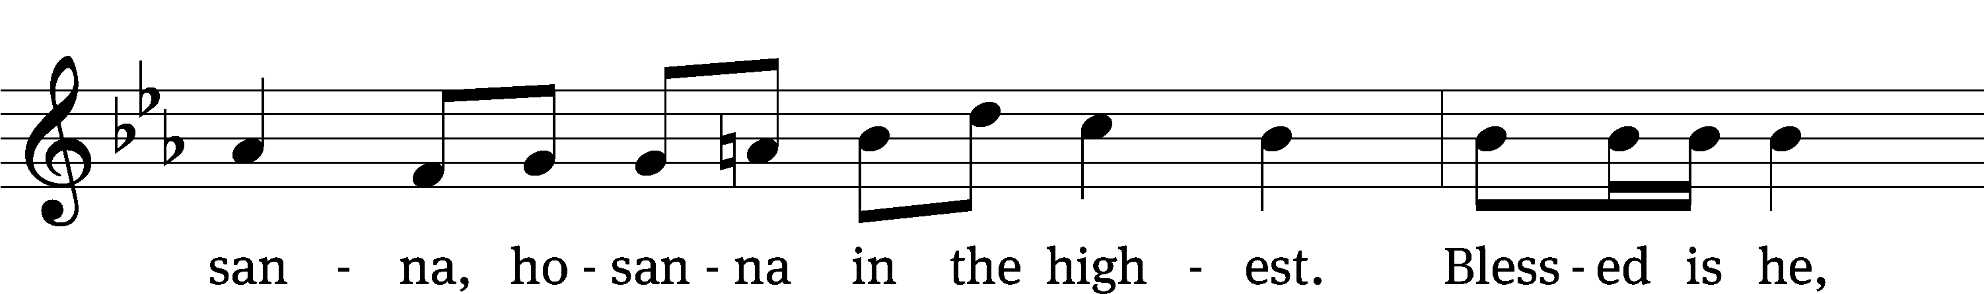
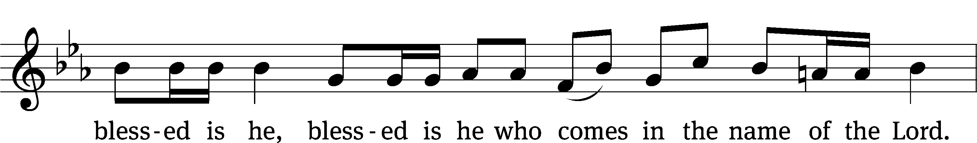
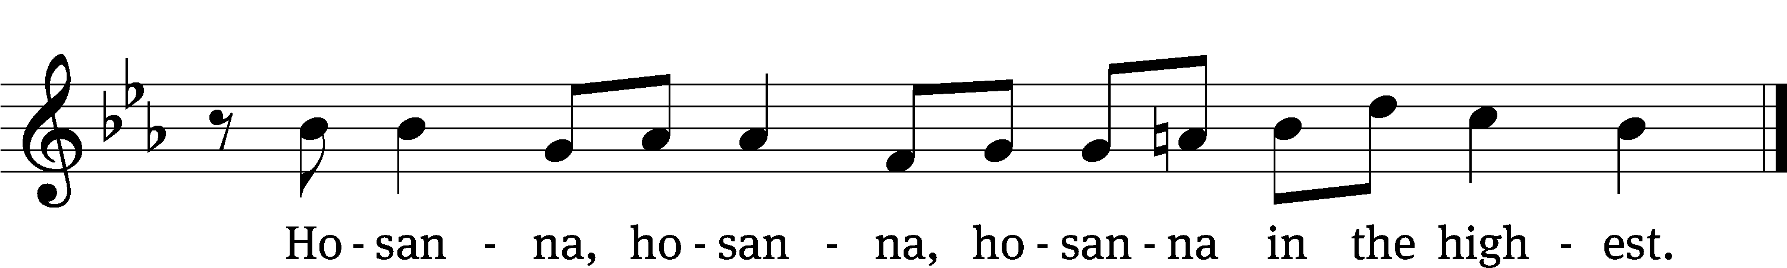

Prayer of Thanksgiving
We give thanks to you, O God, through your dear Son, Jesus Christ, whom you sent to be our Savior, our Redeemer, and the messenger of your grace. Through him you made all things; in him you are well pleased. He is the incarnate Word, conceived by the Holy Spirit and born of the Virgin Mary. To fulfill your promises, he stretched out his hands on the cross and released from eternal death all who believe in you.

As we remember Jesus’ death and resurrection, we thank you that you have gathered us together to receive your Son’s body and blood. Send us your Spirit, unite us as one, and strengthen our faith so that we may praise you in your Son, Jesus Christ. Through him, we glorify and honor you, O God our Father, with the Holy Spirit, one God, now and forever.
Amen.

Lord’s Prayer
Our Father, who art in heaven, hallowed be thy name, thy kingdom come, thy will be done on earth as it is in heaven. Give us this day our daily bread; and forgive us our trespasses, as we forgive those who trespass against us; and lead us not into temptation, but deliver us from evil. For thine is the kingdom and the power and the glory forever and ever. Amen.

Words of Institution
Our Lord Jesus Christ, on the night he was betrayed, took bread; and when he had given thanks, he broke it and gave it to his disciples, saying, “Take and eat; this is my body, which is given for you. Do this in remembrance of me.”
Then he took the cup, gave thanks, and gave it to them, saying, “Drink from it, all of you; this is my blood of the new covenant, which is poured out for you for the forgiveness of sins. Do this, whenever you drink it, in remembrance of me.”

The peace of the Lord be with you always.
Amen.
O Christ, Lamb of God CW 169
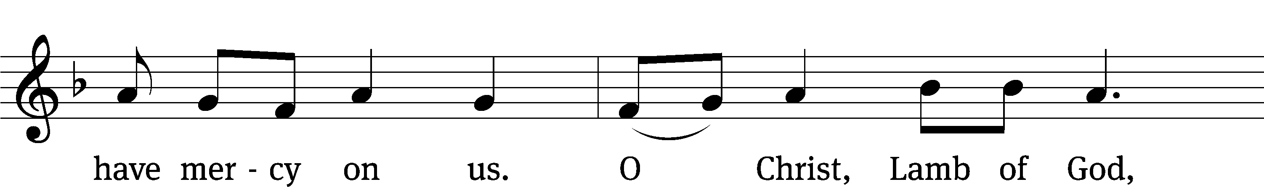
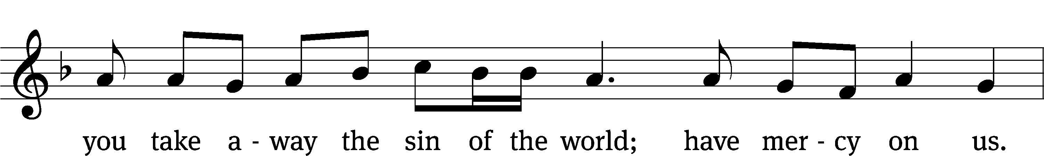
Please be seated
321 God’s Own Son Most Holy CW 321
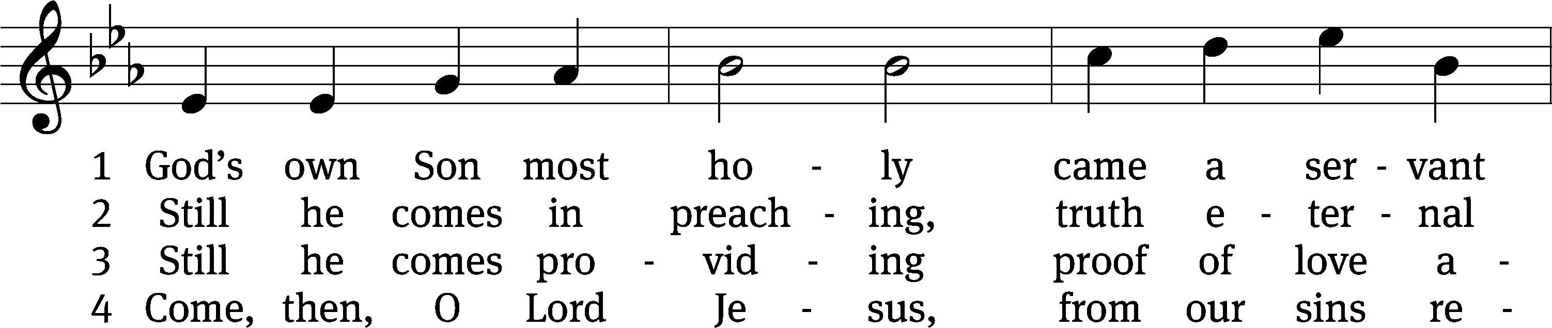
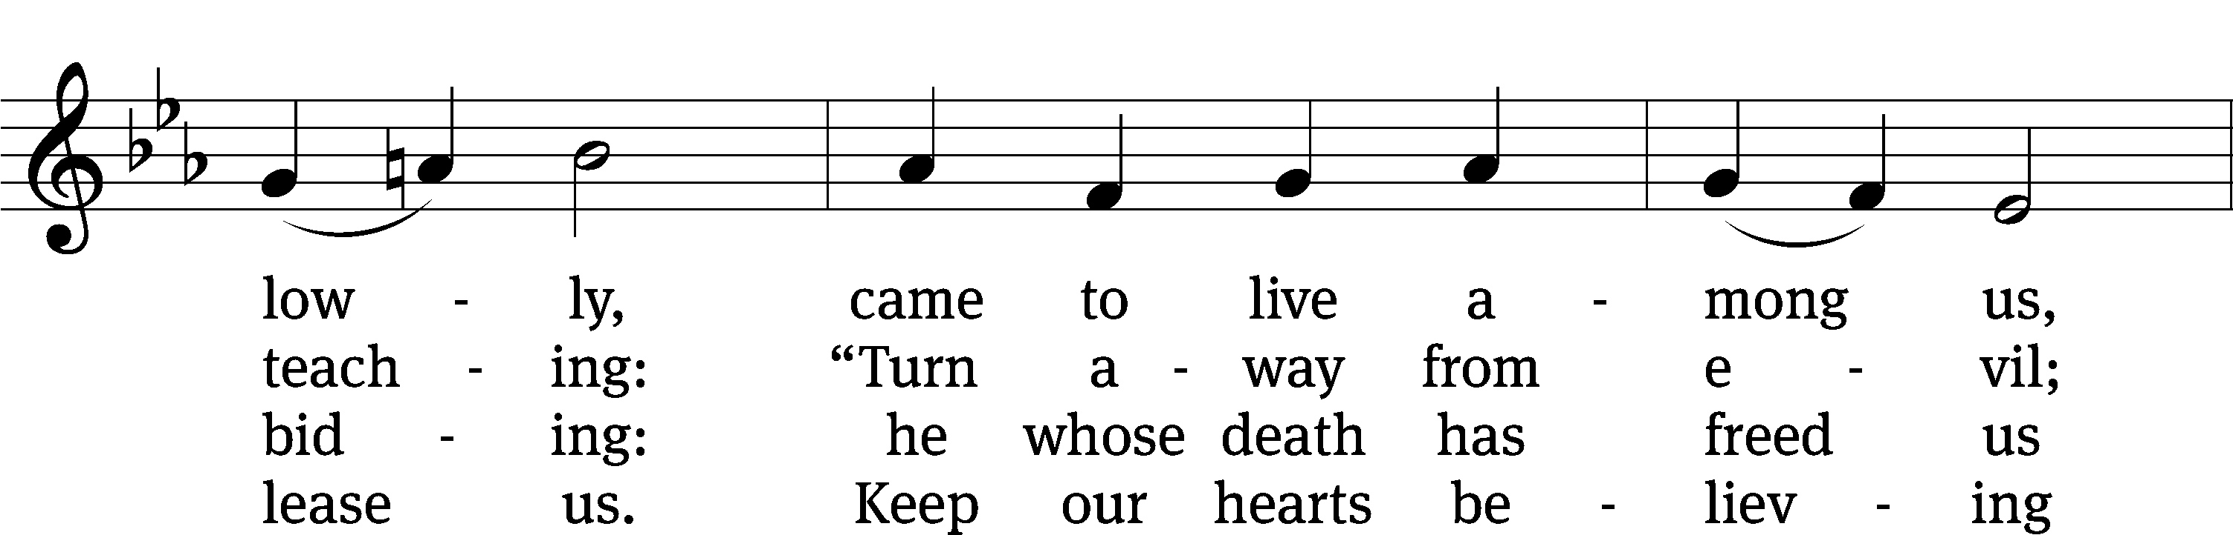
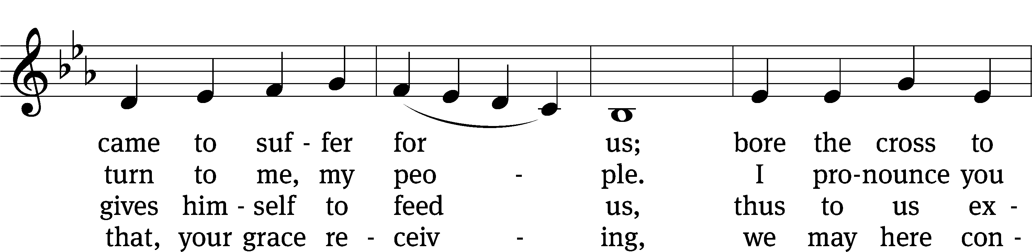
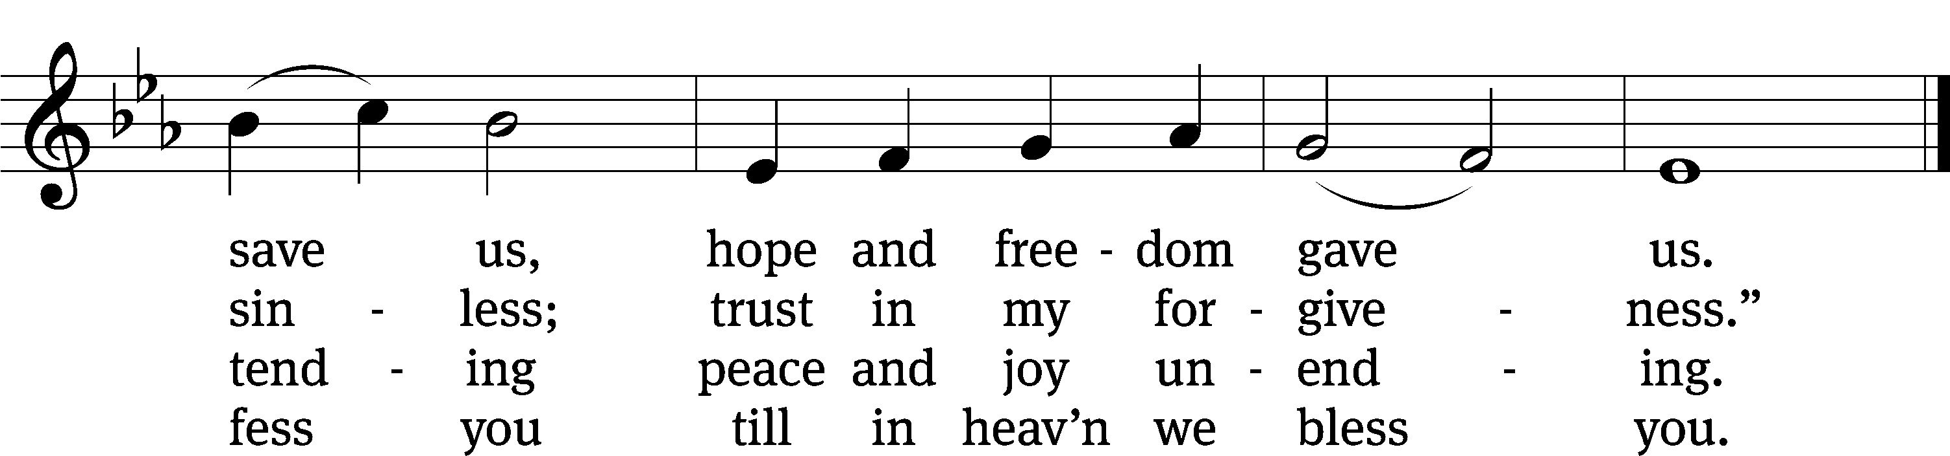
Text: Johann Horn, c. 1490–1547, abr.; (sts. 1, 4): tr. Catherine Winkworth, 1827–1878, alt.; (sts. 2–3): tr. Michael D. Schultz, b. 1963
Tune: attr. Michael Weisse, c. 1480–1534
Text (sts. 2–3): © 2021 Northwestern Publishing House. Used by permission: OneLicense no. 727703
Text (sts. 1, 4) and tune: Public domain

319 Jesus Came, the Heavens Adoring CW 319
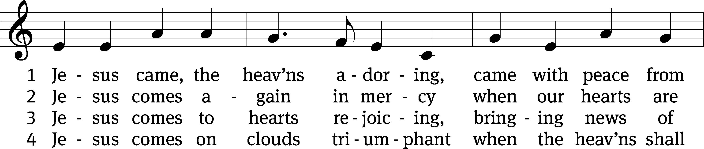
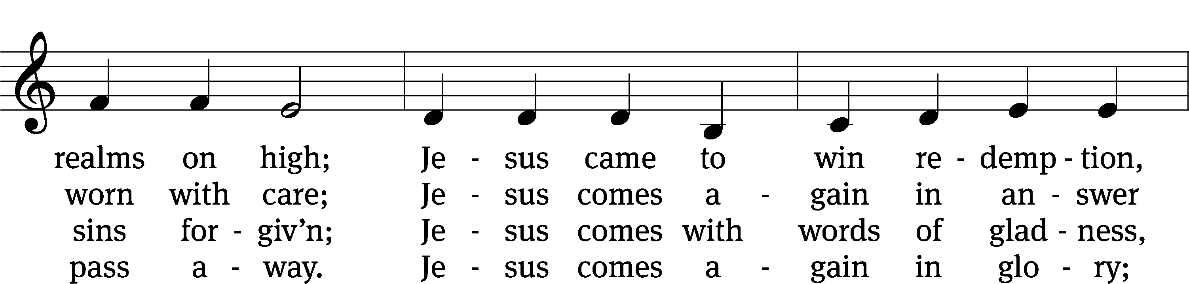
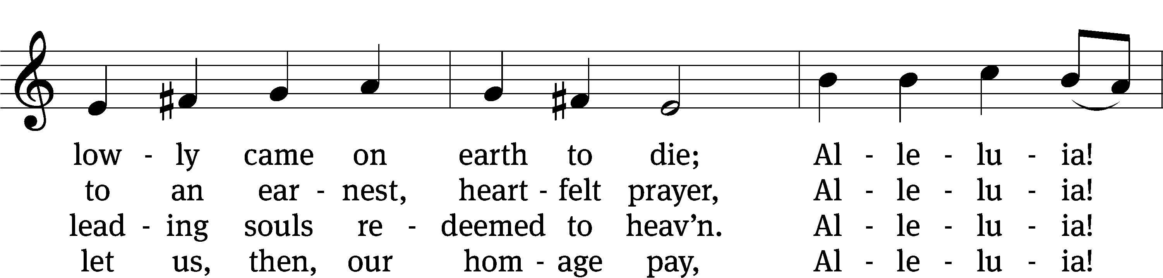
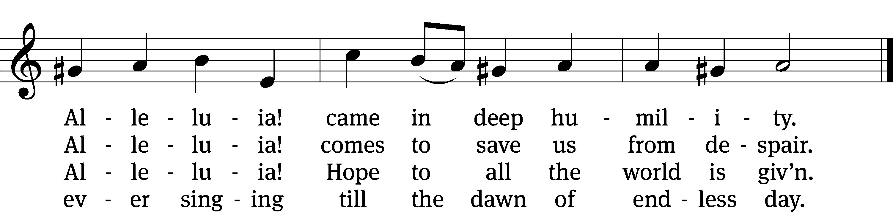
Text: Godfrey Thring, 1823–1903, abr., alt.
Tune: Geistreiches Gesang-Buch, Darmstadt, 1698
Text and tune: Public domain

Please stand, if you are able

Give thanks to the Lord, for he is good;
his mercy endures forever.

Whenever we eat this bread and drink this cup,
we proclaim the Lord’s death until he comes.

We give thanks, almighty God, that you have refreshed us with this saving gift. We pray that through it you will strengthen our faith in you and increase our love for one another. We ask this in the name of Jesus Christ our Lord, who lives and reigns with you and the Holy Spirit, one God, now and forever.
Amen.

Blessing
The Lord bless you and keep you.
The Lord make his face shine on you and be gracious to you.
The Lord look on you with favor and give you peace.
Amen.

318 Hark! A Thrilling Voice Is Sounding CW 318
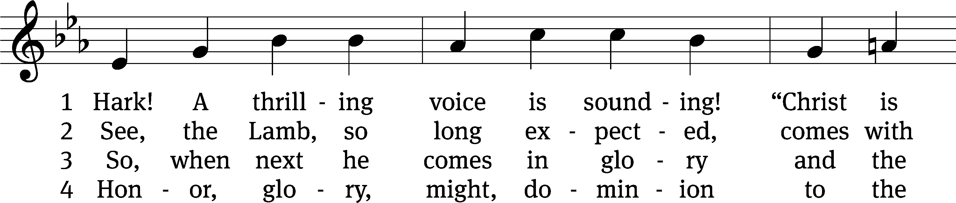
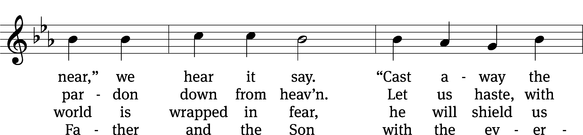
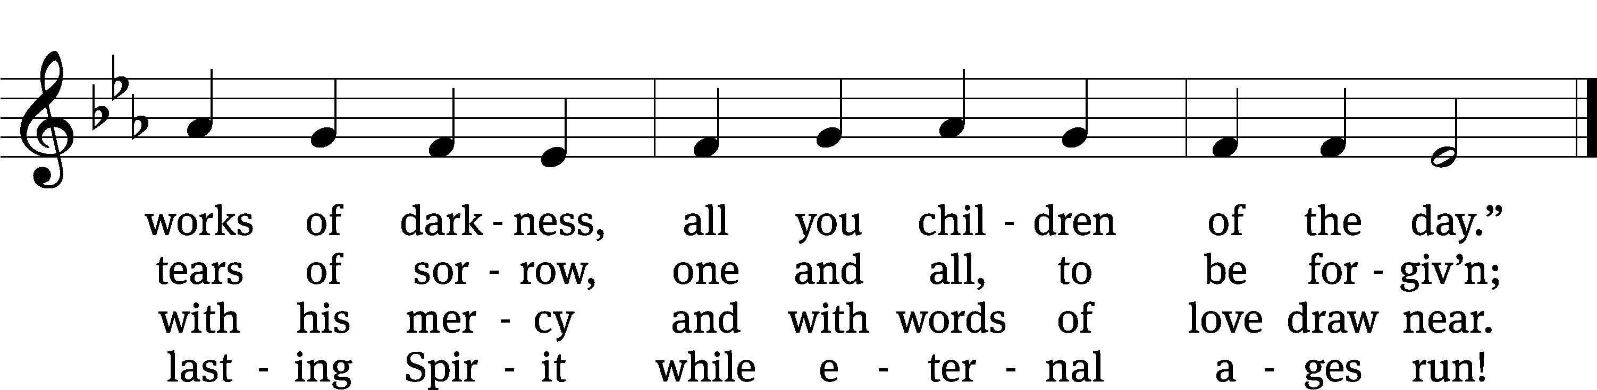
Text: tr. Edward Caswall, 1814–1878, alt.; Latin, c. 5th–10th cent.
Tune: William H. Monk, 1823–1889
Text and tune: Public domain
Acknowledgments
Setting One from Christian Worship
Software distributed in partnership with Northwestern Publishing House.
Created by Christian Worship: Service Builder © 2022 Concordia Publishing House.
Serving in Worship
Officiant Pastor Natsis
Organist Marcia Marion Ackling
Instrumental Duet Marcia Marion Ackling and Malory Marion
Deacons (8:30) Dave Frey and Jim Tice
(11:00) Jeff Neuburger and Ed Wheeler
Ushers (8:30) Robert Newman and Henry Schneider
(11:00) Bill Barnett and Jake Vershum
Altar Guild Sharon Boswell and Connie Marion
Videographer Ann Latowski

