the second sunday
aFTER EPIPHANY
TRINITY EVANGELICAL LUTHERAN CHURCH | Saline, Michigan
WELCOME TO WORSHIP January 15, 2023

Thank you for joining us in God’s house today! We cordially ask that our guests sign one of the guestbooks located at either the front or back entryways.

THANK OFFERING: Members of Trinity give their offering as an expression of love and thankfulness to the Lord and to help support the Lord’s work in our community and around the world. Visitors need not feel obligated to participate in this offering which supports our ministry.

Restrooms are located at the back of the upper level (the annex), and in the basement (down the back stairs of the sanctuary or annex). Handicap access is available, please ask an usher for assistance.

celebration of holy communion:
In His Word, God makes it clear that the Lord’s Supper is to be shared by people of a common proclamation of faith (1 Corinthians 11:26; 1 Corinthians 10:16-17). Without judging anyone’s hearts, we invite those who share in our confession by their membership in our congregation or another congregation of the Wisconsin Evangelical Lutheran Synod (WELS) or the Evangelical Lutheran Synod (ELS) and who are properly prepared (1 Corinthians 11;27-29) to receive the Sacrament. Page 295 in the front of Christian Worship provides a guide for preparation.

Guests, we would love to have you join us in communion fellowship in the future, and for that to be possible, we ask that you speak with one of the pastors so that we may speak with you on how that would be possible. We thank you for respecting the way we celebrate the Lord’s Supper in our congregations.

SERVICE OF WORD AND SACRAMENT

Instrumental Duet - “Angels from the Realms of Glory” (11:00 a.m.)
347 Angels from the Realms of Glory CW 347
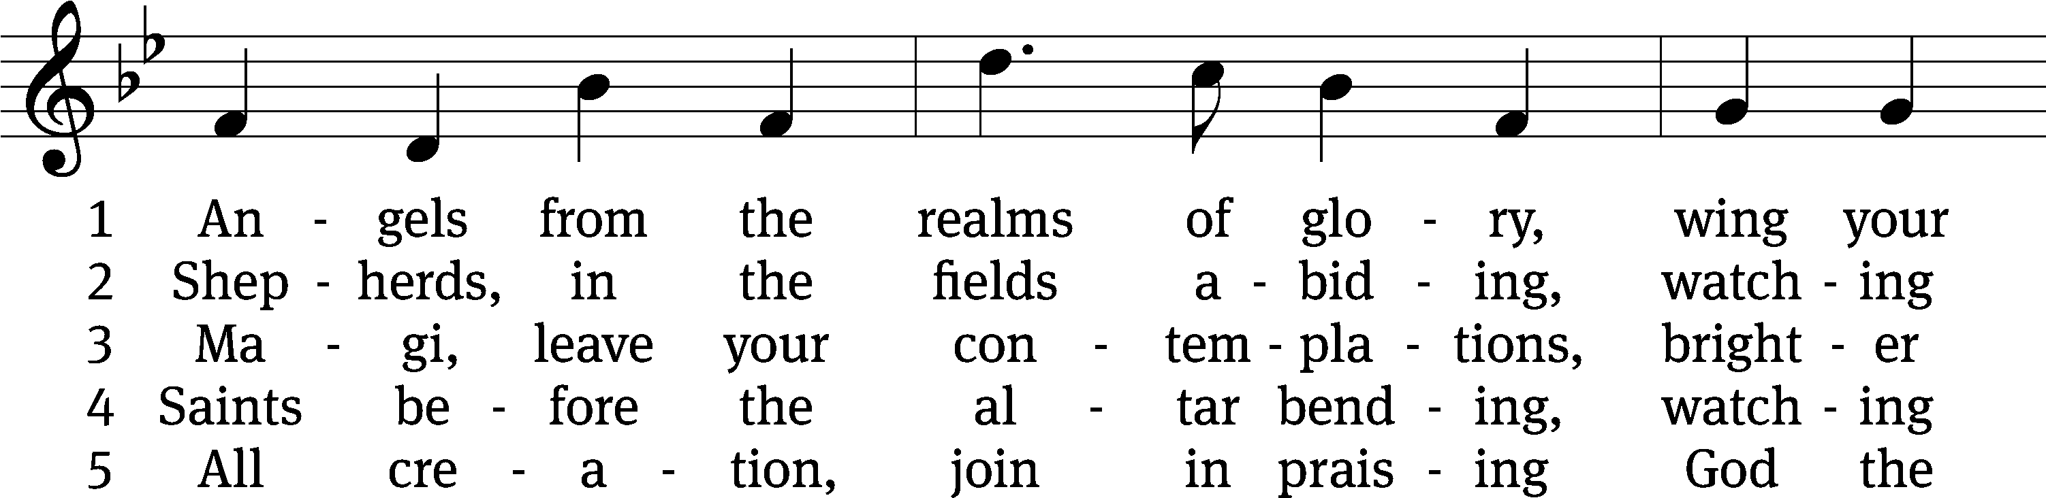
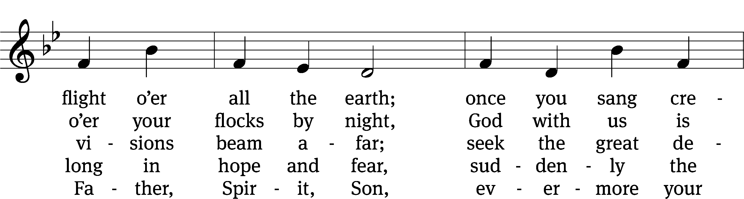
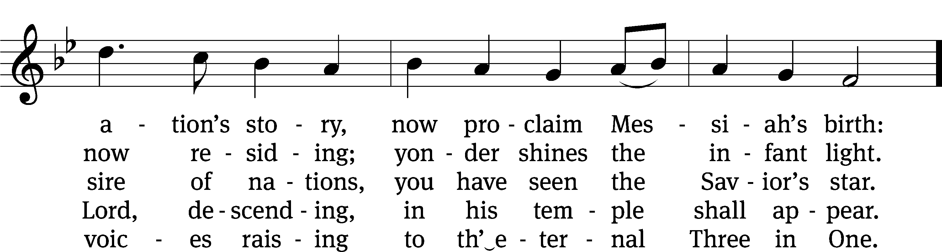
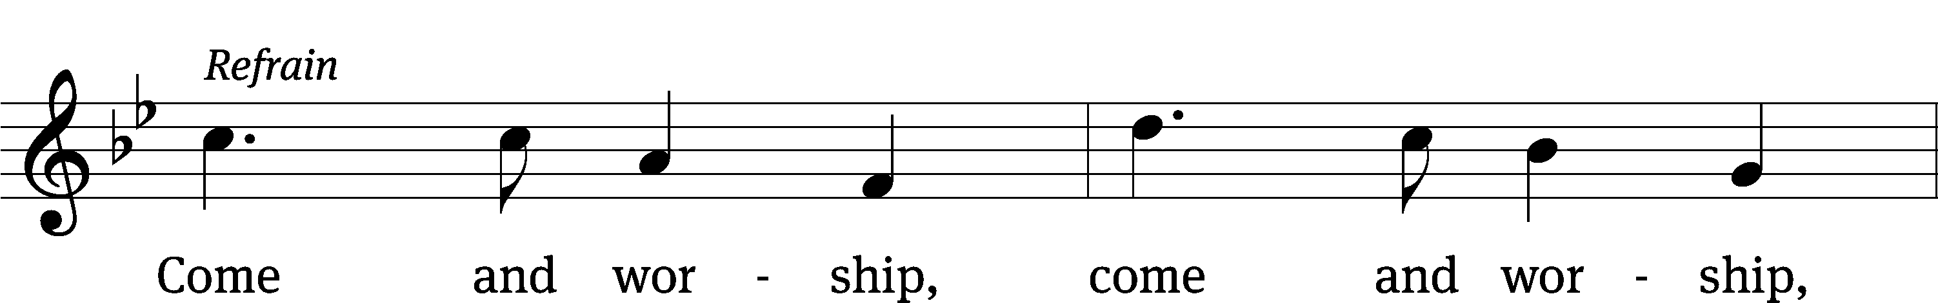
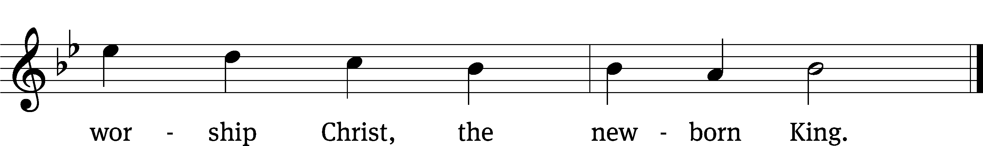
Text (sts. 1–3): James Montgomery, 1771–1854, alt.; (st. 4): Salisbury Hymn Book, 1857, alt.
Tune: Henry T. Smart, 1813–1879
Text and tune: Public domain

PLEASE STAND, IF YOU ARE ABLE

invocation

M: The grace of our Lord (+) Jesus Christ and the love of God and the fellowship of the Holy Spirit be with you.
C: And also with you.
CONFESSION OF SINS
M: God invites us to come into his presence and worship him with humble and penitent hearts. Therefore, let us acknowledge our sinfulness and ask him to forgive us.
C: Holy and merciful Father, I confess that I am by nature sinful, and that I have disobeyed you in my thoughts, words, and actions. I have done what is evil and failed to do what is good. For this I deserve your punishment both now and in eternity. But I am truly sorry for my sins, and trusting in my Savior Jesus Christ, I pray: Lord, have mercy on me, a sinner.
M: God, our heavenly Father, has been merciful to us and has given his only Son to be the atoning sacrifice for our sins. Therefore, as a called servant of Christ and by his authority, I forgive you all your sins in the name of the Father and of the Son (+) and of the Holy Spirit.
C: Amen.
PRAYER AND PRAISE
LORD, HAVE MERCY
Kyrie
M: For all that we need in life and for the wisdom to use all your gifts with gratitude and joy, hear our prayer, O Lord.

M: For the steadfast assurance that nothing can separate us from your love and for the courage to stand firm against the assaults of Satan and every evil, hear our prayer, O Christ.

M: For the well-being of your holy Church in all the world and for those who offer here their worship and praise, hear our prayer, O Lord.

M: Merciful God, maker and preserver of life, uphold us by your power and keep us in your tender care:

M: The works of the Lord are great and glorious; his name is worthy of praise.

Prayer of the day

M: Let us pray.
The minister says the Prayer of the Day.

PLEASE BE SEATED

The Word

first lesson Isaiah 49:1-6
¹ Listen to me, you coastlands.
Pay attention, you faraway peoples!
The Lord called me from the womb.
When I was inside my mother, he mentioned my name.
² He made my mouth like a sharpened sword.
He hid me in the shadow of his hand.
He made me a polished arrow.
He concealed me in his quiver.
³ He said to me, “You are my servant Israel,
in whom I will display my glory.”
⁴ But I said to myself, “I have labored in vain.
I spent my strength and came up empty, with nothing.
Yet a just verdict for me rests with the Lord,
and my reward is with my God.”
⁵ But now the Lord,
who formed me from the womb to be his servant,
to turn Jacob back to him,
so that Israel might be gathered to him,
so that I will be honored in the eyes of the Lord,
because my God has been my strength—
⁶ the Lord said:
It is too small a thing that you should just be my servant
to raise up only the tribes of Jacob
and to restore the ones I have preserved in Israel,
so I will appoint you to be a light for the nations,
so that my salvation will be known to the end of the earth.
Psalm 40B I Waited, Waited for the LORD Psalm 40B
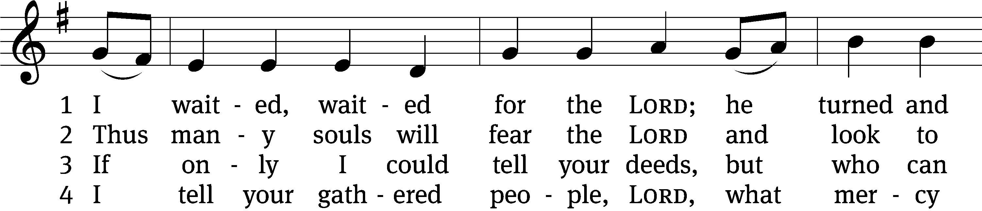
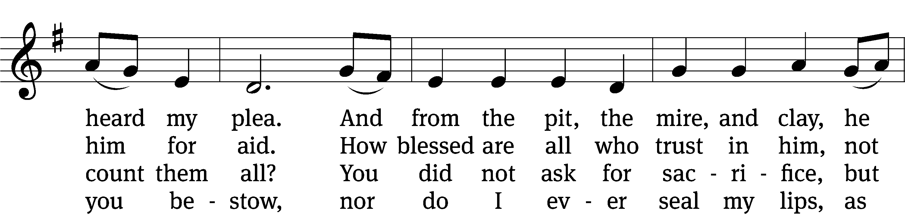
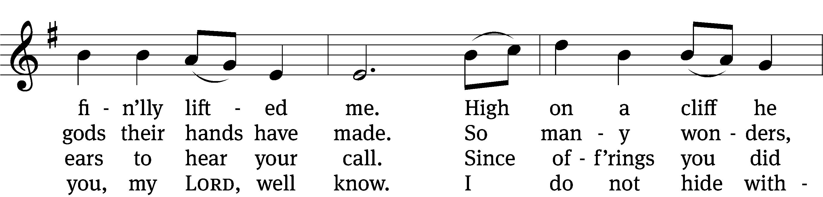
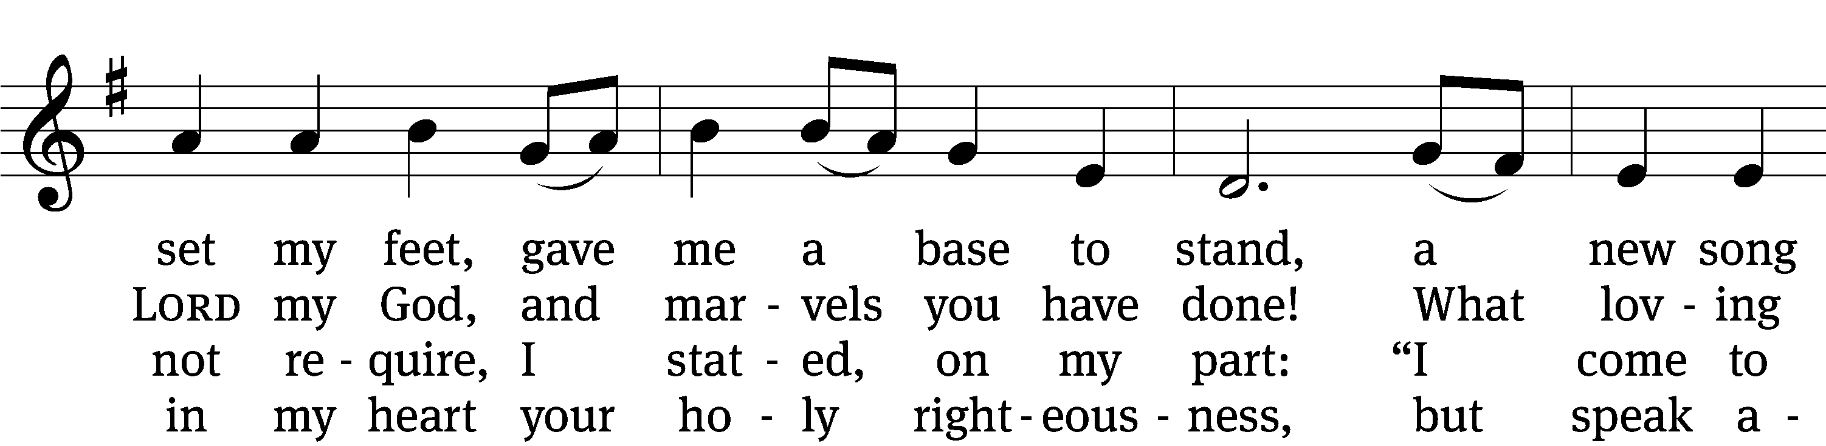
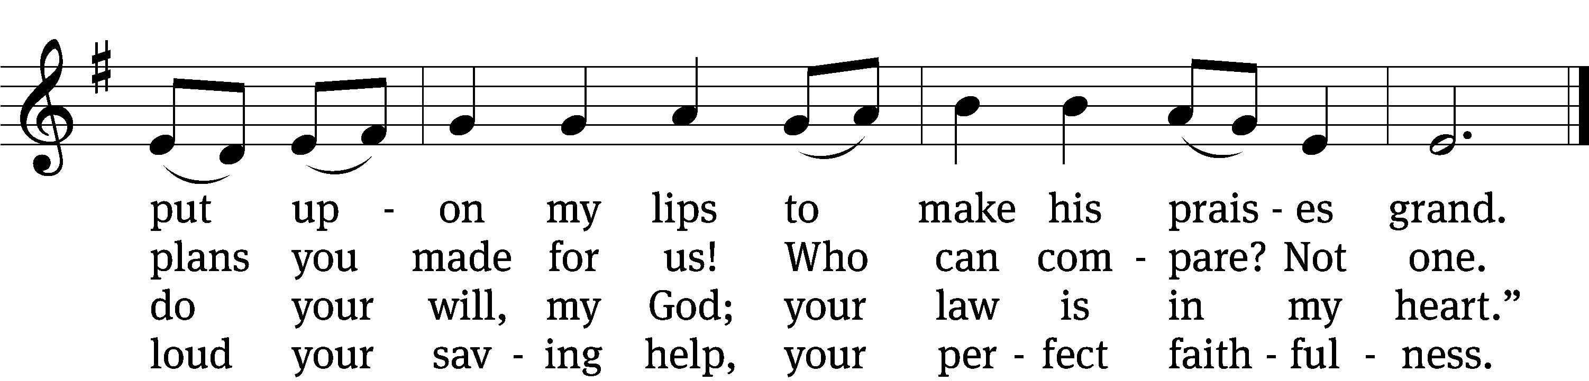

5 Your constant care, your steadfast love
I ever will reveal,
and from the great assembly, LORD,
your truth will not conceal.
Do not withhold your mercy, LORD,
for I can hardly see;
so many sins oppress my soul—
my heart is failing me.

6 May all who seek to take my life
be made to bear the blame;
may all they do fall back on them
and cover them with shame.
Let all who follow you rejoice
and say, “The LORD is great.”
I am so poor. I need so much.
My helper, do not wait.
Tune: English, adapt. and harm. Ralph Vaughan Williams
Text: © 2021 Northwestern Publishing House. Used by permission: OneLicense no. 727703
Tune: Public domain

second lesson Colossians 2:6-15
⁶ Therefore, just as you received Christ Jesus as Lord, continue to walk in him, ⁷ by being rooted and built up in him, and strengthened in the faith just as you were taught, while you overflow in faith with thanksgiving.
⁸ See to it that no one takes you captive through philosophy and empty deceit, which are in accord with human tradition, namely, the basic principles of the world, but not in accord with Christ. ⁹ For all the fullness of God’s being dwells bodily in Christ. ¹⁰ And you have been brought to fullness in him. Christ is the head over every ruler and authority. ¹¹ You were also circumcised in him, with a circumcision not done by human hands, in the putting off of the body of flesh, in the circumcision of Christ, ¹² when you were buried with Christ in baptism. And in baptism you were also raised with him through the faith worked by the God who raised Christ from the dead.
¹³ Even when you were dead in your trespasses and the uncircumcision of your flesh, God made you alive with Christ by forgiving us all our trespasses. ¹⁴ God erased the record of our debt brought against us by his legal demands. This record stood against us, but he took it away by nailing it to the cross. ¹⁵ After disarming the rulers and authorities, he made a public display of them by triumphing over them in Christ.

PLEASE STAND, IF YOU ARE ABLE
VERSE OF THE DAY

GOSPEL John 1:29-41
²⁹ The next day, John saw Jesus coming toward him and said, “Look! The Lamb of God, who takes away the sin of the world! ³⁰ This is the one I was talking about when I said, ‘The one coming after me outranks me because he existed before me.’ ³¹ I myself did not know who he was, but I came baptizing with water so that he would be revealed to Israel.”
³² John also testified, “I saw the Spirit descend like a dove from heaven and remain on him. ³³ I myself did not recognize him, but the one who sent me to baptize with water said to me, ‘The one on whom you see the Spirit descend and remain, he is the one who will baptize with the Holy Spirit.’ ³⁴ I saw this myself and have testified that this is the Son of God.”
³⁵ The next day, John was standing there again with two of his disciples. ³⁶ When John saw Jesus passing by, he said, “Look! The Lamb of God!” ³⁷ The two disciples heard him say this, and they followed Jesus.
³⁸ When Jesus turned around and saw them following him, he asked, “What are you looking for?”
They said to him, “Rabbi” (which means “Teacher”), “where are you staying?”
³⁹ He told them, “Come, and you will see.” So they came and saw where he was staying. They stayed with him that day. It was about the tenth hour.
⁴⁰ Andrew, Simon Peter’s brother, was one of the two who heard John and followed Jesus. ⁴¹ The first thing Andrew did was to find his own brother Simon and say to him, “We have found the Messiah!” (which is translated “the Christ”).

M: This is the Gospel of the Lord.

PLEASE BE SEATED
375 Arise and Shine in Splendor CW 375
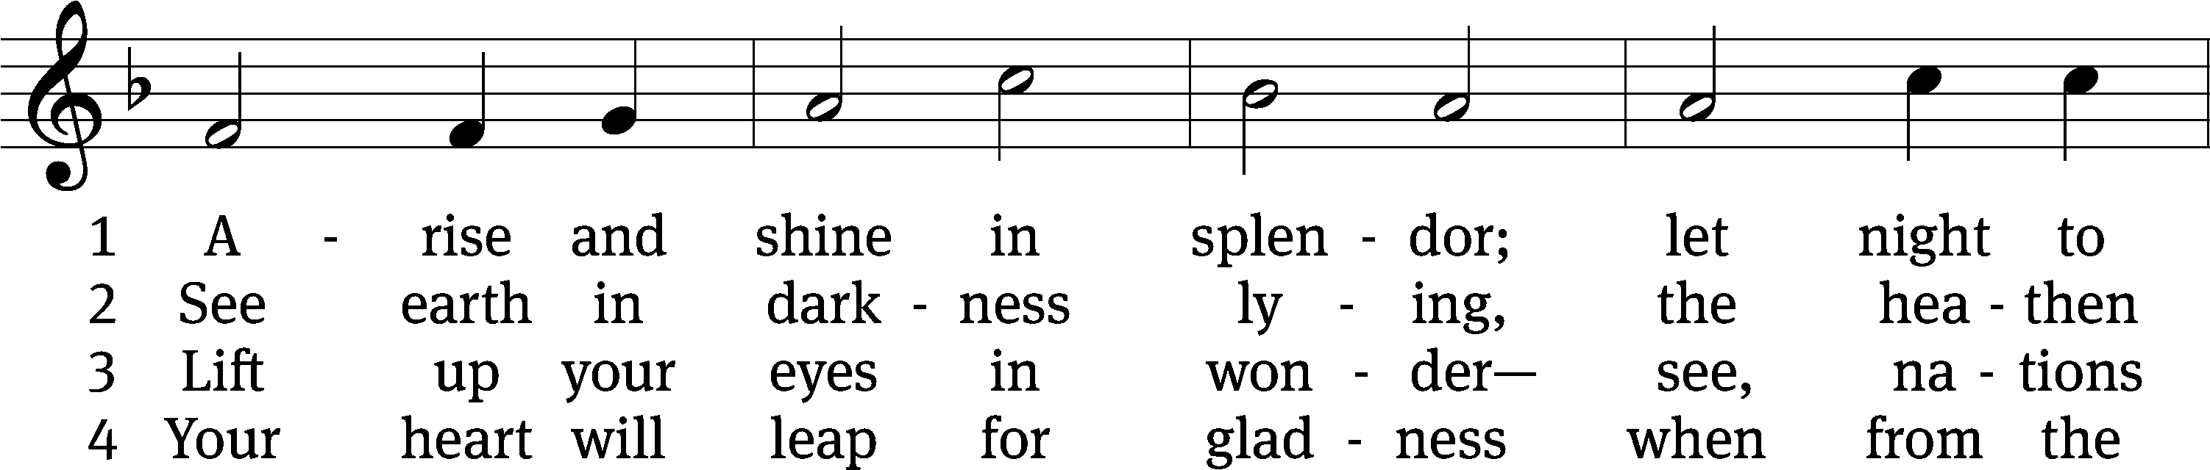
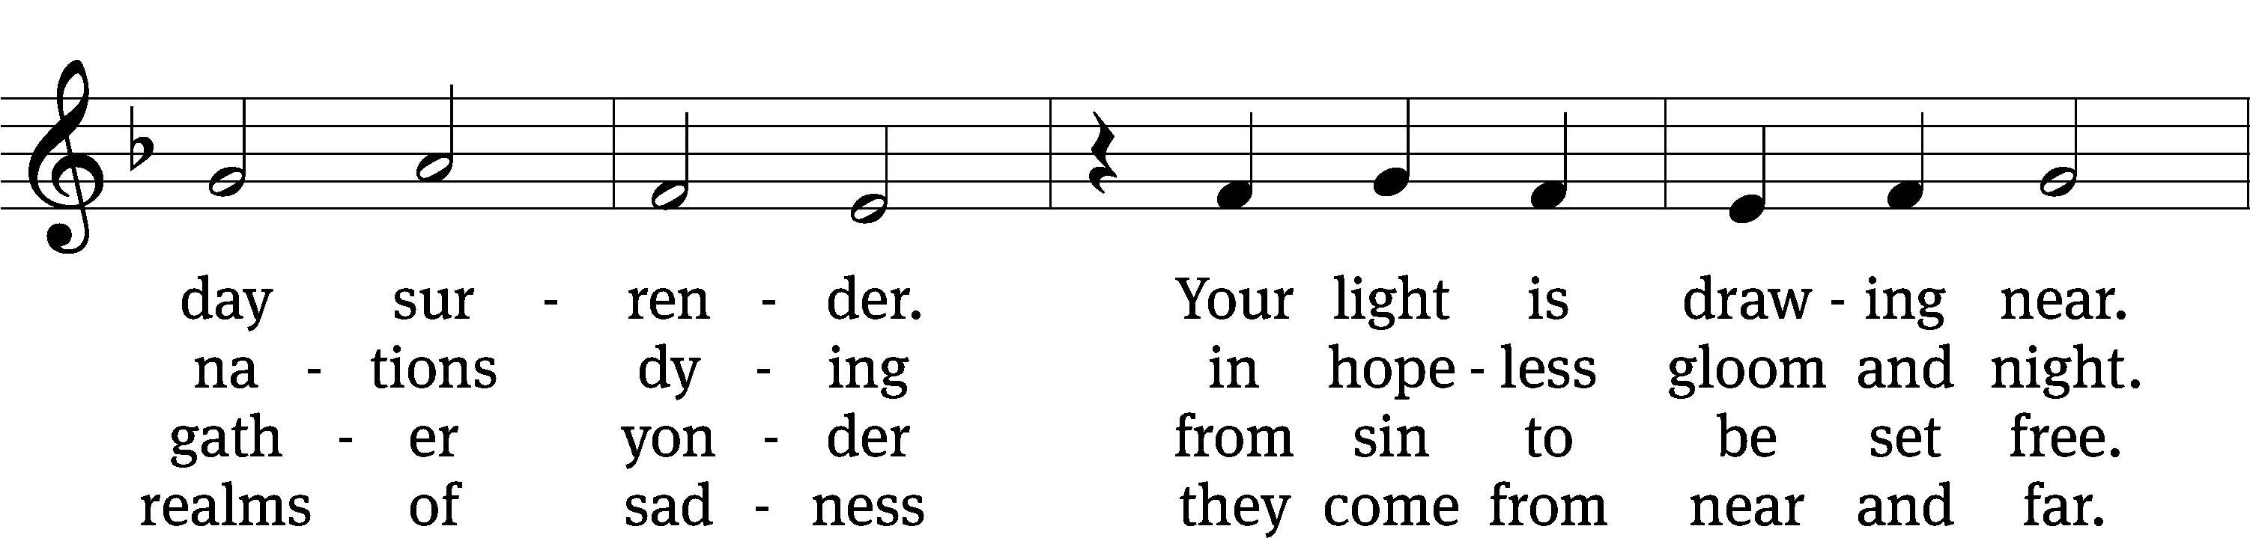
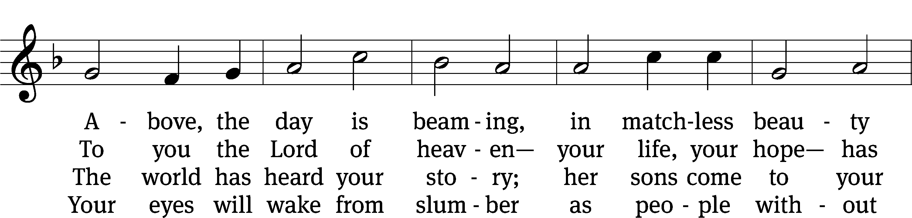
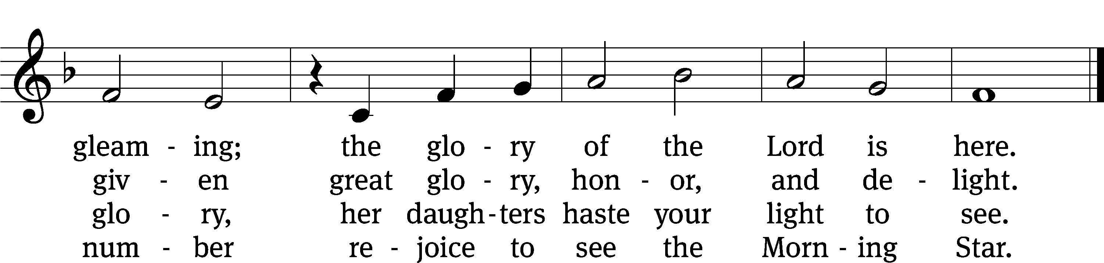
Text: tr. Gerhard Gieschen, 1899–1987, alt.; Martin Opitz, 1597–1639, abr.
Tune: The Lutheran Hymnal, 1941, alt.; Heinrich Isaac, c. 1450–1517
Text: © 1941 Concordia Publishing House. Used by permission: OneLicense no. 727703
Tune: Public domain

Sermon John 1:29-41

“John Defers to Jesus”

please stand, if you are able

nicene creed
We believe in one God, the Father, the Almighty, maker of heaven and earth, of all that is, seen and unseen.
We believe in one Lord, Jesus Christ, the only Son of God, eternally begotten of the Father, God from God, Light from Light, true God from true God, begotten, not made, of one being with the Father. Through him all things were made. For us and for our salvation, he came down from heaven, was incarnate of the Holy Spirit and the virgin Mary, and became truly human. For our sake he was crucified under Pontius Pilate. He suffered death and was buried. On the third day he rose again in accordance with the Scriptures. He ascended into heaven and is seated at the right hand of the Father. He will come again in glory to judge the living and the dead, and his kingdom will have no end.
We believe in the Holy Spirit, the Lord, the giver of life, who proceeds from the Father and the Son, who in unity with the Father and the Son is worshiped and glorified, who has spoken through the prophets. We believe in one holy Christian and apostolic Church. We acknowledge one baptism for the forgiveness of sins. We look for the resurrection of the dead and the life of the world to come. Amen.

PLEASE BE SEATED

OFFERTORY – “Angels from the Realms of Glory” (8:30 a.m.)

INSTALLATION OF OFFICERS (8:30 a.m.)

PLEASE STAND, IF YOU ARE ABLE

prayer of the church

lord’s prayer

C: Our Father, who art in heaven,
hallowed be thy name,
thy kingdom come,
thy will be done
on earth as it is in heaven.
Give us this day our daily bread;
and forgive us our trespasses,
as we forgive those
who trespass against us;
and lead us not into temptation,
but deliver us from evil.
For thine is the kingdom
and the power and the glory
forever and ever. Amen.

The Sacrament of Holy Communion
Trinity Lutheran Church follows the historic Christian practice of close communion. We ask that only members of Trinity or one of our sister congregations partake of the sacrament. If you are not a member, please see the note about Holy Communion in the beginning of the Worship Folder.

M: The Lord be with you.

M: Lift up your hearts.

M: Let us give thanks to the Lord our God.

M: Praise to the God and Father of our Lord Jesus Christ! In love he has blessed us with every spiritual blessing. He sends the Holy Spirit to testify that we are his children and to strengthen us when we are weak. Now have come the salvation and the power and the kingdom of our God and the authority of his Christ. To him who sits on the throne and to the Lamb be praise and thanks and honor and glory for ever and ever:

Holy, Holy, Holy

Words of institution
M: Our Lord Jesus Christ, on the night he was betrayed, took bread; and when he had given thanks, he broke it and gave it to his disciples, saying: “Take and eat. This is my ✙ body, which is given for you. Do this in remembrance of me.”
Then he took the cup, gave thanks, and gave it to them, saying, “Drink from it all of you; this is my ✙ blood of the new covenant, which is poured out for you for the forgiveness of sins. Do this, whenever you drink it, in remembrance of me.”
The peace of the Lord be with you always.

O CHRIST, LAMB OF GOD

380 Jesus Shall Reign Where’er the Sun CW 380
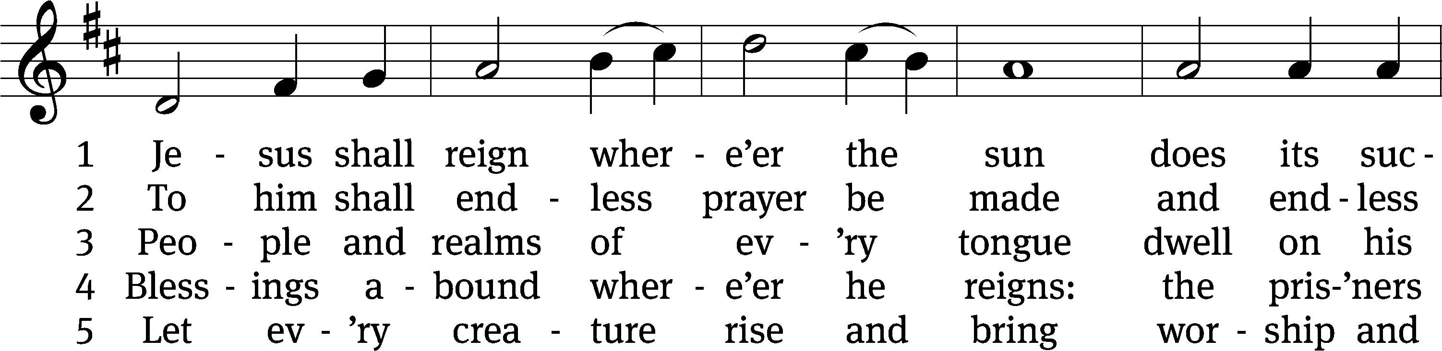
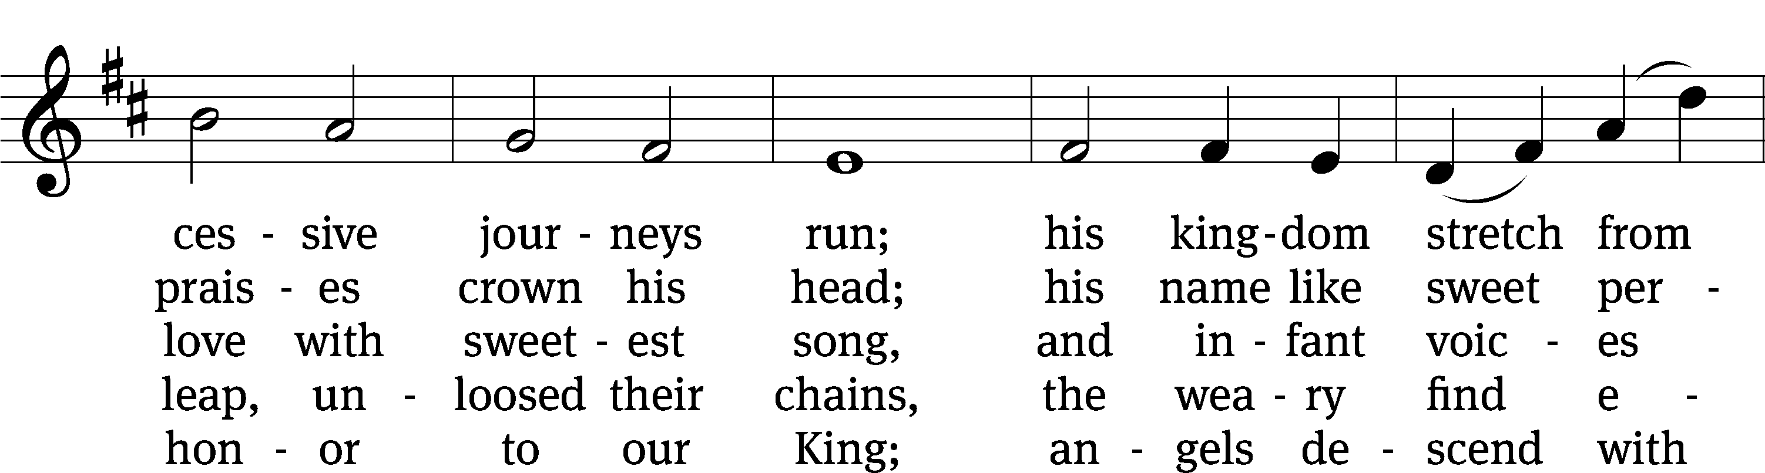
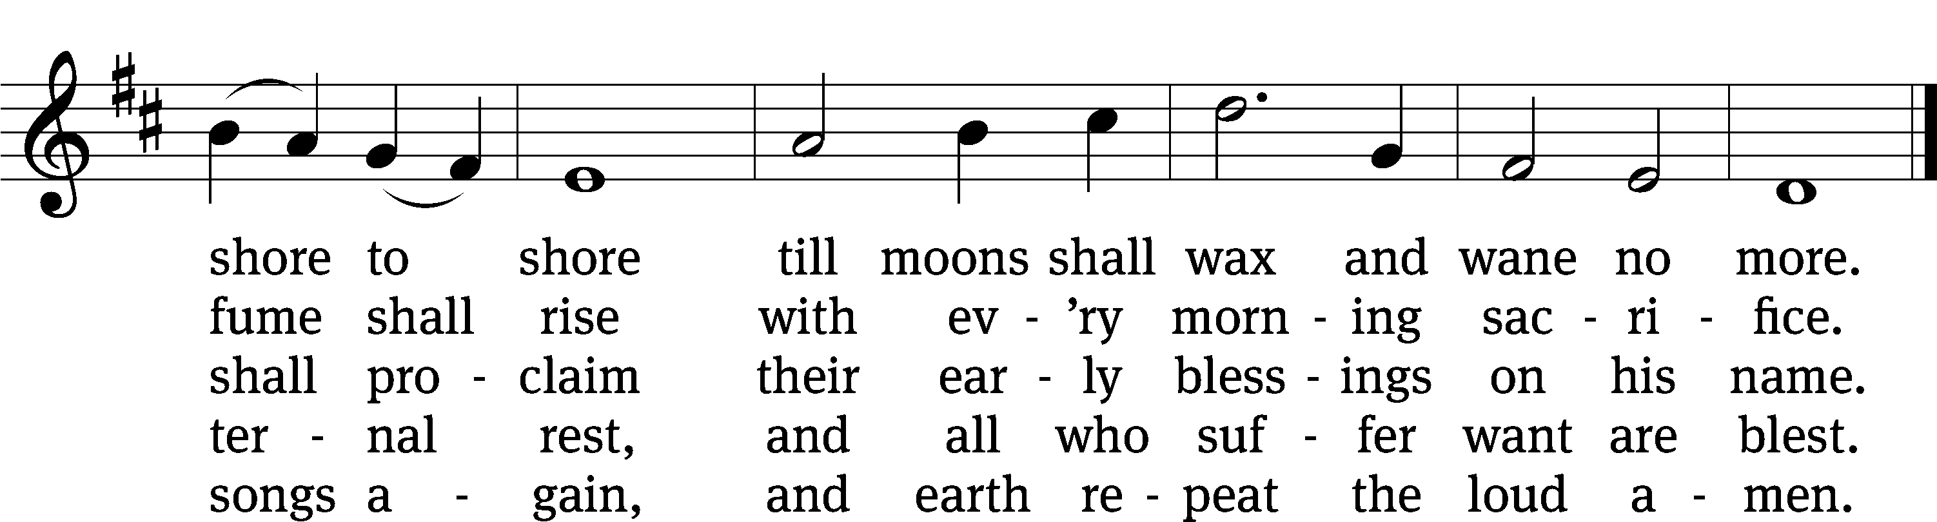
Text: Isaac Watts, 1674–1748, abr., alt.
Tune: attr. John C. Hatton, 1710–1793
Text and tune: Public domain

317 When All the World Was Cursed CW 317
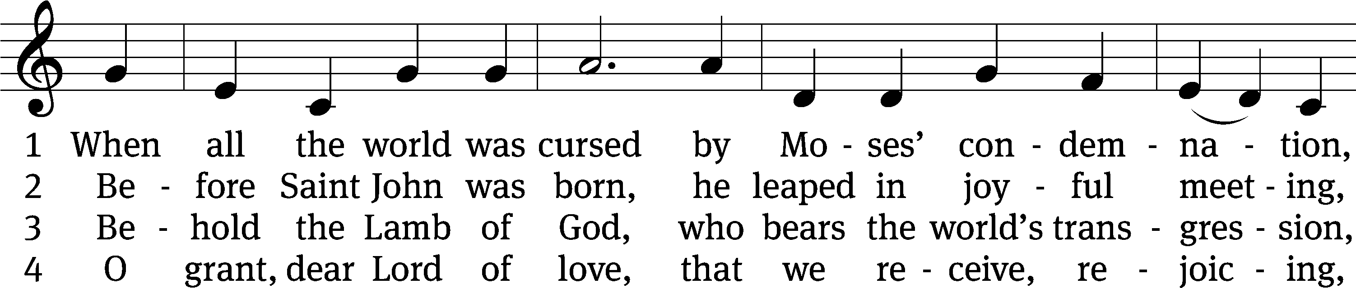
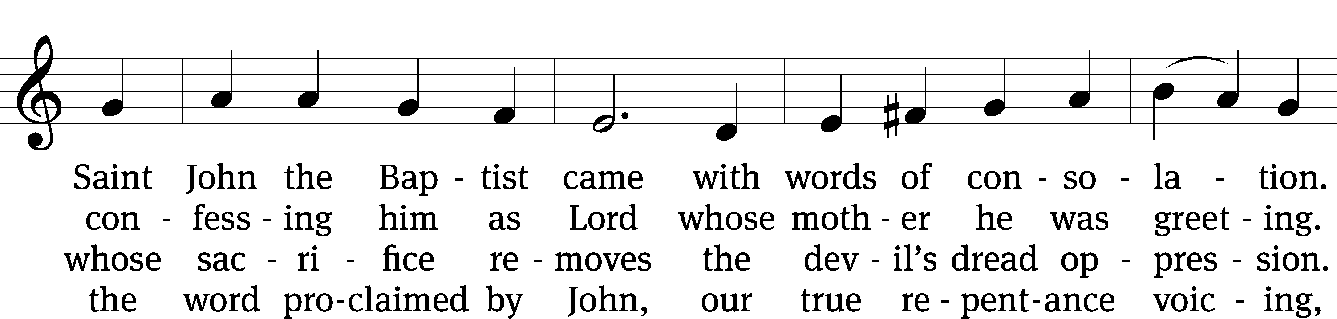
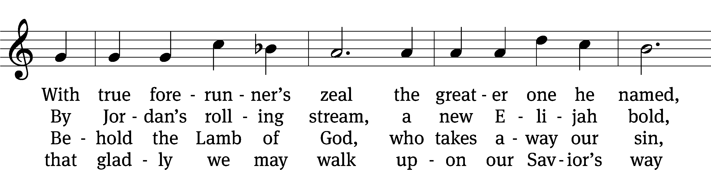
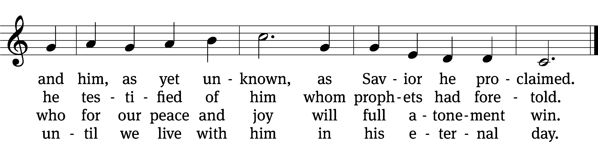
Text: tr. Paul E. Kretzmann, 1883–1965, alt.; Johann G. Olearius, 1635–1711, abr.
Tune: Ahasverus Fritsch, 1629–1701
Text: © 1941 Concordia Publishing House. Used by permission: OneLicense no. 727703
Tune: Public domain

PLEASE STAND, IF YOU ARE ABLE

THANKSGIVING

M: Hear the prayer of your people, O Lord, that the lips which have praised you here may glorify you in the world, that the eyes which have seen the coming of your Son may long for his coming again, and that all who have received in his true body and blood the pledge of your forgiveness may be restored to live a new and holy life, through Jesus Christ, our Lord, who lives and reigns with you and the Holy Spirit, one God, now and forever.

M: Brothers and sisters, go in peace. Live in harmony with one another.
Serve the Lord with gladness.

The Lord bless you and keep you.
The Lord make his face shine on you and be gracious to you.
The Lord look on you with favor and (+) give you peace.

PLEASE BE SEATED

387 Arise, Your Light Is Come CW 387
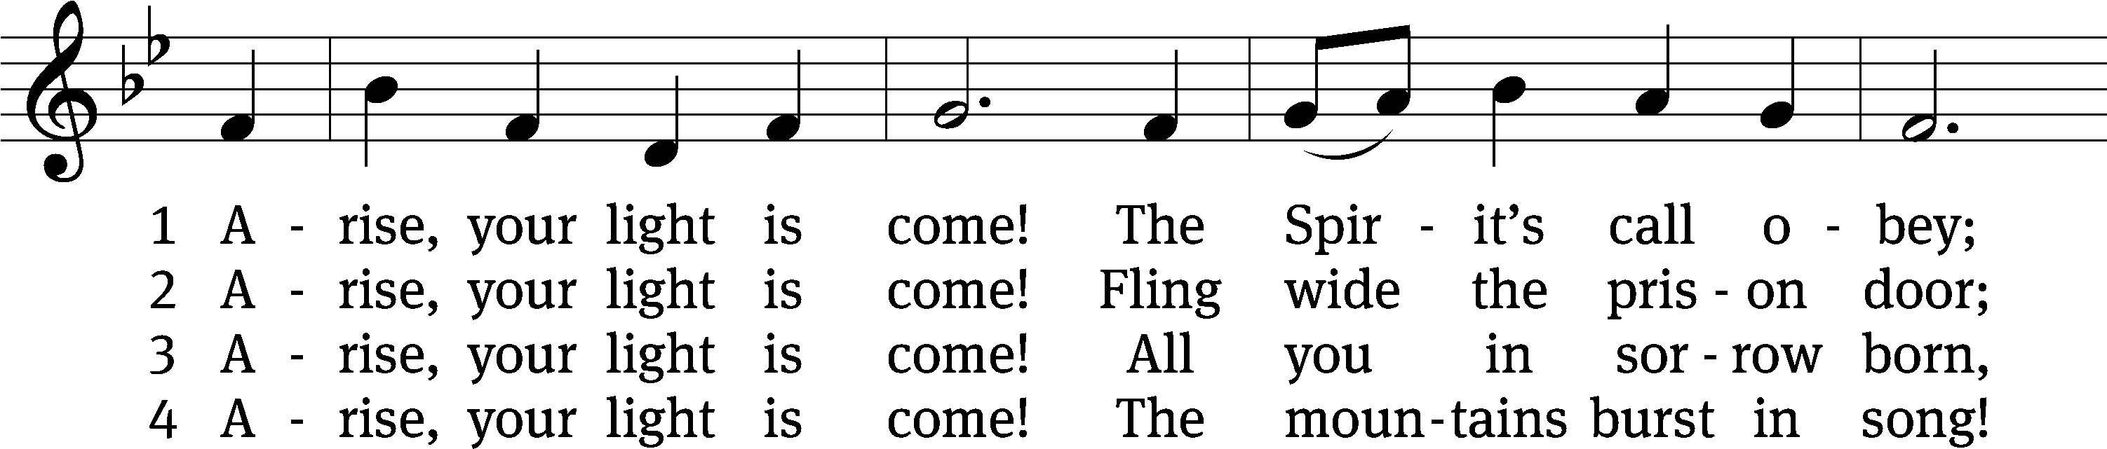
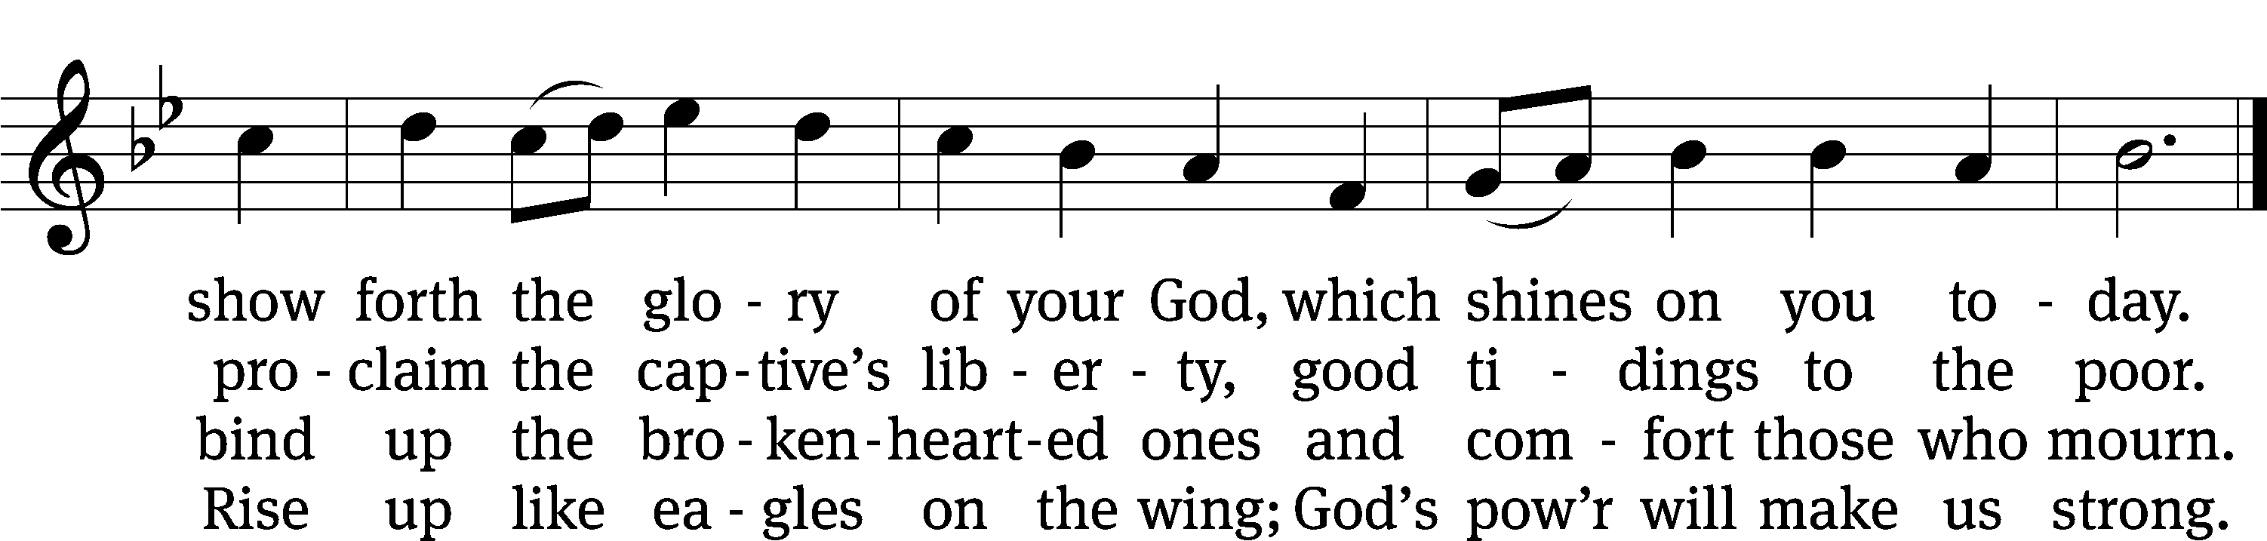
Text: Ruth Duck, b. 1947
Tune: William H. Walter, 1825–1893
Text: © 1992 GIA Publications, Inc. Used by permission: OneLicense no. 727703
Tune: Public domain

Serving In Worship

Officiant Pastor Natsis
Organist Marcia Marion Ackling
Instrumental Duet Malory Marion
Deacons (8:30) Dave Stevenson and Jim Tice
(11:00) Steve Hoeft and Jeff Neuburger
Ushers (8:30) Dale Finkbeiner and Mark Finkbeiner
(11:00) Al Whitley
Altar Guild Sharon Boswell and Brenda Stevenson
Videographer Rick Schneider

Copyright information
Service of Word and Sacrament: Christian Worship. © 1993 Northwestern Publishing House. All rights reserved. Reprinted under ONE LICENSE #A-727703 and CCLI #1151741/ CSPL126093
Words and Music: All rights reserved. Reprinted/Podcast/Streamed with permission under ONE LICENSE #A-727703 and CCLI #1151741/CSPL126093

