The SIXTH sunday
AFTER EPIPHANY

tRINITY EVANGELICAL LUTHERAN CHURCH | Saline, Michigan
February 13, 2022

WELCOME TO WORSHIP

Thank you for joining us in God’s house today! We cordially ask that our Guests with us this morning sign one of the guestbooks located at either the front or back entryways.

THANK OFFERING: Members of Trinity give their offering as an expression of love and thankfulness to the Lord and to help support the Lord’s work in our community and around the world. Visitors need not feel obligated to participate in this offering which supports our ministry.

Restrooms are located at the back of the upper level (the annex), and in the basement (down the back stairs of the sanctuary or annex). Handicap access is available, please ask an usher for assistance.

Young Families / Toddler Bags – We are GLAD YOU BROUGHT YOUR CHILDREN to our worship service. Jesus said: “Let the little children come to me and do not hinder them, for the kingdom of God belongs to such as these.” We know that having little children in church can be a challenge, but DO NOT WORRY about it. Many of your fellow worshippers have been in your shoes and are just happy you brought your children with you. For your convenience, we have reserved the back rows of seating for parents with small children. These areas provide more flexibility for your family, as well as, easy access to move downstairs if necessary. A closed-circuit TV system allows families to continue participating in the service while downstairs. Pre-school toddler bags and children’s bulletins are available for their enjoyment. Ask an usher for one to use during the service and please return the toddler bag afterwards.

SERVICE of the word
OPENING HYMN #800 CW
800 How Firm a Foundation CW 800
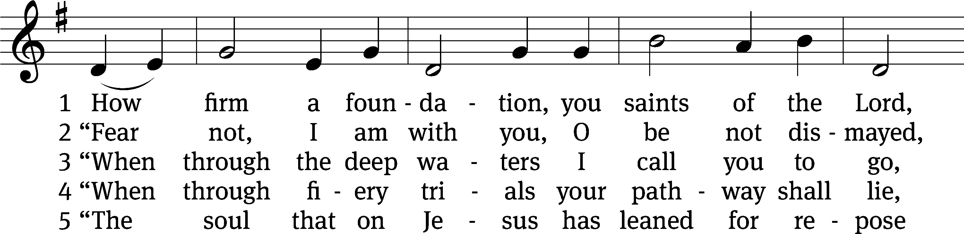
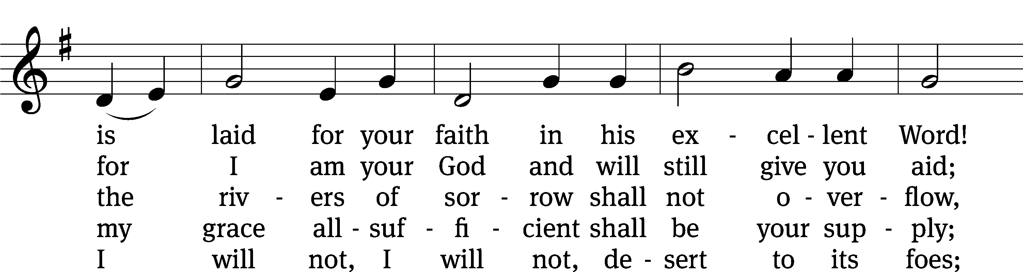
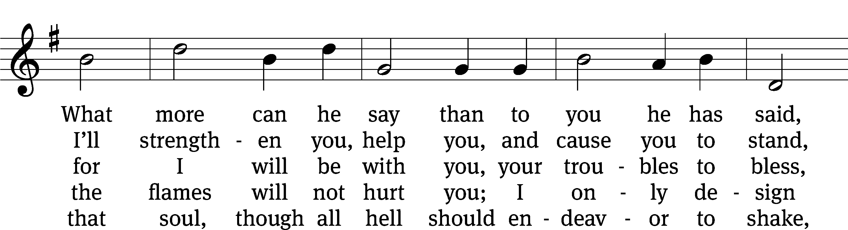
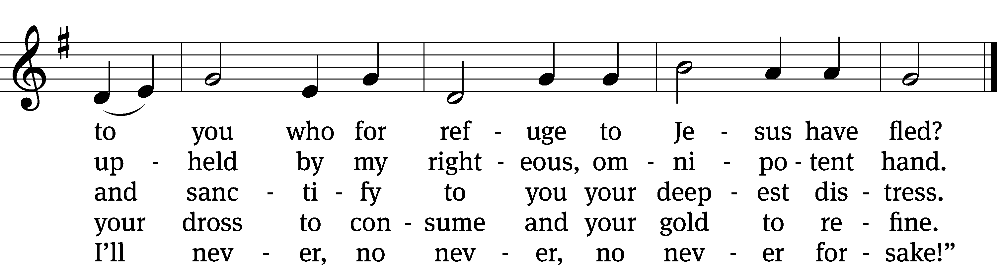
Text and tune: Public domain

PLEASE STAND, IF YOU ARE ABLE

invocation
M: The grace of our Lord (+) Jesus Christ and the love of God and the fellowship of the Holy Spirit be with you.
C: And also with you.

CONFESSION OF SINS
M: We have come into the presence of God, who created us to love and serve him as his dear children. But we have disobeyed him and deserve only his wrath and punishment. Therefore, let us confess our sins to him and plead for his mercy.

C: Merciful Father in heaven, I am altogether sinful from birth. In countless ways I have sinned against you and do not deserve to be called your child. But trusting in Jesus, my Savior, I pray: Have mercy on me according to your unfailing love. Cleanse me from my sin, and take away my guilt.

M: God, our heavenly Father, has forgiven all your sins. By the perfect life and innocent death of our Lord Jesus Christ, he has removed your guilt forever. You are his own dear child. May God give you strength to live according to his will.

C: Amen.
PRAYER AND PRAISE

M: In the peace of forgiveness, let us praise the Lord.

OH, TASTE AND SEE

PRAYER OF THE DAY

M: Let us pray.
The minister says the Prayer of the Day.

PLEASE BE SEATED

The Word

the FIRST LESSON jeremiah 17:5-8

⁵ This is what the Lord says.
Cursed is anyone who trusts in mankind,
who seeks his strength from human flesh,
and who turns his heart away from the Lord.
⁶ He will be like a juniper bush in the wasteland.
He will not see good things when they come.
He lives in a dry place in the wilderness,
in a salty land where no one lives.
⁷ But blessed is anyone who trusts in the Lord,
whose confidence is in him.
⁸ He will be like a tree planted by water.
It sends out its roots to the stream.
It does not fear the heat when it comes.
Its leaves will remain green.
It is not concerned about a time of drought.
It does not stop producing fruit.

PSALM OF THE DAY Psalm 1A

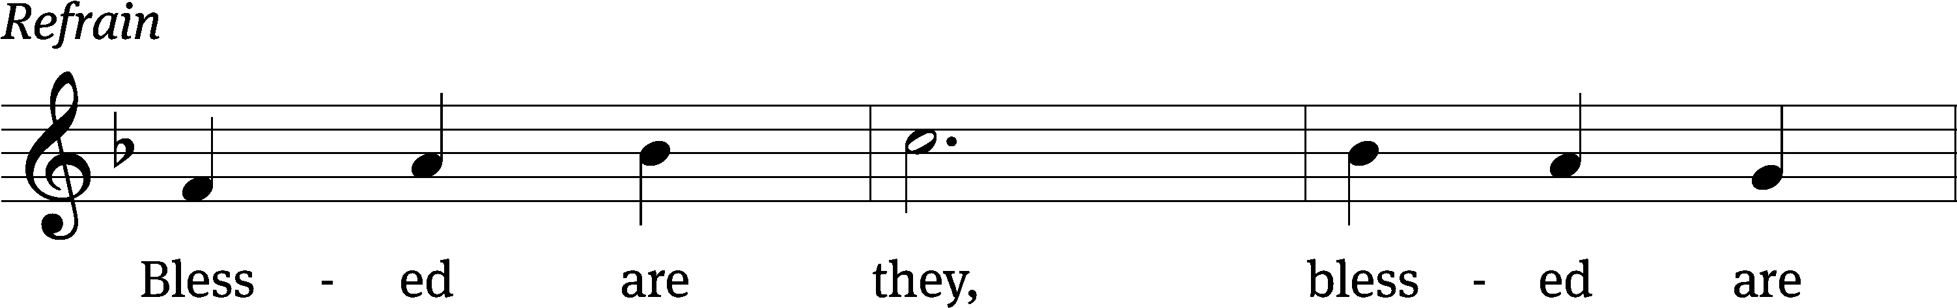

Blessed is the one who / does not walk
in step with the / wicked
or stand in the way that / sinners take
or sit in the company of / mockers,
but whose delight is in the law / of the Lord,
and who meditates on his law / day and night.
That person is like a tree planted by streams of / water,
which yields its fruit in / season
and whose leaf does not / wither—
whatever they do / prospers. Refrain

Not so the / wicked!
They are like chaff that the wind / blows away.
Therefore the wicked will not stand in the / judgment,
nor sinners in the assembly of the / righteous. Refrain

For the Lord watches over the way of the / righteous,
but the way of the wicked leads to de- / struction.
Glory be to the Father and / to the Son
and to the Holy / Spirit,
as it was in the be- / ginning,
is now, and will be forever. / Amen. Refrain
Text: © 1969, 1981, 1997 ICEL. Used by permission: License no. 130003540
Music: © 1998 GIA Publications, Inc. Used by permission: OneLicense no. 727703

THE SECOND LESSON 2 CORINTHIANS 12:7-10
⁷ Therefore, to keep me from becoming arrogant due to the extraordinary nature of these revelations, I was given a thorn in my flesh, a messenger of Satan, to torment me, so that I would not become arrogant. ⁸ Three times I pleaded with the Lord about this, that he would take it away from me. ⁹ And he said to me, “My grace is sufficient for you, because my power is made perfect in weakness.” Therefore I will be glad to boast all the more in my weaknesses, so that the power of Christ may shelter me.
¹⁰ That is why I delight in weaknesses, in insults, in hardships, in persecutions, in difficulties, for the sake of Christ. For whenever I am weak, then am I strong.

Verse of the day

PLEASE Stand, if you are able

THE GOSPEL LESSON LUKE 6:17-26
M: The Gospel according to Luke chapter 6, verses 17-26
¹⁷ He went down with them and stood on a level place with a large crowd of his disciples and a large number of people from all Judea and Jerusalem, as well as from the coastal area of Tyre and Sidon. These people came to listen to him and to be healed of their diseases. ¹⁸ Those who were troubled by unclean spirits were also cured. ¹⁹ The whole crowd kept trying to touch him, because power was going out from him and healing them all.
²⁰ He lifted up his eyes to his disciples and said:
Blessed are you who are poor,
because yours is the kingdom of God.
²¹ Blessed are you who hunger now,
because you will be satisfied.
Blessed are you who weep now,
because you will laugh.
²² Blessed are you whenever people hate you,
and whenever they exclude and insult you
and reject your name as evil because of the Son of Man.
²³ “Rejoice in that day and leap for joy because of this: Your reward is great in heaven! The fact is, their fathers constantly did the same things to the prophets.”
²⁴ But woe to you who are rich,
because you are receiving your comfort now.
²⁵ Woe to you who are well fed now,
because you will be hungry.
Woe to you who laugh now,
because you will be mourning and weeping.
²⁶ Woe to you when all people speak well of you,
because that is how their fathers constantly treated the
false prophets.

M: This is the Gospel of the Lord.

PLEASE BE SEATED

SERMON HYMN #797 CW
797 I Know My Faith Is Founded CW 797
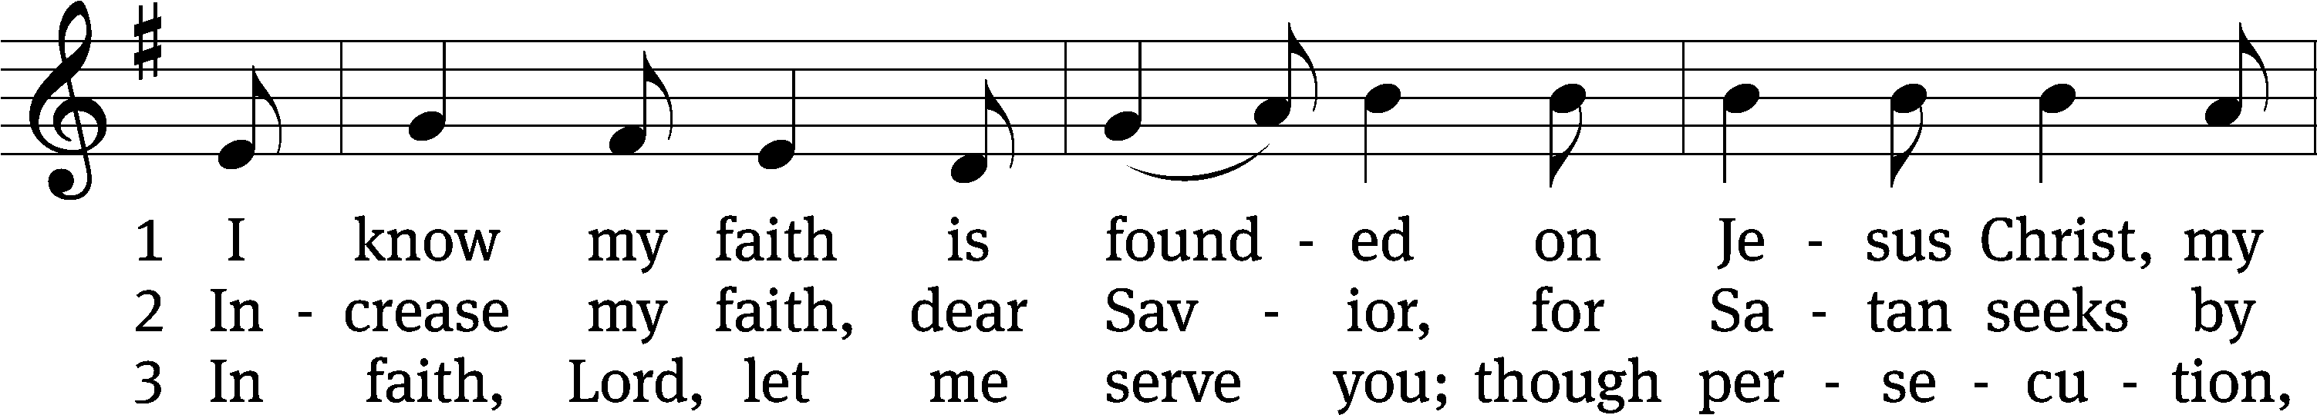
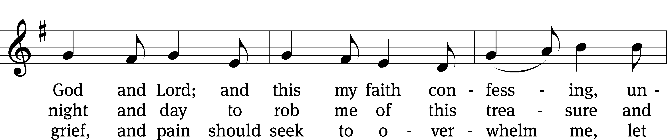
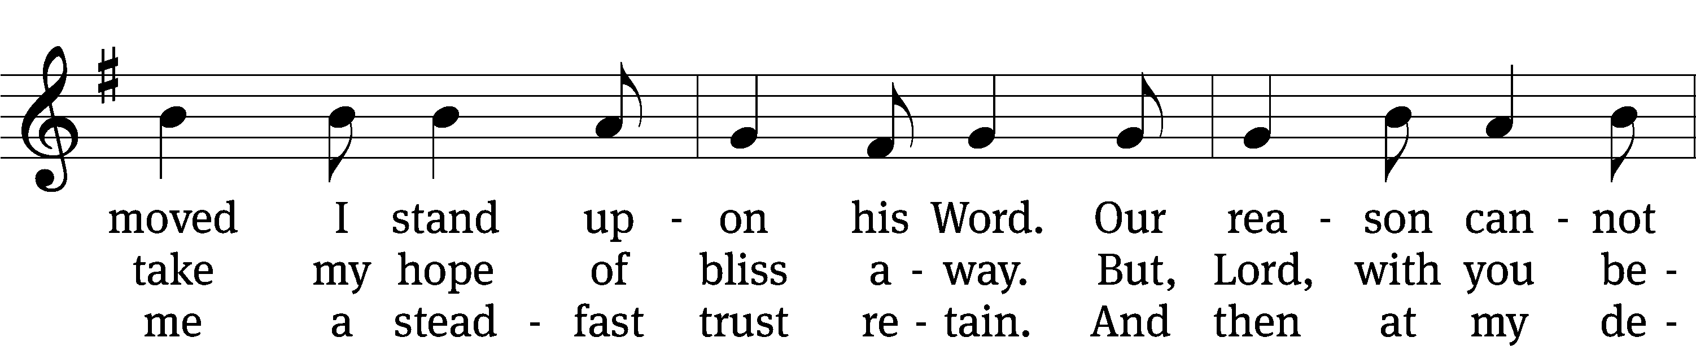
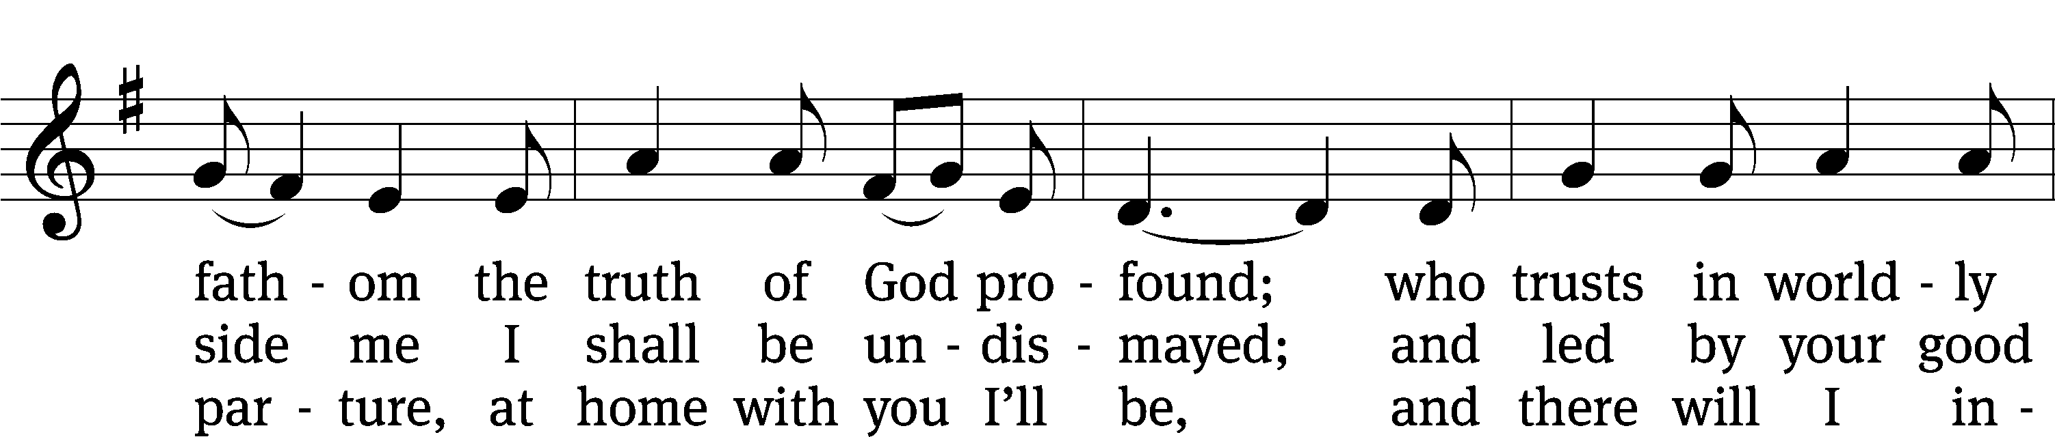
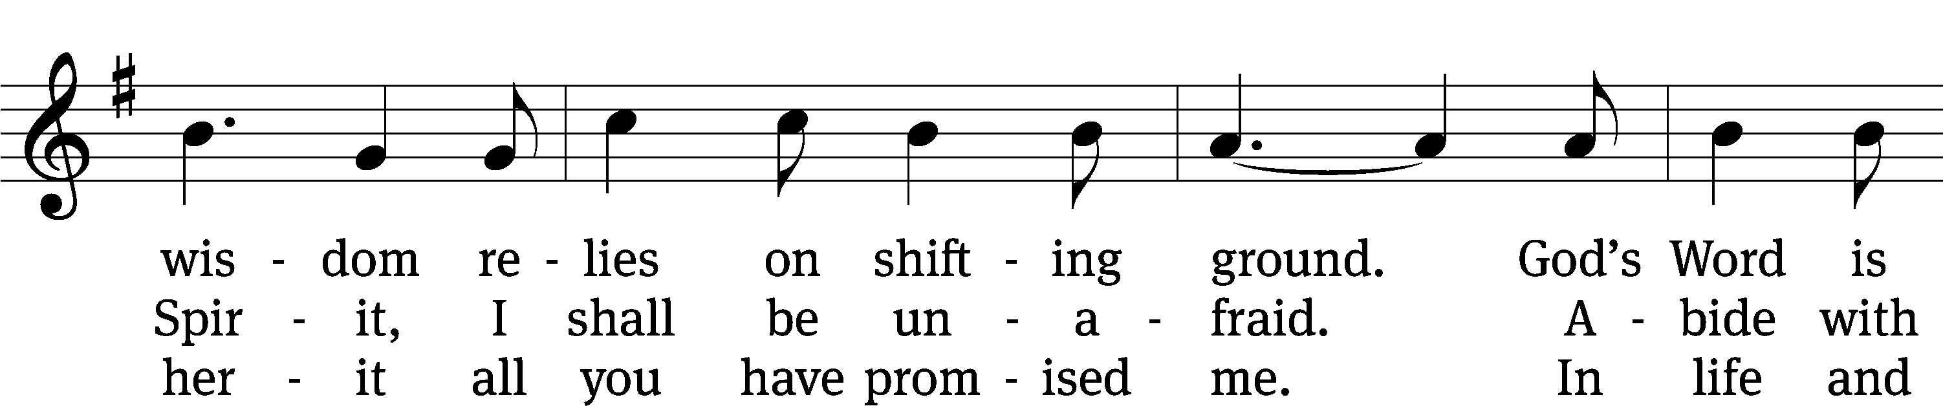
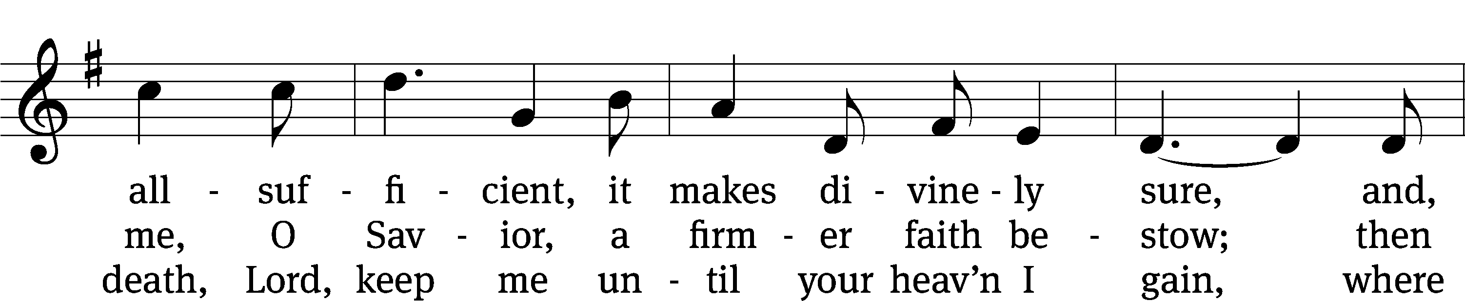
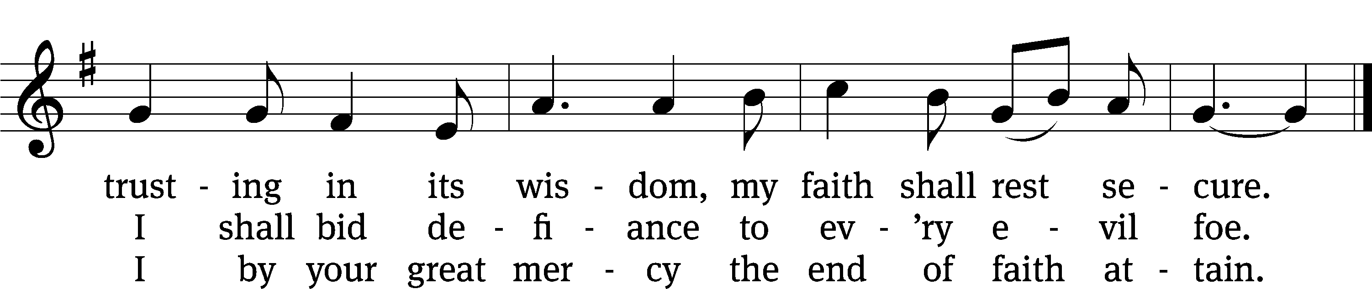
Text and tune: Public domain

SERMON 2 Corinthians 12:7-10
“Paul’s Perfect Paradox”

PLEASE STAND, IF YOU ARE ABLE

THE APOSTLES’ CREED
I believe in God, the Father almighty,
maker of heaven and earth.
I believe in Jesus Christ, his only Son, our Lord,
who was conceived by the Holy Spirit,
born of the virgin Mary,
suffered under Pontius Pilate,
was crucified, died, and was buried.
He descended into hell.
The third day he rose again from the dead.
He ascended into heaven
and is seated at the right hand of God the Father almighty.
From there he will come to judge the living and the dead.
I believe in the Holy Spirit,
the holy Christian Church,
the communion of saints,
the forgiveness of sins,
the resurrection of the body,
and the life everlasting. Amen.

PRAYER OF THE CHURCH

THE LORD’S PRAYER

C: Our Father, who art in heaven, hallowed be thy name, thy kingdom come, thy will be done on earth as it is in heaven. Give us this day our daily bread; and forgive us our trespasses, as we forgive those who trespass against us; and lead us not into temptation, but deliver us from evil. For thine is the kingdom and the power and the glory forever and ever. Amen.

PLEASE BE SEATED

HYMN #576 CW
576 Amazing Grace CW 576
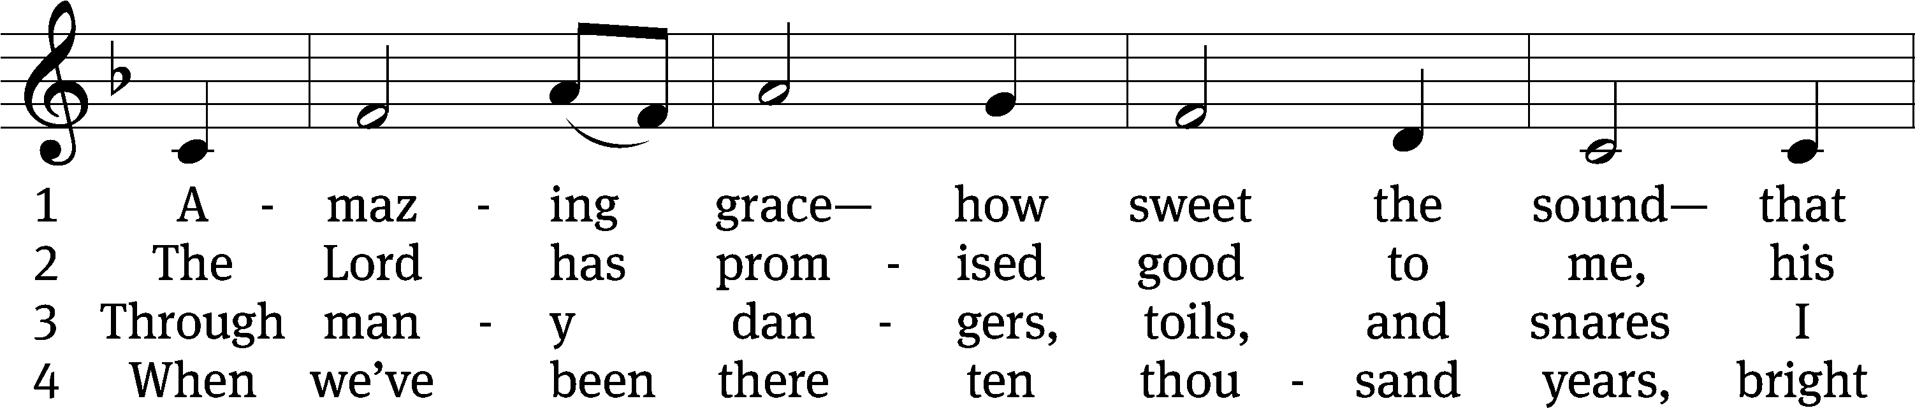
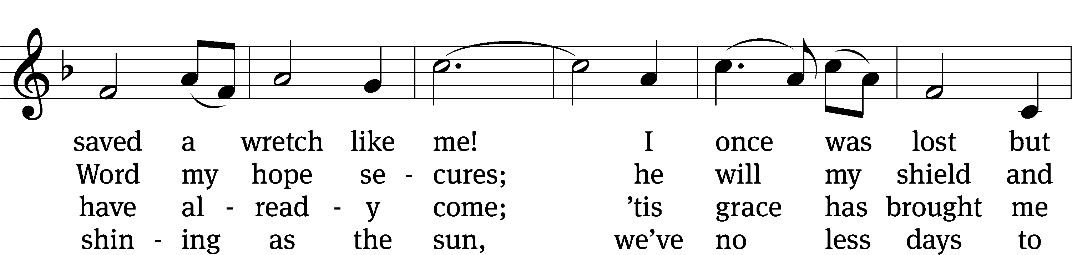
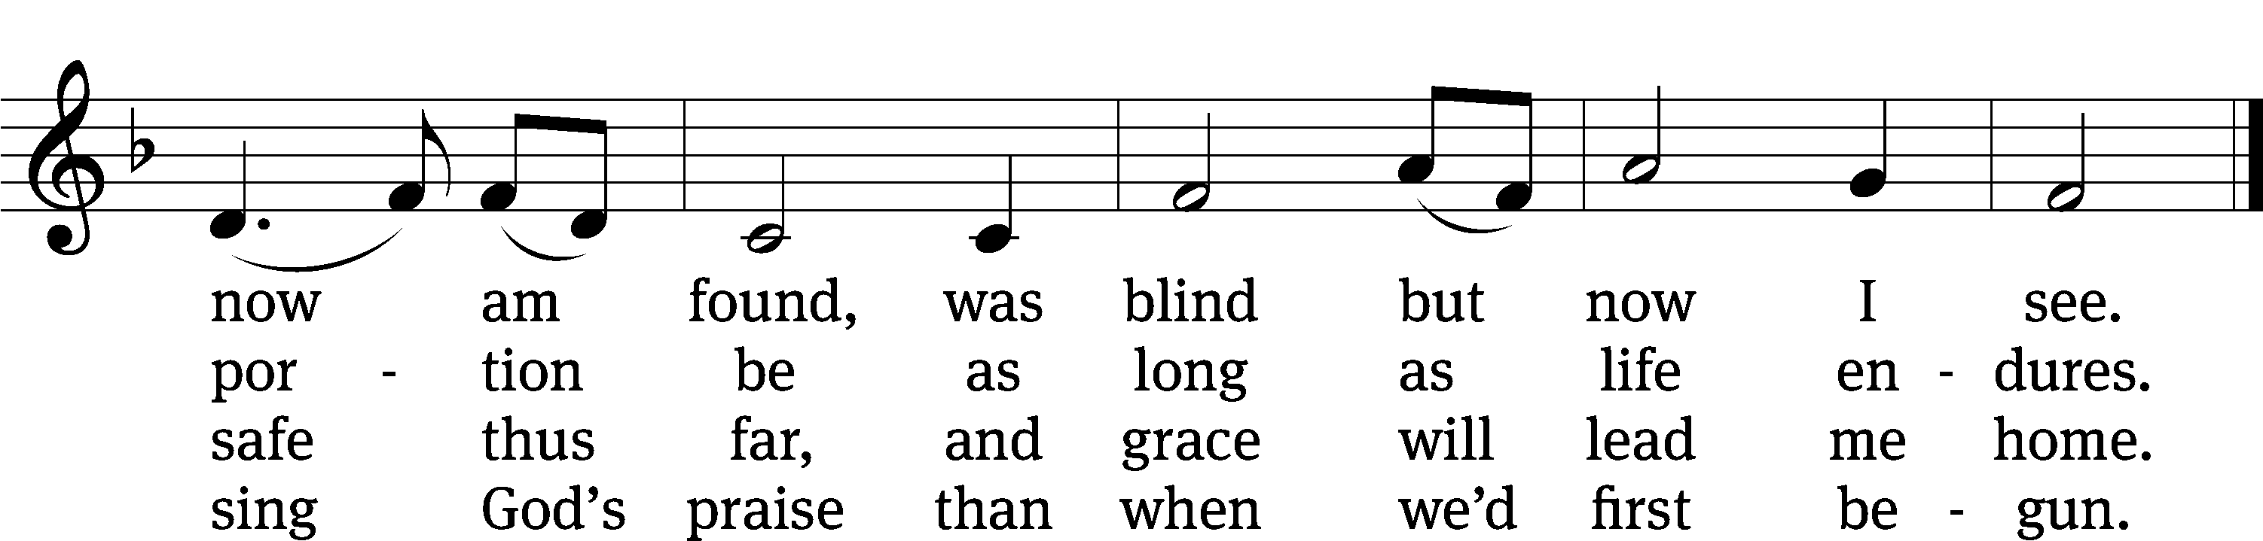
Text and tune: Public domain

PLEASE STAND, IF YOU ARE ABLE

CLOSING PRAYER
M: Almighty God, we thank you for teaching us the things you want us to believe and do. Help us by your Holy Spirit to keep your Word in pure hearts that we may be strengthened in faith, guided in holiness, and comforted in life and in death, through Jesus Christ, our Lord, who lives and reigns with you and the Holy Spirit, one God, now and forever.

M: Brothers and sisters, go in peace. Live in harmony with one another. Serve the Lord with gladness.
The Lord bless you and keep you.
The Lord make his face shine on you and be gracious to you.
The Lord look on you with favor and (+) give you peace.

PLEASE BE SEATED

CLOSING HYMN #803 CW
803 Day by Day CW 803
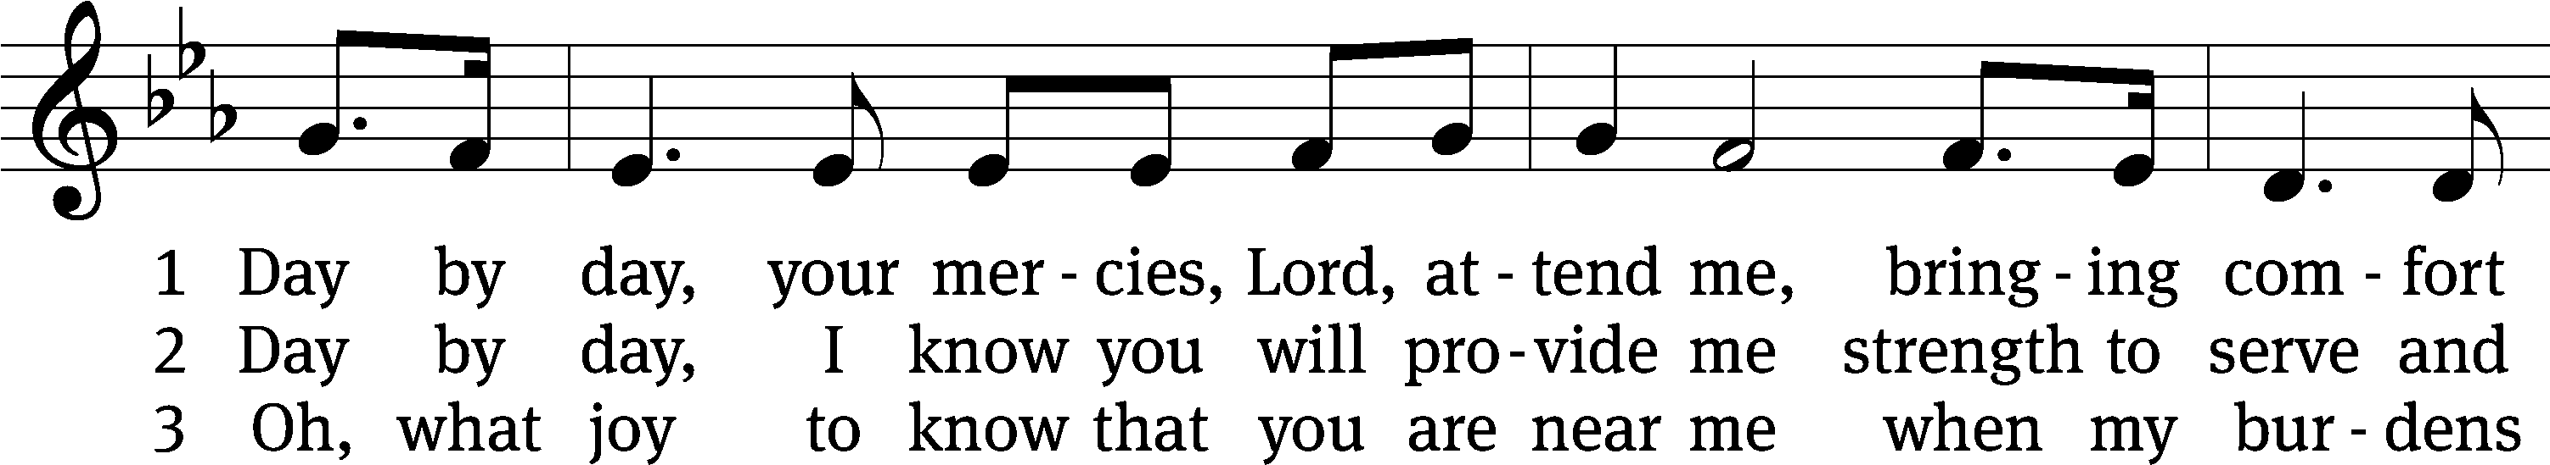
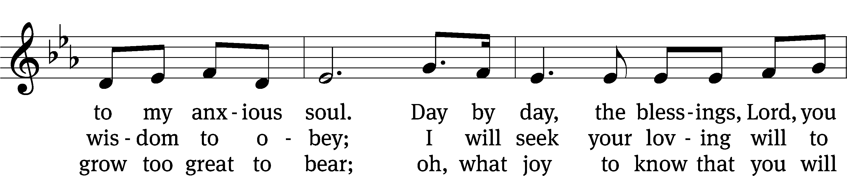
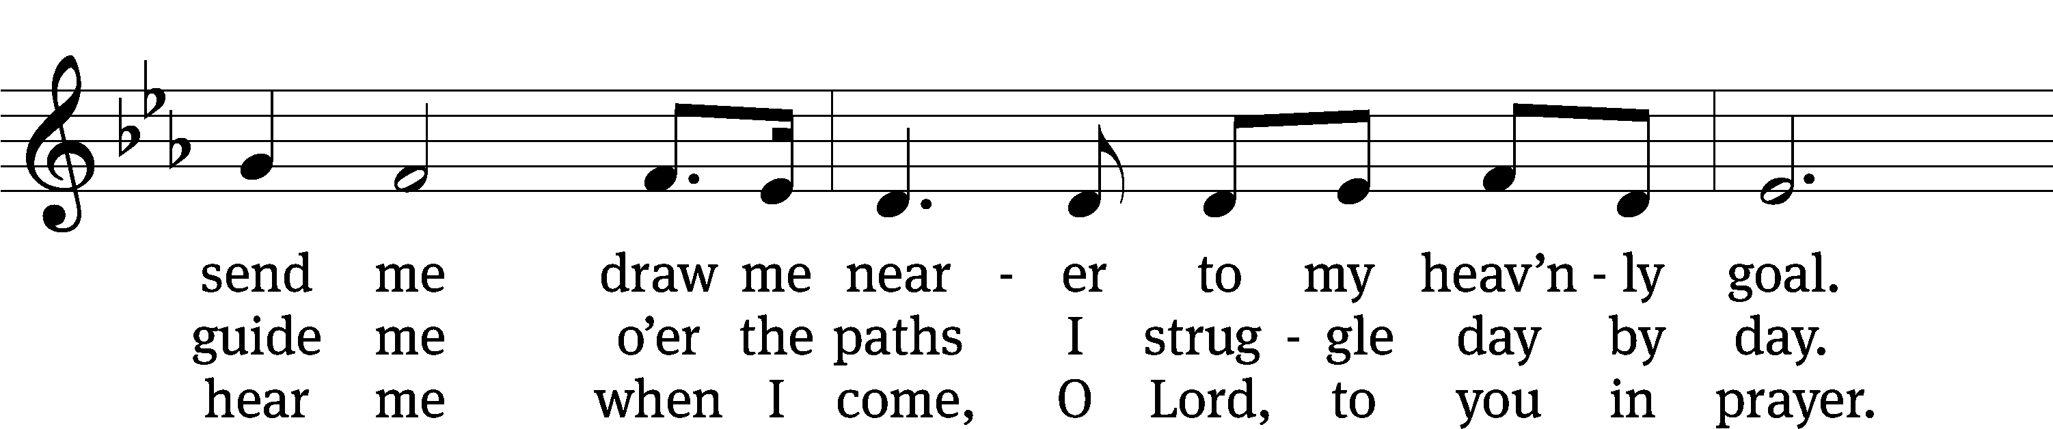
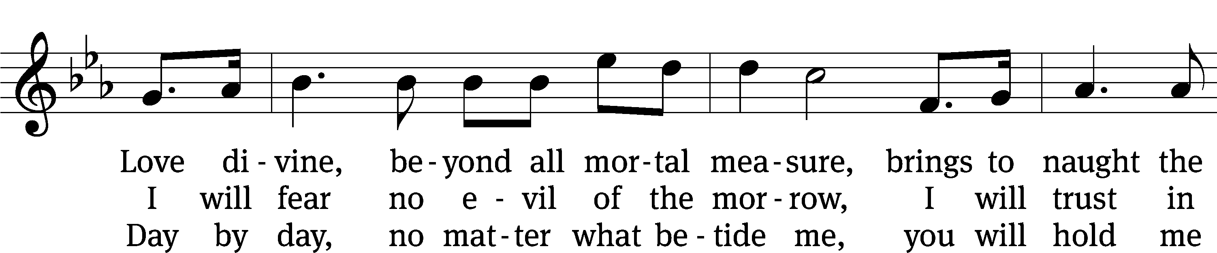
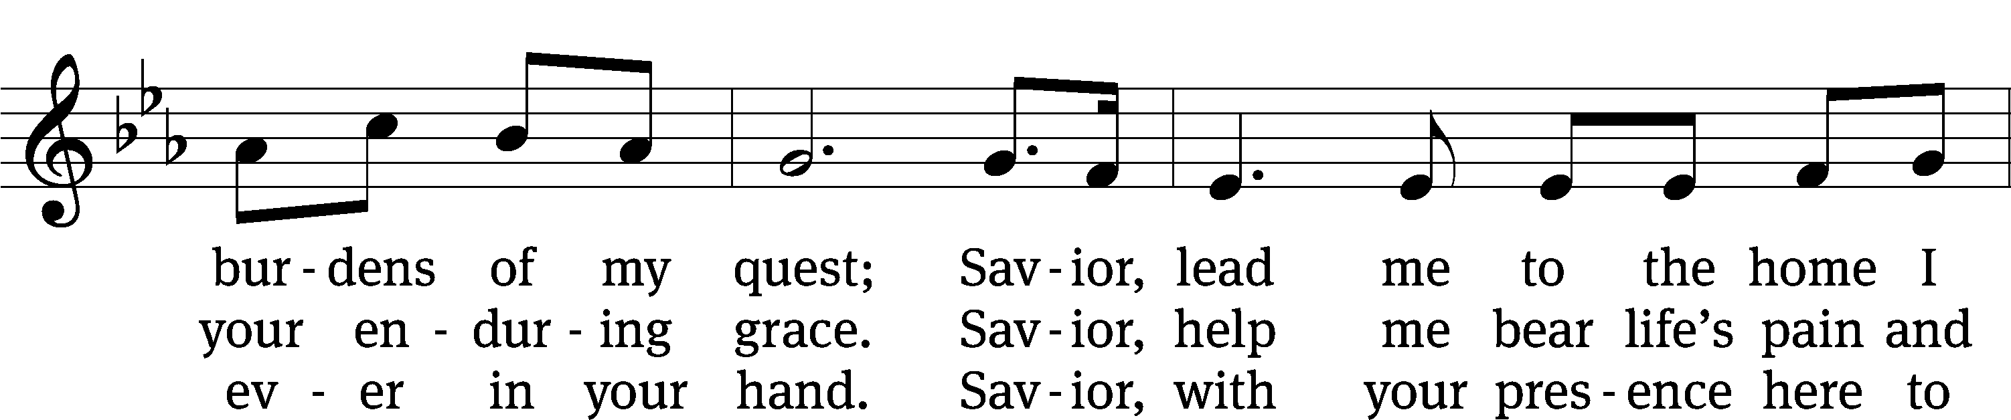
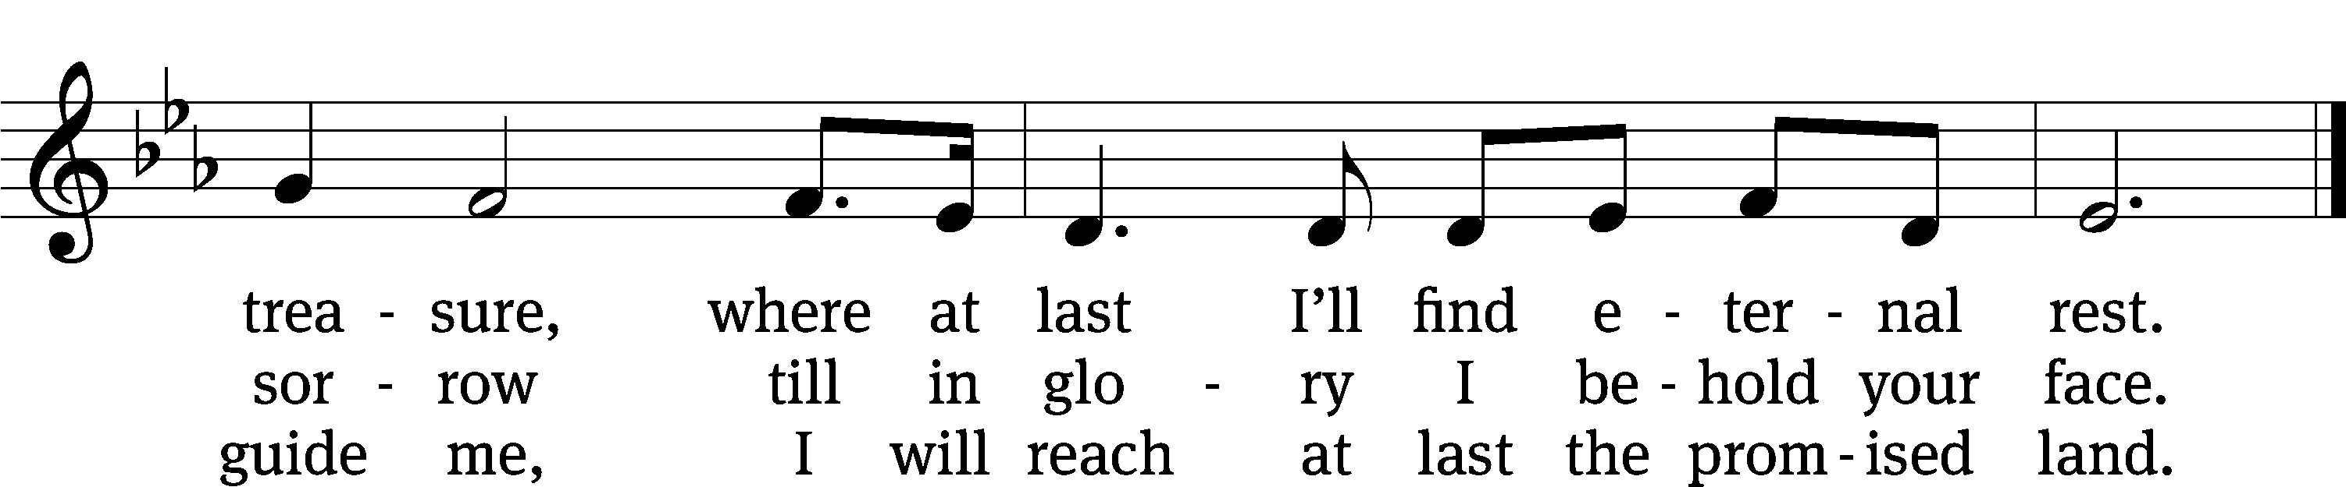
Text: © 1992 Augsburg Fortress. Used by permission: OneLicense no. 727703
Tune: Public domain

Serving In Worship
Officiant Pastor William Natsis
Organist Ann Hoeft
Deacons (8:30) Dave Frey and Dave Stevenson
(11:00) Steve Hoeft and Ed Wheeler
Ushers (8:30) Dale Radak
(11:00) Ron Zahn
Altar Guild Margaret Hoeft and Brenda Stevenson
Videographer Ann Latowski

Copyright information
Service of the Word: Christian Worship. © 1993 Northwestern Publishing House. All rights reserved.
Reprinted with permission under ONE LICENSE #A-727703 and CCLI #1151741/CSPL126093

Words and Music: All rights reserved. Reprinted with permission under ONE LICENSE #A-727703 and
CCLI #1151741/CSPL126093

tlcsaline.church

