THE first SUNDAY after
the epiphany
tRINITY EVANGELICAL LUTHERAN CHURCH | Saline, Michigan
January 8, 2023

WELCOME TO WORSHIP

Thank you for joining us in God’s house today! We cordially ask that our Guests with us this morning sign one of the guestbooks located at either the front or back entryways.

THANK OFFERING: Members of Trinity give their offering as an expression of love and thankfulness to the Lord and to help support the Lord’s work in our community and around the world. Visitors need not feel obligated to participate in this offering which supports our ministry.

Restrooms are located at the back of the upper level (the annex), and in the basement (down the back stairs of the sanctuary or annex). Handicap access is available, please ask an usher for assistance.

Young Families / Toddler Bags – We are GLAD YOU BROUGHT YOUR CHILDREN to our worship service. Jesus said: “Let the little children come to me and do not hinder them, for the kingdom of God belongs to such as these.” We know that having little children in church can be a challenge, but DO NOT WORRY about it. Many of your fellow worshippers have been in your shoes and are just happy you brought your children with you. For your convenience, we have reserved the back rows of seating for parents with small children. These areas provide more flexibility for your family, as well as, easy access to move downstairs if necessary. A closed-circuit TV system allows families to continue participating in the service while downstairs. Pre-school toddler bags and children’s bulletins are available for their enjoyment. Ask an usher for one to use during the service and please return the toddler bag afterwards.

SERVICE of the word
386 Songs of Thankfulness and Praise CW 386
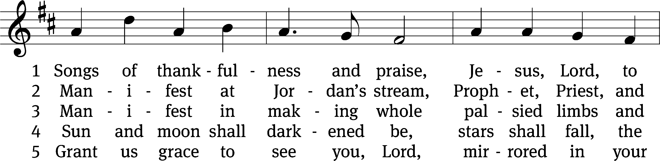
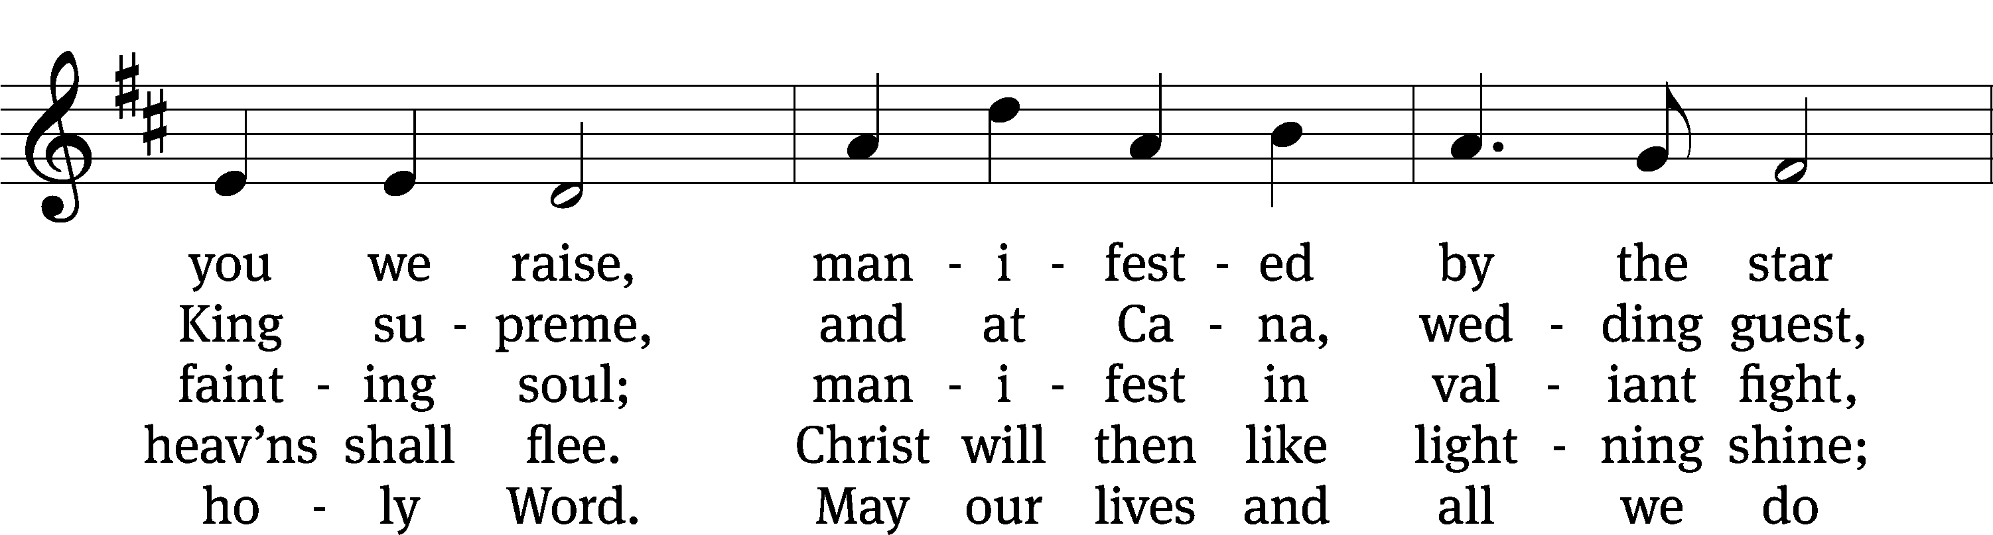
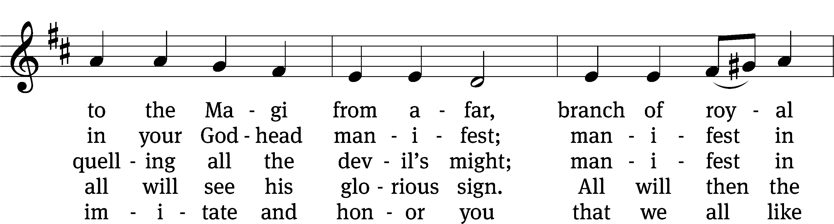
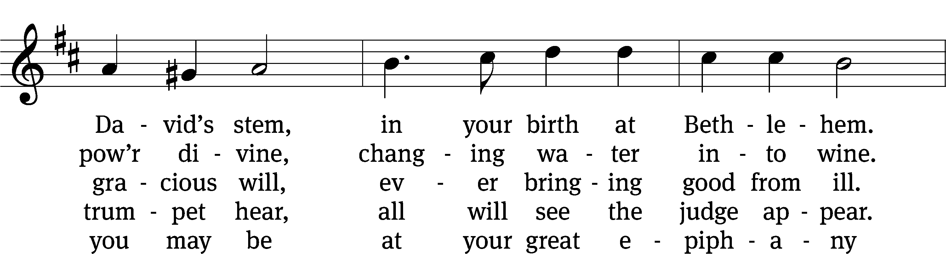
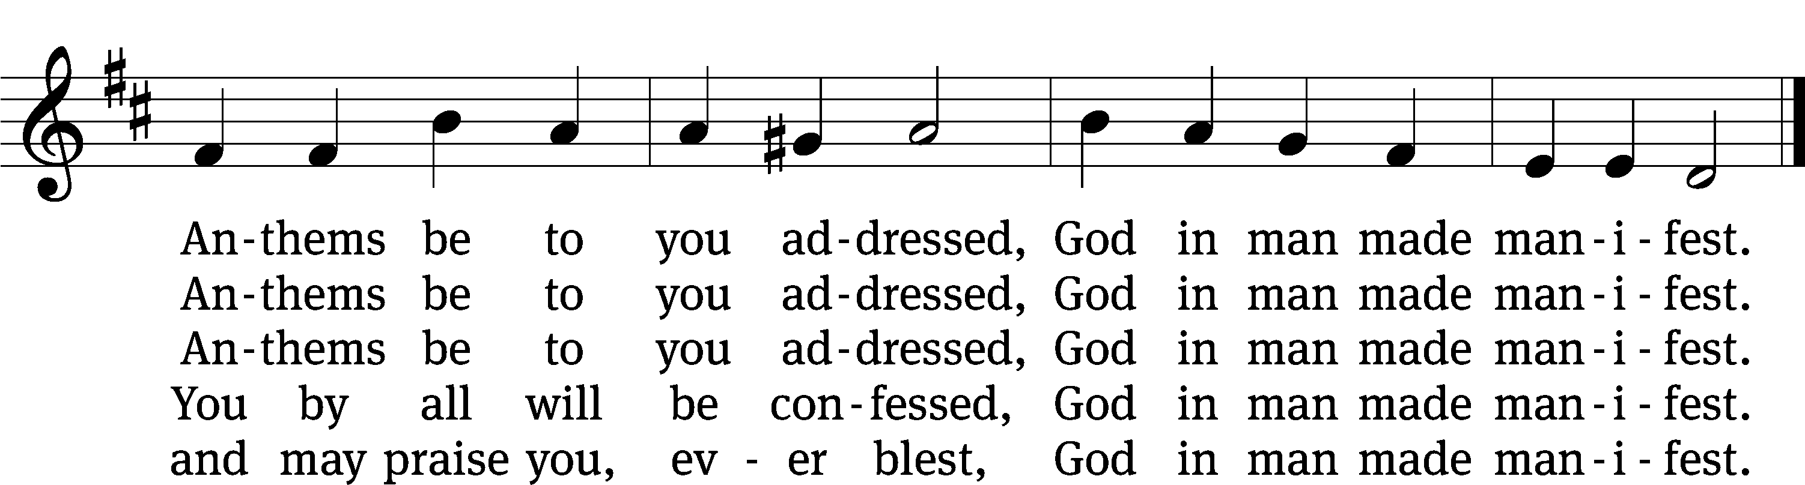
Text: Christopher Wordsworth, 1807–1885, alt.
Tune: Jakob Hintze, 1622–1702
Text and tune: Public domain

PLEASE STAND, IF YOU ARE ABLE

invocation
M: The grace of our Lord (+) Jesus Christ and the love of God and the fellowship of the Holy Spirit be with you.
C: And also with you.
CONFESSION OF SINS
M: We have come into the presence of God, who created us to love and serve him as his dear children. But we have disobeyed him and deserve only his wrath and punishment. Therefore, let us confess our sins to him and plead for his mercy.

C: Merciful Father in heaven, I am altogether sinful from birth. In countless ways I have sinned against you and do not deserve to be called your child. But trusting in Jesus, my Savior, I pray: Have mercy on me according to your unfailing love. Cleanse me from my sin, and take away my guilt.

M: God, our heavenly Father, has forgiven all your sins. By the perfect life and innocent death of our Lord Jesus Christ, he has removed your guilt forever. You are his own dear child. May God give you strength to live according to his will.

C: Amen.

PRAYER AND PRAISE

M: In the peace of forgiveness, let us praise the Lord.

OH, TASTE AND SEE

PRAYER OF THE DAY

Let us pray.

Father in heaven, at the baptism of Jesus in the River Jordan, you proclaimed him your beloved Son and anointed him with the Holy Spirit. Keep us who are baptized into Christ faithful in our calling as your children, and make us heirs with him of everlasting life; through your Son, Jesus Christ our Lord, who lives and reigns with you and the Holy Spirit, one God, now and forever.

PLEASE BE SEATED
The Word

the FIRST LESSON Isaiah 42:1-7

¹ Here is my servant, whom I uphold,
my chosen one in whom I delight.
I am placing my Spirit on him.
He will announce a just verdict for the nations.
² He will not cry out.
He will not raise his voice.
He will not make his voice heard in the street.
³ A bent reed he will not break,
and a dimly burning wick he will not snuff out.
He will faithfully bring forth a just verdict.
⁴ He will not burn out, and he will not be broken
until he establishes justice on the earth.
The coastlands will wait for his law.
⁵ This is what the true God says,
the Lord who creates the heavens and stretches them out,
who spreads out the earth
and everything that it produces,
who gives breath to the people on it
and life to those who walk on it.
⁶ I am the Lord.
I have called you in righteousness.
I will hold on to your hand,
and I will guard you.
I will appoint you to be a covenant for the people,
to be a light for the nations,
⁷ to open the eyes of the blind,
to bring the prisoners out from the dungeon,
and to bring those who sit in darkness out of prison.

45B Great Are the Works of the LORD Psalm 45B
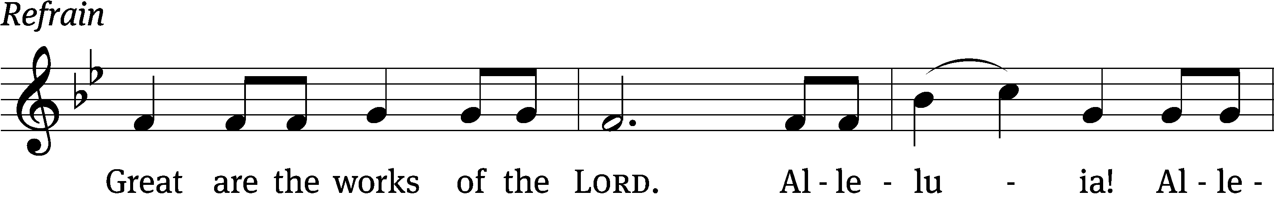
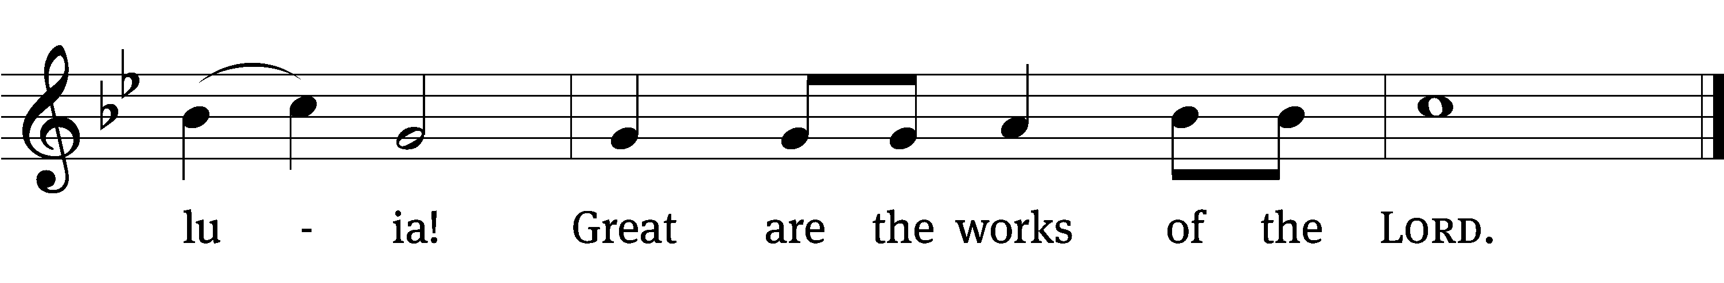
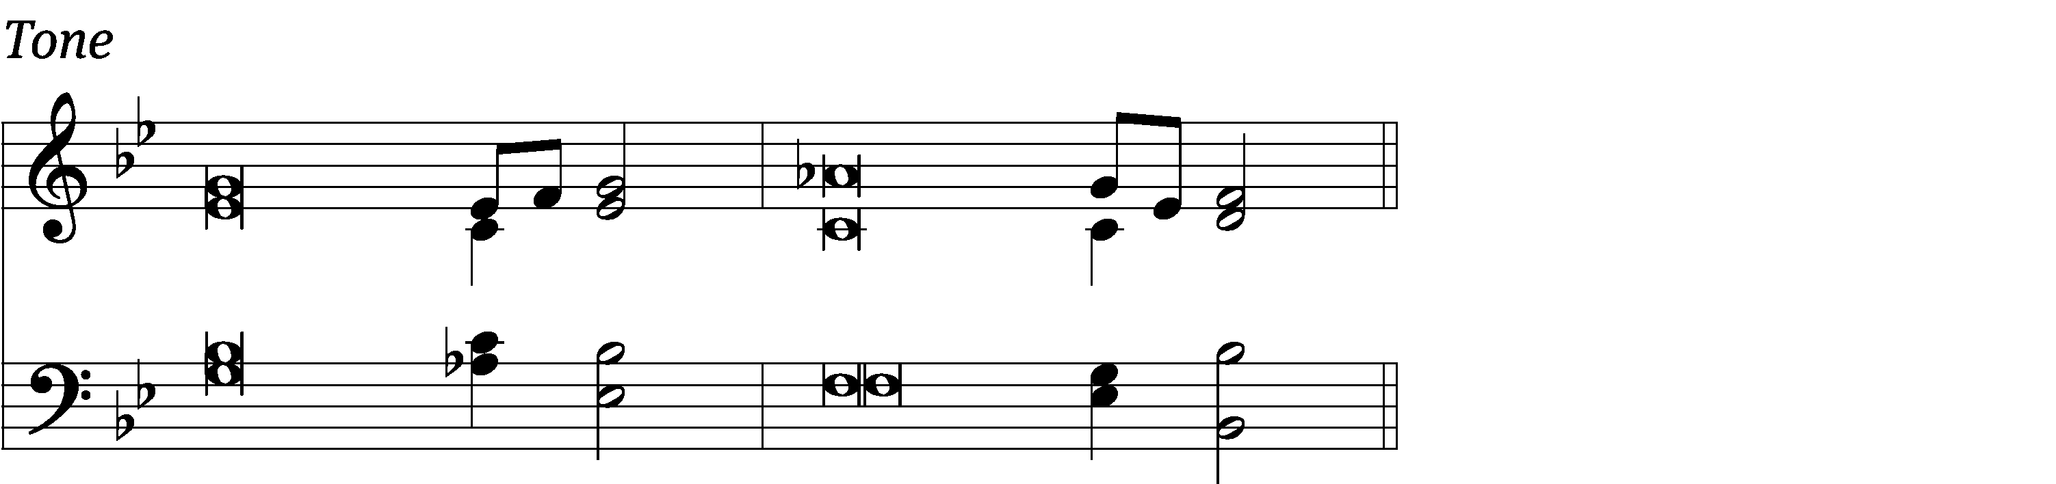

My heart is stirred by a / noble theme
as I recite my verses / for the king.
You are the most excel- / lent of men
and your lips have been anoint- / ed with grace.
Gird your sword on your side, you / mighty one;
clothe yourself with splendor and / majesty. Refrain

Your throne, O God, will last for ever and / ever;
a scepter of justice will be the scepter of your / kingdom.
You love righteousness and hate / wickedness;
therefore God, your God, has set you above your com- / panions.
I will perpetuate your memory through all gener- / ations;
therefore the nations will praise you for ever and / ever.
Glory be to the Father and / to the Son
and to the Holy / Spirit,
as it was in the be- / ginning,
is now, and will be forever. / Amen. Refrain
Music: © 1993 Kermit G. Moldenhauer, admin. Northwestern Publishing House. Used by permission: OneLicense no. 727703

THE SECOND LESSON Acts 10:34-38
³⁴ Then Peter began to speak: “Now I really am beginning to understand that God does not show favoritism, ³⁵ but in every nation, anyone who fears him and does what is right is acceptable to him. ³⁶ He sent his word to the people of Israel, proclaiming the good news of peace through Jesus Christ, who is Lord of all.
³⁷ “You know what happened throughout Judea, beginning in Galilee after the baptism that John preached. ³⁸ God anointed Jesus of Nazareth with the Holy Spirit and with power. He went around doing good and healing all who were oppressed by the Devil, because God was with him.

please stand, if you are able

Verse of the day

Alleluia. You are my Son, whom I love; with you I am well pleased. Alleluia. (Mark 1:11)

THE GOSPEL LESSON Matthew 3:13-17
M: The Gospel according to Matthew chapter 3, verses 13-17
¹³ Then Jesus came from Galilee to be baptized by John at the Jordan. ¹⁴ But John tried to stop him, saying, “I need to be baptized by you, and yet you come to me?”
¹⁵ But Jesus answered him, “Let it be so now, because it is proper for us to fulfill all righteousness.” Then John let him. ¹⁶ After Jesus was baptized, he immediately went up out of the water. Suddenly, the heavens were opened for him! He saw the Spirit of God, descending like a dove and landing on him, ¹⁷ and a voice out of the heavens said, “This is my Son, whom I love. I am well pleased with him.”

M: This is the Gospel of the Lord.

PLEASE BE SEATED
377 To Jordan’s River Came Our Lord CW 377
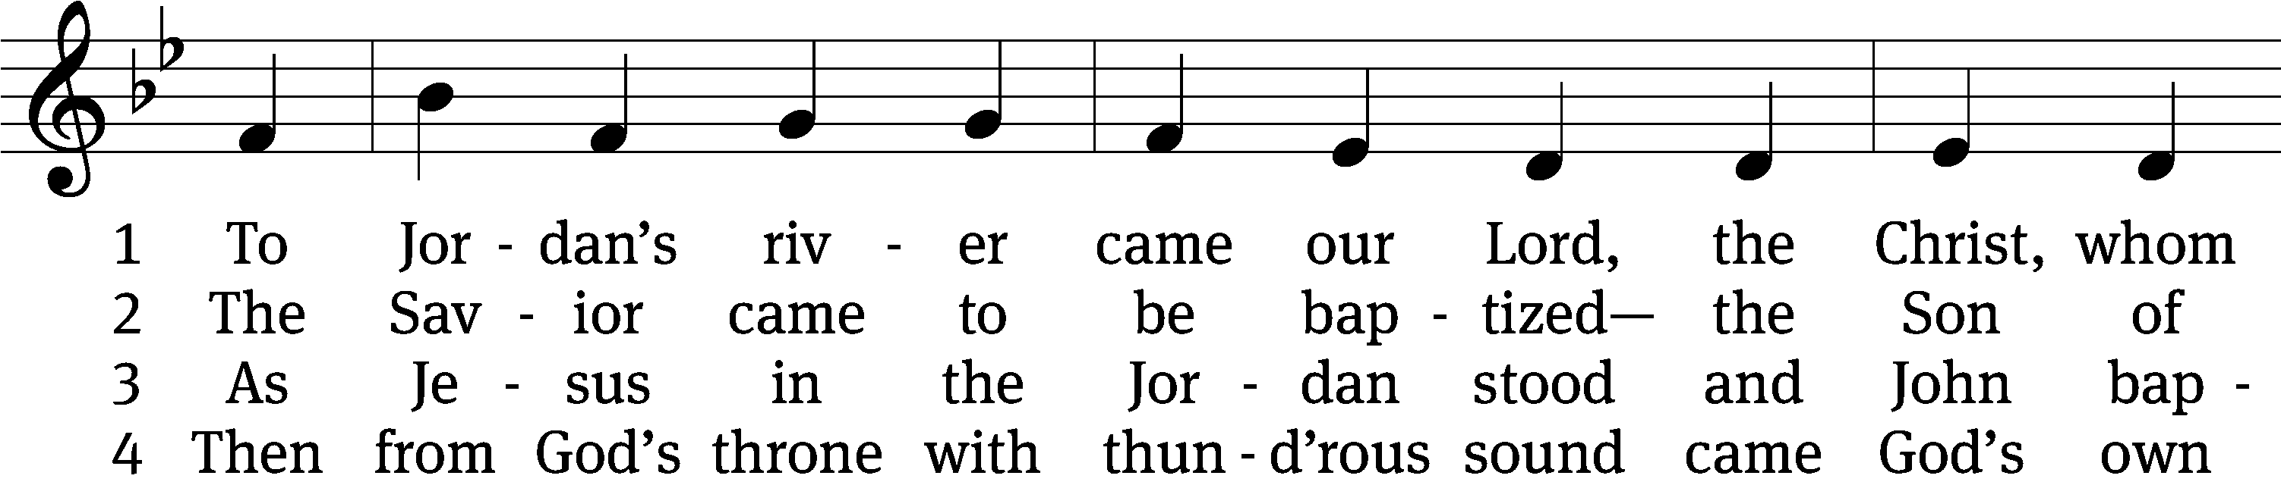
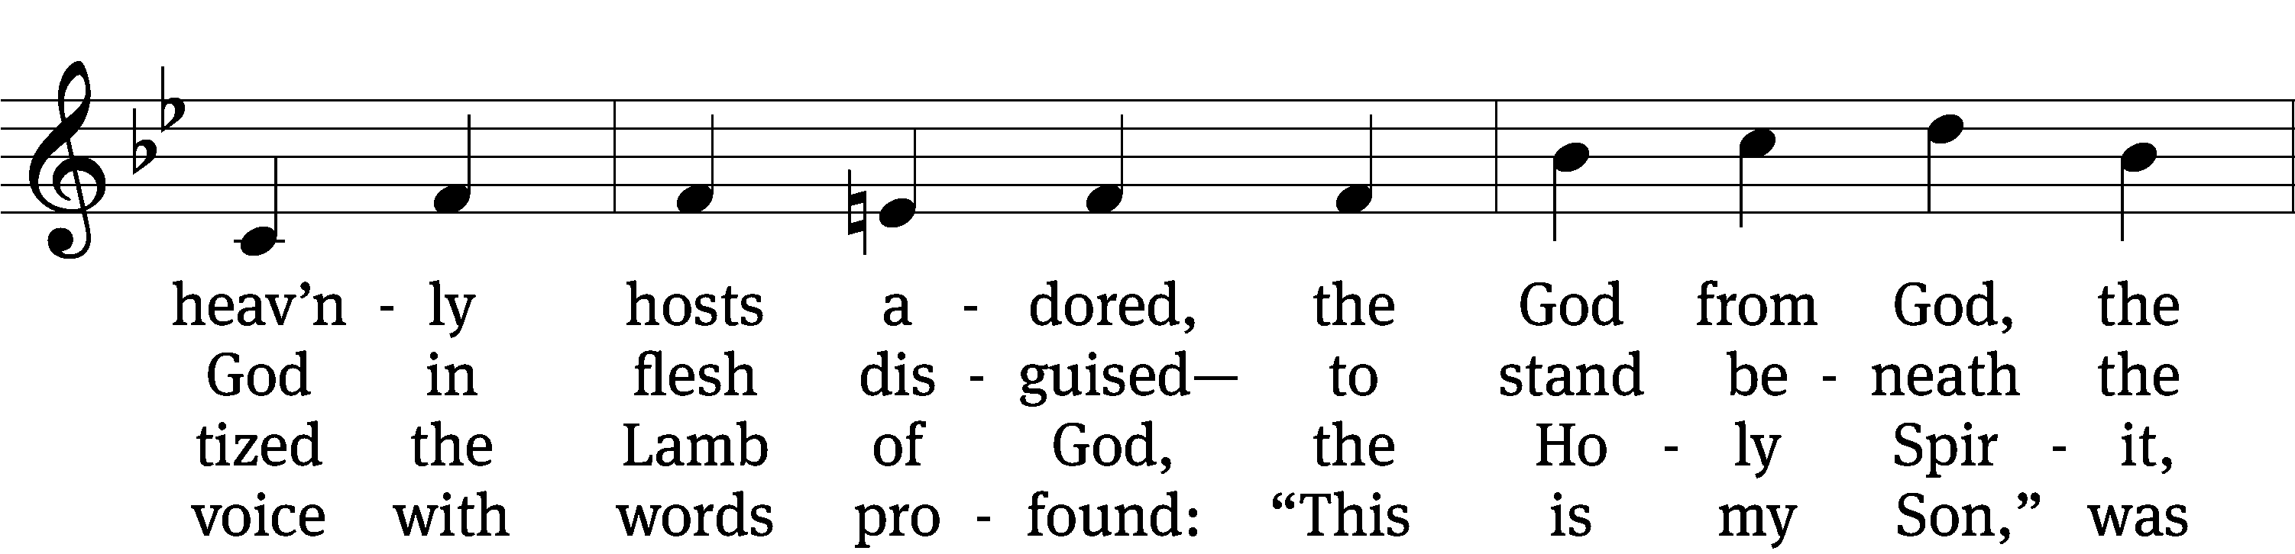
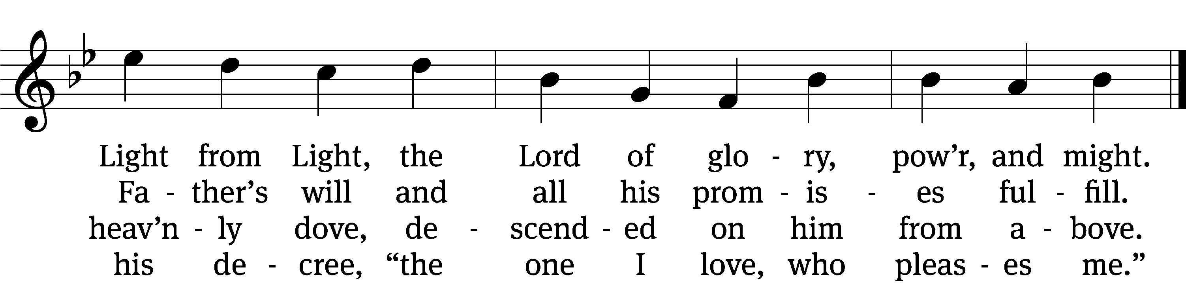

5 The Father’s word, the Spirit’s flight
anointed Christ in glorious sight
as God’s own choice, from Adam’s fall
to save the world and free us all.

6 Now rise, faint hearts: be resolute!
This man is Christ, our substitute!
He was baptized in Jordan’s stream,
proclaimed Redeemer, Lord supreme.
Text: James P. Tiefel, b. 1949
Tune: Musicalisch Hand-Buch der Geistlichen Melodien, Hamburg, 1690, alt.
Text: © 1993 James P. Tiefel, admin. Northwestern Publishing House. Used by permission: OneLicense no. 727703
Tune: Public domain

SERMON Matthew 3:13-17
“Following in Someone Else’s Footprints”

PLEASE STAND, IF YOU ARE ABLE

THE APOSTLES’ CREED
I believe in God, the Father almighty,
maker of heaven and earth.
I believe in Jesus Christ, his only Son, our Lord,
who was conceived by the Holy Spirit,
born of the virgin Mary,
suffered under Pontius Pilate,
was crucified, died, and was buried.
He descended into hell.
The third day he rose again from the dead.
He ascended into heaven
and is seated at the right hand of God the Father almighty.
From there he will come to judge the living and the dead.
I believe in the Holy Spirit,
the holy Christian Church,
the communion of saints,
the forgiveness of sins,
the resurrection of the body,
and the life everlasting. Amen.

PRAYER OF THE CHURCH

THE LORD’S PRAYER

C: Our Father, who art in heaven, hallowed be thy name, thy kingdom come, thy will be done on earth as it is in heaven. Give us this day our daily bread; and forgive us our trespasses, as we forgive those who trespass against us; and lead us not into temptation, but deliver us from evil. For thine is the kingdom and the power and the glory forever and ever. Amen.

PLEASE BE SEATED

379 Christ, Your Footprints through the Desert CW 379
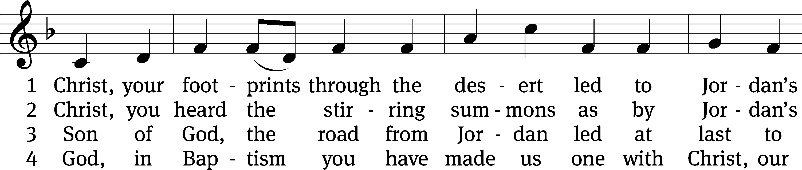
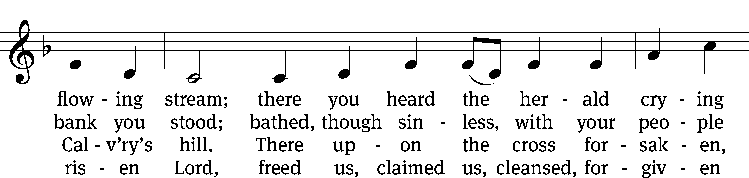
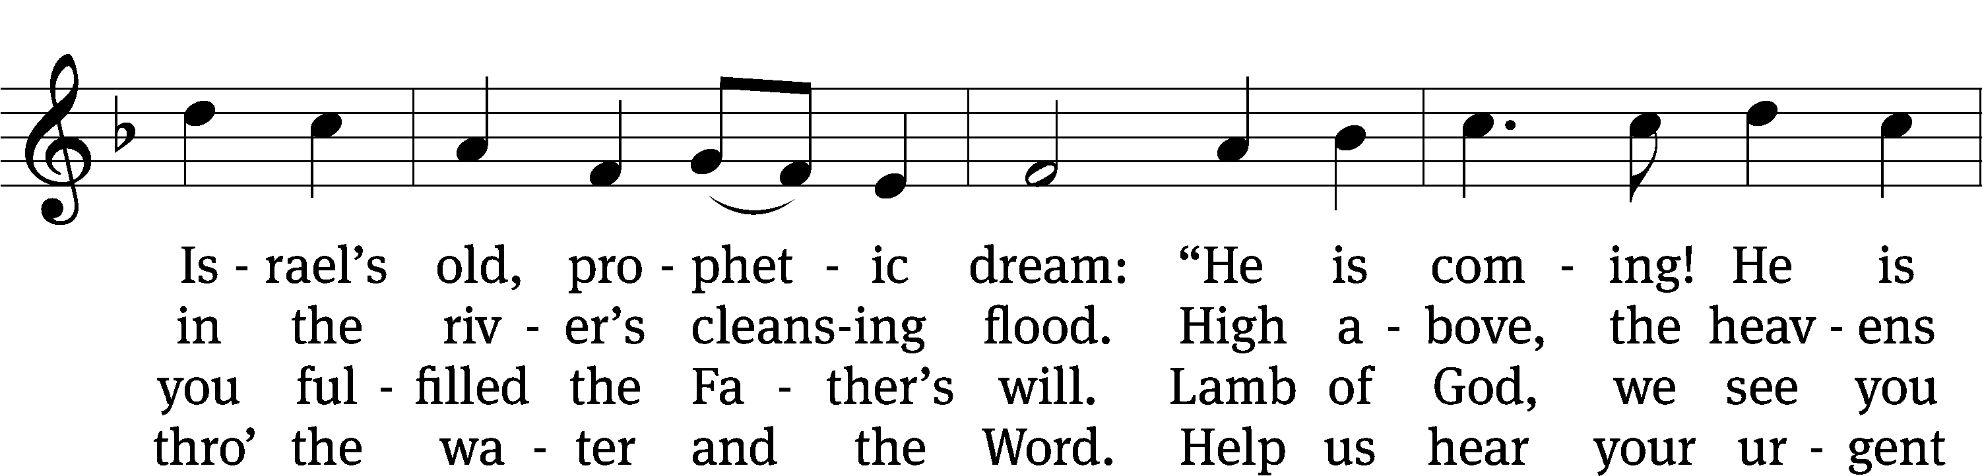
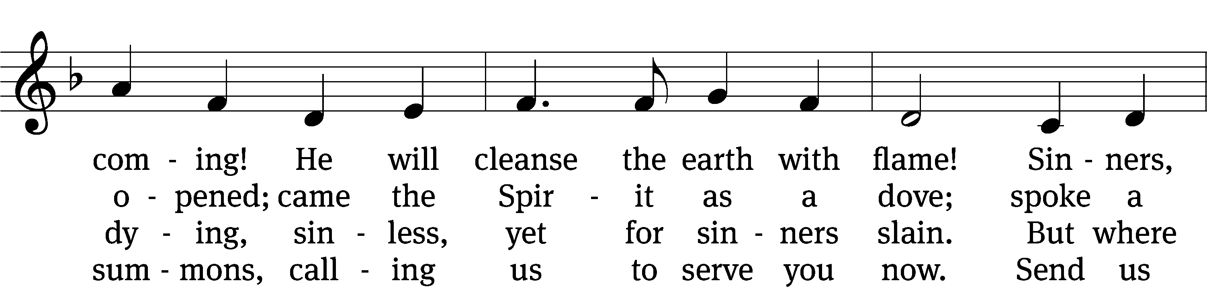
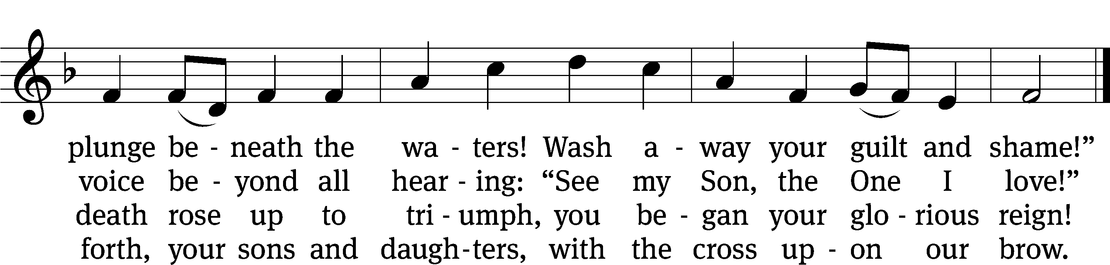
Text: Herman G. Stuempfle, Jr., 1923–2007
Tune: Amanda Husberg, 1940–2021
Text: © 2000 GIA Publications, Inc. Used by permission: OneLicense no. 727703
Tune: © 2000 Selah Publishing Co., Inc. Used by permission: OneLicense no. 727703

PLEASE STAND, IF YOU ARE ABLE

CLOSING PRAYER
M: Almighty God, we thank you for teaching us the things you want us to believe and do. Help us by your Holy Spirit to keep your Word in pure hearts that we may be strengthened in faith, guided in holiness, and comforted in life and in death, through Jesus Christ, our Lord, who lives and reigns with you and the Holy Spirit, one God, now and forever.

M: Brothers and sisters, go in peace. Live in harmony with one another. Serve the Lord with gladness.
The Lord bless you and keep you.
The Lord make his face shine on you and be gracious to you.
The Lord look on you with favor and (+) give you peace.

PLEASE BE SEATED

384 Hail to the Lord’s Anointed CW 384
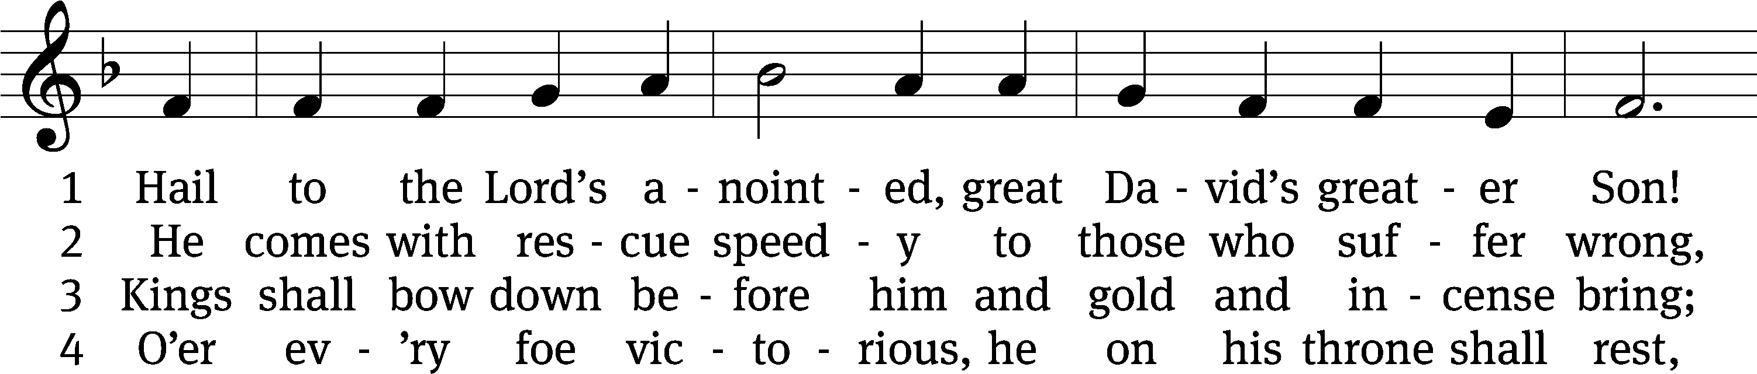
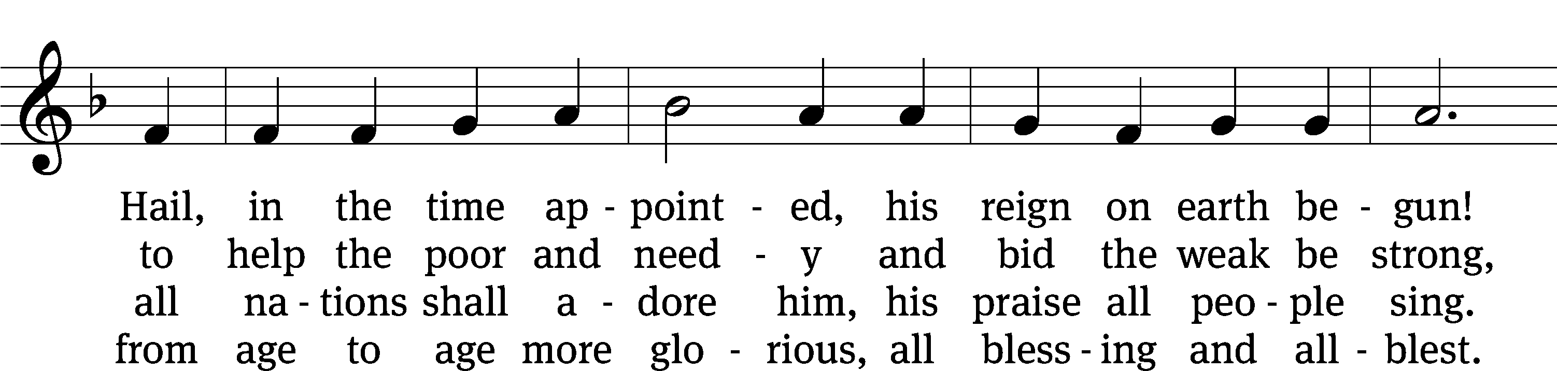
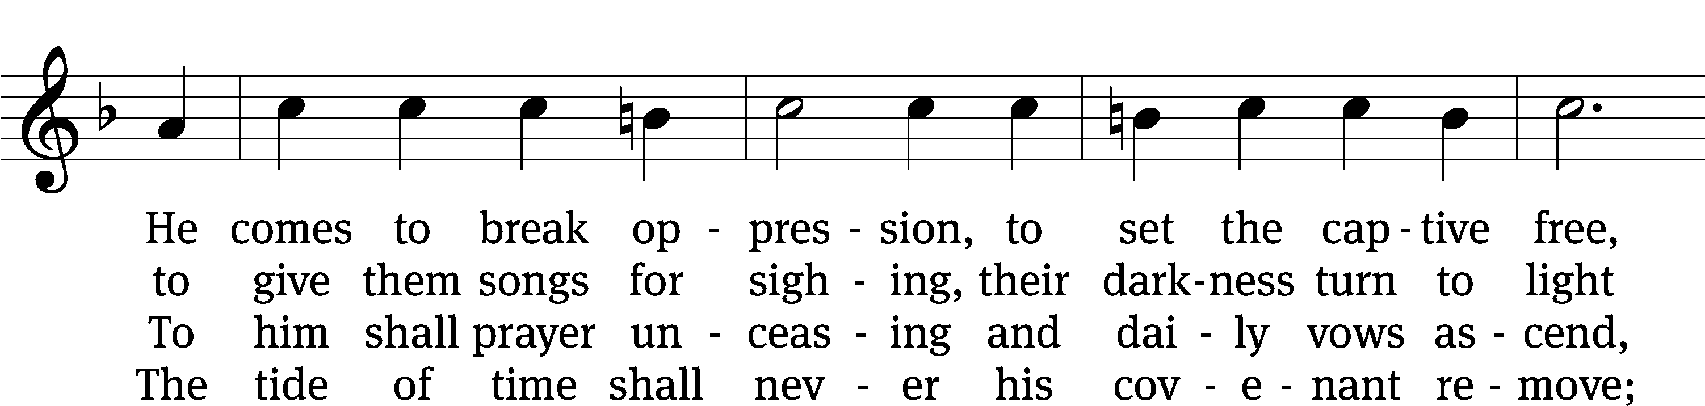
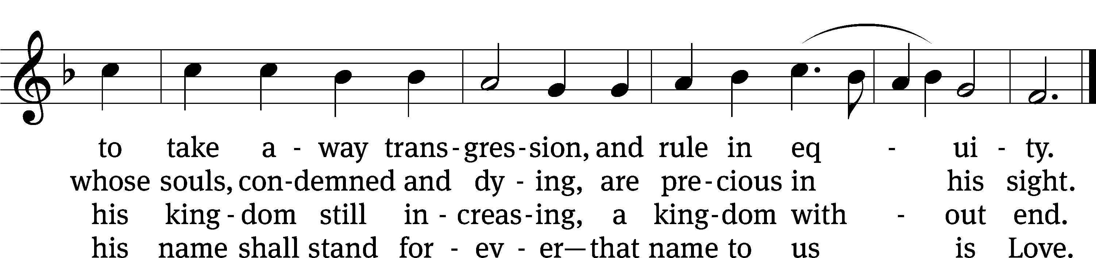
Text: James Montgomery, 1771–1854, abr., alt.
Tune: Leonhart Schröter, c. 1532–c. 1601
Text and tune: Public domain

Serving In Worship
Officiant Pastor Natsis
Organist Ann Hoeft
Deacons (8:30) Dave Stevenson and Jim Tice
(11:00) Steve Hoeft and Jeff Neuburger
Ushers (8:30) Dale Finkbeiner and Mark Finkbeiner
(11:00) Al Whitley
Altar Guild Sharon Boswell and Brenda Stevenson
Videographer Jake Vershum

Copyright information
Service of the Word: Christian Worship. © 1993 Northwestern Publishing House. All rights reserved.
Reprinted with permission under ONE LICENSE #A-727703 and CCLI #1151741/CSPL126093

Words and Music: All rights reserved. Reprinted with permission under ONE LICENSE #A-727703 and
CCLI #1151741/CSPL126093

tlcsaline.church

