THE FIFTH SUNDAY
AFTER EPIPHANY
TRINITY EVANGELICAL LUTHERAN CHURCH | Saline, Michigan
WELCOME TO WORSHIP February 5, 2023
Thank you for joining us in God’s house today! We cordially ask that our Guests sign one of the guestbooks located at either the front or back entryways, or fill out a “Let’s Get Acquainted” card located in the hymnal pew rack and place it in the collection plate.

THANK OFFERING: Members of Trinity give their offering as an expression of love and thankfulness to the Lord and to help support the Lord’s work in our community and around the world. Visitors need not feel obligated to participate in this offering which supports our ministry.

Restrooms are located at the back of the upper level (the annex), and in the basement (down the back stairs of the sanctuary or annex). Handicap access is available, please ask an usher for assistance.

Young Families / Toddler Bags – We are GLAD YOU BROUGHT YOUR CHILDREN to our worship service. Jesus said: “Let the little children come to me and do not hinder them, for the kingdom of God belongs to such as these.” We know that having little children in church can be a challenge, but DO NOT WORRY about it. Many of your fellow worshippers have been in your shoes and are just happy you brought your children with you. For your convenience, we have reserved the back rows of seating for parents with small children. These areas provide more flexibility for your family, as well as, easy access to move downstairs if necessary. A closed-circuit TV system allows families to continue participating in the service while downstairs. Pre-school toddler bags and children’s bulletins are available for their enjoyment. Ask an usher for one to use during the service and please return the toddler bag afterwards.

celebration of holy communion:
In His Word, God makes it clear that the Lord’s Supper is to be shared by people of a common proclamation of faith (1 Corinthians 11:26; 1 Corinthians 10:16-17). Without judging anyone’s hearts, we invite those who share in our confession by their membership in our congregation or another congregation of the Wisconsin Evangelical Lutheran Synod (WELS) or the Evangelical Lutheran Synod (ELS) and who are properly prepared (1 Corinthians 11;27-29) to receive the Sacrament. Page 295 in Christian Worship provides a guide for preparation.
Guests, we would love to have you join us in communion fellowship in the future, and for that to be possible, we ask that you speak with one of the pastors so that we may speak with you on how that would be possible. We thank you for respecting the way we celebrate the Lord’s Supper in our congregations.
the SERVICE – setting one - WITH HOLY COMMUNION CW, page 154

On Eagles’ Wings

Please stand, if you are able

Invocation
In the name of the Father and of the Son and of the Holy Spirit.
Amen.
Confession
If we claim to be without sin, we deceive ourselves and the truth is not in us.
If we confess our sins, God is faithful and just
and will forgive us our sins
and purify us from all unrighteousness.

Let us confess our sins to the Lord.
Holy God, gracious Father,
I am sinful by nature
and have sinned against you in my thoughts, words, and actions.
I have not loved you with my whole heart;
I have not loved others as I should.
I deserve your punishment both now and forever.
But Jesus, my Savior, paid for my sins
with his innocent suffering and death.
Trusting in him, I pray: God, have mercy on me, a sinner.

Our gracious Father in heaven has been merciful to us. He sent his only Son, Jesus Christ, who gave his life as the atoning sacrifice for the sins of the whole world. Therefore, as a called servant of Christ and by his authority, I forgive you all your sins in the name of the Father and of the Son and of the Holy Spirit.
Amen.

Lord, Have Mercy

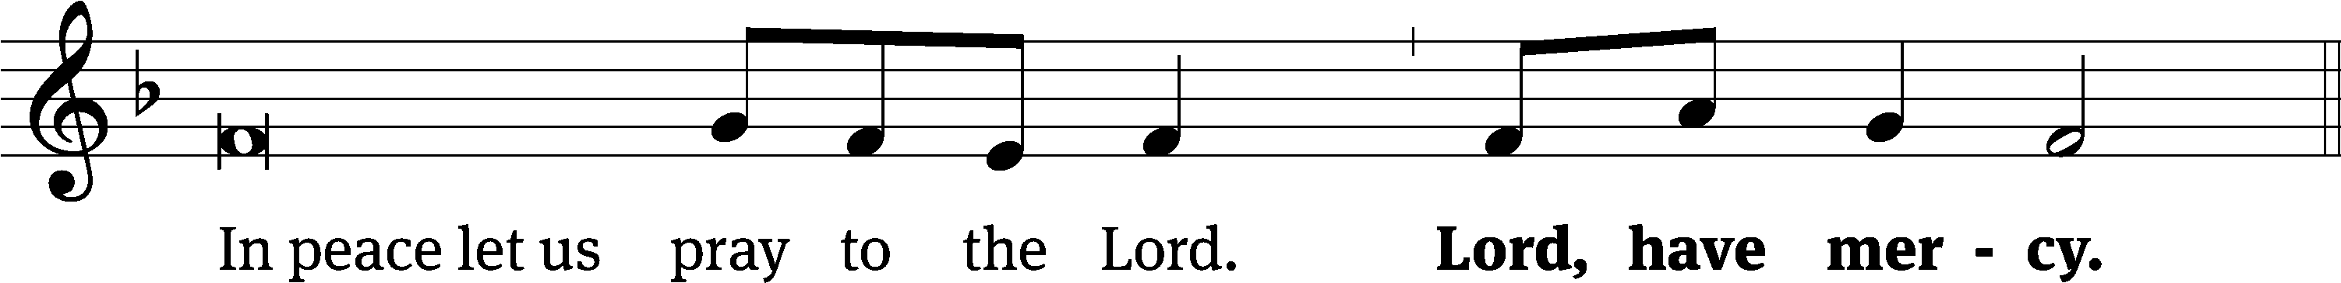
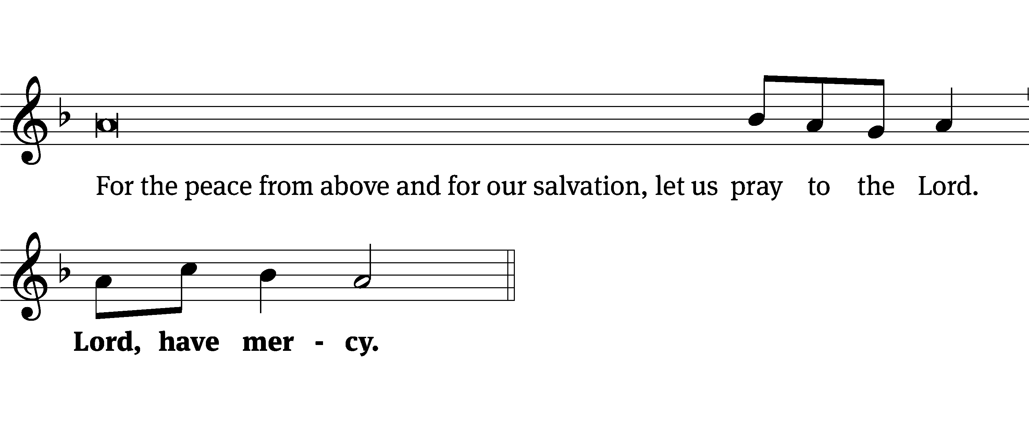
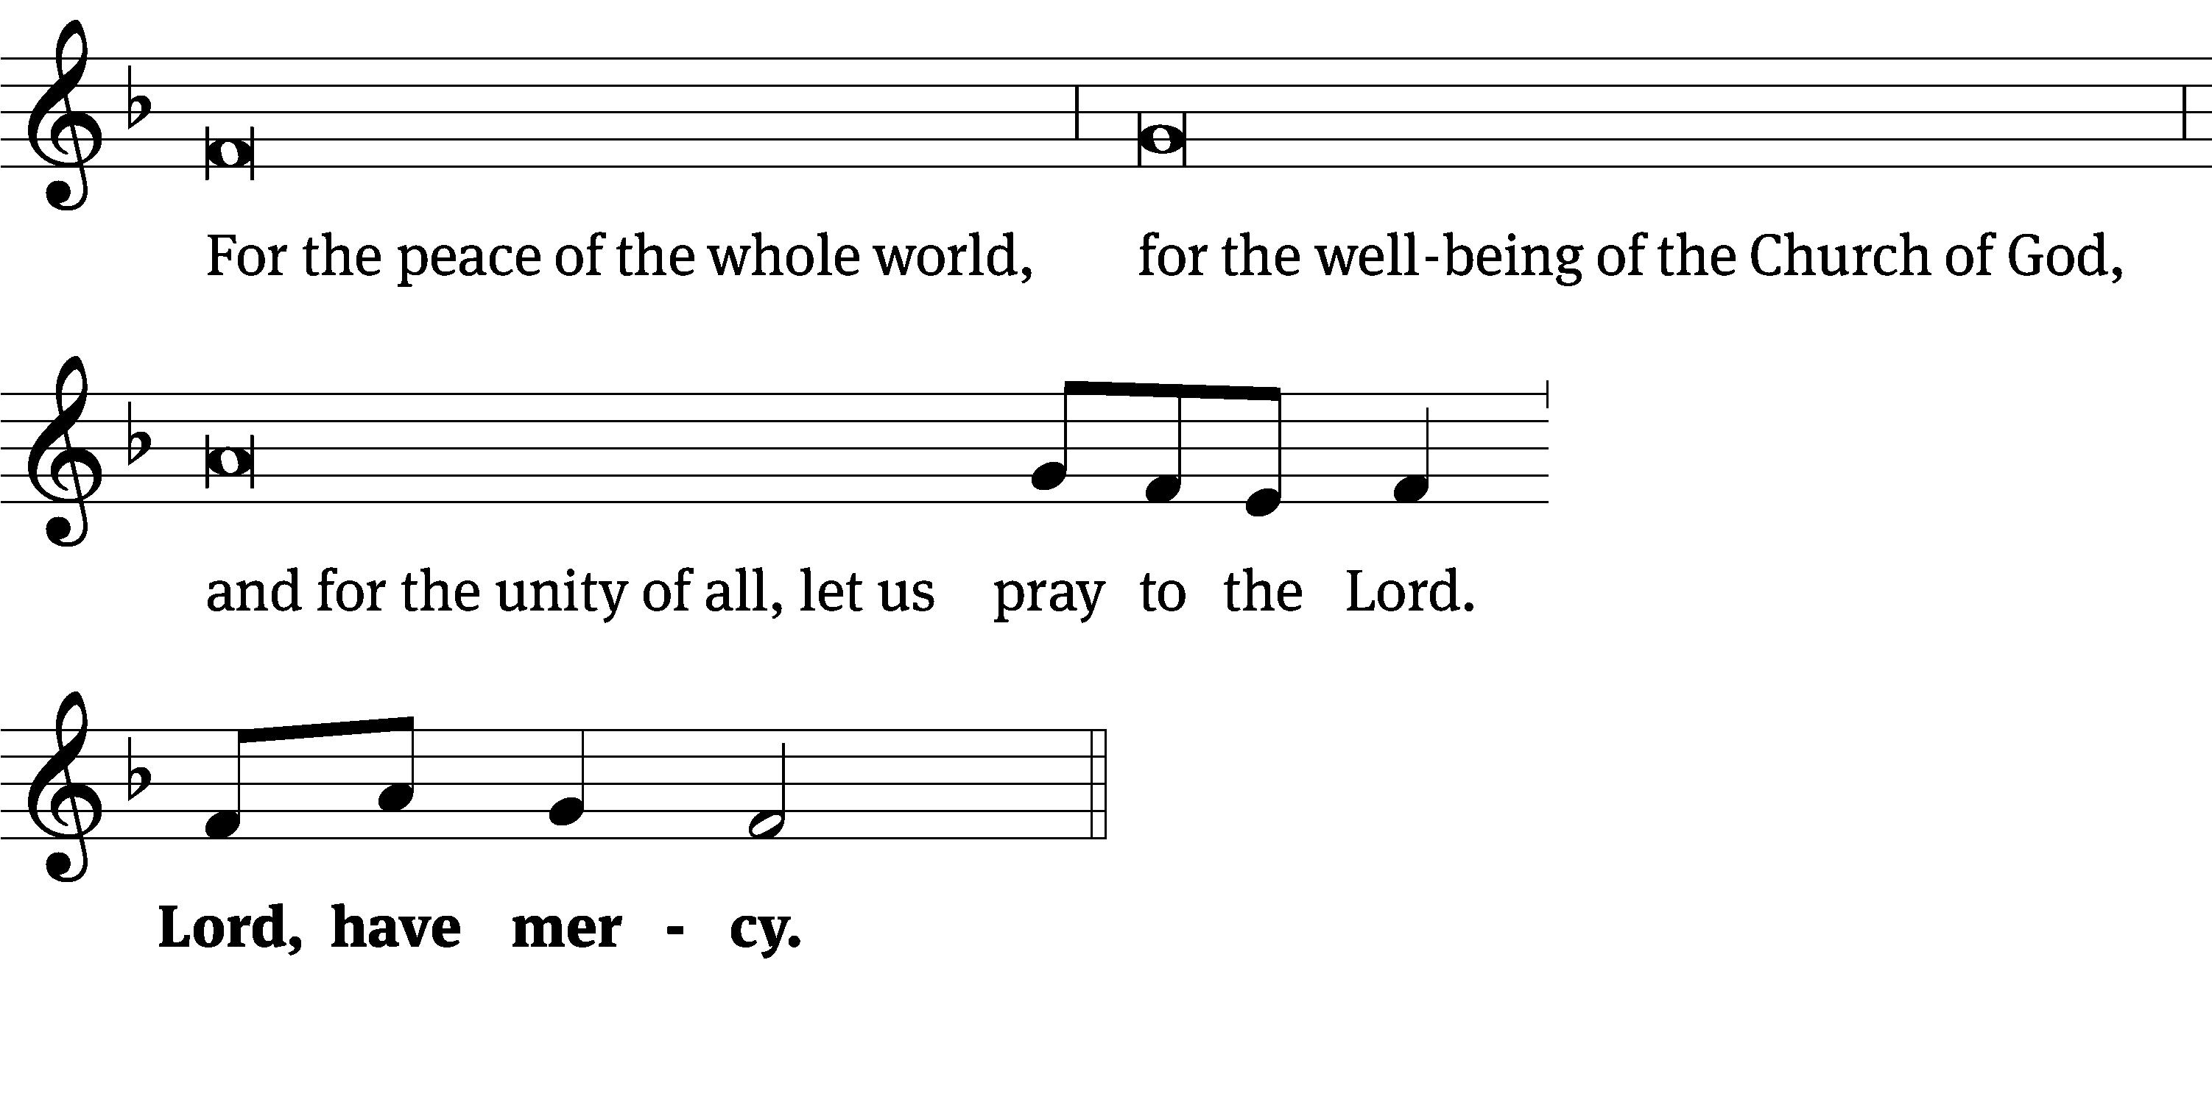
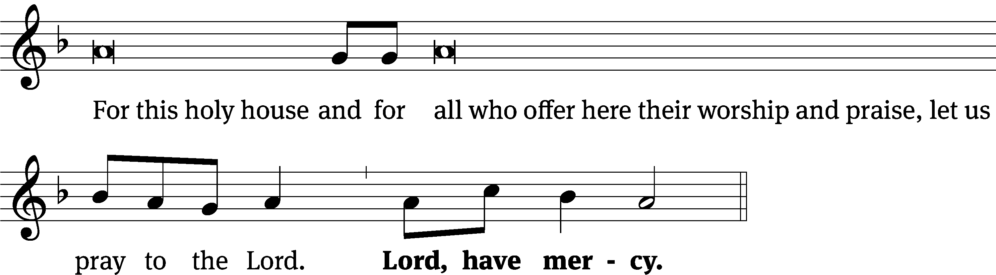
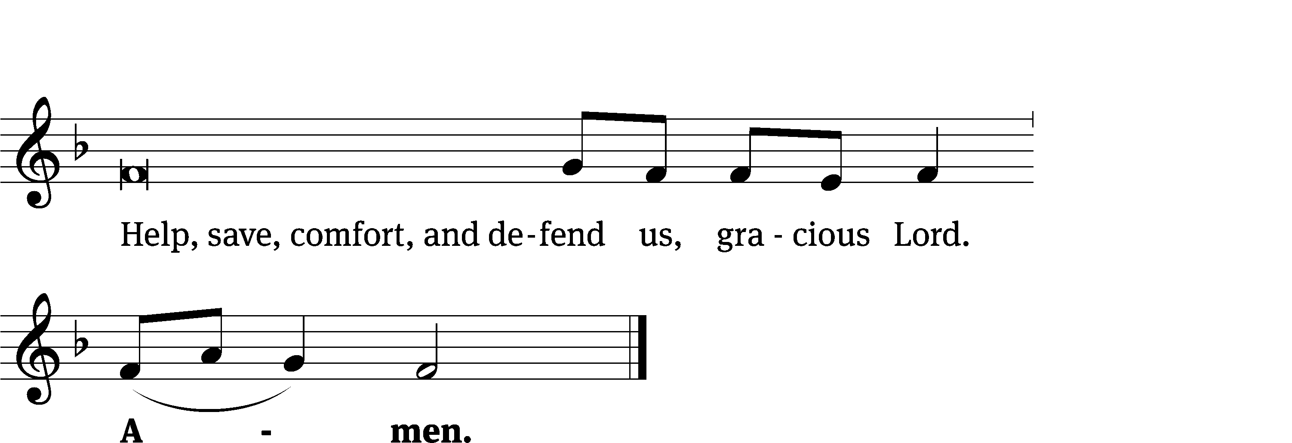
Glory Be to God CW 157
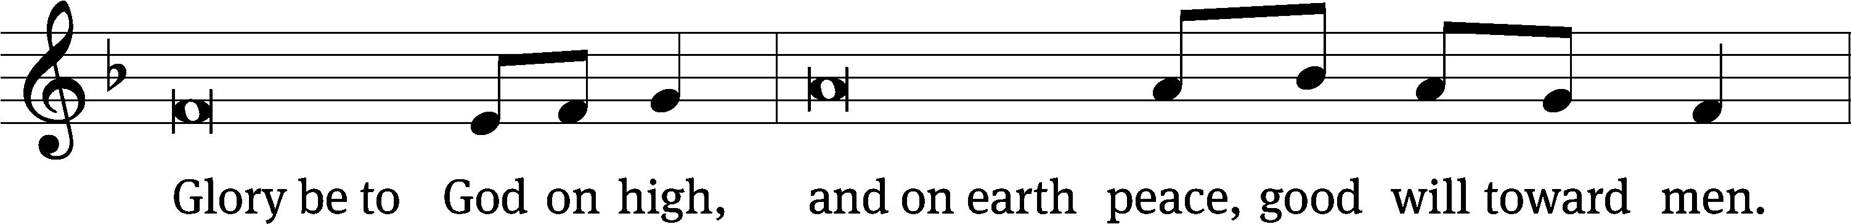
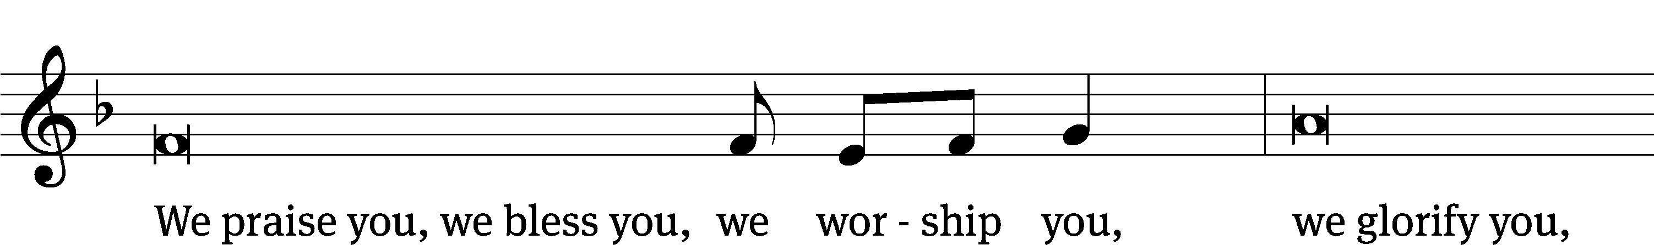
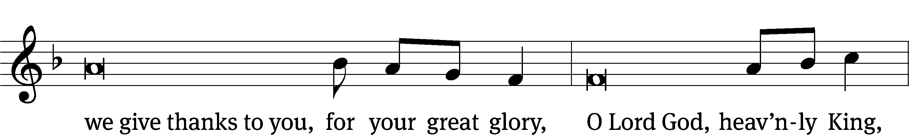
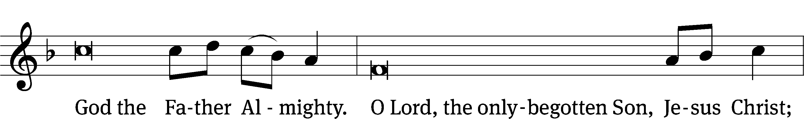
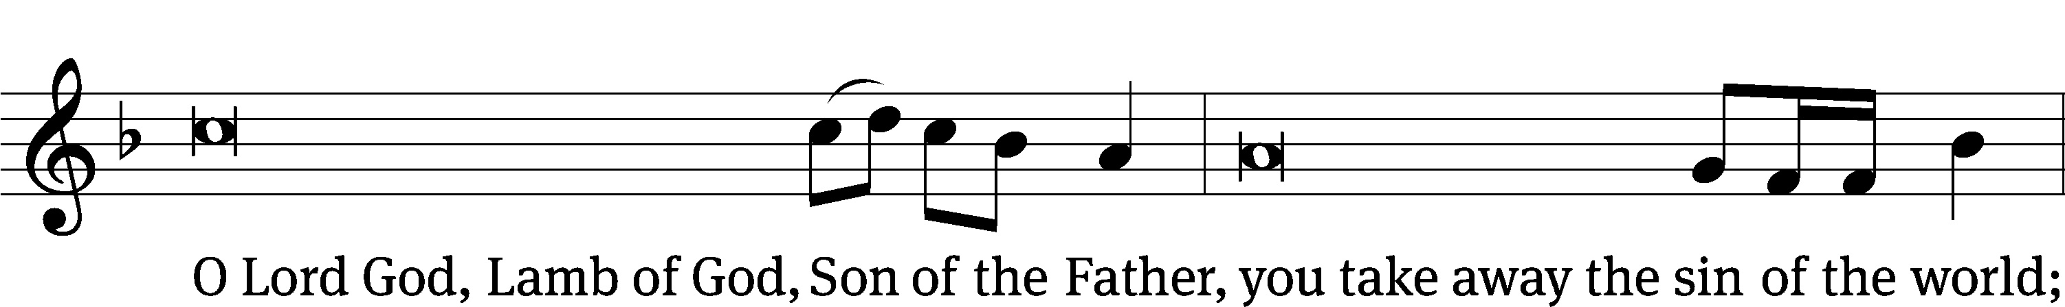
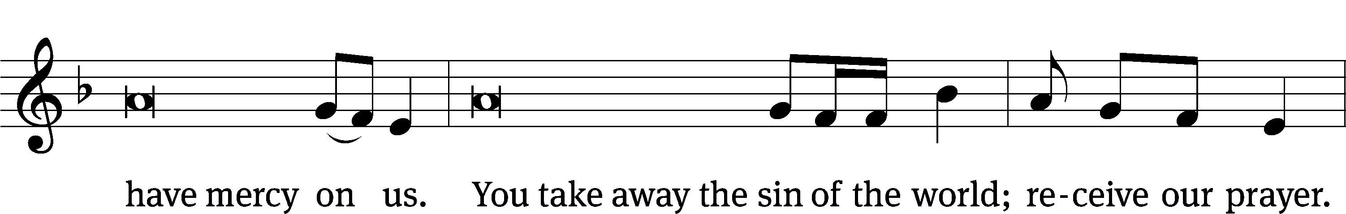
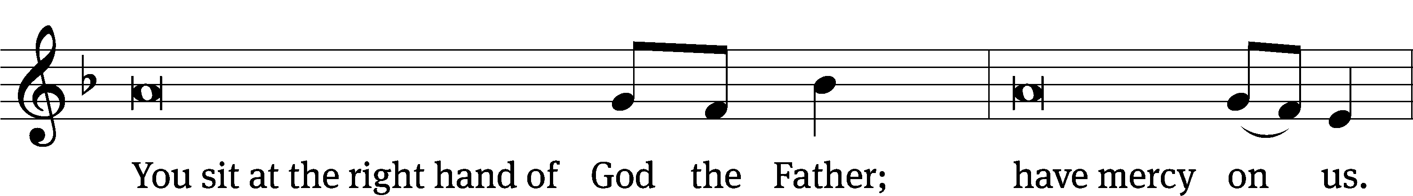
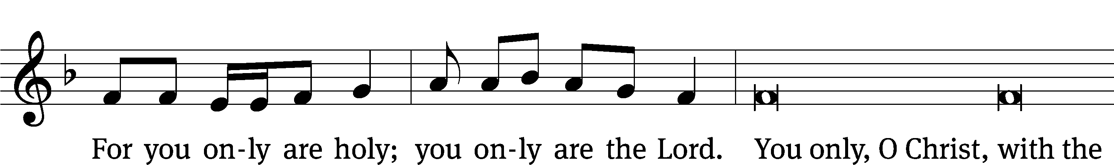
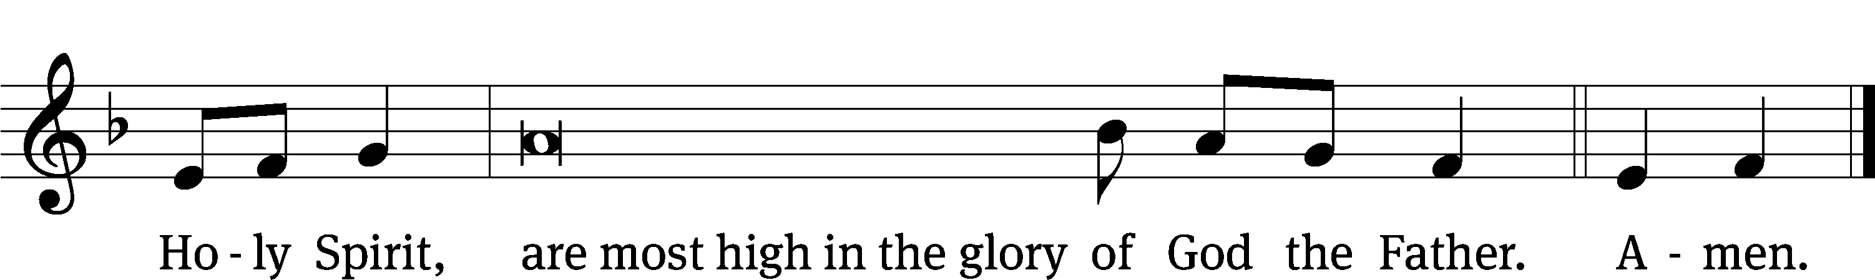

The Lord be with you.
And also with you.
Prayer of the Day
Let us pray.

Almighty God, you sent your one and only Son as the Word of life for our eyes to see and our ears to hear. Help us believe what the Scriptures proclaim about him and do the things that are pleasing in your sight; through your Son, Jesus Christ our Lord, who lives and reigns with you and the Holy Spirit, one God, now and forever.
Amen.

Please be seated

First Reading Exodus 19:1-8a
In the third month after the Israelites had left the land of Egypt, on that same day of the month, they came to the Wilderness of Sinai. ² After they set out from Rephidim and came to the Wilderness of Sinai, they camped in the wilderness. Israel camped there in front of the mountain.
³ Moses went up to God, and the Lord called to him from the mountain, “This is what you are to say to the house of Jacob and to tell the people of Israel: ⁴ ‘You have seen what I did to the Egyptians and how I carried you on eagles’ wings and brought you to myself. ⁵ Now if you will carefully listen to my voice and keep my covenant, then you will be my special treasure out of all the nations, although the entire earth is mine. ⁶ You will be my kingdom of priests and my holy nation.’ These are the words that you are to speak to the Israelites.”
⁷ Moses went and summoned the elders of the people, and he set before them all these words that the Lord had commanded him. ⁸ All the people answered together, “Everything that the Lord has said, we will do.”

The Word of the Lord.
Thanks be to God.

Second Reading 1 Peter 2:9-12
⁹ But you are a chosen people, a royal priesthood, a holy nation, the people who are God’s own possession, so that you may proclaim the praises of him who called you out of darkness into his marvelous light. ¹⁰ At one time you were not a people, but now you are the people of God. At one time you were not shown mercy, but now you have been shown mercy.
¹¹ Dear friends, I urge you, as aliens and temporary residents in the world, to abstain from the desires of the sinful flesh, which war against your soul. ¹² Live an honorable life among the Gentiles so that even though they slander you as evildoers, when they observe your noble deeds, they may glorify God on the day he visits us.

The Word of the Lord.
Thanks be to God.

Please stand, if you are able

Gospel Acclamation Matthew 5:16
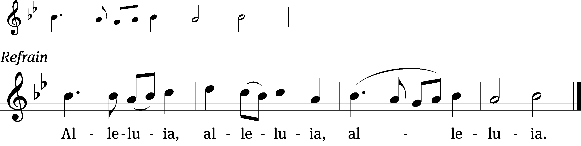
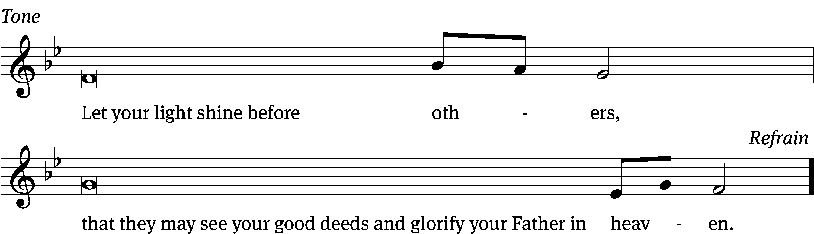
Tune: © 2021 Northwestern Publishing House. Used by permission: OneLicense no. 727703

Gospel Matthew 5:13-20
¹³ “You are the salt of the earth, but if salt has lost its flavor, how will it become salty again? Then it is no good for anything except to be thrown out and trampled on by people. ¹⁴ You are the light of the world. A city located on a hill cannot be hidden. ¹⁵ People do not light a lamp and put it under a basket. No, they put it on a stand, and it gives light to all who are in the house. ¹⁶ In the same way let your light shine in people’s presence, so that they may see your good works and glorify your Father who is in heaven.
¹⁷ “Do not think that I came to destroy the Law or the Prophets. I did not come to destroy them but to fulfill them. ¹⁸ Amen^{[a]} I tell you: Until heaven and earth pass away, not even the smallest letter, or even part of a letter, will in any way pass away from the Law until everything is fulfilled. ¹⁹ So whoever breaks one of the least of these commandments and teaches others to do the same will be called least in the kingdom of heaven. But whoever practices and teaches them will be called great in the kingdom of heaven. ²⁰ Indeed I tell you that unless your righteousness surpasses that of the Pharisees and experts in the law, you will never enter the kingdom of heaven.

The Gospel of the Lord.
Praise be to you, O Christ!

Please be seated

Text: James E. Seddon, 1915–1983
Tune: Cyril V. Taylor, 1907–1992
Text: © 1982 The Jubilate Group, admin. Hope Publishing Co. Used by permission: OneLicense no. 727703
Tune: © 1942, ren. 1970 Hope Publishing Co. Used by permission: OneLicense no. 727703

854 Church of God, Elect and Glorious CW 854
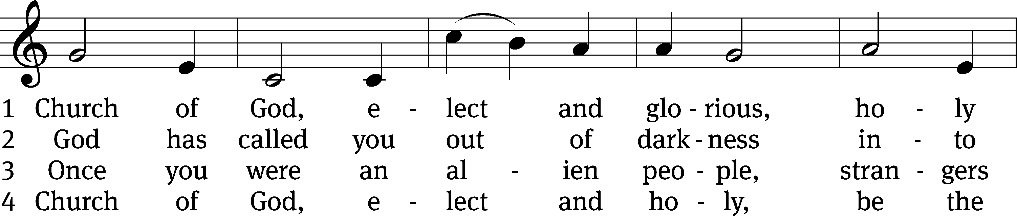
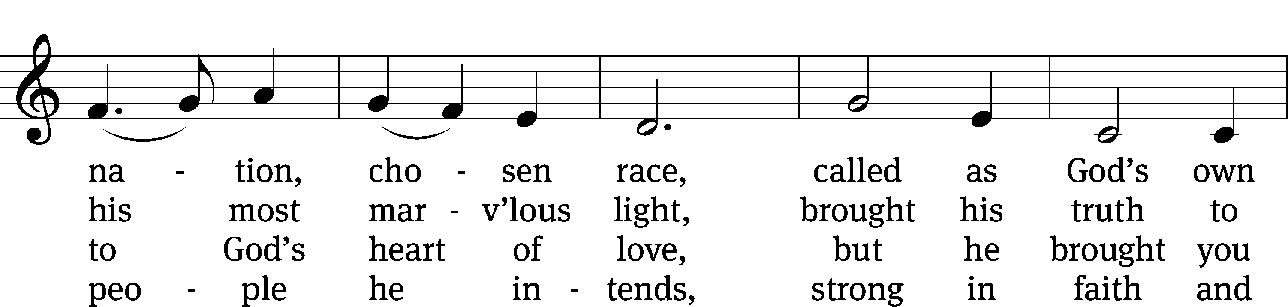
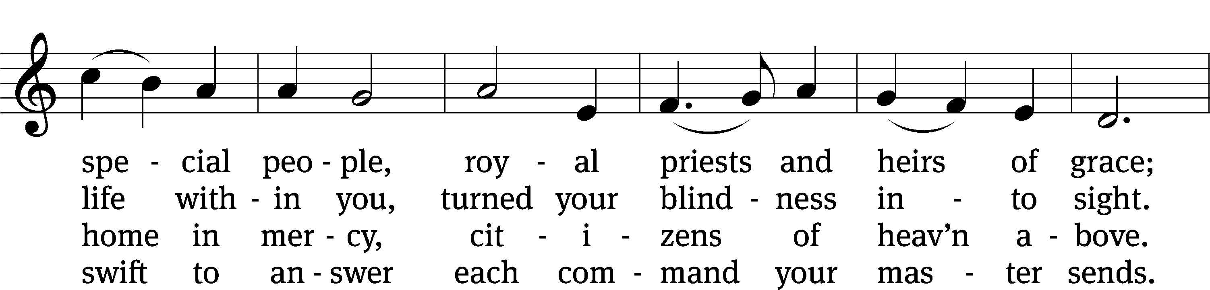
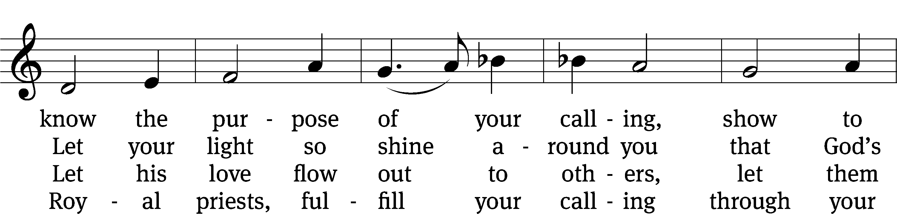
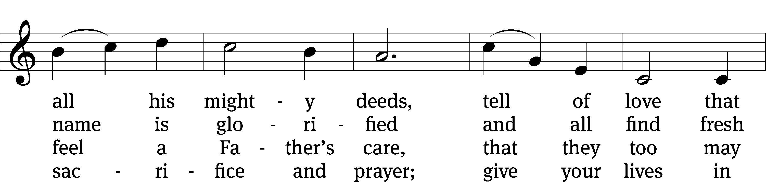
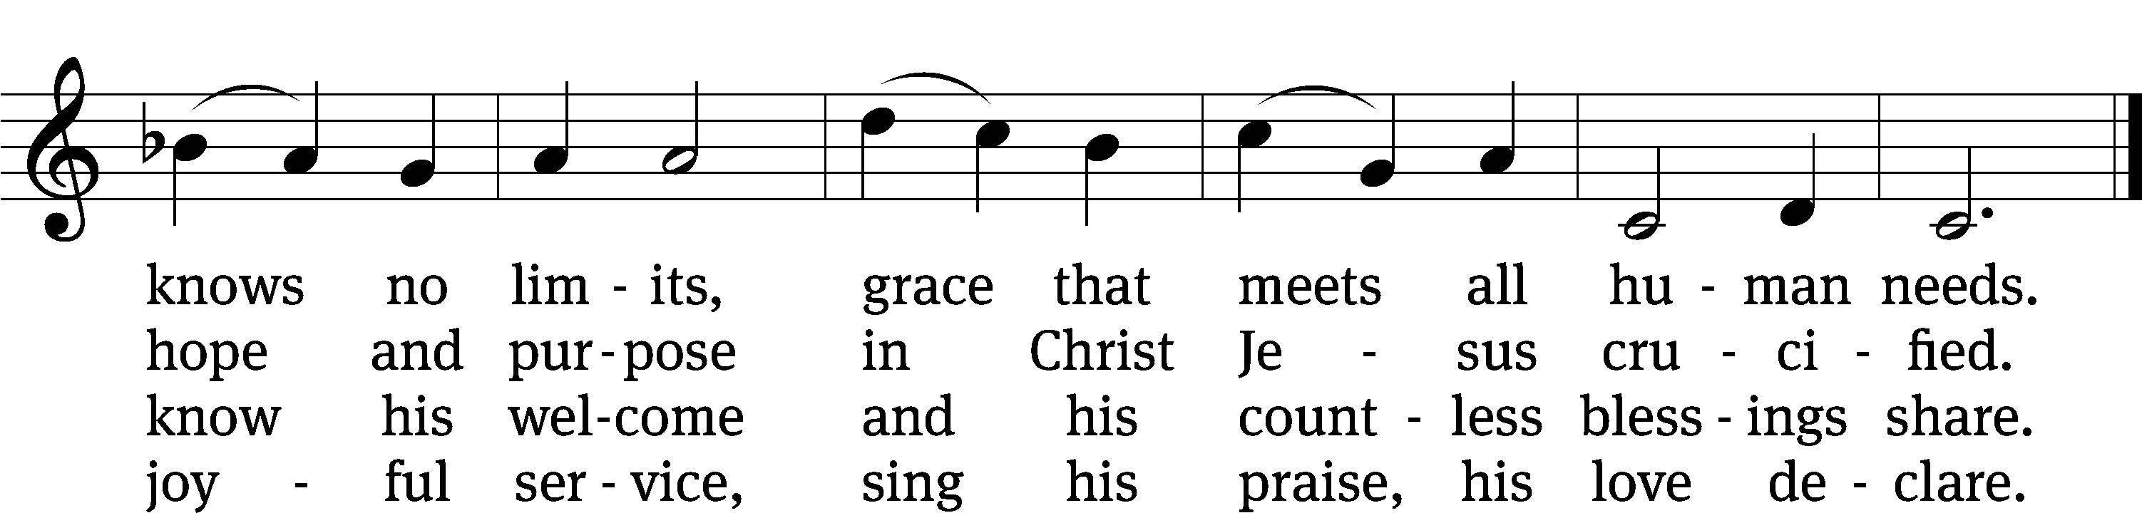
SERMON 1 Peter 2:9
“A People Belonging to God”

Please stand, if you are able

Nicene Creed
We believe in one God, the Father, the Almighty,
maker of heaven and earth,
of all that is,
seen and unseen.
We believe in one Lord, Jesus Christ, the only Son of God,
eternally begotten of the Father,
God from God, Light from Light, true God from true God,
begotten, not made,
of one being with the Father.
Through him all things were made.
For us and for our salvation, he came down from heaven,
was incarnate of the Holy Spirit and the Virgin Mary,
and became truly human.
For our sake he was crucified under Pontius Pilate.
He suffered death and was buried.
On the third day he rose again in accordance with the Scriptures.
He ascended into heaven
and is seated at the right hand of the Father.
He will come again in glory to judge the living and the dead,
and his kingdom will have no end.
We believe in the Holy Spirit,
the Lord, the giver of life,
who proceeds from the Father and the Son,
who in unity with the Father and the Son
is worshiped and glorified,
who has spoken through the prophets.
We believe in one holy Christian and apostolic Church.
We acknowledge one baptism for the forgiveness of sins.
We look for the resurrection of the dead
and the life of the world to come. Amen.
Prayer of the Church

The Sacrament
Preface CW 165
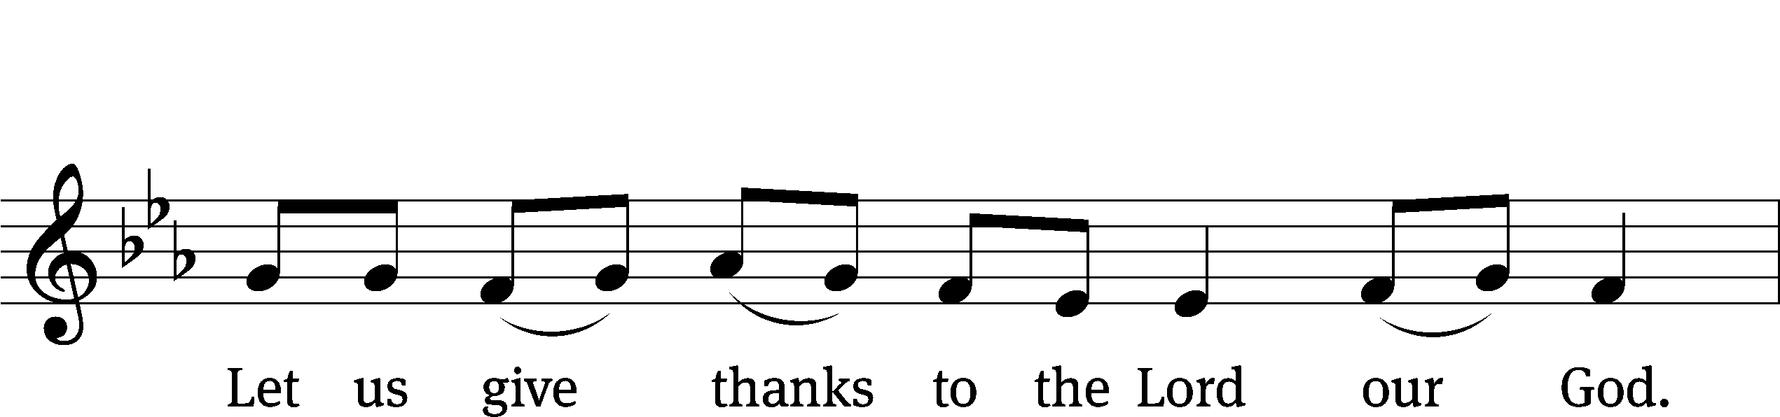
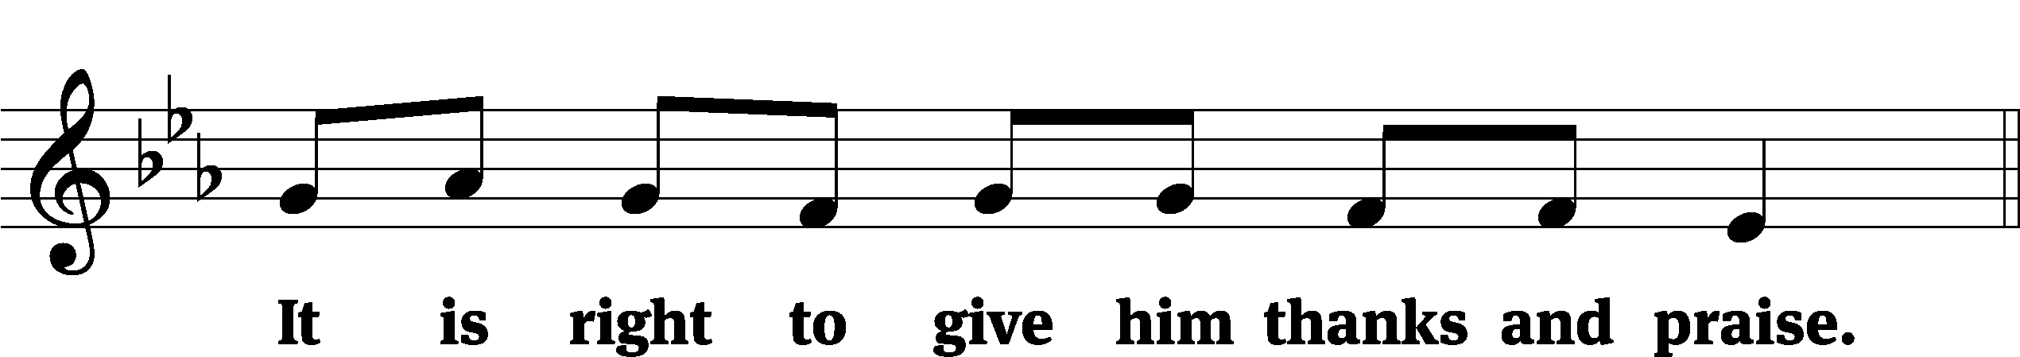

It is truly good and right that we should at all times and in all places give you thanks, O Lord, holy Father, almighty and everlasting God, through Jesus Christ our Lord, who promised that wherever two or three come together in his name, there he is with them to shepherd his flock until he comes again in glory. Therefore, with all the saints on earth and hosts of heaven, we praise your holy name and join their glorious song:
Holy, Holy, Holy CW 167
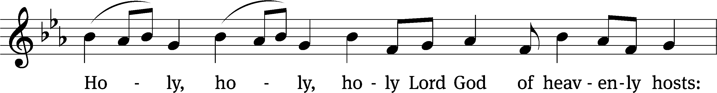
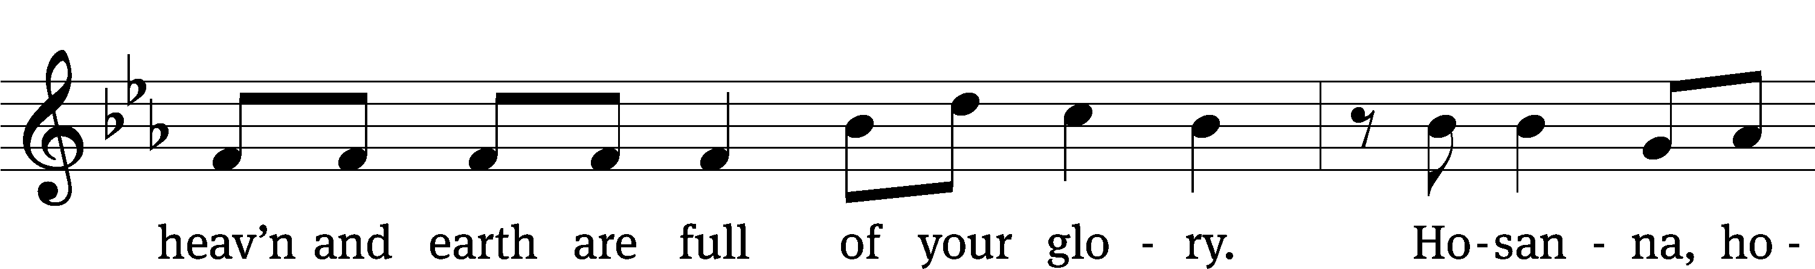
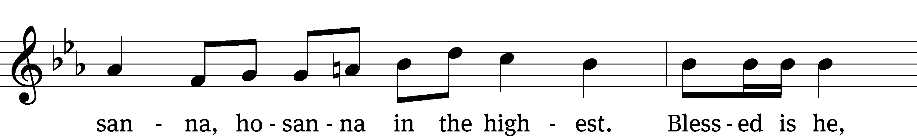
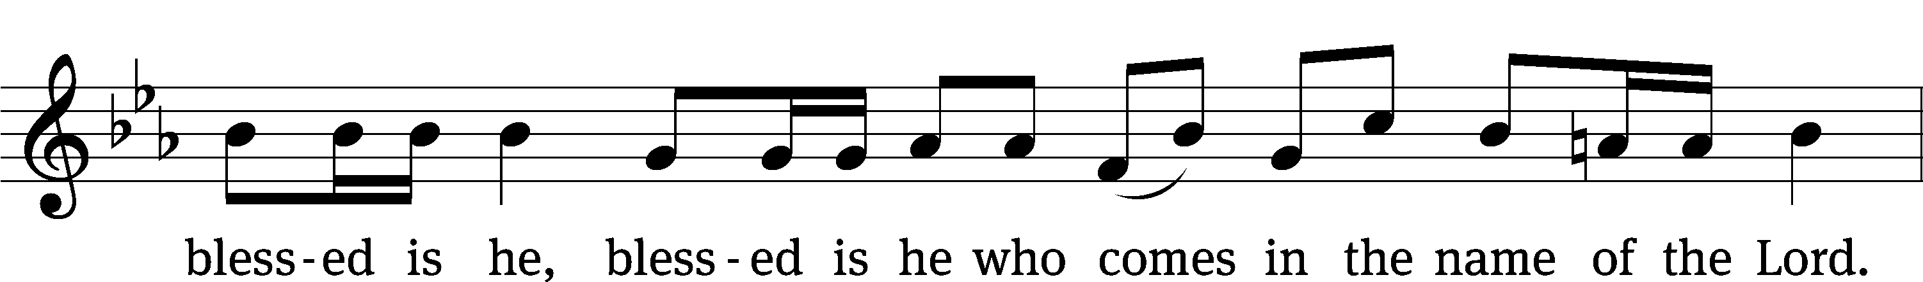
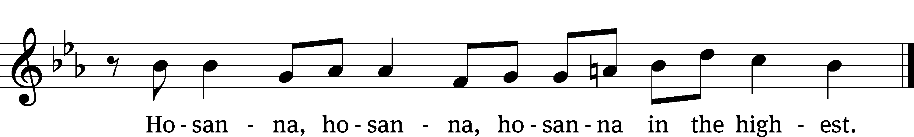

Prayer of Thanksgiving
We give thanks to you, O God, through your dear Son, Jesus Christ, whom you sent to be our Savior, our Redeemer, and the messenger of your grace. Through him you made all things; in him you are well pleased. He is the incarnate Word, conceived by the Holy Spirit and born of the Virgin Mary. To fulfill your promises, he stretched out his hands on the cross and released from eternal death all who believe in you.

As we remember Jesus’ death and resurrection, we thank you that you have gathered us together to receive your Son’s body and blood. Send us your Spirit, unite us as one, and strengthen our faith so that we may praise you in your Son, Jesus Christ. Through him, we glorify and honor you, O God our Father, with the Holy Spirit, one God, now and forever.
Amen.

Lord’s Prayer
Our Father, who art in heaven, hallowed be thy name, thy kingdom come, thy will be done on earth as it is in heaven. Give us this day our daily bread; and forgive us our trespasses, as we forgive those who trespass against us; and lead us not into temptation, but deliver us from evil. For thine is the kingdom and the power and the glory forever and ever. Amen.

Words of Institution
Our Lord Jesus Christ, on the night he was betrayed, took bread; and when he had given thanks, he broke it and gave it to his disciples, saying, “Take and eat; this is my body, which is given for you. Do this in remembrance of me.”
Then he took the cup, gave thanks, and gave it to them, saying, “Drink from it, all of you; this is my blood of the new covenant, which is poured out for you for the forgiveness of sins. Do this, whenever you drink it, in remembrance of me.”

The peace of the Lord be with you always.
Amen.
O Christ, Lamb of God CW 169
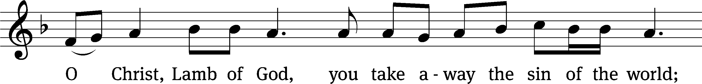
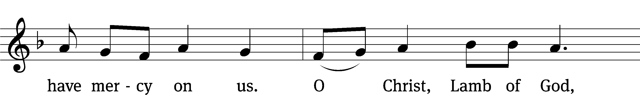
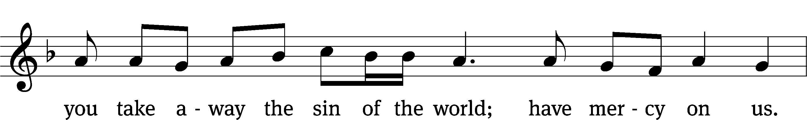
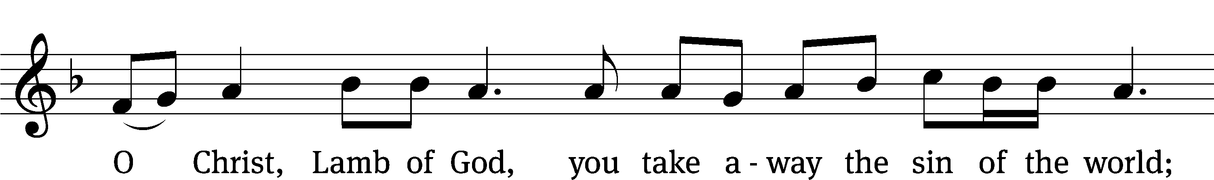
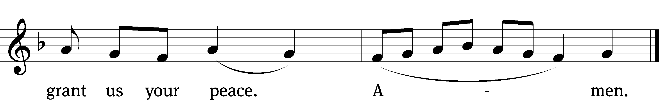
Please be seated
713 I Want to Walk as a Child of the Light CW 713
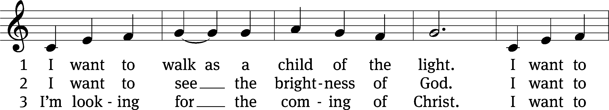
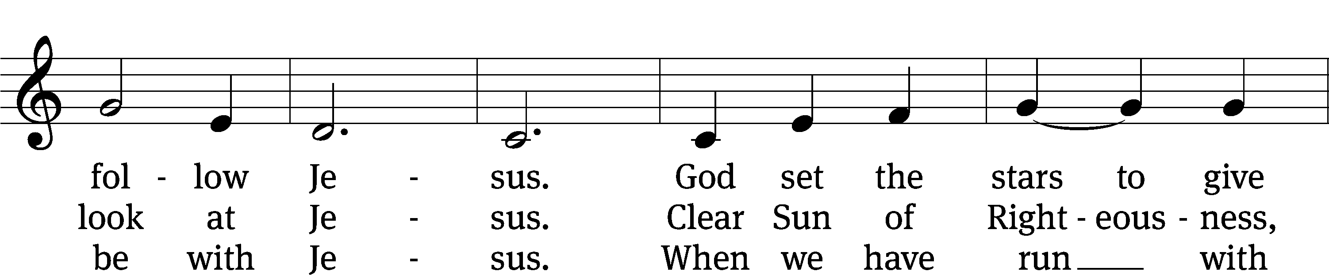
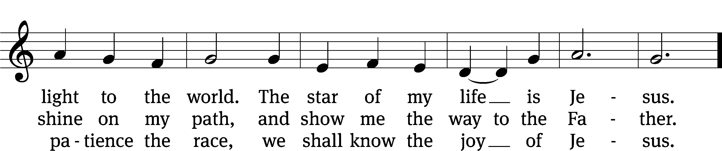
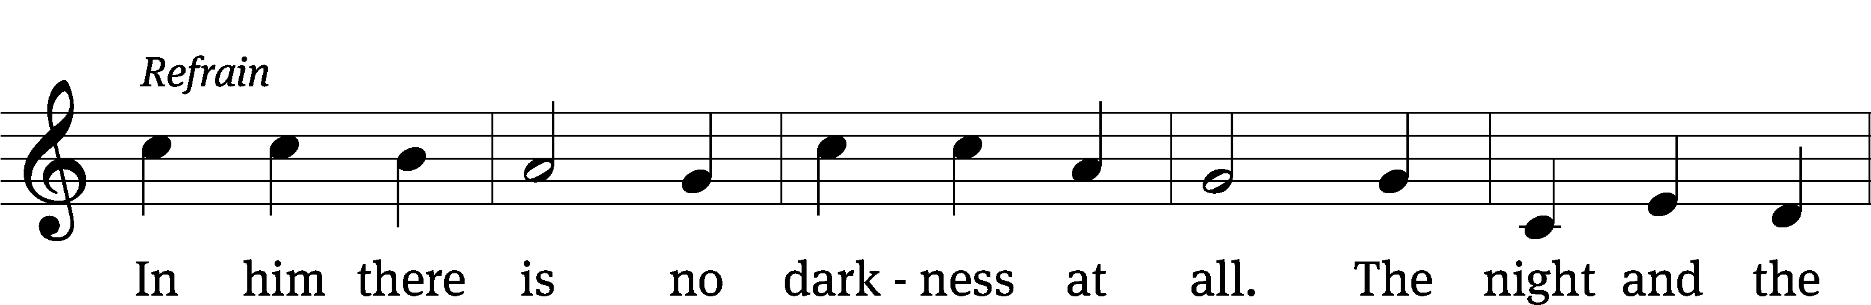
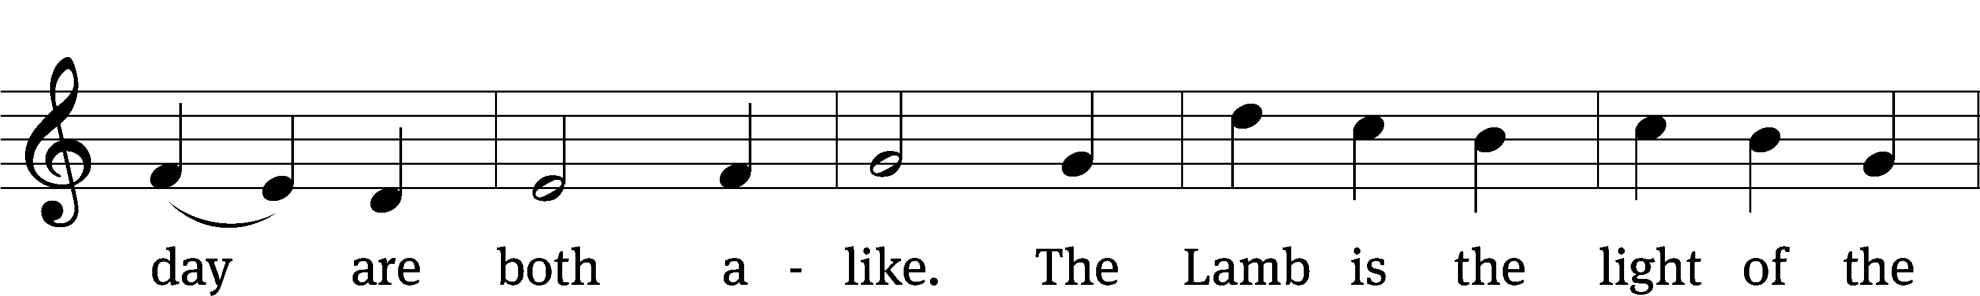
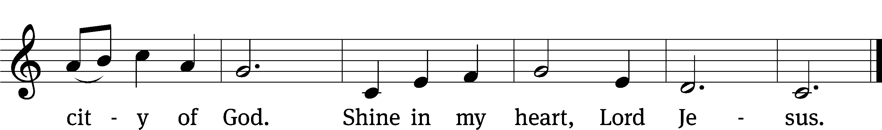
Text: Kathleen Thomerson, b. 1934
Text and tune: © 1970, 1975 Celebration. Used by permission: OneLicense no. 727703

817 Lord, Thee I Love with All My Heart CW 817
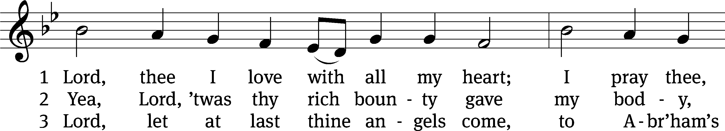
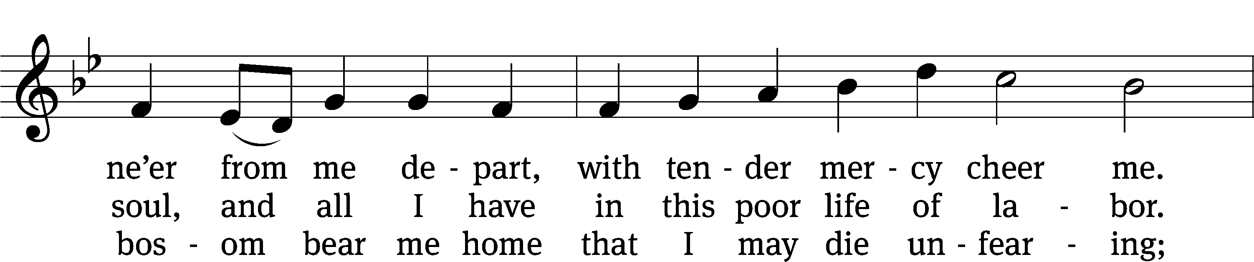
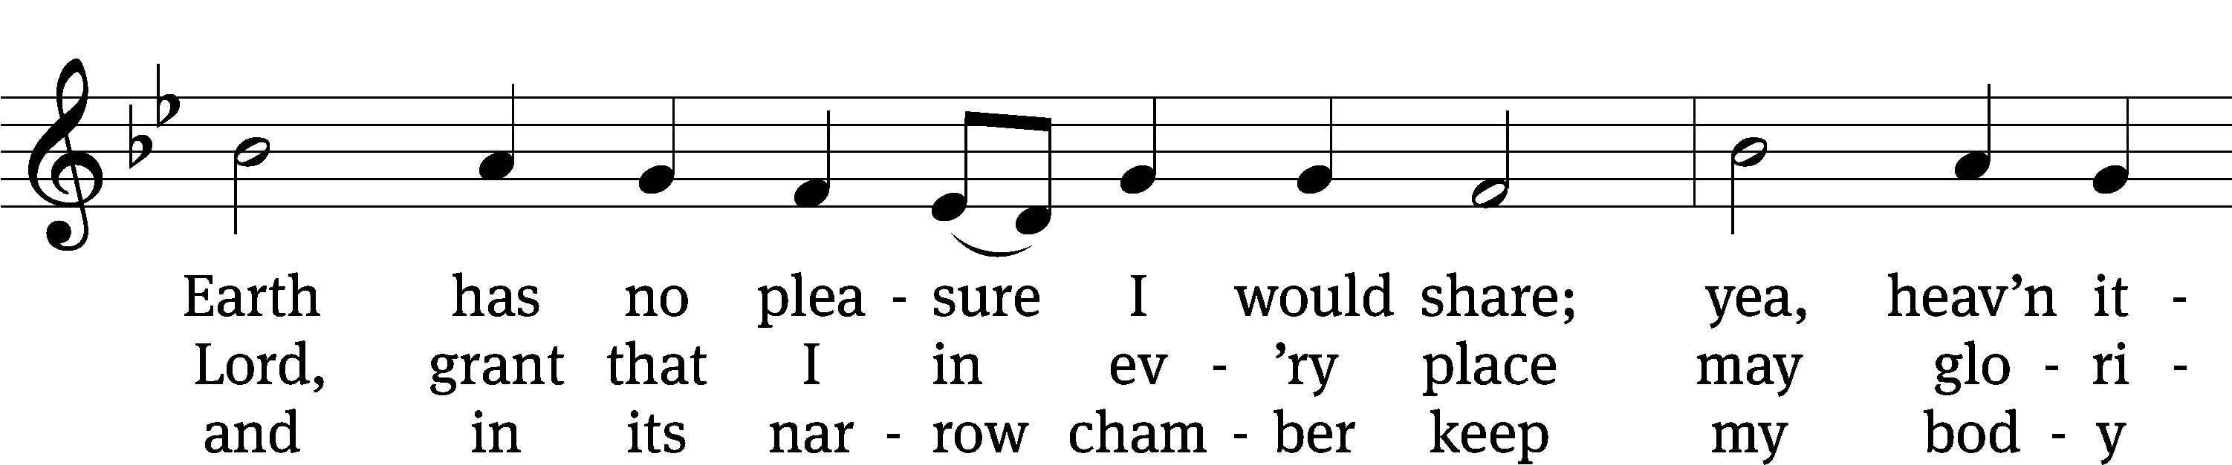
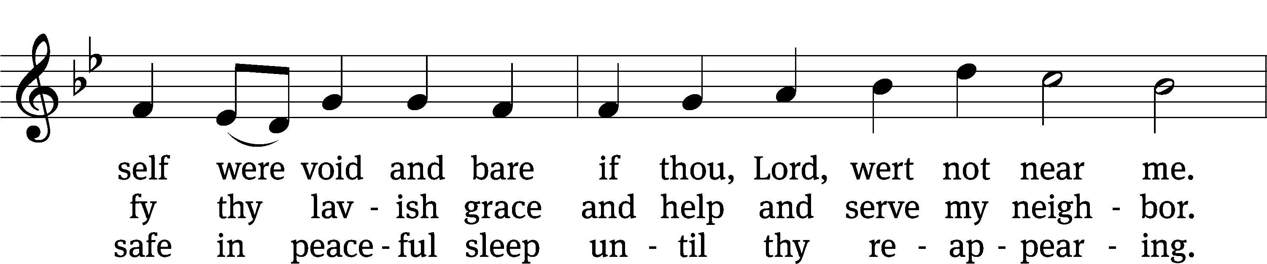
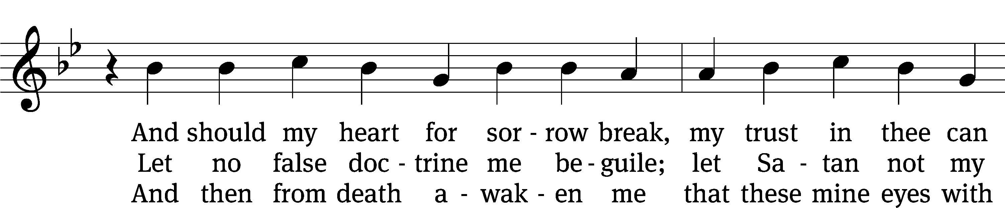
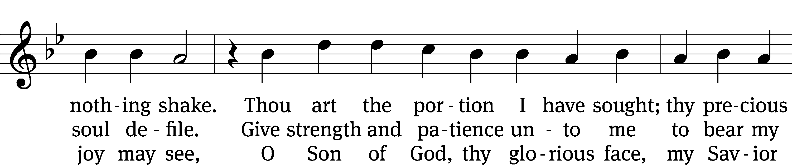
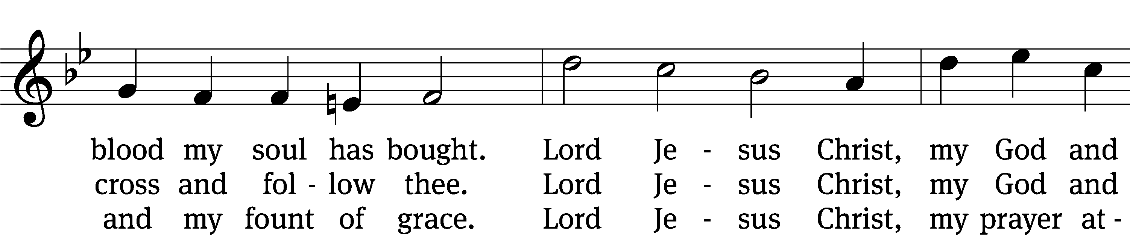
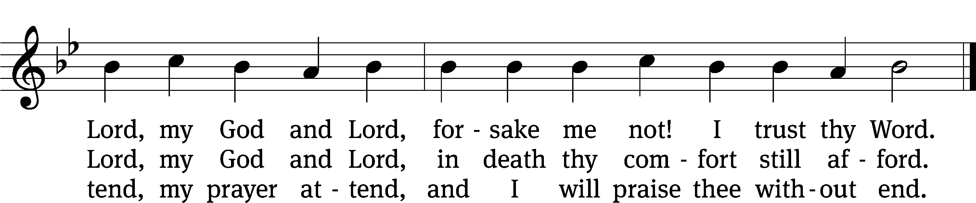
Text: tr. Catherine Winkworth, 1827–1878, alt.; Martin M. Schalling, 1532–1608
Tune: Zwey Bücher . . . Tablatur, Strassburg, 1577
Text and tune: Public domain

Please stand, if you are able

Give thanks to the Lord, for he is good;
his mercy endures forever.

Whenever we eat this bread and drink this cup,
we proclaim the Lord’s death until he comes.

We give thanks, almighty God, that you have refreshed us with this saving gift. We pray that through it you will strengthen our faith in you and increase our love for one another. We ask this in the name of Jesus Christ our Lord, who lives and reigns with you and the Holy Spirit, one God, now and forever.
Amen.

Blessing
The Lord bless you and keep you.
The Lord make his face shine on you and be gracious to you.
The Lord look on you with favor and give you peace.
Amen.

715 Let Me Be Yours Forever CW 715
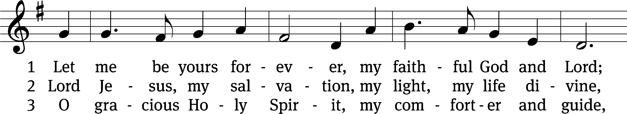
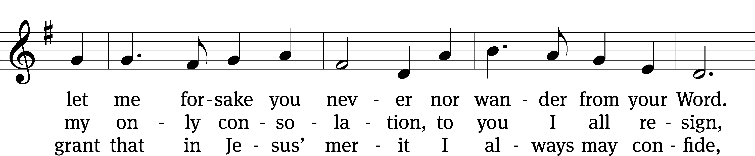
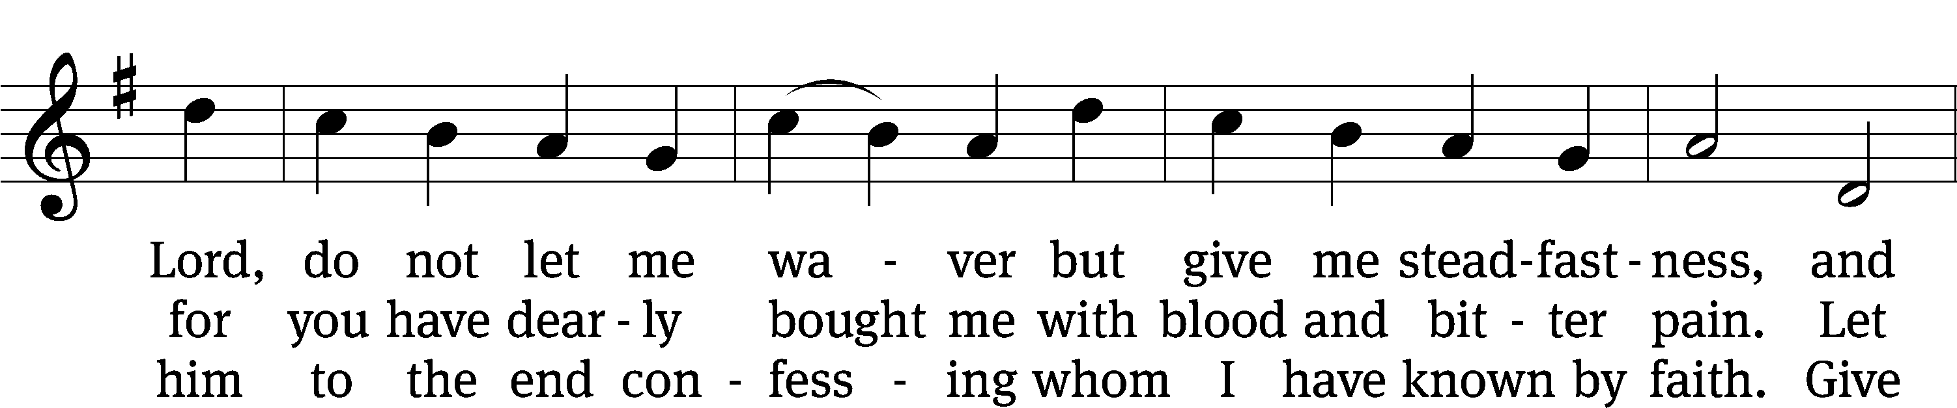
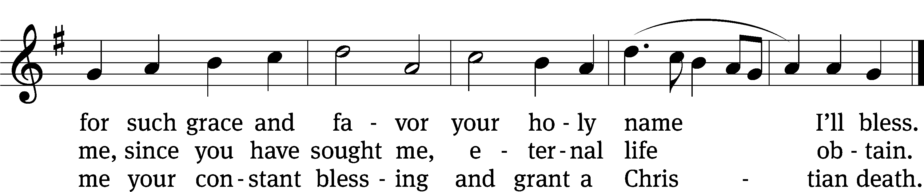
Text: tr. Matthias Loy, 1828–1915, alt.; (st. 1): Nicolaus Selnecker, 1532–1592; (sts. 2–3): Gesang-Büchlein, Rudolstadt, 1688
Tune: Musika Teutsch, Nürnberg, 1532
Text and tune: Public domain

Acknowledgments
Setting One from Christian Worship
Software distributed in partnership with Northwestern Publishing House.
Created by Christian Worship: Service Builder © 2022 Concordia Publishing House.
Serving in Worship
Officiant Pastor WilliamNatsis
Organist Marcia Marion Ackling
Deacons (8:30) Duane Mason and Dave Stevenson
Deacons (11:00) Jeff Neuburger and Robert Niethammer
Ushers (8:30) Tim Phelps
Ushers (11:00) Ron Zahn
Altar Guild Margaret Hoeft and Laura Lindemann
Videographer Jake Vershum

