The second SUNDAY
in Lent

TRINITY EVANGELICAL LUTHERAN CHURCH | Saline, Michigan
WELCOME TO WORSHIP February 25, 2024
Thank you for joining us in God’s house today! We cordially ask that our Guests sign one of the guestbooks located at either the front or back entryways, or fill out a “Let’s Get Acquainted” card located in the hymnal pew rack and place it in the collection plate.

THANK OFFERING: Members of Trinity give their offering as an expression of love and thankfulness to the Lord and to help support the Lord’s work in our community and around the world. Visitors need not feel obligated to participate in this offering which supports our ministry.

Restrooms are located at the back of the upper level (the annex), and in the basement (down the back stairs of the sanctuary or annex). Handicap access is available, please ask an usher for assistance.

Young Families / Toddler Bags – We are GLAD YOU BROUGHT YOUR CHILDREN to our worship service. Jesus said: “Let the little children come to me and do not hinder them, for the kingdom of God belongs to such as these.” We know that having little children in church can be a challenge, but DO NOT WORRY about it. Many of your fellow worshippers have been in your shoes and are just happy you brought your children with you. For your convenience, we have reserved the back rows of seating for parents with small children. These areas provide more flexibility for your family, as well as, easy access to move downstairs if necessary. A closed-circuit TV system allows families to continue participating in the service while downstairs. Pre-school toddler bags and children’s bulletins are available for their enjoyment. Ask an usher for one to use during the service and please return the toddler bag afterwards.

the SERVICE – setting one - WITHOUT HOLY COMMUNION CW, page 154

694 Jesus, I My Cross Have Taken CW 694
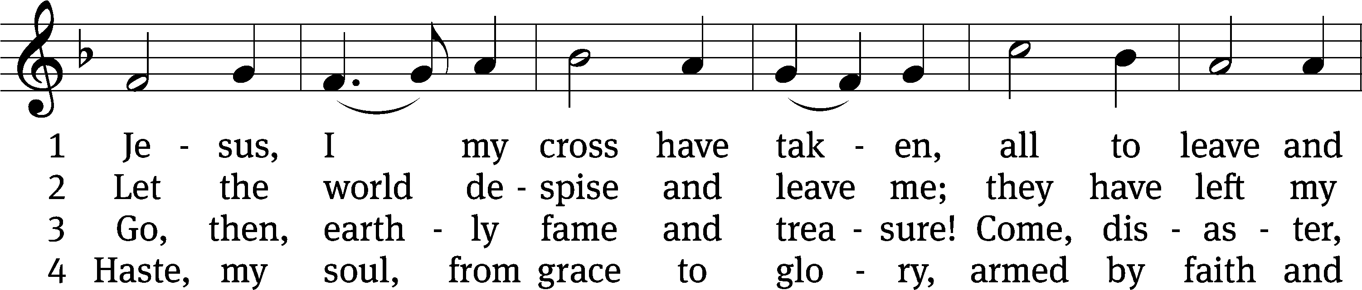
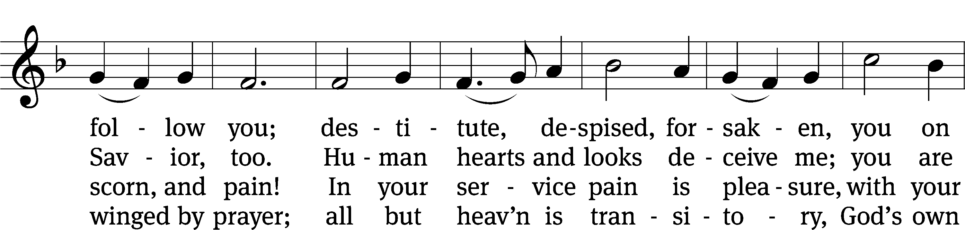
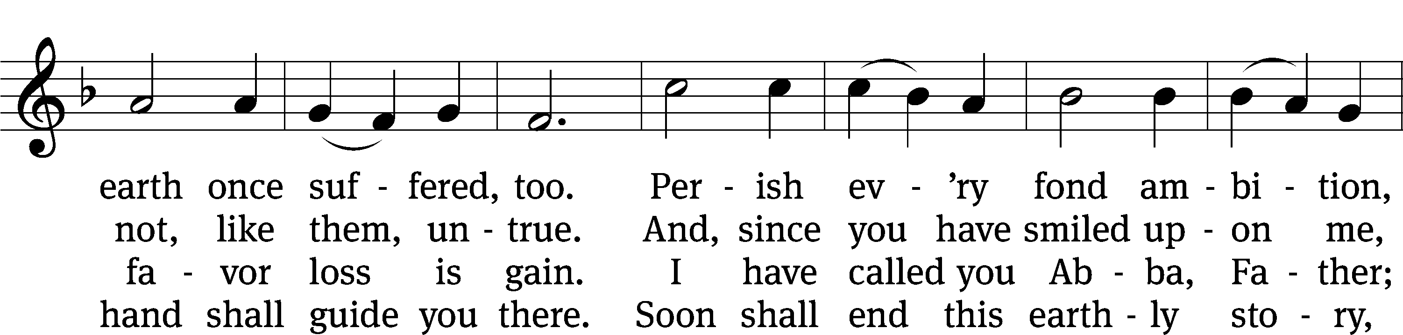
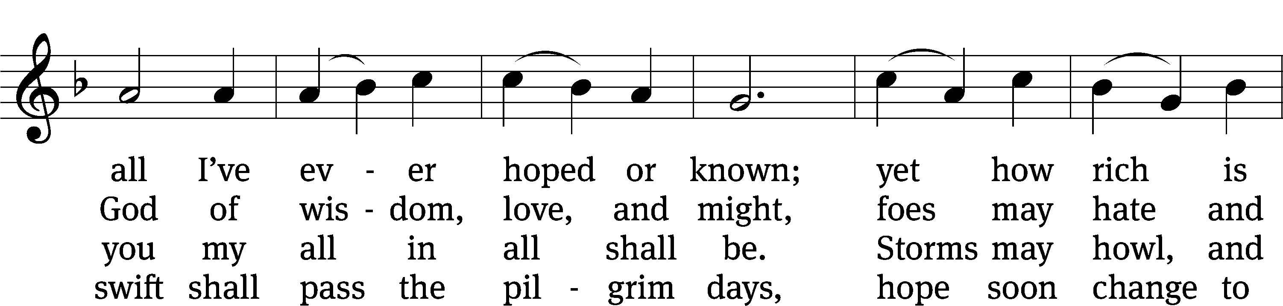
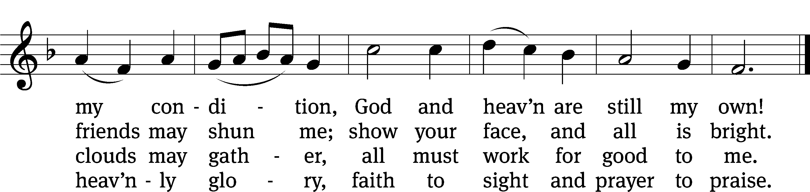
Text: Henry Francis Lyte, 1793–1847, abr., alt.
Tune: Rowland H. Prichard, 1811–1887
Text and tune: Public domain

Please stand, if you are able
Invocation
In the name of the Father and of the Son and of the Holy Spirit.
Amen.

Confession
If we claim to be without sin, we deceive ourselves and the truth is not in us.
If we confess our sins, God is faithful and just
and will forgive us our sins
and purify us from all unrighteousness.

Let us confess our sins to the Lord.
Holy God, gracious Father,
I am sinful by nature
and have sinned against you in my thoughts, words, and actions.
I have not loved you with my whole heart;
I have not loved others as I should.
I deserve your punishment both now and forever.
But Jesus, my Savior, paid for my sins
with his innocent suffering and death.
Trusting in him, I pray: God, have mercy on me, a sinner.

Our gracious Father in heaven has been merciful to us. He sent his only Son, Jesus Christ, who gave his life as the atoning sacrifice for the sins of the whole world. Therefore, as a called servant of Christ and by his authority, I forgive you all your sins in the name of the Father and of the Son and of the Holy Spirit.
Amen.

Lord, Have Mercy
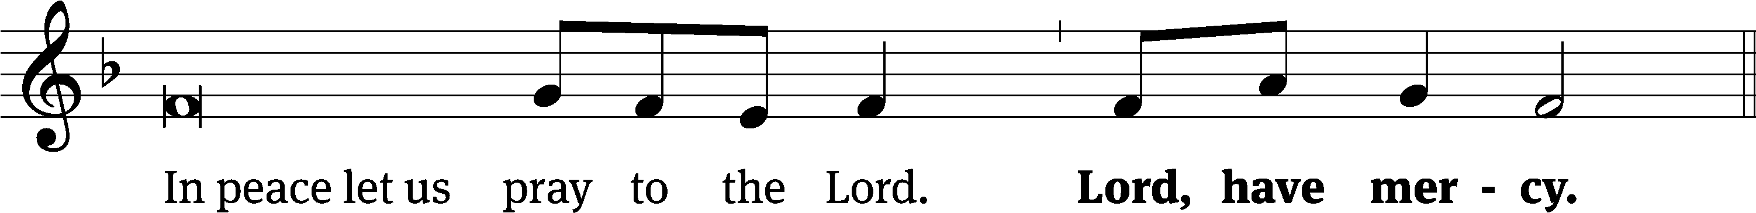
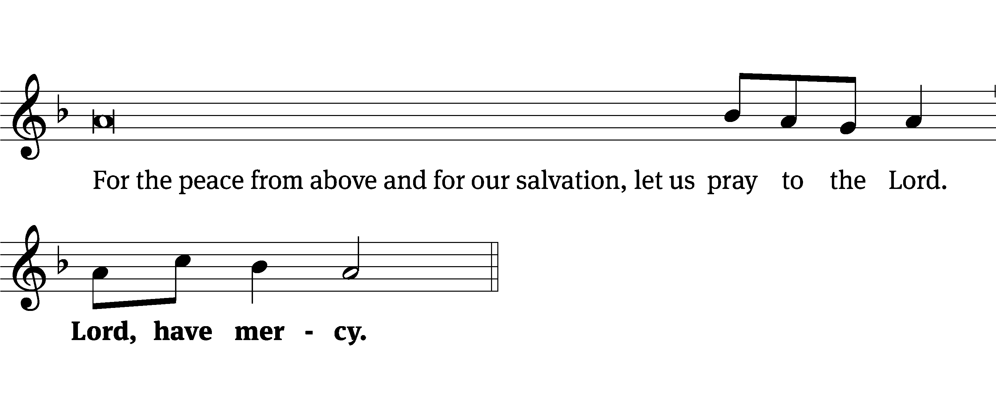
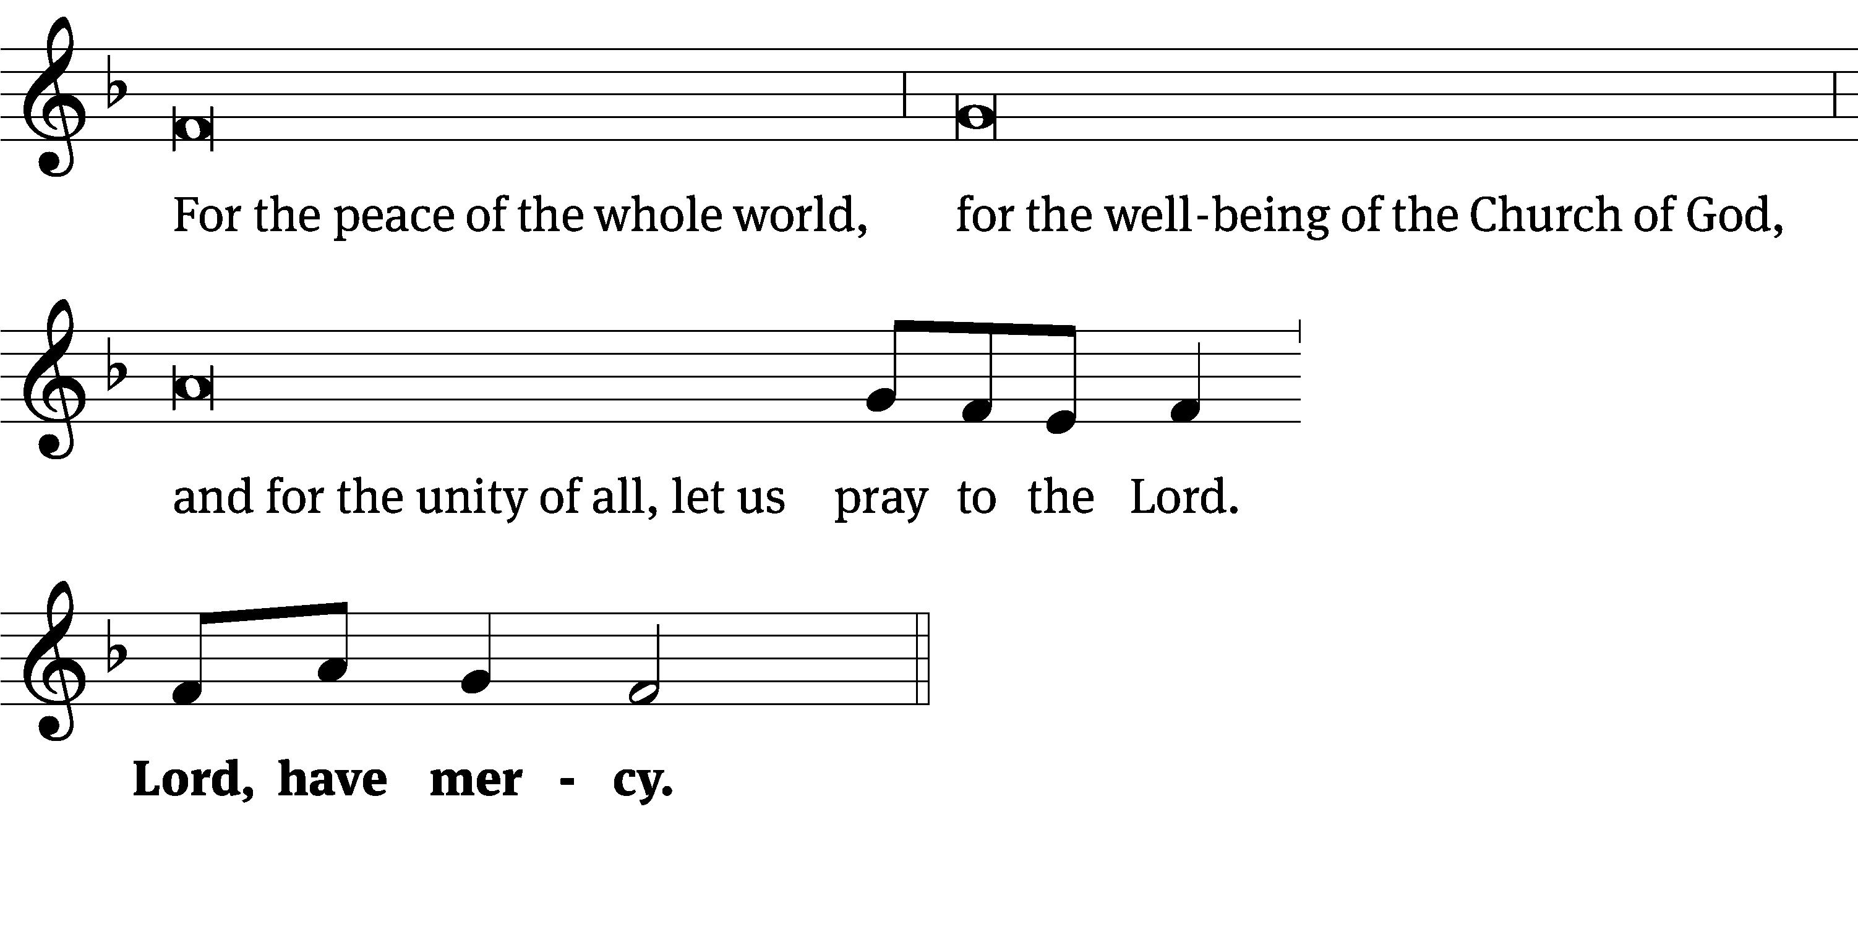
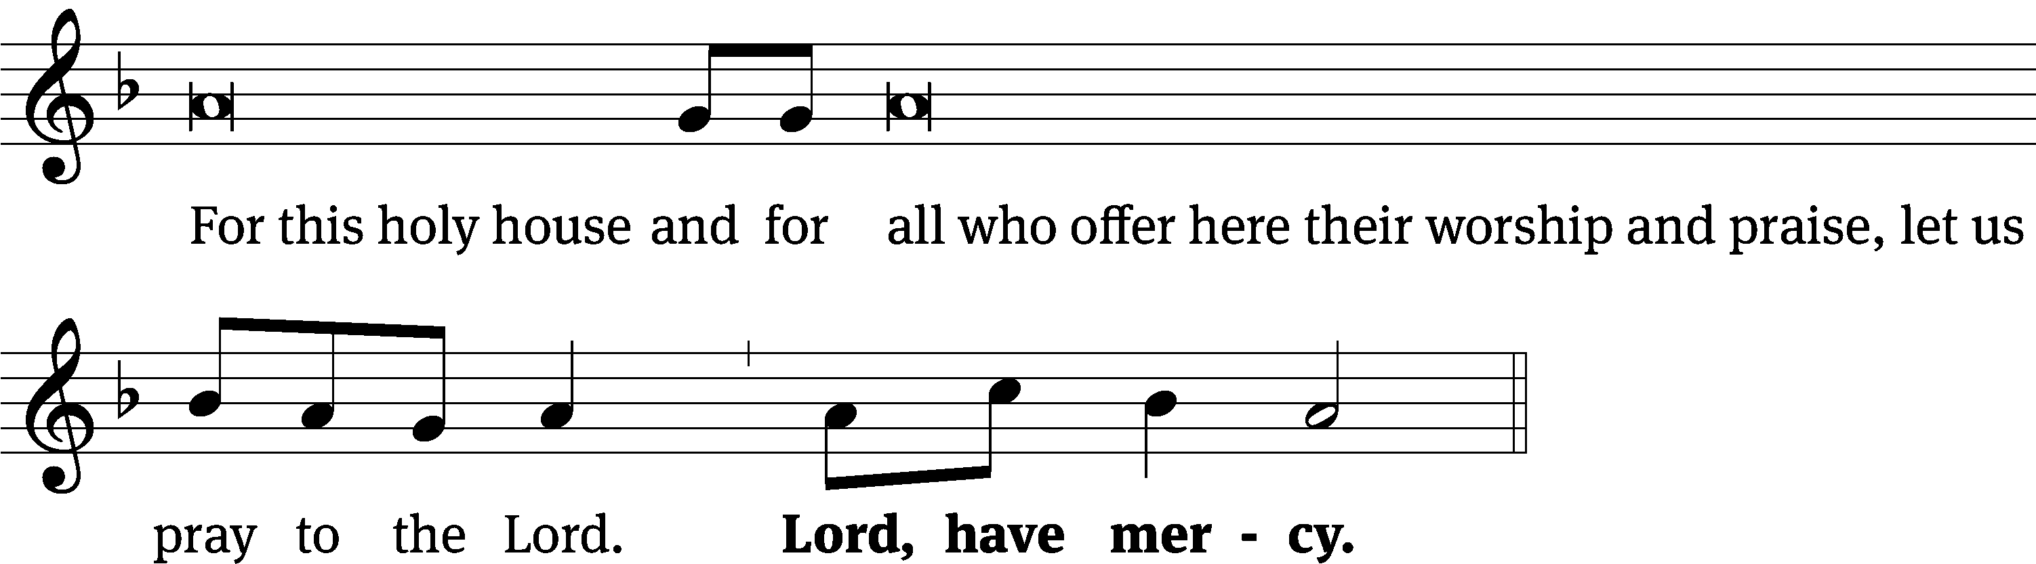
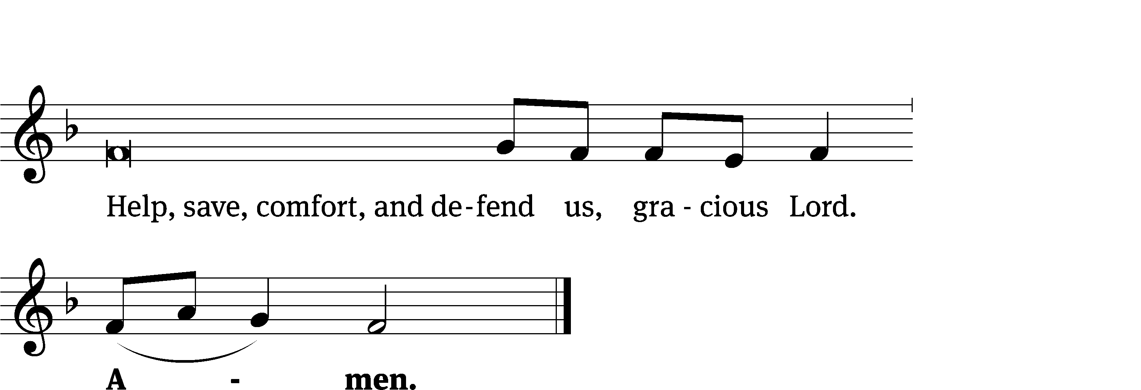
Tune: Kevin Becker
Tune: © 2021 Northwestern Publishing House. Used by permission: OneLicense no. 727703

The Lord be with you.
And also with you.
Prayer of the Day
Let us pray.

Almighty God, you see that we have no power to defend ourselves. Guard and keep us both outwardly and inwardly from all adversities that may happen to the body and all evil thoughts that may assault and hurt the soul; through your Son, Jesus Christ our Lord, who lives and reigns with you and the Holy Spirit, one God, now and forever.
Amen.

Please be seated

First Reading Job 1:13-22

¹³ One day when Job’s sons and daughters were eating and drinking wine in the house of their oldest brother, ¹⁴ a messenger came to Job and said, “The oxen were plowing and the female donkeys were grazing nearby, ¹⁵ when the Sabeans swooped down and took them away. They put the servants to death with the sword, and I am the only one who has escaped to tell you!” ¹⁶ While he was still speaking, another servant came and said, “The fire of God fell from the sky and burned up the flocks and the servants and consumed them, and I am the only one who has escaped to tell you!” ¹⁷ While he was still speaking, another servant came and said, “The Chaldeans formed three raiding parties and plundered the camels and took them away. They put the servants to death with the sword, and I am the only one who has escaped to tell you!”¹⁸ While he was still speaking, another servant came and said, “Your sons and daughters were eating and were drinking wine in the house of their oldest brother. ¹⁹ Suddenly a powerful wind swept in from the wilderness and struck the four corners of the house, and it collapsed on the young people, and they died, and I am the only one who has escaped to tell you!” ²⁰ Then Job stood up, tore his robe, and shaved his head. He fell to the ground and worshipped. ²¹ Then he said, “Naked I came from my mother’s womb, and naked I will return. The Lord gave and the Lord has taken away. May the name of the Lord be blessed.”²² In all this, Job did not sin or blame God.

The Word of the Lord.
Thanks be to God.
Choir “Praise the One Who Breaks the Darkness”

Praise the One who breaks the darkness with a liberating light.
Praise the One who frees the pris’ners, turning blindness into sight.
Praise the One who preached the Gospel, healing ev’ry dread disease,
Calming storms, and feeding thousands with the very Bread of peace.

Praise the One who bless’d the children with a strong, yet gentle, word;
Praise the One who drove out demons with the piercing, two-edged sword.
Praise the One who brings cool water to the desert’s burning sand;
From this well comes living water, quenching thirst in ev’ry land.

Let us praise the Word Incarnate, Christ, who suffered in our place;
Jesus died and rose victorious that we may know God by grace.
Let us sing for joy and gladness, seeing what our God has done;
Let us praise the true Redeemer, praise the One who makes us one.

Second Reading Romans 5:1-11
5 Therefore, since we have been justified by faith, we have peace with God through our Lord Jesus Christ. ² Through him we also have obtained access by faith into this grace in which we stand. And we rejoice confidently on the basis of our hope for the glory of God. ³ Not only this, but we also rejoice confidently in our sufferings, because we know that suffering produces patient endurance, ⁴ and patient endurance produces tested character, and tested character produces hope. ⁵ And hope will not put us to shame, because God’s love has been poured out into our hearts by the Holy Spirit, who was given to us. ⁶ For at the appointed time, while we were still helpless, Christ died for the ungodly. ⁷ It is rare indeed that someone will die for a righteous person. Perhaps someone might actually go so far as to die for a person who has been good to him. ⁸ But God shows his own love for us in this: While we were still sinners, Christ died for us. ⁹ Therefore, since we have now been justified by his blood, it is even more certain that we will be saved from God’s wrath through him. ¹⁰ For if, while we were enemies, we were reconciled to God by the death of his Son, it is even more certain that, since we have been reconciled, we will be saved by his life. ¹¹ And not only is this so, but we also go on rejoicing confidently in God through our Lord Jesus Christ, by whom we have now received this reconciliation.
The Word of the Lord.
Thanks be to God.

Please stand, if you are able
Gospel Acclamation Mark 8:34
Whoever wants to be my disciple must deny themselves
and take up their cross and follow me.

Gospel Mark 8:31-38
³¹ Jesus began to teach them that the Son of Man must suffer many things; be rejected by the elders, the chief priests, and the experts in the law; be killed; and after three days rise again. ³² He was speaking plainly to them. Then Peter took him aside and began to rebuke him. ³³ But after turning around and looking at his disciples, Jesus rebuked Peter and said, “Get behind me, Satan! You do not have your mind set on the things of God, but the things of men.” ³⁴ He called the crowd and his disciples together and said to them, “If anyone wants to follow me, let him deny himself, take up his cross, and follow me. ³⁵ For whoever wants to save his life will lose it. But whoever loses his life for my sake, and for the sake of the gospel, will save it. ³⁶ After all, what good is it for a man to gain the whole world and yet forfeit his soul? ³⁷ Or what can a man give in exchange for his soul? ³⁸ In fact, whoever is ashamed of me and my words in this adulterous and sinful generation, the Son of Man will also be ashamed of him when he comes in the glory of his Father with the holy angels.”
The Gospel of the Lord.
Praise be to you, O Christ!

Please be seated
817 Lord, Thee I Love with All My Heart CW 817
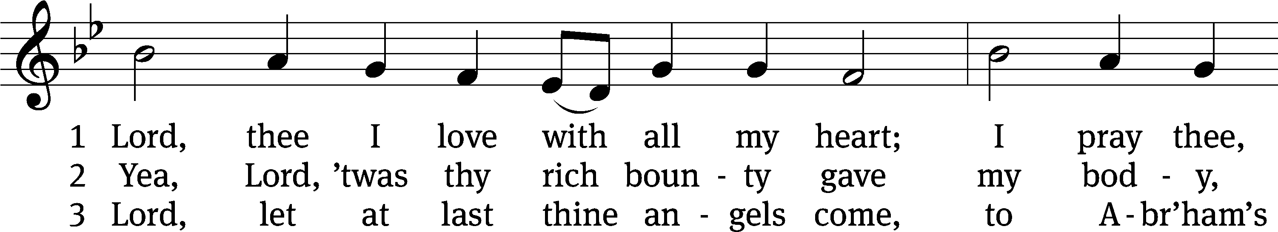
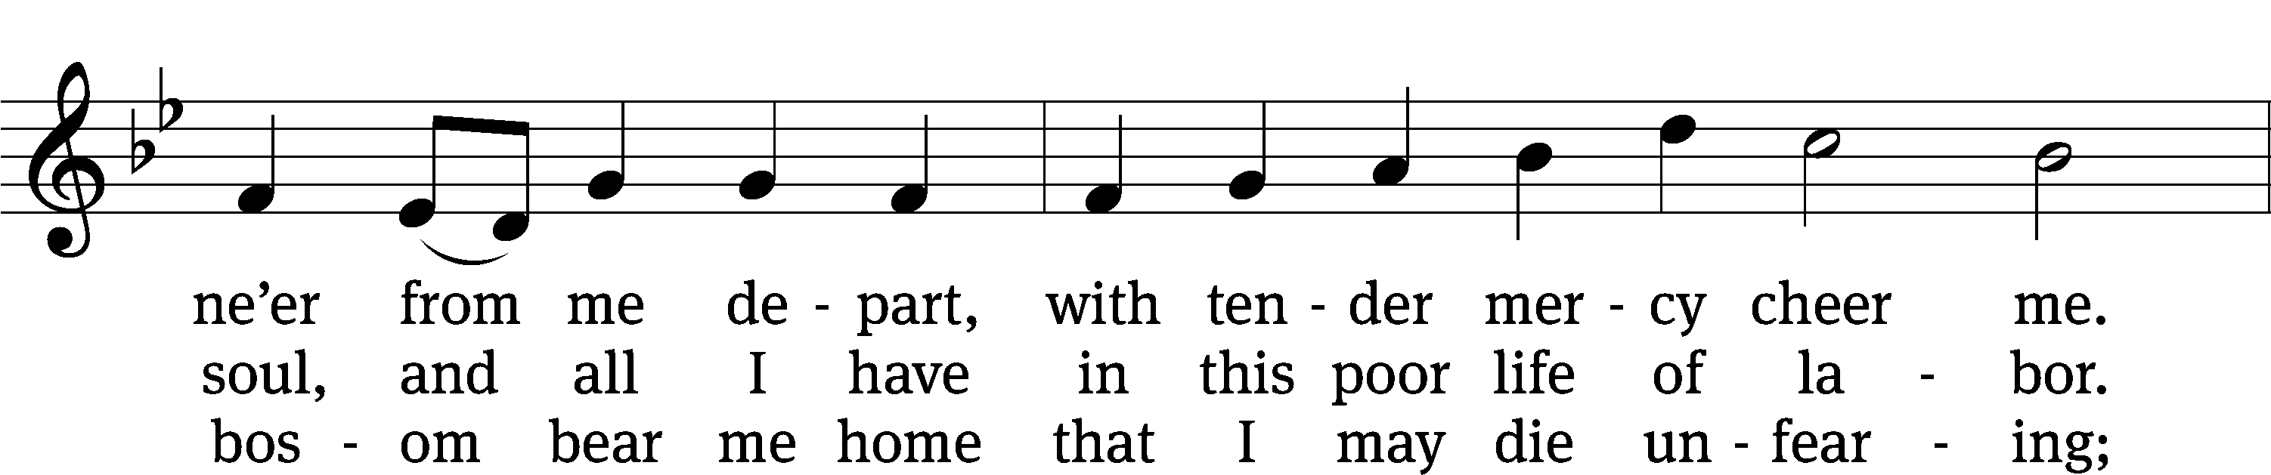
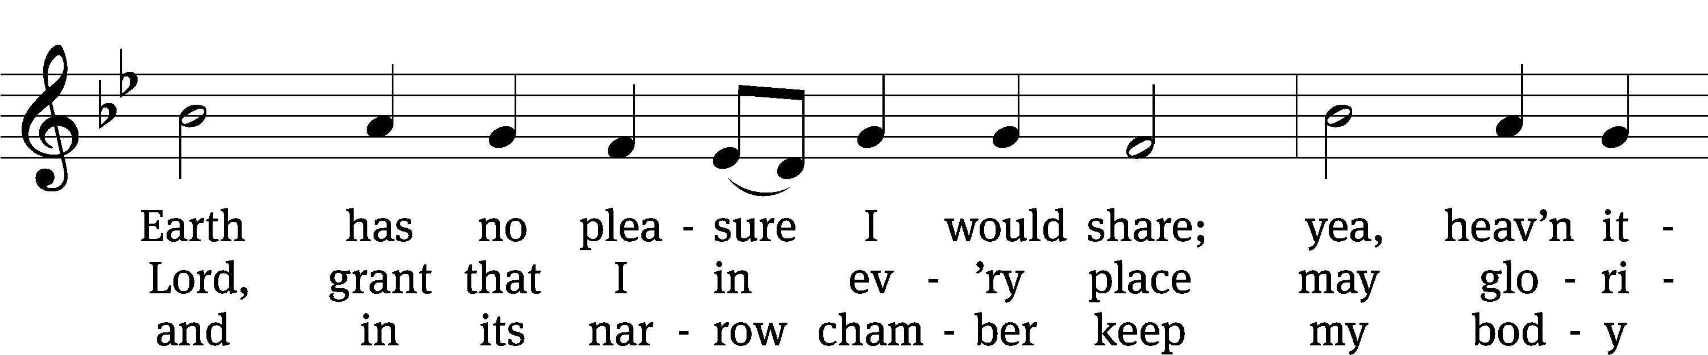
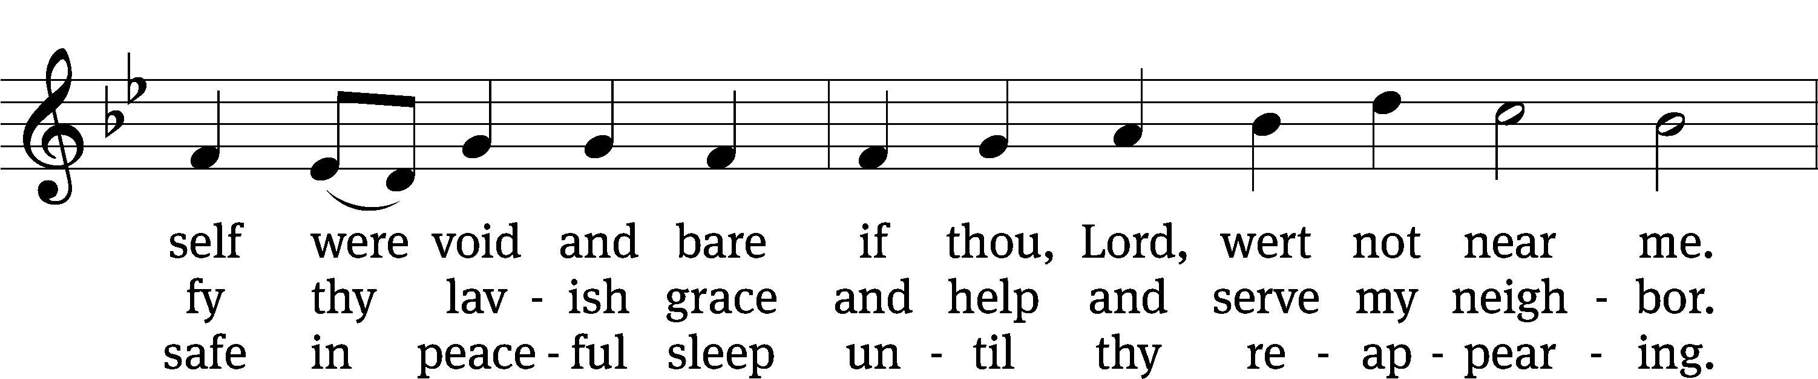
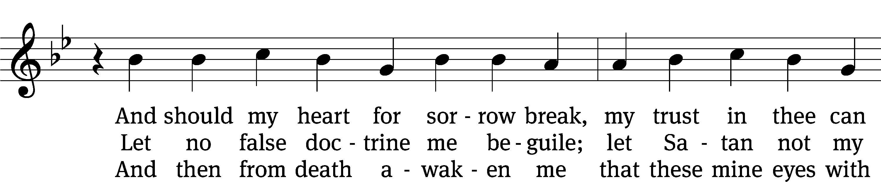
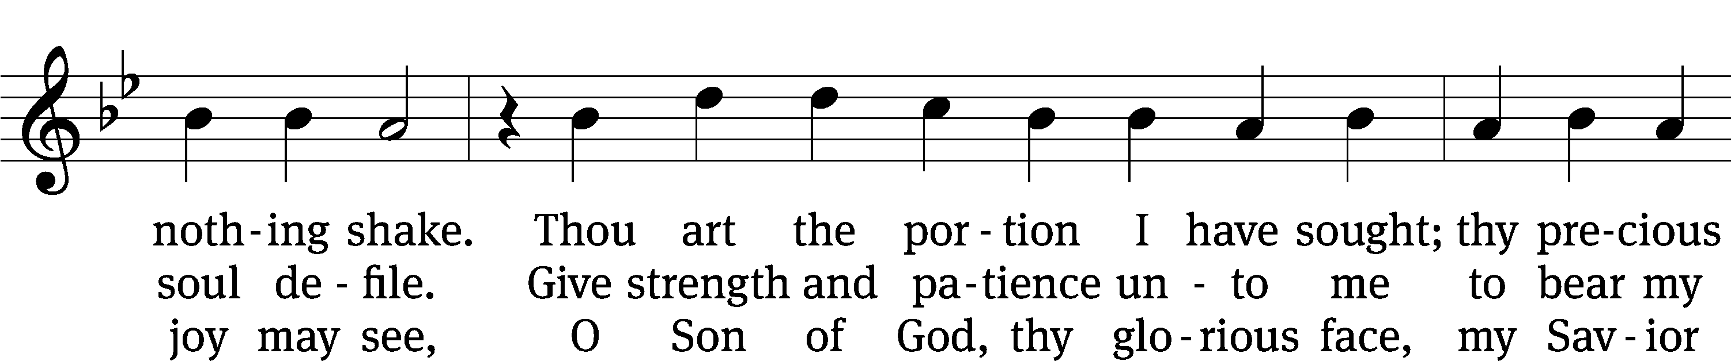
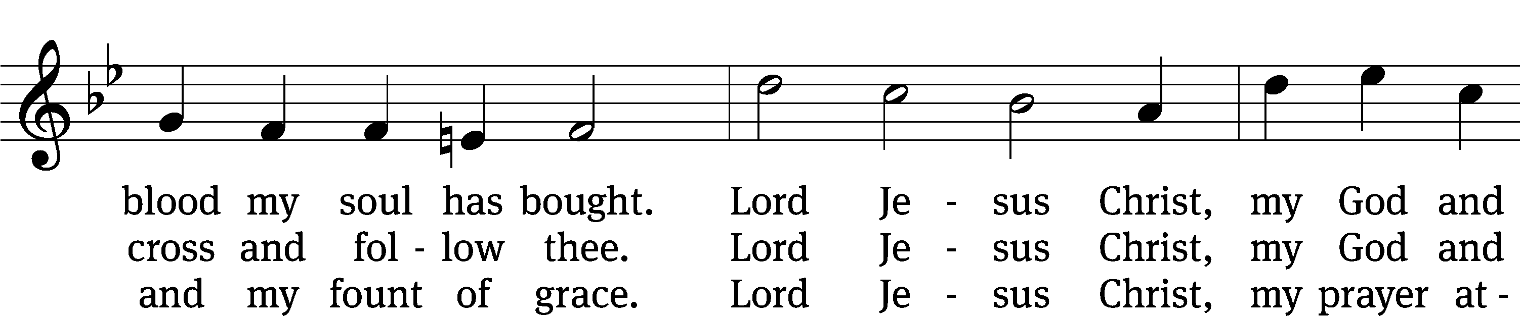
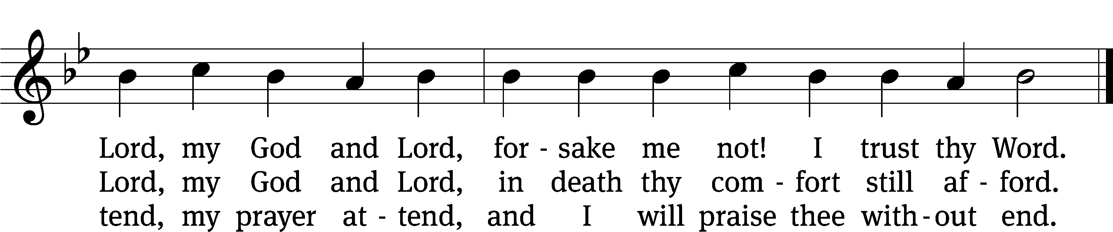

Text: tr. Catherine Winkworth, 1827–1878, alt.; Martin M. Schalling, 1532–1608
Tune: Zwey Bücher . . . Tablatur, Strassburg, 1577
Text and tune: Public domain

Sermon Mark 8:31-38
“Cheer Up! It’s the Cross!”

Please stand, if you are able
Apostles’ Creed
I believe in God, the Father Almighty,
maker of heaven and earth.

I believe in Jesus Christ, his only Son, our Lord,
who was conceived by the Holy Spirit,
born of the Virgin Mary,
suffered under Pontius Pilate,
was crucified, died, and was buried.

He descended into hell.
The third day he rose again from the dead.
He ascended into heaven
and is seated at the right hand of God the Father Almighty.
From there he will come to judge the living and the dead.

I believe in the Holy Spirit,
the holy Christian Church,
the communion of saints,
the forgiveness of sins,
the resurrection of the body,
and the life everlasting. Amen.

Prayer of the Church

Please be seated
844 What God Ordains Is Always Good CW 844
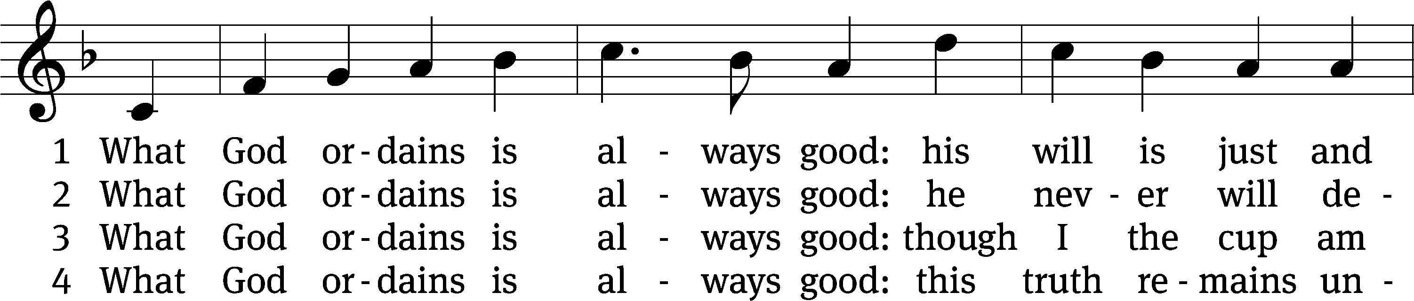
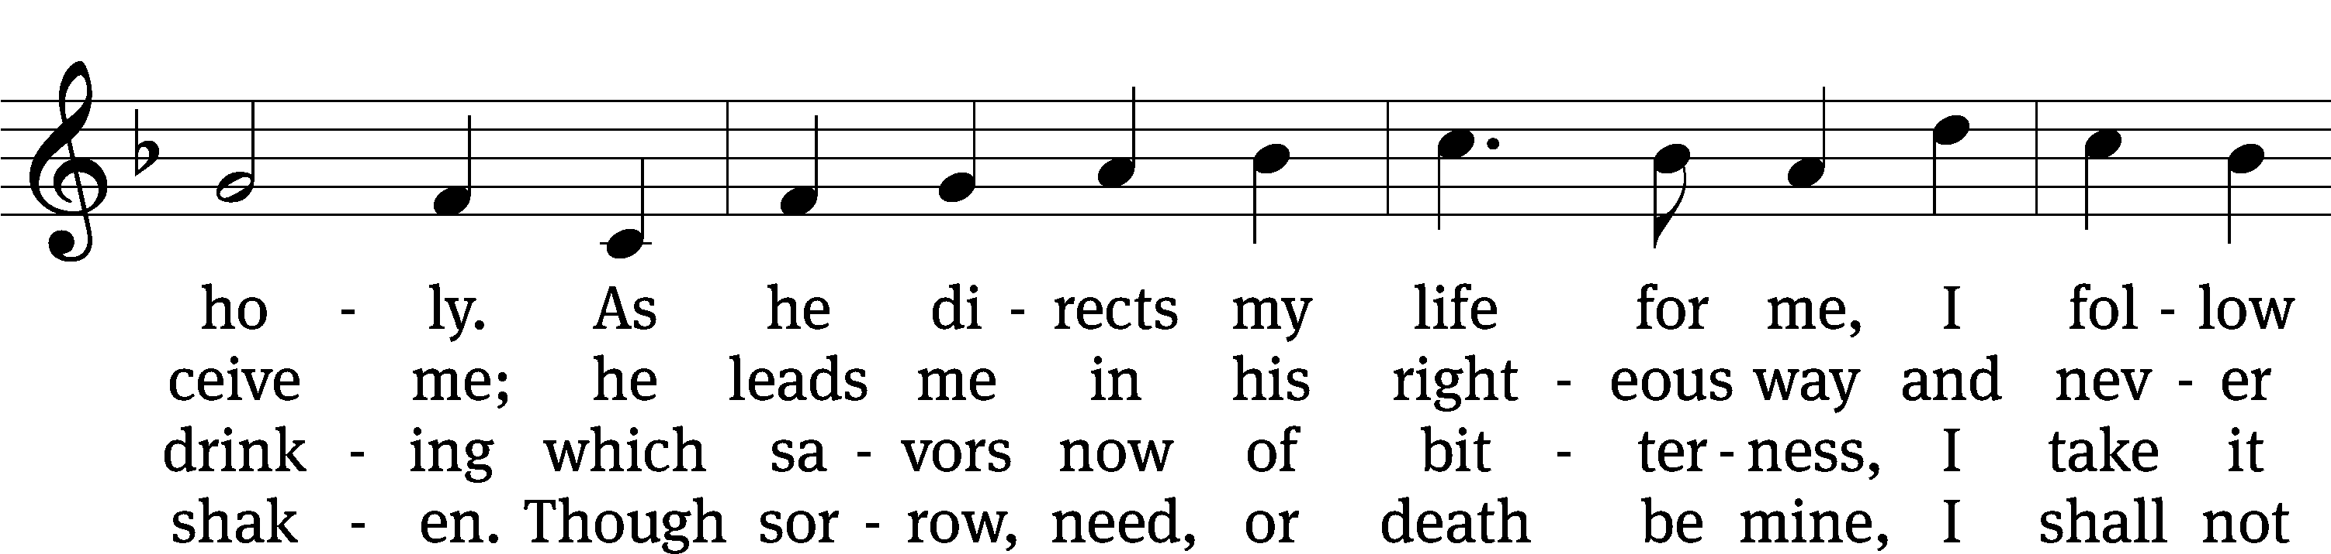
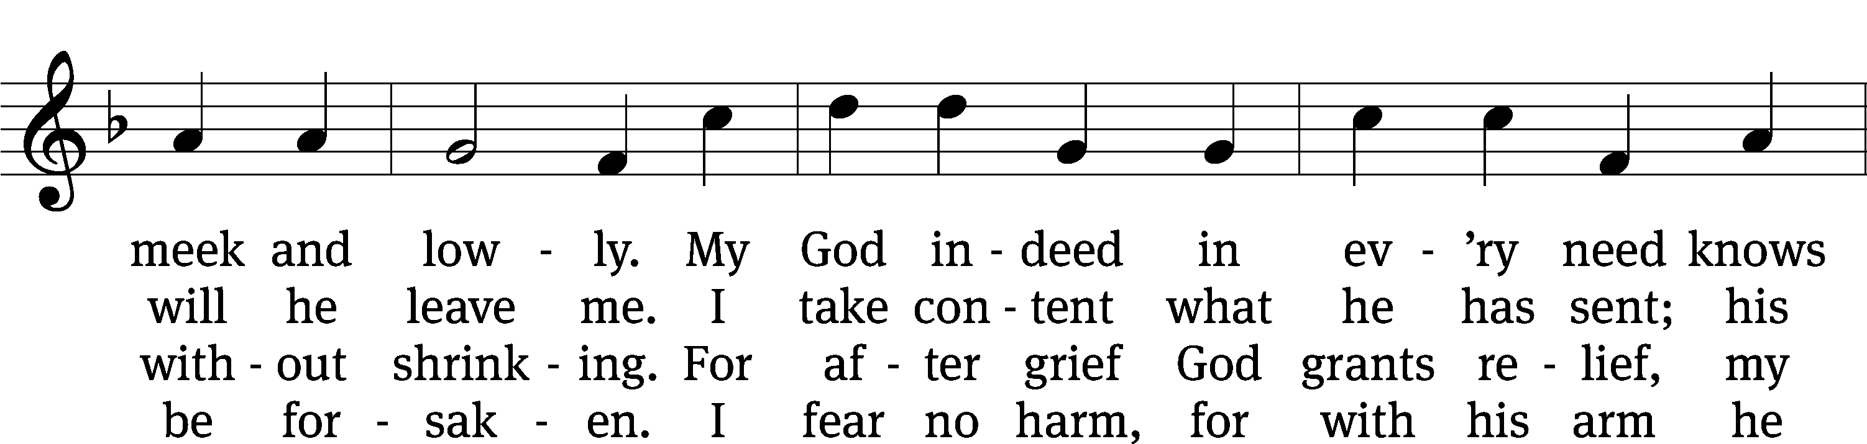
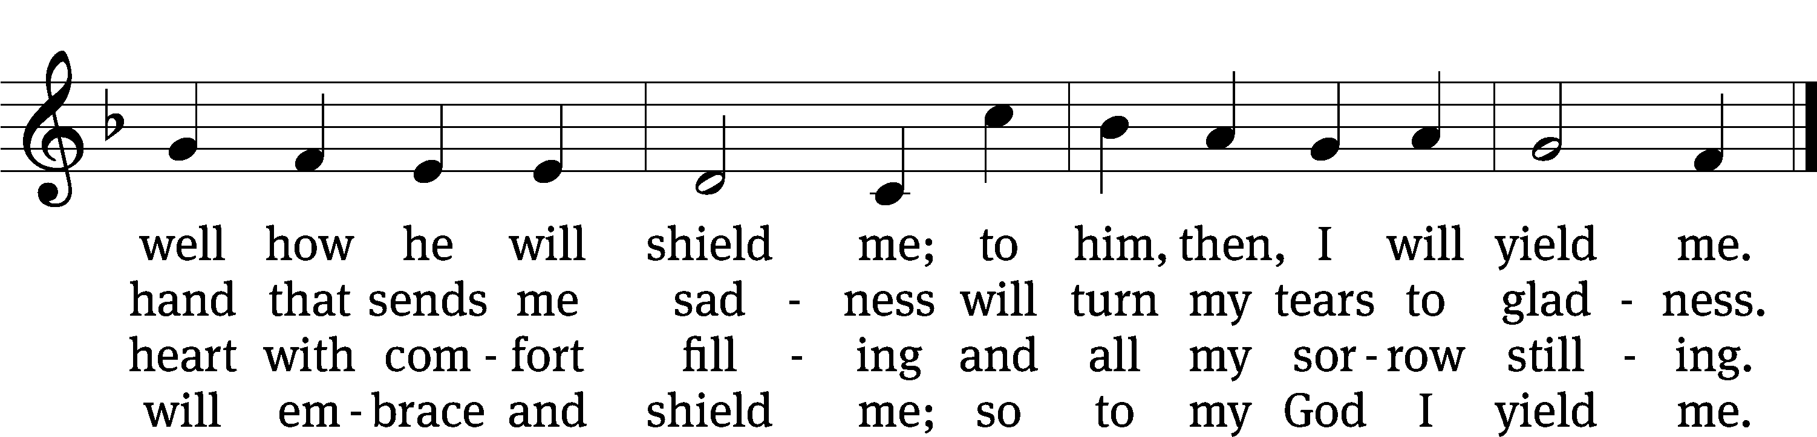
Text: tr. The Lutheran Hymnal, 1941, alt.; Samuel Rodigast, 1649–1708, abr.
Tune: Severus Gastorius, 1646–1682
Text and tune: Public domain

Please stand, if you are able
Prayer
Blessed Lord, you have given us your Holy Scriptures for our learning. May we so hear them, read, learn, and take them to heart that, being strengthened and comforted by your holy Word, we may cling to the blessed hope of everlasting life; through Jesus Christ our Lord, who lives and reigns with you and the Holy Spirit, one God, now and forever.
Amen.
Lord’s Prayer
Our Father, who art in heaven, hallowed be thy name, thy kingdom come, thy will be done on earth as it is in heaven. Give us this day our daily bread; and forgive us our trespasses, as we forgive those who trespass against us; and lead us not into temptation, but deliver us from evil. For thine is the kingdom and the power and the glory forever and ever. Amen.

Blessing
The Lord bless you and keep you.
The Lord make his face shine on you and be gracious to you.
The Lord look on you with favor and give you peace.
Amen.

Please be seated

867 Afflicted Saint, to Christ Draw Near CW 867 sts. 1–2, Ref, 3–4
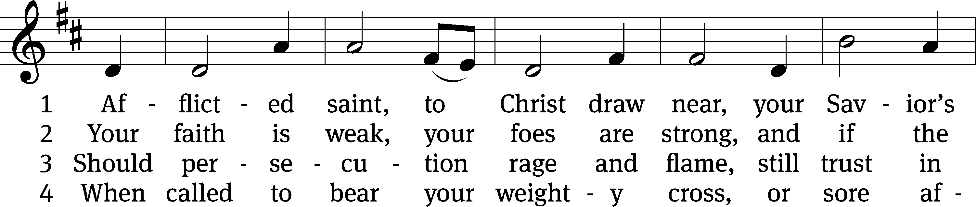
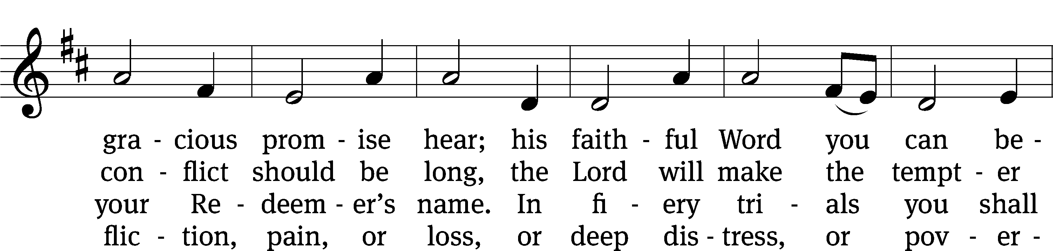
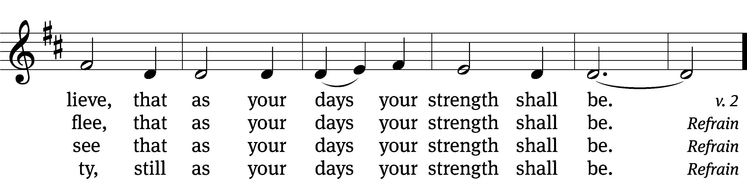
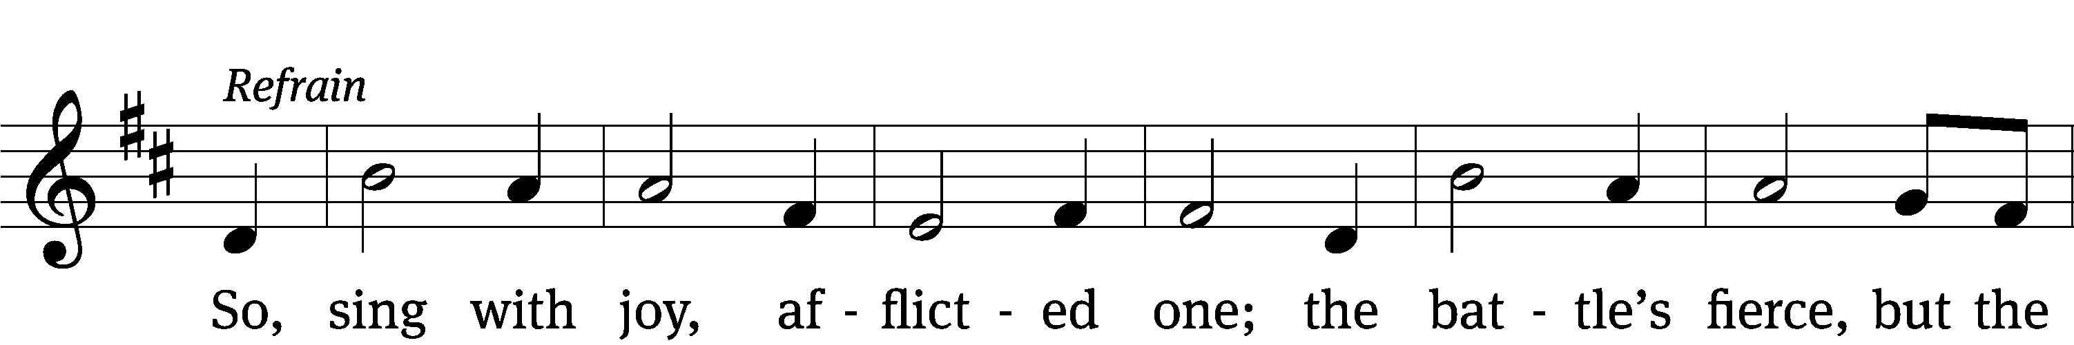
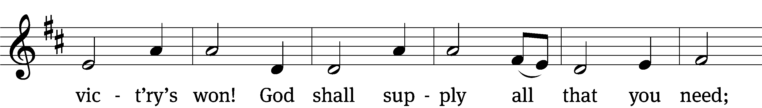
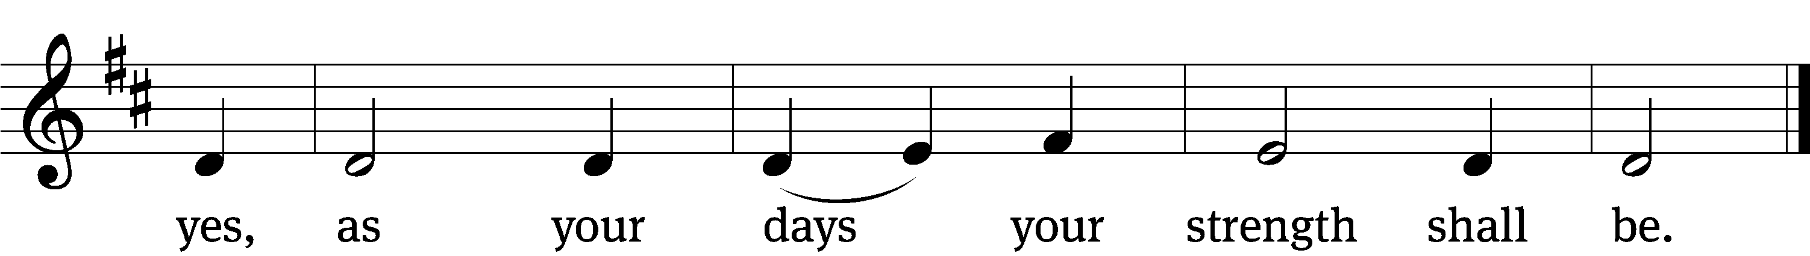
Text (sts. 1–4): John Fawcett, 1740–1817, alt.; (Ref): Constance Dever, b. 1960
Tune: Constance Dever, b. 1960
Text and tune: © 2018 Sovereign Grace Praise, admin. Integrity Music. Used by permission: OneLicense no. 727703

Acknowledgments
Setting One from Christian Worship
Software distributed in partnership with Northwestern Publishing House.
Created by Christian Worship: Service Builder © 2022 Concordia Publishing House.

Serving in Worship
Officiant Pastor Pappenfuss
Organist Marcia Marion Ackling
Choir Director Cynthia Natsis
Accompanist Sarah Hanke
Deacons (8:30) Ron Roehm and Duane Mason
(11:00) Robert Niethammer and Gary Knowlton
Ushers (8:30) Tim Phelps and Brian Graham
(11:00) Ron Zahn
Altar Guild Judy Lindemann and Barb Neuburger
Videographer Jake Vershum

