THE FOURTH sunday
IN LENT

TRINITY EVANGELICAL LUTHERAN CHURCH | Saline, Michigan
WELCOME TO WORSHIP March 19, 2023

Thank you for joining us in God’s house today! We cordially ask that our guests sign one of the guestbooks located at either the front or back entryways.

THANK OFFERING: Members of Trinity give their offering as an expression of love and thankfulness to the Lord and to help support the Lord’s work in our community and around the world. Visitors need not feel obligated to participate in this offering which supports our ministry.

Restrooms are located at the back of the upper level (the annex), and in the basement (down the back stairs of the sanctuary or annex). Handicap access is available, please ask an usher for assistance.

celebration of holy communion:
In His Word, God makes it clear that the Lord’s Supper is to be shared by people of a common proclamation of faith (1 Corinthians 11:26; 1 Corinthians 10:16-17). Without judging anyone’s hearts, we invite those who share in our confession by their membership in our congregation or another congregation of the Wisconsin Evangelical Lutheran Synod (WELS) or the Evangelical Lutheran Synod (ELS) and who are properly prepared (1 Corinthians 11;27-29) to receive the Sacrament. Page 295 in the front of Christian Worship provides a guide for preparation.

Guests, we would love to have you join us in communion fellowship in the future, and for that to be possible, we ask that you speak with one of the pastors so that we may speak with you on how that would be possible. We thank you for respecting the way we celebrate the Lord’s Supper in our congregations.

SERVICE OF WORD AND SACRAMENT
Instrumental Duet (11:00) “Jesus, Name Above All Names”
576 Amazing Grace CW 576
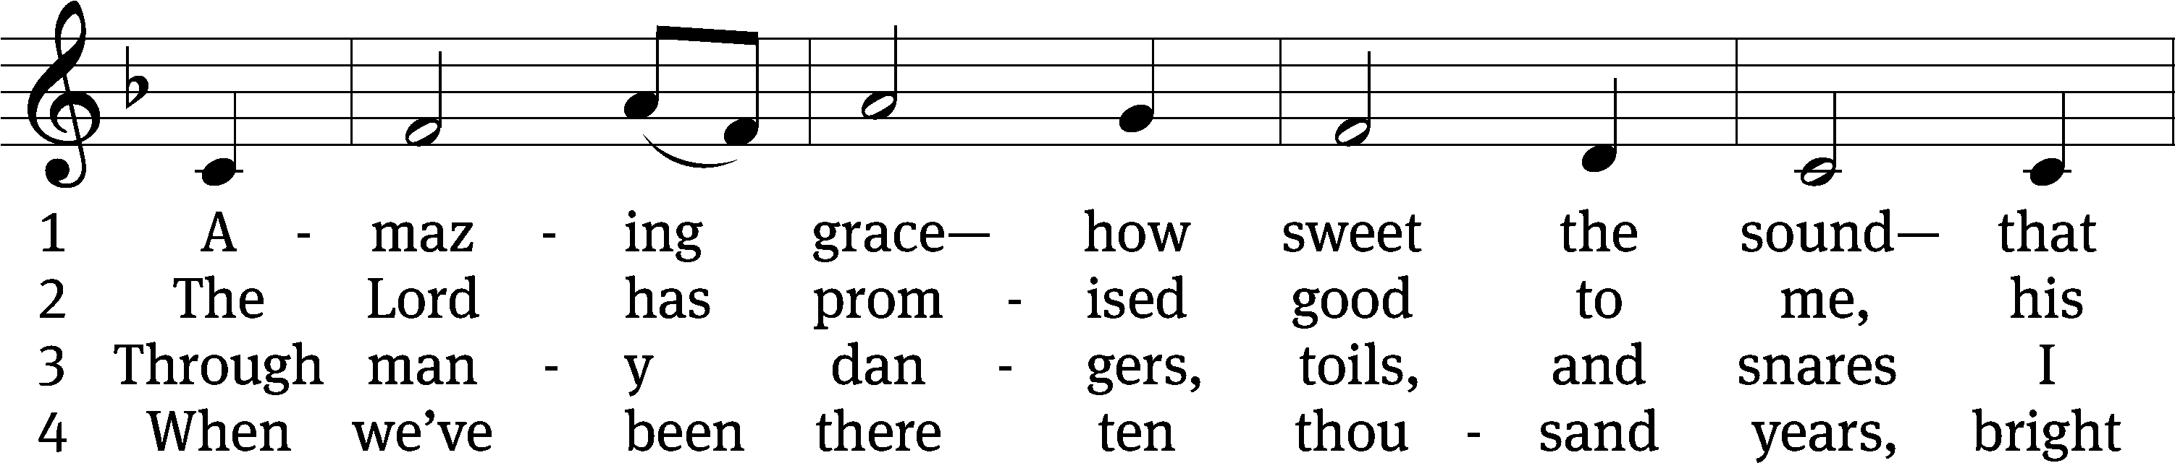
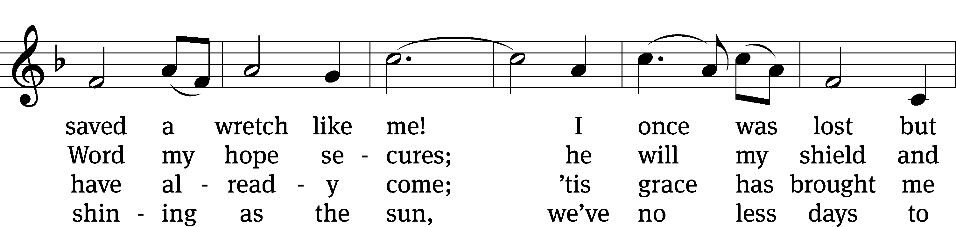
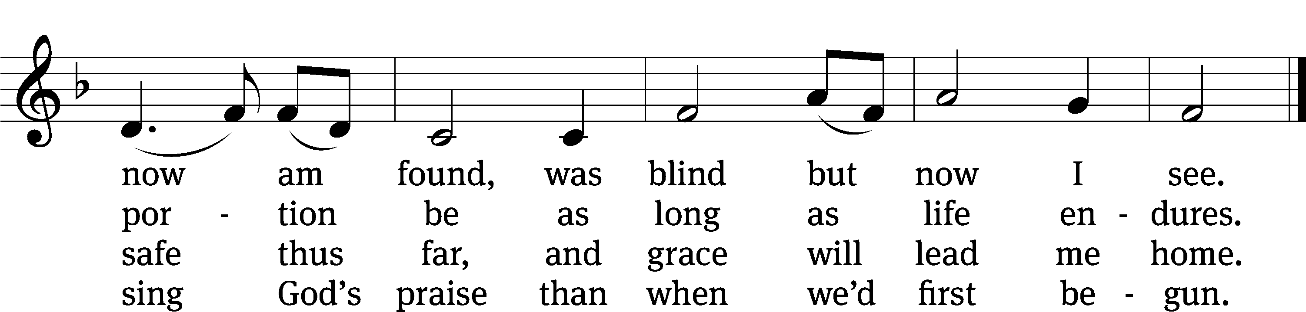
Text (sts. 1–3): John Newton, 1725–1807, alt.; (st. 4): A Collection of Sacred Ballads, Richmond, 1790
Tune: Columbian Harmony, Cincinnati, 1829, ed. Benjamin Shaw; ed. Charles H. Spilman
Text and tune: Public domain

PLEASE STAND, IF YOU ARE ABLE

invocation

M: The grace of our Lord (+) Jesus Christ and the love of God and the fellowship of the Holy Spirit be with you.
C: And also with you.

CONFESSION OF SINS
M: God invites us to come into his presence and worship him with humble and penitent hearts. Therefore, let us acknowledge our sinfulness and ask him to forgive us.
C: Holy and merciful Father, I confess that I am by nature sinful, and that I have disobeyed you in my thoughts, words, and actions. I have done what is evil and failed to do what is good. For this I deserve your punishment both now and in eternity. But I am truly sorry for my sins, and trusting in my Savior Jesus Christ, I pray: Lord, have mercy on me, a sinner.
M: God, our heavenly Father, has been merciful to us and has given his only Son to be the atoning sacrifice for our sins. Therefore, as a called servant of Christ and by his authority, I forgive you all your sins in the name of the Father and of the Son (+) and of the Holy Spirit.
C: Amen.
PRAYER AND PRAISE
LORD, HAVE MERCY
Kyrie
M: For all that we need in life and for the wisdom to use all your gifts with gratitude and joy, hear our prayer, O Lord.

M: For the steadfast assurance that nothing can separate us from your love and for the courage to stand firm against the assaults of Satan and every evil, hear our prayer, O Christ.

M: For the well-being of your holy Church in all the world and for those who offer here their worship and praise, hear our prayer, O Lord.

M: Merciful God, maker and preserver of life, uphold us by your power and keep us in your tender care:

M: The works of the Lord are great and glorious; his name is worthy of praise.

Prayer of the day

M: Let us pray.
The minister says the Prayer of the Day.

PLEASE BE SEATED

The Word

first lesson Isaiah 42:14-21
¹⁴ I have been silent for a long time.
I have kept still. I have restrained myself.
But now, like a woman giving birth, I will scream.
I will gasp and pant.
¹⁵ I will dry up mountains and hills.
I will make all their grass wither.
I will turn rivers into islands.
I will dry up pools.
¹⁶ I will lead the blind on a way they do not know.
Along paths they do not know I will direct them.
Ahead of them I will turn darkness into light
and rough places into level ground.
These are the things I will accomplish for them.
I will not abandon them.
¹⁷ They will be turned back and completely disgraced—
those who trust in an idol,
those who say to molten images, “You are our gods.”
¹⁸ You deaf ones, listen!
You blind ones, watch carefully so that you can see!
¹⁹ Who is as blind as my servant?
Who is as deaf as my messenger whom I sent?
Who is as blind as my associate,
as blind as the servant of the Lord?
²⁰ You, Israel, see many things, but you do not observe.
Israel opens his ears, but he does not hear.
²¹ Because of his own righteousness,
the Lord was pleased to make his law great and glorious.

27D We Are Singing Psalm 27D
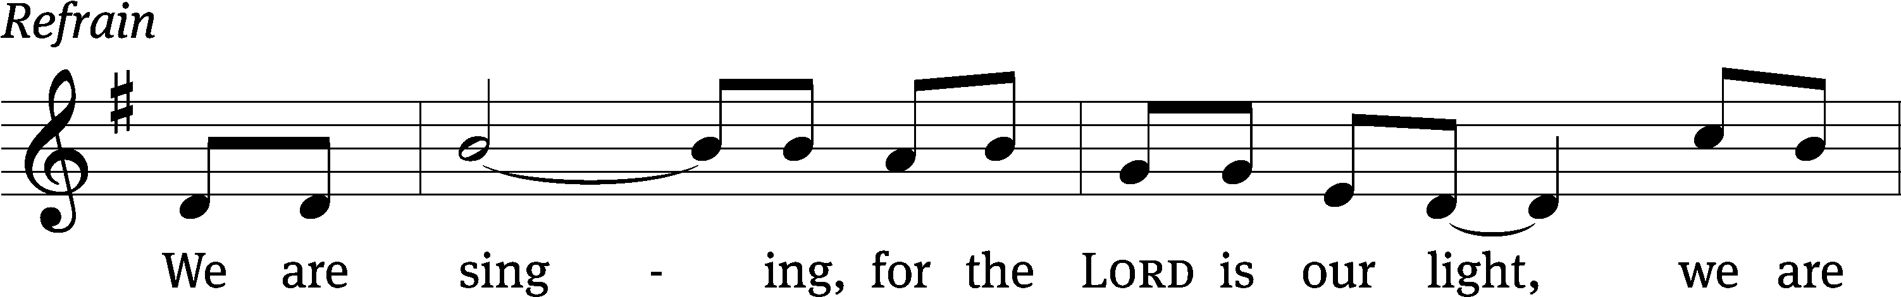
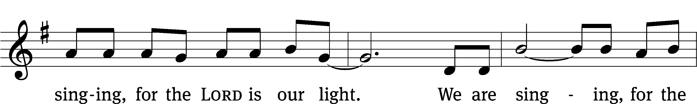
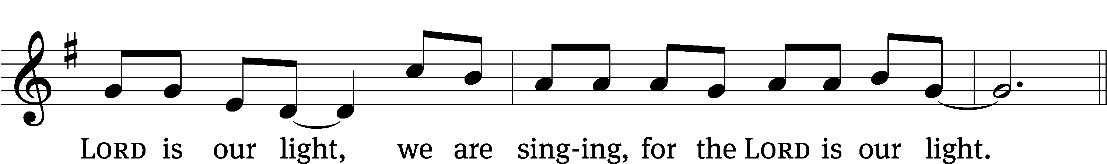
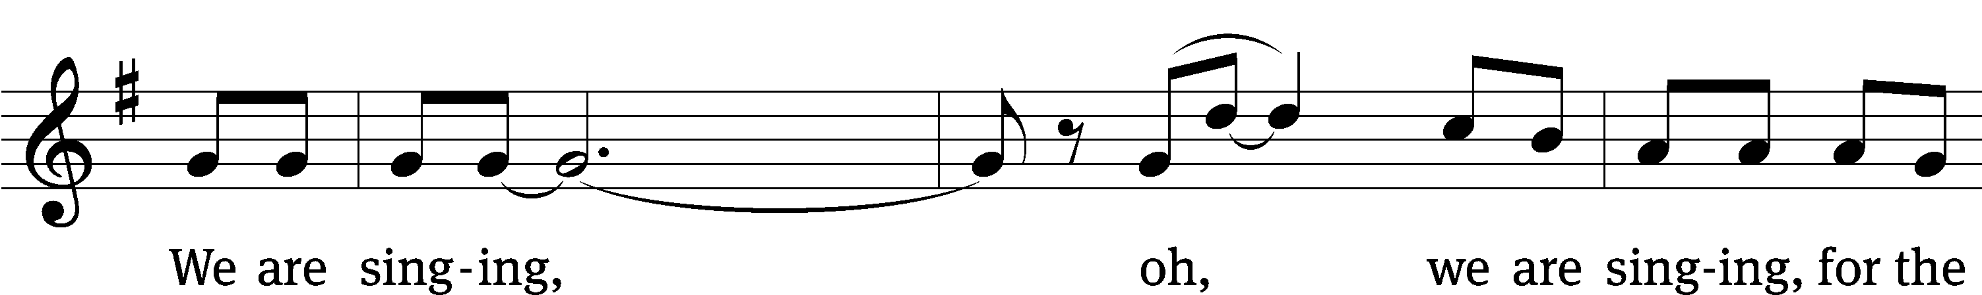
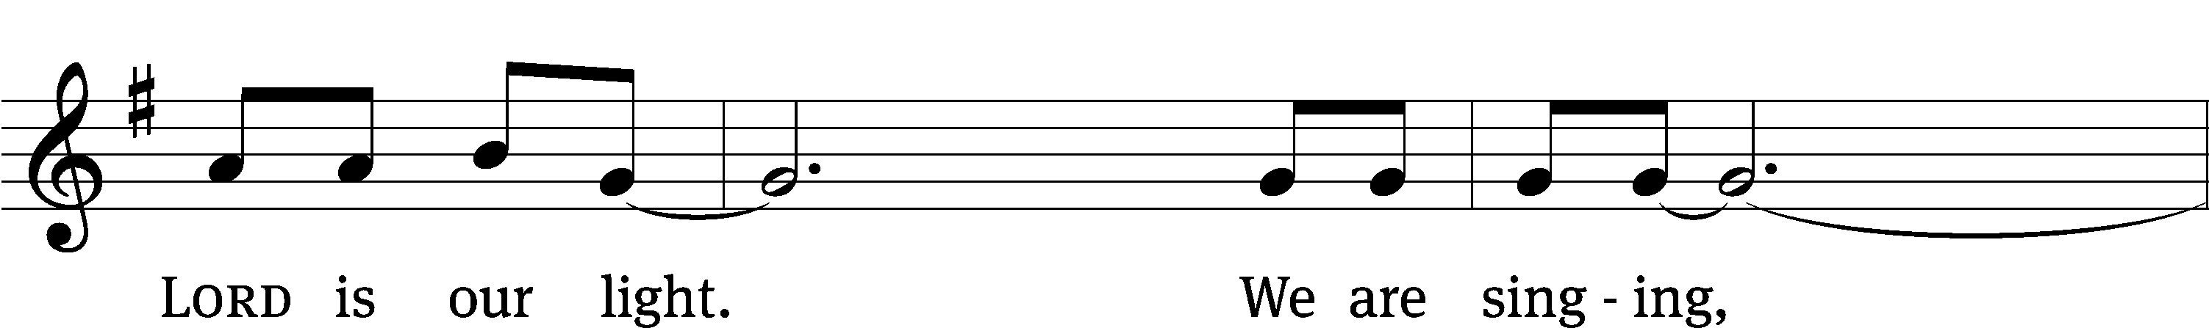
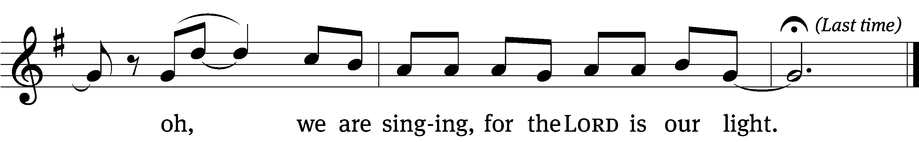
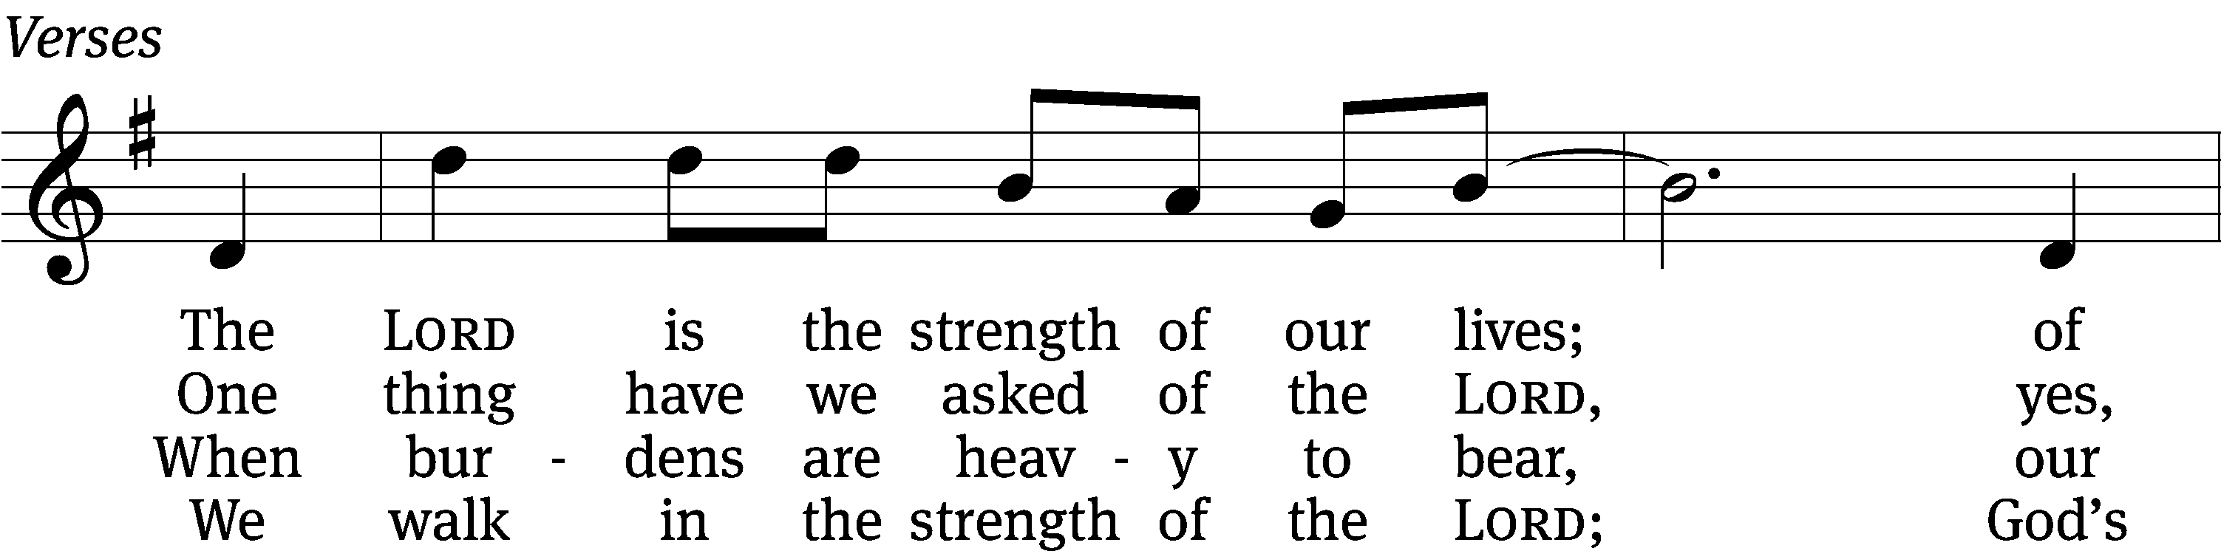
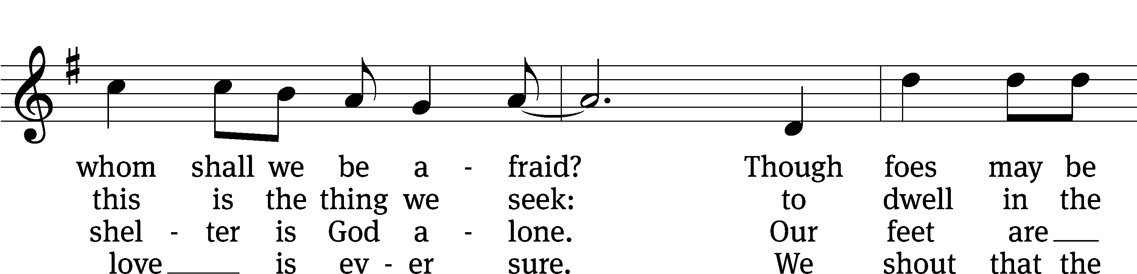
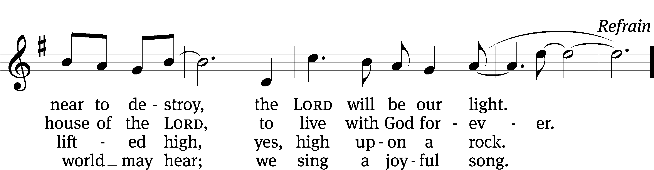
Text: tr. and original verses by Hal H. Hopson; South African
Tune: Zulu melody, adapted by Hal H. Hopson
Text and tune: © 1994 Hope Publishing Co. Used by permission: OneLicense no. 727703

second lesson Ephesians 5:8-14
⁸ For you were once darkness, but now you are light in the Lord. Walk as children of light, ⁹ for the fruit of the light consists in all goodness, righteousness, and truth. ¹⁰ Try to learn what is pleasing to the Lord, ¹¹ and do not participate in fruitless deeds of darkness. Instead, expose them. ¹² For it is shameful even to mention the things that are done by people in secret. ¹³ But everything exposed by the light becomes visible, for it is light that makes things visible. ¹⁴ Therefore it is said, “Awake, sleeper, rise from the dead, and Christ will shine on you.”

PLEASE STAND, IF YOU ARE ABLE

VERSE OF THE DAY
Let us keep our eyes fixed on Jesus, who is the author of our faith and the one who brings it to its goal.

GOSPEL John 9:1-7, 13-17, 34-39
¹ As Jesus was passing by, he saw a man blind from birth. ² His disciples asked him, “Rabbi, who sinned, this man or his parents, that he was born blind?”
³ Jesus answered, “It was not that this man sinned, or his parents, but that God’s works might be revealed in connection with him. ⁴ I must do the works of him who sent me while it is day. Night is coming when no one can work. ⁵ As long as I am in the world, I am the Light of the World.” ⁶ After saying this, Jesus spit on the ground, made some mud with the saliva, and spread the mud on the man’s eyes. ⁷ “Go,” Jesus told him, “wash in the pool of Siloam” (which means “Sent”). So he went and washed, and came back seeing.
¹³ They brought this man who had been blind to the Pharisees. ¹⁴ Now it was a Sabbath day when Jesus made the mud and opened his eyes. ¹⁵ So the Pharisees also asked him how he received his sight. “He put mud on my eyes,” the man told them. “I washed, and now I see.”
¹⁶ Then some of the Pharisees said, “This man is not from God because he does not keep the Sabbath.” Others were saying, “How can a sinful man work such miraculous signs?”
There was division among them, ¹⁷ so they said to the blind man again, “What do you say about him, because he opened your eyes?”
The man replied, “He is a prophet.”
³⁴ They answered him, “You were entirely born in sinfulness! Yet you presume to teach us?” And they threw him out.
³⁵ Jesus heard that they had thrown him out. When he found him, he asked, “Do you believe in the Son of God?”
³⁶ “Who is he, sir,” the man replied, “that I may believe in him?”
³⁷ Jesus answered, “You have seen him, and he is the very one who is speaking with you.”
³⁸ Then he said, “Lord, I believe!” and he knelt down and worshipped him.
³⁹ Jesus said, “For judgment I came into this world, in order that those who do not see will see, and those who do see will become blind.”
M: This is the Gospel of the Lord.

PLEASE BE SEATED
713 I Want to Walk as a Child of the Light CW 713
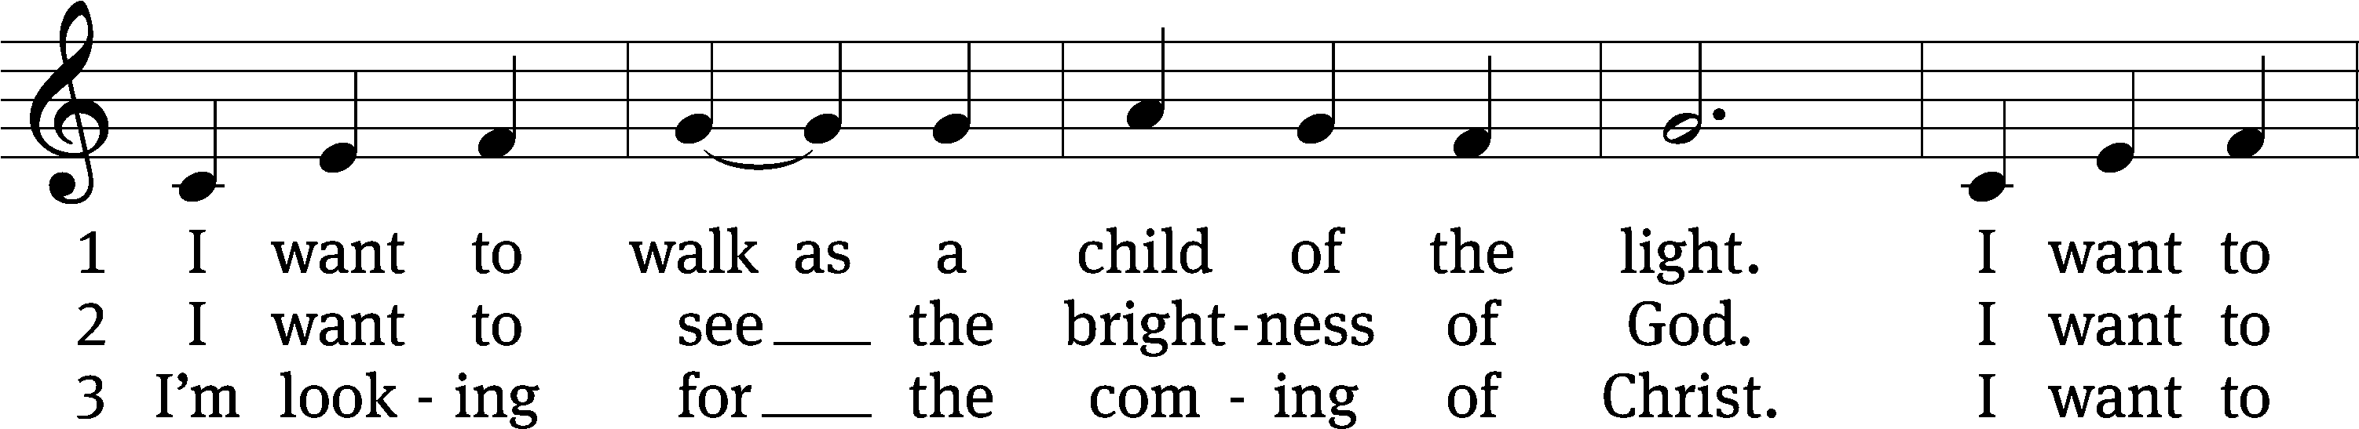
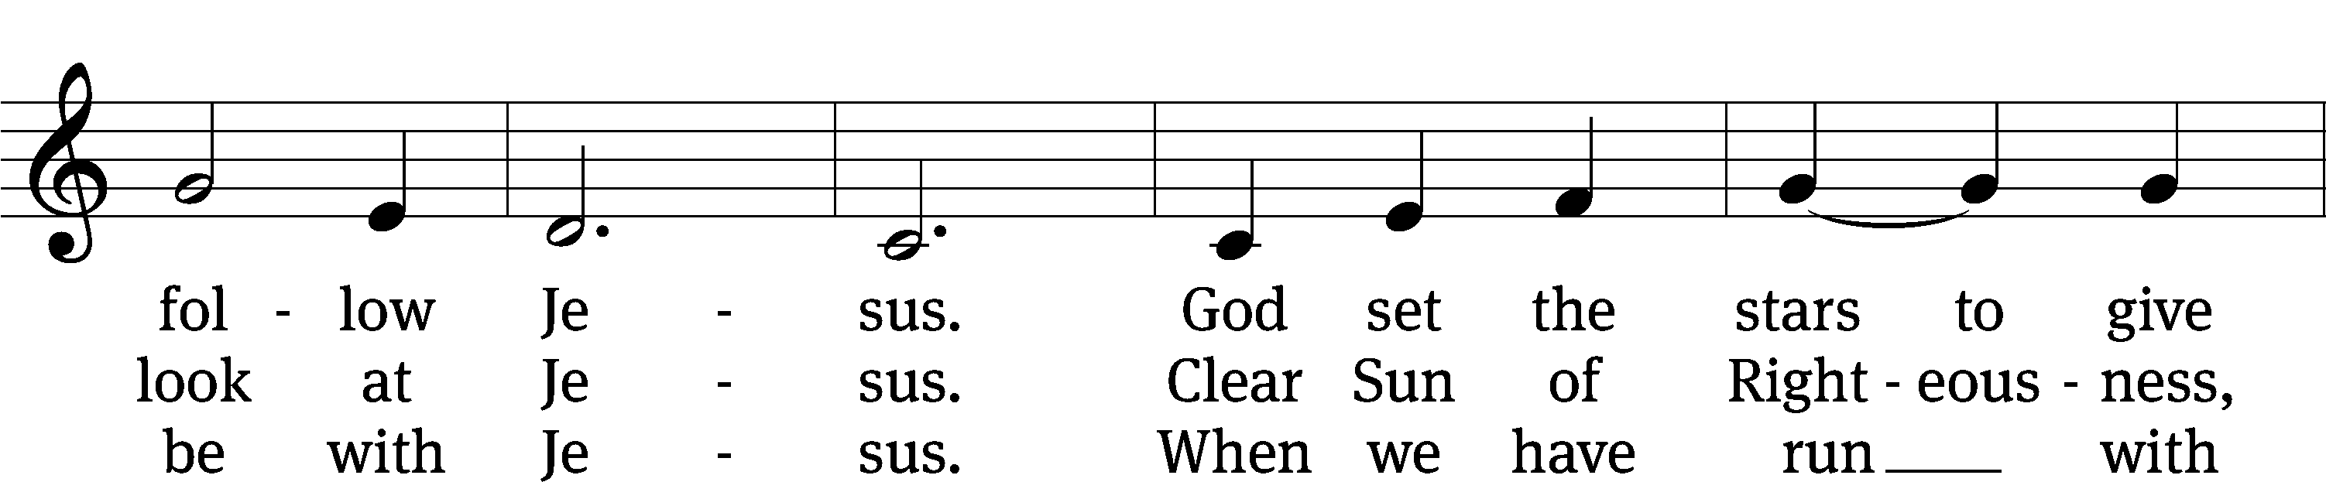
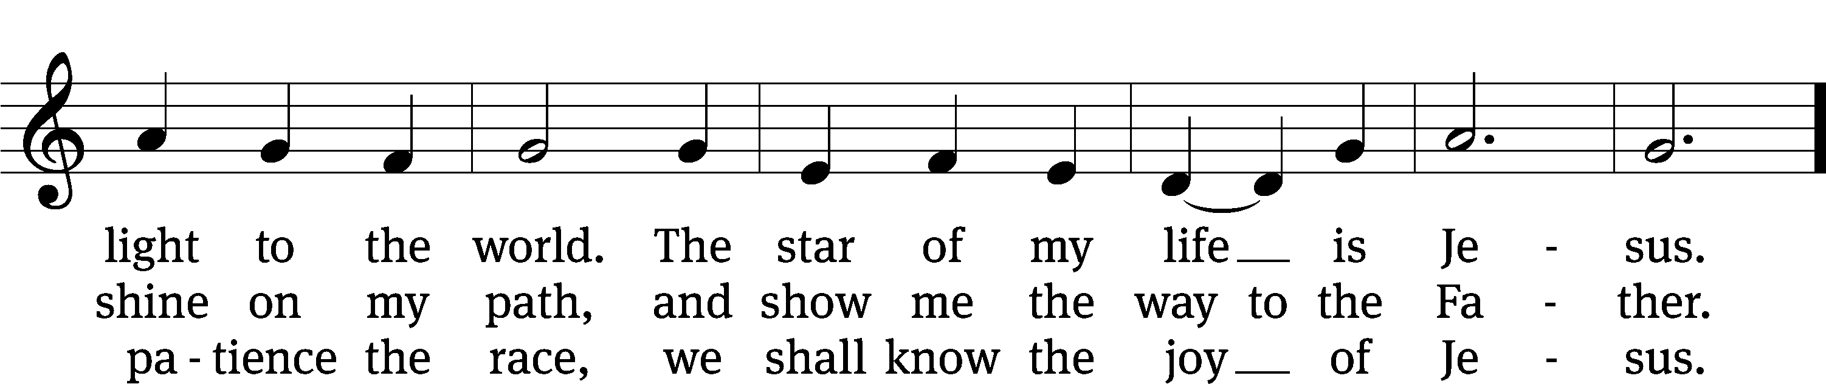
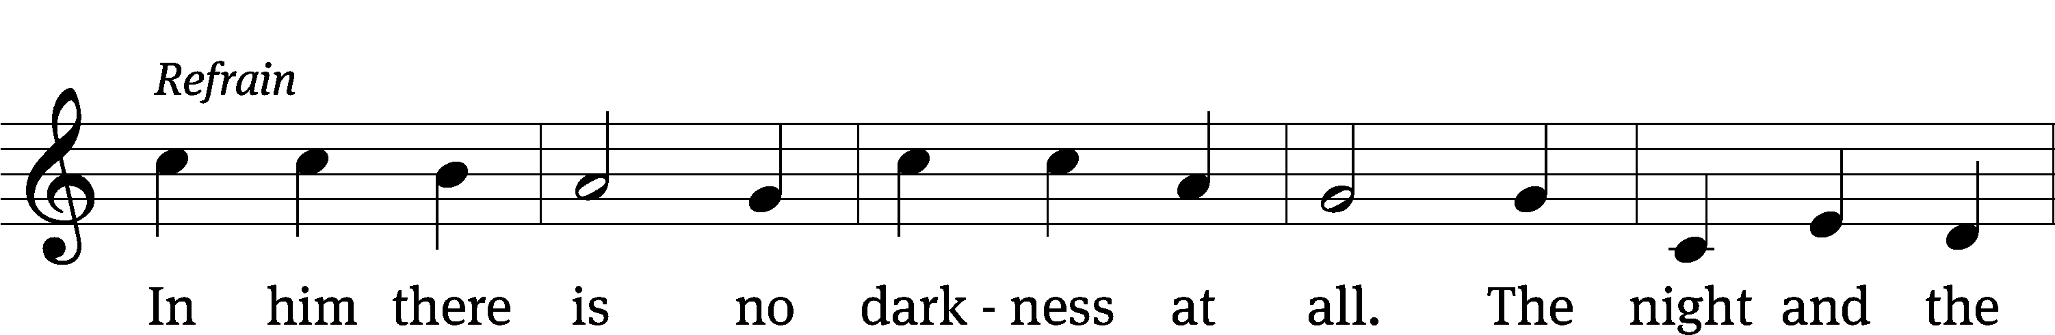
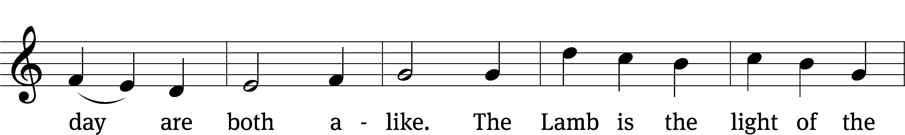
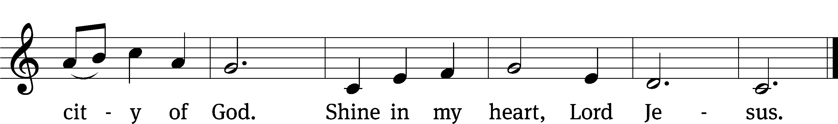
Text: Kathleen Thomerson, b. 1934
Text and tune: © 1970, 1975 Celebration. Used by permission: OneLicense no. 727703

Sermon John 9:1-7, 13-17, 34-39

“I Don’t Believe What I just Saw!”

please stand, if you are able

nicene creed
We believe in one God, the Father, the Almighty, maker of heaven and earth, of all that is, seen and unseen.
We believe in one Lord, Jesus Christ, the only Son of God, eternally begotten of the Father, God from God, Light from Light, true God from true God, begotten, not made, of one being with the Father. Through him all things were made. For us and for our salvation, he came down from heaven, was incarnate of the Holy Spirit and the virgin Mary, and became truly human. For our sake he was crucified under Pontius Pilate. He suffered death and was buried. On the third day he rose again in accordance with the Scriptures. He ascended into heaven and is seated at the right hand of the Father. He will come again in glory to judge the living and the dead, and his kingdom will have no end.
We believe in the Holy Spirit, the Lord, the giver of life, who proceeds from the Father and the Son, who in unity with the Father and the Son is worshiped and glorified, who has spoken through the prophets. We believe in one holy Christian and apostolic Church. We acknowledge one baptism for the forgiveness of sins. We look for the resurrection of the dead and the life of the world to come. Amen.

PLEASE BE SEATED

OFFERTORY – “Jesus, Name Above All Names” (8:30 a.m.)

PLEASE STAND, IF YOU ARE ABLE

prayer of the church

lord’s prayer

C: Our Father, who art in heaven,
hallowed be thy name,
thy kingdom come,
thy will be done
on earth as it is in heaven.
Give us this day our daily bread;
and forgive us our trespasses,
as we forgive those
who trespass against us;
and lead us not into temptation,
but deliver us from evil.
For thine is the kingdom
and the power and the glory
forever and ever. Amen.

The Sacrament of Holy Communion
Trinity Lutheran Church follows the historic Christian practice of close communion. We ask that only members of Trinity or one of our sister congregations partake of the sacrament. If you are not a member, please see the note about Holy Communion in the beginning of the Worship Folder.

M: The Lord be with you.

M: Lift up your hearts.

M: Let us give thanks to the Lord our God.

M: Praise to the God and Father of our Lord Jesus Christ! In love he has blessed us with every spiritual blessing. He sends the Holy Spirit to testify that we are his children and to strengthen us when we are weak. Now have come the salvation and the power and the kingdom of our God and the authority of his Christ. To him who sits on the throne and to the Lamb be praise and thanks and honor and glory for ever and ever:

Holy, Holy, Holy

Words of institution
M: Our Lord Jesus Christ, on the night he was betrayed, took bread; and when he had given thanks, he broke it and gave it to his disciples, saying: “Take and eat. This is my ✙ body, which is given for you. Do this in remembrance of me.”
Then he took the cup, gave thanks, and gave it to them, saying, “Drink from it all of you; this is my ✙ blood of the new covenant, which is poured out for you for the forgiveness of sins. Do this, whenever you drink it, in remembrance of me.”
The peace of the Lord be with you always.

O CHRIST, LAMB OF GOD

PLEASE BE SEATED
670 I Come, O Savior, to Your Table CW 670
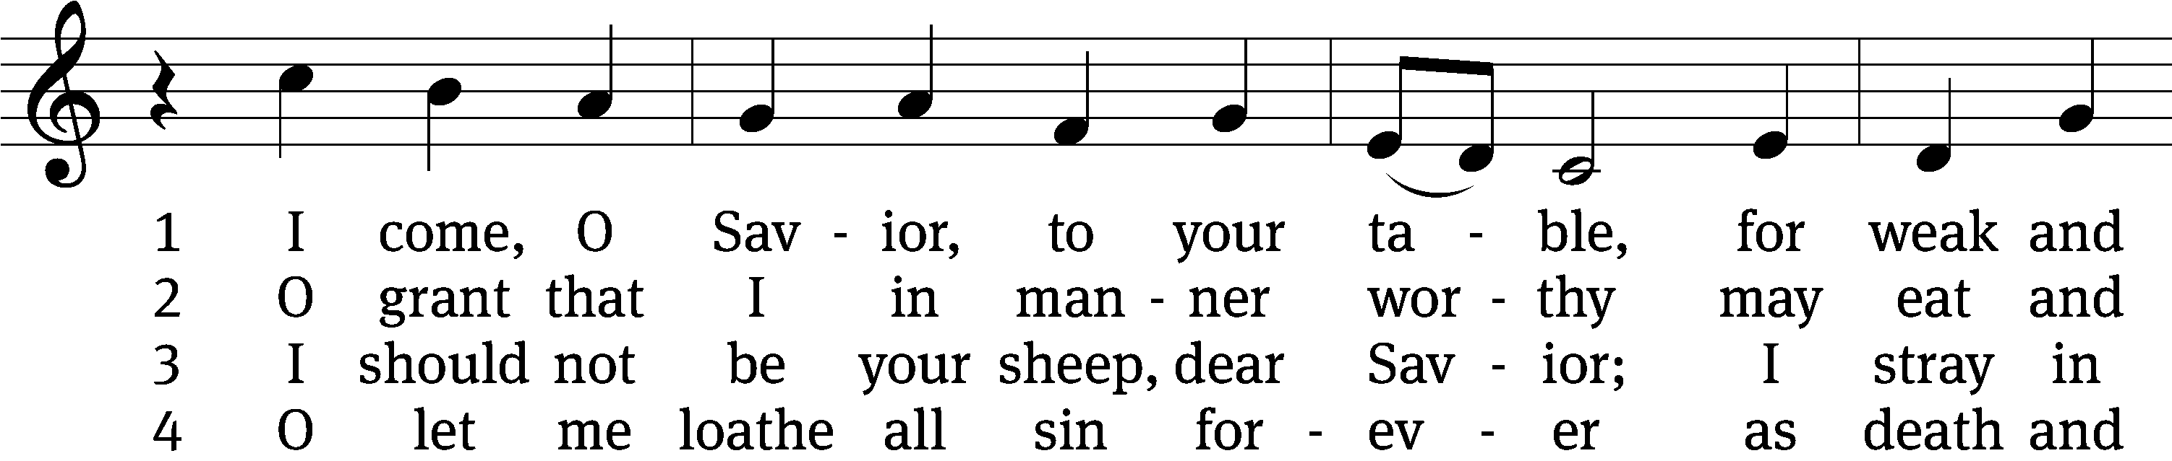
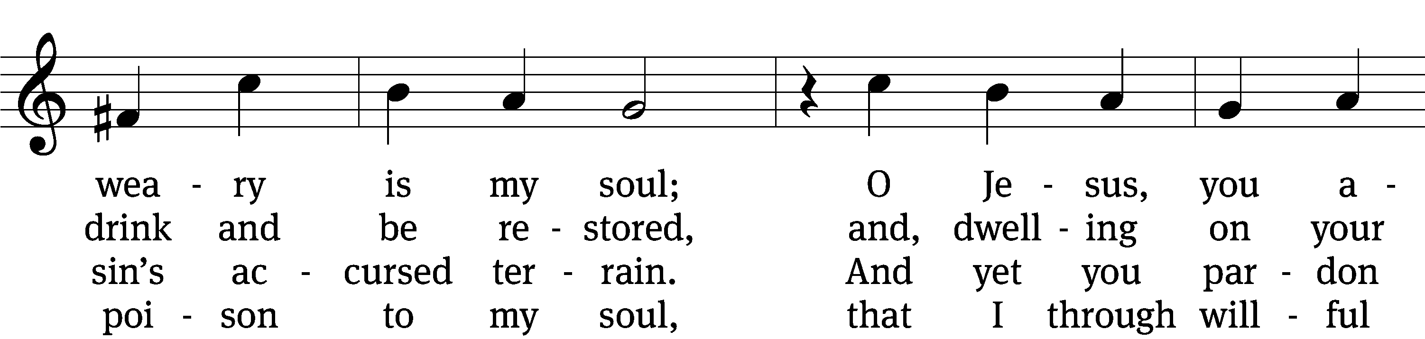
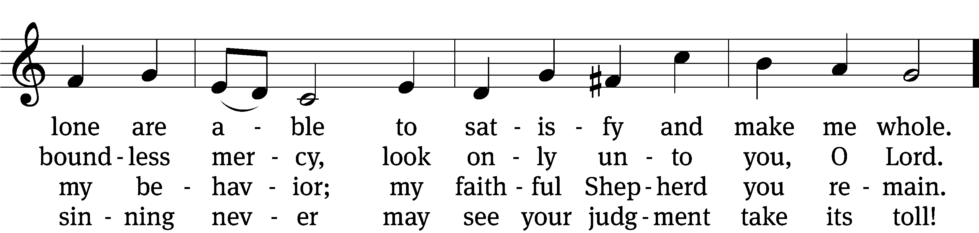
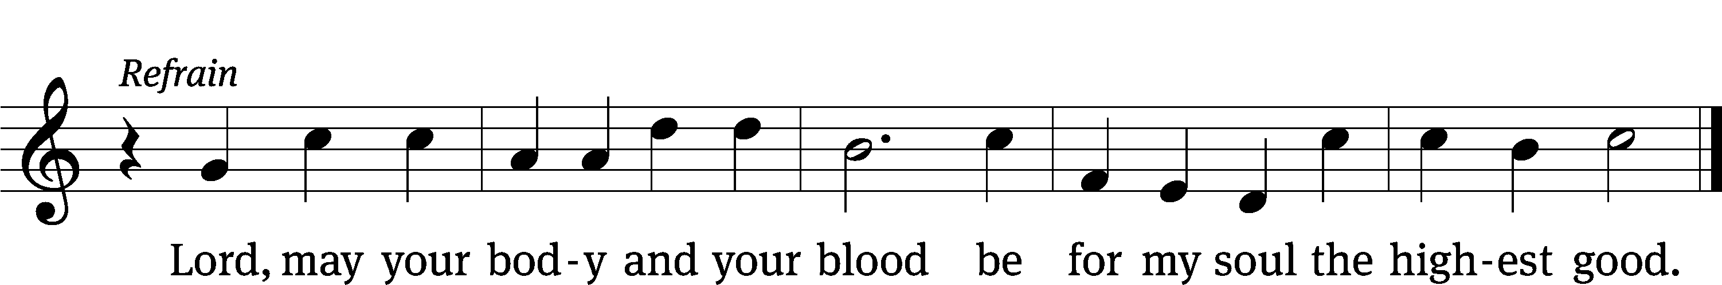

5 Your holy heart has one obsession,
one blessèd thing it burns to do—
to cleanse the sinner from transgression;
so I, a sinner, come to you. (Refrain)

6 My soul is burdened; Lord, relieve me,
by all this weight of sin oppressed!
Though sinful, yet, in grace receive me
and feed me as your grateful guest. (Refrain)

7 Within me, Lord, your vision traces
a heart of deep humility
that mourns its sin and yet embraces
the merit you have earned for me. (Refrain)

8 By faith I call your holy table
the testament of your deep love,
for by your gift I now am able
to know the heart of God above. (Refrain)

9 This meal with blessing is abounding:
to poor ones wealth, to weak ones pow’r,
to angels joy, to hell confounding,
and life for me in death’s dark hour. (Refrain)

10 My heart has now become your dwelling,
O blessèd, holy Trinity.
With angels I, your praises telling,
shall live in joy eternally. (Refrain)
Text: Friedrich C. Heyder, 1677–1754, abr.; (sts. 1, Ref, 2, 4, 8–10): tr. The Lutheran Hymnal, 1941; (sts. 3, 5–7): tr. Michael D. Schultz, b. 1963
Tune: Emskirchner Choral-Buch, Leipzig, 1756
Text (sts. 1, Ref, 2, 4, 8–10): © 1941 Concordia Publishing House; (sts. 3, 5–7): © 2021 Northwestern Publishing House. Used by permission: OneLicense no. 727703
Tune: Public domain

PLEASE STAND, IF YOU ARE ABLE

M: Hear the prayer of your people, O Lord, that the lips which have praised you here may glorify you in the world, that the eyes which have seen the coming of your Son may long for his coming again, and that all who have received in his true body and blood the pledge of your forgiveness may be restored to live a new and holy life, through Jesus Christ, our Lord, who lives and reigns with you and the Holy Spirit, one God, now and forever.

M: Brothers and sisters, go in peace. Live in harmony with one another.
Serve the Lord with gladness.

The Lord bless you and keep you.
The Lord make his face shine on you and be gracious to you.
The Lord look on you with favor and (+) give you peace.

PLEASE BE SEATED
924 Abide, O Dearest Jesus CW 924
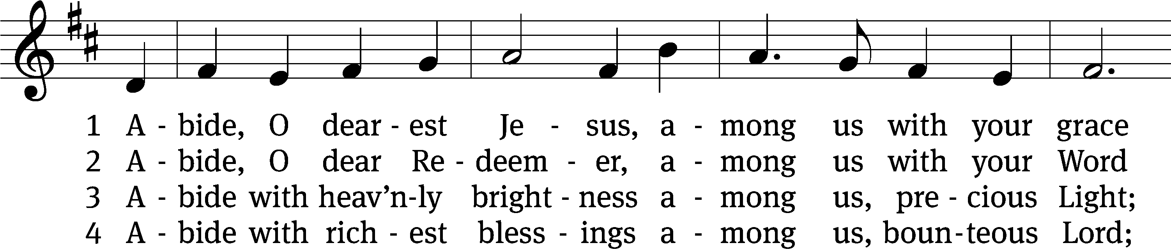
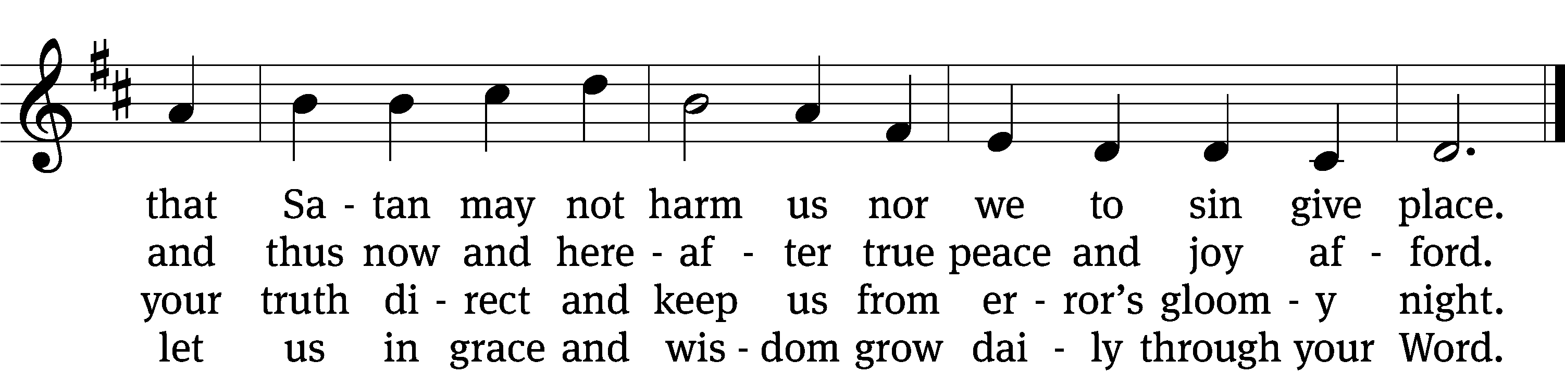

5 Abide with your protection
among us, Lord, our strength,
lest world and Satan fell us
and overcome at length.

6 Abide, O faithful Savior,
among us with your love;
grant steadfastness and help us
to reach our home above.
Text: tr. August Crull, 1845–1923, alt.; Josua Stegmann, 1588–1632
Tune: Melchior Vulpius, c. 1570–1615
Text and tune: Public domain

Serving In Worship

Officiant Pastor Natsis
Organist Ann Hoeft
Instrumental Duet Malory Marion and Marcia Marion Ackling
Psalm Accompaniment Sarah Hanke
Soloists Paula Phelps, Ryan Phelps, Jim Tice
Deacons (8:30) Duane Mason and Jim Tice
(11:00) Steve Hoeft and Robert Niethammer
Ushers (8:30) Robert Newman and Henry Schneider
(11:00) Bill Barnett and Jake Vershum
Altar Guild Jean Fiegel and Ann Latowski
Videographer Cindy Dresch

Copyright information
Service of Word and Sacrament: Christian Worship. © 1993 Northwestern Publishing House. All rights reserved. Reprinted under ONE LICENSE #A-727703 and CCLI #1151741/ CSPL126093
Words and Music: All rights reserved. Reprinted/Podcast/Streamed with permission under ONE LICENSE #A-727703 and CCLI #1151741/CSPL126093

