SECOND SUNDAY OF EASTER

TRINITY EVANGELICAL LUTHERAN CHURCH | Saline, Michigan
WELCOME TO WORSHIP April 24, 2022
Thank you for joining us in God’s house today! We cordially ask that our Guests sign one of the guestbooks located at either the front or back entryways, or fill out a “Let’s Get Acquainted” card located in the hymnal pew rack and place it in the collection plate.

THANK OFFERING: Members of Trinity give their offering as an expression of love and thankfulness to the Lord and to help support the Lord’s work in our community and around the world. Visitors need not feel obligated to participate in this offering which supports our ministry.

Restrooms are located at the back of the upper level (the annex), and in the basement (down the back stairs of the sanctuary or annex). Handicap access is available, please ask an usher for assistance.

Young Families / Toddler Bags – We are GLAD YOU BROUGHT YOUR CHILDREN to our worship service. Jesus said: “Let the little children come to me and do not hinder them, for the kingdom of God belongs to such as these.” We know that having little children in church can be a challenge, but DO NOT WORRY about it. Many of your fellow worshippers have been in your shoes and are just happy you brought your children with you. For your convenience, we have reserved the back rows of seating for parents with small children. These areas provide more flexibility for your family, as well as, easy access to move downstairs if necessary. A closed-circuit TV system allows families to continue participating in the service while downstairs. Pre-school toddler bags and children’s bulletins are available for their enjoyment. Ask an usher for one to use during the service and please return the toddler bag afterwards.

Pre-service (11:00 Service Only)
Bell Choir “This Joyful Eastertide”

the SERVICE – setting one - WITHOUT HOLY COMMUNION CW, page 154
440 Christ Jesus Lay in Death’s Strong Bands CW 440
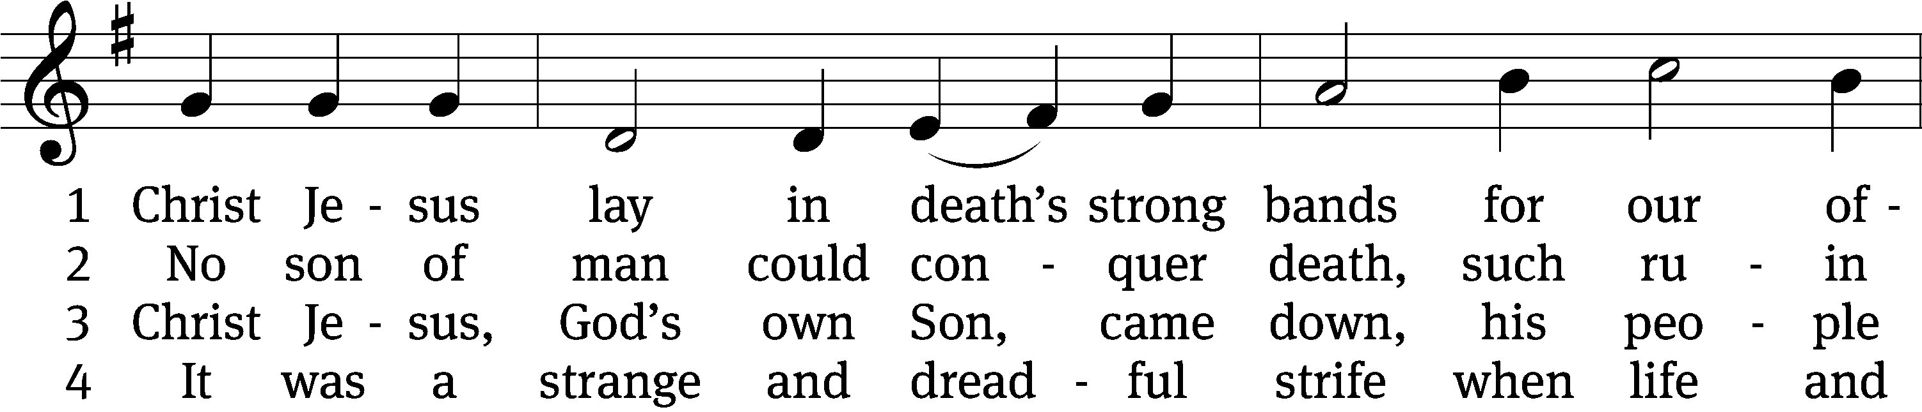
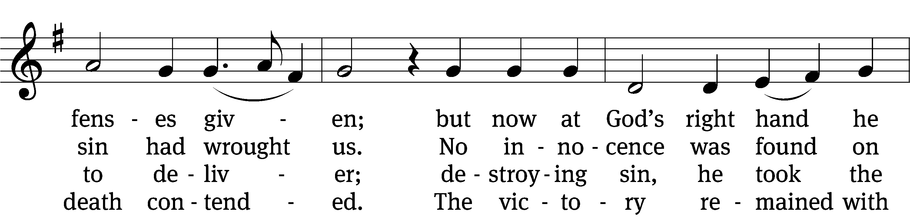
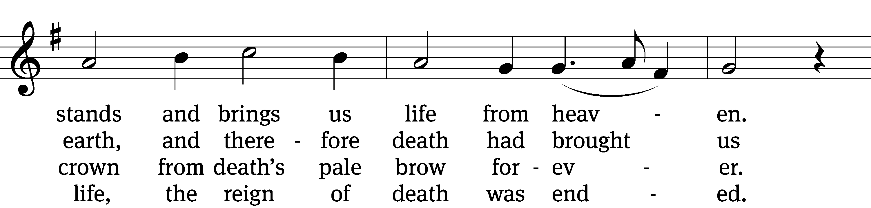
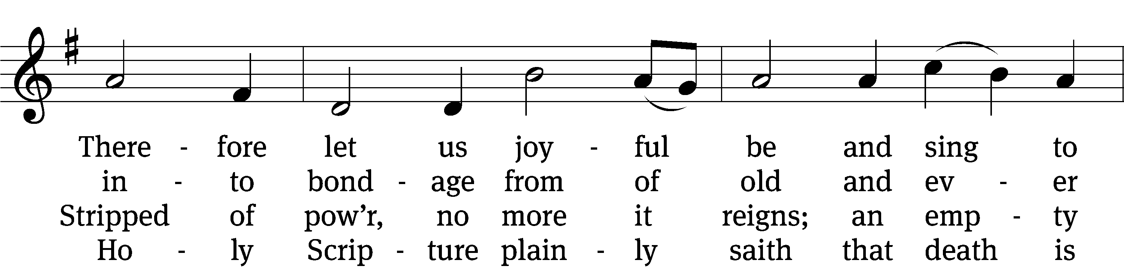
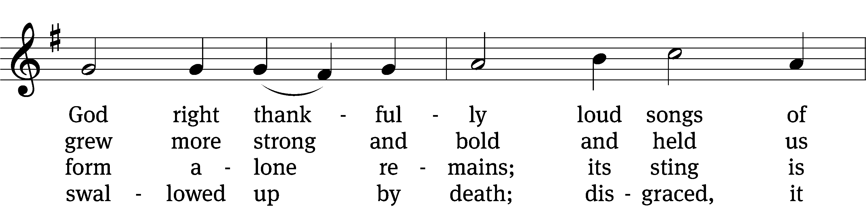
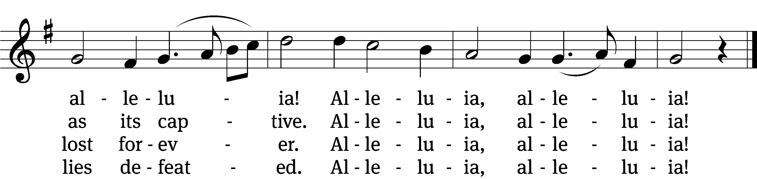

5 Here the true Paschal Lamb we see,
whom God so freely gave us;
he died on the accursèd tree—
so strong his love—to save us.
See, his blood now marks our door;
faith points to it; death passes o’er,
and Satan cannot harm us.
Alleluia, alleluia!

6 So let us keep the festival
to which the Lord invites us;
Christ is himself the joy of all,
the sun that warms and lights us.
Now his grace to us imparts
eternal sunshine to our hearts;
the night of sin is ended.
Alleluia, alleluia!

7 Then let us feast this Easter Day
on Christ, the bread of heaven;
the Word of grace has purged away
the old and evil leaven.
Christ alone our souls will feed;
he is our meat and drink indeed;
faith lives upon no other!
Alleluia, alleluia!

Text: tr. Richard Massie, 1800–1887, alt.; Martin Luther, 1483–1546
Tune: Kermit G. Moldenhauer, b. 1949
Text: Public domain
Tune: © 2005 Kermit G. Moldenhauer, admin. Northwestern Publishing House. Used by permission: OneLicense no. 727703

Please stand, if you are able
Invocation
In the name of the Father and of the Son and of the Holy Spirit.
Amen.
Confession
If we claim to be without sin, we deceive ourselves and the truth is not in us.
If we confess our sins, God is faithful and just
and will forgive us our sins
and purify us from all unrighteousness.

Let us confess our sins to the Lord.
Holy God, gracious Father,
I am sinful by nature
and have sinned against you in my thoughts, words, and actions.
I have not loved you with my whole heart;
I have not loved others as I should.
I deserve your punishment both now and forever.
But Jesus, my Savior, paid for my sins
with his innocent suffering and death.
Trusting in him, I pray: God, have mercy on me, a sinner.

Our gracious Father in heaven has been merciful to us. He sent his only Son, Jesus Christ, who gave his life as the atoning sacrifice for the sins of the whole world. Therefore, as a called servant of Christ and by his authority, I forgive you all your sins in the name of the Father and of the the Son and of the Holy Spirit.
Amen.

Lord, Have Mercy

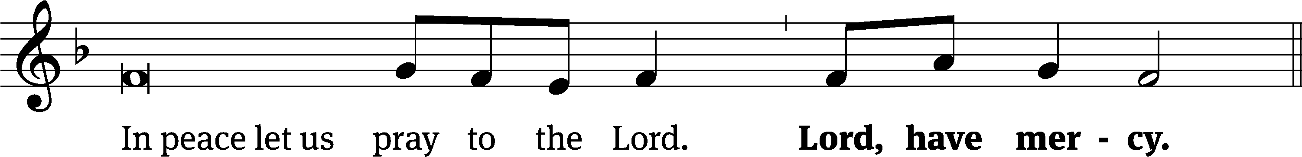
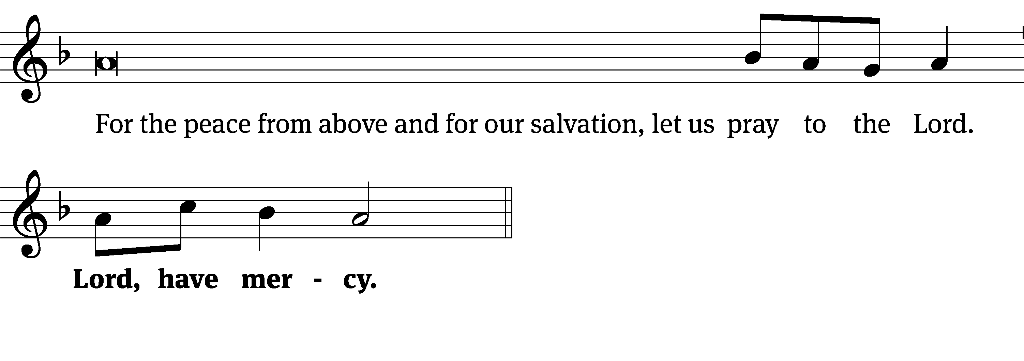
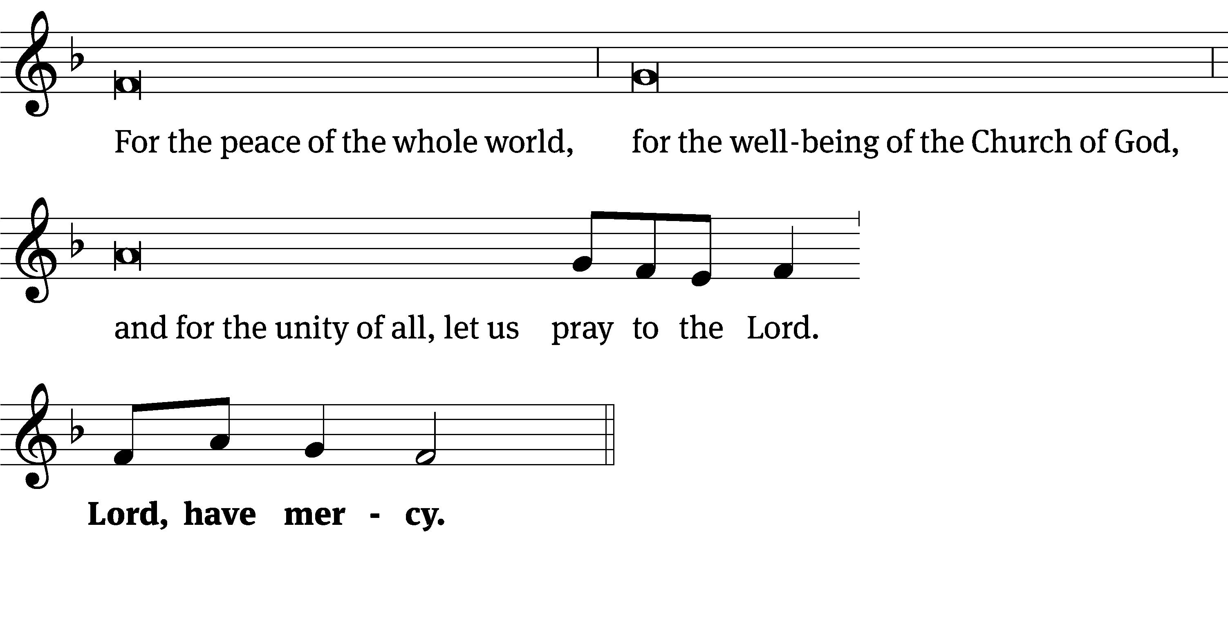
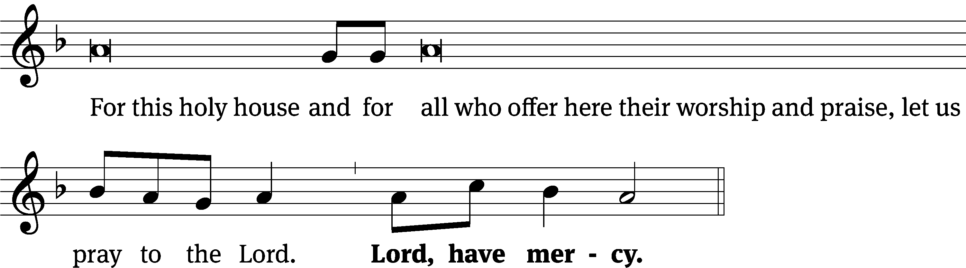
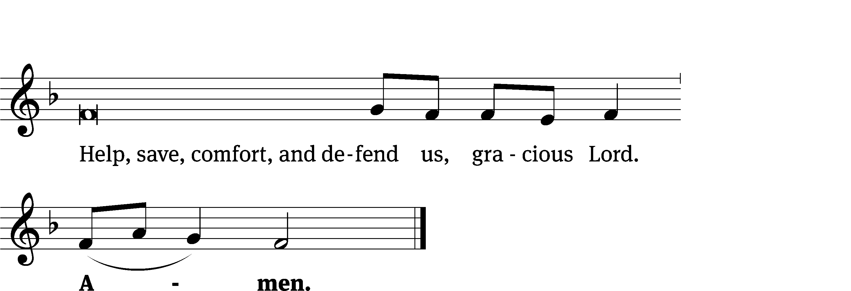

Glory Be to God CW 157
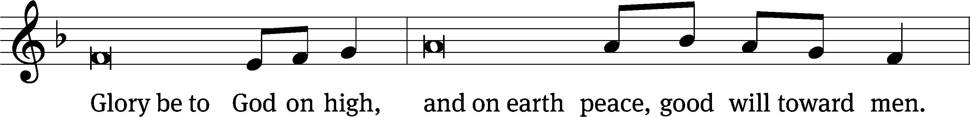
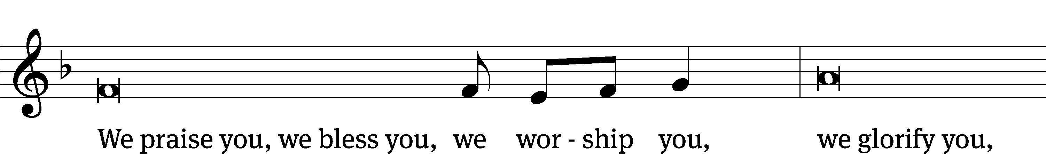
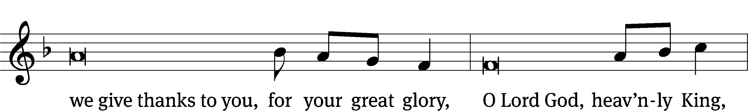
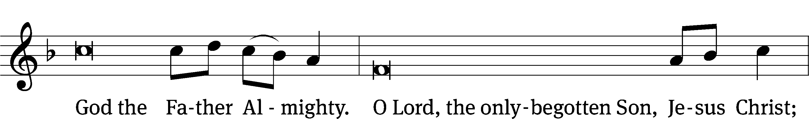
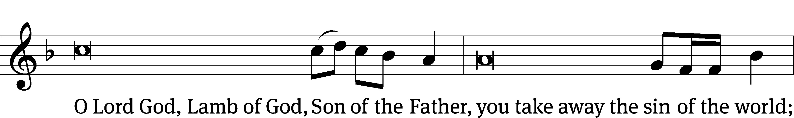
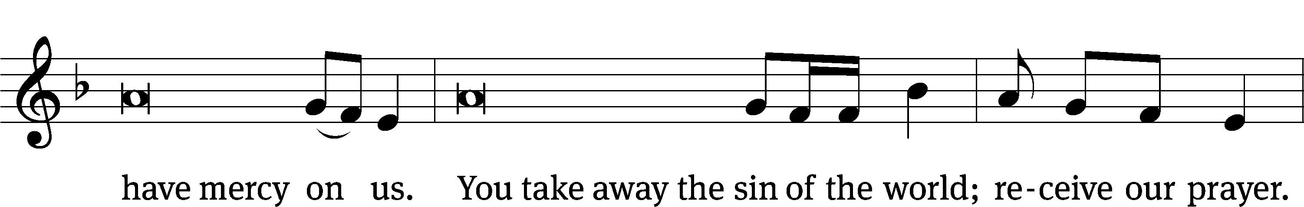
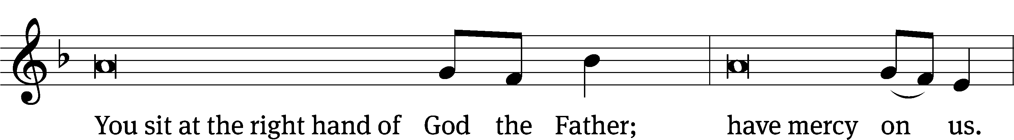
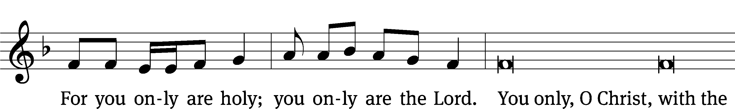
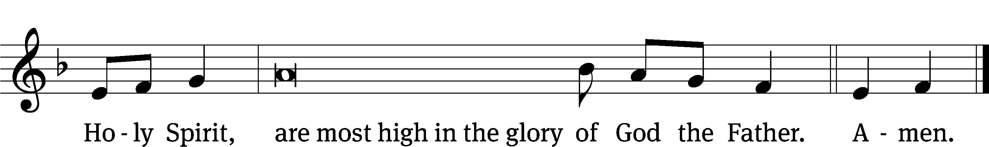

Tune: © 2021 Northwestern Publishing House. Used by permission: OneLicense no. 727703
The Lord be with you.
And also with you.
Prayer of the Day
Let us pray.

O risen Lord, you came to your disciples and took away their fears with your word of peace. Come to us also by Word and sacrament, and banish our fears with the comforting assurance of your abiding presence; for you live and reign with the Father and the Holy Spirit, one God, now and forever.
Amen.

Please be seated

First Reading Acts 5:12, 17-32

¹² Many signs and wonders were done among the people through the hands of the apostles. With one mind, they all continued meeting in Solomon’s Colonnade.
¹⁷ The high priest rose up, along with his associates (that is, the party of the Sadducees), because they were filled with envy. ¹⁸ They arrested the apostles and put them in the public prison. ¹⁹ But during the night an angel of the Lord opened the doors of the prison, brought them out, and said, ²⁰ “Go, stand in the temple and keep on telling the people the whole message about this life.” ²¹ After they heard this, they entered the temple courts at daybreak and began to teach.
When the high priest and his associates arrived, they called together the Sanhedrin (that is, the whole council of elders of the people of Israel). Then they sent orders to the jail to have the apostles brought in. ²² But when the officers arrived, they did not find them in the prison. They returned and reported, ²³ “We found the prison securely locked and the guards standing at the doors, but when we opened them, we found no one inside!” ²⁴ When the captain of the temple guard and the chief priests heard these words, they were puzzled about them, wondering what could have happened.
²⁵ Then someone came and reported to them, “Look! The men you put in prison are standing in the temple courts and teaching the people.”
²⁶ Then the captain went with the officers and brought the apostles in without force, because they were afraid that the people might stone them. ²⁷ After they brought them in, they had them stand before the Sanhedrin. The high priest asked them, ²⁸ “Did we not give you strict orders not to teach in this name? Look, you have filled Jerusalem with your teaching, and you are determined to bring this man’s blood down on us!”
²⁹ But Peter and the apostles replied, “We must obey God rather than men. ³⁰ The God of our fathers raised Jesus, whom you arrested and killed by hanging him on a cross. ³¹ God exalted him to his right hand as Prince and Savior, to give repentance to Israel and the forgiveness of sins. ³² We are witnesses of these things, and so is the Holy Spirit, whom God has given to those who obey him.”
The Word of the Lord.
Thanks be to God.

Psalm of the Day

150B Alleluia! Alleluia! Alleluia! Psalm 150B
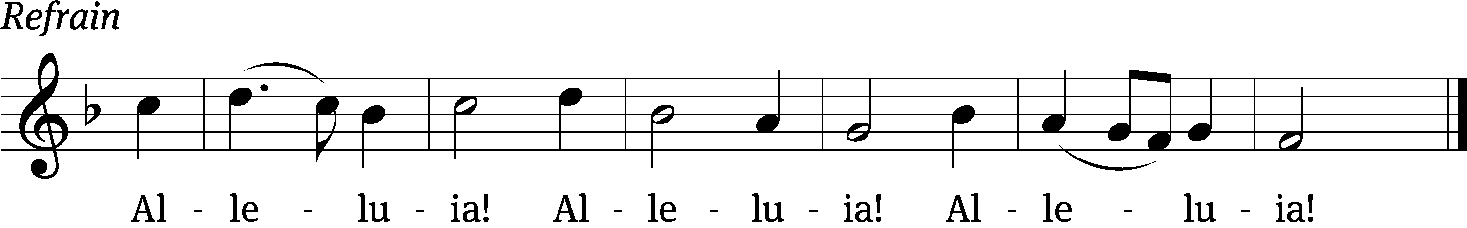

Praise God in his sanctu- / ary;
praise him in his mighty / heavens.
Praise him for his acts of / power;
praise him for his surpassing / greatness. Refrain

Praise him with the sounding of the / trumpet,
praise him with the / harp and lyre,
praise him with timbrel and / dancing,
praise him with the / strings and pipe,
praise him with the clash of / cymbals,
praise him with resounding / cymbals. Refrain

Let everything that has breath / praise the Lord.
Praise / the Lord.
Glory be to the Father and / to the Son
and to the Holy / Spirit,
as it was in the be- / ginning,
is now, and will be forever. Amen. Refrain

Tune: Walter L. Pelz
Text: Public domain
Tune: © 1978 Augsburg Fortress. Used by permission: OneLicense no. 727703
Setting: © 1993 Kermit G. Moldenhauer, admin. Northwestern Publishing House. Used by permission: OneLicense no. 727703
Second Reading Revelation 1:4-18
⁴ John, to the seven churches in the province of Asia:
Grace to you and peace from him who is, who was, and who is coming, and from the seven spirits that are before his throne, ⁵ and from Jesus Christ, the faithful witness, the firstborn from the dead, and the ruler of the kings of the earth.
To him who loves us and has freed us from our sins by his own blood ⁶ and made us a kingdom and priests to God his Father—to him be the glory and the power forever. Amen.
⁷ Look, he is coming with clouds,
and every eye will see him,
including those who pierced him.
And all the nations of the earth will mourn because of him.
Yes. Amen.
⁸ “I am the Alpha and the Omega,” says the Lord God, the one who is, and who was, and who is coming, the Almighty.
⁹ I, John, your brother and companion in the suffering and kingship and patient endurance in Jesus, was on the island called Patmos because of the word of God and the testimony about Jesus.
¹⁰ I was in spirit on the Lord’s Day, and I heard a loud voice behind me, like a trumpet, ¹¹ saying, “Write what you see on a scroll and send it to the seven churches: to Ephesus, Smyrna, Pergamum, Thyatira, Sardis, Philadelphia, and Laodicea.”
¹² I turned to see the voice that was speaking to me. When I turned, I saw seven gold lampstands, ¹³ and among the lampstands was one like a son of man. He was clothed with a robe that reached to his feet, and around his chest he wore a gold sash. ¹⁴ His head and his hair were white, like white wool or like snow. His eyes were like blazing flames. ¹⁵ His feet were like polished bronze being refined in a furnace. His voice was like the roar of many waters. ¹⁶ He held seven stars in his right hand. A sharp two-edged sword was coming out of his mouth. His face was shining as the sun shines in all its brightness.
¹⁷ When I saw him, I fell at his feet like a dead man. He placed his right hand on me and said, “Do not be afraid. I am the First and the Last— ¹⁸ the Living One. I was dead and, see, I am alive forever and ever! I also hold the keys of death and hell.
The Word of the Lord.
Thanks be to God.

Please stand, if you are able
Gospel Acclamation John 20:29
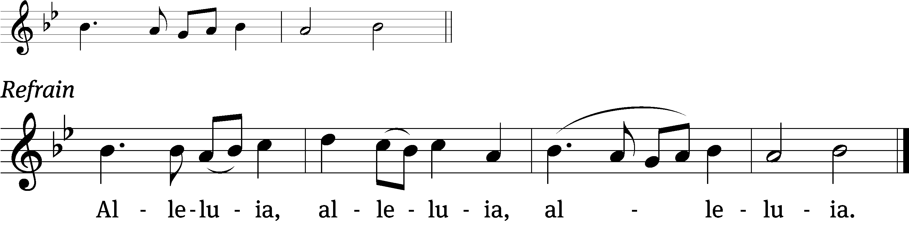

Blessed are those who have not seen
and yet have believed.

Refrain

Blessed are those who have not seen
and yet have believed.

Refrain Tune: © 2021 Northwestern Publishing House. Used by permission: OneLicense no. 727703
Gospel John 20:19-31
¹⁹ On the evening of that first day of the week, the disciples were together behind locked doors because of their fear of the Jews. Jesus came, stood among them, and said to them, “Peace be with you!” ²⁰ After he said this, he showed them his hands and side. So the disciples rejoiced when they saw the Lord.
²¹ Jesus said to them again, “Peace be with you! Just as the Father has sent me, I am also sending you.” ²² After saying this, he breathed on them and said, “Receive the Holy Spirit. ²³ Whenever you forgive people’s sins, they are forgiven. Whenever you do not forgive them, they are not forgiven.”
²⁴ But Thomas, one of the Twelve, the one called the Twin,^{[a]} was not with them when Jesus came. ²⁵ So the other disciples kept telling him, “We have seen the Lord!”
But he said to them, “Unless I see the nail marks in his hands, and put my finger into the mark of the nails, and put my hand into his side, I will never believe.”
²⁶ After eight days, his disciples were inside again, and Thomas was with them. Though the doors were locked, Jesus came and stood among them. “Peace be with you,” he said. ²⁷ Then he said to Thomas, “Put your finger here and look at my hands. Take your hand and put it into my side. Do not continue to doubt, but believe.”
²⁸ Thomas answered him, “My Lord and my God!”
²⁹ Jesus said to him, “Because you have seen me, you have believed. Blessed are those who have not seen and yet have believed.”
³⁰ Jesus, in the presence of his disciples, did many other miraculous signs that are not written in this book. ³¹ But these are written that you may believe that Jesus is the Christ, the Son of God, and that by believing you may have life in his name.

The Gospel of the Lord.
Praise be to you, O Christ!

Please be seated
Sermon Hymn
456 O Sons and Daughters of the King CW 456
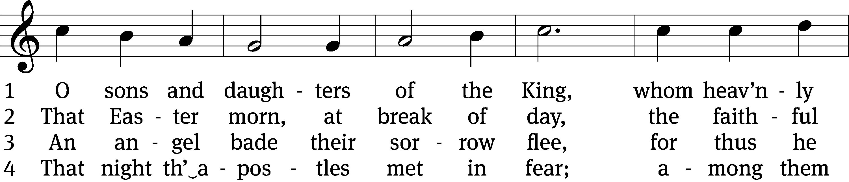
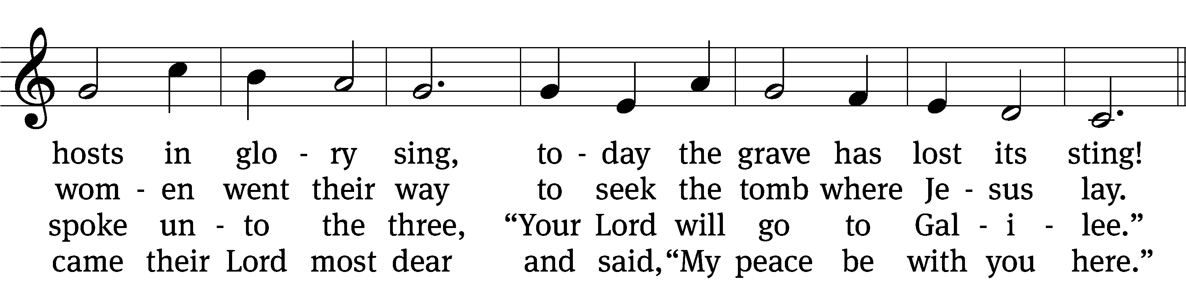
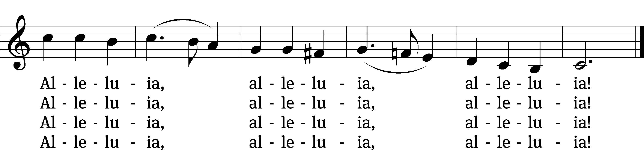

5 When Thomas afterwards had heard
that Jesus had fulfilled his word,
he doubted that it was the Lord.
Alleluia, alleluia, alleluia!

6 “Thomas, behold my side,” said he,
“my hands, my feet, my body see;
and doubt not, but believe in me.”
Alleluia, alleluia, alleluia!

7 No longer Thomas then denied;
he saw the feet, the hands, the side;
“You are my Lord and God,” he cried.
Alleluia, alleluia, alleluia!

8 Blessèd are they that have not seen
and yet whose faith has constant been;
in life eternal they shall reign.
Alleluia, alleluia, alleluia!

9 On this most holy day of days
to God your hearts and voices raise
in laud and jubilee and praise.
Alleluia, alleluia, alleluia!

Text: tr. John Mason Neale, 1818–1866, alt.; attr. Jean Tisserand, d. 1494, abr.
Tune: Melchior Vulpius, c. 1570–1615;
Text and tune: Public domain

Sermon John 20:19-31
“Has Easter Changed You?”

Please stand, if you are able
Apostles’ Creed
I believe in God, the Father Almighty,
maker of heaven and earth.

I believe in Jesus Christ, his only Son, our Lord,
who was conceived by the Holy Spirit,
born of the Virgin Mary,
suffered under Pontius Pilate,
was crucified, died, and was buried.
He descended into hell.
The third day he rose again from the dead.
He ascended into heaven
and is seated at the right hand of God the Father Almighty.
From there he will come to judge the living and the dead.

I believe in the Holy Spirit,
the holy Christian Church,
the communion of saints,
the forgiveness of sins,
the resurrection of the body,
and the life everlasting. Amen.
Offertory (8:30 Service Only) Bell Choir “This Joyful Eastertide”
Prayer of the Church
444 Jesus Lives! The Victory’s Won CW 444
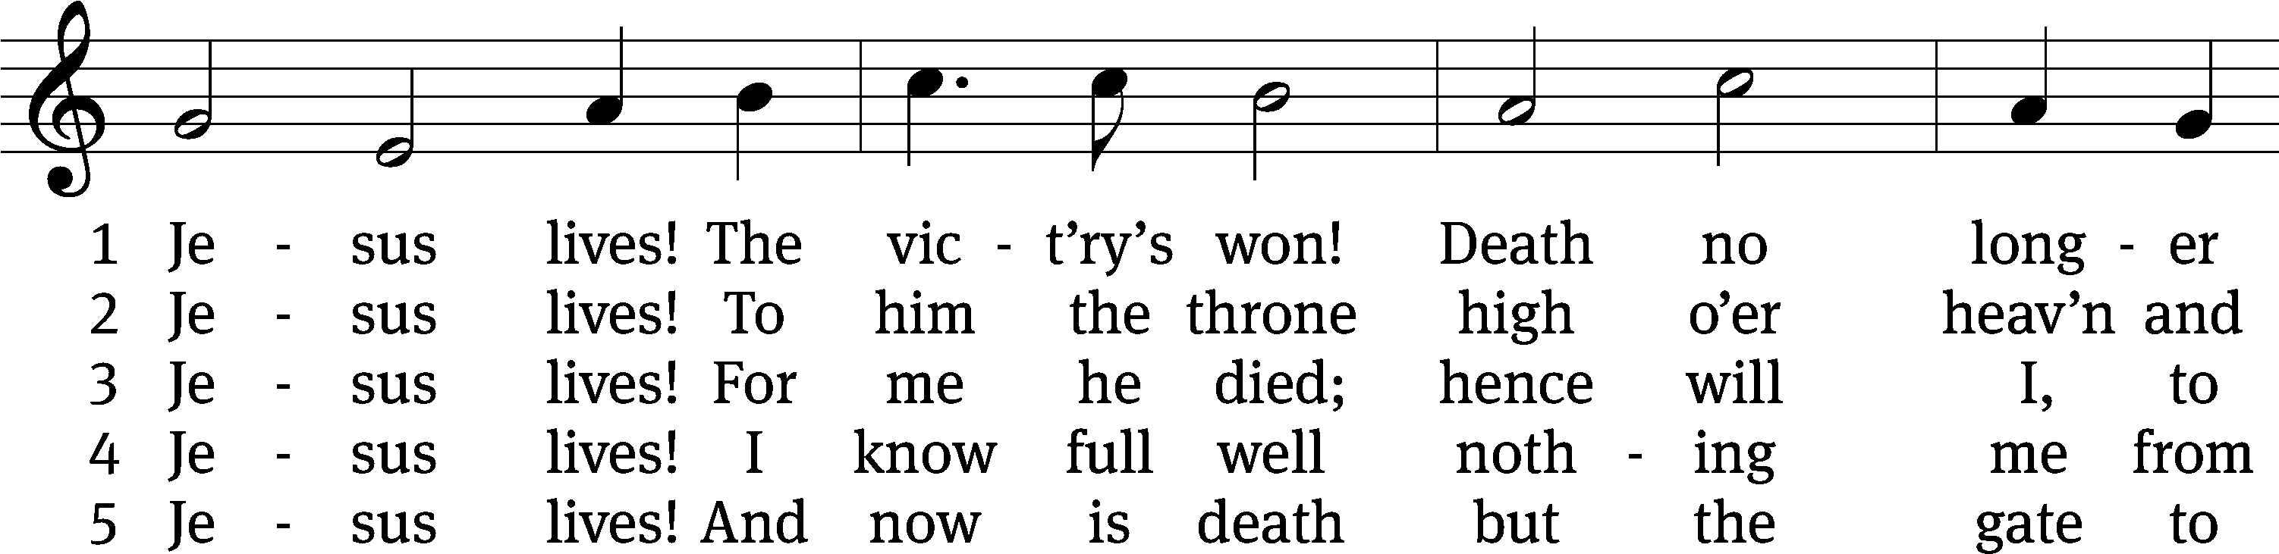
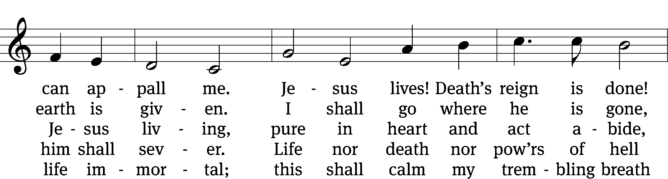
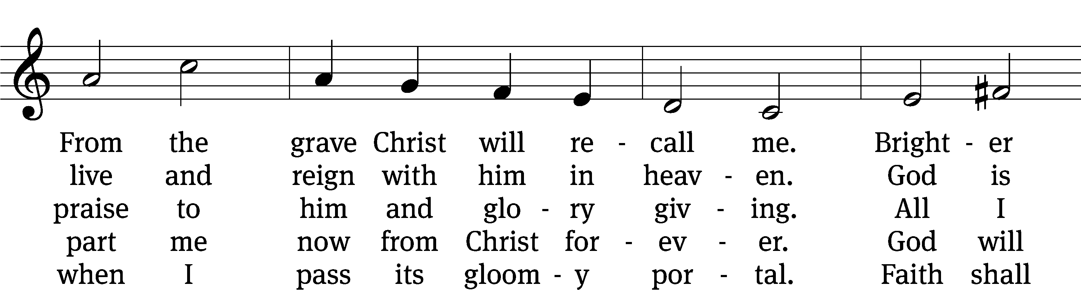
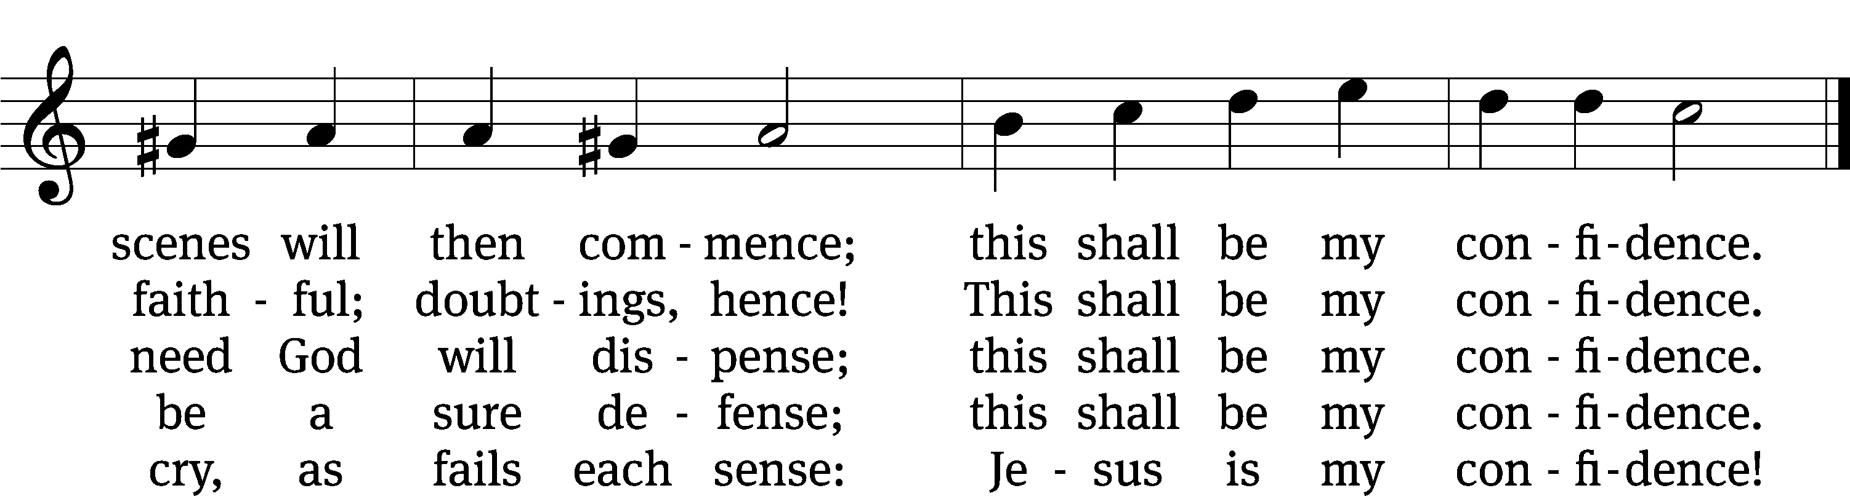

Text: tr. Frances E. Cox, 1812–1897, alt.; Christian F. Gellert, 1715–1769, abr.
Tune: Johann Crüger, 1598–1662
Text and tune: Public domain

Prayer
Blessed Lord, you have given us your Holy Scriptures for our learning. May we so hear them, read, learn, and take them to heart that, being strengthened and comforted by your holy Word, we may cling to the blessed hope of everlasting life; through Jesus Christ our Lord, who lives and reigns with you and the Holy Spirit, one God, now and forever.
Amen.
Lord’s Prayer
Our Father, who art in heaven, hallowed be thy name, thy kingdom come, thy will be done on earth as it is in heaven. Give us this day our daily bread; and forgive us our trespasses, as we forgive those who trespass against us; and lead us not into temptation, but deliver us from evil. For thine is the kingdom and the power and the glory forever and ever. Amen.

Blessing
The Lord bless you and keep you.
The Lord make his face shine on you and be gracious to you.
The Lord look on you with favor and T give you peace.
Amen.

Please be seated

524 Rejoice, the Lord Is King CW 524
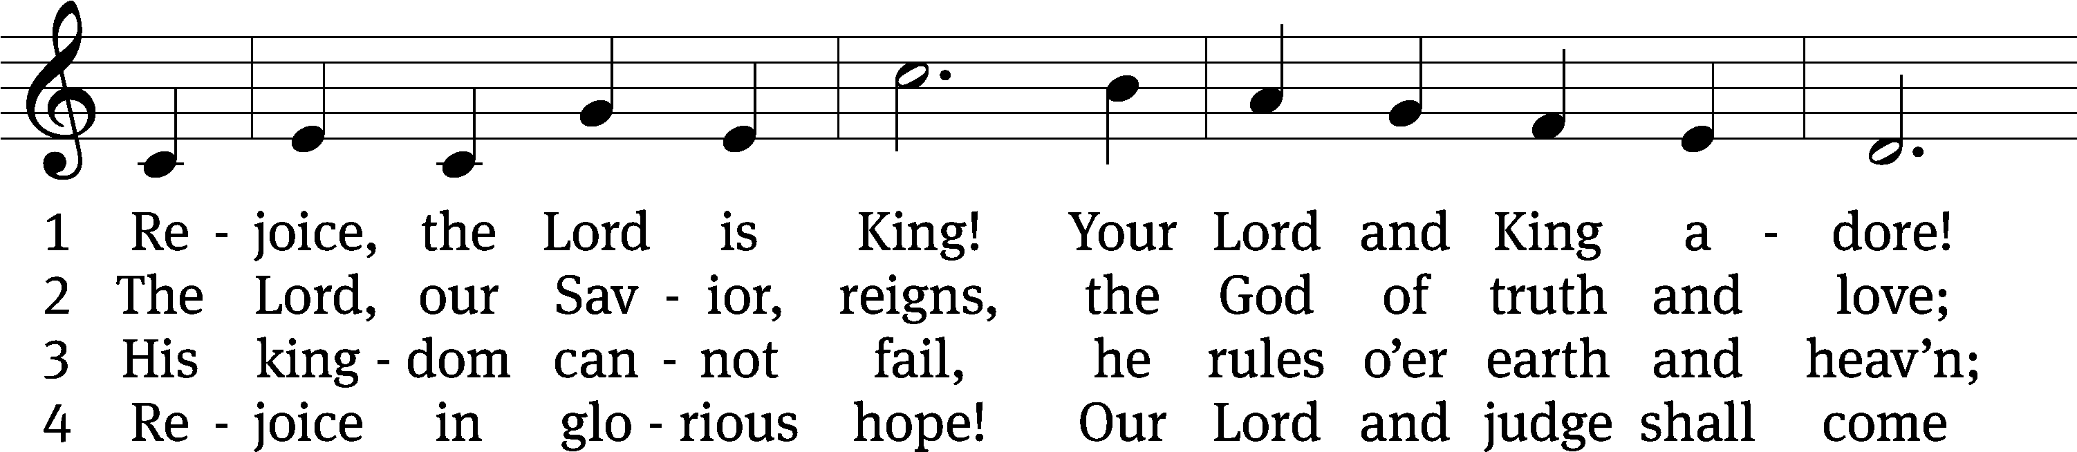
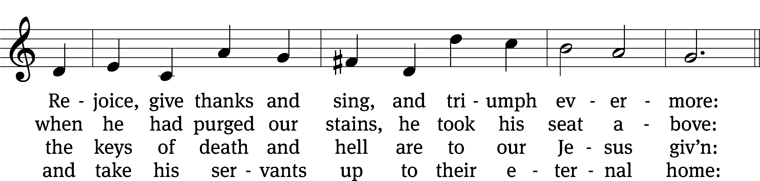
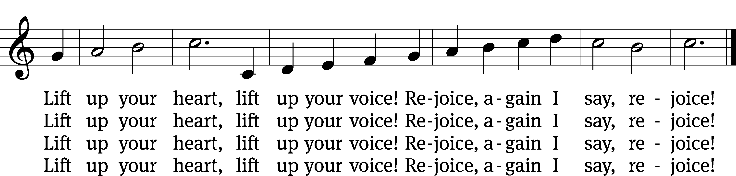

Text: Charles Wesley, 1707–1788, alt.
Tune: John Darwall, 1731–1789
Text and tune: Public domain

Acknowledgments
Setting One from Christian Worship
Software distributed in partnership with Northwestern Publishing House.
Created by Christian Worship: Service Builder © 2022 Concordia Publishing House.

Serving in Worship
Officiant Pastor Natsis
Organist and Bell Choir Director Emily Wheeler
Deacons (8:30) Dave Stevenson and Jim Tice
(11:00) Steve Hoeft and Jeff Neuburger
Ushers (8:30) Dale Finkbeiner and Mark Finkbeiner
(11:00) Ed Sala and Al Whitley
Altar Guild Shirley Klumpp and Ann Latowski
Videographer Ann Latowski

