THE TWENTY-SECOND SUNDAY
after pentecost
reformation Sunday
tRINITY EVANGELICAL LUTHERAN CHURCH | Saline, Michigan
October 29, 2023

WELCOME TO WORSHIP

Thank you for joining us in God’s house today! We cordially ask that our Guests with us this morning sign one of the guestbooks located at either the front or back entryways.

THANK OFFERING: Members of Trinity give their offering as an expression of love and thankfulness to the Lord and to help support the Lord’s work in our community and around the world. Visitors need not feel obligated to participate in this offering which supports our ministry.

Restrooms are located at the back of the upper level (the annex), and in the basement (down the back stairs of the sanctuary or annex). Handicap access is available, please ask an usher for assistance.

Young Families / Toddler Bags – We are GLAD YOU BROUGHT YOUR CHILDREN to our worship service. Jesus said: “Let the little children come to me and do not hinder them, for the kingdom of God belongs to such as these.” We know that having little children in church can be a challenge, but DO NOT WORRY about it. Many of your fellow worshippers have been in your shoes and are just happy you brought your children with you. For your convenience, we have reserved the back rows of seating for parents with small children. These areas provide more flexibility for your family, as well as, easy access to move downstairs if necessary. A closed-circuit TV system allows families to continue participating in the service while downstairs. Pre-school toddler bags and children’s bulletins are available for their enjoyment. Ask an usher for one to use during the service and please return the toddler bag afterwards.

SERVICE of the word
874 Preserve Your Word, O Savior CW 874
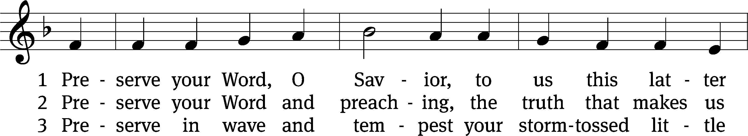
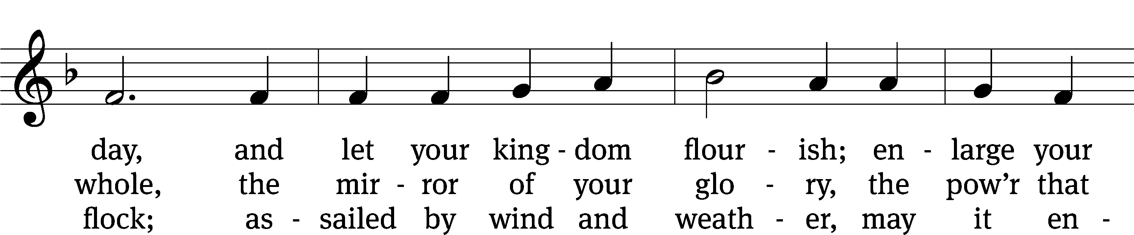
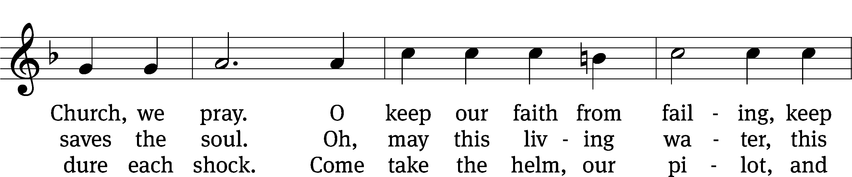
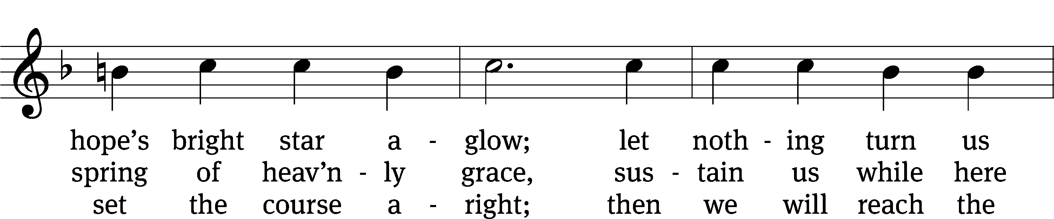
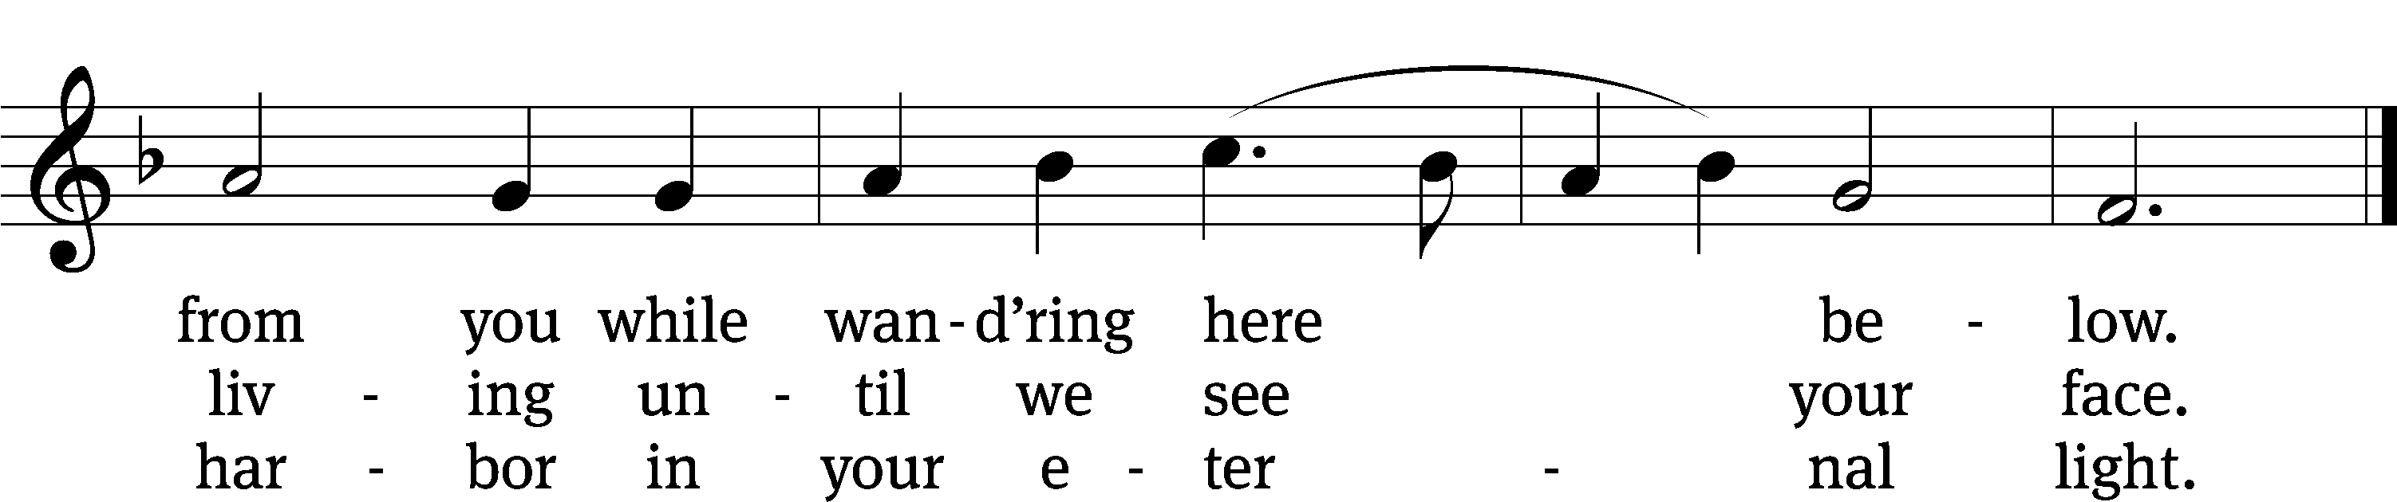
Text: tr. William J. Schaefer, 1891–1976, alt.; Andreas Gryphius, 1616–1664, abr.
Tune: Leonhart Schröter, c. 1532–c. 1601
Text: © 1941 Concordia Publishing House. Used by permission: OneLicense no. 727703
Tune: Public domain

PLEASE STAND, IF YOU ARE ABLE

invocation
M: The grace of our Lord (+) Jesus Christ and the love of God and the fellowship of the Holy Spirit be with you.
C: And also with you.

CONFESSION OF SINS
M: We have come into the presence of God, who created us to love and serve him as his dear children. But we have disobeyed him and deserve only his wrath and punishment. Therefore, let us confess our sins to him and plead for his mercy.

C: Merciful Father in heaven, I am altogether sinful from birth. In countless ways I have sinned against you and do not deserve to be called your child. But trusting in Jesus, my Savior, I pray: Have mercy on me according to your unfailing love. Cleanse me from my sin, and take away my guilt.

M: God, our heavenly Father, has forgiven all your sins. By the perfect life and innocent death of our Lord Jesus Christ, he has removed your guilt forever. You are his own dear child. May God give you strength to live according to his will.

C: Amen.
PRAYER AND PRAISE

M: In the peace of forgiveness, let us praise the Lord.

OH, TASTE AND SEE

PRAYER OF THE DAY

Let us pray.

Gracious Lord, our refuge and strength, pour out your Holy Spirit on your faithful people. Keep them steadfast in your Word, protect and comfort them in all temptations, defend them against all their enemies, and bestow on the church your saving peace; through your Son, Jesus Christ our Lord, who lives and reigns with you and the Holy Spirit, one God, now and forever.

PLEASE BE SEATED
The Word

the FIRST LESSON Daniel 6:10-12, 16-23
¹⁰ Now, when Daniel learned that the document had been signed, he went to his house. It had windows on its upper story that opened toward Jerusalem. Three times each day he would get on his knees and pray and offer praise before his God. He continued to do that, just as he had been doing before this. ¹¹ Then these men came as a group and found Daniel praying and seeking favor from his God.
¹² They then went and asked the king about the decree. “Your Majesty, did you not sign a decree that anyone who prays to any god or person for thirty days except to you, Your Majesty, would be thrown into the den of lions?”
The king answered, “Indeed I did. The order is established as a law of the Medes and the Persians that cannot be revoked.”
¹⁶ Then the king gave the order, and Daniel was brought and thrown into the lions’ den. The king said to Daniel, “May your God, whom you serve continually, rescue you.” ¹⁷ A stone was brought and placed over the mouth of the pit. The king sealed it with his signet ring and the signet rings of his nobles so that nothing could be changed with regard to Daniel’s situation. ¹⁸ Then the king went to his palace. He spent the night without food, and no entertainment was brought before him. But he could not sleep.
¹⁹ At dawn the king arose as soon as it was light and hurried to the lions’ den. ²⁰ As he came near the pit, he cried out in a fearful voice. The king said to Daniel, “Daniel, servant of the living God, was your God, whom you serve continually, able to rescue you from the lions?”
²¹ Then Daniel spoke with the king. “Your Majesty, may you live forever! ²² My God sent his angel and shut the mouth of the lions. They have not hurt me because he found me innocent in his presence. Also before you, Your Majesty, I have committed no crime.”
²³ Then the king was very glad and said that Daniel should be brought up from the pit. So Daniel was brought up from the pit, and he was unharmed because he trusted in his God.

46A The LORD Almighty Is with Us Psalm 46A
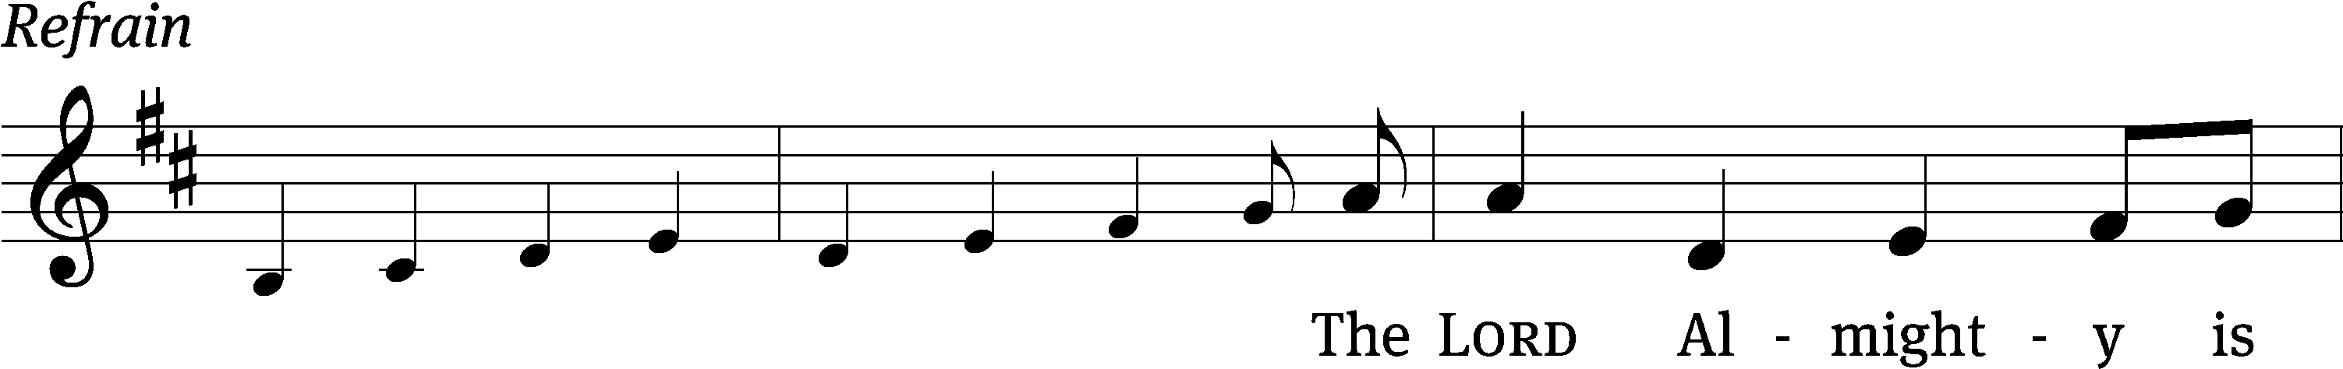
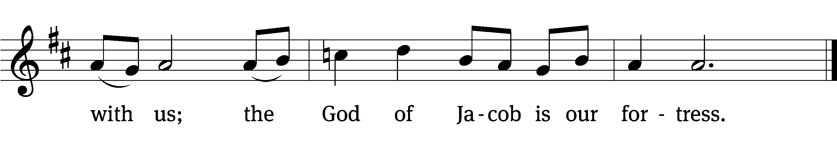

God is our ref- / uge and strength,
an ever-present help in / trouble.
Therefore we will not fear, though the / earth give way
and the mountains fall into the heart / of the sea,
though its waters / roar and foam
and the mountains quake with their / surging. Refrain

There is a river whose streams make glad the cit- / y of God,
the holy place where the Most / High dwells.
God is within her, she / will not fall;
God will help her at / break of day.
“Be still, and know that / I am God;
I will be exalted among the nations, I will be exalted / in the earth.”
Glory be to the Father and / to the Son
and to the Holy / Spirit,
as it was in the be- / ginning,
is now, and will be forever. / Amen. Refrain
Tune: Dale A. Witte
Setting: Dale A. Witte
Music: © 2021 Dale A. Witte, admin. Northwestern Publishing House. Used by permission: OneLicense no. 727703

SECOND LESSON Romans 3:19-28
¹⁹ Now we know that whatever the law says is addressed to those who are under the law, so that every mouth will be silenced and the whole world will be subject to God’s judgment. ²⁰ For this reason, no one will be declared righteous in his sight by works of the law, for through the law we become aware of sin.
²¹ But now, completely apart from the law, a righteousness from God has been made known. The Law and the Prophets testify to it. ²² This righteousness from God comes through faith in Jesus Christ to all and over all who believe.
In fact, there is no difference, ²³ because all have sinned and fall short of the glory of God ²⁴ and are justified freely by his grace through the redemption that is in Christ Jesus, ²⁵ whom God publicly displayed as the atonement seat through faith in his blood. God did this to demonstrate his justice, since, in his divine restraint, he had left the sins that were committed earlier unpunished. ²⁶ He did this to demonstrate his justice at the present time, so that he would be both just and the one who justifies the person who has faith in Jesus.
²⁷ What happens to boasting then? It has been eliminated. By what principle—by the principle of works? No, but by the principle of faith. ²⁸ For we conclude that a person is justified by faith without the works of the law.
CHOIR “Lord, Keep Us Steadfast”
Oh, that my ways may be steadfast in keeping your statutes!
Then I shall not be put to shame. Lord, keep us steadfast in your Word.
Lord, keep us steadfast in your Word; curb those who by deceit or sword
Would seek to overthrow your Son and to destroy what he has done.
And Jesus said, “If you abide in my Word, you are truly my disciples.”
Lord, keep us steadfast in your Word.

Lord, Jesus Christ, your power make known, for you are Lord of lords alone;
Defend your Christendom that we may sing your praise eternally.
There is one body, there is one Spirit, there is one hope for which we live.
One Lord, one faith, one baptism, one God and Father of us all.
Lord, keep us steadfast in your Word.

O Comforter of priceless worth, send peace and unity on earth.
Support us in our final strife and lead us out of death to life.
Lord, keep us steadfast in your Word.

THE GOSPEL LESSON Matthew 10:16-23
M: The Gospel according to Matthew chapter 10, verses 16-23
¹⁶ “Look, I am sending you out as sheep among wolves. So be as shrewd as snakes and as innocent as doves. ¹⁷ Be on guard against people. They will hand you over to councils, and they will whip you in their synagogues. ¹⁸ You will be brought into the presence of governors and kings for my sake, as a testimony to them and to the Gentiles. ¹⁹ Whenever they hand you over, do not be worried about how you will respond or what you will say, because what you say will be given to you in that hour. ²⁰ In fact you will not be the ones speaking, but the Spirit of your Father will be speaking through you.
²¹ “Brother will hand over his brother to death, and a father will do the same with his child. Children will rise up against parents and have them put to death. ²² You will be hated by all people because of my name, but whoever endures to the end will be saved. ²³ And when they persecute you in one town, flee to the next. Amen I tell you: You will not finish going through the cities of Israel before the Son of Man comes.

M: This is the Gospel of the Lord.

PLEASE BE SEATED

633 Speak, O Lord CW 633
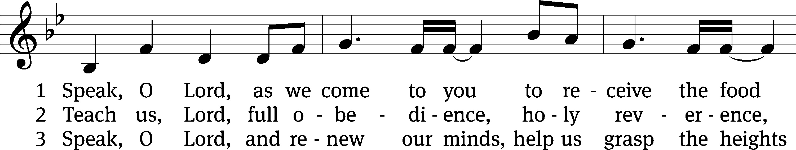
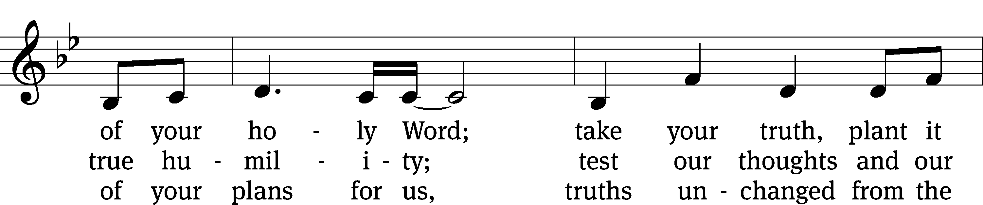
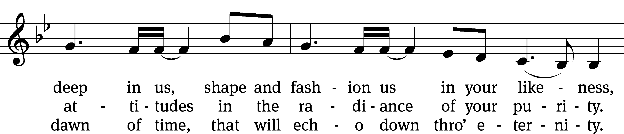
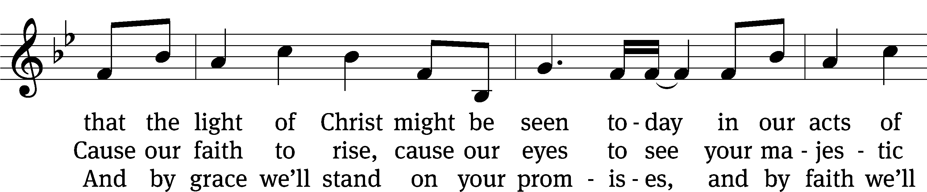
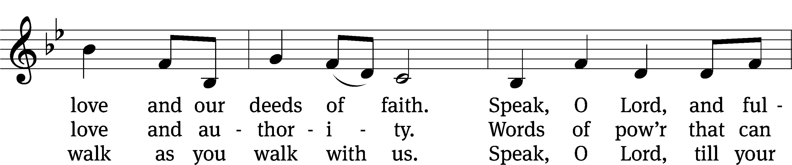
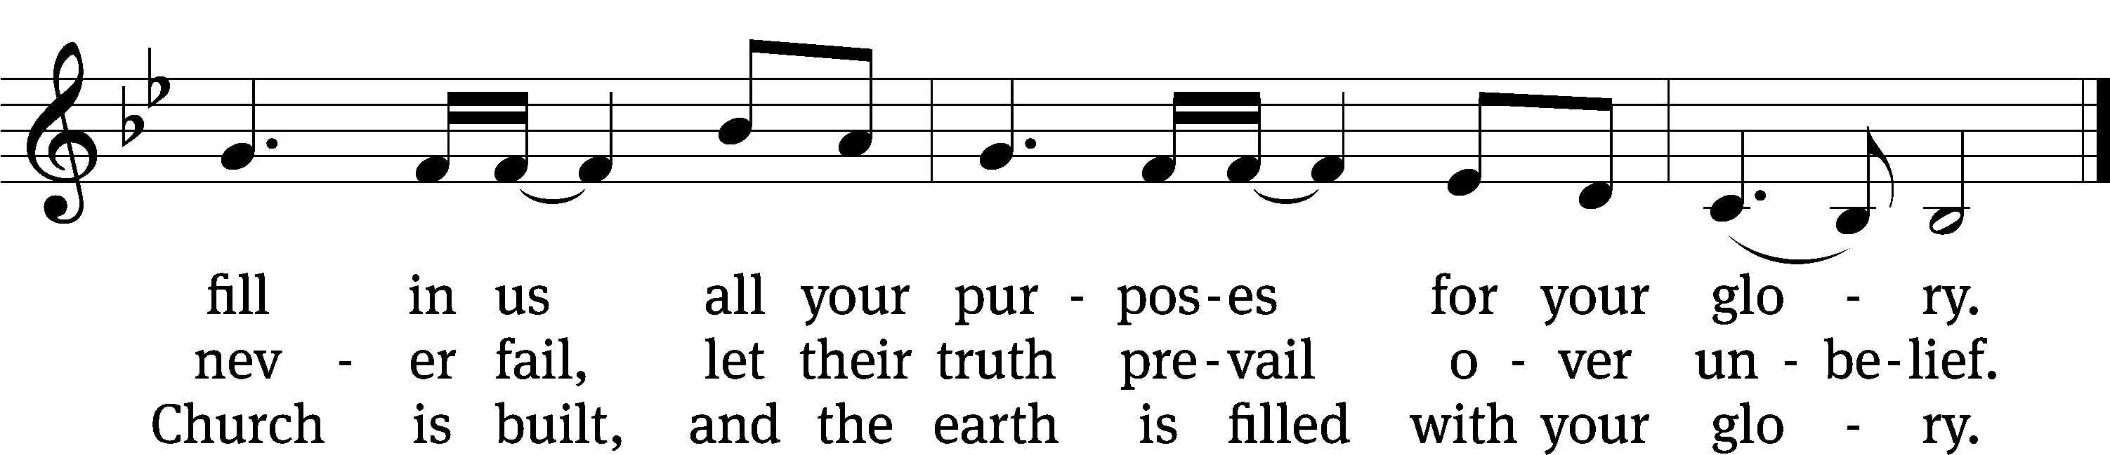
Text: Stuart Townend, b. 1963; Keith Getty, b. 1974
Tune: Stuart Townend, b. 1963; Keith Getty, b. 1974
Text and tune: © 2006 Thankyou Music, admin. CapitolCMGPublishing,com. Used by permission: OneLicense no. 727703

SERMON Romans 16:17
“Could the Reformation Still Work Today?”

¹⁷ But I urge you, brothers, to watch out for those who cause divisions and offenses contrary to the teaching that you learned, and keep away from them.”

PLEASE STAND, IF YOU ARE ABLE

THE APOSTLES’ CREED

I believe in God, the Father almighty,
maker of heaven and earth.
I believe in Jesus Christ, his only Son, our Lord,
who was conceived by the Holy Spirit,
born of the virgin Mary,
suffered under Pontius Pilate,
was crucified, died, and was buried.
He descended into hell.
The third day he rose again from the dead.
He ascended into heaven
and is seated at the right hand of God the Father almighty.
From there he will come to judge the living and the dead.
I believe in the Holy Spirit,
the holy Christian Church,
the communion of saints,
the forgiveness of sins,
the resurrection of the body,
and the life everlasting. Amen.

PRAYER OF THE CHURCH

THE LORD’S PRAYER

C: Our Father, who art in heaven, hallowed be thy name, thy kingdom come, thy will be done on earth as it is in heaven. Give us this day our daily bread; and forgive us our trespasses, as we forgive those who trespass against us; and lead us not into temptation, but deliver us from evil. For thine is the kingdom and the power and the glory forever and ever. Amen.
PLEASE BE SEATED
864 A Mighty Fortress Is Our God CW 864 sts. 1–4
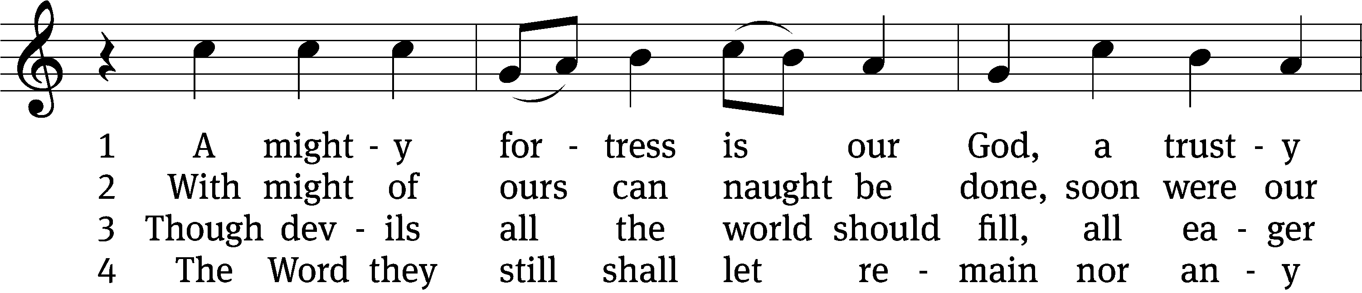
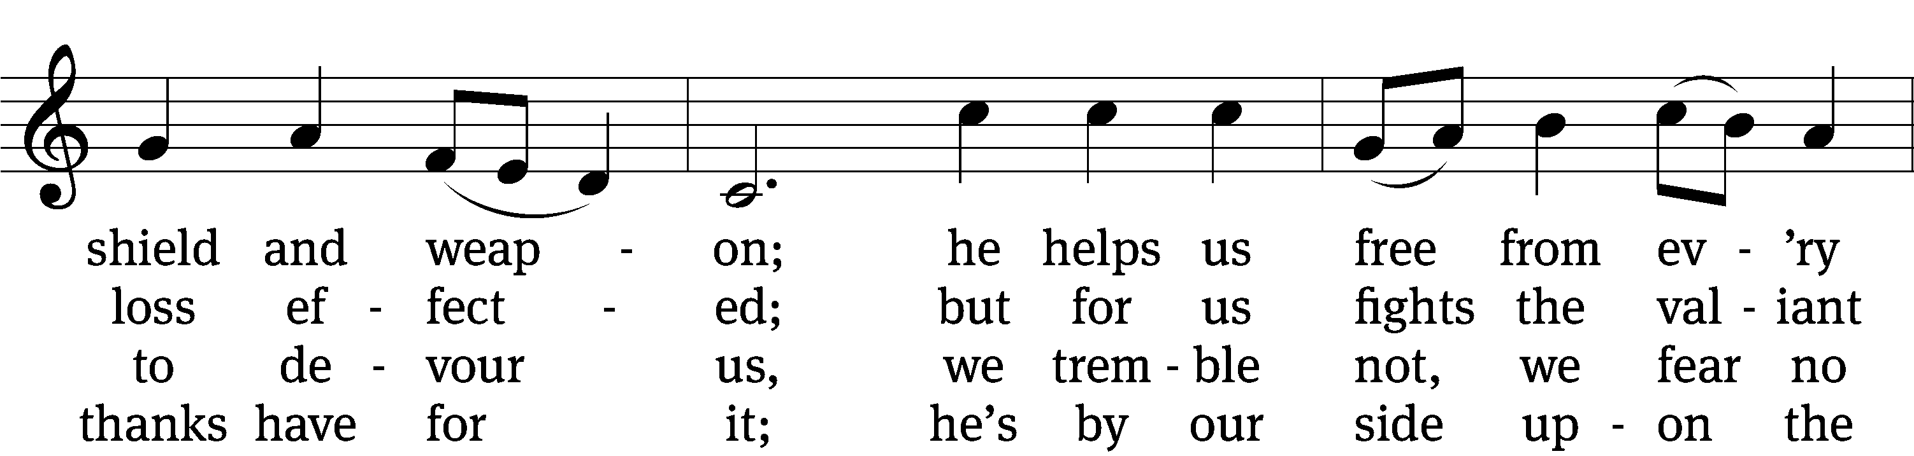
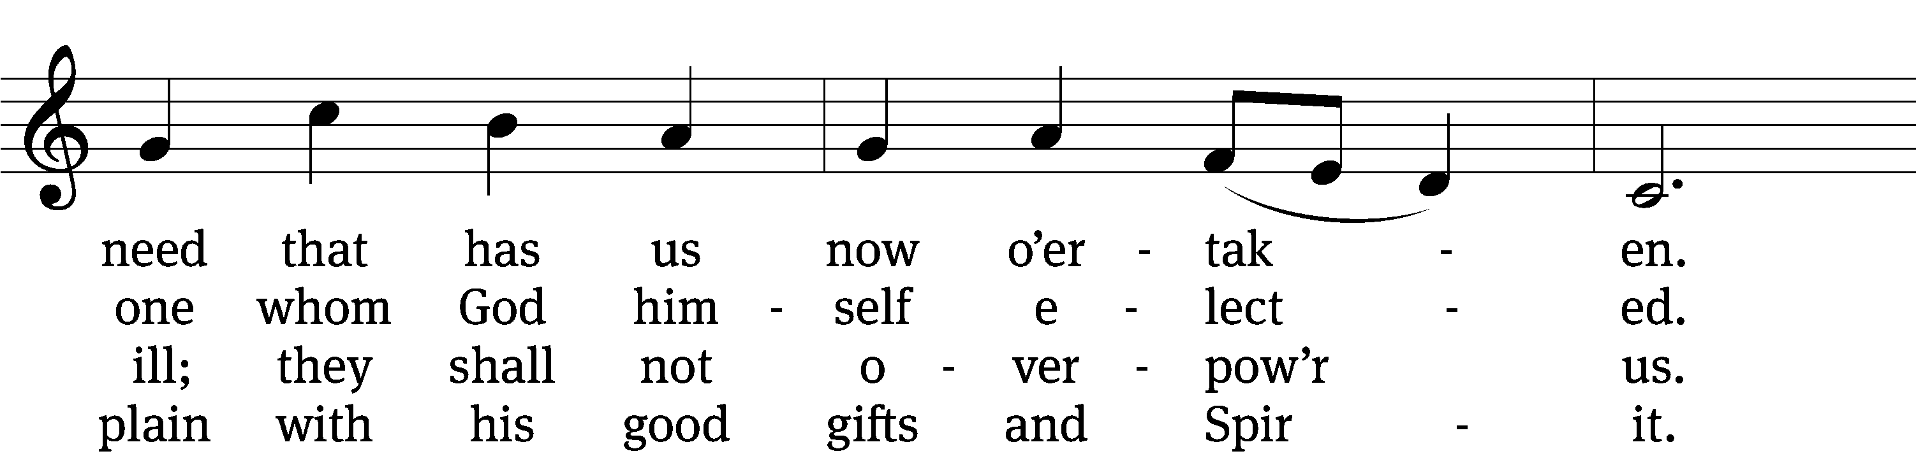
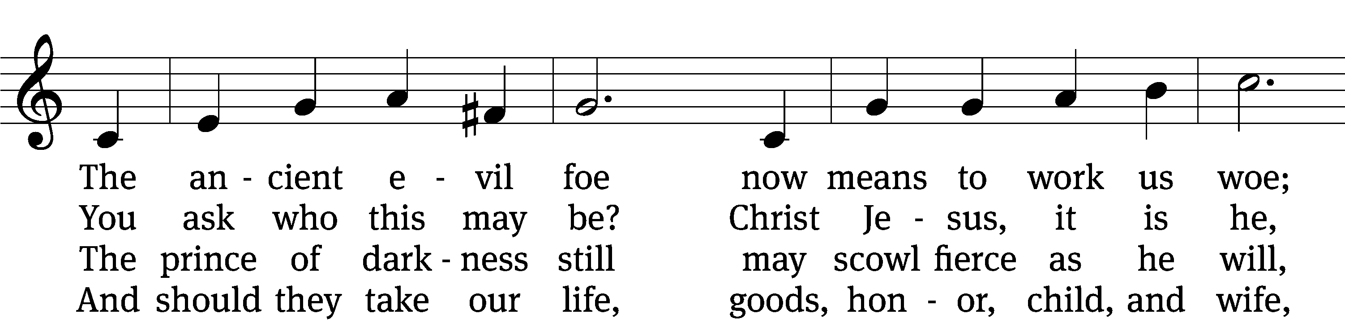
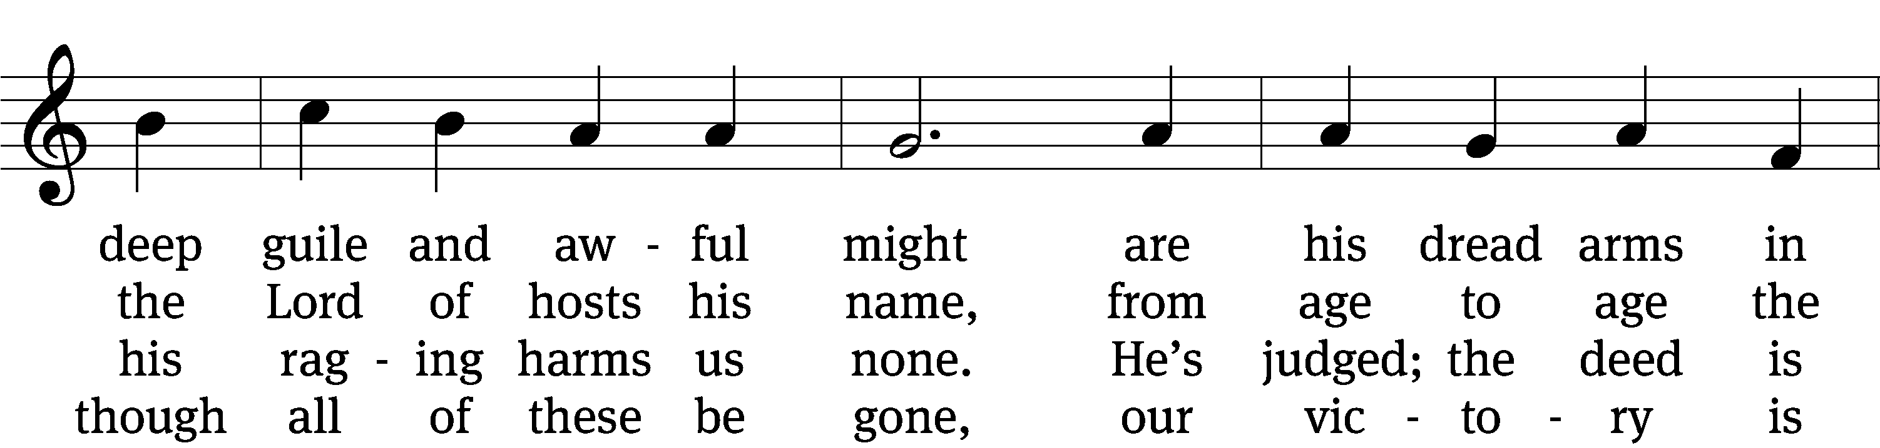
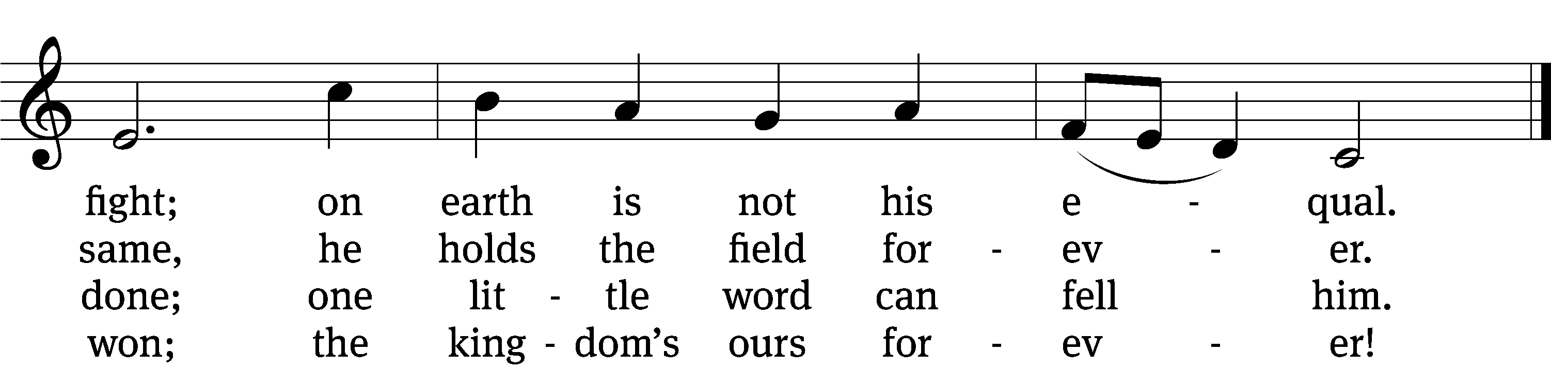
Text: tr. composite; Martin Luther, 1483–1546
Tune: Martin Luther, 1483–1546
Text and tune: Public domain

PLEASE STAND, IF YOU ARE ABLE

CLOSING PRAYER
M: Almighty God, we thank you for teaching us the things you want us to believe and do. Help us by your Holy Spirit to keep your Word in pure hearts that we may be strengthened in faith, guided in holiness, and comforted in life and in death, through Jesus Christ, our Lord, who lives and reigns with you and the Holy Spirit, one God, now and forever.

M: Brothers and sisters, go in peace. Live in harmony with one another. Serve the Lord with gladness.
The Lord bless you and keep you.
The Lord make his face shine on you and be gracious to you.
The Lord look on you with favor and (+) give you peace.

PLEASE BE SEATED

640 God’s Word Is Our Great Heritage CW 640
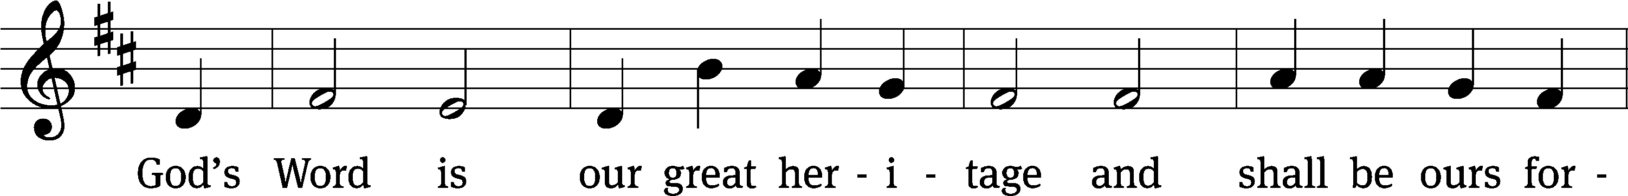
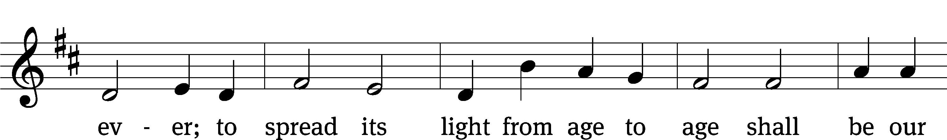
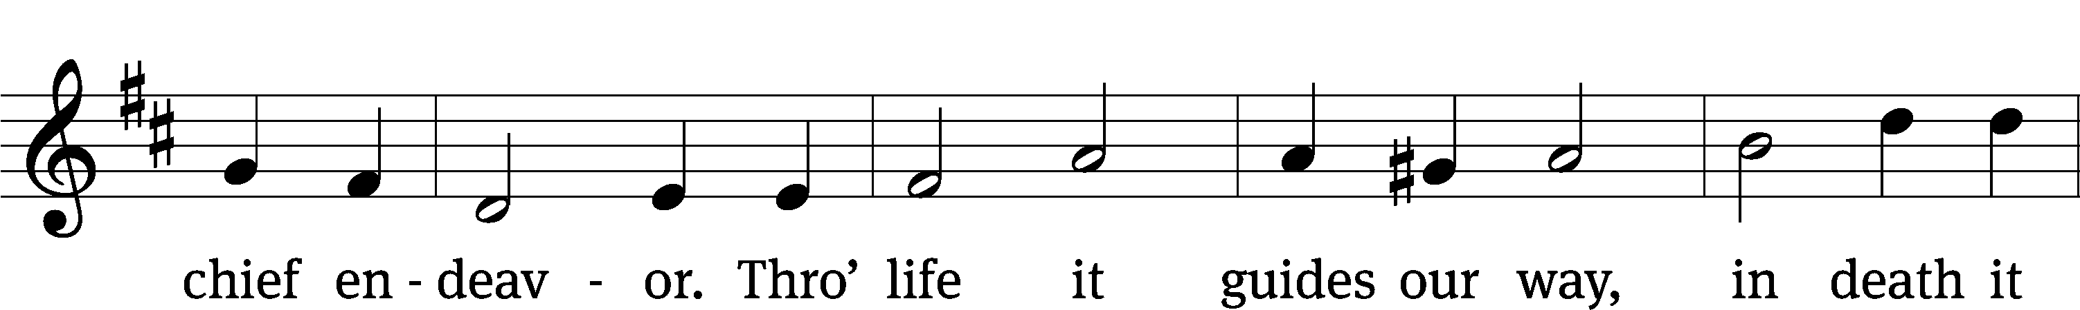
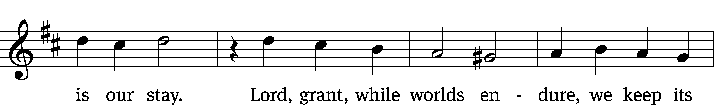
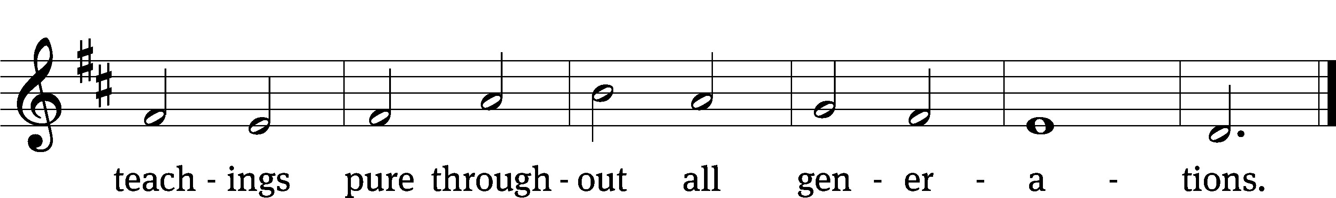

Through years gone by, God’s holy Word has guided and sustained us.
Its light has brought us to the Lord, and in his ways maintained us.
With gracious words of truth, this Word has trained our youth,
And through the years gone by, has taught us to rely
On God for every blessing.

Today this Word still guides our way, and keeps us with our Savior.
Whatever good we have today, whatever grace or favor,
Comes by his grace alone, as his pure Word has shown.
The knowledge of his truth, implanted in our youth,
Will bring increasing blessing.

Now as we look to years to come, our future lies with Jesus.
We trust in God’s pure Word alone; his Word will not mislead us.
His blessings he will pour upon us evermore,
As we his Word retain, and in his ways remain.
Lord, grant us this great blessing. Amen.
Text: tr. Ole G. Belsheim, alt.; Nikolai F. S. Grundtvig, 1783–1872
Tune: Friedrich O. Reuter, 1863–1924
Text and tune: Public domain

Serving In Worship
Officiant Pastor Natsis
Organist and Accompanist Sarah Hanke
Instrumentalist Tom Amerman
Choir Director Cynthia Natsis
Deacons (8:30) Dave Stevenson and Jim Tice
(11:00) Steve Hoeft and Jeff Neuburger
Ushers (8:30) Dale Finkbeiner and Mark Finkbeiner
(11:00) Ed Sala and Al Whitley
Altar Guild Barb Neuburger and Karen Tice
Videographer Ann Latowski

Copyright information
Service of the Word: Christian Worship. © 1993 Northwestern Publishing House. All rights reserved.
Reprinted with permission under ONE LICENSE #A-727703 and CCLI #1151741/CSPL126093

Words and Music: All rights reserved. Reprinted with permission under ONE LICENSE #A-727703 and
CCLI #1151741/CSPL126093
tlcsaline.church

